Professional Career Development Reflection: A Gibbs Reflective Cycle Approach

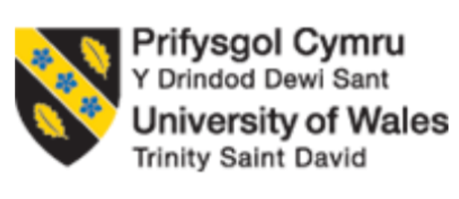

Student Name:
Student Id:
Module Name:
Module Leader:
Module Code:
Date of Submission:
Word Count:

Table of Contents
Introduction 2
SWOT Analysis Reflection 2
Description 2
Feelings 3
Evaluation 3
Analysis 3
Conclusion 3
Action Plan 3
SMART Goals Reflection 3
Description 3
Feelings 4
Evaluation 4
Analysis 4
Conclusion 4
Action Plan 4
Johari Window Reflection 5
Description 5
Feelings 5
Evaluation 5
Analysis 5
Conclusion 5
Action Plan 5
Personal Development Plan (PDP) Reflection 6
Description 6
Personal Development Plan (PDP) 6
Feelings 7
Evaluation 7
Analysis 7
Conclusion 7
Action Plan 7
Learning Styles Reflection 7
Description 7
Feelings 8
Evaluation 8
Analysis 8
Conclusion 8
Action Plan 8
Conclusion

Introduction
Professional career development is crucial for personal progress and career success in today's fast-changing employment environment. Reflecting on experiences and applying academic models to real-life circumstances improves employability and future preparation. Gibbs' reflective cycle, SWOT analysis, SMART goals, Johari Window, Personal progress Plan (PDP), and Learning Styles will be used to evaluate my professional career progress in this article These models helped me recognize my strengths and weaknesses, create reasonable goals, seek feedback, and customize my learning methods, advancing my personal and professional progress.
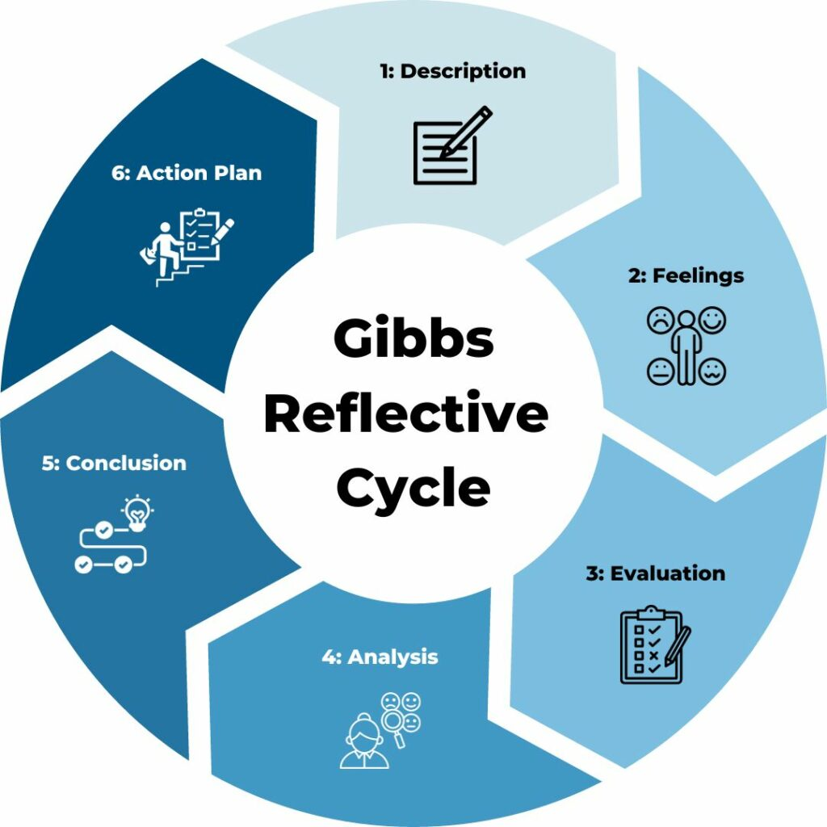

SWOT Analysis Reflection

Description
SWOT analysis, a popular corporate and personal development tool, helped me identify my strengths, weaknesses, opportunities, and threats. I did a SWOT analysis to assess my skills and career path. Communication and adaptability were my strengths, while time management and software competence were my weaknesses. Many jobs in my industry required soft skills, which I have. Threats like automation in my field were prominent.
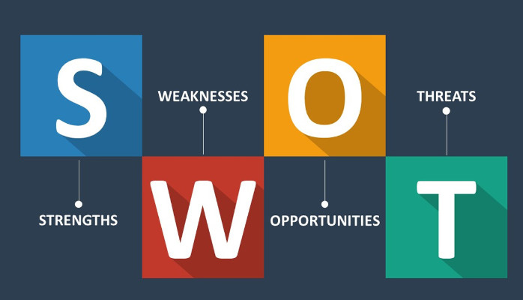

Feelings
I felt awkward identifying my weaknesses. Realizing I was unfamiliar with certain applications slowed my progress. Recognizing my strengths, like adaptability, provided me the confidence to fix these deficiencies. SWOT analysis increased my self-awareness, which challenged and motivated me.

Evaluation
SWOT analysis was crucial. Breaking down my abilities and external circumstances helped me focus my efforts. Developing my technological skills was a priority. According to the Harvard Business Review, 70% of professionals who regularly self-assess using SWOT analysis have more career clarity . It helped me understand how to take advantage of industry possibilities like professio (Minsky and Aron, 2021)nal development courses to stay competitive.

Analysis
SWOT analysis helps my career because it's simple and comprehensive. It revealed areas for improvement and chances I might have missed. World Economic Forum research shows that self-assessment and SWOT analysis help professionals shift 30% more successfully. This methodology helped me focus self-improvement and adapt to industry changes.

Conclusion
The SWOT analysis helped with self-awareness. It guided my career by identifying growth areas and leveraging my strengths. To stay on track with my career goals, I will frequently review my SWOT analysis.

Action Plan
My SWOT analysis will be updated every six months to reflect any changes in my strengths, weaknesses, opportunities, and threats. To ensure my self-assessment is objective and accurate, I will seek mentor and colleague comments.

SMART Goals Reflection

Description
I developed an actionable goal using SMART goals after my SWOT analysis. Microsoft Excel and Python were my data analysis software skills goals for six months. My goal was explicit (increasing technical abilities), quantifiable (completing online courses and projects), feasible (based on my time), relevant (to my job progress), and time-bound (six months).
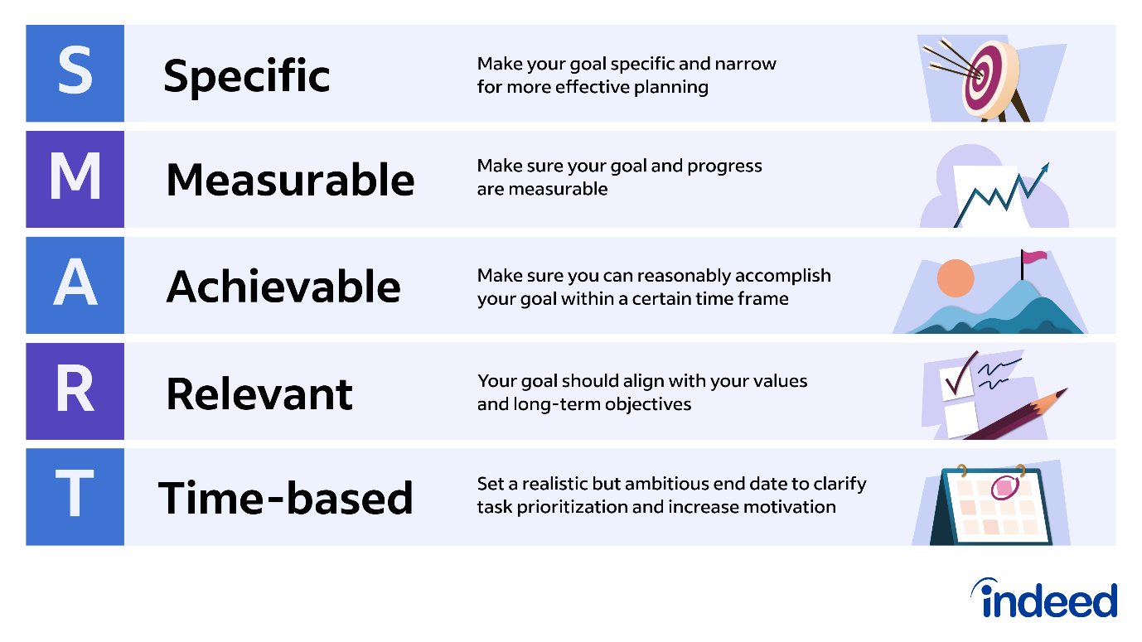

Feelings
Setting SMART goals gave me structure and direction. After feeling overwhelmed by the amount of learning, the SMART framework helped me break it down into manageable chunks, reducing my worry and increasing my desire.

Evaluation
The SMART framework worked well. Clear and quantifiable goals helped me track my development and stay motivated. Locke and Latham (2002) found that those with clear, difficult goals are 90% more likely to attain them than those with ambiguous ones (Mind Tools , 2022). I found that creating learning goals improved my abilities, confidence, and professional chances.

Analysis
The framework of SMART goals allowed me to focus on one area of development at a time, making learning easier. Gallup found that employees with clear goals are 30% more engaged and 50% more likely to stay (Harter, 2024). This strategy helped me organize and track my progress, achieving my goals.

Conclusion
The SMART objectives concept made career development feasible. Setting clear and quantifiable goals helped me enhance my technical skills and gain professional confidence. I will keep establishing goals using this model.

Action Plan
I will keep setting SMART professional growth goals. I want to get a project management certification next year to better my skills.

Johari Window Reflection

Description
My professional development was shaped by the Johari Window concept, which stresses self-awareness and feedback. I asked associates and mentors to evaluate my communication and leadership skills. Their critique revealed my "blind spots" like my reluctance to delegate.
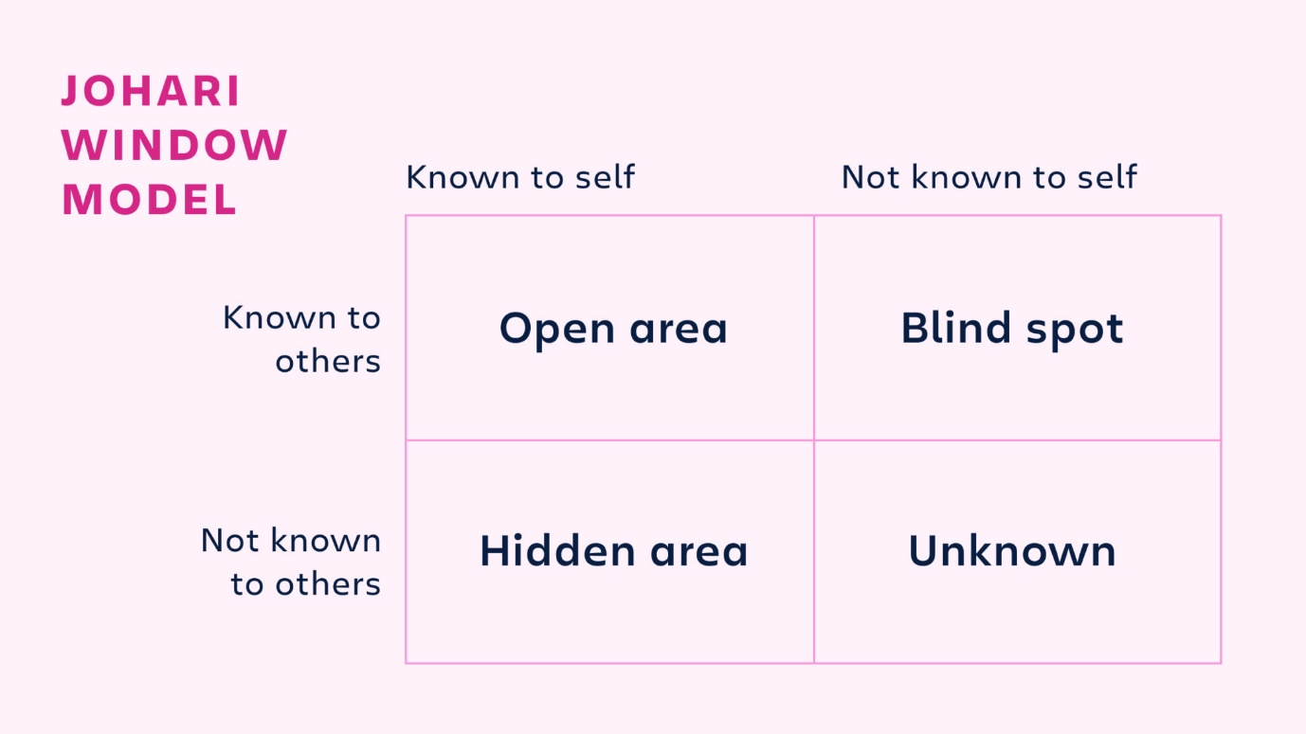

Feelings
Feedback from others was enlightening and disconcerting. I enjoyed the praise for my communication talents, but it was hard to hear about my weaknesses. This feedback was crucial for identifying blind spots and growth opportunities.

Evaluation
The Johari Window approach improved my self-awareness. The Harvard Business Review found that employees who routinely seek feedback improve 20% better over time (Imber, 2023). The feedback helped me understand how others saw my leadership style, which helped me improve.

Analysis
The Johari Window paradigm let me see myself from several angles, which was crucial to my leadership development (Business Balls, 2017). Korn Ferry found that feedback seekers boost their careers. This technique strengthened my interactions with coworkers and improved my interpersonal abilities.

Conclusion
The Johari Window concept improved my self-awareness and relationships. Feedback helped me discover blind spots and strengthen my leadership style. I will use this concept to improve my work relationships and communication.

Action Plan
I will use the Johari Window to routinely seek input from coworkers and mentors. I will also strengthen my leadership by delegating jobs better.

Personal Development Plan (PDP) Reflection

Description
My Personal Development Plan (PDP) helped me plan and achieve my long-term work goals. I had to do professional development courses, improve my technical abilities, and seek leadership chances in my PDP.

Personal Development Plan (PDP)
Development Area | Objective | Actions to Achieve Objective | Success Criteria
Technical Skills | Improve proficiency in Microsoft Excel and Python. | - Complete online courses on Excel and Python. | - Successfully complete courses and apply skills in a project.
Technical Skills | Improve proficiency in Microsoft Excel and Python. | - Work on small projects to practice and refine skills. | - Confidently use Excel for data analysis and basic Python scripts.
Project Management | Obtain Project Management certification (e.g., PMP). | - Enroll in a Project Management certification course (PMP or equivalent). | - Pass certification exam and apply PM skills in real projects.
Leadership & Delegation | Improve leadership skills, especially delegation. | - Seek feedback on leadership performance from colleagues. | - Successfully delegate tasks and manage team projects effectively.
Leadership & Delegation | Improve leadership skills, especially delegation. | - Read leadership books and attend workshops on effective delegation. | - Improved team outcomes and positive feedback from peers.
Self-Awareness | Enhance self-awareness and interpersonal relationships. | - Use the Johari Window for continuous feedback. | - More accurate self-perception and stronger relationships with colleagues.
Self-Awareness | Enhance self-awareness and interpersonal relationships. | - Engage in self-reflection exercises and coaching. | - Increased confidence and understanding of personal impact.
Continuous Learning | Stay updated with industry trends and learning strategies. | - Attend webinars, conferences, and read industry-specific literature. | - Regularly apply new knowledge to current projects and roles.

Feelings
Creating a PDP was intimidating at first because I had several goals. However, dividing these goals into smaller, doable activities reduced my stress and gave me direction.

Evaluation
My progress was tracked well by the PDP. The Chartered Institute of Personnel and Development (CIPD) found that PDP users are 30% more likely to attain career goals (CIPD, 2019). My PDP kept me focused on my long-term goals and gave me a sense of success with each milestone.

Analysis
PDP helped me stay on track with my profession. LinkedIn Learning found that people with formal development plans are 45% more likely to succeed in their careers (Perna, 2022). I kept working toward my career goals by aligning my everyday activities with my long-term goals with the PDP.

Conclusion
The PDP helped me grow professionally. It structured my career goal-setting and achievement, and I hope to use it as I go.

Action Plan
To reflect career goals changes, I will update my PDP often. I will also seek mentorship to keep my plan practical and industry-relevant.

Learning Styles Reflection

Description
Understanding my learning type using the VARK model helped me customize my study habits (VARK, 2022). I used diagrams and charts more because I'm a visual learner.
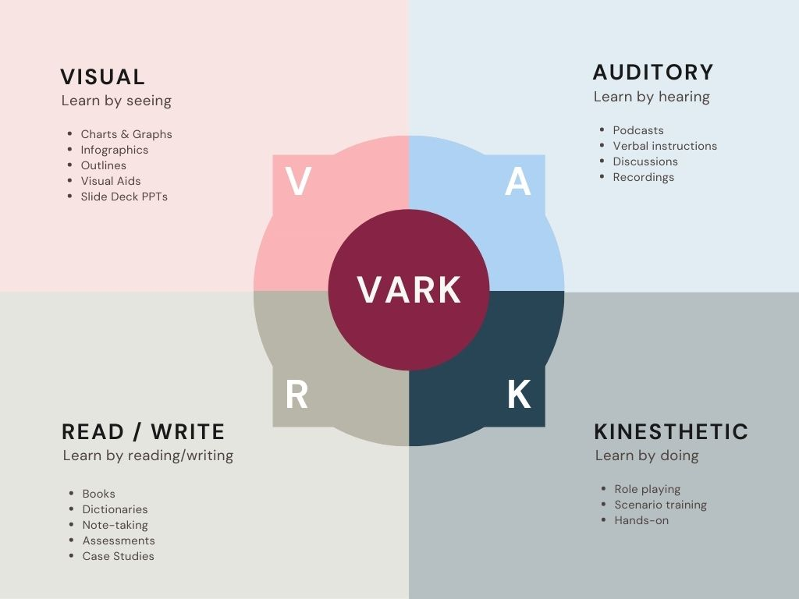

Feelings
Discovering my learning style was eye-opening. It helped me understand why some study approaches had failed and provided me the confidence to try others that fit my learning style.

Evaluation
Adjusting my study methods to my learning style greatly enhanced my memory and comprehension. The National Training Laboratories found that visual learners remember 75% of information compared to 20% when reading (Raiyn, 2016). This methodological change improved my academic achievement.

Analysis
I optimized my learning by understanding my learning style. VARK Research found that people who study according to their learning styles retain 35% more (Bobek and Tversky, 2016). I improved my academic and professional performance by using this methodology to learn faster.

Conclusion
I needed the VARK learning styles model to adjust my learning tactics to my capabilities. I became a better learner and will use this model to improve my learning and career.

Action Plan
Visual learning will be part of my study practice. I'll also try different learning strategies to see whether they improve my learning.

Reference List
Bobek, E. and Tversky, B. (2016). Creating visual explanations improves learning. Cognitive Research: Principles and Implications, [online] 1(1). doi:https://doi.org/10.1186/s41235-016-0031-6.
Business Balls (2017). Johari Window: Model and Free Diagrams - BusinessBalls.com. [online] Businessballs.com. Available at: https://www.businessballs.com/self-awareness/johari-window-model-and-free-diagrams/.
CIPD (2019). CIPD | Department for Work and Pensions achieves CIPD People Development Partner (PDP) status. [online] CIPD. Available at: https://www.cipd.org/en/about/news/dwp-achieves-cipd-people-development-partner-status/ [Accessed 26 Aug. 2024].
Harter, J. (2024). In New Workplace, U.S. Employee Engagement Stagnates. [online] Gallup.com. Available at: https://www.gallup.com/workplace/608675/new-workplace-employee-engagement-stagnates.aspx.
Imber, A. (2023). The Right Time to Ask for Feedback. [online] Harvard Business Review. Available at: https://hbr.org/2023/06/the-right-time-to-ask-for-feedback.
Mind Tools (2022). Locke’s Goal-Setting Theory. [online] www.mindtools.com. Available at: https://www.mindtools.com/azazlu3/lockes-goal-setting-theory.
Minsky, L. and Aron, D. (2021). Are You Doing the SWOT Analysis Backwards? [online] Harvard Business Review. Available at: https://hbr.org/2021/02/are-you-doing-the-swot-analysis-backwards.
Perna, M.C. (2022). Why Learning And Development Is Now A Competitive Differentiator. [online] Forbes. Available at: https://www.forbes.com/sites/markcperna/2022/04/12/why-learning--development-is-now-a-competitive-differentiator-and-how-to-get-on-board/.
Raiyn, J. (2016). The role of visual learning in improving students’ high-order thinking skills. Journal of Education and Practice, [online] 7(24), pp.115–121. Available at: https://files.eric.ed.gov/fulltext/EJ1112894.pdf.
VARK (2022). Online Learning | VARK. [online] VARK - A Guide to Learning Styles. Available at: https://vark-learn.com/vark-and-online-learning/.

Appendix
Model | Key Experience | Feelings | Evaluation | Action Plan
SWOT Analysis | Identified strengths (communication), weaknesses (technical skills), opportunities (job growth), and threats (automation). | Initially uncomfortable identifying weaknesses but motivated by recognizing strengths. | Effective in clarifying personal development priorities. | Reassess SWOT analysis every 6 months and seek feedback from mentors.
SMART Goals | Set goal to improve technical skills in Excel and Python within 6 months. | Structured approach reduced anxiety and improved motivation. | Improved technical skills and confidence in achieving career goals. | Continue setting SMART goals, next focused on obtaining a project management certification.
Johari Window | Sought feedback on leadership and communication skills from colleagues. | Enlightened but unsettled by some feedback. | Valuable for enhancing self-awareness and leadership skills. | Continue seeking feedback regularly to address blind spots.
PDP (Personal Development Plan) | Created a roadmap for long-term career goals, including skill-building and leadership opportunities. | Initially overwhelmed, but breaking tasks down made goals manageable. | Helped track progress and maintain focus on long-term career objectives. | Regularly update PDP and seek mentorship for guidance.
Learning Styles (VARK) | Identified as a visual learner and adapted study methods accordingly. | Felt empowered by recognizing effective learning methods. | Improved retention and understanding of new information. | Continue using visual aids and explore combining multiple learning styles.

