

Embedded Group Project

Module: ACDA5017

Group Development Project

Name/ Student number:
Luis Lloyd – 2220588
Mathew Lewis – 2219439
Rebecca Coles – 2218001
Selena Massey – 2229704

Table of Contents
Table of Contents 1
Abstract 2
1.Introduction 2
1.1 Project Contents: 2
1.1.1 Problem Statement 3
1.1.2 Solution Overview 3
1.2 Aims & Objectives 3
1.2.1 Aim 3
1.2.2 Objectives 3
1.3 Overview of the Report 4
2.Planning and Implementation 5
2.1 Research on Effective Team Dynamics 5
2.2 Roles and Responsibilities 6
2.3 Project Management: 6
2.3.1 Accountability: 7
3.Research and Deveolpment 7
Research Overview 8
3.1 Existing Project Review 8
3.2 Component Selection 8
3.3 Coding Methods and Compatibility 16
3.4 Budget Cost and Feasibility Analysis 17
3.5 Conclusion of the Research Section 20
4. Design and implementation 20
4.1 Design 21
4.2 Schematic build 21
4.3 Code 24
4.4 Fault find 27
4.5 Testing 27
6.Results and Findings 28
7.Conclusion 28
Reference 28

Abstract
This project focuses on the design and implementation of a smart LED lighting system optimized for office environments. The system aims to enhance energy efficiency and user comfort by dynamically adjusting lighting levels based on ambient light conditions. Utilizing a PIC16F877A microcontroller and ambient light sensors, the system intelligently regulates the brightness of LEDs to complement natural lighting, thereby reducing energy consumption while maintaining optimal illumination levels. The project begins with a comprehensive simulation using Proteus software to validate the system's functionality before transitioning to physical prototyping. By integrating simulation results with practical implementation, this study aims to deliver a cost-effective and efficient solution for modern office lighting systems

1.Introduction

1.1 Project Contents:
In modern environments such as offices, classrooms, and residential buildings, conventional lighting systems often operate inefficiently. They typically remain switched on at a constant intensity regardless of ambient light conditions, leading to unnecessary energy consumption and increased operational costs. This inefficiency is particularly evident during the daytime when natural sunlight can adequately illuminate spaces without the need for artificial lighting.
The project involves designing and implementing a cost-effective lighting control system using a lux sensor and a microcontroller. This system aims to optimize energy consumption by adjusting the lighting based on ambient light levels. It is intended to reduce electricity costs and improve energy efficiency in various environments, such as homes, offices, and public spaces.
This project is a collaborative effort undertaken by four team members:
- Luis Lloyd (L.L)
- Mathew Lewis (M.L)
- Rebecca Coles (R.C)
- Selena Massey (S.M)

1.1.1 Problem Statement
The problem our project addresses is the wastage of energy and associated costs due to inefficient lighting practices. Traditional lighting systems lack the capability to adapt dynamically to varying levels of natural light, resulting in continuous energy consumption even when illumination needs are minimal.

1.1.2 Solution Overview
The project proposes the development of a smart lighting system. This system will incorporate a lux sensor that measures ambient light levels in real-time. Based on these measurements, the system will intelligently adjust the brightness of the artificial lights. During bright sunny days, when natural light is sufficient, the system will automatically dim or switch off unnecessary lights. Conversely, in darker conditions or during nighttime, the system will increase light output as needed to maintain optimal visibility.

1.2 Aims & Objectives

1.2.1 Aim
The aim of our project is to design and implement an energy-efficient lighting solution that reduces unnecessary energy consumption and operational costs by dynamically adjusting to ambient light conditions.

1.2.2 Objectives
- Research and Analysis:
  - Conduct a comprehensive review of existing lighting systems and energy consumption patterns in various environments.
  - Analyze the feasibility and potential benefits of implementing a smart lighting system.
- System Design:
  - Design a system architecture that integrates a microcontroller, lux sensor, and control code for dynamic light adjustment.
  - Specify hardware and software components required for the implementation.
- Implementation:
  - Implement the designed system using embedded programming (Embedded C) for the microcontroller.
  - Assemble the hardware components and ensure compatibility and functionality.
- Testing and Evaluation:
  - Perform rigorous testing to validate the system's responsiveness to changing light conditions.
  - Evaluate energy savings and cost-effectiveness compared to traditional lighting systems.
- Documentation and Presentation:
  - Document all phases of the project comprehensively, including design decisions, implementation details, and test results.
  - Prepare a final presentation to demonstrate the project outcomes and
Benefits.

1.3 Overview of the Report
The report will detail the journey from problem identification through to the implementation and evaluation of the smart lighting system. Chapters will include a review of existing literature, methodologies used in research and development, design and implementation processes, analysis of results, evaluation of outcomes, conclusions drawn, and recommendations for future work.
By addressing the inefficiencies of traditional lighting systems through innovation and technology, our project aims to contribute towards sustainable energy practices and cost savings in lighting infrastructure.
By the end of this report, readers will gain insights into the feasibility and benefits of smart lighting technologies in reducing energy consumption and operational costs while enhancing environmental sustainability. The subsequent chapters will provide a detailed exploration of each phase of our project, culminating in a comprehensive understanding of our approach and outcomes.

2.Planning and Implementation
Planning the Project: Implementing Strategies for Team Success
To achieve the required aims and objectives, a clear plan is essential when working within a group environment to facilitate clear communication and understanding of each member's roles and responsibilities.

2.1 Research on Effective Team Dynamics
Before commencing the project, we conducted research on strategies contributing to the success of project teams. According to Belbin's Team Roles theory, each team member should have clearly defined roles and responsibilities to ensure accountability and minimize confusion [1]. Effective communication channels, such as regular team meetings and a shared project management platform, facilitate prompt discussions on progress, challenges, and decisions. Structured project management, utilizing tools like Gantt charts [2], helps visualize project timelines, milestones, and dependencies. Figure 1 below shows Belbin's team roles. Establishing roles and responsibilities alongside individual strengths and weaknesses of the team will allow for efficient successful project execution.

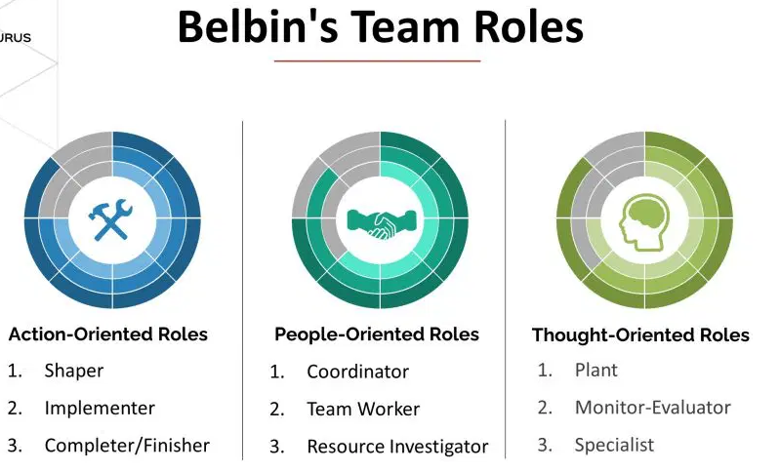
Figure.1 [3]

2.2 Roles and Responsibilities:
To apply these principles effectively, the group has established the following approach:
- Mathew Lewis (M.L): Leads system design and integration, focusing on hardware and software architecture.
- Rebecca Coles (R.C): Drives implementation phase, responsible for coding, testing, and debugging.
- Luis Lloyd (L.L): Manages project coordination and documentation, ensuring clarity and organization.
- Selena Massey (S.M): Prototype build

2.3 Project Management:
A Gantt chart has been designed to outline tasks, deadlines, and assign responsible team members. Regular reviews of this Gantt chart will track progress and allow for timely adjustments to timelines if necessary. This tool is invaluable for maintaining an up-to-date overview of project status and ensuring that delays in one aspect do not affect other parts of the project.
Below is the Gantt chart created using Microsoft Excel

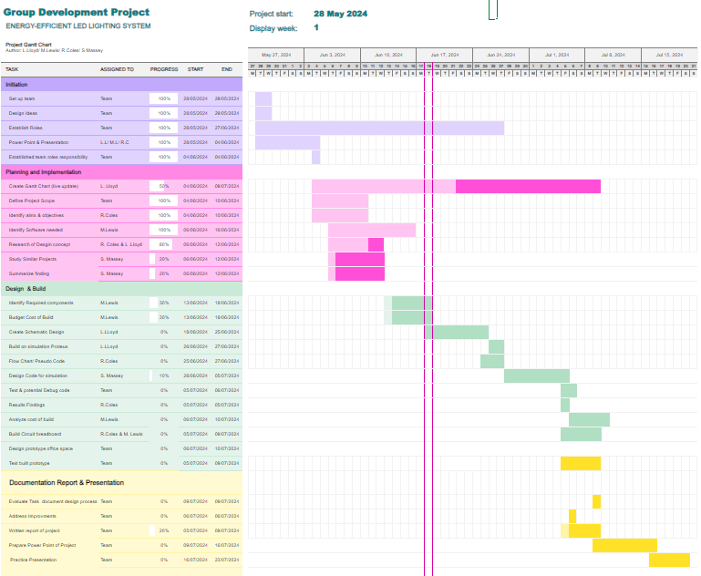
Figure.2 Project Gantt Chart

2.3.1 Accountability:
Each team member will provide regular updates on task progress during team meetings and through the project management platform.
By implementing these researched strategies, we can ensure an efficient team environment. Clear roles, effective communication, structured project management, and accountability will be instrumental in ensuring the success of our smart lighting system project. These practices will not only enhance team collaboration but also contribute to achieving our project objectives within the specified timeline.

3.Research and Deveolpment

Research Overview
The team conducted research on two similar studies based on smart lighting systems to understand the pros and cons of such systems and the importance of selecting the correct components and program logic for the code.

3.1 Existing Project Review
The first study focuses on using LED luminaires and light sensors to create energy-efficient, adaptive lighting environments. The main benefits include significant energy savings, longer lifespan of LEDs, and improved user experience due to precise control of lighting based on real-time data. However, the study also highlights the need for careful system design to address different user needs and varying light conditions [4].
The second study, a streetlamp control system based on the Bolt IoT platform, aiming to reduce electricity wastage and minimize manpower. It uses LEDs and Light Dependent Resistors (LDRs) to control light intensity and Infrared (IR) sensors to detect vehicle movement, adjusting streetlight brightness accordingly. This system offers better performance compared to existing systems by being cost-effective and environmentally friendly [5].
Challenges and Limitations:

3.2 Component Selection
PIC16F877A Microcontroller

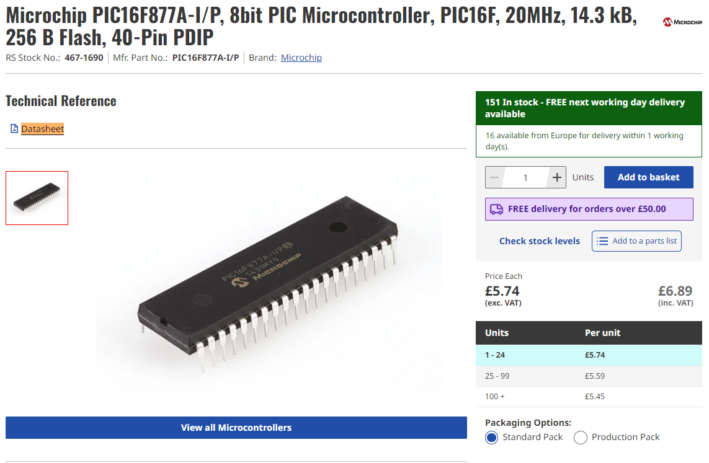
Figure.3 Microcontroller RS [Ref]

The PIC16F877A is a popular microcontroller from Microchip Technology that is well-suited for controlling lighting systems for several reasons:
Cost-Effective: The PIC16F877A is relatively inexpensive, making it a cost-effective choice for projects that do not require high-end processing power.
Ample I/O Pins: It has 33 I/O pins, providing plenty of options for interfacing with multiple lights, switches, sensors, and other peripherals. This makes it suitable for controlling complex lighting systems.
Analog and Digital Capabilities: It includes 8 channels of 10-bit Analog-to-Digital Converters (ADCs), which are useful for reading sensors that provide analog outputs (e.g., light sensors for automatic lighting adjustments).
PWM Modules: The microcontroller features two Pulse Width Modulation (PWM) modules, which can be used for dimming lights. PWM control is an efficient way to manage the brightness of LEDs.
Memory: With 368 bytes of RAM, 256 bytes of EEPROM, and 8 KB of Flash memory, the PIC16F877A provides sufficient storage for most lighting control programs and their configurations.
Ease of Programming: There are numerous development tools and resources available for programming and debugging the PIC16F877A. These include MPLAB X IDE, various compilers like XC8, and a wide community of users providing code examples and support.
Reliable Performance: PIC microcontrollers are known for their reliability and robustness, which is crucial for systems like lighting that often require long-term, maintenance-free operation.
Interrupts and Timers: It has multiple timers and interrupt sources, allowing for precise timing and responsive control of lighting sequences and effects.
Serial Communication: The microcontroller supports various serial communication protocols (USART, SPI, I2C), making it easy to integrate with other devices or networks for remote control and monitoring.
Low Power Consumption: The PIC16F877A is designed to be power-efficient, which is advantageous for applications where energy consumption is a concern, such as battery-operated or green energy systems.
These features make the PIC16F877A a versatile and practical choice for a wide range of lighting control applications, from simple home lighting systems to more complex, automated lighting solutions.

LDR / Photoconductive Cell

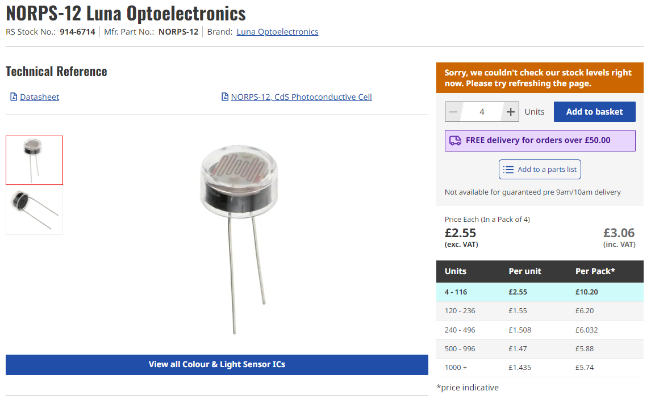
Figure.4 LDR [Ref]

The NORPS-12 from Luna Optoelectronics is a Light Dependent Resistor (LDR), also known as a photoresistor. It is a type of resistor whose resistance decreases as the intensity of light falling on it increases. Here's a detailed overview of its characteristics and applications:
Key Characteristics:
Resistance Range: The NORPS-12 typically has a high resistance in the dark (in the megaohm range) and a much lower resistance under bright light conditions (in the kiloohm range). This change in resistance with light intensity is what makes it useful for light sensing applications.
Spectral Response: The NORPS-12 is sensitive to visible light, making it ideal for applications where detection of ambient light levels is required.
Response Time: LDRs generally have a slower response time compared to other light sensors like photodiodes or phototransistors. This means they are better suited for applications where rapid changes in light levels are not a concern.
Temperature Sensitivity: Like most LDRs, the NORPS-12’s resistance can also be affected by temperature changes, though this is usually a secondary concern compared to light sensitivity.
Applications:
Automatic Lighting Control: The NORPS-12 can be used to turn lights on or off based on ambient light levels, such as streetlights that turn on at dusk and off at dawn.
Light Meters: It can be used in devices that measure light intensity, such as photographic light meters.
Security Systems: LDRs can be part of security systems that detect changes in light levels, indicating the presence of an intruder or other event.
Consumer Electronics: It can be used in devices like nightlights, clock radios with dimming displays, and other gadgets that adjust their behavior based on ambient light.
Integration with Microcontrollers:
When using the NORPS-12 LDR with a microcontroller like the PIC16F877A, the typical setup involves creating a voltage divider circuit. Here’s a simple example:
PIR Sensor

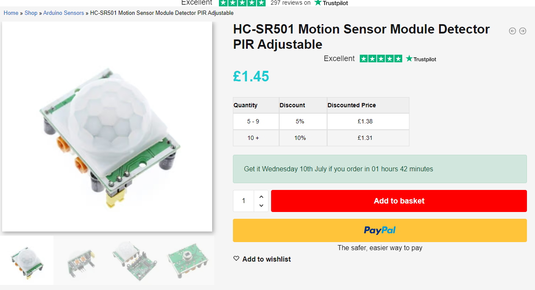
Figure.5 PIR [Ref]

A Passive Infrared (PIR) sensor is a common choice for detecting motion in various applications, including lighting control systems. When choosing a PIR sensor to work with a microcontroller like the PIC16F877A, you should consider factors such as ease of interfacing, power requirements, and the sensor's range and sensitivity.
One popular and widely used PIR sensor is the HC-SR501. Here’s why the HC-SR501 is a good choice and how you can interface it with the PIC16F877A:
Key Features of HC-SR501 PIR Sensor:
Adjustable Sensitivity and Delay: The HC-SR501 allows you to adjust both the sensitivity (range) and the delay time (duration the output remains high after detecting motion), making it versatile for different applications.
Wide Operating Voltage: The sensor operates from 4.5V to 20V, making it compatible with the 5V supply typically used with the PIC16F877A.
Digital Output: The HC-SR501 provides a digital output, which is easy to read with a microcontroller’s digital input pin.
Range: It has a detection range of up to 7 meters and a detection angle of about 120 degrees, suitable for most indoor applications.
LCD Display

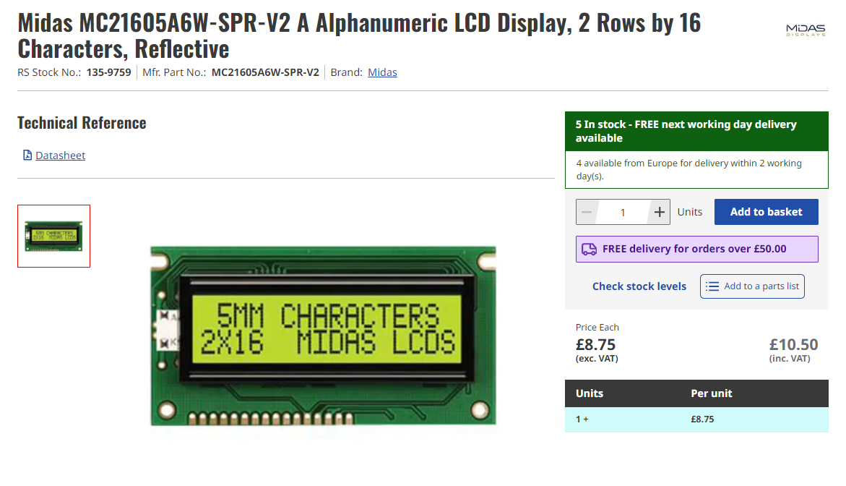Figure.6 Microcontroller RS [Ref]

Capacitors

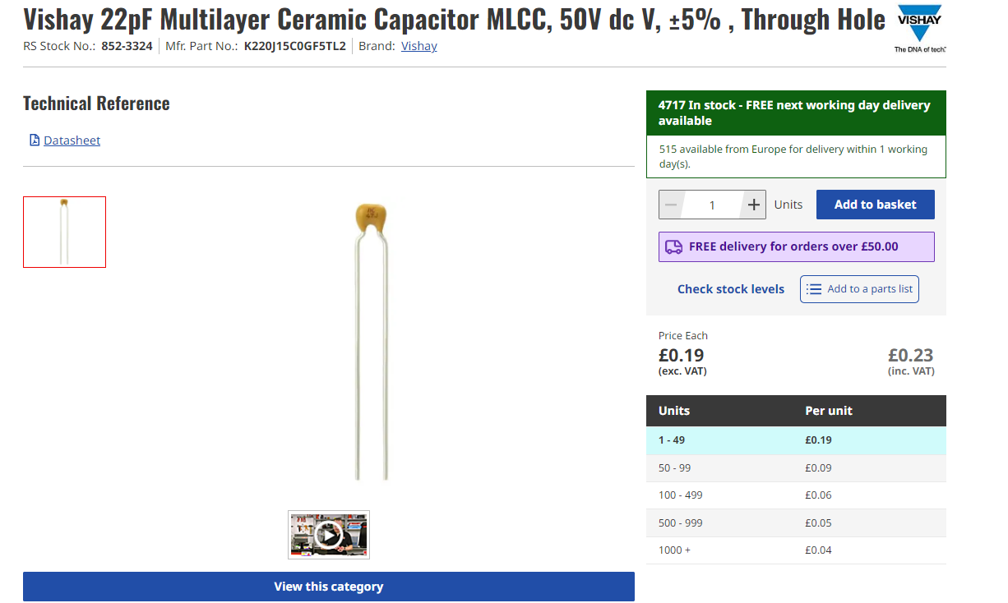Figure.7 Microcontroller RS [Ref]

Resistors

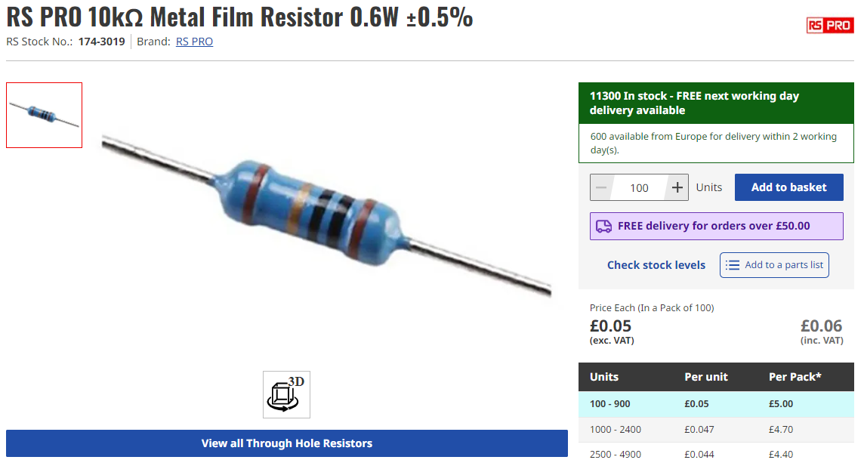
Figure.8 Resistor RS [Ref]

Crystal Oscillator
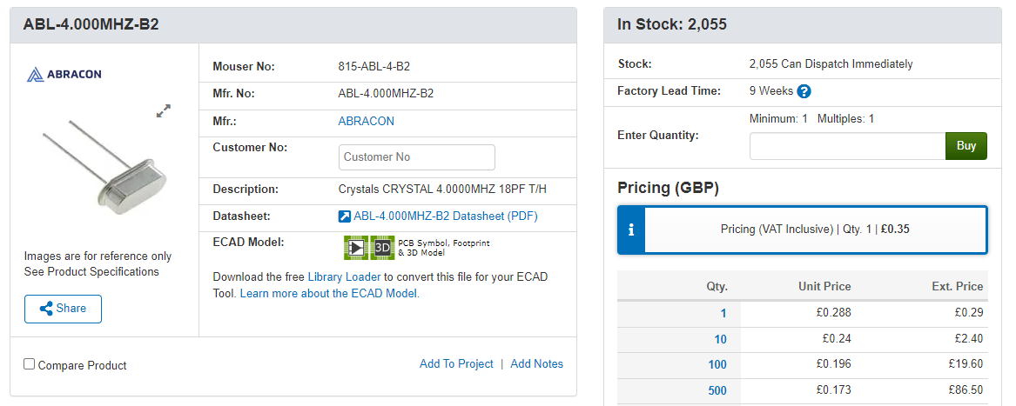Figure.9 Microcontroller RS [Ref]

3.3 Coding Methods and Compatibility
Our research into coding methods primarily focused on selecting the appropriate programming languages for both microcontroller programming and backend systems interfacing. We analyzed several languages, including:
- C/C++: Commonly used for microcontroller programming due to their efficiency and control over hardware.
- Python: Popular for backend systems interfacing and handling data processing due to its simplicity and extensive libraries.
- Arduino: can be compiled to machine code, resulting in highly efficient and compact files. [6]

We have chosen Embedded C for our microcontroller programming. Despite Arduino’s popularity and ease of use, Embedded C was selected because of its practicality and our team's familiarity with the language, ensuring efficient development and debugging processes.

3.4 Budget Cost and Feasibility Analysis
Using a microcontroller with a PIR (Passive Infrared) sensor and an LDR (Light Dependent Resistor) to control office lighting can result in significant energy and cost savings. Here's a detailed analysis:
Energy Savings:
Reduced Lighting Hours:
PIR Sensor: The PIR sensor detects motion and ensures that lights are only on when the office is occupied. This can significantly reduce the number of hours that lights are on, especially in spaces that are not constantly occupied.
LDR: The LDR adjusts the lighting based on ambient light levels, dimming or turning off artificial lights when natural light is sufficient.
Estimate of Savings:
Assume an office uses lighting for 10 hours per day without control.
With a PIR and LDR system, the lighting usage could potentially be reduced to 5 hours per day on average (depending on occupancy patterns and natural light availability).

Energy Consumption:
Assume typical office lighting uses 40 watts per fixture, and there are 100 fixtures in the office. Typically in the UK, offices will use fixtures such as:
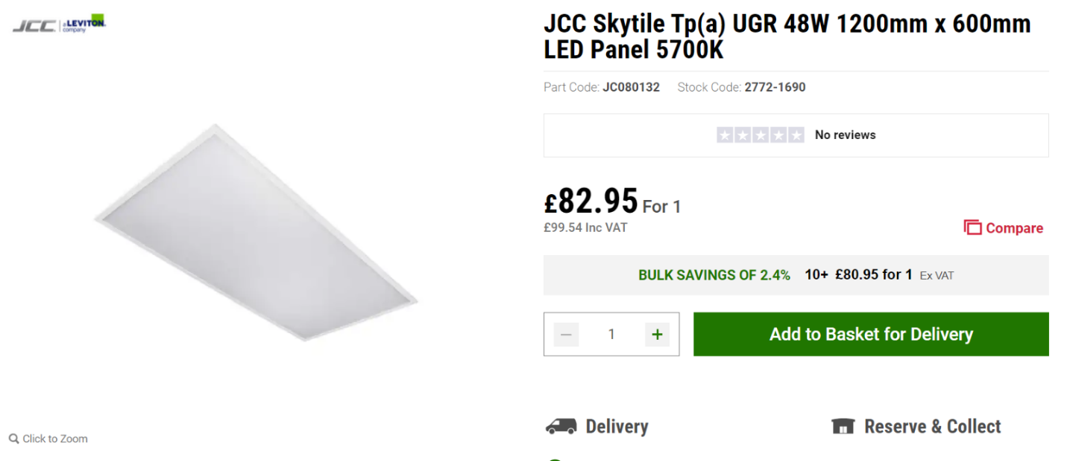Figure.10 LED [Ref]

Daily energy usage without control:
100 fixtures x 40 watts x 10 hours = 40,000 watt-hours or 40kWh.
Daily energy usage with control:
100 fixtures x 40 watts x 5 hours = 20,000 watt-hours or 20kWh.
Cost Savings:
Electricity Cost:
The average cost of energy in the UK is 22.36p per kWh.
Daily cost without control:
40kWh x 22.36p = £8.94 per day
Daily cost with control:
20kWh x 22.36p = £4.47 per day
Daily savings:
£8.94 - £4.47 = £4.47 per day
Annual savings:
365 x £4.47 = £1,631.55
Additional Savings:
Extended Lifespan of Bulbs:
Reduced usage extends the lifespan of light bulbs, reducing replacement costs.
Assume the cost of replacing a single panel light:
Fitting = £85
Labour = £80
Total = £165
Based on the JCC datasheet, the lifespan of the panel light will last 54,000 hours.
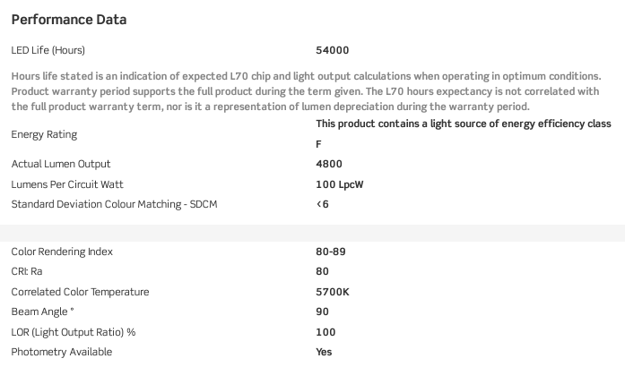Figure.11 Product data sheet [Ref]
Without control, these panels will last:
$$10×365 = 3650 hours$$
$$5400÷3650=14.79years$$
With control:
$$5×365=1825 hours$$
$$5400 ÷ 1825=29.58years$$
Over 30 years, lighting without control will cost approximately £33,000 to maintain. Lighting with control will cost approximately half of that.
Initial Investment:
Cost of System:
Microcontroller | £5.74
LDR | £2.55
PIR Sensor | £1.45
LCD Display | £8.75
Capacitors, resistors, oscillator etc | £2.00
Build and install – 4 hours @ £40 per hour | £160
Total | £180.49

Assume 1 system controls 10 fixtures, for 100 fixtures the installation cost would be:
$$10 × £180.49=£1,804.90$$
Payback Period:
Installation costs / annual savings = payback period
$$£1,804.90/£1,631.55=1.1years$$

3.5 Conclusion of the Research Section
By researching both studies, it highlights the importance of selecting the right components, such as LEDs, sensors, and control systems. This knowledge guides the design and implementation of our smart lighting project, ensuring it is both energy-efficient and user-friendly.

4. Design and implementation

4.1 Design
In the design phase of the smart lighting system project, the initial step involves setting up a simulation using Proteus software. This simulation serves to verify the functionality and interaction of components before progressing to physical prototyping.

The reason we used proteus was for the following reasons explained below.
- Simulation abilities - Proteus provides powerful simulation tools that allow us to model and test the behavior of circuits before physically building them. This capability helps in identifying and fixing issues early in the development process.
- Debugging and analysis - Proteus uses debugging tools such as virtual oscilloscopes, logic analyzers, and voltage probes. These tools help the circuit’s performance and behavior under different conditions, making it easier to troubleshoot and refine the design.
- Integrating codes - Proteus allows for the integration of embedded software with the hardware design. We can load our compiled code from CCS into the simulated microcontroller and see how it interacts with other components, ensuring seamless integration between hardware and software.
- Real-life behaviour - The ability to accurately simulate the real-world behavior of components, such as sensors and microcontrollers, ensures that our design will work as expected when built physically. This reduces the risk of unexpected issues during the physical implementation stage and any delayed timing.

By using Proteus, we could efficiently design, simulate, and validate our circuit, ensuring that it met all the necessary requirements and performed as expected before moving to physical prototyping and implementation.

- Components Identified:
  - Microcontroller: PIC16F877A
  - Display: 16x2 LCD Display
  - Sensors: PIR Sensor, LDR Sensor
  - LEDs: Light sources controlled by the microcontroller
  - Passive Components: Resistors, capacitors, etc.
  - Power Supply: DC power supply unit providing necessary voltage and current.

4.2 Schematic build
This code is structured to enable an automated lighting system that adjusts based on detected motion and ambient lighting levels. It is built on a software called Proteus, which gets compiled on CCS, then transferred back to Proteus for simulation. The project aims to mimic motion detection using either a switch or pulse generator as substitutes for a PIR sensor, which is not available without a license.
Originally, the setup initializes necessary components such as an LCD display and defines pin configurations for interfacing with components such as the LED, LDR (Light Dependent Resistor), and PIR (Motion detection device). The main function continuously loops, managing the detection and response actions. The circuit checks for motion via the ‘motion_detected’ function and reads ambient light intensity using ‘get_lux’, capturing the microcontroller's ADC for accurate analog-to-digital conversion. The ‘control_light’ function plays a vital role in adjusting the LED's state based on the combined inputs of motion presence and measured light intensity. This integrated approach ensures that the lighting system optimally responds to environmental changes, prioritizing energy efficiency and user comfort in its simulated operation.
The initial section of the code focuses on the connections between various components. This includes defining the pins for the LCD, PIR sensor, LDR, and LED. Following this, thresholds for light intensity (lux levels) are set, guiding the system's response based on environmental conditions. The analog-to-digital converter (ADC) is then configured to accurately read data from the LDR, facilitating precise light intensity measurements. The main core functionality of the code revolves around simulating the PIR sensor's behavior. It checks the current lux level readings: if lux is greater than 213, the LED is turned on at full brightness, if lux is between 84 and 212, the LED operates at 50% brightness, and if lux drops below 84, the LED is switched off to conserve energy. In the absence of motion detected by the simulated PIR sensor, the LED remains off, ensuring efficient energy usage when no activity is detected. This sequential setup and logic ensure effective control of lighting based on simulated environmental inputs.
Refer to Figure 14 for the representation of the LED being illuminated. This corresponds to all lux levels greater than 85. Figure 15 displays the LED not illuminated due to lux levels being less than 84.
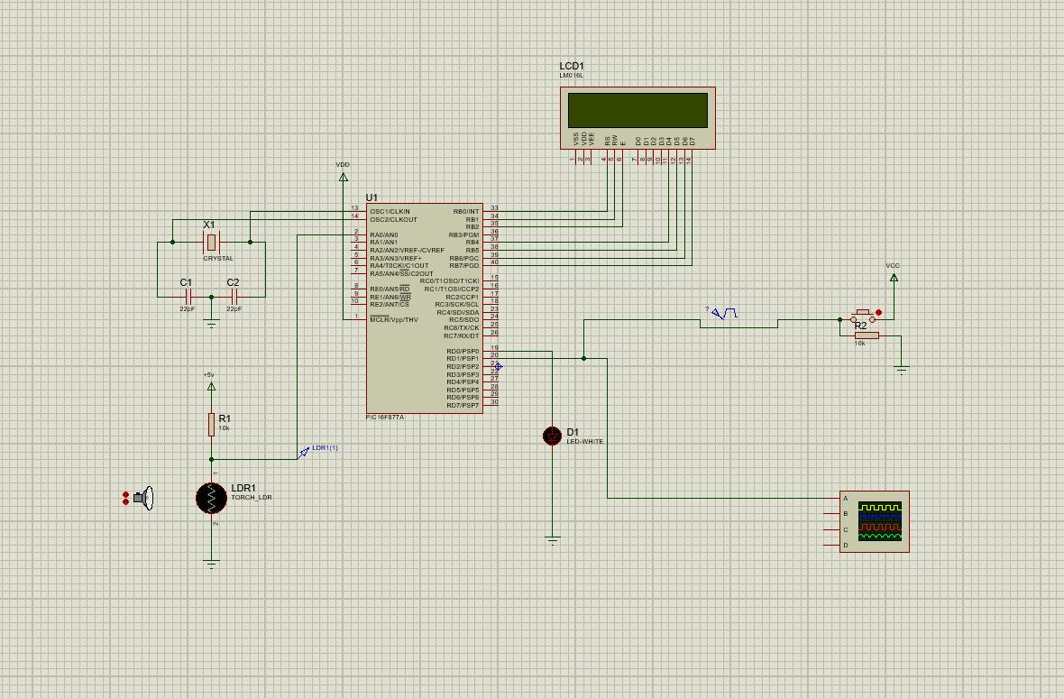
Figure.12 Proteus - Light Intensity and Motion-Based LED Controller.

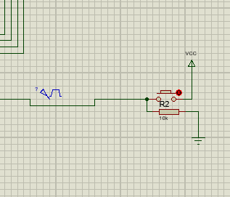
Figure.13 Proteus - Motion Detection Simulation Using Switch or Pulse Generator

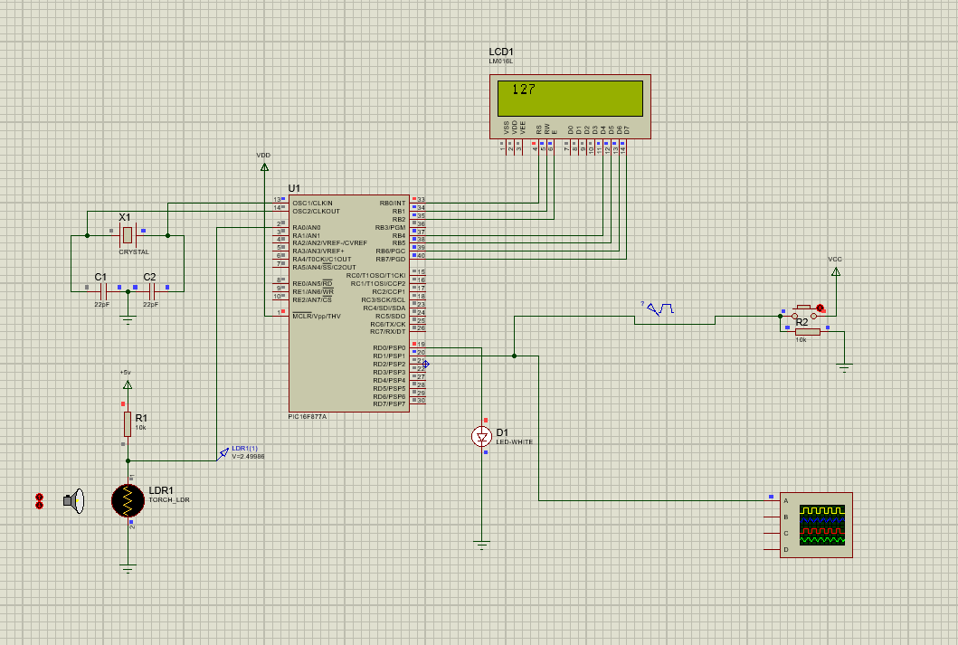Figure.14 Proteus - Light Intensity and Motion-Based LED Controller (LED on)

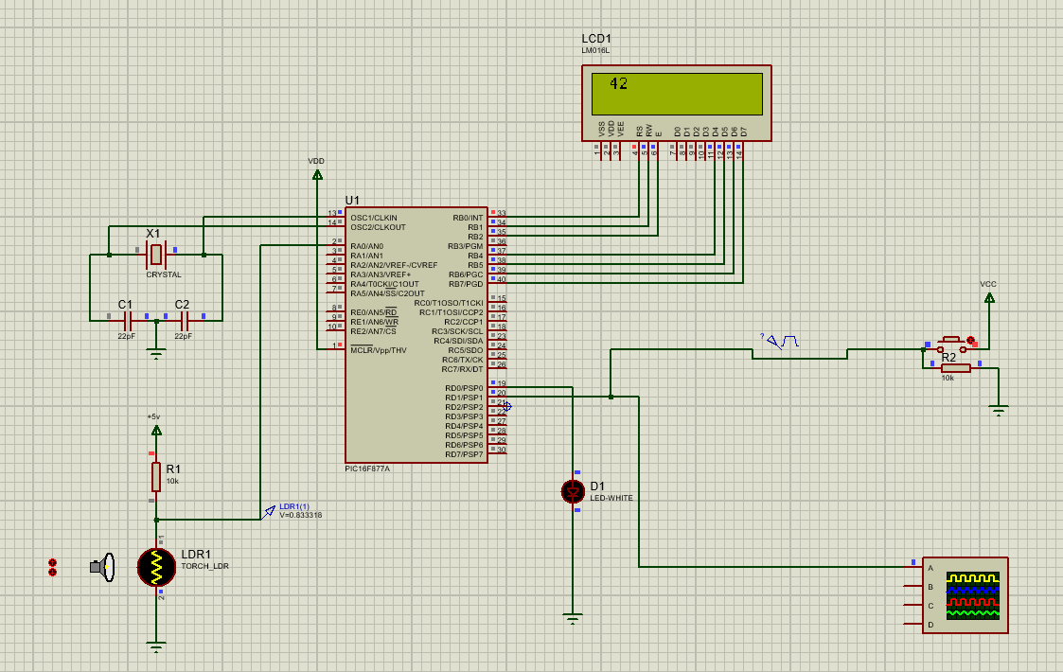Figure.15 Proteus - Light Intensity and Motion-Based LED Controller (LED off)

4.3 Code
This code is a C program designed to control a light based on motion detection and light intensity (lux) levels using a microcontroller. Refer to Figure.14 above as this gives a basic layout of the circuit.
This code implements a simple automated lighting system using a PIR sensor for motion detection and an LDR for light intensity measurement. It initializes necessary ports and the LCD display, then enters an infinite loop where it continuously reads the light intensity and checks for motion. Based on the lux value and motion detection, it adjusts the LED's state and brightness accordingly, while also displaying the lux value on the LCD.
Basic explanation of the code - The ‘get_lux’ function reads the LDR's value via the ADC, and the ‘motion_detected’ function reads the PIR sensor's state. The ‘control_light’ function determines the LED's behavior based on predefined lux thresholds and motion status.
The reason for choosing this code is that it is a clear, modular, and functional structure that effectively utilizes both the PIR sensor and the LDR to control the LED based on environmental conditions and motion detection. Here are the reasons for specific design choices.
- Separation - By breaking the code into distinct functions each responsible for a specific task, the code becomes easier to understand, maintain, and debug. This approach allows for future expansions or modifications with minimal impact on other parts of the code.
- Readability - Using names and comments help make the code self-explanatory. This ensures that someone else can easily understand the code's purpose and functionality.
- Real-time monitoring - The circuit continuously monitors the readings and updates the LED state, ensuring that the system responds promptly to changes in the environment.
- Input - The LCD display provides real-time feedback on the current light level, which makes it easier for debugging and understanding the system's behavior.
Overall, the code is designed to be modular, clear, and efficient, ensuring reliable performance and ease of maintenance while effectively achieving the goal of automated LED control based on environmental conditions and motion detection.

However, during the development of the code, we encountered a couple of challenges. Initially, our plan involved using a PIR sensor for motion detection. However, due to its unavailability in Proteus without a license, we explored alternative approaches. We experimented with two substitutes: a pulse generator and a switch, to replicate the functionality of the PIR sensor in our project.

4.3.1 Flowchart
The flowchart is important because it shows the program's steps clearly, making it easier to understand. It helps find and fix errors by breaking down complex code into simple parts. For teams, it ensures everyone understands the system the same way. It also helps plan and document the program, making future updates easier. The flowchart highlights key decisions and loops, which makes debugging simpler. Overall, it makes the program easier to read, understand, and maintain. Below is an image of a flowchart that we have created to enable us to write the code:
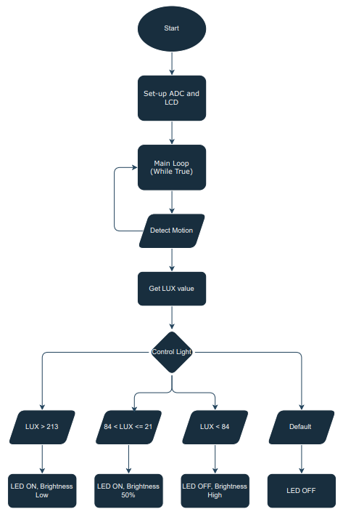
Figure.16 Flowchart

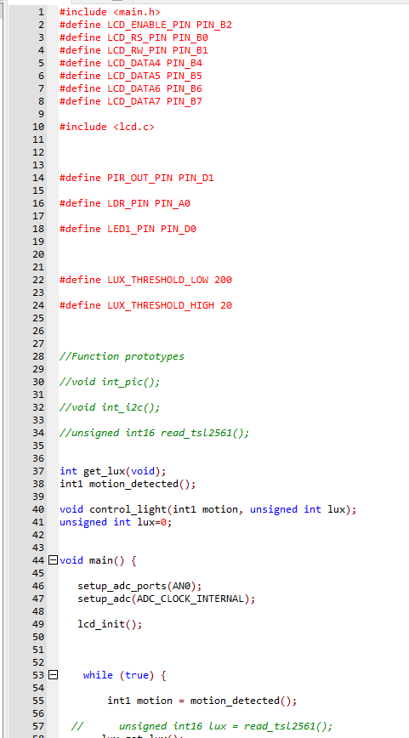
Figure.17 Screen shot of code used
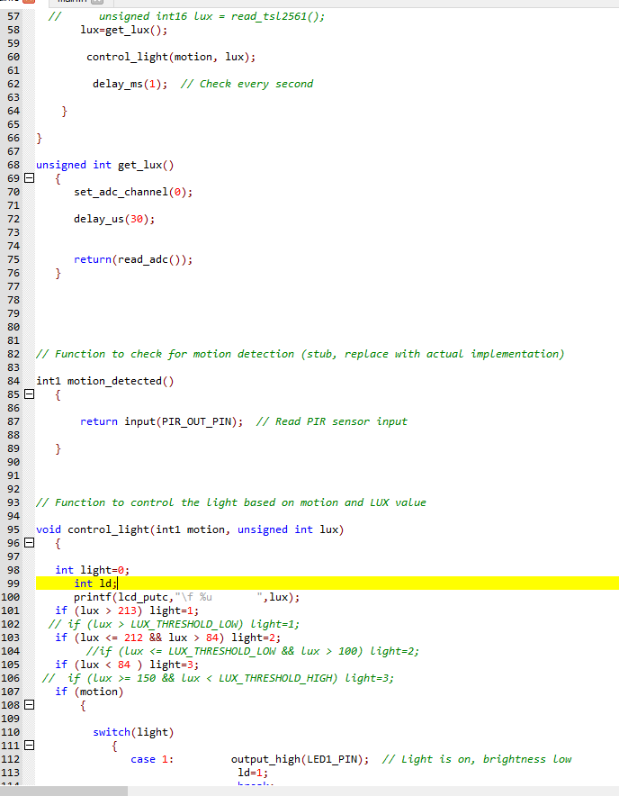
Figure.18 Screen shot of code used

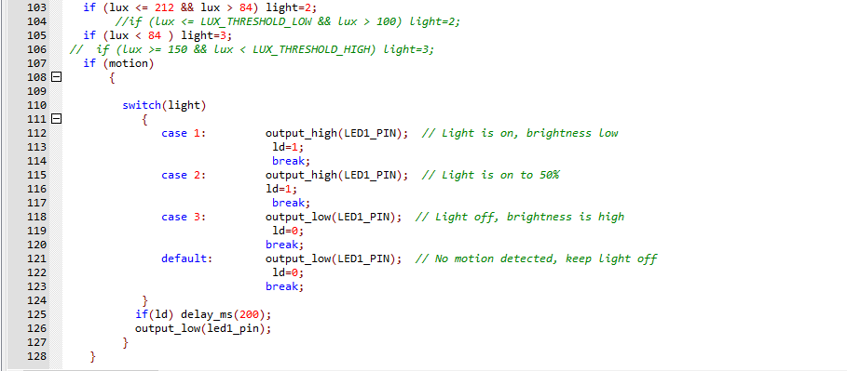 Figure.19 Screen shot of code used

4.4 Fault find
The initial issue we encountered was the absence of a PIR sensor in Proteus. To address this, we initially substituted a switch in its place. During simulation, we observed that the switch needed to be manually activated to simulate the detection behavior of a PIR sensor. Later, we attempted to use a pulse generator as an alternative solution. However, we found that incorporating the pulse generator caused delays affecting both the LED and the LCD display during operation.
Both options were viable for use; however, neither replicated the exact functionality of a PIR sensor. Despite this, we opted to continue using a switch during the simulation because it operated without introducing any delays and functioned adequately in the absence of a PIR sensor. However, we introduced a timer to automatically switch off the light if it stayed on for more than 200 milliseconds. This decision came about during our evaluation of whether to use a pulse generator or a switch for simulating motion detection.

After conducting research, a microwave sensor would be able to perform the same function as a PIR sensor. Microwave sensors emit microwave signals and detect reflections from moving objects, making them effective for detecting motion through walls and obstacles. However, implementing microwave sensors can be more intricate due to their complexity.

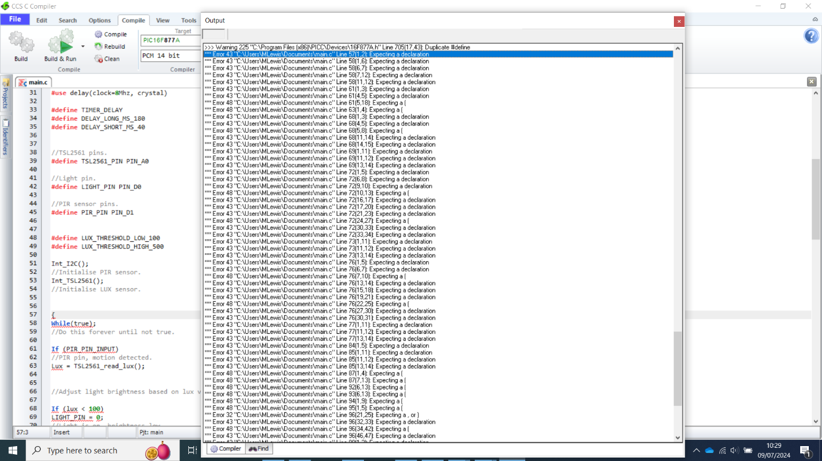Figure.20 Screen shot of the error codes

4.5 Testing

Once the code was finalized, we conducted a series of comprehensive tests to validate its functionality. Firstly, we simulated various lux levels and motion states to ensure the LED responded correctly. We monitored this response not only through the LED itself but also via the LCD display and a voltage probe placed in series. This setup allowed us to observe that brighter lux levels corresponded to lower voltages, while dimmer conditions showed higher voltages.
Secondly, we tested the integration of all components. We verified that motion detection reliably triggered appropriate lighting responses based on lux levels, and we ensured the LCD display consistently presented accurate information.
Boundary testing was also crucial. We examined all lux levels near threshold values, such as just above and below 84 or 213 lux, to confirm correct system behavior. We ensured the system handled extreme lux values and varied motion detection states to validate robustness.
In addition, we assessed the circuit for any delays. We measured the code’s execution speed to ensure that delays were within acceptable limits and that the system responded promptly to changes in lux levels and motion detection.
Finally, we validated that simulated hardware components, including sensors and the microcontroller, mirrored real-world behavior. This verification was particularly crucial when using Proteus, ensuring that simulated outcomes matched those expected from physical testing scenarios.

6.Results and Findings
After testing the code, we obtained results and findings. The LED responded to the values input into the code. The LCD display accurately showed the current lux level, allowing real-time monitoring of light conditions.
The PIR sensor effectively detected motion and triggered the appropriate response in the LED.
When motion was detected, the LED's behavior corresponded to the lux levels as expected. If no motion was detected, the LED remained off regardless of the lux level.

All components, including the ADC for lux measurement, the PIR sensor, and the LED, integrated correctly.
The control logic correctly interpreted sensor inputs and managed the LED output, demonstrating reliable interaction among all components.

These findings confirm that the code is robust, performs as intended, and integrates well with the hardware components, providing a solid foundation for further development or physical prototyping.

Next time, we plan to replace the PIR sensor with a microwave sensor. Microwave sensors offer advantages such as detecting motion through walls and obstacles, providing more reliable and expansive coverage. While they are more complex to implement, their ability to emit microwave signals and measure reflections from moving objects can enhance the accuracy and sensitivity of our motion detection system. This change aims to improve overall system performance and reliability in various environments.

7.Conclusion
The code successfully integrates lux level measurement and motion detection to control an LED's brightness, ensuring efficient lighting based on environmental conditions. The system responded accurately to different lux levels and motion states, and the LCD display provided real-time feedback. However, for future improvements, we plan to replace the PIR sensor with a microwave sensor. Microwave sensors offer enhanced motion detection capabilities through walls and obstacles, potentially increasing the system's accuracy and reliability. This upgrade aims to improve overall performance and adaptability in diverse environments.

Reference
[1] Belbin, R. M. (2010). Team Roles at Work. Routledge.
[2] Jones, P., Smith, K., & Brown, S. (2017). Project Management in Construction. Routledge.
[3] The 9 Belbin Team Roles And What They Accomplish | Quality Gurus
[4] S. Bhardwaj, T. Özçelebi and J. Lukkien, "Smart lighting using LED luminaries," 2010 8th IEEE International Conference on Pervasive Computing and Communications Workshops (PERCOM Workshops), Mannheim, Germany
[5] S. M. Sorif, D. Saha and P. Dutta, "Smart Street Light Management System with Automatic Brightness Adjustment Using Bolt IoT Platform," 2021 IEEE International IOT, Electronics and Mechatronics Conference (IEMTRONICS), Toronto, ON, Canada, 2021, pp. 1-6, doi: 10.1109/IEMTRONICS52119.2021.9422668
[6] Arduino vs Python | What are the differences? (stackshare.io)
[7]

