
Module Assignment Submission

Module Code | BMSK5001
Module Title | Developing Workplace Critical Thinking
Level | 5
Student Name | Sandra Mauwa Khonde
Student ID | 1706732

Contents
Introduction: 3
Overview of the company and its beliefs, attitudes, and values: 3
Beliefs, attitudes, & values and their differences: 4
Advantages and disadvantages of beliefs: 6
Impacts of beliefs, values, and attitudes toward behaviour: 7
Synopsis of past experience of me: 8
Critical evaluation of critical thinking: 8
Management theories regarding critical thinking: 9
Blooms Taxonomy framework: 9
Scientific management theory: 11
Paul-Elder critical thinking framework: 11
Impacts of beliefs, values, and attitudes on behaviour: 12
Contingency theory: 13
Kolb’s learning style theory: 14
Gerald Nosich critical thinking development approach: 15
Implications of the above theories on beliefs, values, and attitudes and their importance in the workplace: 16
The way someone’s beliefs, values, and attitudes could be interpreted by leadership theory: 17
Skills needed for the twenty-first century: 18
Recommendations to Vodafone to improve critical analysis in the workplace: 19
Conclusion: 20
References 21

Introduction:
Critical thinking is a systematic ability to analyze a situation and conclude such a way that ensures the proper solution that is backed up by required evidence, not merely the superficial individual idea sharing. Critical thinking states a process of analyzing, reasoning, solving problems, and making a justifiable decision which meets all criteria to faith (Shahrokh, 2014). At the age of knowledge-driven economy, the critical thinking ability is part and parcel to developing one’s career. Each and every day there are lots of advanced technologies and emerging technologies are coming up and every individual should adjust with that inventions otherwise it will be very difficult to survive against that wave.

Figure 1: Critical thinking
Source: (Tullar, 2014)
In the workplace, critical thinking ability is very crucial and unique assets for every organization. The organizations which have sufficient critical thinkers are very blessed because this unique asset brings competitive advantages. The beliefs, values, and attitudes are very crucial to shape the behaviour of individuals. The success of an individual much more dependent on ways of behaviour to various issues and the individual behaviour larges depends on beliefs, attitudes, and values as well (Weinstein and Oxman-Michelli, 2016).

Overview of the company and its beliefs, attitudes, and values:
The following report will be covered in the perspective of Vodafone, a British multination telecommunication company. It is founded in 1991 and it has its operation among 25 countries. The products or services of the company are IPTV, fixed-line telephone, mobile, broadband, and others. I have worked as a part-time assistant HR officer in the company. This has given lots of experience in real-life working (Vodafone.com, 2019). The company always focus on employee development and takes necessary steps as the employees could think critically. They define critical thinking as the process of taking any decision by backing proper evidence and supports. The company believes that the critical thinking of employee plays the most important role to achieve success. They believe that employee diversity, quality management, and so on are the key to success. The core beliefs of the company are customer satisfaction, quality services and others. The core values of the Vodafone are integrity and ethics, fair and honest, respect every stakeholder, innovation, drive, and others. The values of the Vodafone indicate that the company could be very efficient to attract talent, investors, and other stakeholders. The attitudes of Vodafone are positive firstly. As the company has enough experience, they learned various issues management and for these, they grow some specific attitudes. The perception of the employees is very positive to the customer.

Beliefs, attitudes, & values and their differences:
Beliefs, values, and attitudes are very important factors to shape an individual’s behaviour. Every person has distinctive characteristics and grows up different environment that shape behaviour. Attitude is internal where behaviour is external and individual’s behaviour is very much dependent on beliefs, values, and attitudes (Tullar, 2014).
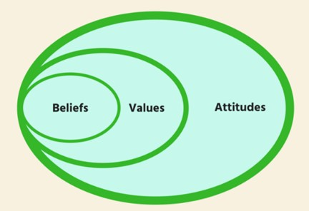
Figure 2: Beliefs, values, and attitudes
Source: (Tullar, 2014)
Beliefs: Beliefs is something (idea) that is held by an individual which is considered as being true. The beliefs of a person develop from his or her past experience and accept a belief that if the same thing happens in future the more or less result will be like that. Beliefs forms by experiencing various trial and error of various events. Beliefs of a person change over the time being. As the time approaches, more learning comes up as well as various knowledge are being gathered and beliefs resurrect as well (Amin and Adiansyah, 2018). Social ethics and norms are very crucial to develop an individual’s beliefs.
Values: Values are long term beliefs toward something. Values are something that states the perception of anything. It could be a perception toward female, male, women empowerment, career, race, ethnicity, wealth, happiness, and others. Here, the word perception is most important because perception towards anything shapes individual behaviour (Sanders, 2017). As time is passing, the values are changing likewise beliefs are changing as well.
Attitudes: It is mental dispositions which are held by an individual toward others and any concurrent circumstances prior to making any decision. This mental disposition is the last step to build an individual’s behaviour. Attitudes are affected by the beliefs and values of a person.

Figure 3: View of attitudes
Source: (Sanders, 2017)
The one-dimensional view of attitudes states that the positive and negative elements are stored at each opposite end that means tend to experience the positive and negative elements either end of the dimension. On the contrary, the two-dimensional view of attitudes postulates that people can possess any combination either positive or negative as these elements are stored along two separate dimensions. Attitudes guide a person’s behaviour and attitudes could be differentiated into a various segment based on functions such as knowledge, ego-defensive or expressive function, social acceptance functions, and others (Sanders, 2017). But attitudes are not equal to the behaviour although attitudes are very influential toward any decision.
There are have some differences among the beliefs, attitudes, and values even though these differences are not so significant. Beliefs are something that people hold as true without actual evidence. Beliefs could be very strong and influence behaviour largely. Beliefs grow to form the various day to day experience, hear, watch, and behaviour of peers or colleagues, and others. On the contrary, the values are a long-term belief toward something. It is more or less the same with the beliefs although there have some significant differences as well. Values are abstract and dynamic concepts. One individual has good views of charity, truthfulness, and other concrete qualities. Some people may have due respect to freedom while some do not. Values are mainly perception while the beliefs are something which is held as true without evidence. The beliefs and values guide the attitudes and attitudes may be either positive or negative (McGregor, 2015). Negative attitude guides good behaviour while negative attitude might guide bad behaviour. These are the main difference among them and these elements of behaviour could change over the time being by following the critical thinking development model.

Advantages and disadvantages of beliefs:
Beliefs grow from the past experience of individuals. Beliefs are completely personal things and the beliefs could be changed by the behaviour of peers, friends, cultural changes, and others. There are various advantages of beliefs like safer and more secure, able to think one's position is right, to find out who sharing same beliefs that are very important for an organization's success, beliefs help to explore new ideas by comparing relationships with others, and others. The disadvantages of beliefs are that truths sometimes misjudge, hamper to learn new things, risk of becoming rigid which indicates danger for an organization and individual as well. Beliefs negatively affect like one person such as one may think he or she superior to another, strong belief create inflexible to change. Although change is very crucial for an organization to survive in a market. these are the major advantages and disadvantages of beliefs.

Impacts of beliefs, values, and attitudes toward behaviour:
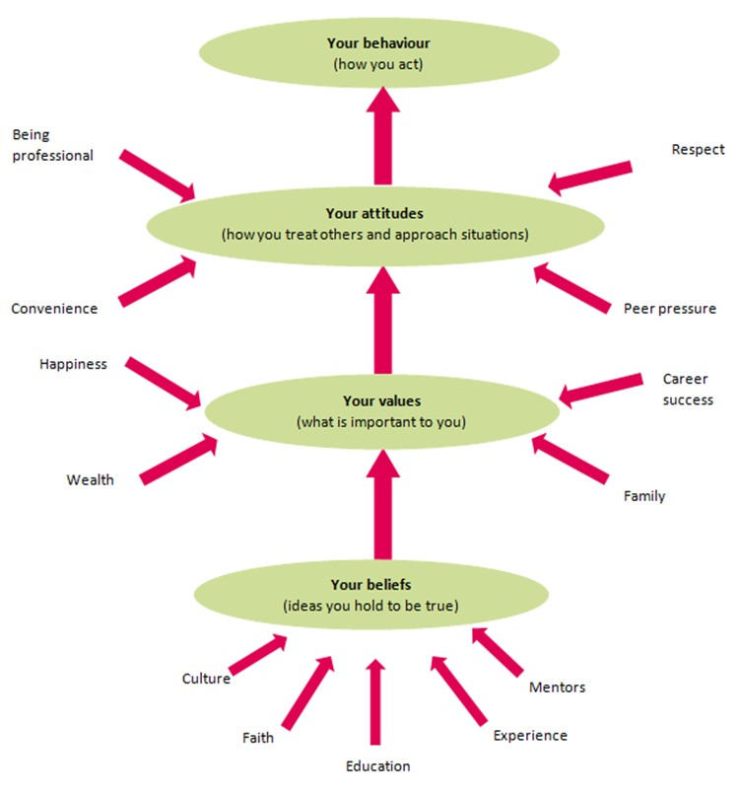
Figure 4: Derivation of behaviour
Source: (Best and Mayerl, 2016)
From the above figure is showing that the behaviour is interrelated with an individual’s beliefs, values, and attitudes. Critical thinking ability is very much dependent on these issues. Culture, faith, experience, educations and others are cause toward one’s beliefs. And perception towards anything indicates the values of a person, and these two along with peer pressure, convenience, and respect cause to form various attitudes, and the attitudes guide an individual’s behaviour finally (Best and Mayerl, 2016).
Critical thinking is largely depending on the expected behaviour of an individual or employee. Critical thinking is very necessary by the employees of an organization because critical thinker can establish good communication with required groups like customers, peers, bosses, and other stakeholders. The employee who has the ability to think critically can manage any complexity and can able to introduce a new idea that brings the ultimate benefits of any organization.
Vodafone is very effective to select employees who have good beliefs, values, and attitudes. They choose employees based on their needs and requirement that ensures the company’s specific demand. They know it clearly that critical thinking is much more dependent on these elements. For example, if a person attitudes toward bribery is not negative, he or she will be corrupted whenever get any chance. Besides, if a person has radical beliefs about religion, any events won’t change his or her stance from the religious beliefs in need he or she will be dangerous. So, it could be said that behaviour is influenced by beliefs, attitudes, and values largely. Lastly, to think is systematic way also depends on these behavioural issues as well because individual behaviour helps to think either systematic or unsystematic ways.

Synopsis of past experience of me:
I have worked as a part-time assistant HR officers in Vodafone, a British multinational company. This engagement or duties were brought lots of learning about real-life corporate learning. The role of the post was to support the human resources, taking necessary steps for administering the test, conducting orientation, keeping and managing various records and information regarding the human resource management of the company. I have worked in the head office of the Vodafone that’s why the great learning about talent management and how to develop critical thinking, and others. There are various duties that had to maintain such as keeping and providing required data of employees by collecting time and attendance records, secretariat support, quality service maintenance, contribute to a team effort, and others (Vodafone.com, 2019). The working in the organization helped a lot to understand about the importance of critical thinking for the workplace. Sometimes various issues come up and it requires very critical thinking ability to solve. It was learning from that are work-life balance and motivation, and motivation guides to think critically. Every team requires to perform high and friendly competition was going on among the teams. The team which has sufficient critical thicker would perform better.

Critical evaluation of critical thinking:
Critical thinking means to a specific skill that could be applied to an entire life or workplace in order to reflection, analysis, and planning. There are various advantages of critical thinking even though it includes some disadvantages. Every issue has a positive and negative tradeoff. Some advantages of critical thinking like it help to create new knowledge. In the current knowledge-driven economic system, the critical thinking ability is one of the important characteristics by which an employee’s or individual’s future career could set. As the world is changing in dynamic nature, the employees of an organization’s need to adopt the changes. Critical thinking ability helps to demonstrate the good presentation and enhance communication skills because a critical thinker may evaluate every new situation in a systematic way that satisfies the emerged issue management. The enhanced or creativity is another important advantage of critical thinking. After all, critical thinking helps to achieve success in both individual and professional success (McGregor, 2015).
Critical thinking ability is good characteristics without any question although there are some disadvantages such as critical thinking can fall someone into a new and frightening situation. The critical thinking environment may affect negatively someone’s life by throwing out from the wave. But it is very ignorable actually. The disadvantages are very low and for these reasons, critical thinking development is very expected for the workplace.

Management theories regarding critical thinking:
There are various models of critical thinking development. Over time being various models have come up for developing the ways critical thinking of individuals. Critical thinking means the ability to question, recognize a problem clearly, ability to identify the proper evaluation method, ability effective reasoning, adding educated judgment, and finally take a decision. Without proper evidence, a decision cannot be a good decision and for developing the quality of taking a decision the various theories could apply. Some management theories are as follows.

Blooms Taxonomy framework:
The original Bloom’s taxonomy has revised several times in order for making suitable to the era. By applying Bloom’s model, critical thinking ability could develop a lot. The original taxonomy consisted of knowledge, comprehension, application, analysis, synthesis, and evaluation. The present revised taxonomy includes remembering, understanding, applying, analyzing, evaluating, and creating.
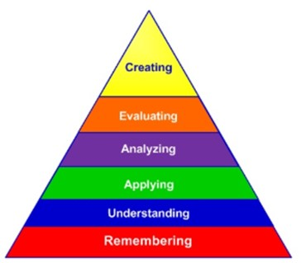
Figure 5: Bloom’s taxonomy
Source: (Rathy, 2013)
The remember stage means to recall facts and basic concepts. It is the first elements of the model and includes duplicate, list, repeat, and state, and so on. The understanding states that explaining ideas or concept based on learning and research. Then an individual can apply the understanding into a new situation, and it requires to draw connection (Analyze) among ideas to approaches systematic ways (Rathy, 2013). Then it should require to evaluate the analysis and needs to justify a stand or decision. The final stage is creating a new idea which is backed up by various evidence as it has to ahead through various rigorous analysis. If the new idea generation follows the revised Bloom's taxonomy, the idea or decision will be very strong, justifiable, developed, and effective as well.
By following Bloom’s taxonomy, the critical thinking ability could increase and the existing views, beliefs, values, and attitudes of an individual could change as well (Rokeach, 2013). In the Vodafone, there is strong practice to develop critical thing and the manager general of HR is always work hard to follow specific steps just like various theories about developing critical thinking which helps a lot to reform values, attitudes, and behaviour.
This theory is mainly relevant to the role of me because I have experience of working Vodafone head office. There are various duties and responsibilities were being done in each working day. To take any critical decision for both individual and organization, Bloom’s taxonomy approach to critical thinking has been followed. Critical thinking is very much dependent on the systematic development of any decision. The beliefs, values, and attitudes of me are positive firstly, then I follow a process-oriented approach to take the final decision. There are various ideas been shared with the team leader in the Vodafone. As I would give systematic evidence to anything, the team leader would happy and satisfied (McGregor, 2015). Finally, to develop a more justifiable decision, Bloom’s taxonomy has been followed.
Basically, the other critical thinking theories are being used by me because the various model could be applied in various situation. The following theories also followed to ensure the quality of any decision.

Scientific management theory:
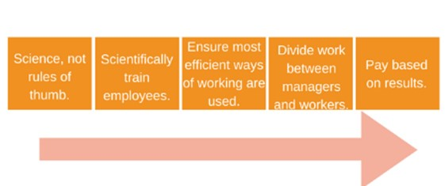
Figure 6: Taylors scientific management
Source: (Lublin, Spoth and Baker, 2014).
The scientific management theory tells that organizational success mostly depends on process-oriented management. Every step of management should have enough evidence in order for taking the right decision. The steps of theory are that decision should be scientific not rules of thumb, employees should train scientifically in order to accomplish a task very effectively, identifying the most efficient and effective ways to approach a decision, then the work should be dividing into teams which include workers and managers, and lastly should pay based on results. The scientific management theory is very helpful to develop critical thinking ability (Lublin, Spoth and Baker, 2014).Vodafone is currently following the scientific management theory in order for ensuring critical thinking in the workplace. The scientific management approach ensures the proper motivation and motivated employees could think deeply toward any issues.

Paul-Elder critical thinking framework:
Various intellectual standards such as accuracy, relevance, logical, precision, fairness, and others are the elements of the intellectual standard. These elements should be applied to elements of reasoning which include purposes, concepts, assumptions, questions, inferences, and others. Implication and consequences are very important elements of critical reasoning. These elements (elements of reasoning) help to develop the intellectual traits such as humility, fair-mindfulness, courage, perseverance, confidence in reasoning, and others.
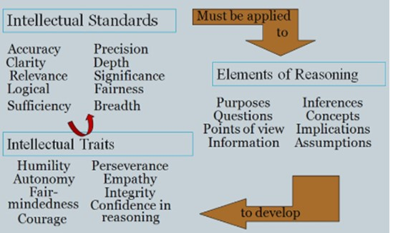
Figure 7: Paul-Elder critical thinking framework
Source: (Elder, 2012)
These model helps a lot to develop critical thinking. By ensuring intellectual standards guides to develop proper reasoning ability and the developed reasoning ability helps to achieve intellectual traits like confidence, intellectual integrity, fair-mindfulness, and so on. The tells that to be a critical thinker at any stage in life, the above model could apply in order for developing critical thinking (Elder, 2012).
In the Vodafone, one of the main duties and responsibilities are to ensure the planning by which the employees will be able to achieve the ability of reasoning and the reasoning ability turns into intellectual traits. The auspicious environment was there and every employee in the office could able to share their ideas with proper evidence and required authenticity. So, gradually a good environment was established in the head-office of Vodafone. These activities help to reform the prevailing individual beliefs, values, and attitudes which guide good behaviour.

Impacts of beliefs, values, and attitudes on behaviour:
According to Kolb’s framework, the only experience is not sufficient to learn. There are various situations happen in the workplace and it needs to handle by following the critical thinking stages (Lublin, Spoth and Baker, 2014). The theory tells that the reflection of experience is necessary to develop critical thinking.
Human beliefs grow from the various experience, hear, read, and so on. From these elements’ beliefs could develop and one’s beliefs could positive and negative. If beliefs and values are wrong to something, the continuous mistakes may happen repeatedly but proper evidence may re-correct the beliefs and values (Howe, 2015). These beliefs and values tend toward the attitudes and attitudes guide the behaviour finally.
In an organization, there could be various groups having positive and negative attitudes. For the perspective of I, it is crucial to treat others likewise what he or she wants to be treated. It is called positive attitudes but it could be changed when the proper evidence comes up. For example, a person takes bribery and the before perception could be positive (Elliott and Turnbull, 2016). But when the actual finding come up about the particular person, the beliefs and values toward this person will be changed. The opposite could happen whose have negative attitudes. For example, Mr John’s negative values and attitudes toward anything. When the proper evidence comes about somethings, his values or perception changes (Feldman, 2013). This is analyzed in the critical thinking approach because the critical thinking approach means to take decision-based on systematic and process-oriented ways.

Contingency theory:
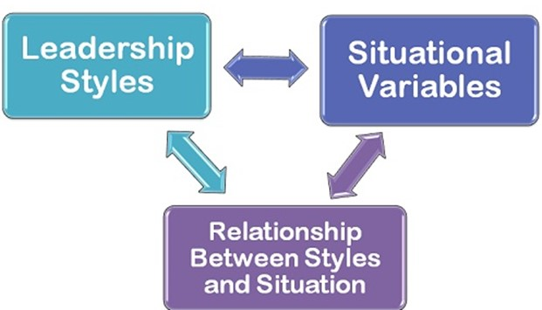
Figure 8: a Contingency model
Source: (Feldman, 2013).
The contingency management theory states that it is not possible to manage an organization based on a predefined model or leadership approach. The theory argues that future issues are uncertain and is not wise to select management techniques early. The optimum actions should be dependent on the various environment such as internal external or micro or macro environment, and so on. It is sometimes stating that the situational leadership and a manager take necessary steps immediately after occurring an issue. The contingency model focuses on the leader-member relationship, degree of task structure, and power of the leader's position. A manager deals with the new issues based on beliefs, values, and attitudes firstly and if not possible, the rigorous analysis is done to handle the issues. when a manager goes to rigorous analysis, he or she follows the scientific approach to solve the problem and by these ways the critical thinking developed (Feldman, 2013). Vodafone does not follow the contingency theory for management because they believe that the contingency model does not maximize their goals and objectives.

Kolb’s learning style theory:
Critical thinking can be developed by following Kolb’s learning style. It includes four stages which are inter-related with one another. The first step is concrete experience (Feeling) or various situation that was encountered by an individual. The second step of the model is reflective observation (watching) which means to understand the discrepancies of understanding and experiencing and follow through the abstract conceptualization which could indicate thinking. The final step is active experimentation (doing). This stage states that the learners could apply their educated idea, educated means justified idea, in practice to see what happens.
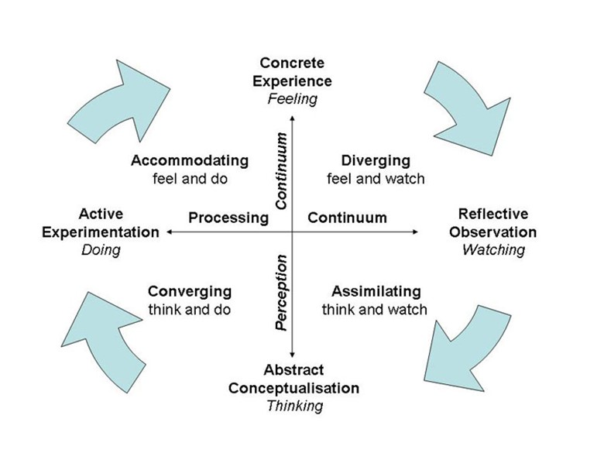
Figure 9: Kolb’s learning style
Source: (Lublin, Spoth and Baker, 2014)
This learning model has great impacts on the beliefs, values, and attitudes. The clear introduction has stated earlier about the influential elements of the behaviour. These elements, beliefs, values, and attitudes, influence behaviour and the above model has a large impact on the behaviour. Beliefs could change when an individual start to evaluate something very systematic ways (Edwards, 2012). Employees of Vodafone has to follow specific guideline just like Kolb’s model before sharing any idea or decision. This activity results in a good environment for critical thinking (Lublin, Spoth and Baker, 2014).

Gerald Nosich critical thinking development approach:
Dr. Gerald notice is one of the famous teachers who had attended more than 250 workshops based on critical thinking. He covered the critical thinking for the workplace from all perspectives. He developed a various process for developing ways to improve the critical thinking approach and he adapted Richard Paul’s components to develop his approach.
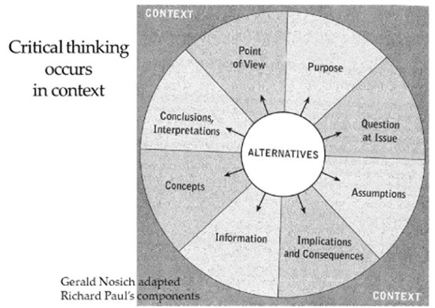
Figure 9: Critical thinking Gerald Nosich model
Source: (Nosich, 2016)
He argued that there are various alternatives that could be used in various situation and context. These alternatives are directly and indirectly affected on beliefs, values, and attitudes and follow through the behaviour changes. Dr. Derald Nosich says that critical thinking occurs when a person faces a new situation. To handle the situation, a particular individual starts thinking critically. In the Vodafone, it could see that they are forming various teams internally to accomplish particular goals and objectives (Vodafone.com, 2019).
Kolb’s theory and Gerald Nosich framework of critical thinking are not similar at all. Kolb’s theory tells that experience reflection is main to think critically. If someone does not evaluate the reflection of experience, the good decision won’t come up. Where Dr. Gerald Nosich tells that critical thinking depends on the context. From the various alternatives, one could be selected by analyzing the pros and cons. The above model could be only the guidelines but in reality, they do not work well. Some philosopher tells that critical thinking ability is inborn. The training and development program could improve a little bit but not substantial.

Implications of the above theories on beliefs, values, and attitudes and their importance in the workplace:
The stated two theories state that critical thinking helps to reform one’s beliefs, values, and attitudes as well. It is very clear that the beliefs, values, and attitudes change continuously by influencing peers, colleagues, family, friends, and other sources. By hearing and watching various events in front of eyes, the beliefs, values can establish but it is not necessarily a positive all the times. It could be negative as well. And the negative attitudes could change by following the critical thinking approach (Best and Mayerl, 2016).
To be a good manager in an organization, it is required to be a good thinker as well. The critical and creative thinker is an asset for a business organization because he or she handles the big issues in cold mind with following systematic critical approach. Critical thinking and behaviour are much more dependent or significant dependent on the beliefs, attitudes, and values. A manager should become positive thinker to become the motivator of the employees. the negative thinker manager might not manage or motivate the subordinate employees effectively (Analoui and Danquah, 2017).
The task management theory might be very effective to enhance the productivity of employees. there is various learning from the task management theory such as it tells how employees’ productivity could increase along with learning to be a good boss. The task management theory tells it very clear that the staffs should be inspired by taking various motivational measures that directly affect the behaviour of the staffs. The behaviour of employees could change when he gets competency-based payment. The competency-based payment has a great impact to change beliefs, values, and attitudes as well (Schoffstall and Ackerman, 2016).
In Vodafone, the task management theory is being applied largely to achieve competitive advantages. The HR general always gives the direction to establish a friendly creative environment. He always concern about the application of various critical thinking development model such as Kolb’s learning style theory, Paul-Elder critical thinking development model, a stage theory, and interestingly arranges various workshop by hiring the resource person in order to change the existing beliefs, values, and attitudes of the employees as there are various kinds of staffs are working in Vodafone. And by accomplishing the various management theories, beliefs, attitudes, and values could change.

The way someone’s beliefs, values, and attitudes could be interpreted by leadership theory:
The interpretation of the theory might misinterpret in various situations. The culture is one of the major examples of how the behaviour might interpret the management theory differently. A particular culture where the issues are managed in different ways, not a systematic way. The reasons could in an organization there might be working various types of staffs with different beliefs, values, and attitudes (Rokeach, 2013). The elements might guide individual behaviour differently. But it might be that the team were becoming a success not following the systematic critical thinking approach. If this happens, the critical thinking theories that interpreted earlier could prove false but actually does not (Ausch, 2014).
A successful manager needs to be a very tactic to manage employees. The manager is very key elements to the success of an organization as they lead the organization and a particular team directly. The good and staff friendly leadership are mostly desired each and every business organization. When a manager recognizes the quality work of the employees, the beliefs and values might change. As stated earlier that the beliefs, values, and attitudes might change due to continuous experience, peer and colleague’s behaviour, hearing and watching, and so on. The leadership style could be a catalyst for this (Ausch, 2014). But various management theories might misinterpret the beliefs and attitudes differently.
Behavioural leadership approach tells how effectively and efficiently a boss or manager will behave. There are various kinds of leadership theories in the corporate world that could affect differently on values and attitudes. Some manager takes comments of employees and some are not. There are various kinds of leadership approach like participatory, dictate leadership, or situational leadership (Carter, Creedy and Sidebotham, 2017). All the theories have a great influence on beliefs, values, and attitudes. When a manager gives the priority to the staff in an organization, the staff could think rightly and share their ideas very effectively to the manager while a dictate leader does not like that. The dictate managers forcefully apply various kinds of decision that might hurt the employees and the employee’s beliefs and values will be changed at a higher potential. But when the situational leadership approach will apply to manage employees of an organization, the positive beliefs, and attitudes develop. Hence, it could be said that the employee’s friendly leadership approach is very influential to the beliefs and attitudes (Epstein and Rooney, 2017). And in this approach, the employees could think independently and the critical thinking environment increases. The competency-based payment system of an organization causes to develop the critical thinking environment that ultimately improves the productivity of employees. And the employee’s productivity is directly related to a company’s goals and objectives (Elliott and Turnbull, 2016).

Skills needed for the twenty-first century:
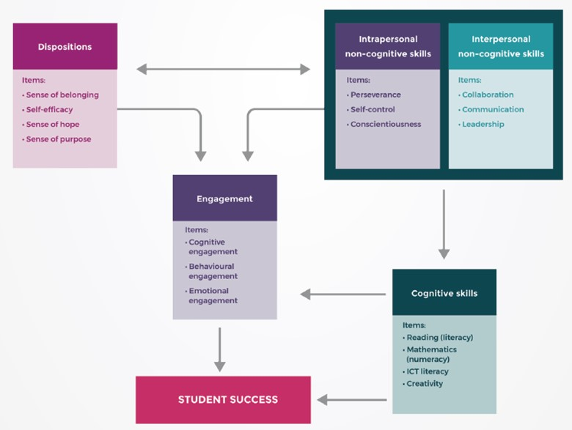
Figure 10: Needed skills for the twenty-first century
Source: (Edwards, 2012)
As the current economy of the world is knowledge-driven, the students needed to develop his or her skills in terms of critical thinking ability to meet the challenges for the twenty-first century. Otherwise, the wave pushes into the back. Student success depends on various skills and qualities like cognitive skills, non-cognitive skills, interpersonal skills, and various traits. The engagement of deposition, interpersonal son-cognitive skills, intrapersonal non-cognitive skills, cognitive skills, and others tend to make an individual critical thinker. And critical thinking ability is the key to success for the workplace (Edwards, 2012). For example, the Vodafone is very careful to build a strong human resource for their organization and for this they always take necessary motivational measures to unleash the creative skills of the employees and they arrange the necessary skill development program in a regular basis. As the Vodafone is belonging in a highly competitive industry, they need a strong bench of human resource to achieve the company’s goals and objectives. They know it clearly that the opportunity to work-life balance, competency-based payment, and various motivation measures are very influential to change beliefs, values, and attitudes of employees (Vodafone.com, 2019).

Recommendations to Vodafone to improve critical analysis in the workplace:
Work-life balance: The Vodafone is very sincere for the work-life balance but it requires to analyses more to select the most appropriate methods that ensure the proper work-life balance. The work-life balance is positively related to critical thinking ability.
Employee development program: The employee development program is very crucial for critical thinking. The Vodafone needs to give training to the employees on a regular basis that will help a lot to develop critical thinking ability to employees.
Consultancy: individual beliefs, values, and attitudes are very important in terms of critical analysis. The beliefs and values normally change very slowly and to overcome from the problem Vodafone could take proper steps to consult the employees to reform beliefs, values, and attitudes.
Innovation management: strong beliefs and values sometimes work against the change. The strong beliefs and attitudes make a man rigid to change. The employees of Vodafone have identical beliefs and values. So, it needs to take a proper management approach to develop critical thing ability and change management.
Select appropriate person: All candidates may not suitable for a particular organization. Sometimes wrong employees were selected by the Vodafone and it should be very careful to select the right one who has good beliefs, values, and attitudes that lead to organizational success.

Conclusion:
Critical thinking means to a specific skill that could be applied to an entire life or workplace in order to reflection, analysis, and planning. At the age of knowledge-driven economy, the critical thinking ability is part and parcel to developing one’s career. Each and every day there are lots of advanced technologies and emerging technologies are coming up and every individual should adjust with that inventions otherwise it will be very difficult to survive against that wave. In the workplace, critical thinking ability is very crucial and unique assets for every organization. The beliefs, values, and attitudes are very crucial to shape the behaviour of individuals. The success of an individual much more dependent on ways of behaviour to various issues and the individual behaviour larges depends on beliefs, attitudes, and values as well. Student success depends on various skills and qualities like cognitive skills, non-cognitive skills, interpersonal skills, and various traits. The engagement of deposition, interpersonal son-cognitive skills, intrapersonal non-cognitive skills, cognitive skills, and others tend to make an individual critical thinker. Hence, critical thinking for the workplace is very important to the sustainable development of an organization.

References
Amin, A. and Adiansyah, R. (2018). Lecturers’ perception of students' critical thinking skills development and problems faced by students in developing their critical thinking skills. Journal Pendidikan Biologi Indonesia, 4(1), p.1.
Analoui, F. and Danquah, J. (2017). Critical Capacity Development. 13th ed. New York: Palgrave Macmillan.
Ausch, R. (2014). An advanced guide to psychological thinking. 8th ed.
Best, H. and Mayerl, J. (2016). Values, Beliefs, Attitudes: An Empirical Study on the Structure of Environmental Concern and Recycling Participation. Social Science Quarterly, 94(3), pp.691-714.
Carter, A., Creedy, D. and Sidebotham, M. (2017). Critical thinking evaluation in reflective writing: Development and testing of Carter Assessment of Critical Thinking in Midwifery (Reflection). Midwifery, 54, pp.73-80.
Edwards, J. (2012). How to teach thinking skills. 3rd ed. Nelson, N.Z.: ThinkShop.
Elder, L. (2012). Critical Thinking and Emotional Intelligence. Inquiry: Critical Thinking Across the Disciplines, 16(2), pp.35-49.
Elliott, C. and Turnbull, S. (2016). Critical thinking in human resource development. 12th ed. London: Routledge.
Epstein, R. and Rooney, M. (2017). Critical thinking. 8th ed. Socorro, NM: Advanced Reasoning Forum.
Feldman, D. (2013). Critical thinking. 8th ed. [Rochester, N.Y.]: Axzo Press.
G.A, R. (2013). Effectiveness of the Power Electronics Curriculum of B. E. Degree Programme using Blooms Revised Taxonomy. International Journal of Computer Applications, 69(15), pp.21-25.
Howe, H. (2015). Beliefs, attitudes, and values. 6th ed. Lincoln: University of Nebraska Press.
Leicester, M. and Taylor, D. (2010). Critical thinking across the curriculum. 7th ed. Maidenhead: Open University Press.
Lublin, S., Spoth, J. and Baker, R. (2014). Strategic Management Development: Using Experiential Learning Theory to Assess and Develop Managerial Competencies. Journal of Management Development, 5(3), pp.13-24.
McGregor, D. (2015). Developing thinking; developing learning. 5th ed. Maidenhead, Berkshire, England: McGraw-Hill.
Nosich, G. (2016). Richard Paul’s Approach to Critical Thinking. Inquiry: Critical Thinking Across the Disciplines, 31(1), pp.34-51.
Rokeach, M. (2013). Beliefs, attitudes, and values. 5th ed. San Francisco: Jossey-Bass.
Sanders, M. (2017). Embracing Critical Thinking as a Model for Professional Development. Inquiry: Critical Thinking Across the Disciplines, 26(1), pp.29-37.
Schoffstall, J. and Ackerman, B. (2016). Attitudes of pre‐service physical educators at a faith‐based university toward individuals with disabilities. Journal of Beliefs & Values, 28(2), pp.183-193.
Shahrokh, R. (2014). Development of Higher-Order Thinking Skills in Students. Inquiry: Critical Thinking Across the Disciplines, 18(2), pp.52-64.
Tullar, W. (2014). Theory development in human resource management. Human Resource Management Review, 1(4), pp.317-323.
Vodafone.com. (2019). Visit the Vodafone corporate website. [online] Available at: https://www.vodafone.com/content/index.html [Accessed 22 Apr. 2019].
Weinstein, M. and Oxman-Michelli, W. (2016). The Faculty Development Program of the Institute for Critical Thinking. Inquiry: Critical Thinking Across the Disciplines, 4(3), pp.9-13.

