Operating systems assignment
Connor Johnson (2517511)

Table of Contents
Introduction 2
Key functions of an Operating System 3
Use of Windows OS CLI commands 5
Use of Linux OS CLI Commands 7
Use of windows OS scripts 8
Conclusion 8

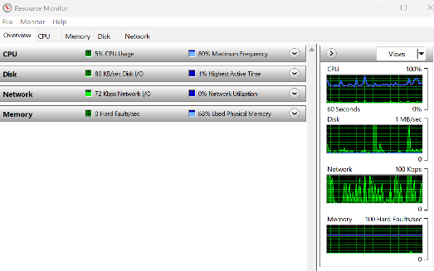
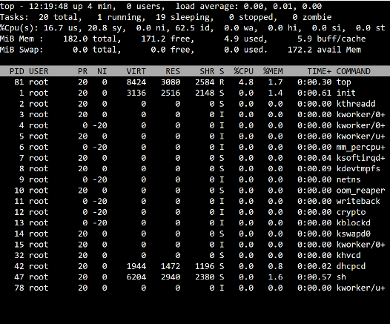
Introduction
Operating systems are essential system software that manages computer hardware, software resources and user interaction. Popular operating systems such as Microsoft Windows, macOS and Ubuntu provide functions including process, memory, file and device management and security. This assignment explores the key functions of operating systems and demonstrates the use of Windows and Linux command line tools.
An operating system or OS acts as an interface between the computer user and the computer hardware. Without an operating system a computer would not be able to run applications or manage hardware devices effectively. The operating system controls communication between software and hardware components such as the processor, memory, storage devices and input/output devices. Modern operating systems are designed to provide stability, security, and efficient resource management for both personal and business environments
One of the key functions of an operating system is process management. The operating system is responsible for creating, scheduling and terminating processes while ensuring that multiple programs can run efficiently at the same time, this is commonly referred to as multitasking. Tools such as task manager in windows or system monitor in Linux allow users to view active processes and monitor CPU usage. Efficient process management helps maintain overall system performance and prevents applications from interfering with each other.
Figure 2 Windows Resource Monitor displaying CPU, memory, disk, and network usage
Figure 1 Real-time process and CPU monitoring using the Linux top command

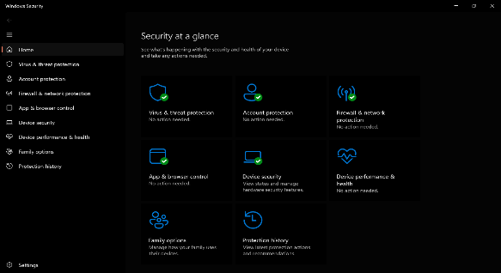
another important function is memory management. The operating system allocates ram to application and services currently running on the system, it also manages virtual memory when physical memory becomes limited. Effective memory management improves system stability and allows several applications to operate simultaneously without crashing.
operating systems can organise files into directories and provide users with methods to create, edit, move and delete files. File systems such as NTFS in windows and ext4 in Linux help manage data storage efficiently while maintaining file permissions and security. File explorer in windows and file management tools in Linux demonstrate how operating systems provide structured access to stored data.
operating systems additionally manage hardware devices with device drivers. This enables communication between the operating system and hardware components such as printers, keyboards, graphics cards and storage devices.
Security management is another essential function, including user authentication, permissions, encryption and firewall protection. These features help protect systems against unauthorised access and malware threats.
Modern operating systems also include command line interfaces and scripting tools that allow users and admins to automate tasks. Windows commonly uses PowerShell and Linux use bash scripting, these scripting environments provide greater control over operating system functions and improve efficiency when managing files, processes and system configurations.
Figure 3 Windows Security demonstrating operating system security features

Key functions of an Operating System
  - General purpose operating systems manage the computer’s hardware and provide a platform for applications to run. Some key functions of widely used operating systems like Microsoft windows and macOS are:
  - Process management – ‘Windows manages processes by prioritising tasks and initiating new ones using system functions like CreateProcess(). This enables smooth multitasking and efficient task management.
process management in macOS leverages UNIX commands fork() and exec(). These commands create and execute new processes concurrently, facilitating the simultaneous operation of multiple applications. The system efficiently determines what task should be run first.’[1]
  - Memory management – ensures safe and efficient use of RAM, the OS assigns memory to processes as needed and reclaims it when no longer used. Systems like Windows and macOS can use disk space to simulate extra RAM, allowing more programs to run simultaneously.
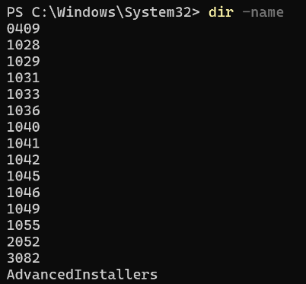
  - File system management – windows can manage files and directories using file systems such as ‘NTFS’[2] and FAT32. The operating systems organizes data into folders and controls how the files are stored, accessed, renamed, copied and deleted. Windows provides built command line tools like dir, copy, move, del and mkdir for file and directory management. NTFS also supports advanced features including file permissions, encryption, compression and disk quotas helping to improve security and storage efficiency.
this screen shot shows the (dir – name) command executed in powershell. the
( -name) switch simplifies the output without additional information such as file size or modification date.

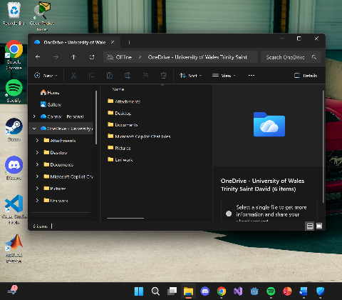

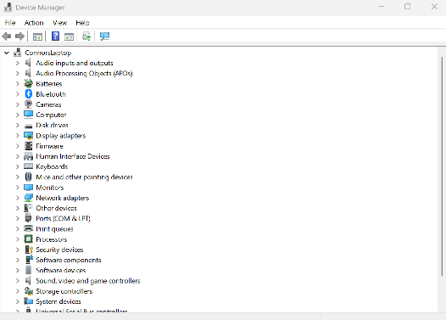
Device management – Microsoft windows manages devices through automatic hardware detection, local management tools and cloud-based admin features. When new hardware is connected, windows uses plug and play technology to detect the new device and automatically install suitable drivers from its system databases or through updates. Users can also manage and trouble shoot hardware manually within the Device manager which provides access to device settings and driver controls. Windows also supports Mobile device Management solutions like Microsoft Intune allowing IT admins to remotely enroll devices, manage security policies and manage software and drivers across multiple systems.
User interface – windows and macOS both use graphical user interfaces or GUIs as a key function of their individual operating systems, in doing so this allows users to interact with computers through icons, menus and windows instead of command line instructions. Windows focuses on flexibility and productivity through features such as the Start menu, taskbar and file explorer whereas macOS emphasis simplicity using the dock, finder and menu bar. Both systems are designed to improve navigation, user experience and multi-tasking.[3]
Security and Access control – Windows and macOS operating systems have built in security systems to protect files, applications and user accounts. These systems use user authentication methods such as passwords, pins and biometric login options to control access.
screenshot of Windows device manager
screenshot showing Windows file explorer, task bar and dashboard.
windows security dashboard showing built in security features.

Use of Windows OS CLI commands

Command 1: Tasklist
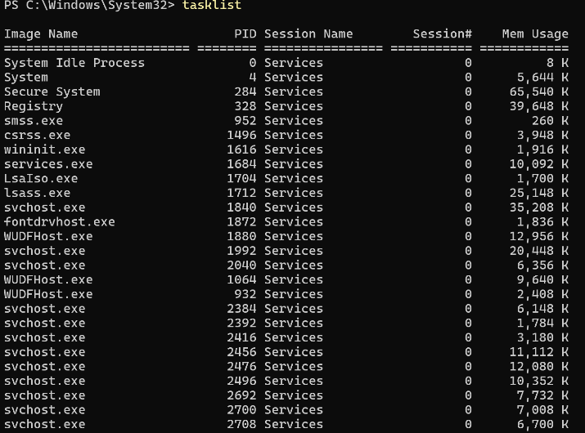
This tasklist command displays all active processes currently running on a system including process ID’s and memory usage.

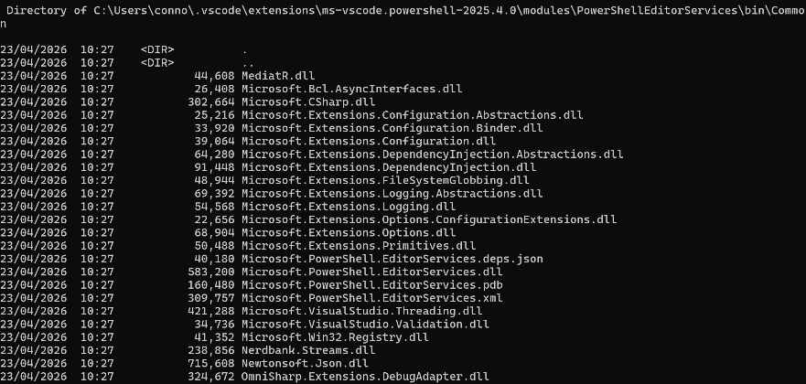
Command 2: dir /s
The dir command lists files and directories, the /s switch displays all files within subdirectories.

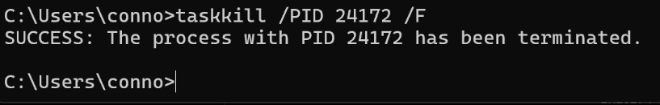
Command 3: Taskkill /PID 24172 /F

The taskkill command terminates a running process using its process ID and the /F switch forces the process to close.
Command 4: ipconfig
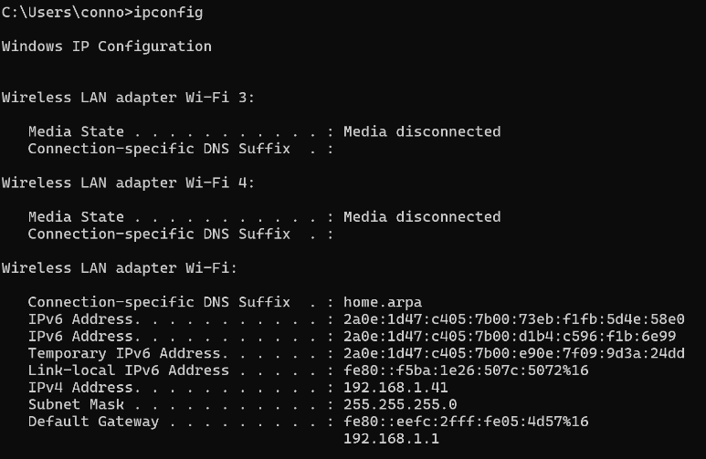
The ipconfig command is used to display detailed information about the network.

Command 5, 6: net user, whoami
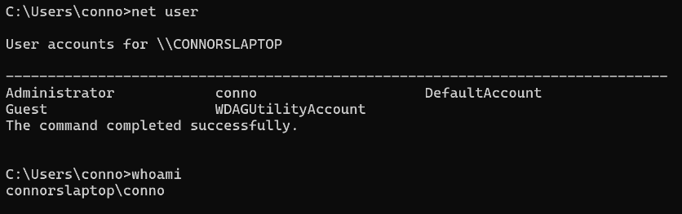
The net user command lists all user accounts configured on this computer.
The whoami command displays the username of the currently logged in account.

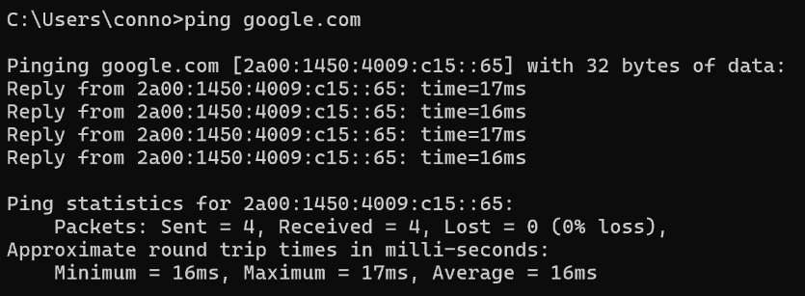
Command 7: ping google.com
The ping command tests connectivity between the local computer and a remote host.

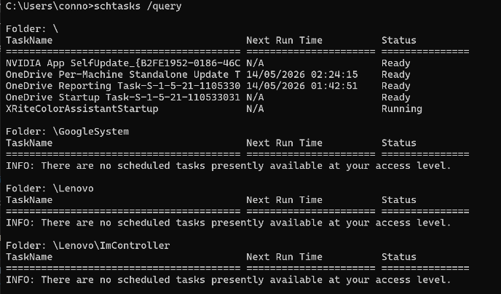
Command 8: schtasks /query
The schtasks command displays scheduled tasks currently configured on the system.

Use of Linux OS CLI Commands
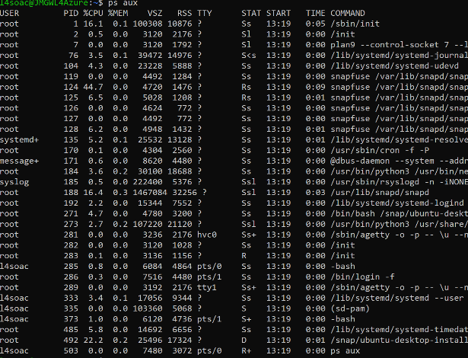
Command 1: ps aux
The ps aux command displays all running processes including CPU usage, memory usage and process ID.

Command 2: top
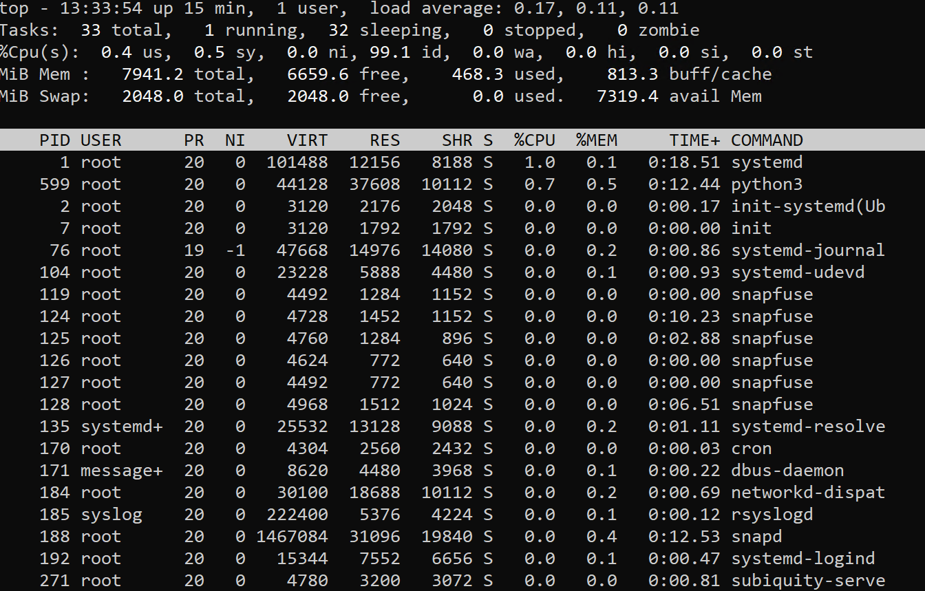
The top command provides a real time view of running processes and system resource usage.

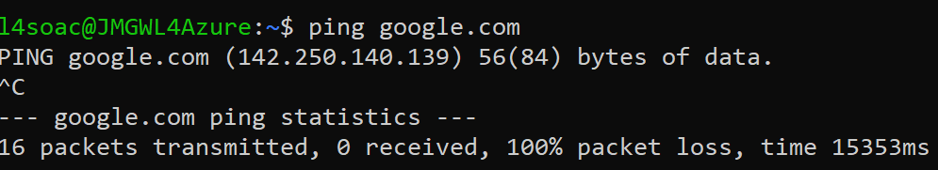
Command 3: ping
The ping command test connectivity to a remote host.

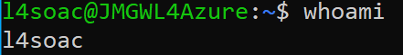
Command 4: whoami
The whoami command displays current logged in user.

Command 5: adduser testruser
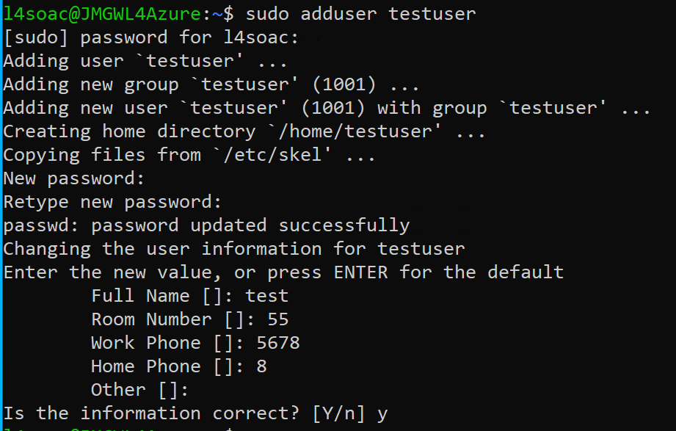
The adduser command creates a new user account on the system.

Use of windows OS scripts
Windows PowerShell is a command-line scripting language used in the Windows operating system for automation, system administration, and performance monitoring. It allows users to run commands that interact directly with system processes, files, and hardware resources. PowerShell is widely used because it enables efficient management of operating system functions through scripting rather than manual navigation of graphical tools.
The script used in this task demonstrates process monitoring within the Windows operating system. It begins by displaying a heading using the Write-Host command, which outputs text to the terminal to improve readability and structure. The main functionality of the script is achieved using the Get-Process command, which retrieves a list of all currently running processes on the system.
The output of Get-Process is then passed through a pipeline (|) to the Where-Object command. This command filters the results based on a condition, in this case selecting only processes where CPU usage is greater than 10. This demonstrates how PowerShell can be used to analyse system performance and identify resource-intensive applications.
The filtered results are then passed to Select-Object, which is used to display only specific properties of each process, including the process name, CPU usage, and process ID. This helps to simplify the output and make it easier to interpret. Finally, Format-Table -AutoSize is used to display the data in a structured table format, improving readability.
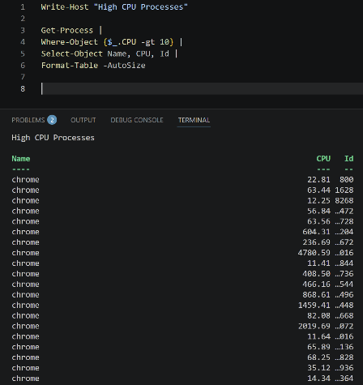
Overall, this script demonstrates key features of Windows operating system scripting, including process management, data filtering, and output formatting. It shows how PowerShell can be used to monitor system performance and retrieve important information about running processes. This type of scripting is useful for system administrators who need to quickly identify applications consuming system resources and manage system efficiency effectively.
Figure 4 PowerShell script showing high CPU process monitoring code

Conclusion
In conclusion, this assignment demonstrates the key functions of modern operating systems, including process management, memory management, file handling, device management, and security. Using both Windows PowerShell and Linux Bash scripting, this shows that operating systems provide powerful tools for monitoring and managing system resources efficiently.
The Windows PowerShell script shows how processes can be filtered and analysed based on CPU usage, allowing users to identify resource-intensive applications and monitor system performance.
Overall, both operating systems provide effective command-line tools that support system administration and automation. These scripting environments improve efficiency by allowing users to perform complex tasks quickly without relying solely on graphical interfaces.

References
[1] v. r. mirabueno. "Process-Memory-and-Storage-Management-Windows-vs-macOS.pdf." slideshare.net. Accessed: May 7 2026. [Online]. Available: https://www.slideshare.net/slideshow/process-memory-and-storage-management-windows-vs-macos-pdf/277653754
[2] Microsoft. "NTFS overview." [Online]. Available: https://learn.microsoft.com/en-us/windows-server/storage/file-server/ntfs-overview?utm_source=chatgpt.com
[3] Microsoft. "User interface overview." [Online]. Available: https://learn.microsoft.com/en-za/windows/apps/develop/user-interface?utm_source=chatgpt.com

