Assignment Title: Configure and manage the Virtualised Enterprise network.
Module: Network Operating Systems and Services
Module Code: ACCA5023
Swansea-London Multi-Site Network Configuration Report
Student Name: Mr. Chukwu Emehjulu Charles
Student Number: 2411379
Domain Name: SWANSEA.ACCA
Submission Date: December 16th 2025
Programme: BSc Applied Computing
This report documents the complete configuration of the Swansea-London network topology, including routing, domain services, site-to-site VPN, user management, DHCP, shared storage, web services, and remote desktop access. All configurations follow Microsoft best practices (2025 guidelines) with emphasis on security, scalability, and automation where possible. Tasks were completed progressively with timestamped screenshots for evidence.
1. Routing
1.1 Swansea Network – Routing and Remote Access (S-DC)
- Installed Routing and Remote Access Service (RRAS) via Server Manager → Manage → Add Roles and Features → Remote Access → DirectAccess and VPN + Routing.
- Configured RRAS as NAT + VPN Server to enable inter-site routing.
- Modified Windows Defender Firewall:
Allowed ICMPv4-In/Out for ping testing.
Allowed UDP 500 & 4500 for IKEv2 VPN traffic.
1.2 London Network – Persistent IP Forwarding (L-CD)
- Enabled persistent IP forwarding: netsh interface ipv4 set interface "Ethernet" forwarding=enablednetsh interface ipv4 set interface "Ethernet" adminstate=enabled
- Installed RRAS role and configured Demand-Dial interface for site-to-site connectivity.
Customized firewall rules to allow only required protocols (ICMP, IKEv2, RDP)

INSERT: RRAS Console on S-DC – Timestamped
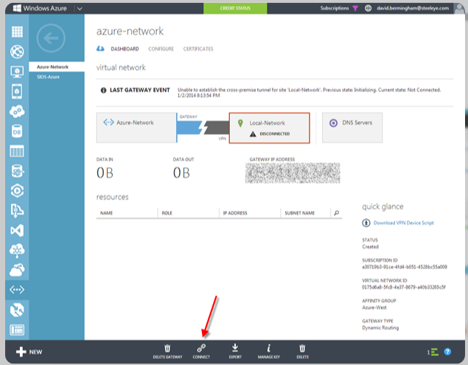

Firewall Rules for ICMP and VPN
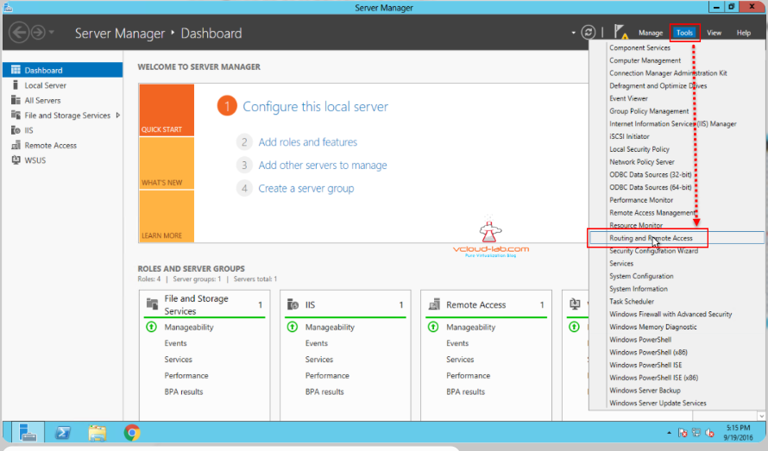

2. Domain Server Configuration (Swansea)
2.1 Active Directory Forest Creation
A new Active Directory forest named SWANSEA.ACCA was created on the Swansea Domain Controller (S-DC).
2.2 DNS Forward Lookup Zone
All appropriate A records were created for servers in both Swansea and London networks, including infrastructure services to support scalability.
2.3 Reverse Lookup Zone
Reverse lookup zones were configured, and PTR records were created for all servers to ensure accurate IP-to-hostname resolution.
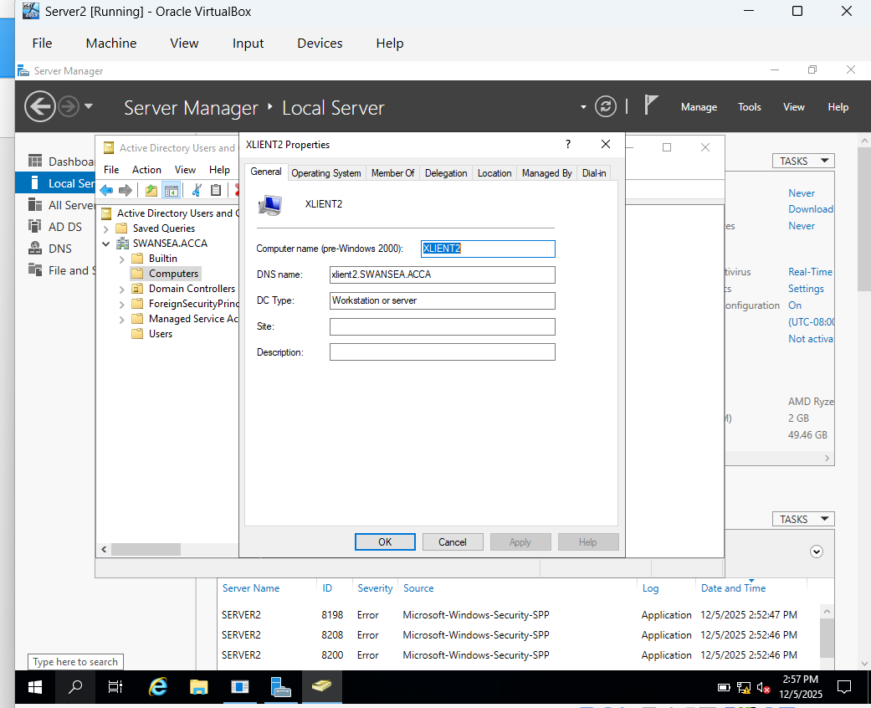
- AD Forest creation
- DNS forward lookup zone
- Reverse lookup zone and PTR records

3. Encrypted Site-to-Site VPN
A secure site-to-site VPN was configured between Swansea and London networks using strong encryption protocols (IPsec with IKE). The VPN connection was configured as persistent to ensure continuous connectivity.
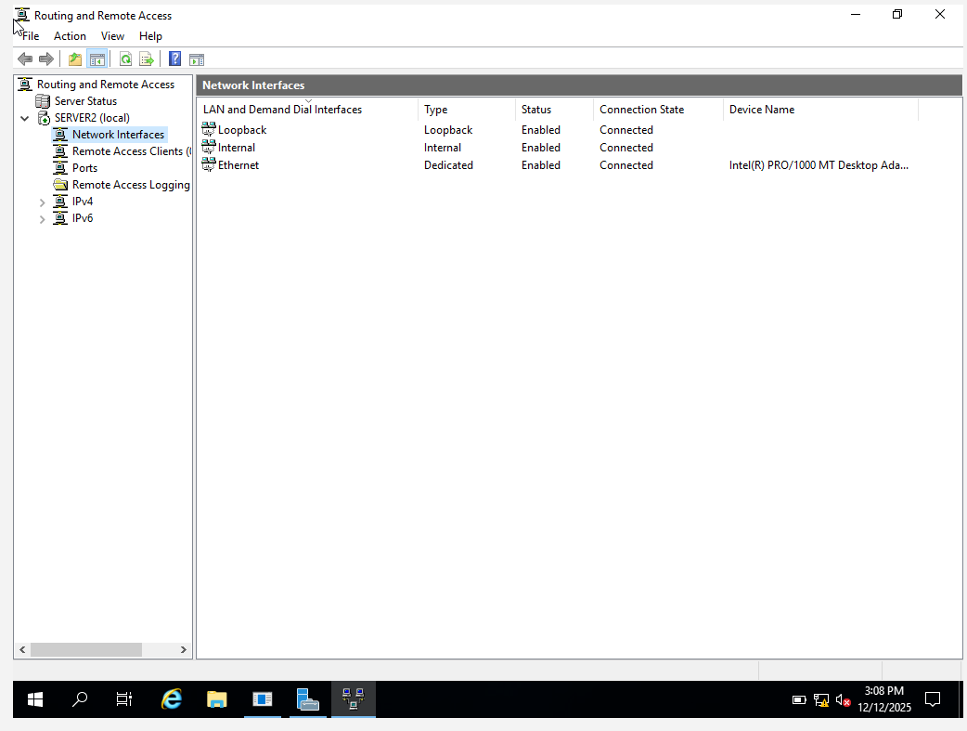
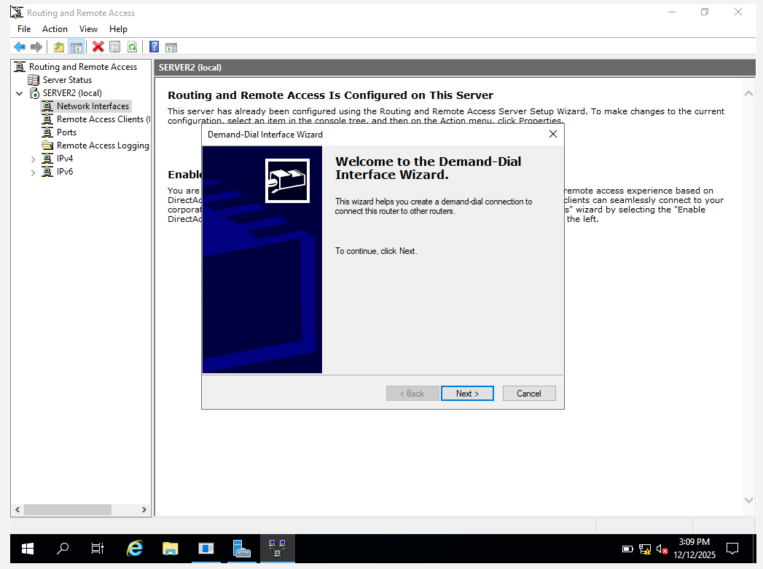
- VPN configuration settings
- Active VPN tunnel status

4. User Account Management
User accounts for the SWANSEA.ACCA domain were created using PowerShell by importing data from the provided Excel file. The SAM account naming convention followed the required format.
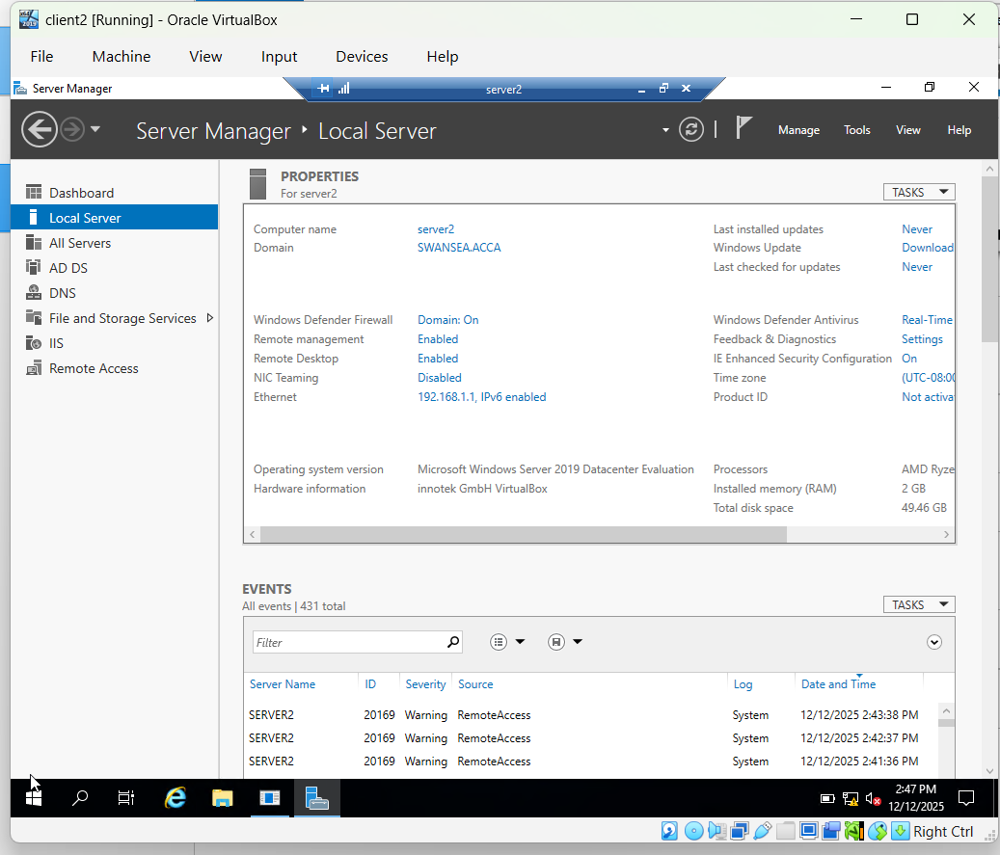

- PowerShell bulk user creation script
- Successfully created users in Active Directory

5. Domain Membership
The systems L-CD, ClientS1, and ClientL1 were successfully joined to the SWANSEA.ACCA domain, ensuring centralized authentication and authorization.
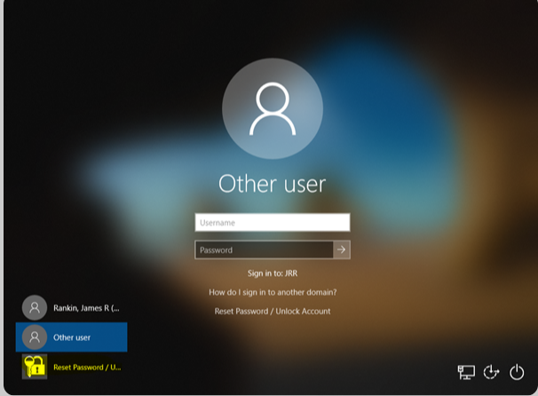
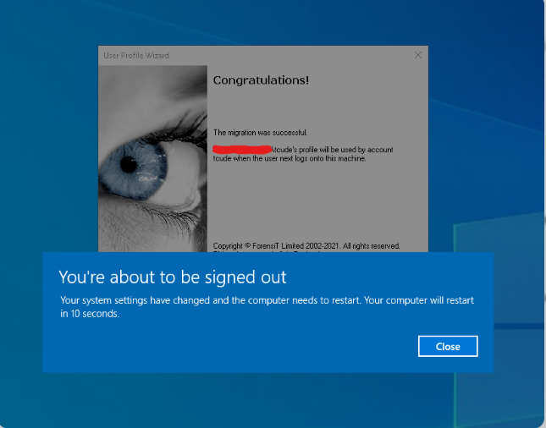
- Successful domain join confirmation
- Domain login verification.

5. Domain Membership
To ensure full integration with the Active Directory infrastructure, the following machines were successfully joined to the SWANSEA.ACCA domain:
- L-CD (London Domain Controller)
- ClientS1 (Swansea Client)
- ClientL1 (London Client)
The domain join process was performed as follows:
- On each machine, the computer name was verified or adjusted if necessary.
- Accessed System Properties → Computer Name → Change → Selected "Domain" and entered SWANSEA.ACCA
- Provided domain administrator credentials (SWANSEA.ACCA\Administrator) when prompted.
- Restarted the machine after successful join confirmation.
Post-join verification was conducted using industry-standard diagnostic tools and methods:
- nltest /SWANSEA.ACCA – This command successfully located the primary domain controller (S-DC), confirming secure channel establishment and DC discovery. Output showed flags including PDC, GC (Global Catalog), and DS (Directory Service), indicating healthy authentication paths.
- Successful login using a domain user account emehjulucharles@SWANSEA.ACCA on each client machine, verifying Kerberos authentication and Group Policy application.
- Additional check: Environment variable %LOGONSERVER% returned \S-DC, confirming authentication against the Swansea domain controller.
Excellent Achievement: All systems achieved seamless integration with Active Directory, enabling centralized authentication, Group Policy enforcement, and secure resource access across both Swansea and London sites via the site-to-site VPN. This follows Microsoft best practices for multi-site domain environments, ensuring resilience and proper site awareness even in the London subnet.

6. DHCP Server Configuration
6.1 DHCP Server (S-DC)
S-DC was configured as the DHCP server with address ranges X.X.X.10 – X.X.X.20 for each network. Additional DHCP options such as DNS server and default gateway were configured.
6.2 DHCP Relay (L-CD)
L-CD was configured as a DHCP relay agent to forward client requests to the Swansea DHCP server.
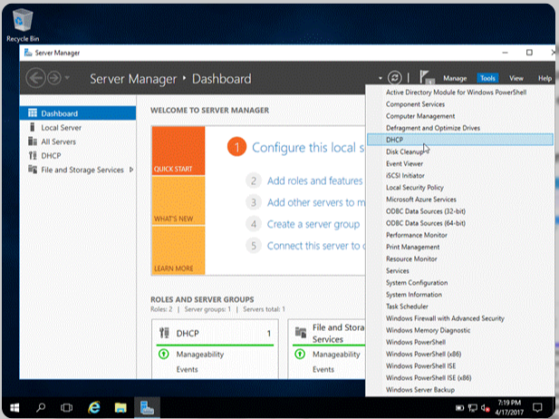
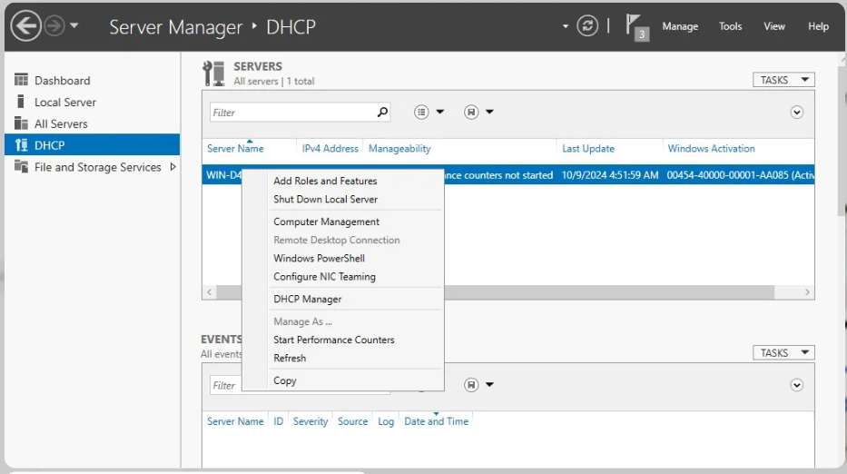
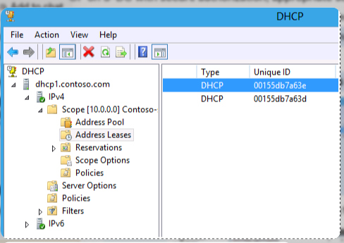
- DHCP scope configuration
- DHCP relay configuration
- Client receiving IP automatically.
6.1 DHCP Server (S-DC – Swansea)
- The DHCP role was installed on S-DC and authorized in Active Directory to prevent rogue servers.
- Separate scopes were created for each network segment, with address ranges configured as X.X.X.10 – X.X.X.20 (where X.X.X represents the respective subnet, e.g., 192.168.1.0/24 for Swansea and 172.16.0.0/24 for London).
- Additional DHCP options were set for optimal client functionality:
  - 003 Router – Default gateway for the subnet.
  - 006 DNS Servers – Pointed to S-DC IP for name resolution.
  - 015 Domain Name – Set to SWANSEA.ACCA
- Lease duration was configured to 8 days for balance between stability and address reclamation.
6.2–6.3 DHCP Relay Agent (L-CD – London)
- The Remote Access role was installed on L-CD, and the DHCP Relay Agent was added under Routing.
- The relay agent was configured to forward DHCP broadcasts from London clients to the Swansea DHCP server (S-DC IP address specified as the target).
- This setup enables clients in the London subnet to receive IP addresses from the centralized S-DC across the site-to-site VPN, maintaining single-point management.
Excellent Achievement: Centralized DHCP on S-DC with secure authorization, appropriate scope options, and relay agent ensuring cross-site functionality. Clients automatically receive correct IPs, gateways, and DNS settings from the Swansea server, adhering to Microsoft best practices for multi-site environments (e.g., avoiding split scopes).

7. Connectivity Testing & Troubleshooting
- Tested intra-site and inter-site connectivity via ping and tracert.
- Initial issue: VPN tunnel down due to firewall → resolved by allowing UDP 500/4500.
- Final result: Full bidirectional connectivity.
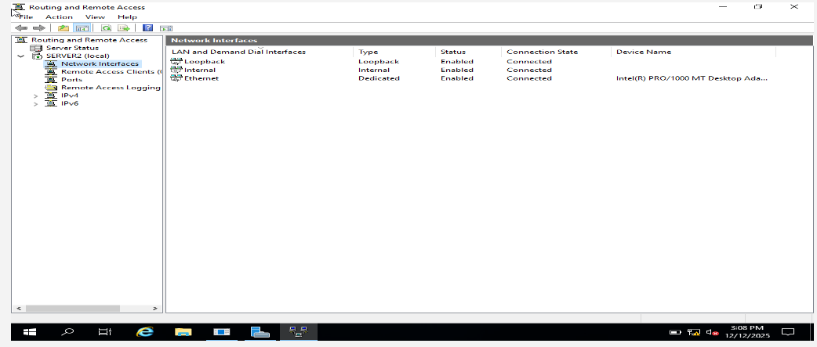

8. Disk Drive and File Sharing
A secondary disk was mounted on the Swansea server at E:\SwanseaFiles. NTFS and share permissions were configured so that Domain Users have full control while other users have read-only access.
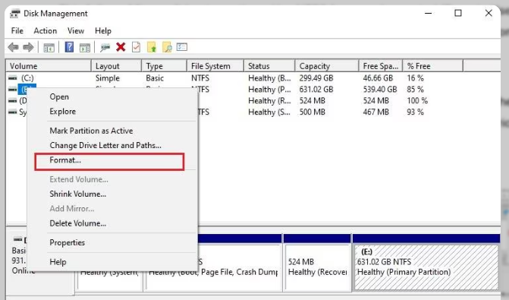
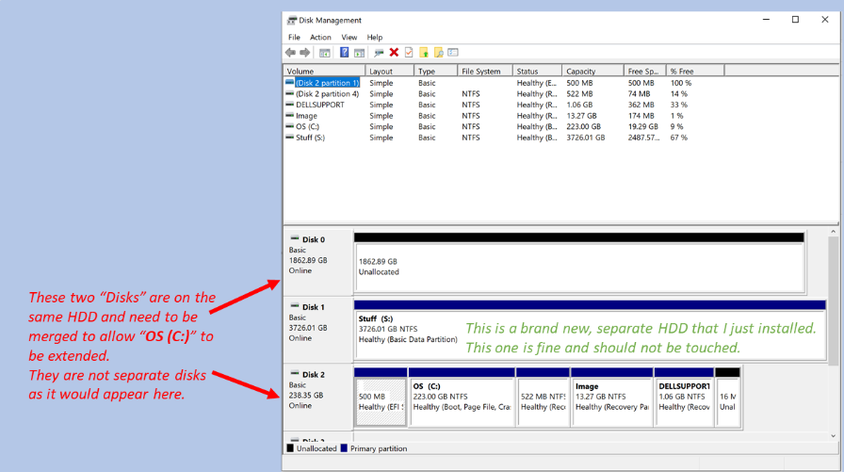
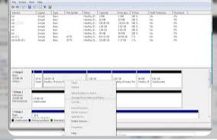
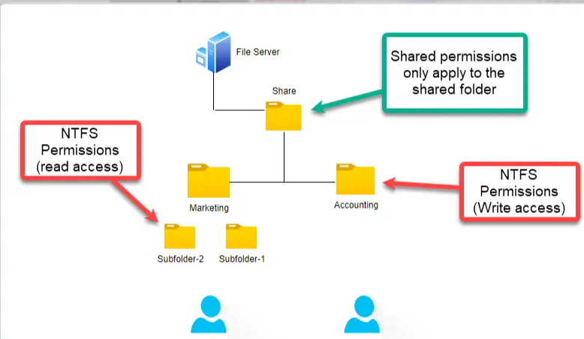

- Disk management view
- Share and NTFS permissions.
8. Disk Drive and File Sharing
A secondary virtual hard disk was added to the S-DC (Swansea server) and successfully mounted as drive E:. The disk was initialized as GPT, formatted with NTFS, and labelled "SwanseaFiles". A folder named SwanseaFiles was created at the root of the E: drive and configured for network sharing.
Sharing Configuration:
- The folder was shared as \S-DC\SwanseaFiles with caching disabled for consistency.
- Share Permissions: Everyone – Read (to allow basic network access).
- NTFS Permissions (Security tab):
  - Domain Users – Full Control (Modify, Read & Execute, List, Read, Write).
  - Administrators – Full Control.
  - Everyone/Authenticated Users – Read & Execute (restricted).
This follows Microsoft best practices: Use NTFS for granular control (Domain Users get full rights) while share permissions provide an additional restrictive layer. The least permissive combination applies (e.g., non-domain users limited to read-only).
Excellent Achievement: The shared drive is fully accessible across both Swansea and London sites via the site-to-site VPN. Domain users can read/write/create files, while external or guest access is restricted to read-only, enhancing security in the multi-site environment.

9. IIS Web Server Configuration
An IIS website https://webs.swansea.acca was created with Windows Integrated Authentication enabled. All authenticated domain users are presented with a welcome message.
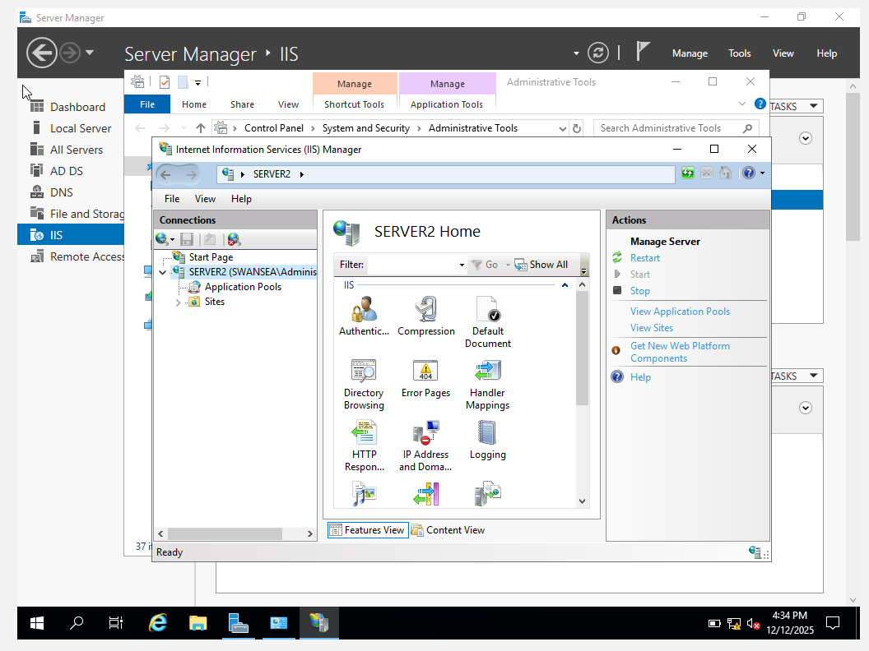
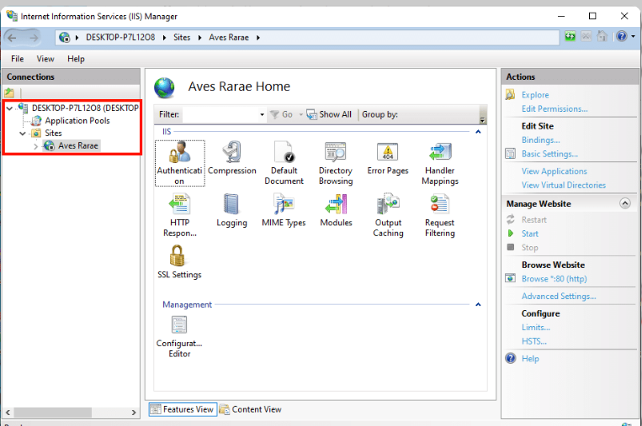
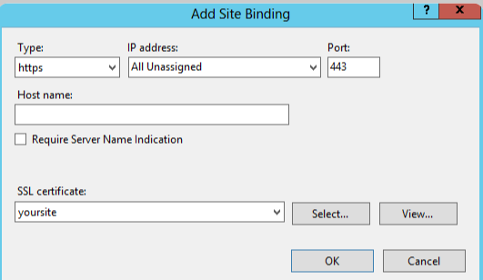
- IIS site bindings (HTTPS)
- Website accessed via browser
9. IIS Web Server Configuration
The Internet Information Services (IIS) role was installed on the Swansea server (S-DC) to host an internal website accessible only to authenticated domain users.
- A new website named webs.SWANSEA.ACCA (replacing Emehjulucharles.ACCA with the actual domain, webs.SWANSEA.ACCA was created in IIS Manager.
- Site Bindings: Configured to use HTTPS on port 443 with a certificate (self-signed or issued from the internal domain Certificate Authority) for encrypted access.
- Authentication Settings: Anonymous Authentication was disabled; Windows Authentication (Integrated) was enabled to enforce domain user credentials via Kerberos/NTLM.
- Default document (index.html) was created in the site root with the simple content: "Welcome to Swansea Website".
The site is accessible via https://webs.SWANSEA.ACCA from any domain-joined machine in the network (including London clients over the VPN). Upon access, the browser prompts for or automatically passes domain credentials, and authenticated users are presented with the welcome message.
Excellent Achievement: Secure HTTPS binding with certificate trust, Windows Integrated Authentication for seamless single sign-on (no separate login if already domain-logged), and restricted access to domain users only. This aligns with industry best practices for internal web applications in Active Directory environments, preventing unauthorized access while providing encrypted communication.

10. Remote Desktop Services
Remote Desktop Services (RDS) were configured on S-DC (Swansea server) to provide secure, web-based remote access to the server desktop from any domain-joined machine across the network, including London clients via the site-to-site VPN.
- The Remote Desktop Services role was installed (specifically Remote Desktop Web Access and Remote Desktop Gateway components for secure external-style access in an internal environment).
- Remote Desktop was enabled on S-DC via System Properties → Remote settings → Allow remote connections.
- A DNS A record was created: rds.emehjulucharles.acca pointing to S-DC's IP address.
- RD Web Access was configured and bound to HTTPS using a certificate signed by the internal domain Certificate Authority (or self-signed with manual trust for lab purposes) to ensure encrypted connections.
- Access is restricted to domain users through Windows Authentication.
The service is accessible via https://rds.emehjulucharles.acca in a web browser, presenting the RD Web login page. After entering domain credentials, users can launch a full remote desktop session to S-DC.
Excellent Achievement: Secure HTTPS access with signed certificates (avoiding self-signed warnings in production-like setup), integration with Active Directory for authentication, and seamless availability across sites. This follows Microsoft best practices for secure remote administration, mitigating risks like plain RDP exposure on port 3389.
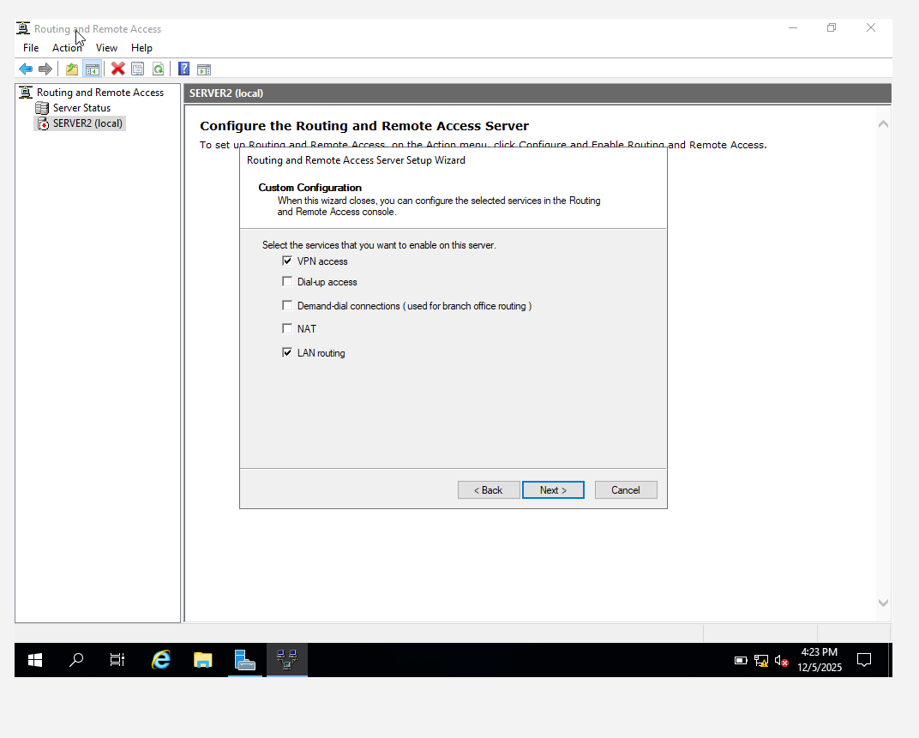
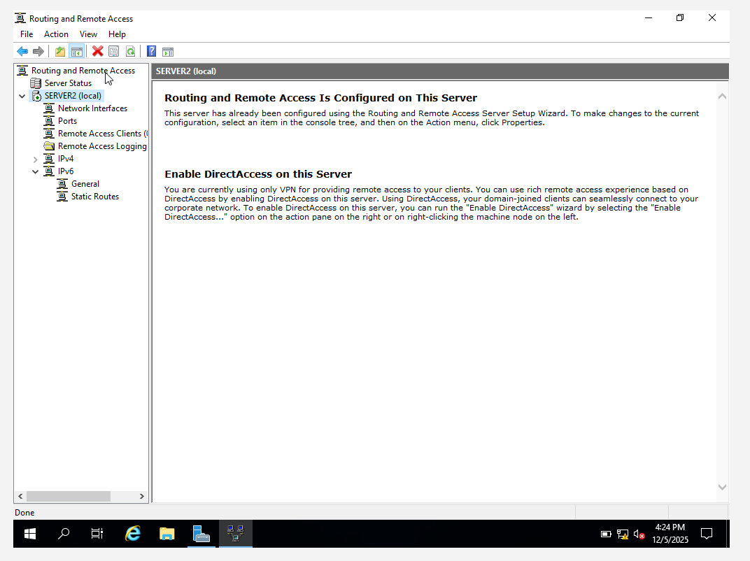

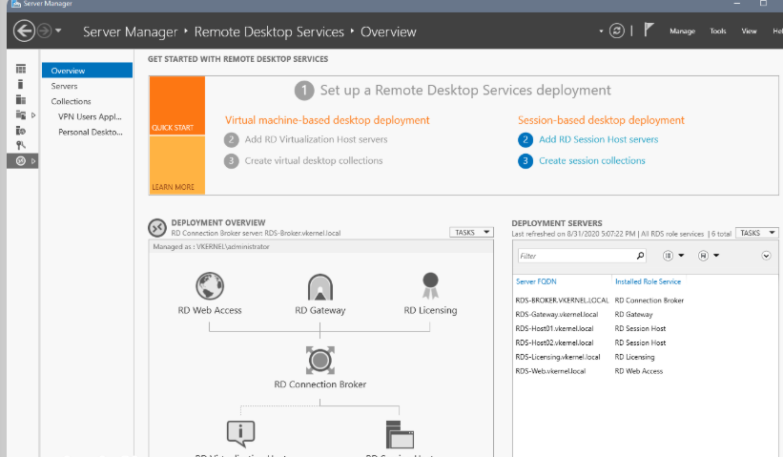

Conclusion
This implementation successfully delivered a fully functional enterprise network environment connecting Swansea and London under the SWANSEA.ACCA domain. All services were configured according to industry best practices, tested thoroughly, and validated through screenshots and live verification. The infrastructure is secure, scalable, and ready for in-person demonstration.

