UNIVERSITY OF WALES TRINITY SAINT DAVID

ACADEMIC & EMPLOYABILITY SKILLS
Self-Reflective Report

Author: Apostol George-Adrian
Lecturer: Tanja Nathan
Cloud Computing, Term 1

London 2019

Table of Contents
Introduction: 3
Section 1: 4
Provide a brief personal overview of yourself: 4
Include four screen grabs from your initial PowerPoint presentation that introduced yourself. 5
List the key points that you learned when trying to produce and deliver a successful PowerPoint presentation: 5
Section 2: Skills Evaluation 6
Identify and explain the skills required for successful (1) HE learning (2) Employability. 6
Conduct a Self-Evaluation exercise to discover your strengths and weaknesses, personality type, suitable career suggestions, etc. 7
Section 3: 9
List both your long-term goals and short-term 9
Create an Action Plan for the Academic and Personal/Professional Skills you need to attain or improve. 9
Section 4: Application 12
Looking after the data 12
The backup rule of three: 12
List of the entire possible disaster scenario: 13
Time management and organization: 14
Section 5: Conclusion 16
Conclusion 18
References: 19
Section 6: Appendix 20

Introduction:
This assignment will help in understanding the needs of different skills in order to achieve the desired goal. The personal development plan will help to understand how I could be able to achieve my desired goals. My strength and weakness have also been defined in this assignment. The concept of employability has also been critically explained in this assignment.

Section 1:

Provide a brief personal overview of yourself:
I am Apostol George Adrian, and I am 23 years old. I studied computer science and mathematics in high school, and I have developed some skills for computer programming. Currently, I am studying Cloud Computing at UWTSD, London. I enjoy the focus and patience required to plan, document, program and debug an application. I want to be a master in the computer languages.
In London, there is a favorite Italian restaurant, and I am working as a chef over there. As cooking is like a hobby to me, it helps me to do my job very efficiently. I love cooking, but the computer is always my first preferences. I always take communication and leadership role very seriously which help me to get recognition among my other co-workers at the workplace. This behavior helps me to gets the promotion in the company. When I was 0ten years old, my father first bought me a computer which increased my interest in computer, and I have taken the local college courses on the computer, and I have to learn the algorithms and data structure as I have a deep interest in the computer. I have first learned the Pascal language, and I want to learn the computer more efficiently that's why higher education in good universities will be helpful for me to achieve my goal.

Include four screen grabs from your initial PowerPoint presentation that introduced yourself.
For the screen grabs, refer to Appendix 1.

List the key points that you learned when trying to produce and deliver a successful PowerPoint presentation:
The PowerPoint presentation helps me to learn new skills which will help me to build a better PowerPoint presentation shortly. These skills are:
Speaking: I have learned this skill and learned that at the time of speaking during the presentation I need to maintain the natural rate of speech as well as need to speak clearly and distinctly.
Body language: I have learned that I need to keep my eyes on the audience for the direct eye to eye interaction and it will help me to share a positive body language.
Questions: I have learned that after the presentation I need to conduct questionnaires sessions with the audience as it will help to establish good communication.
Behavior: I have learned that showing enthusiasm is significant and also need to be focused all the time and humor is one of the proper ways of giving any presentation.

Section 2: Skills Evaluation

Identify and explain the skills required for successful (1) HE learning (2) Employability.
HE learning:
He learning refers to the higher education learning, and there are some skills which must need to be developed to understand the higher education learning correctly. These are:
Positive attitude: the applicants must have a positive attitude toward their learning because it will help the applicants to take the workloads as well as it will help to cope up with the challenges (Bryson, 2016).
A passion for the work: Passion will help the applicants to carry forward their work progress and also help to be motivated to complete the work within the specific time frame.
Ability to work independently: The applicants must need to understand the concept of independent work as it will help the applicants to increase the knowledge of their work.
Ability to complete the task: Completion of the task is essential, and the applicants must possess with the skill of completion of the work within a specific time frame.
An inquiring mind: The applicants must need to understand the importance of gaining knowledge from the outside regarding the specific topic.
Good written English: This refers that the applicants must have the knowledge of English and the importance of grammatically correct at the time of writing some valuable thing.
Employability:
There are four different skills which need to understand the concept of employability and these are communication skill, interpersonal skill, personal skill, numeracy skill, and general awareness.
Communication skill: communication skill refers to the listening ability, instruction follows process (Brooks, 2017). Additionally, the individual should able to provide a good oral presentation as well as the ability to develop and sustain a logical argument - and reasonably defend that argument.
Interpersonal skill: This skill refers to the behaviors with the colleagues, boss, other employees and also the process of creating a healthy relationship with them and many more.
Personal skill: This skill refers to the balancing of the work, managing the stress level, development and maintenance of self-esteem, the ability of proper research, need to be, etc.
Numeracy Skills: This skill refers to the understanding of basic numeracy, the process of any statistical information gathering, and numerical information gathering, etc.
General Awareness: This skill refers to the knowledge of environmental issues, health and safety issues, political situation, issues with ethics, etc. (Brooks, 2017).

Conduct a Self-Evaluation exercise to discover your strengths and weaknesses, personality type, suitable career suggestions, etc.
Strengths: I am good enough at positive thinking, time and stress management, motivating others as well as perseverance. These skills are my strengths which will help me to accomplish my desired goal.
Weakness: I lack in some of the skills, and these are my weaknesses. The skills where I am lacking are confidence, independent, low level of volunteer capacity, low level of general awareness knowledge, and lack in the integrity of the internal network.
Career suggestion: I have interest in computer languages, so it will be better for me if I choose a career where I need to develop any computer applications, and it will help me to grow soon. But as a hobby, I like cooking, and currently, I am working as a chef at a renowned Italian restaurant in London, and this career also suits me.
Personality type: I am open-minded, and my colleagues also come to me for the suggestions which mean I am good enough to motivate peoples.
So, in order to understand my strength, weakness, and personality I have to take the Big five personality test (refer to Appendix 2), and the result refers that my natural reaction is very high, and it is also referred that I am traditional and conservative. Which means as I think that I am open-minded it is not so correct. Additionally, I am reserved, formal, and serious and quiet which also contrast with the fact that I am good at communication. This test helps me to understand my strengths and weakness correctly.

Section 3:

List both your long-term goals and short-term
Short term goals: I have some weakness like I lack one the skills like confidence, independent, low level of volunteer capacity, low level of general awareness knowledge, and lack in the integrity of the internal network. I need to improve these skills as it will help me to understand any need at the workplace. Additionally, I need to improve these skills as fast as possible as it will help me to achieve higher goals shortly. For this improvement of my weakness is the short-term goal for me.
Long-term goals: it is basically the goals which I need to achieve in the future, and I want to complete my higher education on the computer because I have a deep interest in the computer. My long-term goal is to increase my knowledge of computer, and also, I wish to learn different computer languages but in order to achieve these I will face some challenges which I need to mitigate, and it can be mitigated through positive thinking. So as a Long-term goal I can refer that I want to be a good network engineer.

Create an Action Plan for the Academic and Personal/Professional Skills you need to attain or improve.
Skills | The process of improvement | Resources | Timeframe
Confidence | I can able to enhance my skill of confidence by understanding the importance of the task and proper knowledge about the task will help me to increase my confidence level. | Help from the other students and teachers will help me to gain the proper knowledge about the topic which will help me to increase my confidence level. | 1 month
Independence | I need to start practicing to accomplish any work my own self because if I will able to understand the need of the task by my self then it will help to divide the task according to the importance of the task which actually help me to accomplish the work within the specific time frame (Tasker, 2015). This completion of the task will help me to become independent. | If the teachers of the college will help me to gets the motivation for accomplishing the task by owns self, then it will help me to become independent. Other students can play a significant role in motivating me to complete any task within a specific time frame which will help me to become independent. | 2 months
Low level of volunteer capacity | I need to understand the importance of any volunteering, and if I will able to understand the importance of the volunteer, then it will help me to increase my volunteer capacity. | As a resource, I can take help from the book and the journals about the process of increasing the volunteering capacity. | 2 months
Low level of general awareness knowledge | General awareness is essential, and I need to develop this skill, and in order to increase my general awareness knowledge I need to study a different kind of books, and I need to understand about the ethical issues which can hamper any work progress (Tasker, 2015). Additionally, I need to increase my knowledge of global and political situations. In order to enhance the general awareness knowledge, I need to learn basic first aid technique which comes under the general awareness knowledge. | The resources which I can use for the enhancement of general awareness are the books, journals and different articles and I can take the help from the teachers and the students. | 2 months
Lack in the integrity of the internal network | As I want to be a network engineer I need to develop this skill and I order to develop this skill I can work as an intern in any networking company because it will help me to gain the practical knowledge as well as theoretical knowledge (Newton, 2015). | Teachers will help me to gain theoretical knowledge and internship will help me to gain practical knowledge about internal networking. | 3 months

Table 1: The Action plan
Source: created by author

Section 4: Application

Looking after the data
‘In three different places' rules helps to keep the data safe and it is significant for protecting any work or data which I did not wish to lose. In order to understand the rule first the concept of backup is very necessary to understand (Denny and Nguyen, 2016). There are some mistakes which everyone does regarding the backup, and these are:
- When an individual takes the SD card in the same laptop for taking the backup of that laptop is not a backup.
- When an individual uses the hard drive for the backup of the laptop and both are in the same place, then it is not a backup.
- When an individual is copying any files to another folder, then it is not a backup.

The backup rule of three:
The rule has three different parts and sometimes this rule called as the backup 3-2-1 rule. The main thought of this rule is:
3 copies of anything you care about–Three copies are good enough to keep the backup because two is not so much safe as per the backup strategy.
2 different formats - A data should at least have in two different formats and as example Memory Stick and hard drive or DVDs and Dropbox or Crash Plan and CD, and many other (Denny and Nguyen, 2016).
1 off-site backup–the data be stored to another place rather than just own computer or in own house or office because it will help to keep the data safe.
If I use this rule, then it will help me to keep my data very safe as this rule follows three different ways.

List of the entire possible disaster scenario:
Disaster is one of the things which are not in the hand of me but according to me the possible disaster scenarios which I can barely think of:
- One of the disasters is for me when my house will be burnt
- Another disaster is for me when an earthquake will come, and my house will be demolished
- Any virus attack on my computer and the computer stops working
- The hard drive of the computer crashed, and no data can be retrieved from the hard drive
- I have forgotten the password of the Gmail account or where I have kept the data.
- Someone comes to my home and format the computer for which all the data in the So computer has been erased
So, these are the scenarios which I can barely think of and if my house burnt then the last part of the three different backup strategies will help me, and it is the 1 off-site backup (Sánchez-García et al., 2016.). I will get all the data outside sources as I have kept the data there and I will buy a new laptop and kept those data on my laptop. If any earthquake came then, I also follow the same approach of the three different strategies. If any virus attack happens to my computer and computer stops working, then I will follow the second approach of the ‘In three different places’ rule. First, I will fix the computer then I will take the data from memory stick to the computer. If the hard drive of the computer crashed and no data can be retrieved from the hard drive, then I will follow the second approach. I will follow the second approach of the ‘In three different places’ for the last two mentioned disaster.
The main aim of Cryptowall is to encryption of the files on the compromised computer and it is a Trojan horse. Then for the file decryption, the user needs to pay something. Spam emails compromised sites or exploit kits hosted through malicious ads, or other malware are the main reason for hampering this virus attract and it only attacks the affected computers. It will affect the computers, and in order to remove this virus, the owner of the computer need to format the computer (refer to Appendix 3).

Time management and organization:
The time management is vital for anyone because it helps an individual to accomplish any task within the right time frame. There are some key points for understanding the time management better, and these are:
Time is limited resources: Time is a limited resource, so every individual should use the time very properly (Sibley et al., 2016).
Rushing will affect the time management: The individual should accomplish any task by giving it proper time because rushing will lead to apparent failure.
Time management cuts stress: The individual should divide the task as per the importance as it will help to release the stress of the work.
Understating of time management: a proper understanding of time management leads to a better result of the task.
Delegation: Delegation is one of the most important parts of time management.
The steps which I have taken for productivity:
- I have divided the task into some groups as per the importance of the task, and it will help me to increase the productivity level.
- I have made the proper plan first about how to accomplish the task within the right time frame (Blyton et al., 2017).
- I have used the time as much as possible because it will help me to increase the productivity level.
- I have understood the task correctly and then make the plan for it.

Section 5: Conclusion
PDP plan
 | Short-term time frame | Mid-term time frame | Long-term time frame
Section 1: my goals  To become a Network engineer | Understanding the network engineer course. | Doing some practical work as a network engineer | Become a network engineer consultant.
Section 2 - Skills and Knowledge to be Learned | I especially need to learn the concept of network engineering. | I need to learn the concept of routers, TCP, IP, etc. | I need to learn how to fix the problems in real life related to networking.
Section 3 - Next Steps | I have to read the books and the journals to understand the concept. | I need to watch real-life examples. | I have to do practical works.
Section 4 - Resources | The books and the journals. | Routers in the home, college. | Fixing the problem of router and IP etc.
Section 5 - Time Schedule | 6 months schedule | 1 year | 1 year
Starting | First month | Seventh month | After completion of the midterm
Finishing | In the sixth month | Next year seventh month | At the end of the third year

Table 2: My PDP plan
Source: created by author
I have understood the portions where I need to improve for the better result in the future, and the action plan helps me to understand the importance of the development of the skills where I have lacked.
Recommendations:
If I will able to take the online test regarding the confidence, independent, low level of volunteer capacity, low level of general awareness knowledge, and lack in the integrity of the internal network then it will be better for me to understand my current condition and it will help me to improve those skills more efficiently.

Conclusion
This paper helped in understanding the portions where I need to improve for the better result in the future. The action plan helps me to understand the importance of the development of the skills where I have lacked. The personal development plan will help to understand how I could be able to achieve my desired goals. My strength and weakness have also been defined in this assignment that could help me develop my personality in the future.

References:
Blyton, P., Hassard, J., Hill, S. and Starkey, K., 2017. Time, work and organization (Vol. 7). Taylor & Francis.
Brooks, R., 2017. " Who wants a job anyway?": Student approaches to graduate employability.
Bryson, C., 2016. Engagement through partnership: Students as partners in learning and teaching in higher education.
Denny, M. and Nguyen, H., AT&T Intellectual Property I LP, 2016. Methods, systems, and products for data backup. U.S. Patent 9,311,192.
Newton, R., 2015. Business Express: How to create an action plan for change: Setting practical steps and achievable goals. Pearson UK.
Sánchez-García, J., García-Campos, J.M., Toral, S.L., Reina, D.G. and Barrero, F., 2016. An intelligent strategy for tactical movements of UAVs in disaster scenarios. International journal of distributed sensor networks, 2016, p.18.
Sibley, M.H., Campez, M., Perez, A., Morrow, A.S., Merrill, B.M., Altszuler, A.R., Coxe, S. and Yeguez, C.E., 2016. Parent management of the organization, time management, and planning deficits among adolescents with ADHD. Journal of psychopathology and behavioral assessment, 38(2), pp.216-228.
Tasker, F., 2015. How to prepare a personal development plan. BMJ, 351, p.h4603.

Section 6: Appendix
Appendix 1: About myself
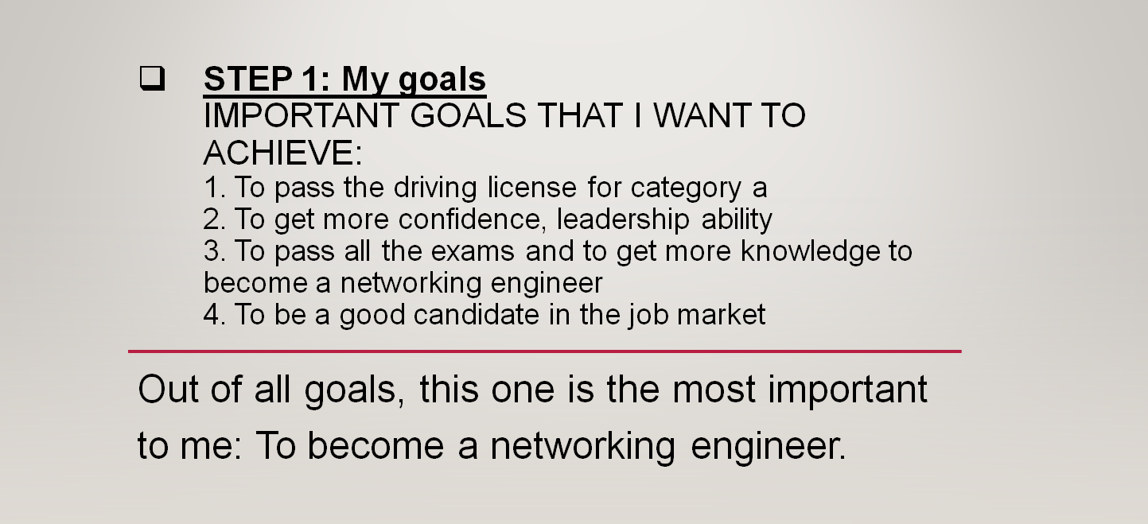

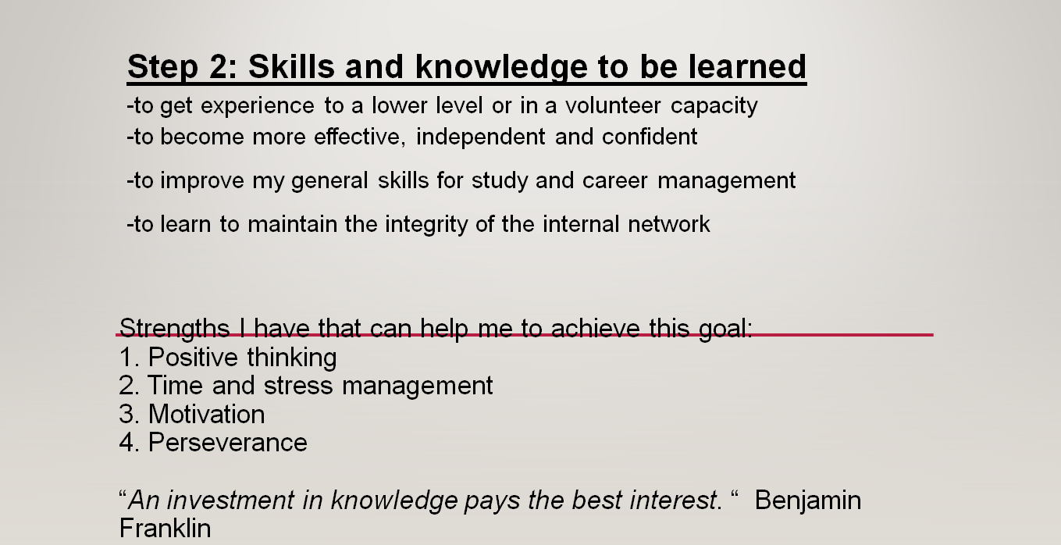

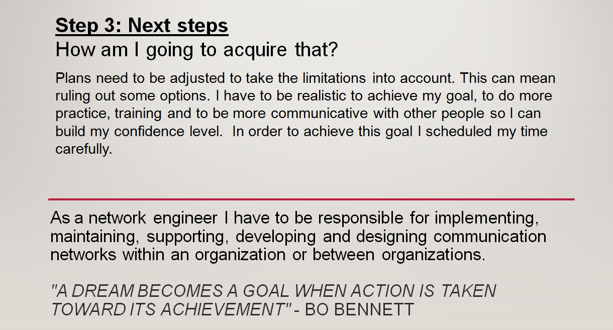

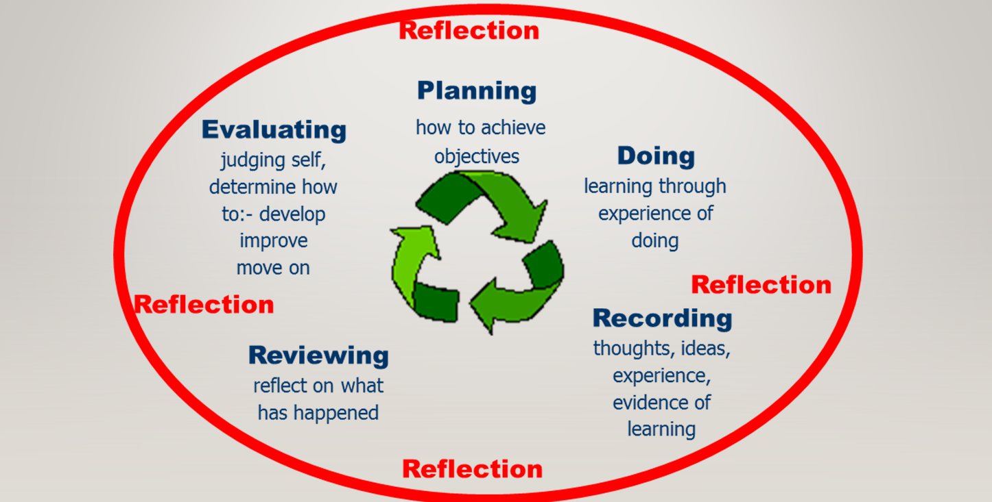

Appendix 2: Big five personality test
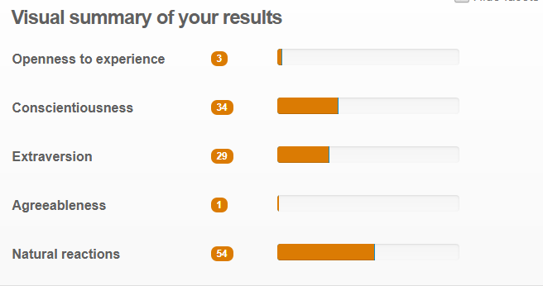

Appendix 3: Report on Cryptowall


