

BMSW4005

Professional Career Development

Professional Career Development Report and Role Play

Student Name: Elena Angelica Dobriu
Student ID: 2011624

Table of Contents
Introduction 2
Reflection Report 3
Gibbs Reflections Cycle 4
Description 5
Feeling 5
Evaluation 5
Analysis 6
Conclusion 6
Action Plan 7
Recruitment and Selection 9
Conclusion 12
Reference 13

List of figures –
Figure 1: Skills 3
Figure 2: Gibbs Reflection Model 4
Figure 3: Gibbs model 6
Figure 4: Gibbs processes 8

List of tables
Table 1: Roleplay 9

Introduction
Professional Career Development skills are skills that are included with the understanding of advanced skills and the traits of the career development process that plays a major work in the process of development of learning. The report below will cover the several types of the learning process that can be used to create a professional reflection that helps to find problems in the task of skill development. To show learning experience it can be done with the help of several types of reflection methods such as Kolb’s learning methods and Gibbs's cycles of reflection. This report has selected the process of Gibbs's learning reflection that can be used as a method of representing managing overall career. As the career can be defined a work sequence that can use as a method of getting a described job because of that there is are several types of skill set such as communication skills, leadership skills, teamwork, etc. are required to manage the overall working of the process. to get a good job in the sector of Professional Career Development student it is recommended to participate in various type of actives as these actives are designed to develop skills. for the student, it is recommended to utilize for the process of getting a job that can provide a high salary.

Reflection Report
In the process of professional skill development, several types of skills are required to maintain sustainable growth in most organizations. As roleplays’ shows the reflection of a two people conversion where it has shown several types of issues that have occurred due to condition of covid 19. As Flaviu has played the role of unsatisfied employees and he has to face issues and problems due to the Conditions of covid. Coronavirus has affected several people including businesses, industries, employees as well as several individuals because of that they all people are facing problems in the condition of covid. covid has affected people in a manner that those People how lacks skills are affected most of it because most of the organization has fired those employees that have shown low performance and lack skills because of that to manage their skills it can be done with the help of several types of the skills development process can be used to develop skills. In the sector of professional career development, there are following types of skills are required –
- Communication and networking skills
- Interpersonal and teamwork skill
- Leadership and management skill
- The skill of self-management
- Research and planning skills
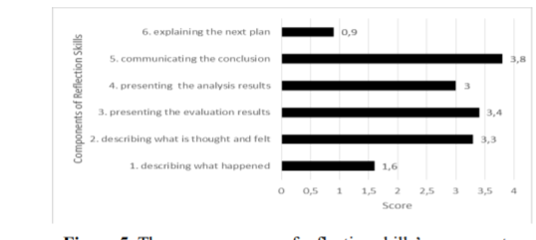
Figure 1: Skills
Source: (Sekarwinahyu, Rustaman and Widodo 2019).
So these are the crucial five skills that are required to become a professional development career. As transferable skills can be adopted between jobs and these are not meant for specific for a single person’s roles because of that it is required to build these skills as an expanding medium of a career that can be adopted for the process of professional carrier program. As the process of communication and networking skills plays a major role in the process of establishing a process of a good relationship with a colleague, employees, client, and also with other people. It is important to have good communication skills as communication is the key that includes processes of the effective project management process.

Gibbs Reflections Cycle
One of the most famous cyclical models for the process of effective reflection that can lead thoughts of people’s in six types of explaining process that can be used in for the task of effective project management process that helps to devote several types of skills that can be sued for the process of managing overall. This reflection cycle has been creating by Graham Gibbs in 1988 (Michael Page 2022). It provides learnings experience and frameworks that can be used to examine the experience and gives the process of planning that I can use for the process of managing overall work. As it covers mainly the following steps –
- Description
- Feelings
- Evaluation ‘
- Analysis
- Actions plan
- Conclusions
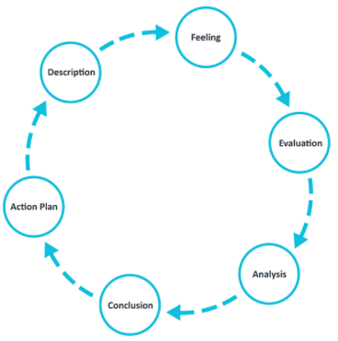
Figure 2: Gibbs Reflection Model
Source: (The University of Edinburgh, 2020).
So with the help of these steps, it is possible to create a project that can be used to show the overall growth of the tasks. as per my thought, it is possible to maintain overall skills as there the Gibbs model gives tools that can be used for finding overall errors as well as it provides tools that help to find skills that people lack (Targetjobs 2022).

Description
as there are several types of processes that can be used in the process of finding the overall task of data magnet process that can be used to improve the overall skill set. as the model of Gibbs provides tools for the process of finding overall lack of issues it can be found by the tools called Description. This process helps me to find skills that I lace such as the process of effective communication that can be used as a key to communicating with others. By the following description, it has provided information such as what happened, when and where it happened, what is the overall situation has occurred, etc. as the role plays give ideas and description of the overall model and show the impacts of Covid and how it has harmed the overall economy. The overall scenarios have been explained in process of description (Mindtools 2022).

Feeling
The process of finding several processors can be done with the help of the process of managing. the overalls task of defining processes that can help in process of managing condition that provides overall ideas for what people thinks during covid 19s phases.

Evaluation
The process of evaluations contains information that is important to manage during the consisting of finding critical information that can be as a way to express its feeling and happiness. By the following process of data management in the carrier management process, it describes key steps that are important to Mange for me as actives that are based on the task of Gibbs models are interconnected with each other there for if the process of data finding cannot be handled process of dividing skills sets that I don’t have because of that by taking advantage of a method that is based on Gibbs evaluation tools (Mindtools 2022).
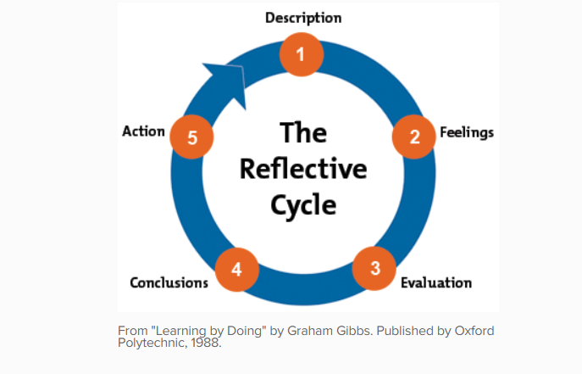
Figure 3: Gibbs model
Source: (Mindtools 2022).

Analysis
The process of Analysis as it is mainly based on the task of analyzing the overall condition and are well as these process has provided tools for the task of data management. That can be utilized as a way to solve errors that are present in the overall method of creating a process that we can utilize to build processes that are based on the method of finding issues that can occur during the task of hiring recruiters as well as getting a suitable job.

Conclusion
As there are several types of processes that can be utilized as a process that helps to manage the overall task of removing errors that give helps in the process of handing various methods that can utilize for the method of handing overall values. As the role pay gives an overview that helps to define overall career (The University of Edinburgh 2020). The careers can be defined as a sequence of the work process as well as experience that helps to create a method that helps to evolve the overall working as well as the task of industrial life and the process of the obituary are highly complexness because of that with help of individuals as well as the dynamic overtime awareness it is possible to outline a later in the book or covers type of skill set that can help me to understand the overall basic growth. As the line and the process of development are mainly based on the session of hanging overall information and the value of life because of that to management that lifespans and morality can be overlooked as a typical prospective task (De Vos, Akkermans and Van Der Heijden 2019).

Action Plan
As this reflection is based on the process of managing the overall improvement of the process because of that there are several types of process and task has been accounted to manage our overall skill development process because of that there are several types of methods that are involved teg actions planning step (Zorin et al. 2018). Action planning is a part of the Gibbs model that gives an overview of the actions statement. By taking advantage of tools that involve a method of data handling mainly depends on the process of creating methods as well as the process. As the phase of action planning in the role played gives overall ideas because of that it became important to handle and overcome the lack of skills that are the main part of Gibbs reflections module. As the reflection gives help over the management process because of that in professional speech culture that is based on liner (‌Schlesinger, O'Shea and Blesso 2021). As the main objective of the process of managing carriers givers helps because of that I can take several types of approaches for example – improvement of skill, performance development, implementing overall confidence, etc. can be managed and I can improve. These skills develop my skills to a level that no one can achieve.
As this role-play has been helping me to understated several types of method and process that I can utilize as a method of transformation of skills of the student because of that there are several process method I can recommend such as-
- It is a part of professional career development for the student to improve their critical thinking because there are several types of an occasion where the professional career to providing solutions that are based on problem-solving skills.
- For the student that is trying to get a good job in the sector of career manager, it is recommended to have good communications skills as it is recommended in all organizations (Sekarwinahyu, Rustaman and Widodo 2019).
- For professional career development, it is recommended to have skills that are based on the process of effective leadership and team management skills.
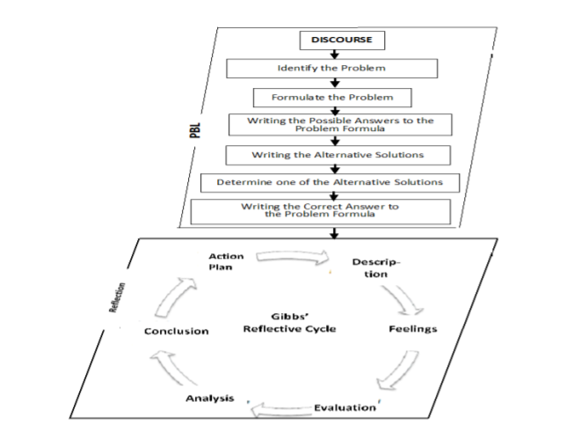
Figure 4: Gibbs processes
Source: (Sekarwinahyu, Rustaman and Widodo 2019).
So these are the main type of skills that I have to work on because I lack skills that are based on the process of Professional career Development. As the role-play helped to understand the frustration of an employee that is not satisfied form their company because there are several types of skills that I have observed by taking Gibbs lifecycle because I have to improve my skills communication, teamwork, negotiation, and persuasions skills, teamwork skills and skills at that plays an important part of Career development (Tejan, and Sabil 2019).
In the role as it is based on dissatisfied employee and also a consulting manager and the role has been played by Flavisu and Elena we have a lot of fun to play this part as this roleplay has allowed practically showcasing over skills. Because of that, there are several types of methods such as Kolb’s and Gibbs methods can be used to evaluate skills that have mastered as well as skills that I lack because of that by taking help of Gibbs model it is possible to manage and improve skill as model help to observe several types of skills and also it also helps to use these skills in real-life based tasks.

Recruitment and Selection
Table 1: Roleplay
Flaviu | Hello Mrs Elena, how are you?
Elena | Hello Sir, I am fine.
Flaviu | I am glad to hear. Tell me is there any type of problems?
Elena | Yes, sir, currently I am having issues due to the negative effect of covid and I don’t feel like I have issue’s regarding the financial issues. Is there any way you can help me?
Flaviu | Sorry to hear that you are facing issues due to covid. I understand how you are feeling. Covid has affected many people and they all are facing issues regarding the person and as a financial.  I understand your problems but as you know we don’t have many profits due to covid so we can’t support your financial condition.
Elena | Okay sir but I think I can’t remain in this organization due to Covid, sir I am afraid that I can’t travel long distances. So I am wondering is it possible for me to get permission to work from home. Because in my neighborhood hood cases of Covid are increasing.
Flaviu | Sorry as you already know that our office has to work on 50% of its capacity as the office has sent 50% of employees to WFH and you don’t have the property skill and experience to handle work on your own.
Elena | Yes sir I know that, but from last months I am working on my skills and now I understand all work and I can handle all work on my own. If you have dought you can review my last month's performance.  As I know I still lack some communication skills because of that I can’t convey my thought property but now I have improved my skills. if you have any questions you can text me.
Flaviu | Ok, then I am going to ask you some basic questions.
Elena | Ok Sir
Flaviu | Tell me about your greatest strengths?
Elena | As a Professional career department expect my passion and dedication to the industry to be my graters’ strength.
Flaviu | Good answer.  Tell me one positive thing about our company?
Elena | Sir, I think over the company has several types of positive things such as it has good work cultures, our company has good learning and the overall environment is good. But the one most positive thing I like about our company is that our company has excellent Ethical and human regulation, which I think are the most important feature that most organizations lack.
Flaviu | Wow, I am impressed by your answer. I see you have improved your communication skills quite well.  Now tell me what is the guaranty that your will work effectively and handle your work in WFH?
Elena | Sir, Based on last month's performance I think I can manage all my work without any problems and sir I promise that I will work properly during work from home.
Flaviu | Okay, based on your confidence and test I think you can manage your all work without any problems.  So I will allow you to take work from home from next week. You just have to write an application and submit an application to HR.
Elena | Thank you, sir, I will submit applicants at the end of the day.
Flaviu | Ok, are there any other issues you have?
Elena | No sir I don’t have any other problems. But I think our company has to implement some covid guidelines to prevent employees to affect form covid. some of them are fearing these viruses.
Flaviu | Yes, I understand your concerns but the management team is already working to implement some policy that everyone can follow to avoid the virus. You don’t have to be wary.
Elena | Ok, sir.
Flaviu | Ok then now I have to go to a meeting. If you have any problem you can ask me after 1 hr. Okay
Elena | Ok, sir thank you for helping me I hope everything will become better soon.
Flaviu | I also hope that. Ok good, I will see you next time.
Elena | OK, sir goodbye.

Conclusion
As there are several types of methods that can be used in the process of improving overall skills. the report above has explained several types of processes that can be used to improve overall skill. To get a good job it is recommended to develop several types of skills such as communication skills, leadership skills as these are the main type of skills that are required to get a good career opportunity in the sector of Professional Career Development. The report above has also explained several types of the process such as the Gibbs model. It is a professional method that can be used for the process of analyzing skills after the analysis of skills that helps in the process of creating self-reflection help to understand the overall requirements of the role plays.

Reference
De Vos, A., Akkermans, J. and Van Der Heijden, B.I.J.M., 2019. From occupational choice to career crafting. The Routledge companion to career studies, pp.128-142.
Michael Page. 2022. What career skills are the most valued by employers?. Available at: https://www.michaelpage.com.au/advice/career-advice/career-progression/what-career-skills-are-most-valued-employers [Accessed 12 Jan. 2022].
Mindtools. 2022. Gibbs’ Reflective Cycle: Helping People Learn From Experience. Available at: https://www.mindtools.com/pages/article/reflective-cycle.htm [Accessed 12 Jan. 2022].
‌Schlesinger, J., O'Shea, C. and Blesso, J., 2021. Undergraduate Student Career Development and Career Center Services: Faculty Perspectives. The Career Development Quarterly, 69(2), pp.145-157.
Sekarwinahyu, M., Rustaman, N.Y. and Widodo, A., 2019, November. Problem-based learning skills and reflection skills of biology education students through the problem-based online tutorial. In Journal of Physics: Conference Series (Vol. 1280, No. 3, p. 032004). IOP Publishing.
Targetjobs. 2022. What are the top 10 skills that’ll get you a job when you graduate?. Available at: https://targetjobs.co.uk/careers-advice/skills-for-getting-a-job/what-are-top-10-skills-thatll-get-you-job-when-you-graduate [Accessed 12 Jan. 2022].
Tejan, O.A. and Sabil, A., 2019. Understanding employers’ perception of employability skills and career development in Morocco. International Journal of Education and Literacy Studies, 7(2), pp.134-138.
The University of Edinburgh. 2020. Gibbs’ Reflective Cycle. Available at: https://www.ed.ac.uk/reflection/reflectors-toolkit/reflecting-on-experience/gibbs-reflective-cycle [Accessed 12 Jan. 2022].
Zorina, E., Kartavtzeva, I., Krusian, I. and Mikhienko, S., 2018. Aspects in formatting professional speech culture for rural career development courses listeners. In Engineering for Rural Development 17. Сер." 17th International Scientific Conference Engineering for Rural Development, Proceedings" (p. 1125).
‌
‌

