Outline an anthropological perspective on art and consider its potential use for examining and interpreting ancient art from the Near East/Aegean.

Anthropologists use different perspectives to examine and interpret ancient art from all over the world. These perspectives include aesthetics, theory of enchantment, symbolic communication, and art and agency. There are many more perspectives that this paper does not have the breadth for. Individual scholars who champion the different perspectives will be outlined below. The main focus of this essay will be the aesthetic approach, as argued by Bloch and Steel, nevertheless, another perspective will be examined for both comparison, and to test the boundaries and limitations of specific anthropological approaches. Art used to test the theories will include the Red Polished figurative art explored in Steel's paper, the Uruk Vase and very early art from the beginnings of the Neolithic in the Ancient Near East. As MacClancy (2021) states, anthropology of art as a separate discipline is a relatively new focus of study for scholars, so whilst theories across historical studies are always developing – this development is more notable for the anthropology of art. It should also be noted that theories and scholars from the modern Western world, will always hold an unconscious prejudice, although there are attempts to circumvent this.
It may seem an obvious way to examine and interpret ancient art to use the aesthetic anthropological perspective, however it can provide a valuable insight into the purposes of the object or image and help to designate the object or image as an art object. The dictionary definition for aesthetic is “relating to the enjoyment or the study of beauty” (Cambridge Dictionary 2022). It is hardly unreasonable therefore, to argue that beautiful objects and images can, and perhaps should, be classed as art. This is further emphasised by the dictionary definition of art being: “the making of objects... that are beautiful...” (Cambridge Dictionary 2022). However, if it were that simple then there would not be a debated involving the other anthropological perspectives in existence. Some anthropological approaches to art overlap in their perspectives to other approaches, for example the aesthetic and Gell's art as agency are intertwined; art as agency will be explored further later in this paper. A prime example of the aesthetic nature of art involves the carvings into the wooden structures in Madagascar. These show the perspective of art of a living culture being interpreted by scholars from outside that culture in which they are being made. Bloch (2005) explains how many scholars before him had not understood why the Malagasy people were creating these intricately beautiful carvings on the wood – they all assumed there must be some deeper meaning or function behind them. Yet he concludes that they are doing it purely to make the wood beautiful without any hidden meaning (Bloch 2005). The Zafimaniry in Madagascar still produce these intricate carvings on their houses as seen in Figure 1. Bloch, therefore, shows how using an aesthetic perspective – namely that the carvings are just pleasing to look at, led to an understanding of the Malagasy culture that had not been there before. So, the art that the people created purely for aesthetic purposes and for no hidden, deeper meaning, actually provided information on those people and their way of life. However, this paper will be applying the aesthetic anthropological perspective to the Near East and Aegean. Steel achieves this in her paper on Red Polished figurative art from the Bronze Age of Cyprus (2022). She argues that modern scholarship tends to focus on other aspects of ancient art and largely ignores the notion that ancient art could have been created simply to be appreciated for its visual – or aesthetic – properties (Steel 2022: 2). She uses the phrase “Cypriot aesthetic” (Steel 2022: 8) to group together the varying pottery that is stylised in a similar manner. This shows another meaning behind the use of aesthetic. Certain styles are used both by scholars to make sense of the ancient world but were clearly also used by the ancient people for unclear reasons. They may have wanted to create an “aesthetic” that was theirs, or since the creation of art objects would have been taught and passed down by a small percentage of the population in a version of apprenticeships (Crawford 2004: 69), it makes sense that they styles would be similar. There is a distinct aesthetic for the bevelled-rim bowls found in Sumerian cities such as Uruk (See Figure 2), however one would not argue they are aesthetically pleasing. They are also merely functional bowls, used, probably, for the dishing out of rations to the city's worker population (Van De Mieroop 2007: 20). They are not then, by all definitions, art objects. However, just because an object is functional, does not mean it is not also an art object. This is where the definitions and boundaries of the different anthropological perspectives for interpreting art objects come to the fore. If we apply the “functional but aesthetic” theory to something in the modern world, like mugs, for example, we can see that incredibly mundane and functional objects could also be seen as art objects due to their aesthetic nature. A plain white mug may be seen as a simple object – but brightly painted mugs with patterns, or images on them, may, to some, become aesthetically pleasing. If they are beautiful objects – surely, they can be classed as art objects. This then would be examining and interpreting art as something that enchants the viewer (Gell 1992). Looking at Figure 3, we can see another example of a functional, yet aesthetically pleasing art object. It is a jar from the Jemdet Nasr Period of the Near East, and it is objectively an object made beautifully – i.e., a piece of art. However, it is also a functioning object – a jar. This goes against what Bloch argued for with his study of the Zafimaniry wood carvings and proves Steel's argument that scholars are a little too obsessed with ignoring the simple aesthetic beauty in ancient art objects. Nonetheless, the aesthetic anthropological perspective can still be applied to an object like a Jemdet Nasr Period jar. If we ignore its functional aspect, the jar is still a piece of clay shaped and painted to look beautiful – it goes beyond its functional purpose to become not just a jar, but an artistic jar, that can be appreciated aesthetically. However, it cannot be stated that these objects are examined through a purely aesthetic perspective unlike the Zafimaniry wood carvings mentioned above, instead the mugs from the modern day, and the storage jars from the Jemdet Nasr Period, are examined through Gell's Theory of Enchantment (1992).
Nevertheless, there are further examples of art from the ancient world that we can apply a pure aesthetic anthropological perspective to in the same way Bloch (2005) and Steel (2022) do. Found in numerous Sumerian sites are copper figures of men and animals dating from the Early Dynastic II Period onwards (Crawford 2004: 169). Crawford concludes that many of these figures, although some were used to prop up small jars, had no apparent function beyond their aesthetic appeal (2004: 169). Considering the malleability of copper, it is easy to imagine the ancient peoples of Sumer making copper figures without purpose. Obviously just because scholars cannot see a reason for some of these copper figurines does not mean that is how the creator intended them. However, in the same way Bloch (2005) was the first recorded scholar to accept that the wood carvings on the dwellings of the Zafimaniry were made simply to look nice, it is clear there is a prejudice to find a purpose for everything archaeologists and anthropologists discover from the ancient world. It may be cynical to presume this prejudice is because it makes for a better discovery and story if the objects found can be attributed a purpose, but this does seem quite likely – it is almost natural to want to ascribe a deeper meaning to objects as they are excavated. But these ancient people would not have been too dissimilar to modern humans, and it is normal for people to doodle meaningless art in today's world – so it follows that this may have happened thousands of years ago. Although some of the copper figurines did have a function, the presence of objects that seem to have been created simply to look nice aligns with Steel (2022) and Bloch's (2005) articles. This shows that using the aesthetic anthropological perspective can be useful in examining and interpreting ancient art. If the figurines were made with no other purpose than their aesthetics, it means the people who made them must have appreciated art, had the surplus materials to create the art, and had the time in a safe space to create the art in the first place. Therefore, there is the potential to learn about an ancient culture through studying their creation of art.
In contrast, applying the theory of aesthetics to all ancient art objects is undeniably not going to work. Some times other perspectives are needed to fully examine and interpret ancient art. If we take the Uruk Vase, for example, the aesthetic approach would not allow for a full interpretation of it as an art piece. The Uruk Vase (Figure 4) whilst possibly without function in the strictest sense – i.e., it does not actually function as a vase, does have a purpose from its art work. The vase is clearly meant as something more than just a beautiful piece of art. As Pollock (1999) argues, the vase is meant to legitimise the new social order of the cities with their governing temples. Whilst the vase definitely entails art with its images carved onto it, it is not just meant as a beautiful piece of art. If scholars examined and interpreted the vase using the aesthetic perspective, they would not be getting the full picture of what the vase was created for. Whilst modern viewers of the vase would not be able to appreciate it fully in the same way that the original viewers would have, scholars can garner information about the past by attempting to do so. Gell (1998) argues that objects do not hold their own intrinsic natures, instead relying upon their relational contexts. He argues that there are too many different emotions evoked from different artefacts, and that the aesthetic perspective reduces a viewer's response to just the object being “beautiful”, ignoring the rest of the possible responses to the art (1998: 6). So, if we apply this to the Uruk Vase, the object is definitely awe-inspiring as well as beautiful, and it has its deeper meaning besides just its aesthetic value. Therefore, only applying a single anthropological perspective to an object, in this instance aesthetics, is not conducive to a full interpretation of the art object. Firstly, as Gell argues, artists make art for a specific reason – even if that is just for the object to be seen or viewed (1998: 24). His implications that art has agency (Gell 1998), includes the maker of the object creating it for a reason and the viewer getting something out of the object. The copper figures mentioned above were clearly created by an artist however it would be unusual to interpret them in any way other than through an aesthetic lens, as they are made just to be appreciated for their aesthetics. The Uruk Vase, on the other hand, is clearly not created just to be aesthetically pleasing, and has some deeper meaning to it. Gell's perspective, however, is too limited in its boundaries as Gell (1998: 6) rejects any notion of an art object having the ability to communicate things to its viewer. He argues that only language has a visual code that actually means something (Gell 1998: 6). Whilst this could work for the copper figurines and the Red Polished artefacts from the Aegean, both mentioned above, where they have no hidden meaning that must be deciphered from a visual code; I believe this cannot be applied to art like the Uruk Vase. The Uruk Vase clearly has a communicative nature, with Pollock using the Vase as evidence that the people in charge during the evolving Uruk Period, needed a way to legitimise their rule and the way that the society had changed over the years (1999: 189). Using only the imagery on the vase, the artist who created it portrays the idealised normality of the societal order – a new hierarchy where the goddess must be served. Whilst it is impossible for any scholar to truly know how this vase was received by its contemporaries, they can at least interpret the vase as conveying something visually without any written supporting evidence. They may designate the vase as art because of its aesthetic beauty, it can only be fully examined and interpreted by taking into account other anthropological perspectives. For instance, if Pollock had either only examined the vase through an aesthetic perspective, or only thought of it in terms of its agency, she would not have reached the conclusions about her interpretation of the vase that she did (1999).
Overall, it appears that an aesthetic anthropological perspective does have its uses when it comes to examining and interpreting ancient art from the Near East and the Aegean. Bloch's novel interpretation of the Malagasy wood carvings of the Zafimaniry culture proved that art can be created just to be art and because it looks beautiful. Steel applies this to the Red Polished artefacts of the ancient Aegean, whereby she concludes the objects were made purely for their aesthetic appeal. This is further documented through the interpretation of copper figurines from the Sumerian sites, which were created just to be appreciated and had no deeper, hidden purpose or meaning. However, there are also examples of functional objects being created that had an extra use of also looking aesthetically pleasing, like the jar from the Jemdet Nasr Period. Whilst the beauty of the jar had no purpose beyond its beauty, the jar itself was also functional as a jar. These perspectives are developed further in examples like the Uruk Vase. This art object is clearly very aesthetic, but it was also created to communicate and legitimise a new societal norm – if scholars ignored this perspective in their interpretation, they would be ignoring one of the main reasons the vase was made. In conclusion, different anthropological perspectives are useful in varying ways to examine and interpret ancient art. Some objects only require one perspective to understand its meaning and use in both its ancient and modern setting, whereas others need numerous perspectives to interpret its context fully. In addition, not all anthropological perspectives can be applied to all ancient art objects.

Figures
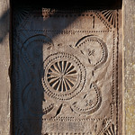
Figure 1: Malagasy Carvings. After: Zecchin
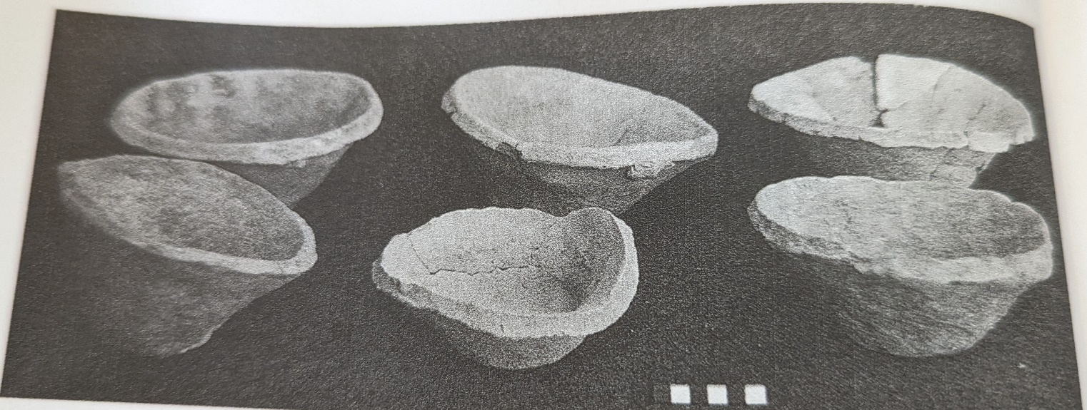
Figure 2: Bevelled-rim Bowls. After: Pollock
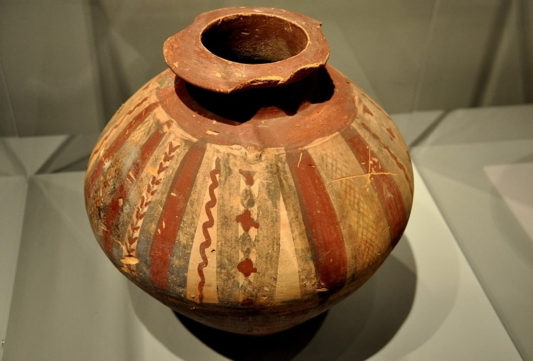
Figure 3: Jar from Jemdet Nasr Period. After: Amin
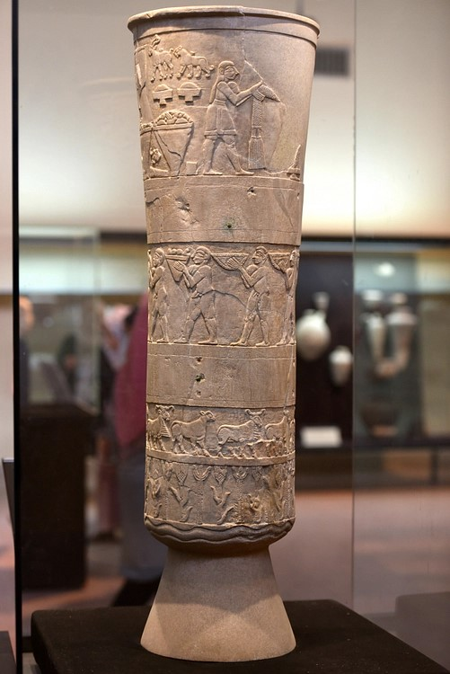
Figure 4: The Uruk Vase. After: Amin

Bibliography
Bloch, M. 2005. Essays on Cultural Transmission. Berg: Oxford.
Cambridge Dictionary. 2022. Cambridge University Press. Available at www.dictionary.cambridge.org [accessed 21st May 2022]
Crawford, H. 2004. Sumer and the Sumerians. (2nd ed.). Cambridge University Press: Cambridge.
Gell, A. 1992. Technology of enchantment and the enchantment of technology, in Coote, J. and Shelton, A. (eds.) Anthropology, Art, and Aesthetics. Clarendon Press: Oxford.
Gell, A. 1998. Art and Agency, An Anthropological Theory. Clarendon Press: Oxford.
MacClancy, J. 2021. Art/Aesthetics. Available at https://www.oxfordbibliographies.com/view/document/obo-9780199766567/obo-9780199766567-0031.xml?rskey=WRB7ih&result=1&q=anthropology+of+art#firstMatch [accessed 20th May 2022]
Pollock, S. 1999. Ancient Mesopotamia, The Eden that Never Was. Cambridge University Press: Cambridge.
Van de Mieroop, M. 2007. A History of the Ancient Near East ca. 3000 – 323 BC. (2nd ed.). Blackwell Publishing: Oxford.

