MARTIN DARZINS ID 1909722 HW3 – STRAIGHT THRU & CROSSOVER CABLES
Qu 1
What is the TIA/EIA Standards?
The TIA/EIA structured cabling standards define how to design, build, and manage a cabling system that is structured, meaning that the system is designed in blocks that have very specific performance characteristics. The blocks are integrated in a hierarchical manner to create a unified communication system.

TIA means the Telecommunications Industries Association and EIA, Electronic Industries Association which publishes the TIA/EIA Telecommunications Building Wiring Standards. ANSI/TIA-568 was developed through the efforts of more than 60 contributing organizations including manufacturers, end-users, and consultants. Work on the standard began with the Electronic Industries Alliance (EIA), to define standards for telecommunications cabling systems.

TIA/EIA 568A and TIA/EIA 568B refer to the two major standards used in the networking and telecommunications industries.

How does 568 A differ from 568 B?
TIA/EIA 568A and TIA/EIA-568B are standards that determine the order of the wires placed in the RJ45 connector.
Functionally, there is no difference between TIA/EIA 568A and TIA/EIA-568B standards, the only the difference is that the position of Green and Orange wires (on pin sets) are switched. Knowing the different uses and pinout positions of each cable is essential to ensure a network’s proper functionality, as you can follow any standard. Pinout positions refer to the arrangement of pins on an integrated circuit.
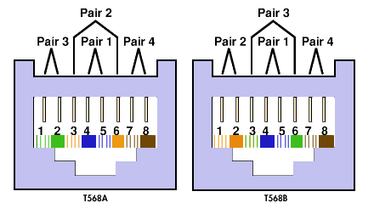
The difference between the two standards is the location of the orange and green pins, as shown above & below:
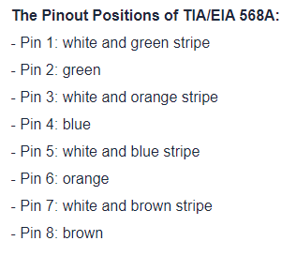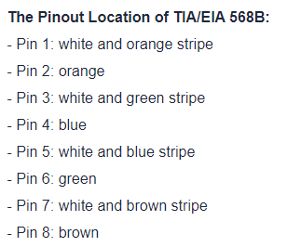
Are there any other standards?
Yes, within the cabling industry, there are four main standards bodies who are all responsible for developing industry protocols. These standards specify the differing levels of performance required for different components, such as cables, connectors, installation, field testing, and administration.

Having these globally recognised standards ensures that the systems perform at their required level, allowing customers to compare competing products, knowing that quality has been maintained throughout.
Although there are many crossovers, each cabling body specialises in a different area.
The main bodies include the TIA, ISO, CENELEC and BSI. The TIA is generally adhered to by North American technicians, whereas ISO and CENELEC are used more so in the global market, with the UK meeting the requirements set by the main British cable standards body, the BSI.

Qu 2
What is a Straight Through Cable and Cross Over Cable?
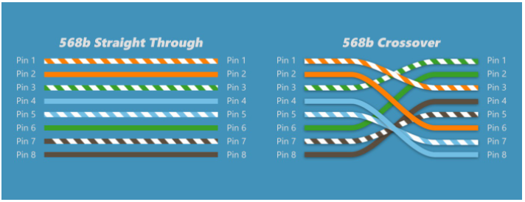
When connecting two devices of different types together, you use a straight through cable.
Straight-Through refers to cables that have the pin assignments on each end of the cable, i.e. Pin 1 connector A goes to Pin 1 on connector B, Pin 2 to Pin 2, etc.
Straight-Through wired cables are most commonly used to connect a host to a client.

When you connect two devices of the same type together, you use a crossover cable.
A crossover cable connects two devices of the same type to communicate together, such as a PC to a PC, or a switch to a switch. It is a type of cable installation that is used for the interconnection of two similar devices.
It is enabled by reversing the transmission and receiving pins at both ends, so that output from one computer becomes input to the other, and vice versa

The patch cable connects two different devices to each other, like a PC and a switch, but all cables are straight through if you insert a network device between two devices of the same kind.

Which cable should be selected during a simple network installation (topology – routers/switches & end devices)
Cables are a key component in wired home network and twisted-pair Ethernet cable is the most common type of home network wiring used today. Twisted-pair Ethernet cabling is commonly referred to as simply Ethernet, Cat5, or UTP (Unshielded Twisted Pair) cable.

Technically, Ethernet is a wiring and signalling standard that covers many types of cabling technologies; Cat5 is one category of several available and UTP is one of two possible types (STP= Shielded Twisted Pair). However, these terms are commonly understood to refer to twisted-pair Ethernet cabling.


