Managing Projects in the Organisation
Report

Date 20th December 2019
Student Name: Shaful Miah
Student ID: 1709507
University of Wales Trinity Saint David

Introduction
A project management is when a group of people gets involved to create or design a unique product or service by structuring in four stages that is initiating, planning, executing and project closing that can be applied from project life cycle, which can be effective for the delivering of the project. Project life cycle is used by organisations for a particular project, because the work is carried out can be split into distinct and manageable phases. Project will need to be establish or created by using the materials and resources within the parameters of cost, schedule on time and achieve with quality, for the project to be successful (Parker & William 2008). However, it is important for individuals to understand and identify the potential risk factors during the project that can allow individuals making crucial decisions and have alternative plan in place that will maintain the flow of the project.
The are different tools and techniques that can be applied for various types of projects, such as Quad chart which can be used for planning and communication of the project, by dividing into four quadrants that is purpose of the project, identifying the stakeholders, secondary benefits and measure of success. Also, the is a Work- Breakdown- Structure that can be applied for a project so that individuals’ tasks and subtasks that can allow the completion, organising and understanding of the project in smaller potions and manageable components (Harned, 2019). On the other hand, it is important to select a project leader that can solve problem and have strong leadership skills so that project can be elaborated, examined and executed effectively.
Sortyourfuture.com is a career website to help people from different backgrounds to access information about job vacancy and career opportunities. The website was launched on 7th November 2019 and the team had to deliver a project by using people from all age groups to find out what they think about using career websites and how they would search and access information about job vacancy or career change. Team decided to deliver the Sor project because a career website is a great way to market a business and job seekers to browse for a job vacancy and this is something can benefit the team in the future for career opportunities.

Page 1

Project Life Cycle
According to (Aston, 2016) A Project Life Cycle is used for structuring and monitoring a new project so that team can deliver and identify how the project is progressing in order to meet project’s objectives. The project life cycle has four stages that is initiating, planning, executing and closing. The first phase is the project initiation, that is the beginning of the project, where the team can identify problems and find solutions so that project can be build and delivered effectively (Westland, 2007). During this stage the team have appointed a team leader for the SortYourFuture.com project because, as stated by (Chittoor, 2012) that a project leader can ensure activities is getting done at the schedule time while motivating individuals towards completing the project successfully, which was done by team communicated through What’s App and Google Docs that enabled to make changes accordingly.
The planning stage is when the team discussed and analysed everyone’s tasks and estimated the costs and timeframe, that gave the team a general idea about the project’s feasibility and deliver time (Green, 2019). During this stage the project leader was overseeing all aspects of the project and making sure each task was coming together cohesively before the deadline. It further mentioned by (Vogt, 2019) the benefit of planning phase is that it can allow the team to avoiding delaying in completing tasks on time. Third stage is executing, this is when the team track assigned tasks by holding several meetings and face to face communication so that project can be monitored and appropriate changes can be made accordingly (BC, Campus, 2019). During this phase the team sent out questions and surveys to participants via e-mail on regards to the sortyoufuture.com website on what their insights into usability and features of the website. The feedback and responses from the participants were essential for the project to be successful. The final stage is the closing the projects, the team analysed the response and feedback back from participants and used google forms that created a chart and showed an effective result of the sortyourfuture.com project.
Quad Chart
A quad chart was used in the sortyourfuture.com project that identify project purpose, stakeholders, secondary benefits and measure of success. The team decided to apply quad chart because, it’s an effective tool for planning and communication purpose that can be breakdown into manageable pieces (Chegg, Study 2019). According to (Covey, 2009) the quad chart can allow individuals to manage crisis and problems dramatically during the process in a one-page summary. This tool the team decided to use because it can save time, cost and various strategies and techniques can be used to complete the project successfully.

Page 2

PURPOSE  SORTYoureFuture.com is launching a new career path and job search platform. Group must recruit a minimum of 5 potential users of SORT.com and by conducting various research methods we will then evaluate this information and present our findings and insights on how people think about using careers websites and for the second phase of the project we are required to report back our findings on the useability and design for this new platform once the server goes live. | CUSTOMERS(Stakeholders)  - UWTSD  - SORTYourfuture.com  - Participants(hawks)  - Employers (organisations)  - Jobseekers  - Schools  To help the underprivileged, ethnic minorities and benefit the older persons looking for jobs and provide a wider choice.  - Career Services
DESIRED END RESULT  The desired result is to understand positive and negative points about the content and design element of the websites the usefulness and what was the user experience using the careers website and to develop its database.  SECONDRY BENEFITS  - To help underprivileged communities  - Guidance to younger people  - Simplify platform usage  - Help ethnic minorities | MEASURES OF SUCCSESS  - Help people find jobs  - Help to Change career  - SORTYourfuture.com makes use of insights to improve their platform  - Promote the service

Page 3
This quad chart was created by the team, which was easy and quick to read and made it simple to track and complete each task on schedule time. Key was to identify stakeholders for the project in order to collect accurate information from participants, which gave the team the insights into the usability and features of the sortyourfuture.com website. On the other hand (Czarto, 2012) mentions that by dividing activities into four quadrants that are important and urgent, important but not urgent, not important but urgent, not important and not urgent. This can allow the team to plan better by not ignoring the urgent things. Below is an example of Stephen covey’s quad chart. Reflecting back on the project this quad chart would have benefited the team to plan more effectively, by identifying the right participants for the phase two of the project, which did not go to plan accordingly for example, not all participants responded back to the questionnaires that was sent via e-mail. However, the team did communicate well via What’s App and Google Docs, which kept the team leader to analysis what is being delivered is it right or wrong, which allowed team leader to give feedback and solutions to problems. It further mentions by (Sharma, 2019) that google docs can allow the team to share, edit and type information to each other and that information gets saved automatically.

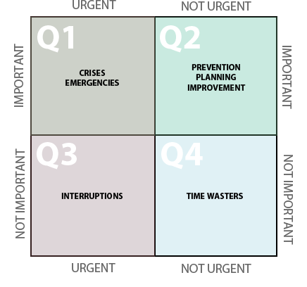

page 4
Risk Analysis
According to (Beeye, 2019) a risk analysis in project management is when potential risks can occur during a project that can negatively impact on project outcome, so it is important for a team to identify risks by forecasting situations so that different strategies can be applied, which can have an positive impact on project success. Sortyourfuture.com have identified that that external stakeholders such as Job seekers and school leavers may have a risks element to the questionnaire and surveys that was sent to them. For example, will participants sign consent form, or the questions written will it affect participants emotionally or sociologically all these factors will need to be considered. According to (Edwards & Bowen 2005) identifying the risks in a project will allow individuals to clearly understand the risks factors for the stakeholders that can be analysed, response and controlled during the progress of the project. However, the team could have approached the risk factors differently for example, (Reddy, 2016) states that to accomplish a project successfully it is important to run a effective risk management process by monitoring and review the risks can be able to identify the project’s strength, weakness and opportunities, which could have help the team to plan, prepare and evaluate the process efficiently.
Work Breakdown Structure
A work breakdown structure is an effective tool for teams to apply in any project’s that will help to organise tasks into manageable sections, which can allow the team to understand and structure the project faster and more efficiently workbreakdownstructure.com. However, (Brotherton, Shelly & Norman 2008) mentions that a poor WBS can impact on repeated tasks and extensions, unclear work being carried out and deadline can be missed that will result in project achieving its goals. This tool has been very effective for the team to controlled and monitor the project and allowed the team to:
- Define tasks and organised the work needs carrying out.
- It helped the team to identify potential risks that may occur.
- It kept them team on track and not to fall behind deadline.
- It provided the team to estimate projects costs and key approach to planning.
- Importantly it helped the team to brainstorm and communicated key points.

page 5
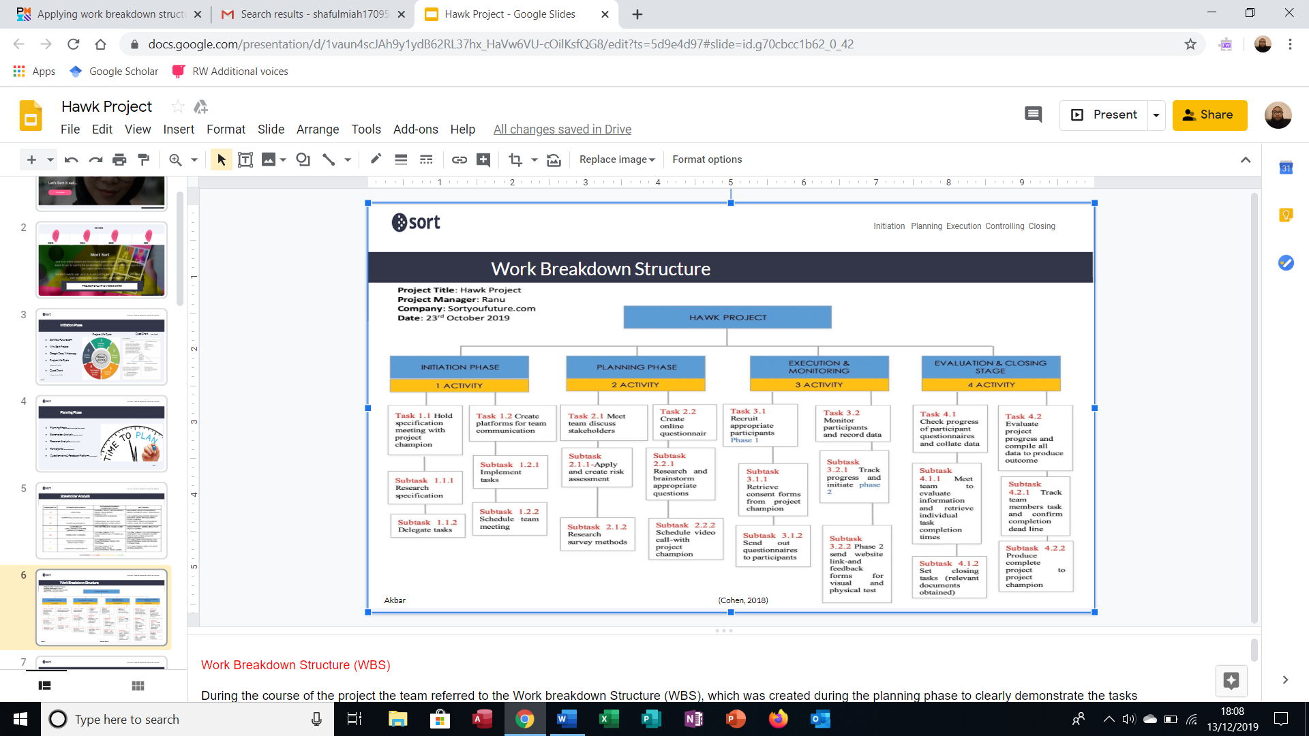

This is the Work breakdown structure that was created by the team in order to manage and structure each tasks and activities within the timeframe. According to university of Waterloo a work breakdown structure can help the project team the opportunity to engage and make individuals feel invested in the planning. Also, the team selected WBS because, it allowed the project leader to plan their work more efficiently as well as assigning tasks to individuals so that project can be effectively executed (Markgraf, 2019).
Page 6

Conclusion
The report concluded that it is highly recommended for organisations to apply quad charts, work breakdown structures, risk analysis and project life cycles in project managements strategies, so that projects can be planned and executed effectively in order to achieve projects objectives. Also, applying these tools and techniques will ensure what is being delivered, is it right and will it deliver real value against the business opportunity (Aston, 2017). On the other hand the report concluded that sortyourfuture.com website will be beneficial to job seekers and school leavers to find their career job opportunities through its platform, and finally it benefited the team to understand and reflect back on different tools and techniques for future projects managements.

Page 7

Reference Lists
Markgraf, B (2019). ‘The Importance of a Work Breakdown Structure: (Online Available) https://smallbusiness.chron.com/importance-work-breakdown-structure-54294.html Accessed 2019, 14th December
University of Waterloo ‘WBS Benefits: Why create a work breakdown structure? (Online Available) https://uwaterloo.ca/ist-project-management-office/methodologies/project-management/planning/work-breakdown-structure/wbs-benefits Accessed 2019, 14th December
Brotherton, S. A., Fried, R. T., & Norman, E. S. (2008). Applying the work breakdown structure to the project management lifecycle. Paper presented at PMI® Global Congress 2008—North America, Denver, CO. Newtown Square, PA: Project Management Institute.
Reddy, C (2016). ‘What is Risk Management: Advantages and Disadvantages : (Online Available) https://content.wisestep.com/advantage-disadvantage-risk-management/ Accessed 2019, 13th December
Chittoor, R (2012). ‘ Importance of Leadership for Project success’ (Online Available) https://project-management.com/importance-of-leadership-for-project-success/ Accessed 2019, 9th December
Vogt, C (2019). ‘The Advantage of Planning the Management of a Project: (Online Available) https://smallbusiness.chron.com/advantages-planning-management-project-22209.html Accessed 2019, 10th December
Green, J (2019). ‘Four Phases That Make Up a Project: (Online available) https://smallbusiness.chron.com/four-phases-make-up-project-31547.html Accessed 2019, 10th December
Parker, DP William, D Craig MA (2008). ‘Managing Projects, Managing People: Macmillan Education AU: Australia:
Edwards, PJ & Bowen, PA (2013). ‘Risk Management in Project Organisations: Routledge: Australia & New Zealand:
Covey, SR (2009). ‘The 7 Habits of Highly Effective People: Rosetta Books; A. Kindle Edition:

Page 8
Harned, B (2019). ‘What Is a Work Breakdown Structure? (Online Available) https://www.teamgantt.com/blog/how-to-estimate-projects-accurately-using-a-work-breakdown-structure Accessed 2019, 8th December
Westland, J (2007). ‘The Project Management Life Cycle: A Step-by-Step Methodology for Initiation, Planning, Executing and Closing a Project Successfully: Kogan Page Publishers: UK:
Aston, B (2016). ‘Project Management Life Cycle: The Complete Guide’ (Online Available) https://www.thedigitalprojectmanager.com/project-management-life-cycle/ Accessed 2019, 9th December
BC, Campus (2019). ‘Project Management: (Online Available) https://opentextbc.ca/projectmanagement/chapter/chapter-3-the-project-life-cycle-phases-project-management/ Accessed 2019, 11th December
Chegg, Study (2019). ‘What is A quad chart Is A One-page Summary: (Online Available) https://www.chegg.com/homework-help/questions-and-answers/quad-chart-quad-chart-one-page-summary-project-visual-well-descriptive-simple-tool-extreme-q25204961 Accessed 2019, 11th December
Beeye, (2019). ‘What is risk analysis? (Online Available) https://www.mybeeye.com/en/management-tools/risk-analysis accessed 2019, 13th December
Czarto, A (2012). ‘The Four Quadrants of Time Management: (Online Available) https://czarto.com/2012/04/24/four-quadrants-of-time/ Accessed 2019, 14th December
Aston, B (2017). ‘Why Is Project Management Important? (Online Available) https://thedigitalprojectmanager.com/why-is-project-management-important/ Accessed 2019, 14 December
Sharma, VK (2019). Uses of Google Docs Features for Students and Professionals: http://www.klientsolutech.com/uses-of-google-docs-features-for-students-and-professionals/

page 9

