
ASSIGNMENT

Object-Oriented Programming
(ACCA7003)

BY
WENXUAN ZENG

Student ID: 2200378

Contents
1. Task Description 3
2. Demand Analysis and best practice suggestions 3
3. Outline Design 4
3.1 Definition of every class 4
3.2 Main function 5
4. Detailed Design 5
4.1 IDReader 5
4.2 CarPark 7
5. Unit tests and results 9
6. Summary 12
7 References 13
Appendix: Source code 13

1. Task Description
Use C++ language and characteristics of object oriented programming(OOP) to develop a car park application, based upon the car park narrative we analysed in class.
In the car park application, we should create and implement at least five classes(more classes may be added): Carpark, Barrier, Sensor, IDReader and FullSign. Every class should be divided into .h and .cpp files, to simulate the execution of the car park.
Meanwhile, we should store and display the information of the cars that enter the carpark and remove them when they leave, and implement a suitable static/dynamic data structure to store the information above.

2. Demand Analysis and best practice suggestions
Based on the task description above, we can find that the car park application reflects the C++ OOP principle directly^{[1]}. Therefore, we can abstract the entities of the application as many classes. In every class, the parts below should be considered.
- Attributes: describe the components of the class, which should be declared by permission modifier “private”.
- Functions: describe the behaviors of the class. Different functions may have similar or different behaviors. They should be declared by permission modifier “public”.
- Constructors: Initialize the attributes and functions object.
- Getter/Setter: The former gets the value of attributes of object, while the latter sets the value of attributes of object.
Meanwhile, some class may have specific relationships^{[2]} such as polymerization, inherit, polymorphism, etc, which can makes the structure and call relationship between different classes more clear, and conforms to the design idea of high cohesion and low coupling in software engineering^{[3]}. If there are some classes that have much same attributes and methods, and one class is the other classes’ base implementation, then we can consider using the characteristics of polymerization, inherit, polymorphism, etc.
Aggregation^{[4]} is a way of representing relationships between objects, where one object contains a reference to another object, but the lifecycle of the two objects is independent. In a car park, we can aggregate a car park object into a car park manager object, and the car park manager can manage multiple car parks, but the lifecycle of the car park and the manager are independent. Inheritance^{[5]} is a concept in object-oriented programming that allows us to define a class that inherits the properties and methods of another class. Polymorphism^{[6]} is the multiple representation of one object. In a car park, one can define a car park interface or base class that defines methods and properties that all car parks must implement, such as "parking" and "picking up", and then one can define multiple concrete car park classes that all implement the The parking interface or base class is defined, but they are implemented in different ways. When we call the "parking" method, we don't need to know the specific type of car park, we just need to know that they both implement the car park interface or base class.
Finally, we can seperate the classes into appropriate .h and .cpp files, that .h declares every class, while .cpp implements functions of every class.

3. Outline Design
The outline design of the car park application is as follows:

3.1 Definition of every class
In this application, we design six classes:
- Car: Information of every car, including car’s name, barcode id, number id, and user that used the car.
- Barrier: Simulation the barrier of the entrance of the car park. It has two states: raise and lower, which represents the car park is open or close respectively.
- Sensor: Representation of whether there has a car join or leave the car park.
- IDReader: When a car join or leave the car park, the IDReader will recognise and display the id of car. Every car has two different types of id: barcode id and traditional number id, that corresponds to two specific IDReaders: BarcodeIDReader and NumberIDReader. Meanwhile, a serialNumber will also be recorded, which represents the total number of join/leave the car park.
- FullSign: A sign that represents whether there has free park spaces. If the park is full, then the full sign signal is “on”. Otherwise, it is “off”.
- CarPark: Information of every car park, including capacity(total spaces for parking cars), free spaces(useful spaces for parking cars), carList(cars that have parked), and four polymerized objects: barrier, sensor, idReader and fullSign.
The class diagram that describes the components and relationships of every class is shown as follows. Here, class IDReader has two subclasses: BarcodeIDReader and NumberIDReader. They have same attributes and methods as their parent class IDReader.
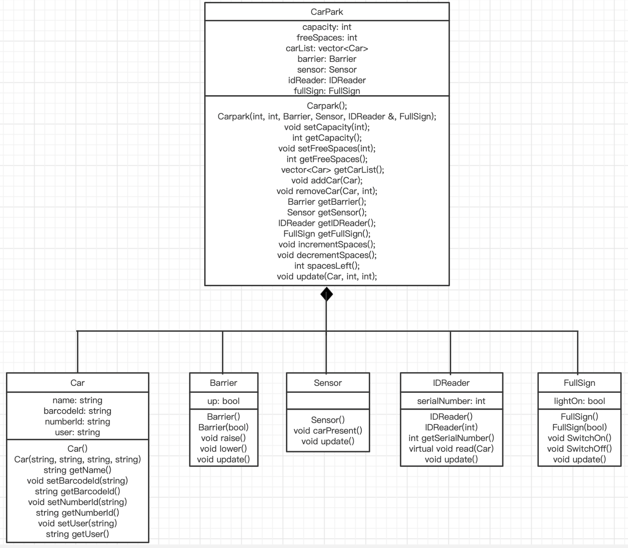

3.2 Main function
In main function, we design a command-based menu for user to use the car park application. User only needs to input the digit 1/2/3/0, to enter specific functional modules. When user input wrong digits(such as -1, 4, etc.), a message is displayed indicating that user input is incorrect and need to re-enter it, until the digit is correct.

4. Detailed Design
Based on the outline design above, here we take two classes IDReader and CarPark as example, to show the detailed design of the car park application.

4.1 IDReader
IDReader is an abstract class that defines the common attributes and behaviors of IDReader. It has an attribute to count the total number of cars of parking in / leaving from the car park. For a car parking in / leaving from the car park, it can collect its’ information and output it, that represents an operation of parking or leaving has finished.
IDReader has two specific classes that extend from IDReader: BarCodeIDReader and NumberIDReader that accepts barcodeId and numberId respectively, which makes the collection of car information more diversified. The code snippet is shown as follows:
IDReader::IDReader() {

}
IDReader::IDReader(int serialNumber) {
this->serialNumber = serialNumber;
}
int IDReader::getSerialNumber() {
return serialNumber;
}
void IDReader::read(Car car) {
cout << "Name: " << car.getName() << ", ";
cout << "Barcode ID: " << car.getBarcodeId() << ", ";
cout << "Number ID: " << car.getNumberId() << ", ";
cout << "User: " << car.getUser() << endl;
}
void IDReader::update() {
this->serialNumber++;
}

BarcodeIDReader::BarcodeIDReader() {

}
BarcodeIDReader::BarcodeIDReader(int serialNumber) {
this->serialNumber = serialNumber;
}
void BarcodeIDReader::read(Car car) {
cout << "Name: " << car.getName() << ", ";
cout << "Barcode ID: " << car.getBarcodeId() << ", ";
cout << "User: " << car.getUser() << endl;
}

NumberIDReader::NumberIDReader() {

}
NumberIDReader::NumberIDReader(int serialNumber) {
this->serialNumber = serialNumber;
}
void NumberIDReader::read(Car car) {
cout << "Name: " << car.getName() << ", ";
cout << "Number ID: " << car.getNumberId() << ", ";
cout << "User: " << car.getUser() << endl;
}

4.2 CarPark
CarPark is a main class for parking and leaving operations. After initialization of car park, it can control the whole process of car operations and judge the legality of them. If operations are legal, then it can update the status of the car park.
Here, we should use a data structure to store the information of cars that parked in the car park. There are two typical type of structure^{[7]}: static and dynamic.
Static data structure: When it is initialized, its’ size of storage is fixed and cannot be changed all the time(i.e. An array with value of maximum elements is 5). If the number of elems is greater than its’ maximum number of elems, it will throw out of memory exception.
Dynamic data structure: its’ size of storage can be changed according to our actual need, and inserting and removing operations are more efficient than those of static data structure.
Therefore, considering the operation of inserting and removing cars are frequently, and the number of cars can be changed frequently, we use a dynamic data structure vector to store the information of cars(C++ STL library^{[8]} just provides the implementation of it). The code snippet is shown as follows:
Carpark::Carpark() {

}
Carpark::Carpark(int capacity, int freeSpaces, Barrier barrier, Sensor sensor, IDReader &idReader, FullSign fullSign) {
this->capacity = capacity;
this->freeSpaces = freeSpaces;
vector<Car> carList;
this->carList = carList;
this->barrier = barrier;
this->sensor = sensor;
this->idReader = idReader;
this->fullSign = fullSign;
}
void Carpark::setCapacity(int capacity) {
this->capacity = capacity;
}
int Carpark::getCapacity() {
return capacity;
}
void Carpark::setFreeSpaces(int freeSpaces) {
this->freeSpaces = freeSpaces;
}
int Carpark::getFreeSpaces() {
return freeSpaces;
}
vector<Car> Carpark::getCarList() {
return carList;
}
void Carpark::addCar(Car car) {
carList.push_back(car);
}
void Carpark::removeCar(Car car, int offset) {
carList.erase(carList.begin() + offset);
}
Barrier Carpark::getBarrier() {
return barrier;
}
Sensor Carpark::getSensor() {
return sensor;
}
IDReader Carpark::getIDReader() {
return idReader;
}
FullSign Carpark::getFullSign() {
return fullSign;
}
void Carpark::incrementSpaces() {
this->setFreeSpaces(freeSpaces + 1);
}
void Carpark::decrementSpaces() {
this->setFreeSpaces(freeSpaces - 1);
}
int Carpark::spacesLeft() {
return freeSpaces;
}
void readHelper(IDReader &idReader, Car currentCar) {
idReader.read(currentCar);
}
void Carpark::update(Car currentCar, int offset, int type) {
if (type < 1 || type > 2) {
return;
}
cout << "Barrier raise ..." << endl;
this->getBarrier().update();
cout << "Car is driven into the car park ..." << endl;
this->getBarrier().update();
this->getSensor().carPresent();
this->getSensor().update();
cout << "Barrier lower ..." << endl;
IDReader idReader = getIDReader();
cout << "IDReader reads... " << endl;
readHelper(idReader, currentCar);
if (type == 1) { // park car
addCar(currentCar);
decrementSpaces();
if (this->getFreeSpaces() == 0) {
cout << "Full sign switch on! " << endl;
this->getFullSign().SwitchOn();
}
} else if (type == 2) { // leave car
removeCar(currentCar, offset);
incrementSpaces();
if (this->getFreeSpaces() > 0) {
cout << "Full sign switch off! " << endl;
this->getFullSign().SwitchOff();
}
}
}

5. Unit tests and results
For three functions of the car park application above, here we use some test cases to justify that our application can get correct output when facing various inputs.
For the first time user enters the application, a command-based menu is shown:
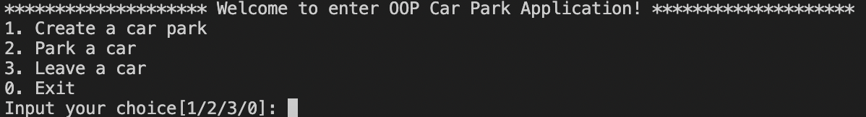
User can input digit 1, 2 or 3 to enter the functional modules, or enter 0 to exit the application. If user enter other digits(such as -1, 4, etc.), a message is displayed indicating that user input is incorrect and need to re-enter it, until the digit is correct.
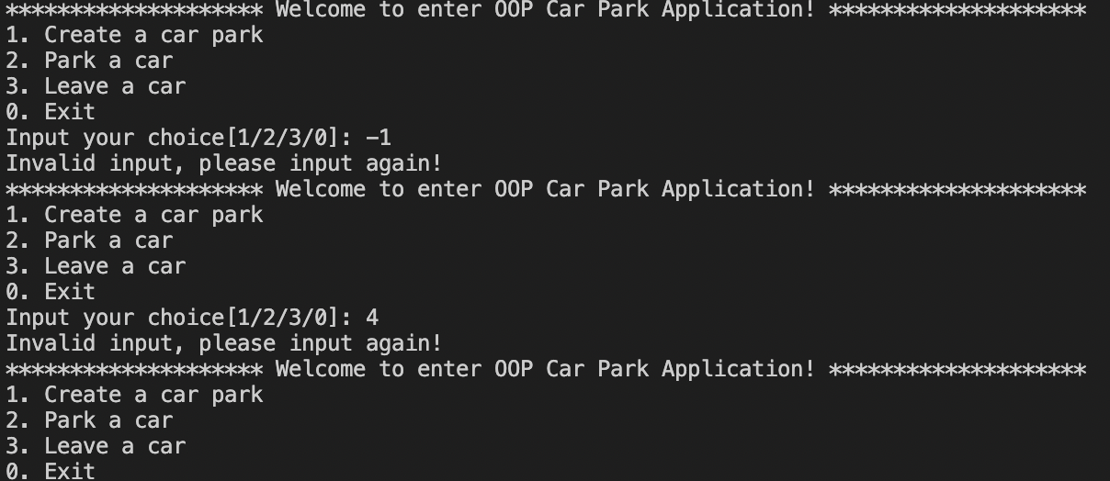
If user enter 1, then he enters intot the module for creating a car park. Then, he can input the information of car park including capacity, free spaces and IDReader type, and a car park will be created.
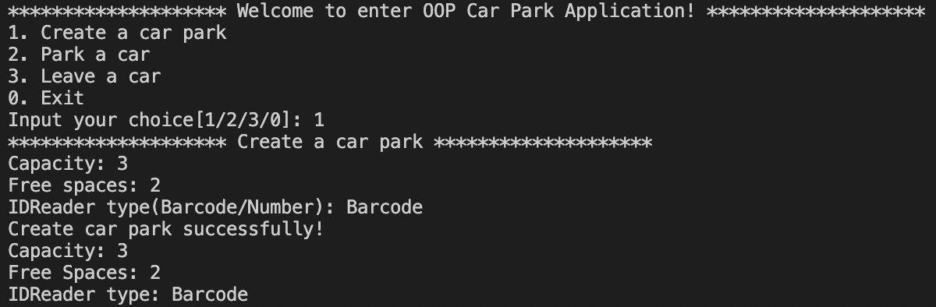
If user enters 2, then he enters into the module for parking a car. Then, he can input the information of car including car’s name, barcode ID, number ID and user that drives the car. If the car has not parked in the car park, and at least one free spaces can be used, then the car can be parked. Simulation of the whole process of parking will be shown, and carList and free spaces will be updated. Otherwise, a message is displayed indicating that there are no more free spaces.
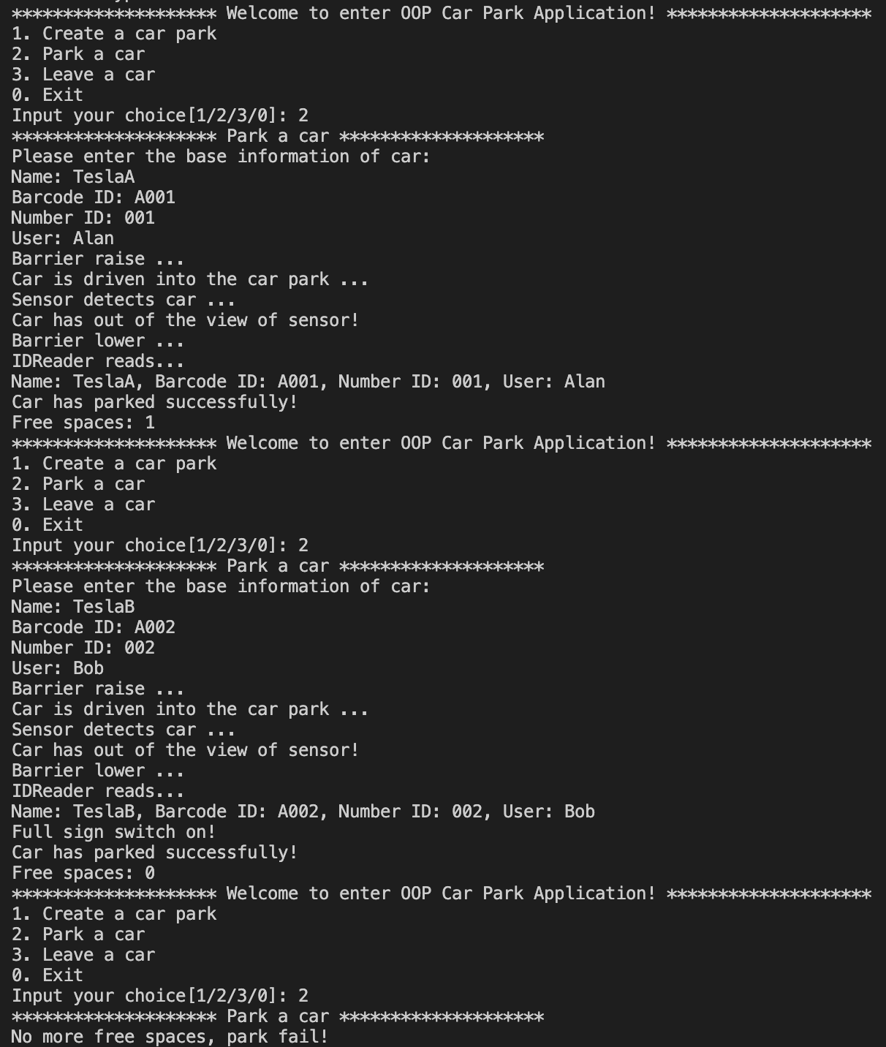
If user enters 3, then he enters into the module for leaving a car. Then, he can input the information of car including car’s name, barcode ID, number ID and user that drives the car. If the car has parked in the car park, then the car can be leaved. Simulation of the whole process of leaving will be shown, and carList and free spaces will be updated. Otherwise, a message is displayed indicating that there are no more cars parked in the car park.
Meanwhile, after leaving operation, there are more than one free spaces. If user enters 2, then a new car can be parked in the car park.
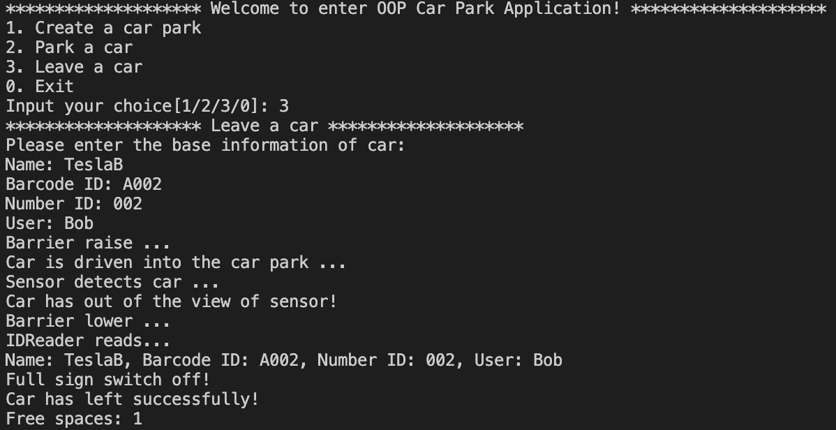
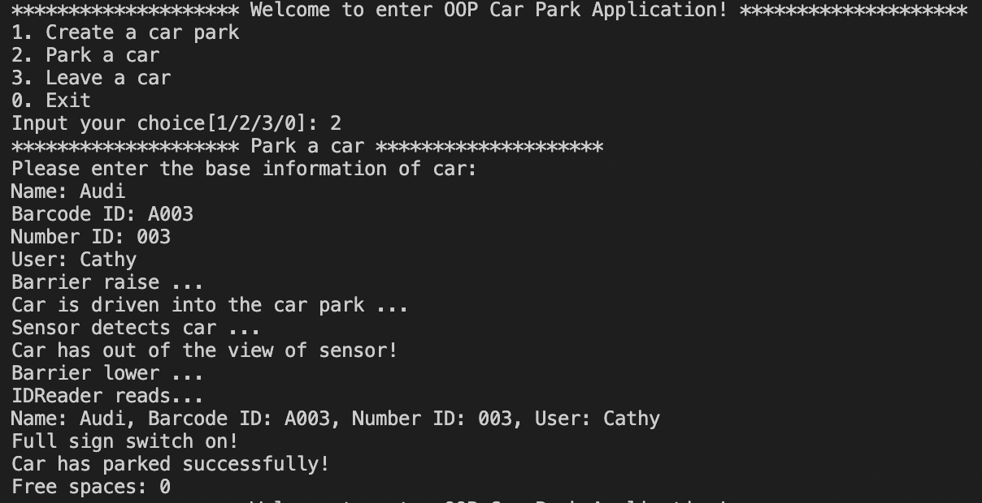
If user enters 0, then he will exit the application. At this point, the execution of program ends.
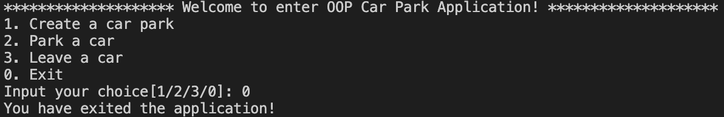

6. Summary
In summary, we use C++ OOP technology such as encapsulation, inherit, polymorphism, polymerization, etc., to design a car park application. This application simulates the workflow of car parking in our real life. Especially the design of barrier, sensor, IDReader and fullSign vividly shows the process of cars entering from the outside and driving out of the car park. As you can see, the object-oriented features of C++ are closely related to our daily life and widely used in various engineering projects, making workflow clearer and more intuitive, improving user experience in software development, and making software with better availability, maintainability, fault tolerance and scalability.

7 References
[1] Liu Yanshang. Research on computer software programming based on C++ language [J]. Digital World, 2020.
[2] Bjarne Stroustrup. The C++ Programming Language. 2002.
2):54-56.
[3] Stanley B. Lippman. C++ Primer. 2002.
[4] Zhao Lei. An introduction to coupling and cohesion in OOP [J]. Computer CD-ROM Software and Applications,2014,17(20):280-281.
[5] Liu D, Lu Y. Experimental study of OOP inheritance in various programming languages [J]. Information and Computer (Theory Edition),2018,No.417(23):57-59+62.
[6] Ma Ruimin.A study on dynamic polymorphism in OOPC++ and its underlying implementation mechanism[J]. Journal of Changzhi College,2014,31(0
[7] H. Sutter and J. Hyslop. Collecting Shared Objects. C/C++ Users Journal, 22(8), 2004.
[8] Li Hongwei. Analysis of computer software programming based on C++ language[J]. Digital World,2017,No.146(12):45.

Appendix: Source code
// Car.h
#include <iostream>
#include <string>
using namespace std;
class Car {
private:
string name;
string barcodeId;
string numberId;
string user;
public:
Car();
Car(string, string, string, string);
void setName(string);
string getName();
void setBarcodeId(string);
string getBarcodeId();
void setNumberId(string);
string getNumberId();
void setUser(string);
string getUser();
};

// Barrier.h
class Barrier {
private:
bool up;
public:
Barrier();
Barrier(bool);
void raise();
void lower();
void update();
};

// Sensor.h
class Sensor {
public:
Sensor();
void carPresent();
void update();
};

// IDReader.h
class IDReader {
private:
int serialNumber;
public:
IDReader();
IDReader(int);
int getSerialNumber();
virtual void read(Car);
void update();
};
class BarcodeIDReader: public IDReader {
private:
int serialNumber;
public:
BarcodeIDReader();
BarcodeIDReader(int);
virtual void read(Car);
};
class NumberIDReader: public IDReader {
private:
int serialNumber;
public:
NumberIDReader();
NumberIDReader(int);
virtual void read(Car);
};

// FullSign.h
class FullSign {
private:
bool lightOn;
public:
FullSign();
FullSign(bool);
void SwitchOn();
void SwitchOff();
void update();
};

// CarPark.h
#include <iostream>
#include <vector>
#include "Car.h"
#include "Barrier.h"
#include "Sensor.h"
#include "IDReader.h"
#include "FullSign.h"
using namespace std;
class Carpark {
private:
int capacity;
int freeSpaces;
vector<Car> carList;
Barrier barrier;
Sensor sensor;
IDReader idReader;
FullSign fullSign;
public:
Carpark();
Carpark(int, int, Barrier, Sensor, IDReader &, FullSign);
void setCapacity(int);
int getCapacity();
void setFreeSpaces(int);
int getFreeSpaces();
vector<Car> getCarList();
void addCar(Car);
void removeCar(Car, int);
Barrier getBarrier();
Sensor getSensor();
IDReader getIDReader();
FullSign getFullSign();
void incrementSpaces();
void decrementSpaces();
int spacesLeft();
void update(Car, int, int);
};

// Car.cpp
#include "Car.h"
Car::Car() {

}
Car::Car(string name, string barcodeId, string numberId, string user) {
this->name = name;
this->barcodeId = barcodeId;
this->numberId = numberId;
this->user = user;
}
void Car::setName(string name) {
this->name = name;
}
string Car::getName() {
return name;
}
void Car::setBarcodeId(string barcodeId) {
this->barcodeId = barcodeId;
}
string Car::getBarcodeId() {
return barcodeId;
}
void Car::setNumberId(string numberId) {
this->numberId = numberId;
}
string Car::getNumberId() {
return numberId;
}
void Car::setUser(string user) {
this->user = user;
}
string Car::getUser() {
return user;
}

// Barrier.cpp
#include "Barrier.h"
Barrier::Barrier() {

}
Barrier::Barrier(bool up) {
this->up = up;
}
void Barrier::raise() {
this->up = true;
}
void Barrier::lower() {
this->up = false;
}
void Barrier::update() {
this->up = !this->up;
}

// IDReader.cpp
#include <iostream>
#include "Car.h"
#include "IDReader.h"
using namespace std;
IDReader::IDReader() {

}
IDReader::IDReader(int serialNumber) {
this->serialNumber = serialNumber;
}
int IDReader::getSerialNumber() {
return serialNumber;
}
void IDReader::read(Car car) {
cout << "Name: " << car.getName() << ", ";
cout << "Barcode ID: " << car.getBarcodeId() << ", ";
cout << "Number ID: " << car.getNumberId() << ", ";
cout << "User: " << car.getUser() << endl;
}
void IDReader::update() {
this->serialNumber++;
}

BarcodeIDReader::BarcodeIDReader() {

}
BarcodeIDReader::BarcodeIDReader(int serialNumber) {
this->serialNumber = serialNumber;
}
void BarcodeIDReader::read(Car car) {
cout << "Name: " << car.getName() << ", ";
cout << "Barcode ID: " << car.getBarcodeId() << ", ";
cout << "User: " << car.getUser() << endl;
}

NumberIDReader::NumberIDReader() {

}
NumberIDReader::NumberIDReader(int serialNumber) {
this->serialNumber = serialNumber;
}
void NumberIDReader::read(Car car) {
cout << "Name: " << car.getName() << ", ";
cout << "Number ID: " << car.getNumberId() << ", ";
cout << "User: " << car.getUser() << endl;
}

// FullSign.cpp
#include "FullSign.h"
FullSign::FullSign() {

}
FullSign::FullSign(bool lightOn) {
this->lightOn = lightOn;
}
void FullSign::SwitchOn() {
this->lightOn = true;
}
void FullSign::SwitchOff() {
this->lightOn = false;
}
void FullSign::update() {
this->lightOn = !this->lightOn;
}

// CarPark.cpp
#include "CarPark.h"
Carpark::Carpark() {

}
Carpark::Carpark(int capacity, int freeSpaces, Barrier barrier, Sensor sensor, IDReader &idReader, FullSign fullSign) {
this->capacity = capacity;
this->freeSpaces = freeSpaces;
vector<Car> carList;
this->carList = carList;
this->barrier = barrier;
this->sensor = sensor;
this->idReader = idReader;
this->fullSign = fullSign;
}
void Carpark::setCapacity(int capacity) {
this->capacity = capacity;
}
int Carpark::getCapacity() {
return capacity;
}
void Carpark::setFreeSpaces(int freeSpaces) {
this->freeSpaces = freeSpaces;
}
int Carpark::getFreeSpaces() {
return freeSpaces;
}
vector<Car> Carpark::getCarList() {
return carList;
}
void Carpark::addCar(Car car) {
carList.push_back(car);
}
void Carpark::removeCar(Car car, int offset) {
carList.erase(carList.begin() + offset);
}
Barrier Carpark::getBarrier() {
return barrier;
}
Sensor Carpark::getSensor() {
return sensor;
}
IDReader Carpark::getIDReader() {
return idReader;
}
FullSign Carpark::getFullSign() {
return fullSign;
}
void Carpark::incrementSpaces() {
this->setFreeSpaces(freeSpaces + 1);
}
void Carpark::decrementSpaces() {
this->setFreeSpaces(freeSpaces - 1);
}
int Carpark::spacesLeft() {
return freeSpaces;
}
void readHelper(IDReader &idReader, Car currentCar) {
idReader.read(currentCar);
}
void Carpark::update(Car currentCar, int offset, int type) {
if (type < 1 || type > 2) {
return;
}
cout << "Barrier raise ..." << endl;
this->getBarrier().update();
cout << "Car is driven into the car park ..." << endl;
this->getBarrier().update();
this->getSensor().carPresent();
this->getSensor().update();
cout << "Barrier lower ..." << endl;
IDReader idReader = getIDReader();
cout << "IDReader reads... " << endl;
readHelper(idReader, currentCar);
if (type == 1) { // park car
addCar(currentCar);
decrementSpaces();
if (this->getFreeSpaces() == 0) {
cout << "Full sign switch on! " << endl;
this->getFullSign().SwitchOn();
}
} else if (type == 2) { // leave car
removeCar(currentCar, offset);
incrementSpaces();
if (this->getFreeSpaces() > 0) {
cout << "Full sign switch off! " << endl;
this->getFullSign().SwitchOff();
}
}
}

// Source.cpp
#include <iostream>
#include "CarPark.h"
using namespace std;
Carpark createCarPark() {
int capacity;
int freeSpaces;
Barrier barrier = Barrier();
Sensor sensor = Sensor();
FullSign fullSign = FullSign();
string idReaderType;
cout << "******************** Create a car park ********************" << endl;
while (1) {
cout << "Capacity: "; cin >> capacity;
cout << "Free spaces: "; cin >> freeSpaces;
getchar();
cout << "IDReader type(Barcode/Number): "; getline(cin, idReaderType);
if (capacity < 0 || freeSpaces < 0 || capacity < freeSpaces || idReaderType != "Barcode" && idReaderType != "Number") {
cout << "Illegal params of car park, please input again! " << endl;
} else {
break;
}
}
IDReader idReader = IDReader(1);
Carpark newCarPark;
if (idReaderType == "Barcode") {
idReader = BarcodeIDReader(1);
newCarPark = Carpark(capacity, freeSpaces, barrier, sensor, idReader, fullSign);
} else if (idReaderType == "Number") {
idReader = NumberIDReader(1);
newCarPark = Carpark(capacity, freeSpaces, barrier, sensor, idReader, fullSign);
}
cout << "Create car park successfully! " << endl;
cout << "Capacity: " << newCarPark.getCapacity() << endl;
cout << "Free Spaces: " << newCarPark.getFreeSpaces() << endl;
cout << "IDReader type: " << idReaderType << endl;
return newCarPark;
}
void parkCar(Carpark& carPark) {
string name;
string barcodeId;
string numberId;
string user;
cout << "******************** Park a car ********************" << endl;
if (carPark.getFreeSpaces() == 0) {
cout << "No more free spaces, park fail! " << endl;
return;
}
cout << "Please enter the base information of car: " << endl;
cout << "Name: "; getline(cin, name);
cout << "Barcode ID: "; getline(cin, barcodeId);
cout << "Number ID: "; getline(cin, numberId);
cout << "User: "; getline(cin, user);
Barrier barrier = carPark.getBarrier();
Sensor sensor = carPark.getSensor();
IDReader idReader = carPark.getIDReader();
FullSign fullSign = carPark.getFullSign();
vector<Car> carList = carPark.getCarList();
int suc = 1;
for (int i = 0; i < carList.size(); i++) {
if (carList[i].getBarcodeId() == barcodeId || carList[i].getNumberId() == numberId) {
cout << "Car has existed, park fail! ";
suc = 0;
break;
}
}
if (suc == 1) {
Car newCar = Car(name, barcodeId, numberId, user);
carPark.update(newCar, -1, 1);
cout << "Car has parked successfully! " << endl;
cout << "Free spaces: " << carPark.getFreeSpaces() << endl;
}
}
void leaveCar(Carpark &carPark) {
string name;
string barcodeId;
string numberId;
string user;
cout << "******************** Leave a car ********************" << endl;
if (carPark.getFreeSpaces() == carPark.getCapacity()) {
cout << "No parked cars, leave fail! " << endl;
return;
}
cout << "Please enter the base information of car: " << endl;
cout << "Name: "; getline(cin, name);
cout << "Barcode ID: "; getline(cin, barcodeId);
cout << "Number ID: "; getline(cin, numberId);
cout << "User: "; getline(cin, user);
Barrier barrier = carPark.getBarrier();
Sensor sensor = carPark.getSensor();
IDReader idReader = carPark.getIDReader();
FullSign fullSign = carPark.getFullSign();
vector<Car> carList = carPark.getCarList();
int suc = 0;
for (int i = 0; i < carList.size(); i++) {
if (carList[i].getName() == name && carList[i].getBarcodeId() == barcodeId && carList[i].getNumberId() == numberId && carList[i].getUser() == user) {
carPark.update(carList[i], i, 2);
cout << "Car has left successfully! " << endl;
cout << "Free spaces: " << carPark.getFreeSpaces() << endl;
suc = 1;
break;
}
}
if (suc == 0) {
cout << "Car does not exist, leave fail! " << endl;
}
}
void menu() {
Barrier barrier = Barrier(false);
Sensor sensor = Sensor();
IDReader idReader = IDReader();
FullSign fullSign = FullSign();
Carpark carPark;
bool hasCarPark;
int choice;
while (1) {
cout << "******************** Welcome to enter OOP Car Park Application! ********************" << endl;
cout << "1. Create a car park" << endl;
cout << "2. Park a car" << endl;
cout << "3. Leave a car" << endl;
cout << "0. Exit" << endl;
cout << "Input your choice[1/2/3/0]: ";
cin >> choice;
getchar();
if (choice == 1) { // Create car park
if (hasCarPark) {
cout << "Car park has created! " << endl;
} else {
carPark = createCarPark();
hasCarPark = true;
}
} else if (choice == 2) { // Park a car
if (!hasCarPark) {
cout << "Car park has not created! " << endl;
} else {
parkCar(carPark);
}
} else if (choice == 3) { // Leave a car
if (!hasCarPark) {
cout << "Car park has not created! " << endl;
} else {
leaveCar(carPark);
}
} else if (choice == 0) { // Exit
cout << "You have exited the application! " << endl;
break;
} else {
cout << "Invalid input, please input again! " << endl;
}
}
}
int main() {
menu();
return 0;
}

Appendix: Video

