Information Engineering Assignment

Hristo Hristov
Level 4 BSc (Hons) Cloud Computing – Term 2
Table of Content:

1-Designing a database for Universal Sports
1.1-Task 1
-entity relationship diagram showing entities, relationships, degree of relationships, membership class and descriptions for each relationship

1.2-Documentation about design techniques in Task 1
Fields, tables, foreign keys, primary keys, relationships…

1.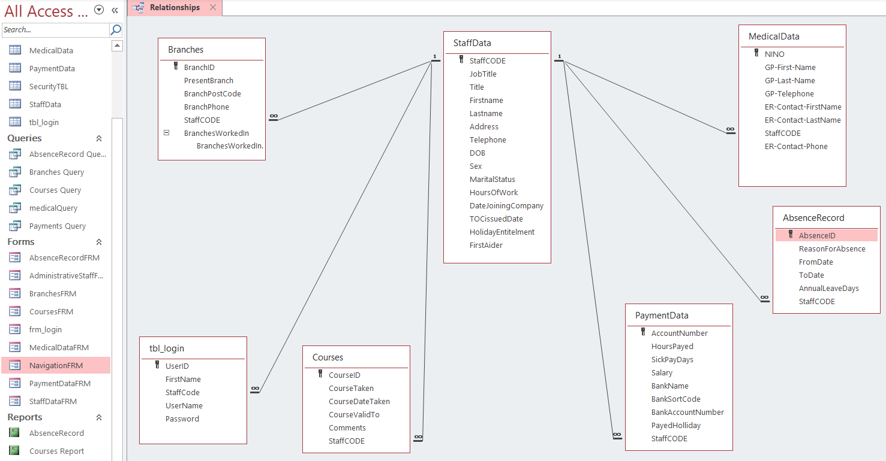
The design aims to meet requirements of Universal Sports. A creation of the tables is according their structure.

StaffData is a parent table with the main information about the employees of Universal Sports. The attributes are first and last name, job title, address, telephone, date of birth, sex, marital status, hours of work, date joining the company, terms and conditions issue date, holiday entitlement and if an employee is first aider.
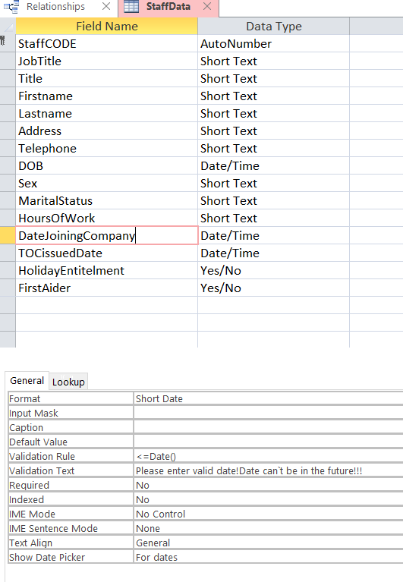
Table Branches relates to the parent table StaffData and gives information about present branch in which an employee is based. In branches table you can also find information about branch post code, branch phone number, staffcode and branches in which an employee has been worked. The relationship here is one to many because one member of staff can work in more than one branch.
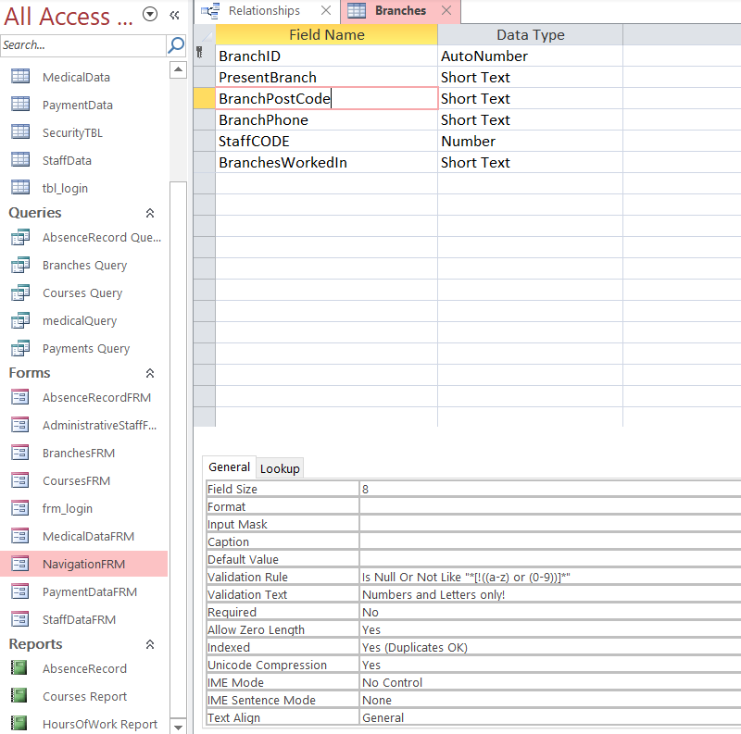
Medical data table have all attributes needed for the employee’s medical record. In the table you can find information about employees GP name and telephone, also emergency contacts and telephone numbers. The relationship is one to many because one person can have many medical records through the years worked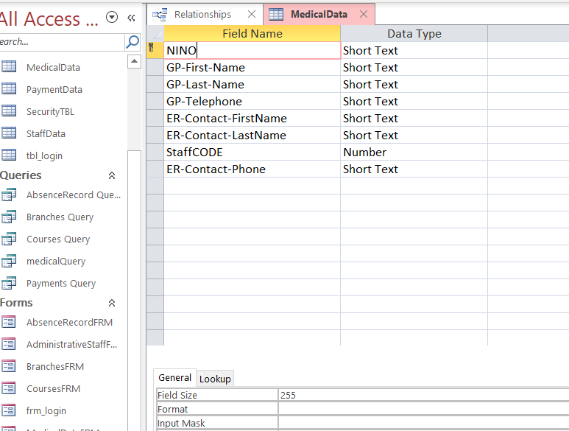.

Absence record is the table were Universal Sports keep record about the reasons for absence, from and to dates and annual leave days entitlement. One to many relationship with the parent table because one member of staff can have many absence record like sick leave, holiday, personal reason etc.
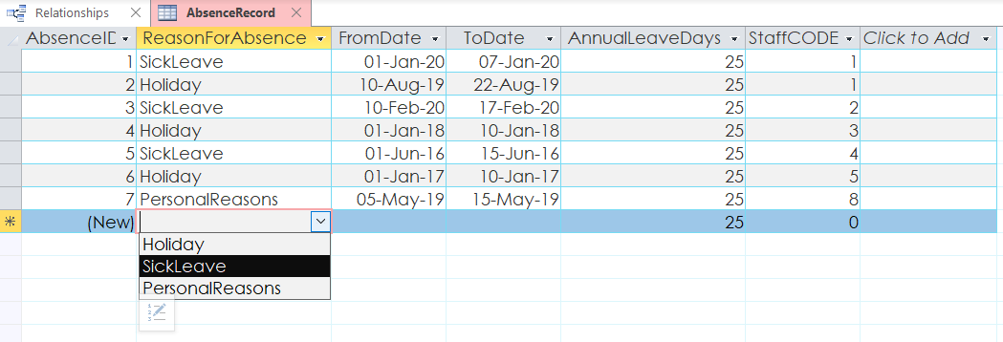
The user can choose from three options about reason for absence!
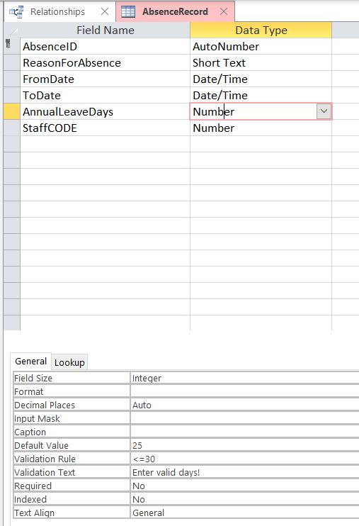
A default annual leave days are set to 25 and a validation rule is set to no more than 30!
Payment data table contents all information about financial side about employees like salary, hours payed, sick pay days, payed holiday, bank name, bank sort code and account number. Another one-to-many relationship because a member of staff can have many payment details like if the member changes the bank for example..
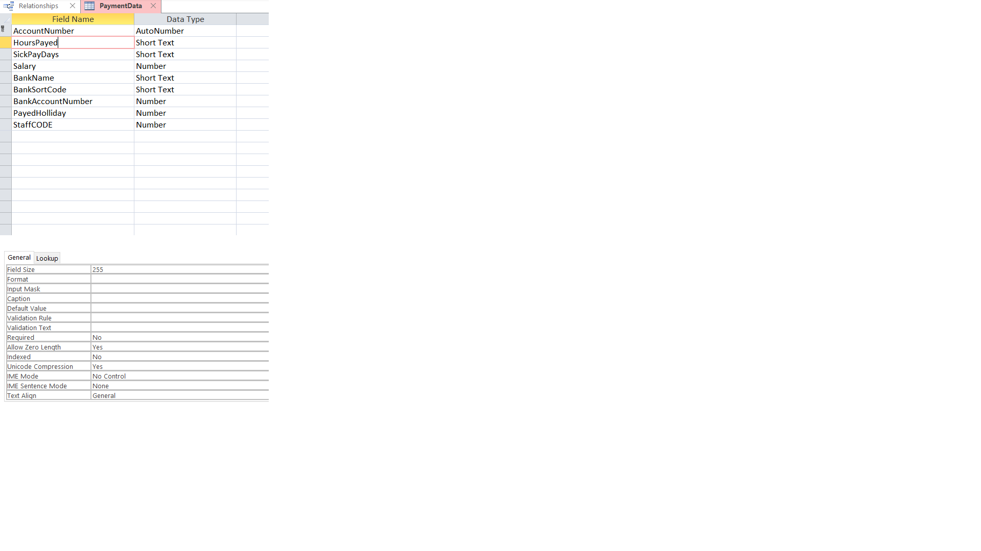
Courses table keeps information about different courses taken from the employees, dates, comments, and expiration if they expire. A member of staff could have many courses taken so the relationship with the parent table is one-to-many.


Login table have attributes about user name, password, first name and staffcode of the persons who will have or already have access to the data base. One-to-many relationship with the staffdata (parent table), because one member could have many login credentials also different level of accessing the data base.
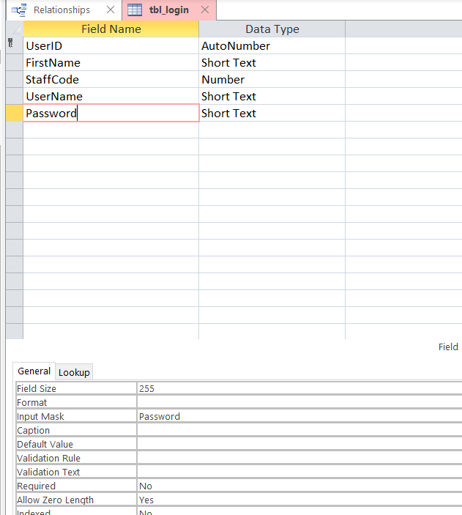
The input mask is set to password so when a user enters the password the characters are shown with Asterix so no one can see it.
Foreign key for each child table is StaffCODE.

