3D WORKING INSTRUCTIONS
Reflective Project Report
ACMA5002
Morgan Phillips (2012414)

(Tsai-C.Kuo, 2001)

Table of Contents
Introduction 3
Concept Design Appraisal 3
Manufacturing Process Proposal 4
Design and Development Work Undertaken 5
Manufacturing Process Design 7
Conclusion 9
Works Cited 9
Appendix 10

List of Figures
Figure 1- QFD 3 Jaw Grabber 10
Figure 2- QFD Comparison 10
Figure 3- PDS Cover Page 11
Figure 4- PDS Contents Page 12
Figure 5- PDS Market Requirements 13
Figure 6- PDS Life in Serve Requirements 14
Figure 7- PDS Production Requirements 15
Figure 8- PDS Conformance Requirements 16
Figure 9- Kano Quality Model 17
Figure 10- Arms Clash 17
Figure 11-Sharp Grippers 18
Figure 12- Hole Miss alignment 18
Figure 13- Fixings Missing 19
Figure 14- Design Over hang 19
Figure 15- Potential for slippage 20
Figure 16- Fillets added to support 20
Figure 17- Fillets added for handling 21
Figure 18- Fixings Added 21
Figure 19- Gaps Reduced 22
Figure 20- Hole Realigned 22
Figure 21- Overhangs removed 23
Figure 22- POKE YOKE 23
Figure 23- Rounded Grippers 24
Figure 24- Claws Filleted 24
Figure 25- Claw Scaled up 25
Figure 26- Claw Scaled length 25
Figure 27- Key added to stop slippage 26
Figure 28- FMEA 26
Figure 29- FMEA Ratings 27
Figure 30- Clevis Pin 27
Figure 31- Costing comparison 28

Introduction

This report is the findings of a study that looked to development a 3-jaw gripper that was intended to be used on cobot systems. It is important the design and manufacturability of the product is developed to be more efficient and reduce any manufacturing costs that occur. Simplifying the design and reduce the number is important for any product, for each part there is an opportunity for a defective part or an assembly error. The probability of a perfect product goes down exponentially as the number of parts increases. Increasing the number of components increases the total cost of fabricating and assembly costs. Automation becomes more difficult and more expensive when more parts are handled and processed. So it is vital that designs are developed as much as possible using different techniques to optimise the design and reduce manufacturing costs.

Concept Design Appraisal

It is important that the concept design appraisal takes all the customers’ requirements into consideration and tries to meet them as best possible and improve on them if there is opportunity to increase customer satisfaction. By taking the customer requirements and comparing those to the design requirements for the grabber are, we created QFD (Figure 1) this give us clear targets for key aspects of the grabber and what the design has to achieve. By looking at competing products it allows us to out design their products and undercut their price giving us a chance to gain a larger market share.
Completing the QFD will help us further develop the product and look at the key aspects of it, by knowing the key components will make sure that these are developed to the highest quality. By completing market research and speaking to the customer will allow the us to achieve ‘excitement’ in aspects of quality. Dr Noriaki Kano developed the ‘Kano’ model of quality (Figure 9) which shows the customer satisfaction to degree of achievement, it is important that the product reach those high standards of achievement and good customer satisfaction. This will lead to giving the brand a good image and identify which is associated with top quality products.

I compared the design to two other competitors on the market to see how their specifications compared to ours. There was a lot of differences between the three claws so this just goes to show that there is such a wide range on this market it is going to be difficult to get brands and products recognised when there is so many more “well known” brands available. It is difficult to get people and businesses to change alliance over to our brand as people will have good relationships with competitors so it is important to make sure the product can offer something more than others can.
The QFD has now given us a set of target specifications which will make our claw more efficient and outperform competitors which should entice customers to try our brand and gain the recognition it needs.
To make sure the product is designed to a high quality standard and meets critical criteria it is vital that a product design specification was developed. This would cover key aspects such product performance, production requirements, market requirements and conformance requirements. When designing it is easy to forget that the product has got to adhere to legal requirements such as European standards (CE) and ISO requirements for cobot systems. The PDS will outlie all these standards in which the product must meet to be eligible to go to market. The PDS can be found in (Figure 5, Figure 6, Figure 7,Figure 8) this data has come from the QFD, the customer requirements and research from governments websites meaning all information is accurate at the time of creating the PDS.

Manufacturing Process Proposal

To manufacture the grabber there is going to be different processes to complete the full product; Components have been design to try to have the same processes, but with the profile of some of the components, this is not possible. The grabber and link arms have been design so that they can go through the same manufacturing process this is too decrease production time and reduce set up time for the components.
The process proposal for creating the grabber and link arms is to laser cut 10mm sheets of aluminium, this will be a very efficient process as the programme will be able to maximise the sheet of aluminium to produce the maximum amount of parts from it with very little waste material compared to milling process. Any wastage can then be recycled to help reduce the businesses carbon footprint with potential to earn money back on waste scrappage.
The decision to go with laser cutting compared to conventional milling came down to research found online (How to laser, 2016), comparing the differences between the two processes, It was surprising to find that the costs were such a difference. Figure 31 shows that per annual the laser cutting is 87.5% more cost efficient compared to the conventional milling, this it to do with tooling replacement costs, set up times and waste material. With laser cutting once the programme has been created for the components, it can then be reused for future orders.
The credibility of that information needs to be taken lightly as it has come from a blog about a company who sells laser cutters so the information maybe more bias towards the laser cutters.
Reducing the labour costs is important because this a one the largest cost driver that is with in the business so by limiting the number of hours spent programming and using the same set up will be beneficial for the business. Another way to keep the cost drivers down is engineering changes, it is important that a final design is nailed down quickly with limited changes available. Any changes after the final design will cost the business a lot of money in re work orders and machine tooling. (Bragg, n.d.)
For the main body of the grabber this is going to be manufactured just using a 3-axis CNC milling machine. This will be the best process because it would mean that the billet would not have to be prepared before being placed in the jaws. We could use a CNC lathe first to get the overall shape then set up in the CNC mill to finish off but this is then an extra step in the manufacturing process that we do not want as It will slow down production time changing the set ups and transports the components between machines.
With the designs being produced on CAD it will allow us to calculate manufacturing features and lead times can be extracted. This information can then be fed back instantly, by modifying the CAD model using DFM guidelines, I can then obtain cost information for design alternatives and choose a favourable design. (Tsai-C.Kuo, 2001)
“All parts should be assembled from one direction whenever possible. Extra directions mean wasted time and motion as well as more transfer stations, inspection station and fixture nests. The best possible assembly is when all parts are added in a top–down fashion to create a Z-axis stack. Multi-motion insertion should be avoided” (Tsai-C.Kuo, 2001)
This is important when I come to designing the product I need to consider having all the components being assembled from the top where possible. It’s not only the assembly process I need to consider it’s disassembly to as it has been recognized that disassembly of used products is necessary in order to make recycling economically viable in the current state-of-the-art reprocessing technology. Therefore, I will need to think of a solution with will allow the product to be easily disassembled while also limiting parts used in the process.

Design and Development Work Undertaken

After reviewing the current design there was numerous errors that was primarily identified. There was a clash between two of the arm links (Figure 10) which would have caused the grabber to stop operating or cause a part to fail. This component was move to the correct side of the jaw and to prevent this from happening again, a small ridge has formed to the right hand side of the claws; this POKE YOKE feature (Figure 22) would stop the grabber being manufactured in correctly.
The original design seemed to have many sharp edges (Figure 11), which could be a danger to anyone handling the grabber, it also posed a risk to the product it would be picking up as the grabbers sharp edges could easily scratch any product. Adding a 2mm fillet to the claws would reduce the risk of damage to the products it is picking up but would also provide more grip as rubber grips could now be applied to the rounded grips if needed (Figure 23).
The tabs that attach the main body to the grippers were design in a way that they were over hanging, this again would cause an injury when handling, not only that they look like they would fail the stress testing (Figure 14). There’s very limited material between the parts which would mean it could fracture very easily, to overcome this a support was added to the underside. This would not affect the claws movement and provided extra strength to the design (Figure 16). With the supports added it was time to remove the over hangs to make handing more comfortable and safer for the user (Figure 21).
One of the through holes for the fixings to secure the grabber to the main body was miss placed (Figure 12), this was adjusted. This then allowed me to create clevis pin fixings, which was secured with spring clips to allow the components to be easily replaced if broken (Figure 18). The design of the main body also concerned me; there was large gaps that could allow potential foreign objects to get inside and cause damage. I reduced these gaps to decrease the risk of any objects getting inside and causing damage, the gap remained big enough to allow the arms to rotate to their maximum angle (Figure 19)
An FMEA was carried out on the design and function of the grabber to try to look for any issues that may occur during its lifecycle (Figure 28). The FMEA threw up a few problems, which could occur, and these were then used to help drive design changes to eradicate them. One the problems that became known was the potential for motor slippage, this forced the design change to add in a key to stop any potential slippage (Figure 27) which could occur from lifting heavier components.
I tried to keep the design as simplistic as possible as this will make the manufacturing process a lot easier, this will also help with replacement parts for any maintenance required to the grabber. With the grabber and linker arm both designed to be made of the same material and thickness; this will allow the components to be manufactured from the same sheet of material, which will reduce lead times for the components.
The material selected to manufacture the grabber and linker arms is an aluminium alloy, this is due to the material having a good tensile strength and other great properties needed for this type of role. The material is quiet soft as well so wont damage the products getting picked up during operation; there is also the option then to recycle the material that would help reduce the company’s carbon footprint.
The holes for the fixings are designed to take 16mm clevis pins (Figure 30), which are a standard off the shelf part. This will allow the customer to be able to source them quickly and easily if there was any need to replace them. When a consumer purchases a grabber they will receive the product unassembled in a cardboard box, this will allow the consumer to dispose of the packaging through recycling. The product will come unassembled as this allows us to use a smaller cardboard so we can save on shipping costs as we’d be able to ship more products in one go.

Manufacturing Process Design

Stage one – Receive Materials
Stage 1 is receiving the raw materials from a recognised supplier with high quality grades of aluminium. The materials need to be checked, sorted and stored in known locations so that they can easily be sourced when needed.
Stage two – Prepare Materials
When an order is raised the material need to be prepped ready for the laser cutting, so the material would have to be deburred, it is vital that the material is deburred as this can lead to errors and parts not meeting the tolerances required (Niknam, 2018). Cut to the correct lengths (if not already) and then transported to the correct machinery. For the main body of the grabber this is going to be milled, this is due to the complex form meaning it will have a larger lead-time then the rest the components. Therefore, these billets of aluminium again would have to be cut to size on the band saw and prepped ready for milling.
Stage three – Machining
For the grabbers and links, these components are going to be laser cut, so they billet of aluminium will be loaded onto the laser cut machine and the programmer will maximise the space and produce as many of the component as possible as they can be stored for future orders. The main body will be machined when orders are raised, it is possible to create a certain amount of stock but it is important to not over stock the main body as they will take up more storage and there is a chance of them being damaged.

Stage four – Polishing and Painting
The components then need to be deburred and polished give a high quality finish, the customer can then have the choice to leave the components with just a polished finish or they can have them paint to their requirements.
Stage five – Quality inspection
The components need to be checked to make sure that they are produced to a high standard that we want to keep, this is vital we want to build a business on the reputation of only producing the best products. It is important that the parts are within the tight tolerances as well if not the parts would have to be rejected or reworked to meet requirements.
Stage six – Testing
At this stage every 100 assemblies manufactured we will take some them components to make sure they can be fully assembled in the correct way and tested to see if they can meet the requirements set in the PDS.
Stage seven – Packaging and Shipping
The components are then gathered and packaged neatly into the small cardboard boxes, not assembled. It is vital though that the correct numbers of parts are packaged along with two spares for future maintenance needs. The products are then loaded into crates if being shipped abroad or packaged into Lorries if they are to be delivered within the UK.

Conclusion

On conclusion of the study, I think I have made some crucial developments on the product, first of all I believe the product looks better overall with the softer edges the fillets gave the design make it look more professional and appealing to the eye. There was then functional design changes which were needed, the standard fixings added, the hole alignment correcting, the supports added and the overhangs removed, links corrected and poke yoke added to the design. All these are critical changes to the components, without them the product would have failed or caused injury to someone and the product would never have got the trust of any of the consumers again.
Not all these changes were found through visual inspection some were picked up during the FMEA such as the key being added due to potential for motor slippage on the shaft. Moreover, the decision to scale the design up three times to achieve the minimum opening distance of 155mm came from the QFD, which compared our specification to our competition products and was found that we needed to improve on that aspect.
I believe that the best manufacturing process for this product will be to laser cut the arms and grabbers from a block of aluminium, this will allow us to maximise the sheet of material and reduce setup and programming times if we just use the same one each time.
For the main body this will be manufactured on a 3-axis CNC milling machine this will mean the whole component will be able to be manufactured on this machine and not having to go through other machining processes. The part will have different operations on the machine but these jaws and set ups can be produced rather quickly compared to changing machinery all together.
Materials and packaging have been selected in the intent for them to be recycled after their life cycle, this is important for the business image and ethically correct thing to do. The business wants to try to reduce its carbon footprint as much as possible and by designing a product which can be assembled and dissembled which is then fully recyclable is a great start for the business.

Works Cited
Bragg, S. (n.d.). Accounting tools . Retrieved from Cost driver defeintion : https://www.accountingtools.com/articles/2017/5/4/cost-driver
How to laser. (2016). Retrieved from Laser vs CNC Mill : https://howtolaser.com/blog/laser-vs-cnc-mill-why-buy-a-laser/#:~:text=A%20trotec%20laser%20has%20the,2mm%20%2F%200.08%20inches%20and%20up.&text=A%20laser%20is%20able%20to,to%20cut%20the%20same%20thickness.
Niknam, S. A. (2018). Mechanical deburring and edge-finishing processes for aluminum parts—a review. The International Journal of Advanced Manufacturing Technology, 1101-1125.
Tsai-C.Kuo. (2001). Design for manufacture and design for ‘X’: concepts, applications, and perspectives. Computers & Industrial Engineering, 241-260.

Appendix

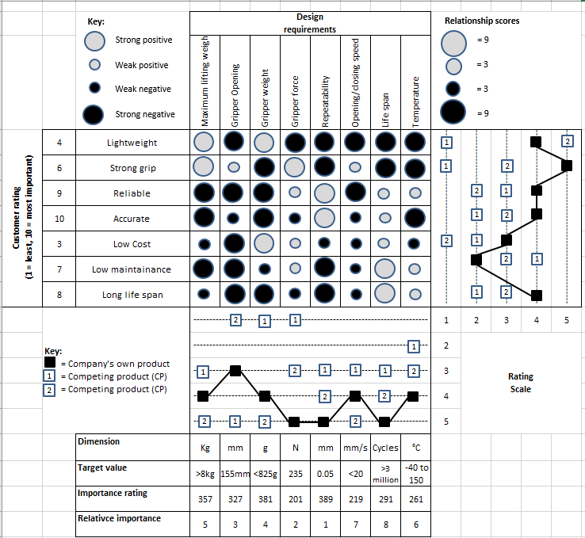
Figure 1- QFD 3 Jaw Grabber
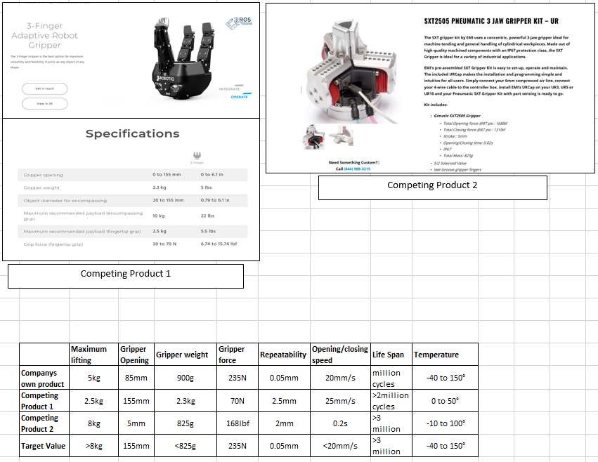
Figure 2- QFD Comparison

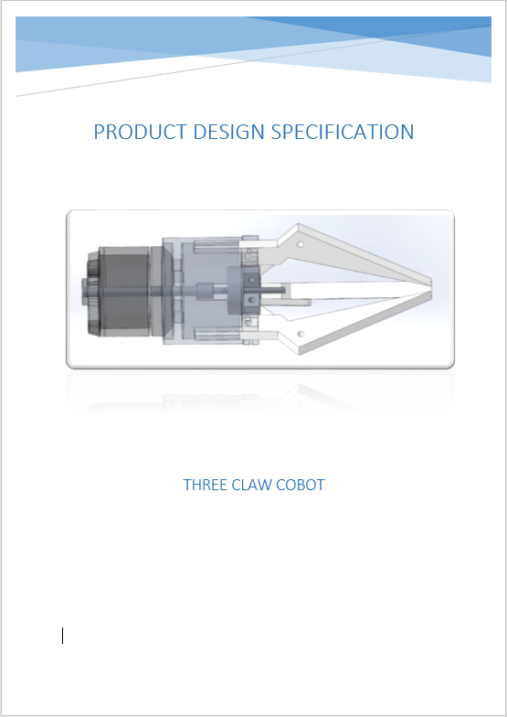
Figure 3- PDS Cover Page

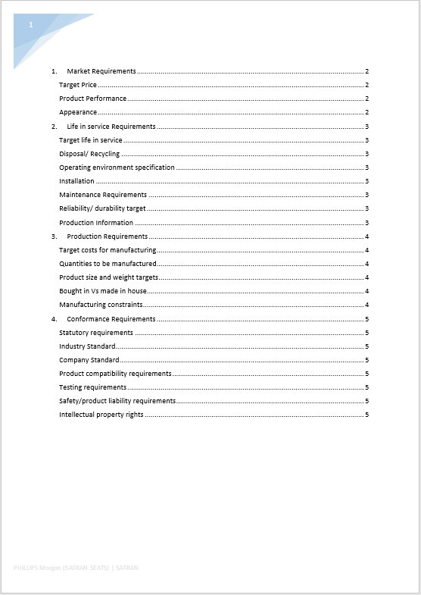
Figure 4- PDS Contents Page

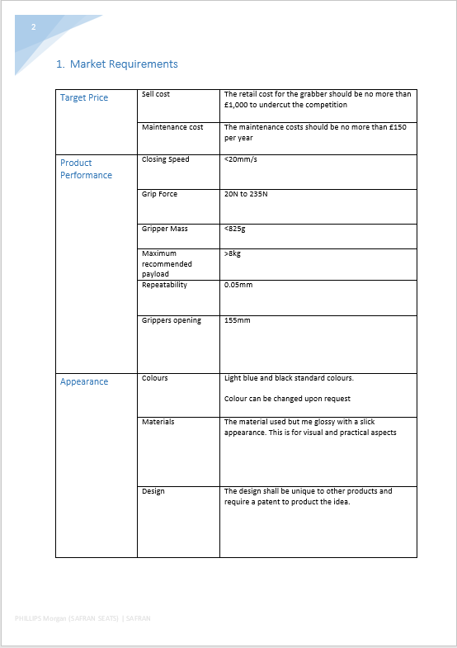
Figure 5- PDS Market Requirements

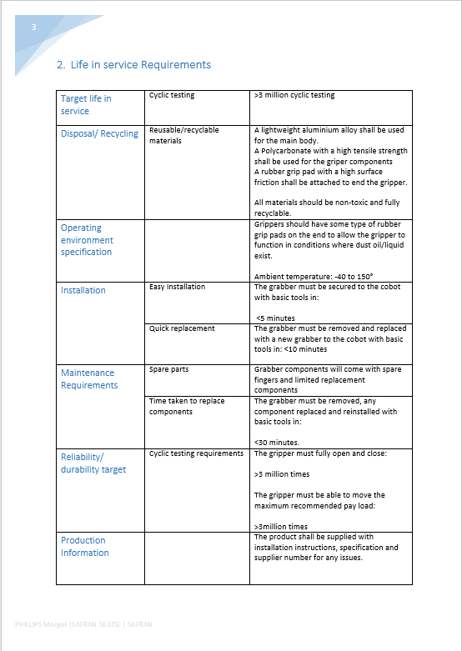
Figure 6- PDS Life in Serve Requirements

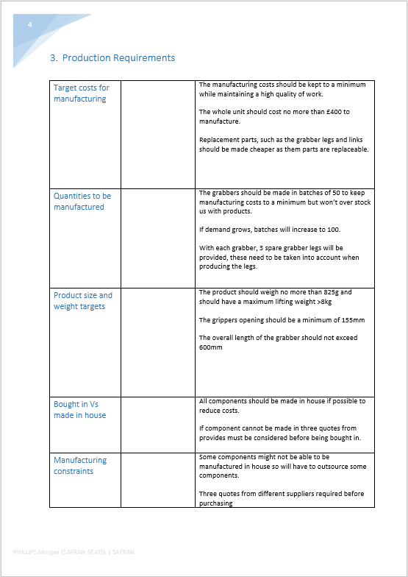
Figure 7- PDS Production Requirements

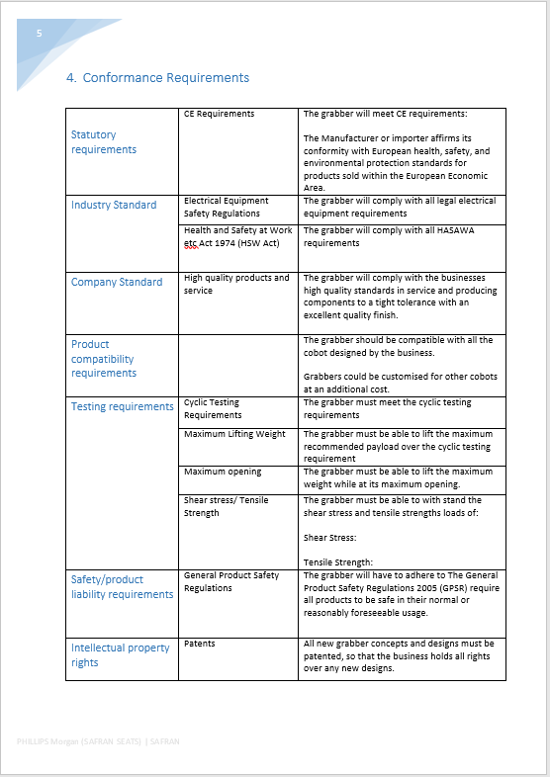
Figure 8- PDS Conformance Requirements

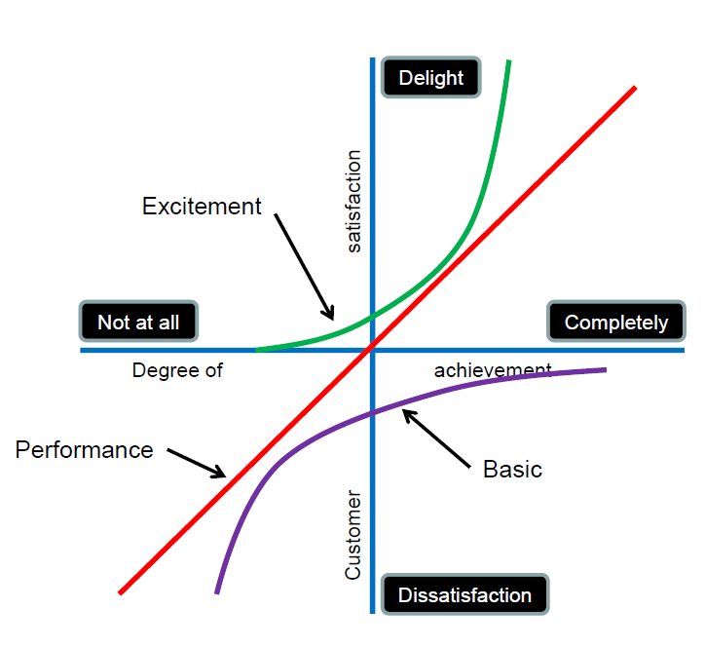
Figure 9- Kano Quality Model
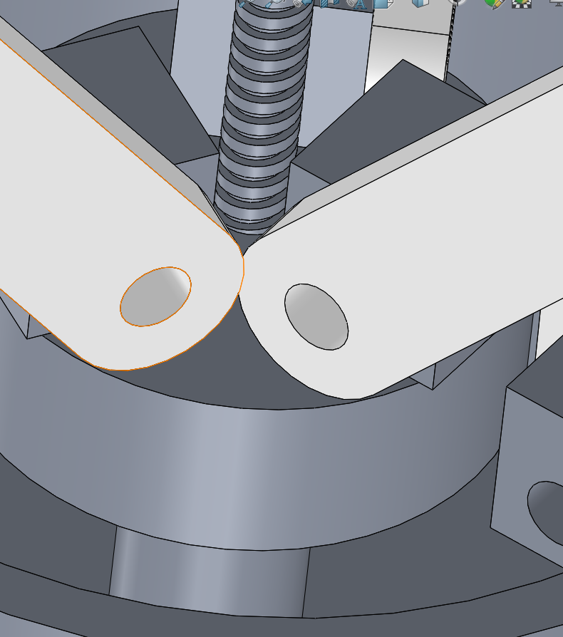
Figure 10- Arms Clash

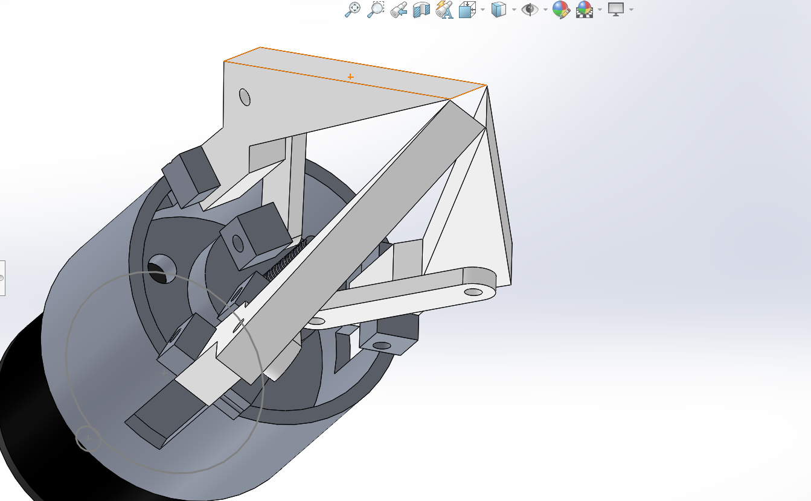
Figure 11-Sharp Grippers

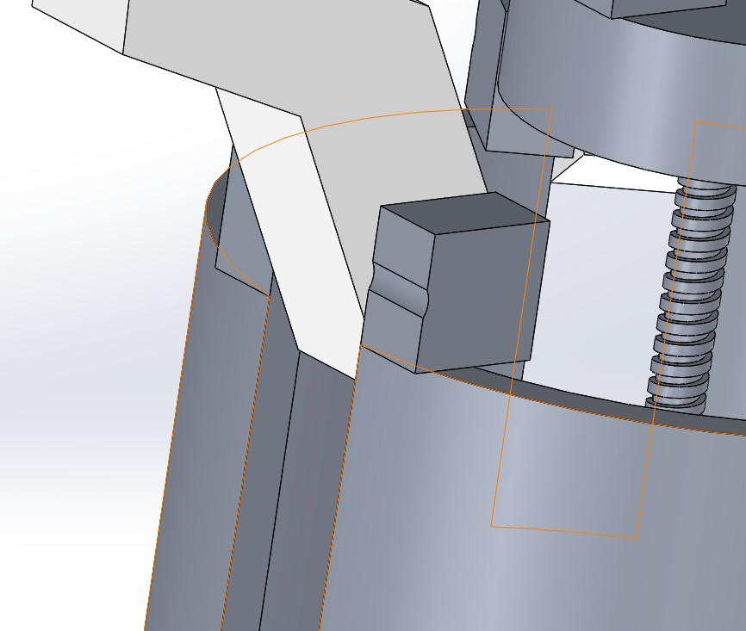
Figure 12- Hole Miss alignment

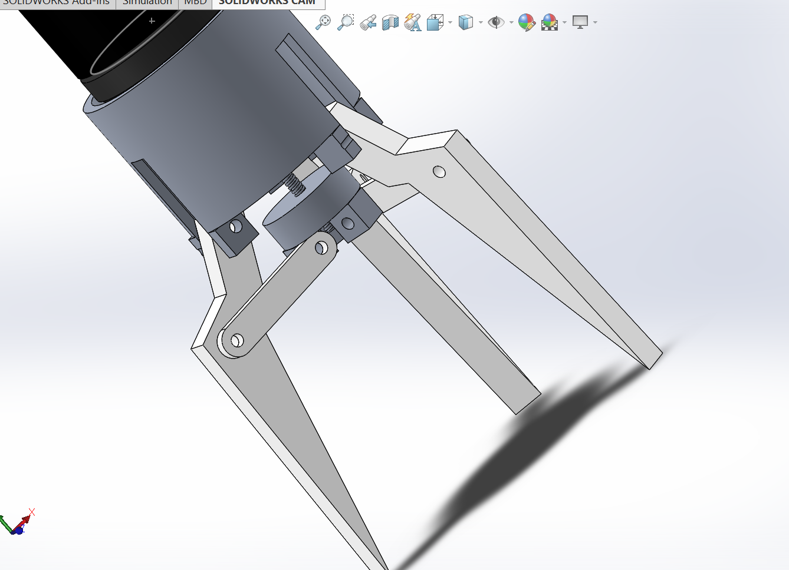
Figure 13- Fixings Missing
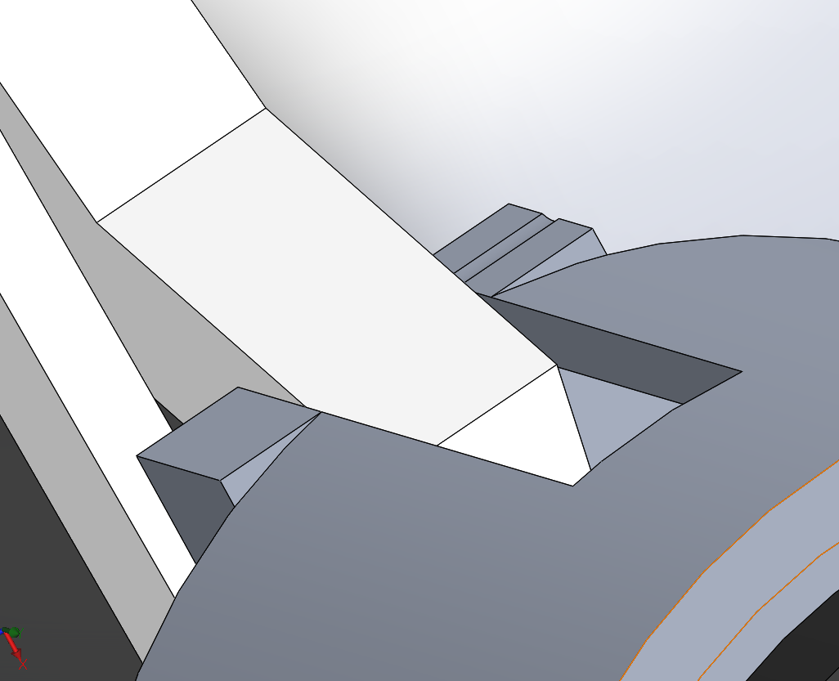
Figure 14- Design Over hang

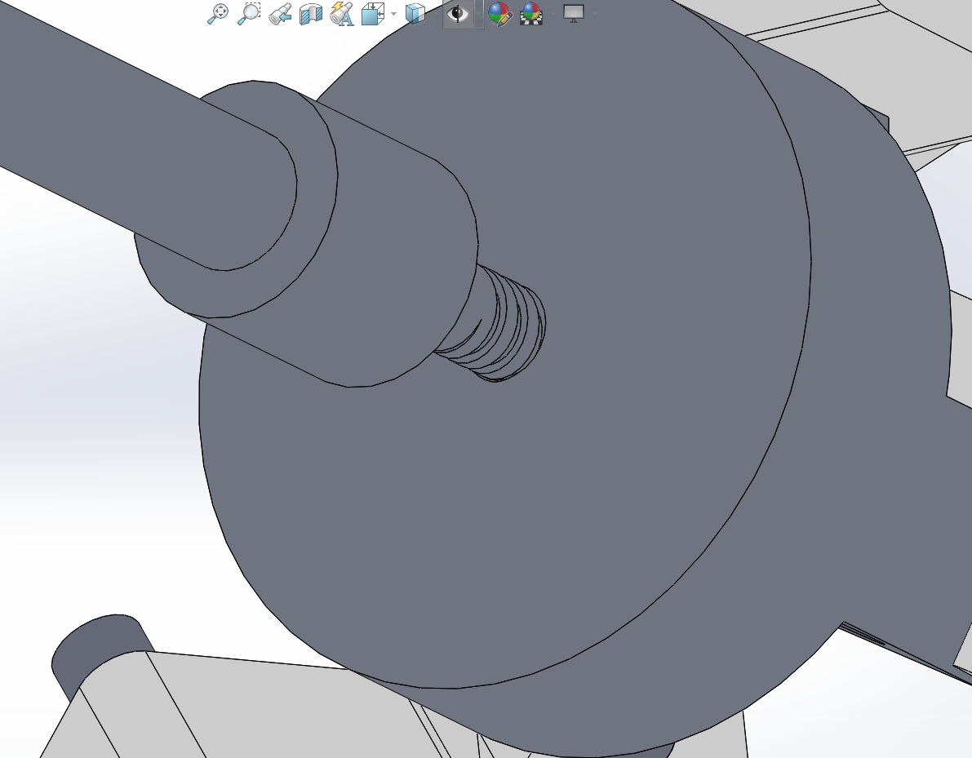
Figure 15- Potential for slippage

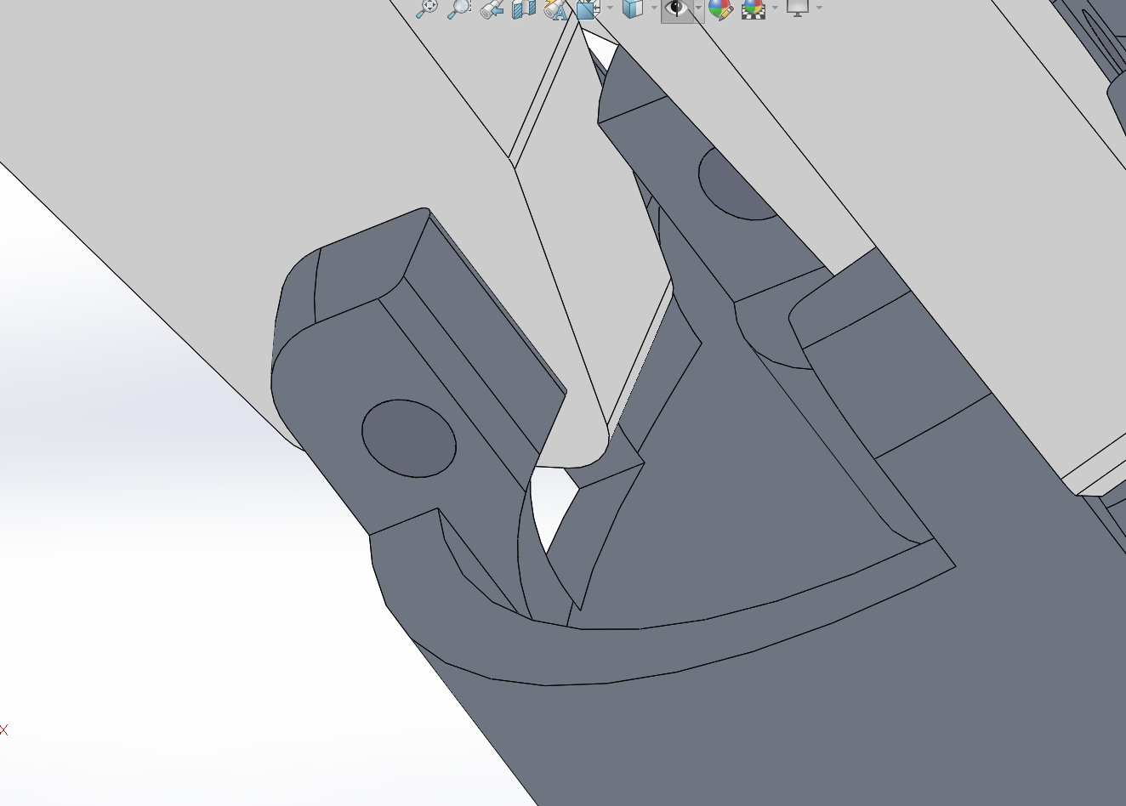
Figure 16- Fillets added to support
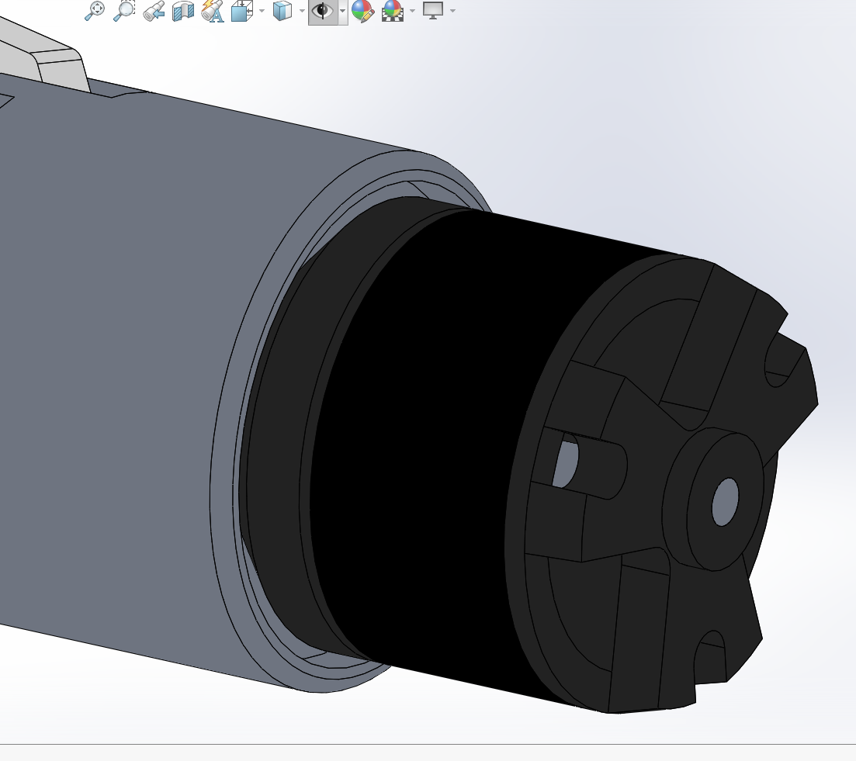
Figure 17- Fillets added for handling
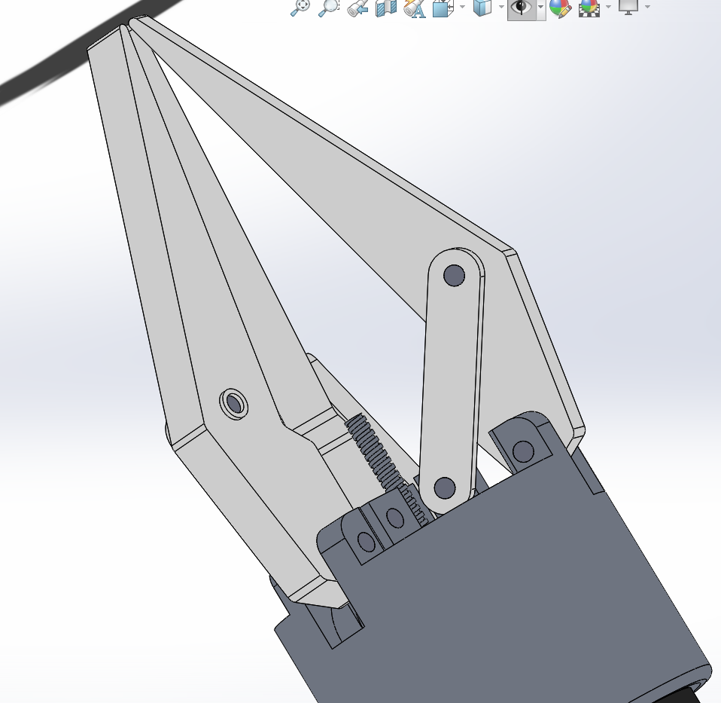
Figure 18- Fixings Added
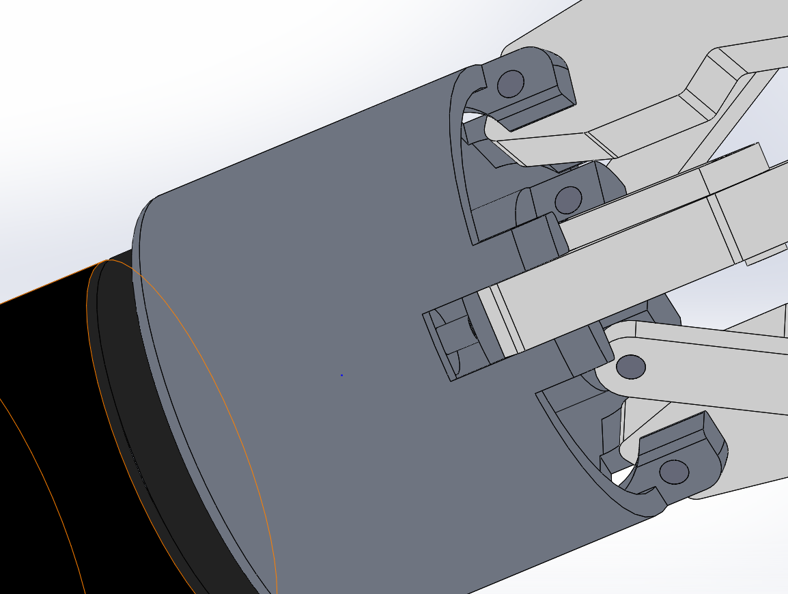
Figure 19- Gaps Reduced

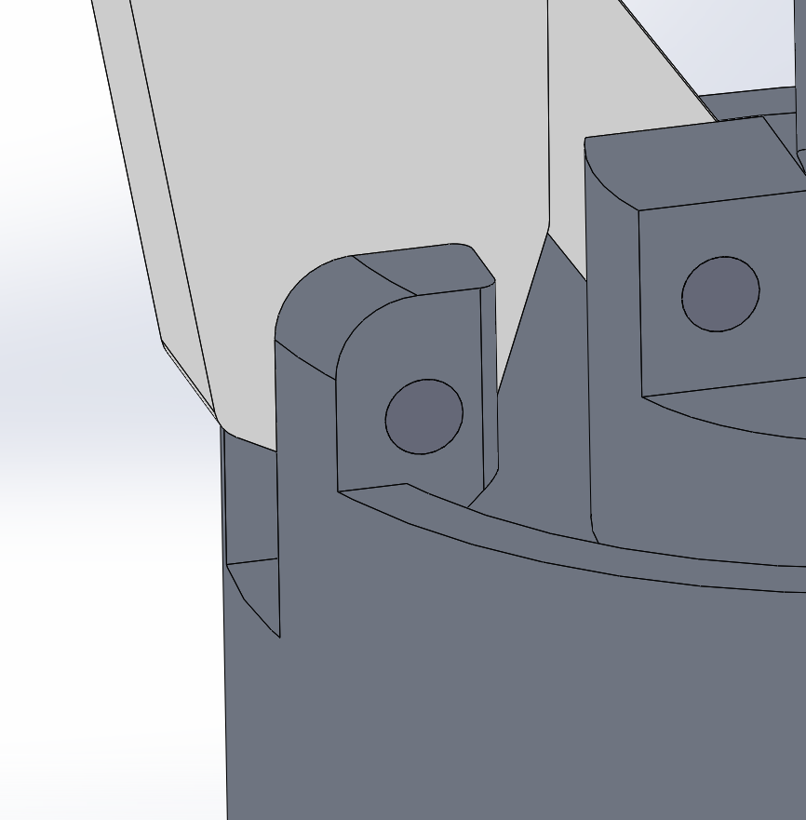
Figure 20- Hole Realigned
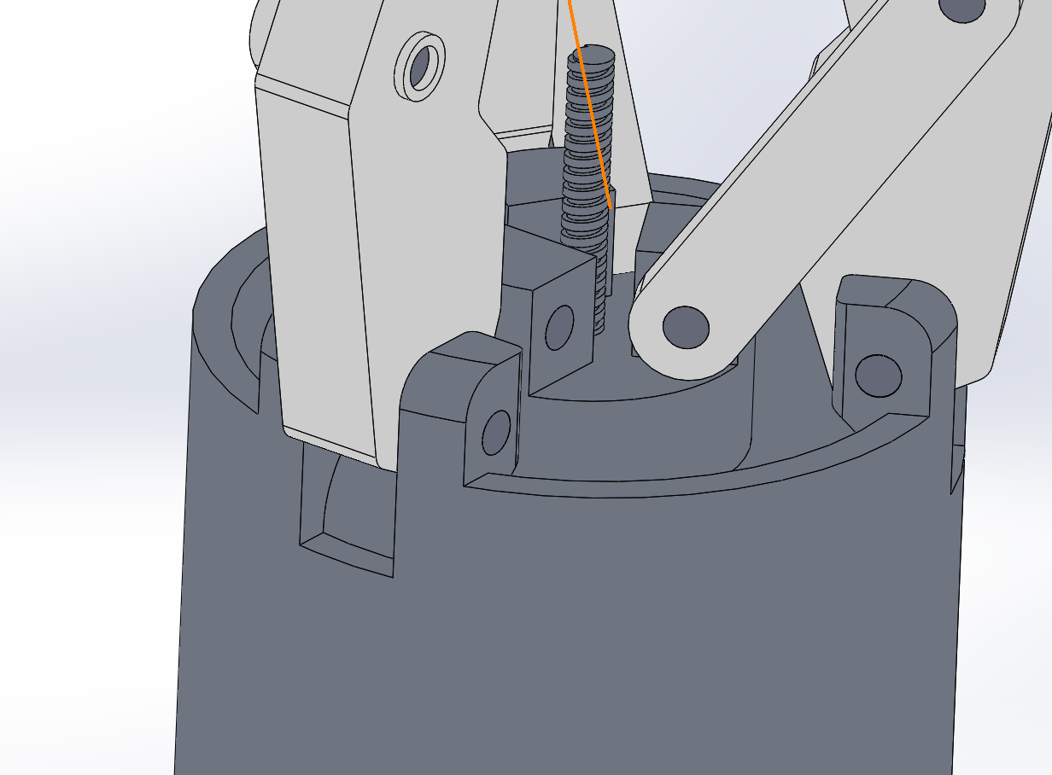
Figure 21- Overhangs removed

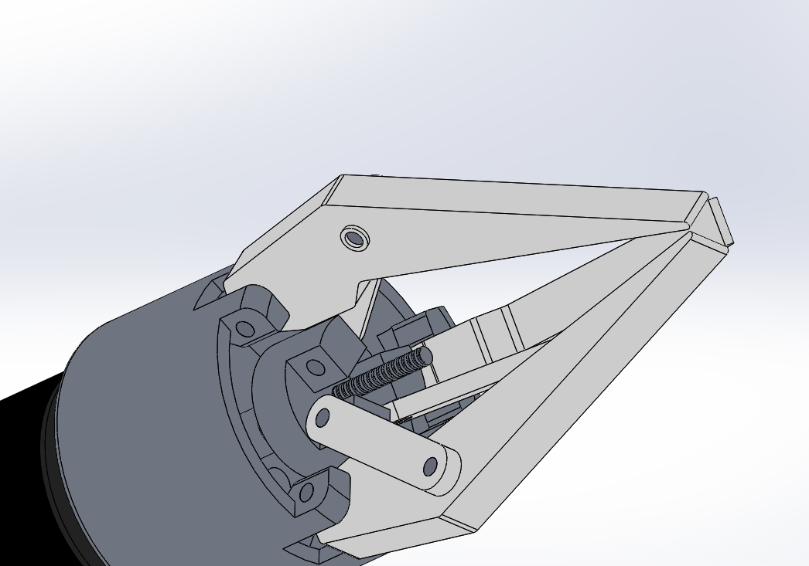
Figure 22- POKE YOKE
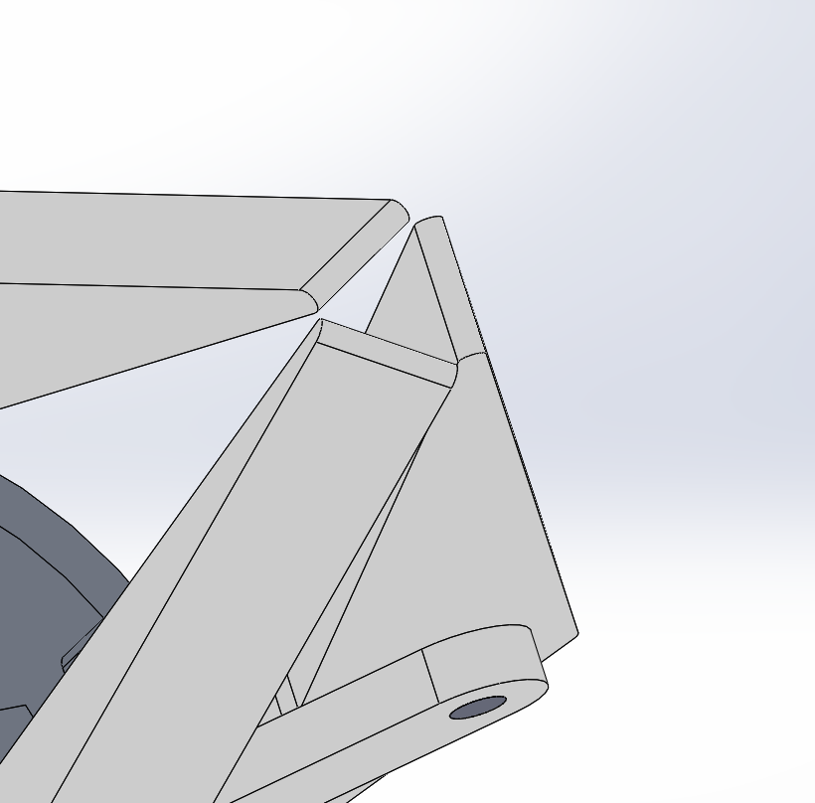
Figure 23- Rounded Grippers

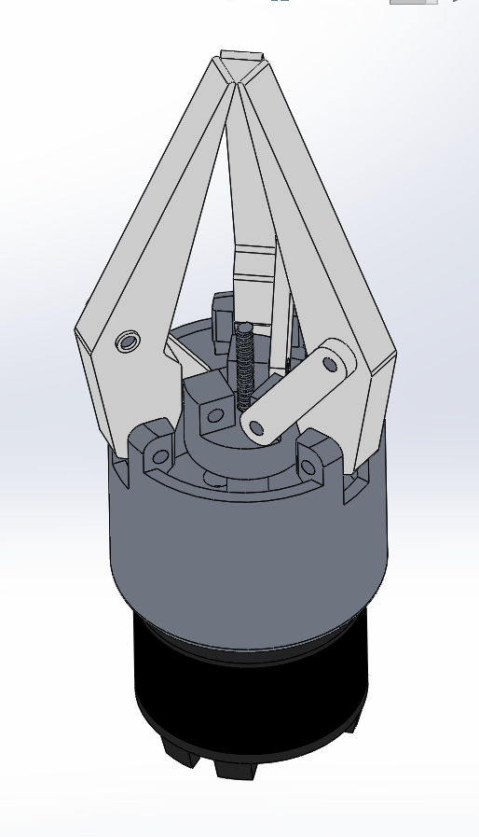
Figure 24- Claws Filleted

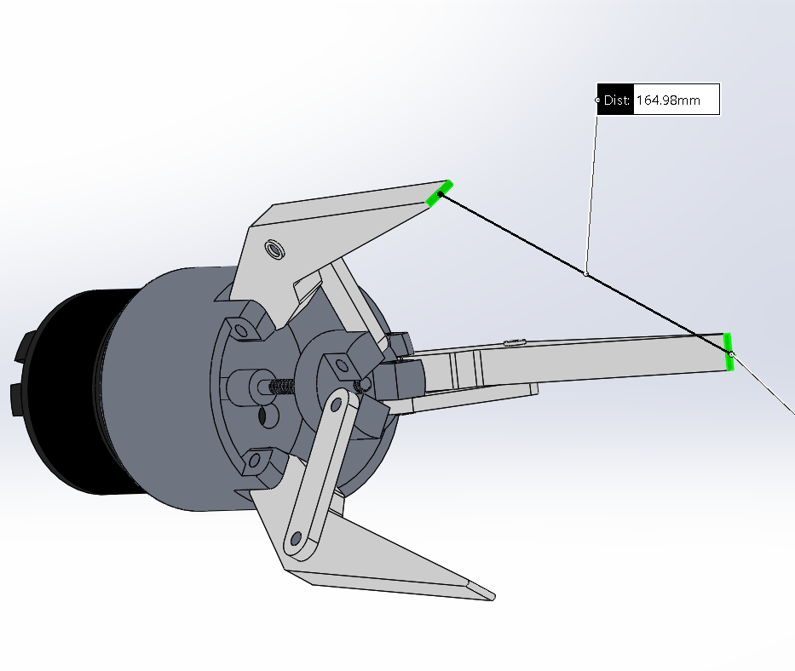
Figure 25- Claw Scaled up

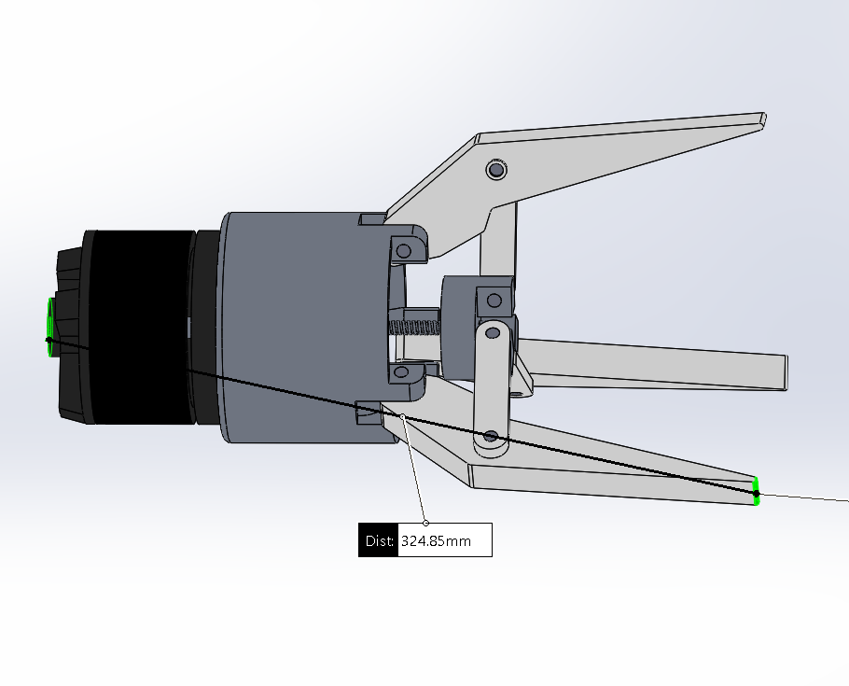
Figure 26- Claw Scaled length
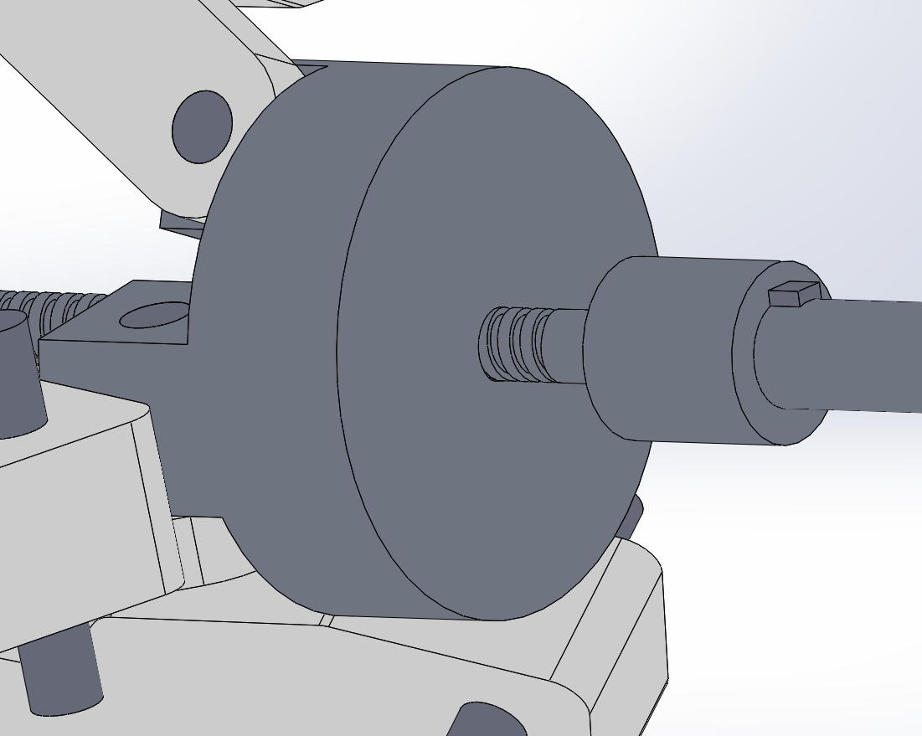
Figure 27- Key added to stop slippage

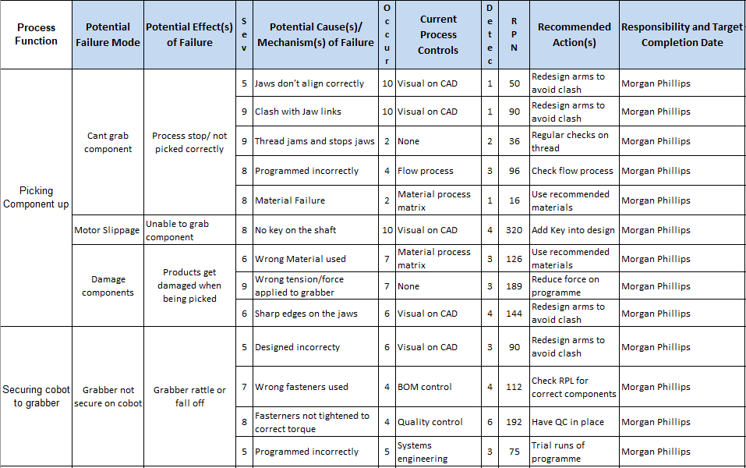
Figure 28- FMEA

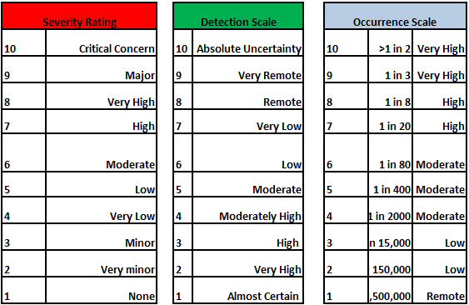
Figure 29- FMEA Ratings

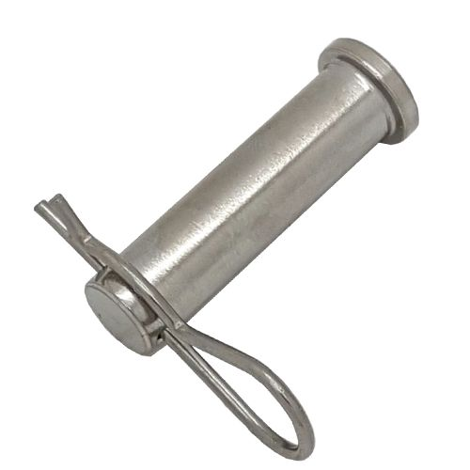
Figure 30- Clevis Pin

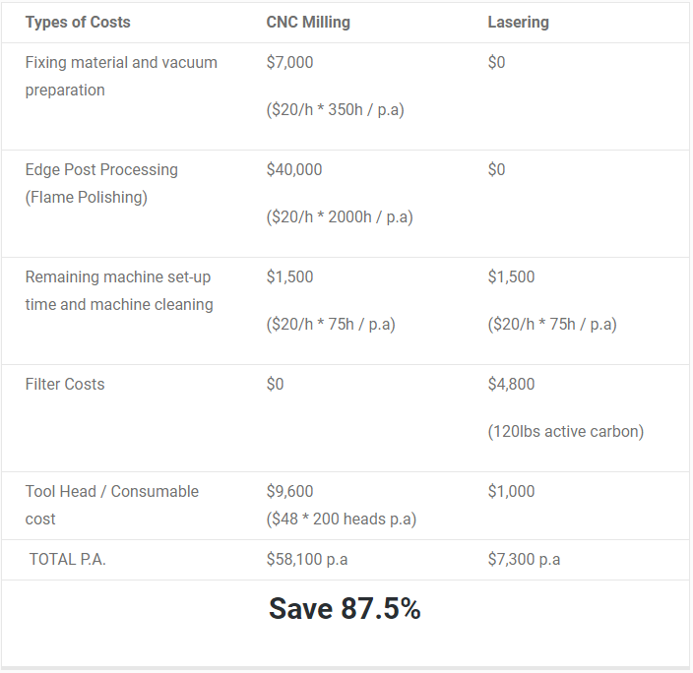
Figure 31- Costing comparison

