Html and css web development report
Assignment 2
Module: Introduction to Web and Database Concepts (ACCA4023)
Student Name: Jonathan Alexander Hernandez
Student ID: 2513126
Course: _Computing Skills for the Workplace
Submission Date: 23/04/2025

Table of Contents
Contents
Table of Contents 1
1.Introduction 2
2. Requirements 3
3. Implementation 3
Validation 7
4. Evaluation 12
Research 12
Usability 12
Usability means the quality of how easily users can navigate, understand or interact with a website to achieve goals. According to 12
Accessibility 12
SEO 12
Website Evaluation 12
SEO Techniques Used 13
5. Conclusion 13
6. References (IEEE Format) 13
7. Appendices 14

1.Introduction

This report describes and explains the design of Webpages using HTML and CSS by personal development. The website includes some pages such as Home, About, Contact, and Hobbies. It demonstrates the use of web standards, responsive design, and basic User Interface structure that allows users to navigate through the page successfully. Some pages contain images to be connected to the text, also they present some features such as headings, tables, lists, a navigation bar(menu) to navigate through the pages. This was created using CSS to design this website so the layout might be friendly and dynamic for other users. The report will outline the requirements of the project, the implementation process and final evaluation of the project.

2. Requirements
The purpose of this Website is to present personal information and interests about the web developer so I can present information in an accessible way. The target audience is lecturers and peers evaluating the assignment and testing the pages to check Usability and Accessibility.
The way includes four pages with sections:
A Home page that introduces the website.
An About page that presents personal information about the web developer.
A Hobbies page that highlights personal interests of the web developer.
A Contact page that provides contact information.
The design prioritizes readability, simplicity and consistency across all the pages, Also It includes a navigation bar so users can navigate through the pages and move easier into sections.

3. Implementation
This website was created by using HTML and CSS without use of automated tools, this ensures full control over design and structure of the pages. Each page follows a same layout to ensure consistency, also, it includes a navigation bar at the top so users can go through other pages. It includes a search bar at the top right however, this is not functional, it is just an aesthetic tool to see how the pages would look with a search bar. Besides, a footer at the bottom of the page.
CSS was used to style the layout, using elements such as flexbox to align items as navigation bar or footer. A consistent scheme and font style were applied to maintain a professional appearance.
Images were included to represent interests or to know about the web developer. These images were styled to fit in page and maintain responsiveness across different sizes.
Screenshots of each page are provided below to show the final design of the webpage:
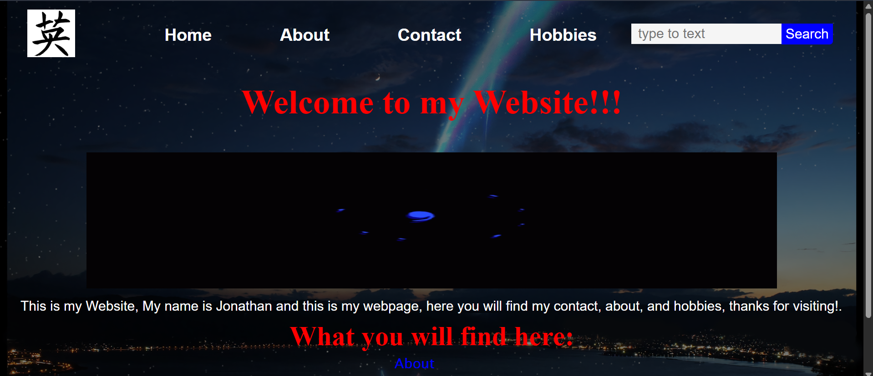
Figure 1 Homepage website

Figure 2 Homepage website
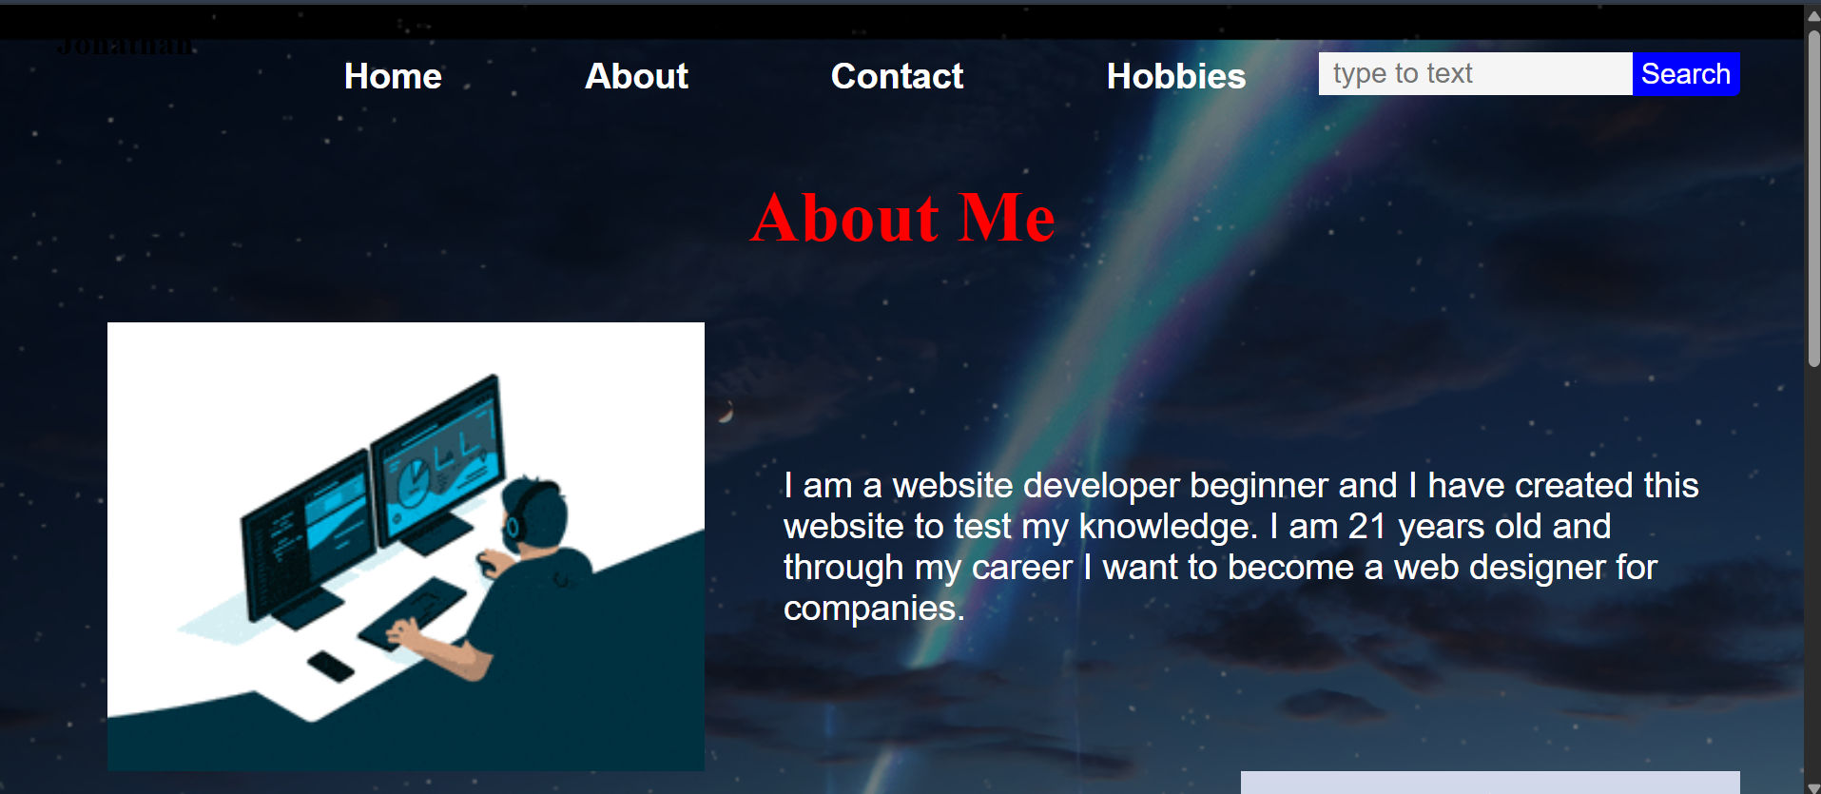
Figure 3 About page website

Figure 4 About page

Figure 5 About page
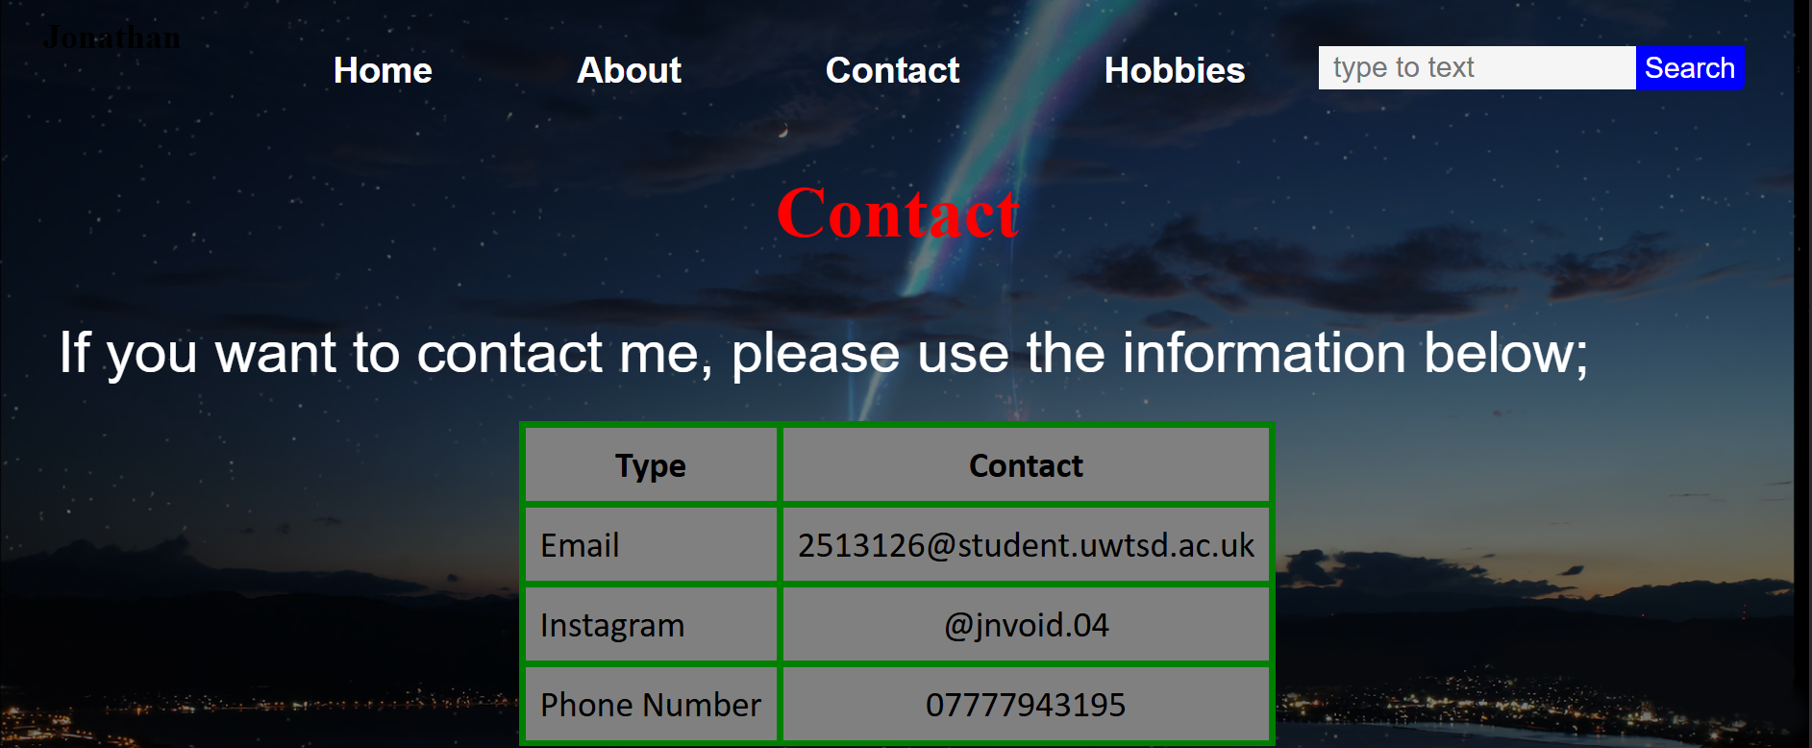
Figure 6 Contact page
Figure 7 contact page
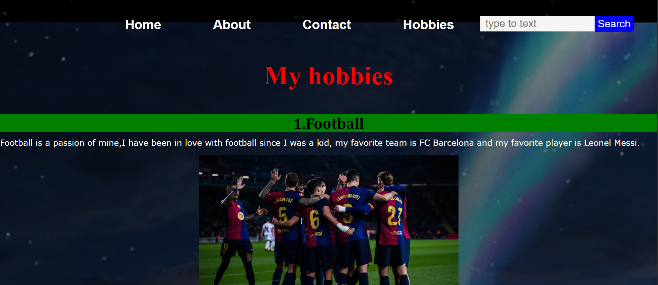
Figure 8 Hobbies page
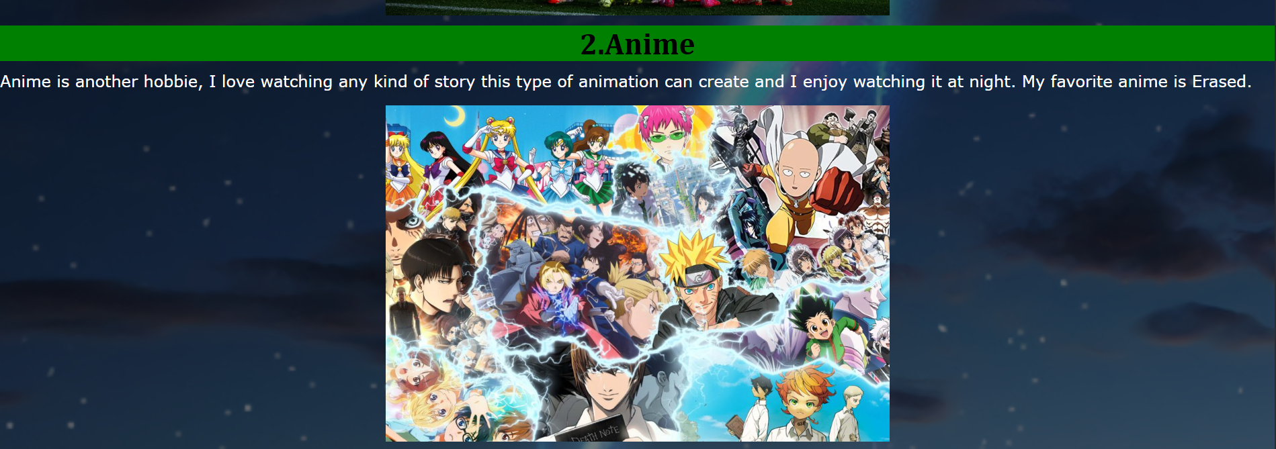
Figure 9 Hobbies page
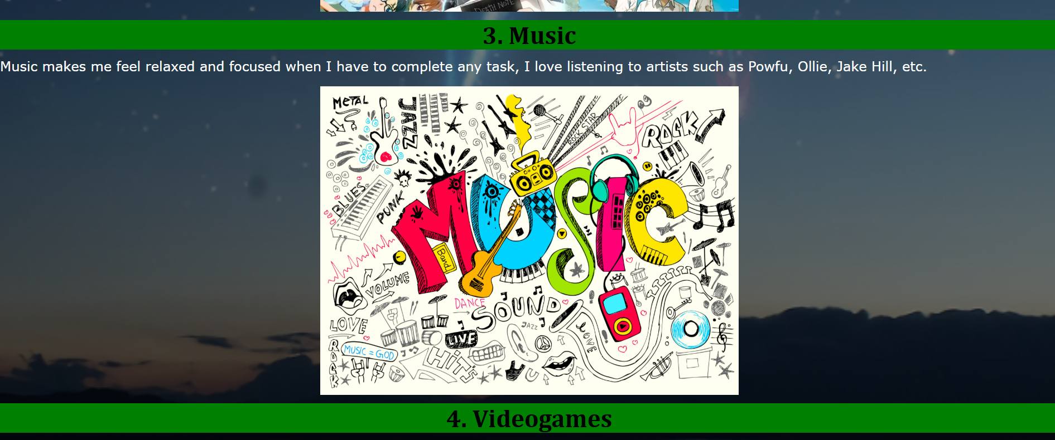
Figure 10 Hobbies page
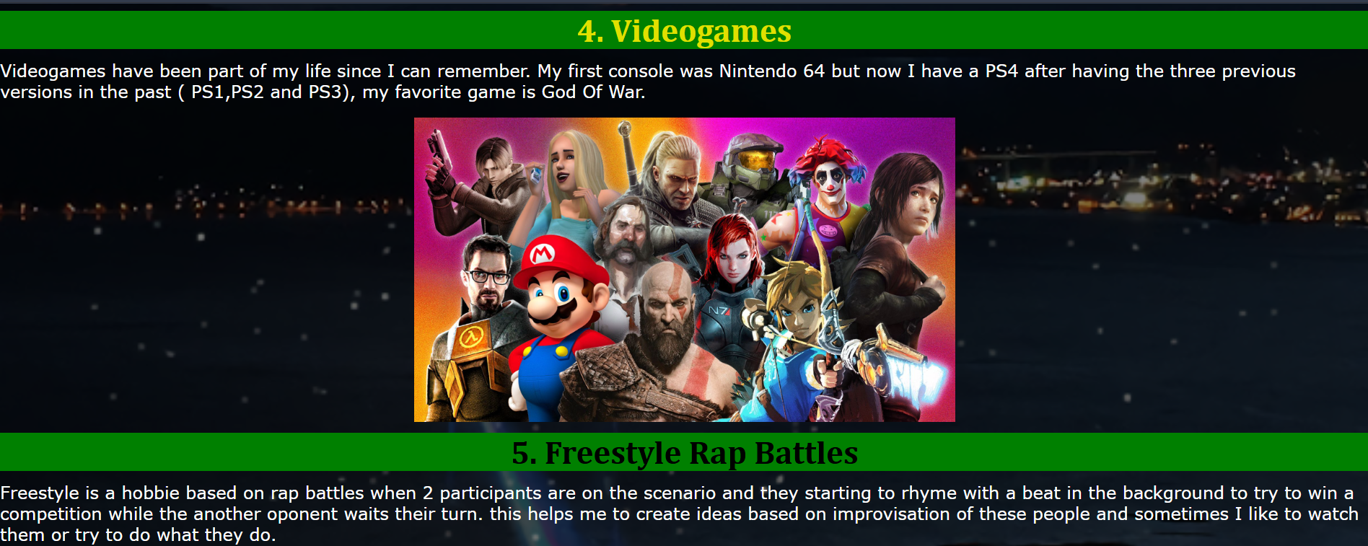
Figure 11 Hobbies page

Figure 12 Hobbies page

Validation
I have validated my HTML file and CSS file using ValidatorW3 and https://jigsaw.w3.org/css-validator/. These tools have helped me to find errors in my files, and I have corrected them by knowing what I have to change in my files, this ensures proper style in my pages and improves the quality and accessibility of my website.
Screenshots below present errors and corrections for each page and CSS style: 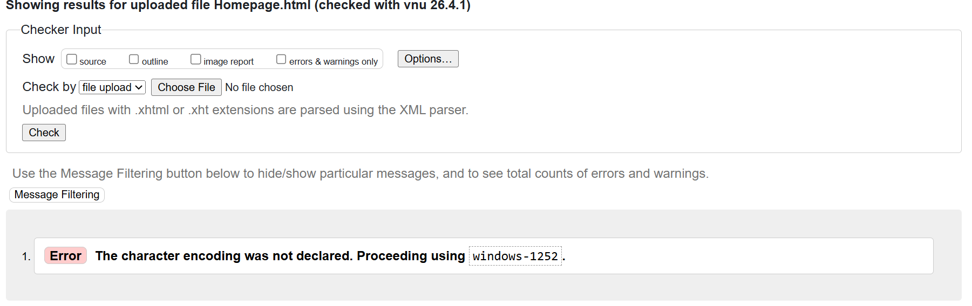
Figure 13 Homepage errors
This error was found in my Home page, it means that my character encoding was not specified, this may cause issues about how the text is displayed especially if my document has non-ASCII characters (American Standard Code for Information Interchange).
To fix this error I have added the tag <meta charset =” UTF-8”> in the head section in my homepage, this ensures that web browsers interpret any type of languages, characters, and symbols correctly.
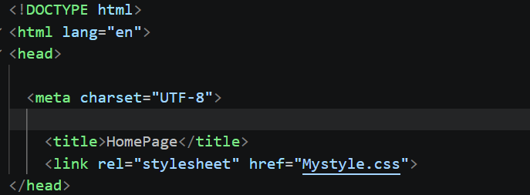
Figure 14 Homepage fixed error
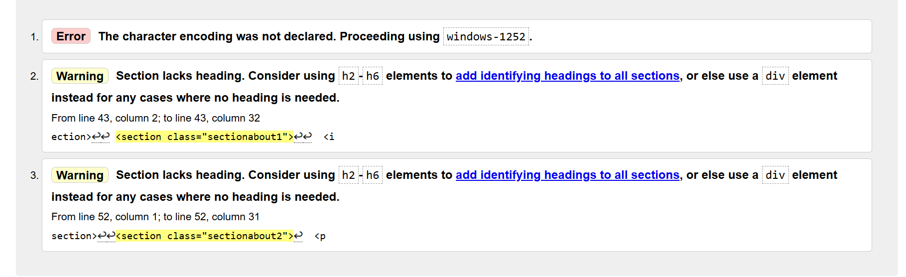
Figure 15 About page errors
These errors and warnings were found in my About page, the first one means that my character encoding was not specified, this may cause issues about how the text is displayed especially if my document has non-ASCII characters (American Standard Code for Information Interchange). The second one and third one is warning the user to use the tag <div> instead of section tag, the div is used when heading is not required while section tag need heading to identify headings in sections.
To fix the first error I have added the tag <meta charset =” UTF-8”> in the head section in my about page, this ensures that web browsers interpret any type of languages, characters, and symbols correctly. The second and third errors were fixed by replacing the tag <section> for the tag <div> as this part does not include any headings.
and symbols correctly. The second and third errors were fixed by replacing the tag <section> for the tag <div> as this part does not include any headings.
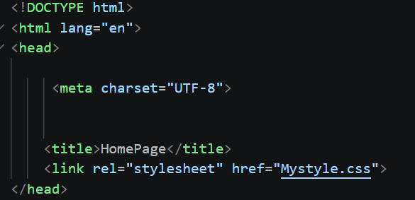
Figure 16 About Page first error fixed
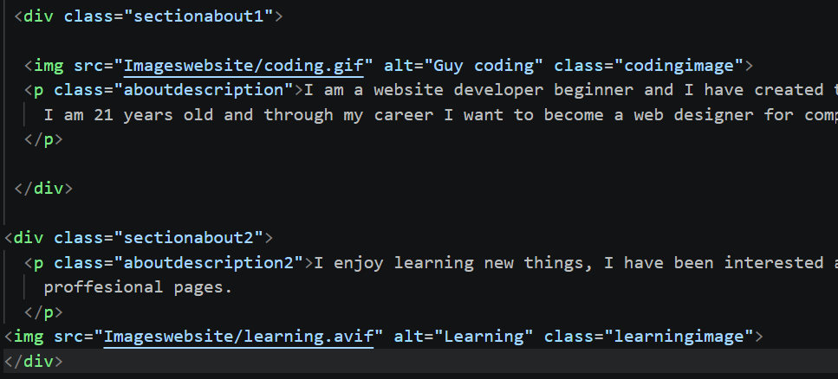
Figure 17 About page second and third error fixed
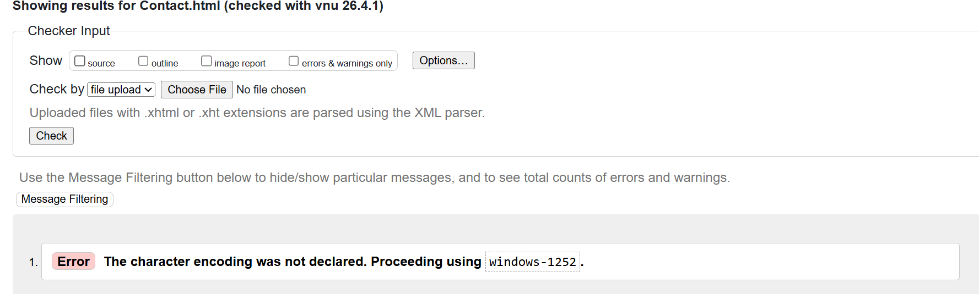
Figure 18 Contact page error
This error was found in my Contact page, it means that my character encoding was not specified, this may cause issues about how the text is displayed especially if my document has non-ASCII characters (American Standard Code for Information Interchange).
To fix this error I have added the tag <meta charset =” UTF-8”> in the head section in my contact page file, this ensures that web browsers interpret any type of languages, characters, and symbols correctly.
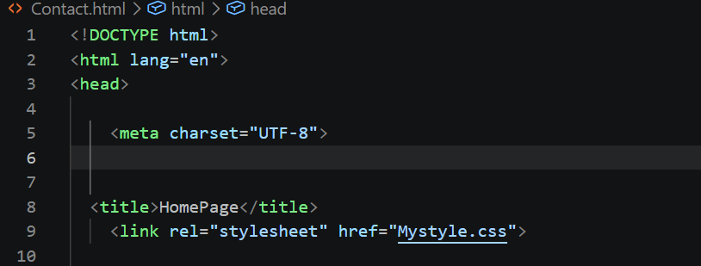
Figure 19 Contact page error fixed
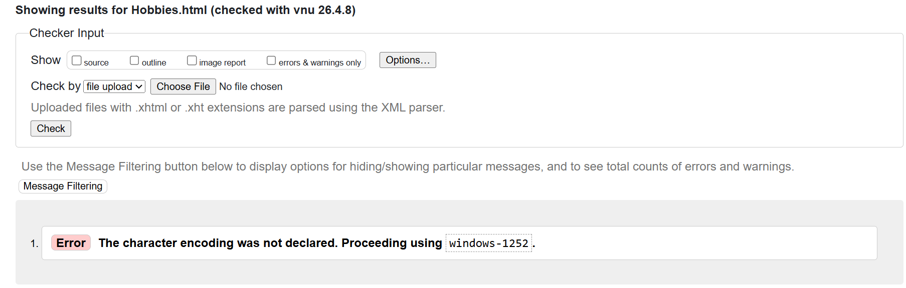
Figure 20 Hobbies page error
This error was found in my hobbies file page, it means that my character encoding was not specified, this may cause issues about how the text is displayed especially if my document has non-ASCII characters (American Standard Code for Information Interchange).
To fix this error I have added the tag <meta charset =” UTF-8”> in the head section in my hobbies page file, this ensures that web browsers interpret any type of languages, characters, and symbols correctly.
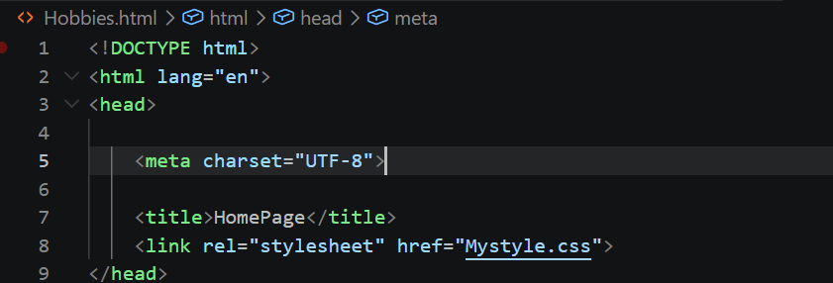
Figure 21 Hobbies page error fixed
Figure 22 CSS errors
This error was found in my CSS file; this means that the element border-top-left-radius does not have any value, it is repeated or it is not useful in my CSS.
To fix it, there are two ways to do it, the first is adding any value to the element or it could be deleted if it is not needed or repeated in the code, I have chosen the third option which is deleting it.

Figure 23 CSS error fixed before
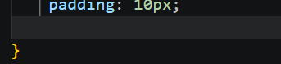
Figure 24 CSS error fixed after

4. Evaluation

Research

Usability

Usability means the quality of how easily users can navigate, understand or interact with a website to achieve goals. According to Abdulrahaman Abdul Ganiyu (2017), it helps the site to keep a good relationship with people and organizations, especially if the audience is big. It makes it easier to perform a bunch of tasks that facilitate services for students, companies, staff, etc. [1] [2]

Accessibility

Accessibility means the practice of designing and developing websites, tools and technologies so people can navigate, understand or interact with the web. According to Shawn Henry (2006), it refers to the way people with disabilities use websites. This embraces all disabilities such as visual, cognitive or auditive, etc. [3] [4]

SEO
SEO or Search Engine Optimization means to the process to improve the visibility of a website and organic traffic sites like Google or Opera; this makes it easier for users find websites quickly. According to Nursel Yarcin (2010), it is important to have a good structure, a web-designed page or good looking to introduce services better. This makes the page easier to appear in top lists using keywords that allow them to relate to SEO. [5] [6]

Website Evaluation

Usability and utility:
The website I have created works properly; this website provides a menu that allows users to navigate across all the pages. Each link attached to it works correctly, so users can go through them to find more information about interests or hobbies. The web also achieves the purpose or goal which is showing personal information about the web developer. Basically, the website presents a friendly structure to navigate on it and makes sure the user can understand what the website is about. All these features ensure that users cannot get confused on what they are navigating and it is easier to understand for anyone.

SEO Techniques Used

Through my web design structure, I have applied some elements that improve search visibility for users when they look for my website and it allows them to appear on the top lists of search engines such as Google, Opera etc. Some attributes or elements I have used for my web design have been h1, h2; these elements allow us to present clear headings so the users can understand what section is about. Also, I have added alt attributes in images in case users cannot visualize the image in some search engines. Besides the name of each page (Home, about, contact, etc.) helps search engines understand content.

Accessibility (WCAG 2.1)

This website was created with consideration of accessibility WCAG 2.1 guidelines.
In terms of perceivable definition, the website presents a clear and visible content well structured using heading, images, tables, footer, menu, paragraphs, etc. According to operability, the website is easy to navigate using a consistent and simple menu that allows users to move across all the pages with no stress. For understandability, the content was written using simple and clear language so users can follow easily. Finally, for robustness, the website uses HTML and CSS to ensure compatibility across different search engines. However, my website presents some limitations, such as the lack of advanced accessibility and potential improvements in color contrast, which could be implemented in future updates.
Website Comparison: Transfermarkt and OneFootball
Usability
Transfermarkt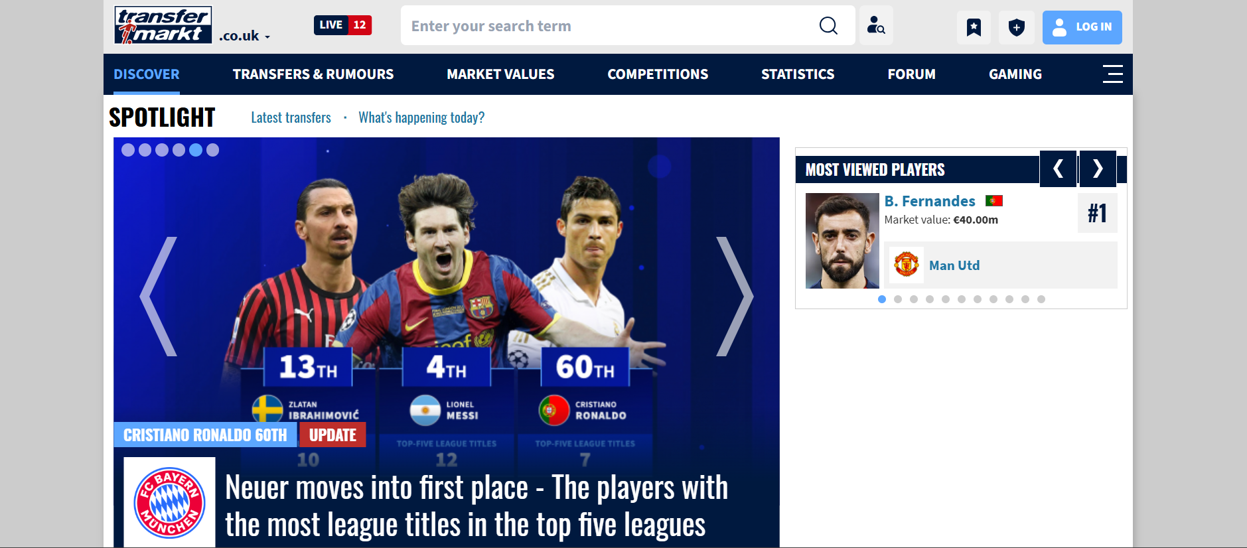
Figure 25 Transfermarkt Home page
Transfermarkt is highly functional and it provides detailed information about any player and their statistics, but it can be challenging for new users. The larger amount of data can be complex and harder to navigate faster. Anyway, experienced users can find it interesting for depth analysis.
OneFootball
One football has a better user-friendly interface to navigate through scores and news due to its simple layout and modern structure. This improves usability making it more accessible and easier for new users.
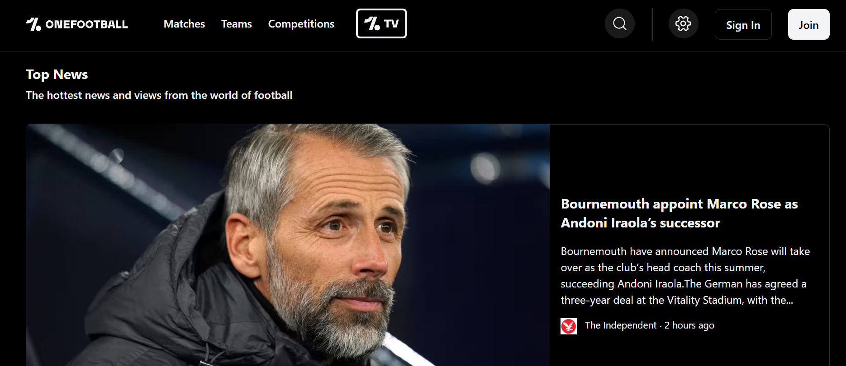
Figure 26 OneFootball Homepage
Accessibility
Transfermarkt
Transfermakt presents a large amount of data, however, its layout might be dense and complex due to the use of many tables. The text can appear small, and it might be readable for users, especially those users with visual disabilities. Although the site is functional, it presents lack of hierarchy or spacing, this makes navigation difficult and uncomfortable.
OneFootball
OneFootball offers better accessibility due to clear design, text and use of spacing the layout is more visually structured, which improves user experience. Content is easier to follow, and interface is more friendly for a wide range of users, including those ones with disabilities.
SEO
Transfermarkt
It presents stronger SEO due to structure data, also better player pages with info about their careers, teams, and statistics which improves search engine visibility.
OneFootball
OneFootball also uses SEO techniques such as headings, menu, tables, etc. However, it relies more on news-based content and does not have the same depth of structured data as Transfermartk.
Mobile friendless
Transfermarkt
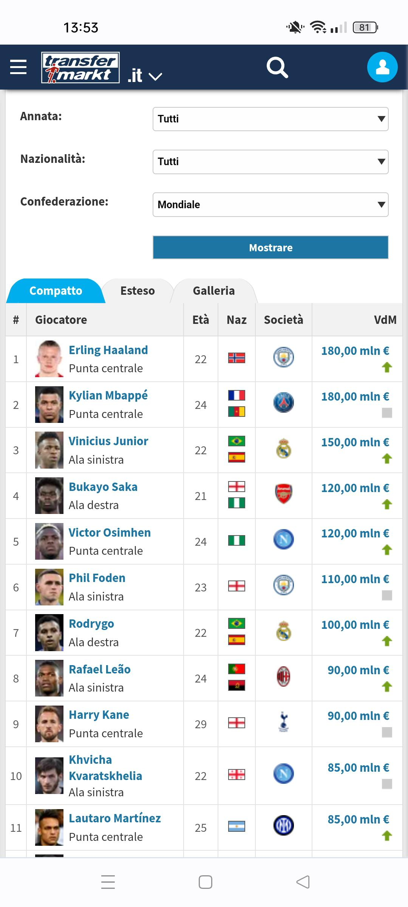
Figure 27 Transfermark Mobile layout
Transfermartk is accessible on any mobile devices, however the layout is not optimized for smaller screens. The larger amount of data makes it difficult to navigate on phones.
Onefootball
Onefootball is highly optimized for mobile use. The responsive design adapts well to different screen sizes, and the interface is smooth and easy to use, providing better use for mobile users.

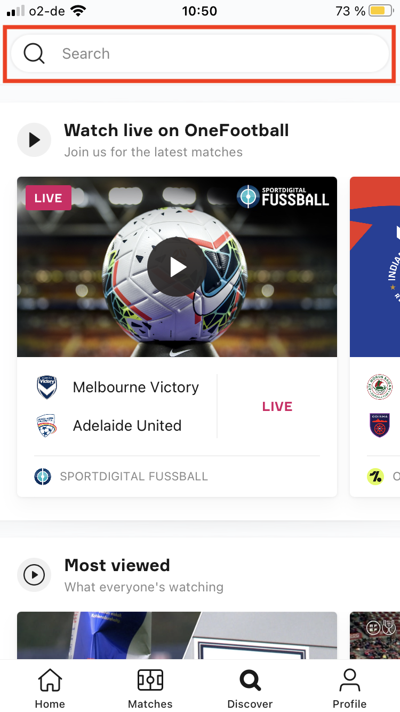
Figure 28 Onefootball Mobile layout

Conclusion
Overall, Transfermarkt is more suitable for users looking for detailed information on statistics and data. While Onefootball provides better user experience. Onefootball stands out in terms of usability, accessibility or mobile friendlessness, whereas transfermarkt performs better in SEO and data depth.

5. Conclusion
In conclusion, this assignment has successfully demonstrated the design and development of a multipage website using HTML and CSS. The website has met its main goal of presenting personal information in a clear and structured way with a functional navigation and consistent layout across all the pages. It also meets key features or principles such as Usability, Accessibility, and SEO that were applied throughout the project, while the website performs well in terms of simplicity and usability. There are areas for improvement, including more advanced styling, increased interactivity and enhanced accessibility features. Overall, the project provided a functional website and good user experience an good foundation for future improvements.

6. References (IEEE Format)
[1]
A. A. Ganiyu, A. Mishra, J. Elijah, and U. M. Gana, “The importance of usability of a website,” vol. 13, no. 3, pp. 27–35, 2017.
[2]
Y. Lee and K. A. Kozar, “Understanding of website usability: Specifying and measuring constructs and their relationships,” vol. 52, no. 2, pp. 450–463, 2012.
[3]
S. L. Henry, Understanding web accessibility. in Web accessibility: Web standards and regulatory compliance. Springer, 2006, pp. 1–51.
[4]
M. Campoverde-Molina, S. Luján-Mora, and L. Valverde, “Accessibility of university websites worldwide: a systematic literature review,” vol. 22, no. 1, pp. 133–168, 2023
[5]
N. Yalçın and U. Köse, “What is search engine optimization: SEO?” vol. 9, pp. 487–493, 2010.
[6]
A. Barbar and A. Ismail, “Search engine optimization (SEO) for websites,” presented at the Proceedings of the 2019 5th international conference on computer and technology applications, 2019, pp. 51–55.

7. Appendices
HTML Code listings
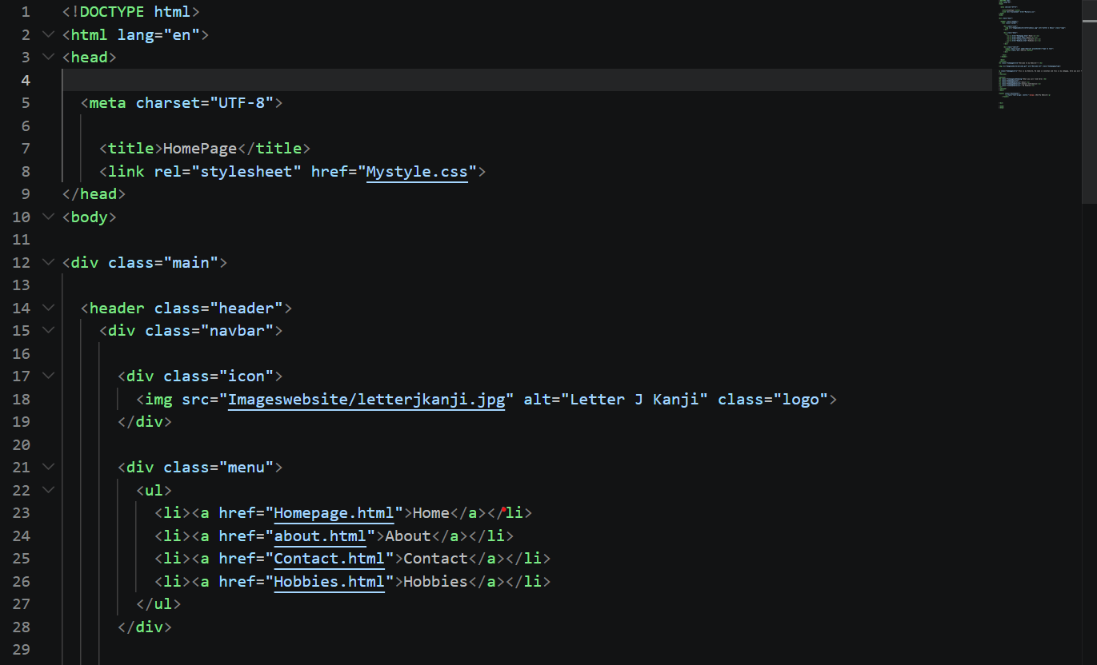
Figure 29 HTML Homepage code listing
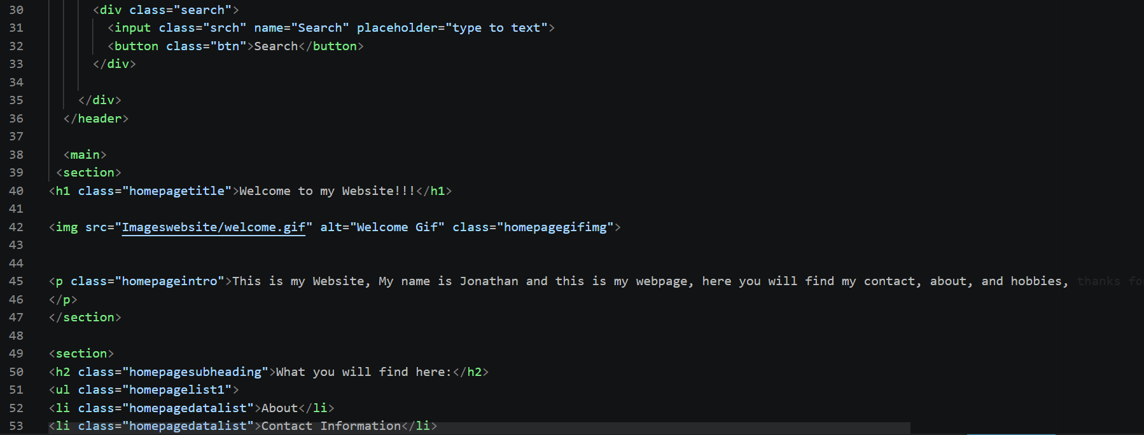
Figure 30 Html Homepage Code listing
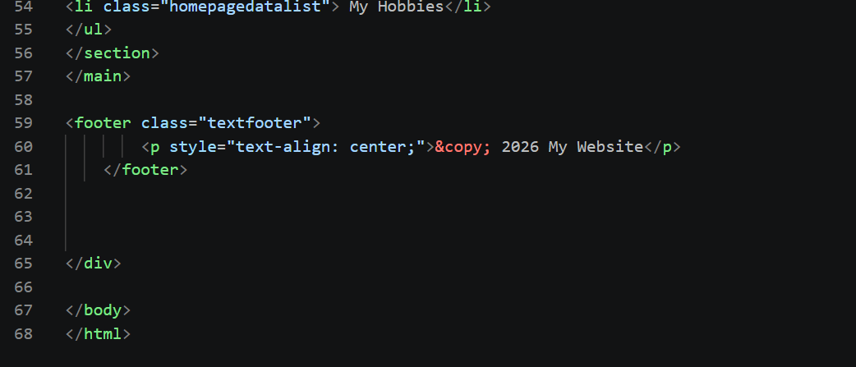
Figure 31 HTML Homepage code listing
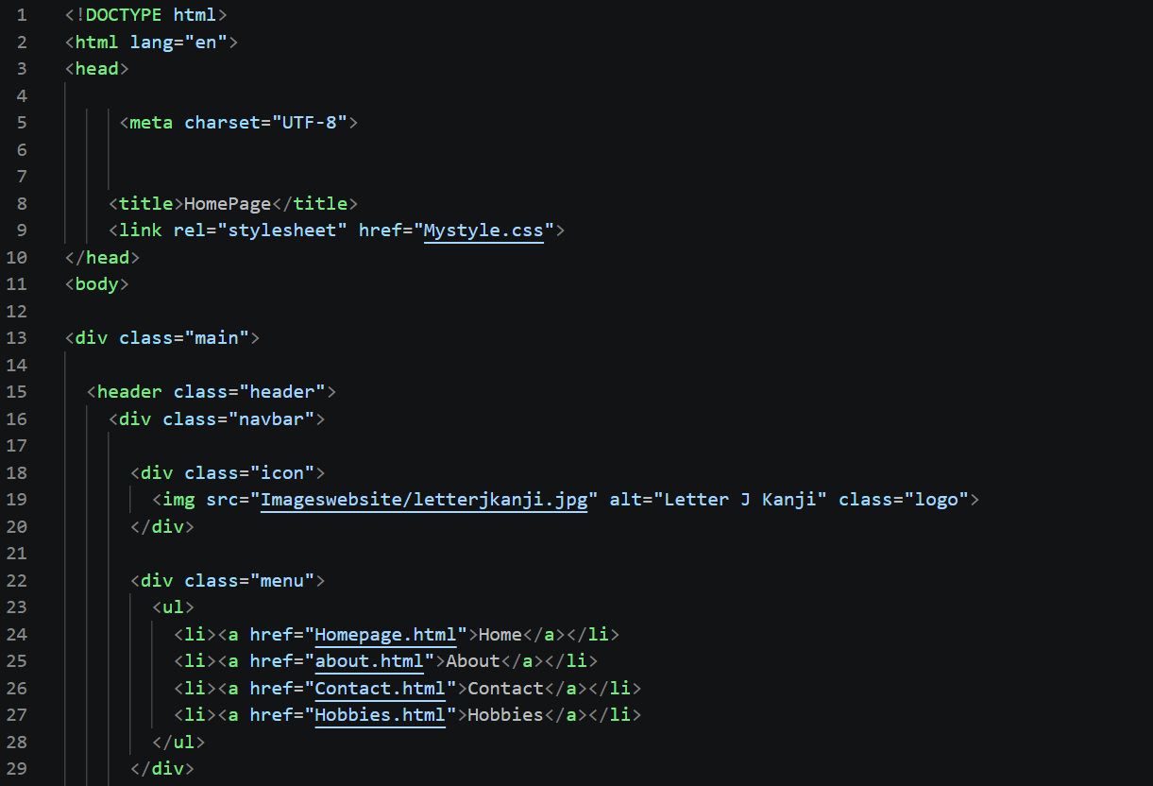
Figure 32 HTML About Page code listing
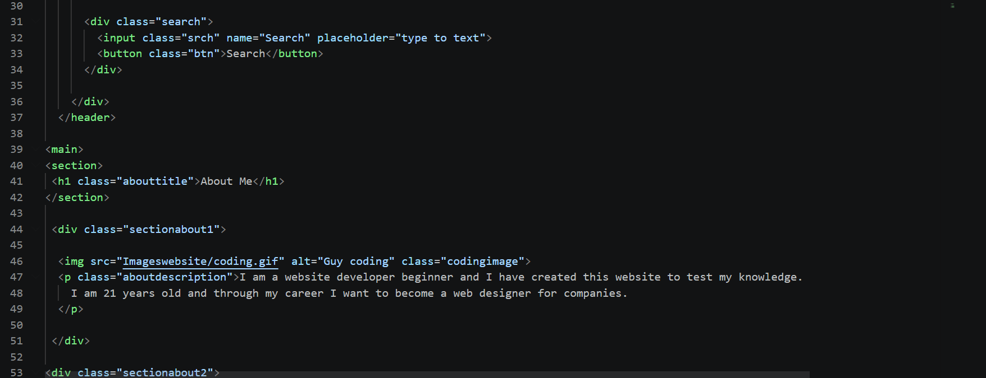
Figure 33 About Page code listing
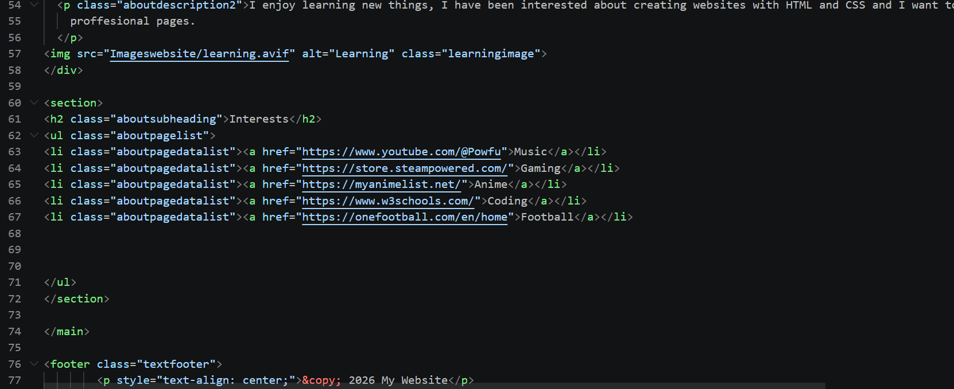
Figure 34 about page code listing
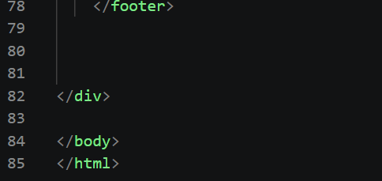
Figure 35 about page code listing
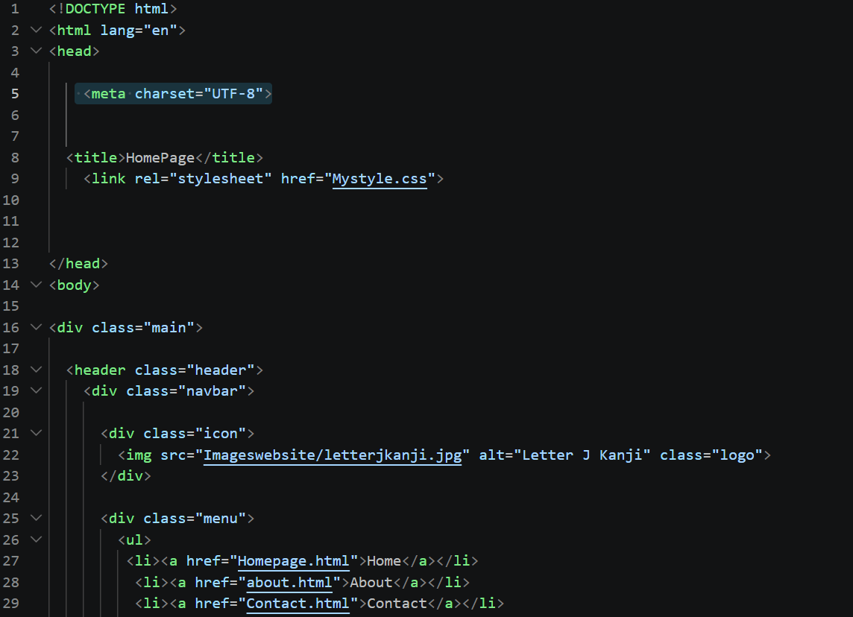
Figure 36 Contact page code
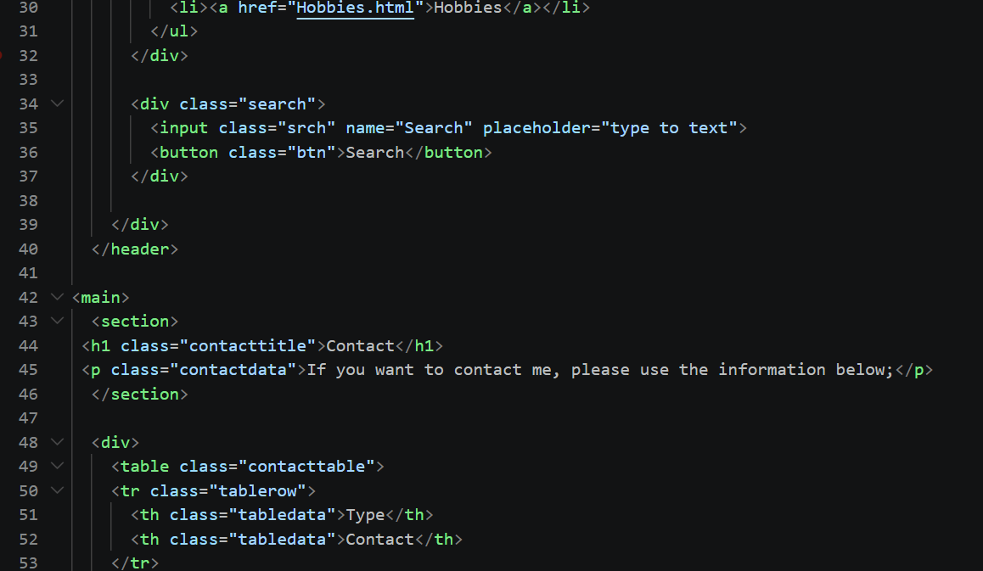
Figure 37 contact page code
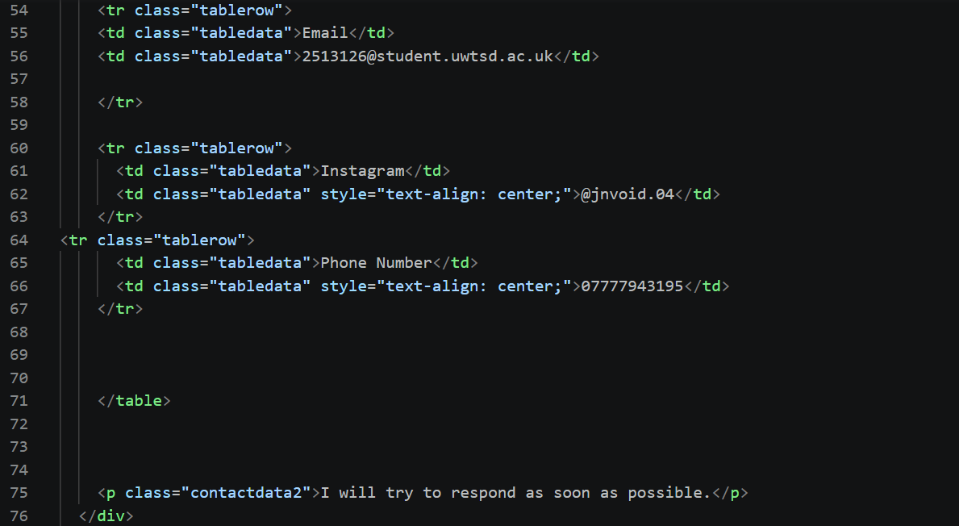
Figure 38 Contact page code
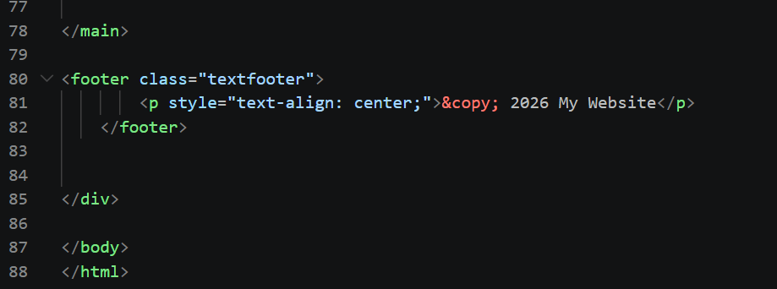
Figure 39 contact page code listing
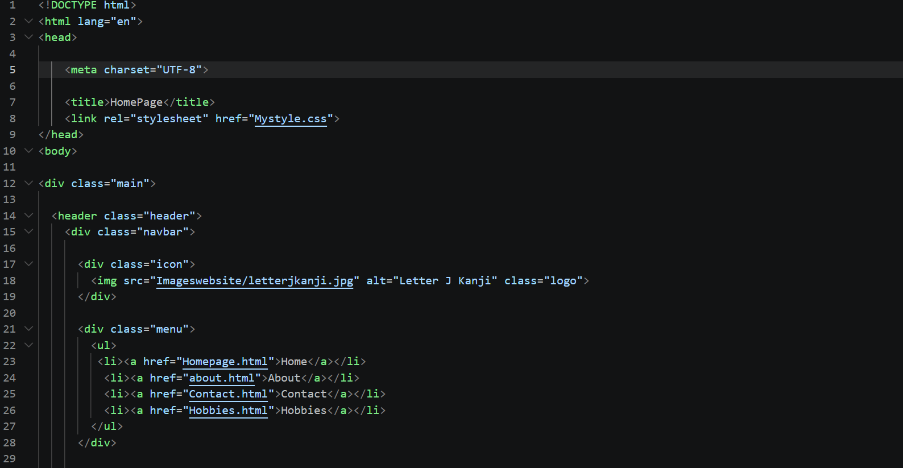
Figure 40 Hobbies page code
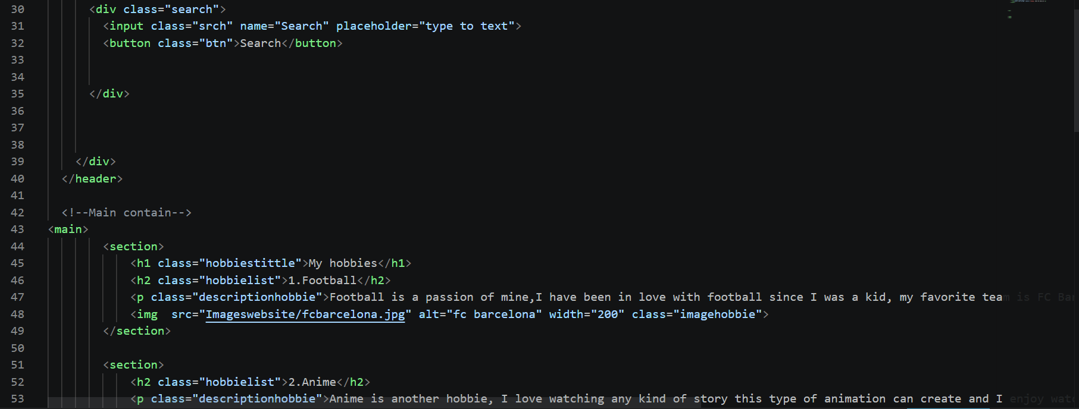
Figure 41 Hobbies page Code
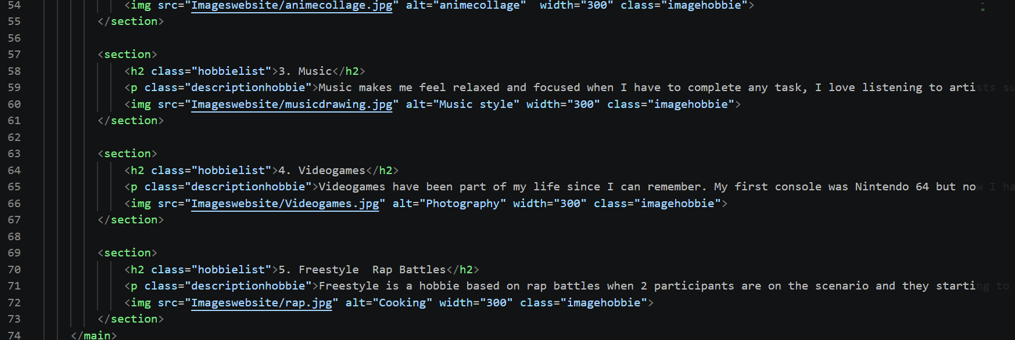
Figure 42 Hobbies page code

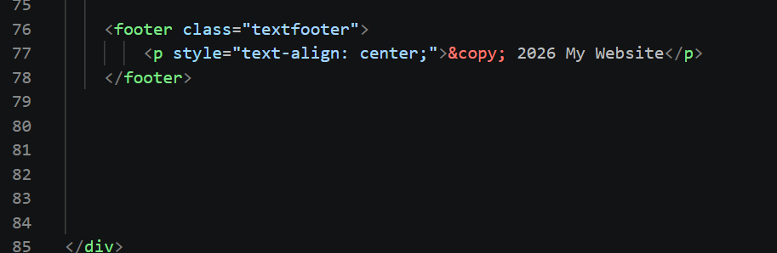
Figure 43 Hobbies page code
CSS


