Task 3 – Source Evaluation

Student Details
Name and student ID: Vasile Barbulescu/ 2539943
Topic chosen: The use of social media to promote businesses.
Title of source: Using affective content to promote high-involvement services on social media
Author(s): Tran, H.A., Farrell, A., Evanschitzky, H., Nguyen, B. and Ackfeldt, A.L.
Year published: 2024

How did you find this source?
This article was located on Google Scholar by doing a search for recent peer-reviewed journal articles about social media marketing and business promotion.
Why did you choose this source?
My choice of source is due to it being directly associated with my topic and the information's impact on the customers purchase intent and engagement with information through social media. It is a recent study from a credible academic journal that is peer-reviewed, and a good source of information regarding businesses and how they effectively use social media.
Relevance: The article particularly emphasises the role of social media contents and how it can minimise the perceived risk of customers to increase their purchase intention by enhancing the customer engagement in businesses. Therefore, it is very relevant with respect to the issue topic: Businesses and social media.
Usefulness: The article presents the results of four experiments, and offers some practical advice for companies to leverage emotional information to induce positive consumer response and to advance their enterprises.
Academic source: Fully peer-reviewed journal article, published in a recognised academic journal from Elsevier (Journal of Business Research) or similar internationally recognised academic journal.
When was it published? Is it recent enough? Why?
The year of the article is 2024, which is a relatively new article to read to learn about what's going on in social media marketing. Social media and digital marketing is always evolving, here is some fresher, more up to date and relevant research.
Author Credibility
The author(s) have a wealth of experience in Marketing and Business. They have relationships with prestigious universities in the UK including the University of Manchester, Aston University and University of Exeter and they have a wealth of expertise in marketing, consumer behaviour and social media research. They have an academic expertise which makes the study credible.
Reliability
This is because it is published in a reputable international journal (Journal of Business Research) with Elsevier which is peer reviewed. It has been peer-reviewed by other researchers in the field, and provides a report of the four experiments that provide good evidence for the conclusions drawn. It has also been freely available using an open access CC BY licence to ensure transparency and accessibility of the research.

Source Evaluation Presentation

Introduction

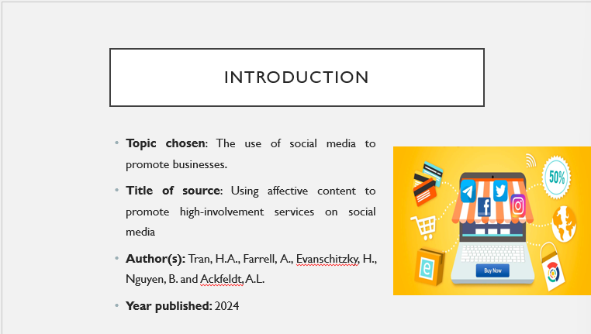

This presentation will explore/analyse one of the academic texts on the use of social media to promote business. Tran et al. (2024) of Journal of Business Research have selected. It is because social media is now a necessity in terms of marketing in this current era that it is important for everybody to know about their brand and be able to communicate effectively with their customers so that they can market their products properly. It is my presentation which I made on why I chose this specific article.

How I Found the Source
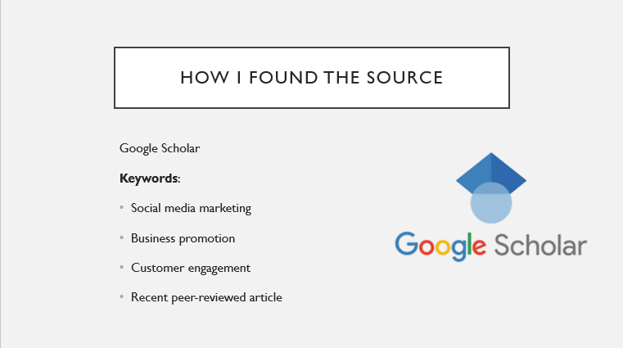

It was very easy for me to obtain this article using the technique of searching through Google Scholar, where I used the following keywords: social media marketing, business promotion, and customer engagement. There were two main reasons for selecting this particular article. First, it was recently published in the year 2024; secondly, it was related to my research topic and published in a credible peer-reviewed journal. This article was useful to me through Google Scholar because it helped me find a relevant source that I could use in my academic work (Pottier et al., 2024).

Source Evaluation
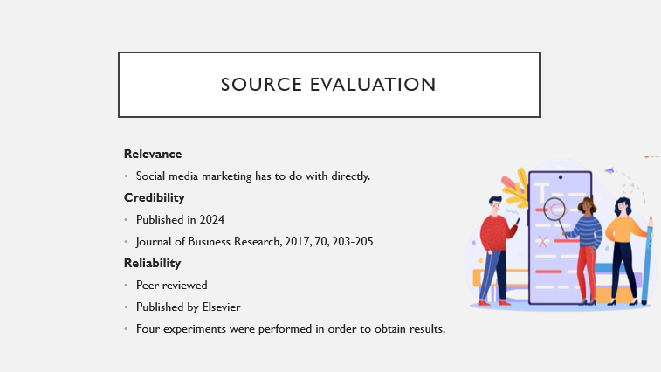

Articles such as this are applicable regarding learning how businesses engage the content from social media, when it involves consumers' behaviour/action towards purchasing. It is revised in 2024 for its relevance and applicability to the fast-changing field of digital marketing. It appears in Elsevier's well-known peer-reviewed journal, The Journal of Business Research. The study is carried on four experiments, which give strong evidence to support the findings (Coleman, 2022)

Author Credibility
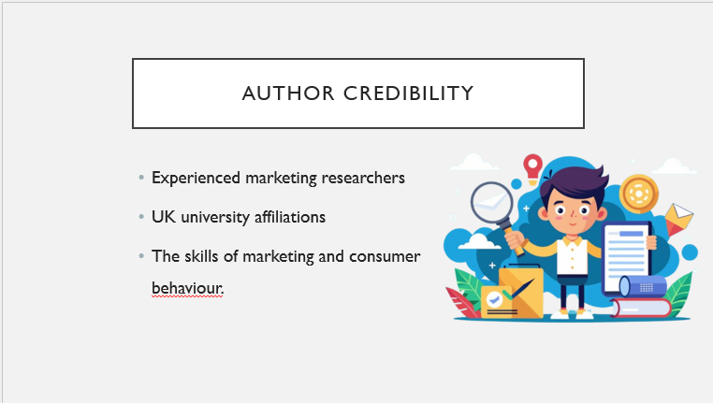

The authors have significant research experience in the areas of marketing and consumer behaviour. They have excellent links with well-known institutions, like Alliance Manchester Business School, Aston Business School and the University of Exeter Business School. Knows his/her research and academic study, lends more credibility to the article and will make it appropriate for university level research.

Reflection and Learning
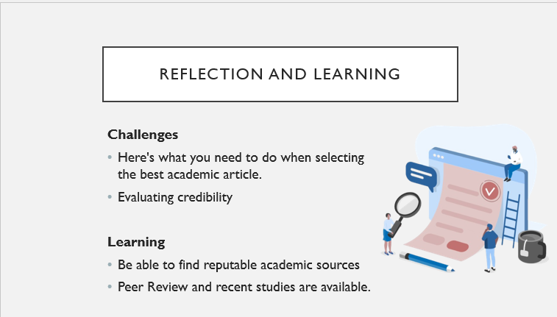

The most challenging aspects of this task was finding an appropriate article of the many that were published via Google Scholar. But at the same time, it was hard to check the validity of the source, keeping in mind the journal, the authors and the date. The two biggest things I learned out of this Task were how to identify good academic sources and how to know before using the sources in an academic task whether it was reliable or not. I also gained knowledge that I should choose the newest research one which has been peer-reviewed by capable writers. These skills will enable me to write better in the future.

References
Coleman, P. (2022) Validity and reliability within qualitative research for the caring sciences. International journal of caring sciences, 14(3), pp.2041-2045. Available at: https://oro.open.ac.uk/81588/1/Coleman%20Validity%20and%20Reliability.pdf
Pottier, P., Lagisz, M., Burke, S., Drobniak, S.M., Downing, P.A., Macartney, E.L., Martinig, A.R., Mizuno, A., Morrison, K., Pollo, P. and Ricolfi, L. (2024) , abstract and keywords: A practical guide to maximize the visibility and impact of academic papers. Proceedings of the Royal Society B: Biological Sciences, 291(2027), p.20241222. Available at: https://pmc.ncbi.nlm.nih.gov/articles/PMC11288685/pdf/rspb.2024.1222.pdf
Tran, H.A., Farrell, A., Evanschitzky, H., Nguyen, B. and Ackfeldt, A.L. (2024) Using affective content to promote high-involvement services on social media. Journal of Business Research, 179, p.114676. Available at: https://www.sciencedirect.com/science/article/pii/S0148296324001802

