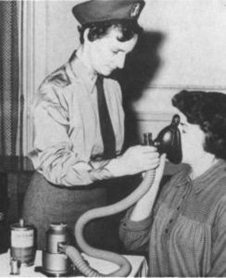
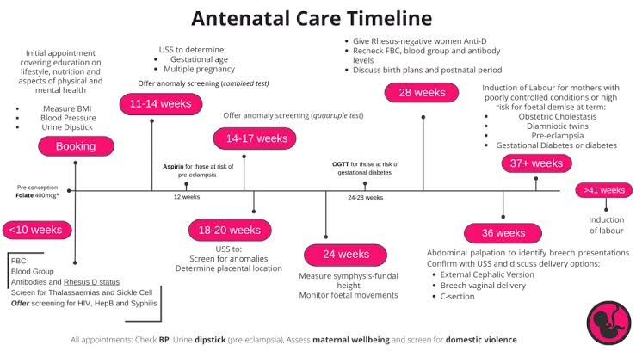
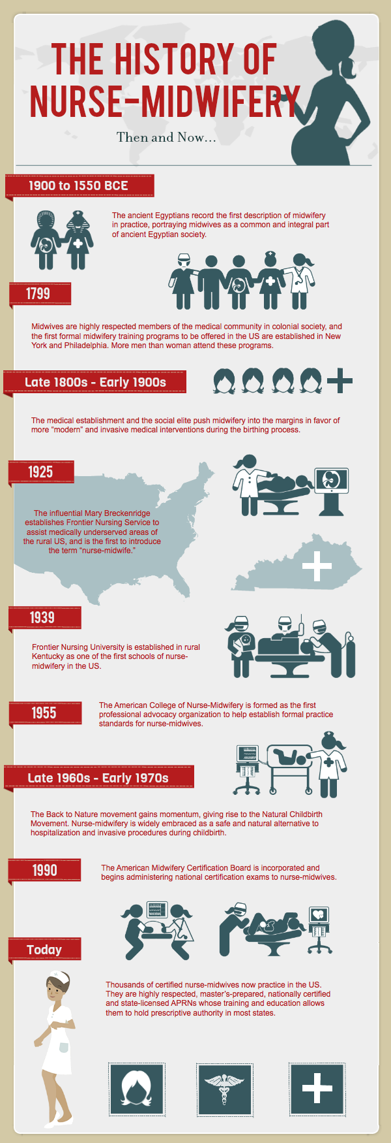
https://www.aims.org.uk/journal/item/history-district-midwifery
CHOSEN HEALTH SERVICE
Community antenatal midwifery services provide care and support to pregnant women throughout pregnancy in the community settings such as GP surgeries, children’s centres, community clinics, and sometimes within the women’s home ( National institute for health and care excellence [NICE], 2021; NHS England, 2023).
The services aim to promote maternal and foetal wellbeing, identify risks early, and prepare women and their families for birth and parent and parenthood.
https://teachmeobgyn.com/pregnancy/antenatal/antenatal-care/
FUNCTIONING SKILLS OF THE SERVICE
The functioning skills of a community Antenatal Midwifery Service include assessing and monitoring the health of pregnant women and their babies, providing health education and advice, offering emotional support, identifying and managing risks, maintaining accurate records, and coordinating care with other healthcare professionals. Midwives use effective communication, clinical assessment, decision-making, and teamwork skills to ensure safe, high-quality care throughout pregnancy and to prepare families for childbirth and parenthood.
CHALLENGES FACED BY THE SERVICE

Workforce shortage
The UK is experiencing significant midwifery staff shortages, driven by slow workforce growth, high attrition, and recruitment challenges, which are putting maternity services under severe pressure.
Current Workforce Challenges
Despite reaching a record high of 47,481 midwives on the UK register, workforce growth has slowed to just 1.9% over six months, with international recruitment nearly halved and more midwives leaving the profession than joining.
England alone faces a shortage of around 2,500 full-time midwives, with 87% of surveyed members reporting unsafe staffing levels in their units.
Newly qualified midwives are struggling to secure employment, with almost a third unable to find posts and many taking temporary or part-time roles

British Journal of Midwifery - Tales of two midwives: medical conditions of pregnancy that changed our midwifery practice - British Journal of Midwifery

Community antenatal midwifery services provide care, monitoring, education, and support throughout pregnancy within community settings. According to the NHS, antenatal care involves "regular appointments with a midwife" to check the health of both mother and baby and provide information and support during pregnancy (NHS, 2025). Community midwives assess maternal and foetal wellbeing, offer health promotion advice, undertake screening tests, and coordinate referrals to specialist services when required. NICE states that women should receive "continuity of carer" during pregnancy, meaning care is provided by a known midwife or small team of midwives, which promotes personalised and coordinated maternity care
COMMUNITY ANTENATAL MIDWIFERY SERVICES

Sophie hall
2528575
Introduction to health and social
LCHS4003
t

