BMSW4003

Digital Skills and Research Methods

DSR Assessment 2
Individual Report

Student’s Name: Oliver Tabala
Student ID: 2111307

Table of Contents
Introduction 1
Objectives 2
Methodology 3
Results of Primary Research 4
Secondary Research 6
Results of Secondary Research 6
Conclusion 9
References 10

Table of Figures
Figure 1: Analysis of Assessed Dimensions in the Survey Questionnaire Source: (Herrera, 2017) 5
Figure 2: Demographic Data for Module Source: (Barari et al., 2020) 6
Figure 3: Page Views for Five Key Resources Source: (Alves et al., 2017) 7

Introduction
Virtual learning environments (VLEs) are still used by part-time, distant students in blended learning contexts, and a well-designed VLE can be an excellent learning tool. The five essential elements of an effective virtual learning environment are comprehensive content, regularly updated information, easily accessible content, simple access, and active teachers. Pre-planned, synchronous and asynchronous VLE exercises with related feedback benefit students and improve the possibility that they will use VLEs (Phungsuk et al., 2017). This report aims to evaluate the engagement of a subset of distant, part-time students with different parts of their institution's virtual learning environment (VLE). Student page views are analysed to reveal patterns in interest, and contributors to those trends are probed for insight. Solutions for boosting participation are presented, along with recommendations for future study.

Objectives
In order to determine how the Virtual Learning Environment (VLE) can be adapted and validated across cultural contexts, we will examine a number of questionnaires and instruments created for the evaluation of learning environments. The research focuses on the following questions answered through the primary research:
- What makes for a successful digital classroom setting?
- Do current surveys of the virtual classroom take into account these vital elements? Which statistical methods are employed to evaluate surveys?
- Have the surveys about the virtual classroom been field-tested and fine-tuned for usage in various settings?
- How peaceful is your study space when you get down to business?
- Do you feel you have sufficient access to the necessary resources for online learning?
- How crucial is in-person contact for distant education?
- When you're not in class, do you hang out with your [high school/college] friends often?
- Exactly how frequently do you get extra help from your instructors?

Methodology
The study followed a descriptive approach that was reminiscent of an integrative review because its ultimate goal was to synthesise the results of prior research (a secondary analysis) in order to tackle unanticipated issues, put forth novel ideas, and identify previously unnoticed associations. Primary Research was also surveyed according to the questionnaires that was passed on to the students of University of Wales Trinity Saint David London Campus and analysed properly. The discussion of both the primary and secondary research is given in this report. Journal articles published between 2000 and 2010 on surveys of online learning environments in higher education were culled from the ERIC database. Online learning, survey, questionnaire, computers in education, online learning environment, perceptual measures, evaluation, and students' perception were among the terms used in the search. Finally, the cited leads were followed from the publications of secondary research. In the research conducted through primary and secondary data, learnings were collected on: (1) how a scale or questionnaire was created and/or validated; (2) how it was used in higher education; and (3) how it was validated across cultures. Seven Online Learning Environment Surveys were located after careful consideration of all inclusion criteria. Out of these surveys, a specific article was selected to obtain information for secondary research.

Results of Primary Research
40 students were present for the lessons. There was no statistically significant difference between the VLE and didactic groups in terms of mean retention, but the VLE group did perform better. The utilisation of a virtual learning environment was connected to more happiness and involvement than the acquisition of pedagogical information (P =.003). There was no correlation between students' preferred learning styles and their levels of happiness or engagement. Three main themes emerged from the qualitative data: (1) the presentation was instructive; (2) the graphics were helpful; and (3) more information/visuals were needed.
The primary findings of the research suggest that VLEs can be useful in education. Virtual reality (VR) programmes like Virtual Environment of Radiotherapy have been shown to increase student happiness, engagement, and retention; therefore, cutting-edge technology should be used into health care education. These preliminary results are intriguing, even if it remains unclear whether VLEs better qualify students than traditional didactic education.
The New Zealand version of the OLES was created by (Rashid et al., 2021). Information design and appeal (the degree to which course materials are understandable, engaging, and aesthetically appealing to the student), active learning (the extent to which reflective activities are promoted and how much students enjoyed studying and engaging in this setting are two measures taken into account by the OLLES), and pedagogical rigour (the extent to which computer activities support students in their learning and provide ongoing and relevant feedback) (Molotsi, 2020). Students' preconceptions about and experiences with computers, their socioeconomic status, and other factors (extent to which the computer hardware and software are adequate and user friendly). All of these Core Dimensions are covered by the OLLES, and it has been easily verified for use in higher education.
The Distance Education Learning Environment Survey (DELES) is a relatively new addition to the literature on distance education learning environments, and it takes into account the perspectives of both students and teachers in higher education with regard to six psychosocial scales: 1) instructor support; 2) student interaction and collaboration; 3) personal relevance; 4) authentic learning; 5) active learning; and 6) student autonomy.
However, the DELES improves upon its investigative capabilities by including a student happiness measure that places special emphasis on the pleasures of distant learning, hence facilitating the examination of correlations between student contentment and the surrounding psychosocial context. Recent changes to the DELES were informed by the responses of 680 college and university students from North America and Oceania (Jain, 2015). Preliminary findings suggest that the Personal Relevance measure is most strongly linked to students' satisfaction with distance learning and the psychological and social context.
The three-scale Constructivist Virtual Learning Environment Survey (CVLES) served as the basis for the five-scale Constructivist Online Learning Environment Survey (COLLES). Relevance, reflection, interaction, tutor aid, peer assistance, and interpretative are the six dimensions into which the COLLES are divided (Thamarana, 2016). Statistical methods were used in the development of the COLLES, which was made with higher education in mind. By comparing the original scales to the Core Dimensions, we find that there is no correlation between student-interface contact and student-media interaction.
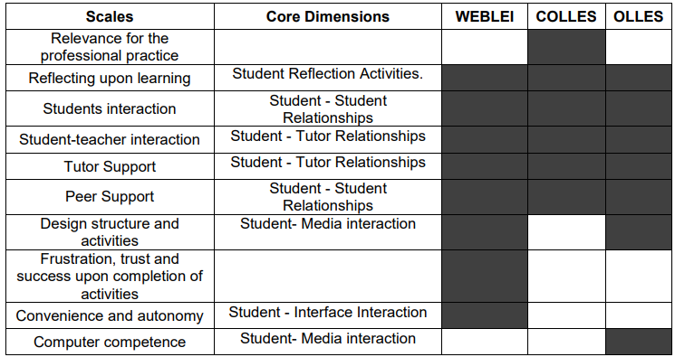
Figure 1: Analysis of Assessed Dimensions in the Survey Questionnaire
Source: (Herrera, 2017)
The development and distribution of pedagogically effective e-learning environments depends critically on clear, actionable instructions and suggestions. This is because e-learning (or online education) is becoming increasingly commonplace in today's higher education landscape.

Secondary Research
The "Social Work Practice" course was chosen for this analysis because it includes a sizable number of participants and hence should yield reliable results. In Wales, social workers must spend 9 months at Level 6 studying this material as part of their post qualification requirements (i.e., year 3 undergraduate level). This module is provided through a series of in-person advising meetings led by faculty and staff of the delivering institution and the relevant hiring organisation (Rashid et al., 2021). The UWTSD Moodle VLE provides resources, although most of the work for this module is independent. In Figure 2 below, a summary of demographic data for the case study population is given.
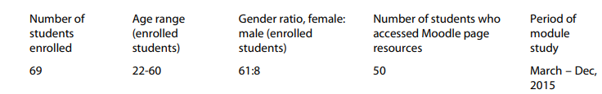
Figure 2: Demographic Data for Module
Source: (Barari et al., 2020)
After the study time ended, "course participation reports" were generated in Moodle VLE for the relevant module. Information on how many students examined each module's resources and how often they did so was included in the reports (referred to as "page views" in the reports). Page views by staff and others were excluded, even though multiple views by the same learner were kept because any student views were considered as signs of VLE involvement. Students' ages and sexes could be determined, but all data collected has been anonymized to protect privacy (Flavin and Bhandari, 2021).

Results of Secondary Research
Seventy-two percent is the fraction obtained by dividing the number of students who accessed the module's online platform by the total number of students enrolled in the course. In Moodle, students saw 7.5 pages on average, with female students viewing 8.2 pages and male students viewing 3.1. Just 8 of the students in this sample were male, thus it's possible that this comparison isn't valid.
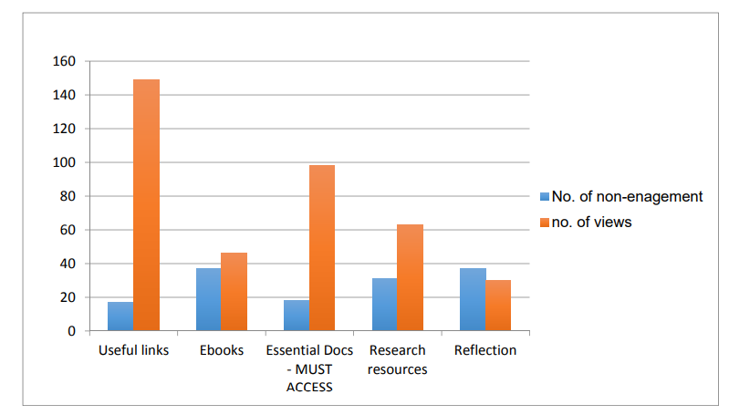
Figure 3: Page Views for Five Key Resources
Source: (Alves et al., 2017)
Figure 3 shows how often students accessed five essential materials from the module's Moodle site. All of the views shown here are those of the students, even those presented more than once by the same person. Figure 3 shows that students spent the most time on the "helpful links" and "important papers" pages because they were included in the list of necessary readings for the course (Barari et al., 2020). The "reflection" post appeared to have the fewest visits, yet despite being extensively covered during, it still managed to get more than 30 page views.
There are many approaches that teachers can take to boost student engagement. Work on learning design has highlighted the need of thoughtfully crafting the VLE's appearance and content, as well as the larger study plan, instructor interaction, and assistance. If you want to get the most out of your virtual learning environment (VLE), you should utilise the capabilities it offers rather than depending solely on documents.
Audio and video are not only more engaging than text, but they also may be more conducive to the preferred learning styles of the audience. Quizzes and SCORM-compliant learning objects are two examples of the kinds of interactive elements that might encourage active learning (Phungsuk et al., 2017). There is also the possibility that making some materials available to students before class may encourage them to come prepared. It is a great benefit of having a virtual learning environment to be able to see lecture notes before the actual class. This might be a very basic application of the technique known as "flipping," in which course materials are sent in advance of classroom lectures (Alves et al., 2017). Even if there are no concrete, unbiased information on the topic at the time, it is believed that this method will improve learning.
The secondary research was in relation to the primary research conducted as it concluded that the e-learning environment, necessitates instructional practises that help students to draw connections between previously learned material, acquire relevant knowledge, and use metacognitive thinking skills (Molotsi, 2020). It is necessary to analyse the learner, the learning environment, and the unique demands of the learners. When it comes to the success of the student and the online learning environment as a whole, different researchers have different ideas about what needs to be taken into account.

Conclusion
This report concludes that the number of student page views per resource on VLE sites is an accurate measure of student engagement with VLEs. When it comes to promoting VLE resources, it appears that the quantity of tutor and programme assistance, and especially tutor direction, is vital for work-based learners. Therefore, instructors play a crucial role in the instructional strategy employed while utilising a VLE. Almost all of these studies found that students fared worse online than in-person, with the exception of one that found hybrid education students outperformed their in-person counterparts. Because there is no external pressure from a teacher, students may lack motivation when they aren't able to interact with their peers or teachers in person (Al-Azawei and Al-Masoudy, 2020).

References
Al-Azawei, A. and Al-Masoudy, M., 2020. Predicting Learners' Performance in Virtual Learning Environment (VLE) based on Demographic, Behavioral and Engagement Antecedents. International Journal of Emerging Technologies in Learning (IJET), 15(9), pp.60-75.
Alves, P., Miranda, L. and Morais, C., 2017. The influence of virtual learning environments in students’ performance. Universal Journal of Educational Research, 5(3), pp.517-527.
Barari, N., RezaeiZadeh, M. and Alami, F., 2020. Designing and validating educational standards for E-teaching in virtual learning environments (VLEs), based on revised Bloom’s taxonomy. Interactive learning environments, pp.1-13.
Flavin, M. and Bhandari, A., 2021. What we talk about when we talk about virtual learning environments. International Review of Research in Open and Distributed Learning, 22(4), pp.164-193.
Herrera, L., 2017. Impact of implementing a virtual learning environment (VLE) in the EFL classroom. Íkala, revista de lenguaje y cultura, 22(3), pp.479-498.
Jain, P., 2015. Virtual learning environment. International Journal in IT & Engineering, 3(5), pp.75-84.
Molotsi, A., 2020. The university staff experience of using a virtual learning environment as a platform for e-learning. Journal of Educational Technology and Online Learning, 3(2), pp.133-151.
Phungsuk, R., Viriyavejakul, C. and Ratanaolarn, T., 2017. Development of a problem-based learning model via a virtual learning environment. Kasetsart Journal of Social Sciences, 38(3), pp.297-306.
Rashid, A., Shukor, N. and Na, K., 2021. Teachers' Perceptions and Readiness toward the Implementation of Virtual Learning Environment. International journal of evaluation and research in education, 10(1), pp.209-214.
Thamarana, S., 2016. Role of E-learning and Virtual Learning Environment in English language learning. Teaching English Language and Literature: Innovative Methods and Practices, ELTAI Tirupati, pp.61-62.

