Using at least 3 examples, consider how image makers have utilised digital technology to explore one of the following: Conflict, Identity, the Surveillance State, the Technological World?

Student Name: Alice Oliver
P Number: 1702213
Programme of Study: Photography in the Arts
Tutor: Paul Duerinckx

Module: M5X01599

Illustrations List

- Figure 1. Acconci, V. (1970). Service Area. [Installation] New York: MoMA.
- Figure 2 Bentham, J. (2018). Interior View of Cell House, New Illinois State Penitentiary at Stateville. Based on Bentham’s Original ‘Panopticon’. [image] Available at: https://off-guardian.org/2017/03/08/wikileaks-timely-reminder-of-our-digital-panopticon/ [Accessed 2 Nov. 2018].
- Figure 3. Paik, N. (1994). Internet Dream. [Video Wall] London: Whitechapel Gallery.
- Figure 4. Bartholl, A. (2010). Dead Drops. [USB Installation] New York: On the Streets.
- Figure 5. Bartholl, A. (2010). Dead Drops. [USB Installation] New York: On the Streets.
- Figure 6. Ulman, A. (2014). Excellences & Perfections. [Instagram] World Wide: Online.
- Figure 7. Wilson, A. (2012). ScanOps. [Photograph/Scan] London: The Photographers Gallery.
- Figure 8. Wilson, A. (2012). ScanOps. [Photograph/Scan] London: The Photographers Gallery.
- Figure 9. Wilson, A. (2012). ScanOps. [Photograph/Scan] London: The Photographers Gallery.

Using at least 3 examples, consider how image makers have utilised digital technology to explore one of the following: Conflict, Identity, the Surveillance State, the Technological World?

Artists from the 1960s onwards have drawn distinctions between digital technology, information, data, and their practice, questioning the validity and importance of these scientific terms and their boundaries. Through their work, artists have explored the art movement of Informatism and the relevance of information in everyday life, like semiotics, rules and instructions, social interaction and the political world. Informatism or information art is a developing field of art that is influenced by the technological world combining computer science, data and information technology with more traditional forms of art like visual, conceptual and performance art. Artists have questioned information’s overload and uncontrollable excess and access through digital technology. Through their work they have analysed technology’s potential to both misinform and disinform you, and how the digital world has the power to subliminally alter our perceptions. In this essay, I want to explore how data and information has influenced art and how artists have used information as more than just a material for art, and more so a process or method for art. I will discuss the (im)materiality of digital information, the ways in which artists receive and transmit data as art and how these new methods are revolutionising the industry.

Informatism is a movement that follows the 1970 exhibition organised by Kynaston McShine called ‘Information', which was held at the MoMA in New York. As an exhibition, it formally established that conceptual art was emerging not only in the US but also internationally. Vito Acconci’s work ‘Service Area’, was his contribution to the exhibition, at
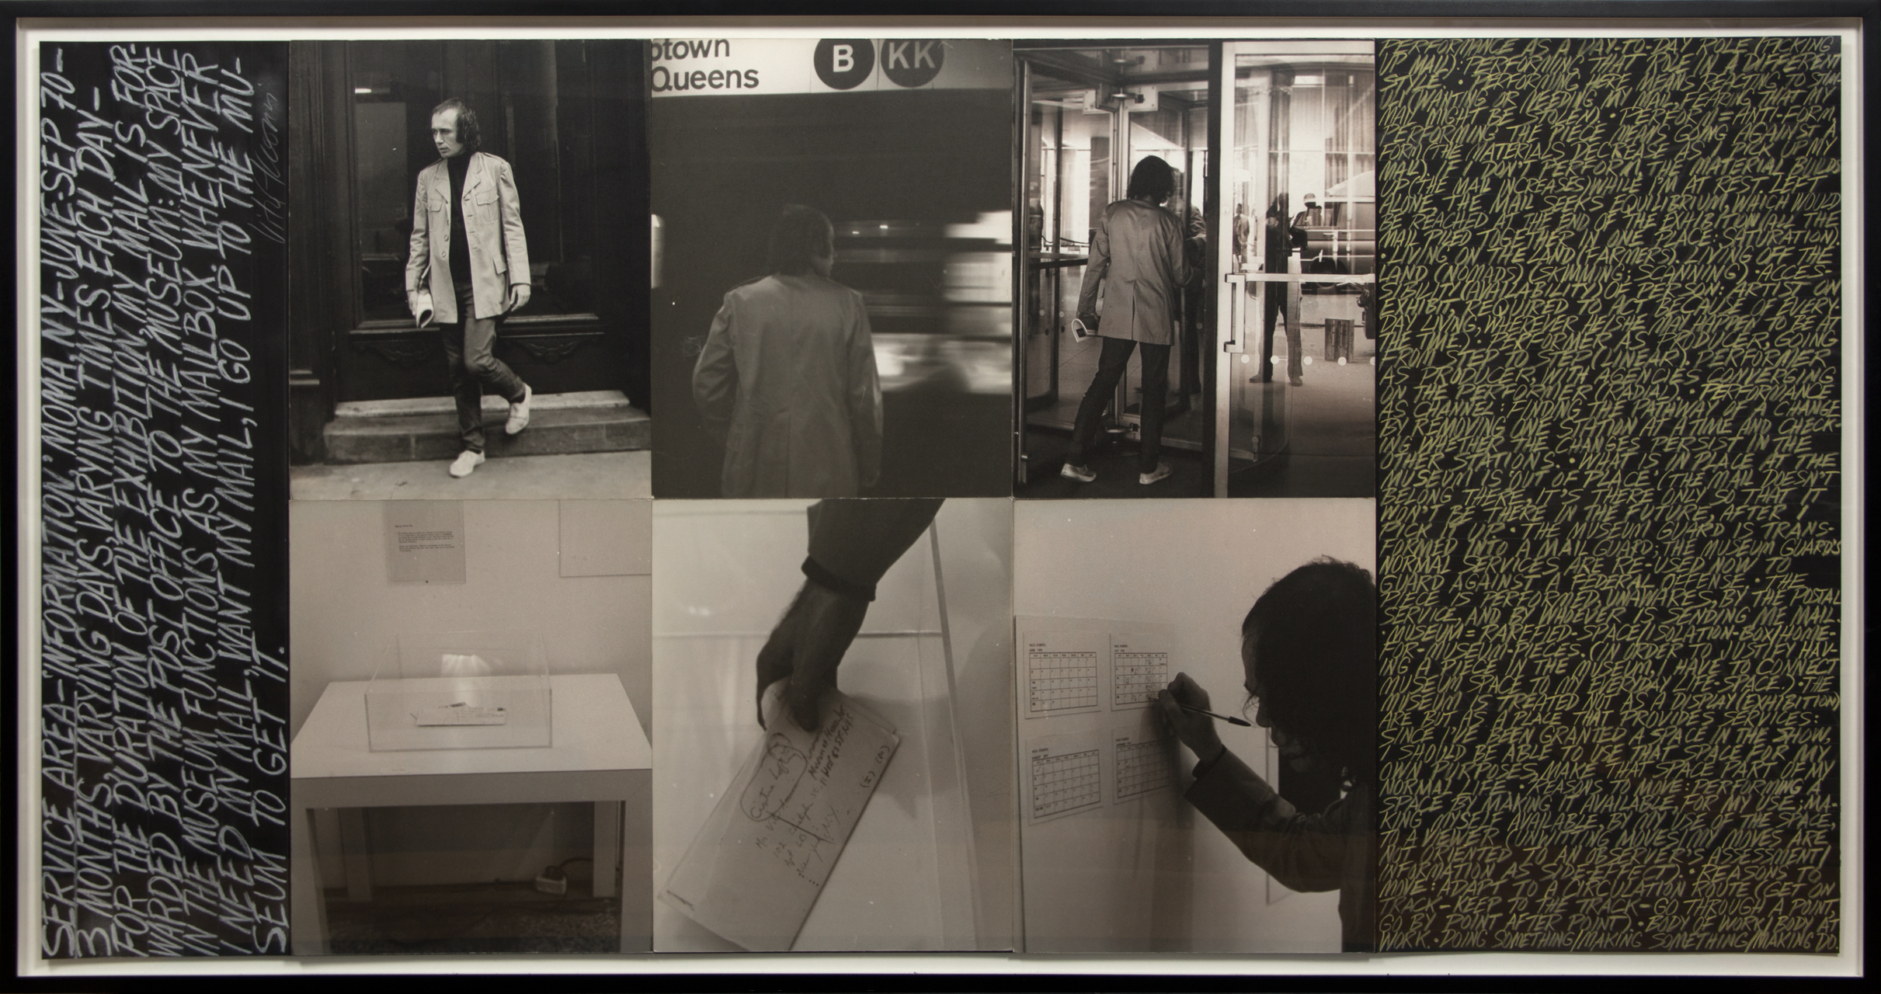
fig. 1
the MoMA (1970). This installation works with one of the most basic forms of information, mail. During the exhibition, Acconci’s post was forwarded to the MoMA by the post office. Acconci’s installation, a clear perspex box, functioned as his mailbox for the duration of the exhibition. When his mail was delivered to the museum, the museum-staff deposited it in Acconci’s box. Everyday, Acconci would arrive at the MoMA, pick up his mail, mark on a calendar the time and date of pick up, and leave. Like some of his other works from this time period, this installation explores the boundaries of the public and the private, commenting on the surveillance state. Acconci takes what is normally a private object and has the ‘state’ place it in a clear box for everyone to see. This now strongly relates to the technological world, both the use of social media, posting your private life for everyone to see and also, again, the surveillance state, with the government reading our private emails and texts. As Foucault states, ‘Our society is not one of spectacle, but of surveillance’ (Foucault, 1975). Foucault proposed the social theory of ‘Panopticism’, which refers to the ‘Panopticon’, a scientific experimental building designed by Jeremy Bentham in the late 18th century. A ‘Panopticon’ is a prison like structure that was designed in a way where everyone can be seen at all times. In Foucault’s words, ‘Bentham invented a technology of power designed to solve the problems of surveillance’ (Foucault, 1980). Foucault saw the ‘Panopticon’ as a symbol for society and the surveillance state. Through the use of surveillance cameras the Panopticon’s power is now continued electronically. Within his work, Acconci is subtly commenting on the power of surveillance, as if he knew how bad the surveillance state would get. However, it is interesting that the ‘Panopticon’ had involuntary surveillance whereas Acconci’s work was voluntary, perhaps suggesting a degree of narcissism.

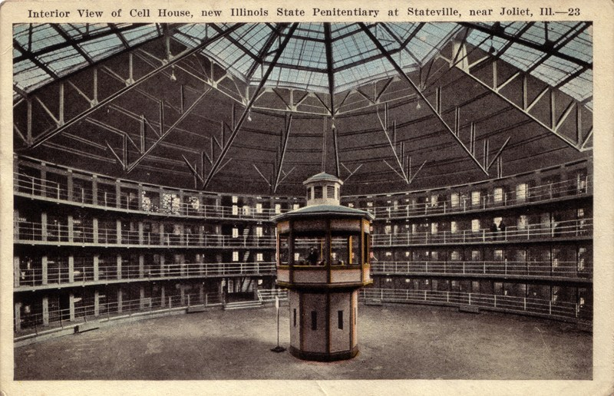
fig. 2

But digital technology isn’t all bad. For example, Nam June Paik embraced modern technology and in doing so, foresaw the future and predicted applications like Youtube and Skype. Paik's 1994 video wall entitled ‘Internet Dream’, a wall of 52 television screens playing electronically generated imagery and video, comments on the saturation of information we face. Paik was an innovator in the video art world, and in his 1974 essay, ‘Media Planning for the Postindustrial Society’, Paik came up with a theory for what we now think of as Skype or FaceTime, ‘I wonder what would happen if two groups can hear and see each other by means of a two-way cable television set-up…The building of new electronic super highways will become an even huger enterprise.’ (Paik, 1974) There seems to be a common theme between pre-internet artists. They foresaw the Internet age, both the potential of global connections through this technology but also it’s negatives.
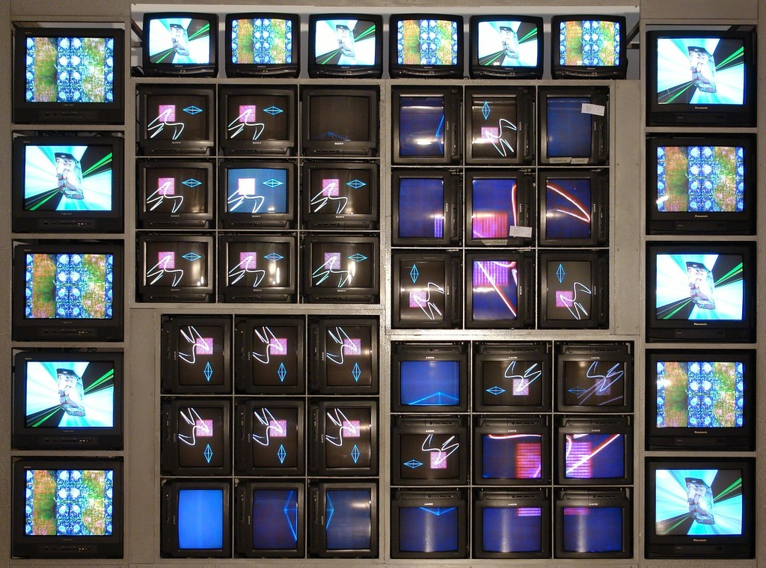
fig. 3

Another artist who used the idea of globally connecting is Berlin based artist, Aram Bartholl. In 2010, he placed a series of USB sticks around cities, titled ‘Dead Drops’. Often imbedded into walls and other permanent elements of the street, inviting members of the public to plug in their laptops, and share files. Bartholl describes ‘Dead Drops’ as ‘an anonymous, offline, peer to peer file-sharing network in public space.’ (Bartholl, 2010). Each USB was installed completely empty apart from a readme.txt file explaining the project. This project is both anonymous and collaborative at the same time, and digital technology allows for that. There are many arguments for the need of anonymity as well as the lack of it, in the digital age. As Google’s CEO, Eric Schmidt, said ‘the only way to manage this is through true transparency and no anonymity. In a world of threats, it is too dangerous for there not to be some way to identify you. We need a verified name service for people. Governments will demand it.’ (Schmidt, 2010). Schmidt is trying to imply that keeping details private doesn’t mean you have to be anonymous, but of course being anonymous will keep your identity private, however the government wants to know everyone’s identity. Bartholl plays with this idea of anonymous digital file sharing, not in a malicious way, but just to show how easy anonymity can be.
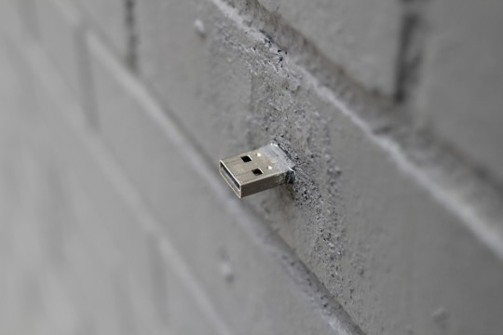
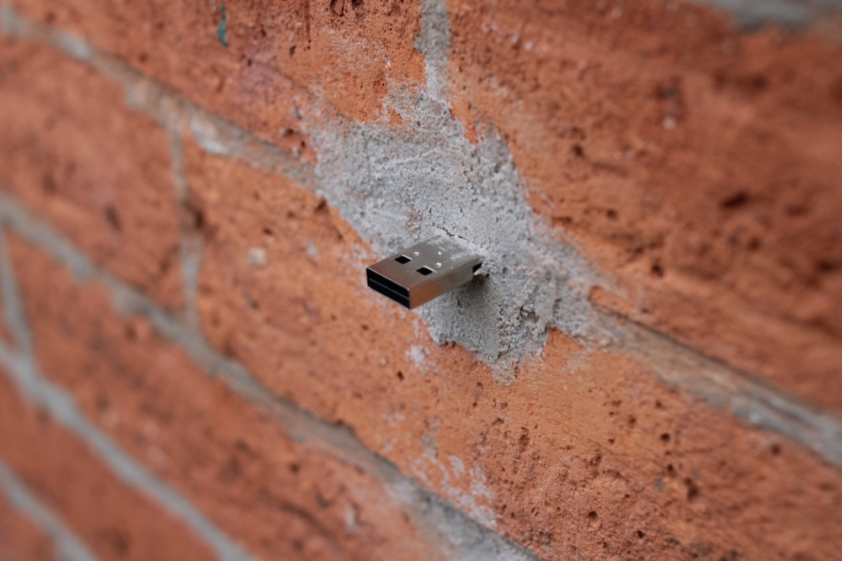
fig. 4 fig. 5

In 2003 a group of people started an group called ‘Anonymous’, which is an international ‘hacktivist’ group that is known worldwide for their cyber attacks against numerous governments, corporations and institutions. In 2010, they famously protested in support of WikiLeaks, an organisation who published and exposed information that governments were trying to hide. Anonymous marched to stand up to the mass Internet surveillance and other issues, ‘We have seen the pushes to make the Internet yet another part of the surveillance state’ (Anonymous, 2016). What I find most interesting about this hacktivist group is that they march wearing Guy Fawkes masks, to hide their identity and obviously, stay anonymous. The act of literally masking their identity mirrors the idea of hiding behind a computer screen as the digital age allows us to, having both pros and cons.

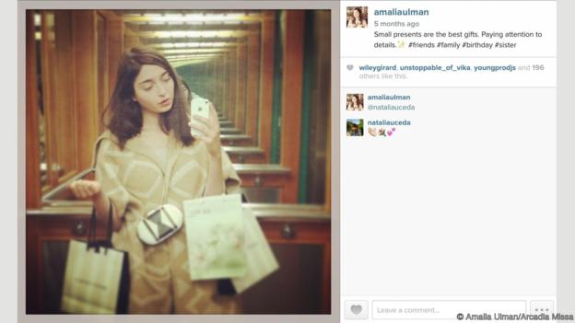
More recently social media has boomed, most people have one or more social media accounts, and we post too much about our lives and perhaps show too much interest in other people’s lives. Conceptual artist Amalia Ulman, known as the ‘Instagram artist who fooled thousands’ (Kinsey, 2016) carried out a four month long Instagram experiment, named ‘Excellences & Perfections’ in 2014. She created an online persona and took to Instagram to ask her followers questions about gender and sexism. She used fashionable hashtags and mimicked other ‘Instagram Famous’ accounts, Ulman turned her account into a three part performance that she used to explore a woman’s image online, how they present themselves and how they are seen. She took on three roles, ‘Cute Girl’, ‘Sugar Baby’ and ‘Life Goddess’, which Ulman said she chose because ‘they seemed to be the most popular trends online (for women)’ (Ulman, 2016). Ulman posted them in a chronological order, giving a better sense of narrative. Her story went along the lines of: she moved to the big city; broke up with her long term boyfriend; did some drugs; had plastic surgery; self-destructed; apologised; recovered and found a new boyfriend. By the final post of the act, on 19th September 2014, Ulman had compiled 88 906 followers. She then exposed herself and confessed that it was all a performance, fake and not real life. ‘Excellences & Perfections’ brought in a lot of criticisms and was described as a hoax, people felt as if they had been lied to or tricked. Ulman refers to this as a glitch, which is the gap between our real life and how we chose to present our lives on social media, and the way her followers reacted illustrates how easy it is to be fooled on the Internet. We will never know what is true and what isn’t. Throughout social media we are told to be ourselves and with the Internet in general, authenticity is what the government wants. Referring back to what Schmidt said about anonymity, these ideals are fortified by technology. The first question on a sign up form is always ‘what is your first and last name’ we are required to use our real names, but what’s to stop us from using fake ones? When the world wide web started there were less concerns about anonymity. As the anthropologist Daniel Miller said in a paper about online identities, commissioned by the government, ‘the Internet initially appeared to expand the field of anonymity, which meant people could explore new forms of identity, shift identity, or secure multi-identities with relative freedom. By contrast, Facebook has been associated with not just the loss of anonymity but as a threat to all aspects of privacy.’ (Miller, 2013). I guess the question is, are all social media accounts manipulated and performed to one degree or another? No one posts their real life, that would be impossible. So you could say that Ulman shows the same level of authenticity as every other account.
fig. 6
Leading on from false identities online, truth is a central theme in today’s society and with the present phenomenon of ‘Fake News’, the truth seems very hard to find. Online and on paper, there are news stories being written that aren’t true, and like the people who believed Ulman’s Instagram account was real, we fall for the misinformation and sometimes disinformation presented in the news. Whether the journalist just hasn’t got the facts straight or perhaps someone is maliciously trying to sell lies as the truth. ‘Fake news’ is often viewed as a negative effect of social media. For example, in 2016, ‘Facebook’ circulated numerous fake news articles, ahead of the U.S presidential elections. News stories that went viral during the presidential campaign often turned out to be completely untrue. It has been found that 68% of American adults say they often use social media as their morning newspaper (Matsa and Shearer, 2018), and more often than not they believe articles that are fake. We live in a Post Truth society, and as futurist philosopher, Yuval Noah Harari says ‘disinformation and propaganda were serious problems throughout history. Nowadays, the problem is exacerbated by the business model that has come to dominate the news market. In essence, this model is: exciting news that cost you nothing — in exchange for your attention. Your attention is captured by a sensational headline and is then sold to advertisers and politicians. In this battle for attention, there is little incentive to safeguard the truth’ (Harari, 2018).

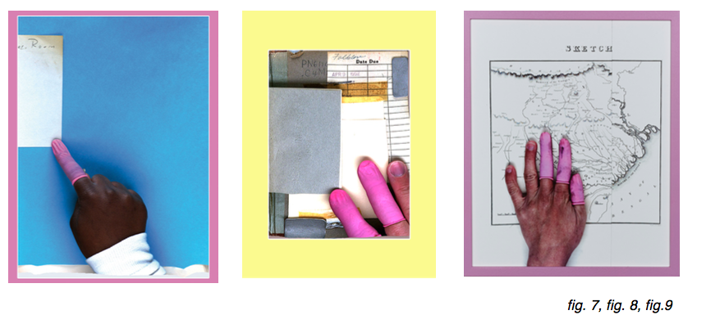
We expect the news to be true and we’re conditioned to believe that information produced by a computer is correct. For example, we take to Google to find all our answers and we naturally believe in the scientific algorithms, but how are we to know what is and isn't true? One artist that shows that it’s not all algorithms, is Andrew Norman Wilson and his body of work ‘ScanOps’. ‘ScanOps’ examines the systems, processes and hands behind Google Books. Surprisingly, Google Books are still scanned by hand; it’s still a manual process that is controlled by humans. Wilson’s body of work shows the anomalies and errors of the scanning process. The photographs show hands that are adjusting the texts in the scanners; their fingers are covered in single finger gloves. The gloves are used to protect the books from fingerprints, but they also cover the identities of the people. I find it interesting that we assume that Google presents all the right answers, but knowing that there are still humans behind it all, makes me realise how easy it would be for them to manipulate the information, and the world may still believe it to be true.

Digital technology has transformed the world, a world that is an increasingly quantifiable one, which is both, drowning and thriving in information. Artists have started to work with new modes of creativity, to question and challenge our modern society. The digital age has brought us negatives but it has allowed artists to come up with new innovative strategies to create art. Whether it is using data and information within their work, using forms of digital technology to make and present their work or to predict the future of the digital age through their work, they have successfully utilised the medium of digital technology to explore many topics including the surveillance state, identity, anonymity and the future of the digital age.

Word Count: 2164
References

Books

- Foucault, M. (1975). Discipline and punish. New York: Vintage Books.
- Foucault, M. and Gordon, C. (1980). POWER/KNOWLEDGE Selected Interviews and Other Writings 1972-1977. New York: Pantheon Books.

Articles, Journals and Papers

- Dundas, D. (2018). Yuval Noah Harari on big data, a post-truth world and why you need to meditate — now | The Star. [online] thestar.com. Available at: https://www.thestar.com/entertainment/books/2018/09/01/yuval-noah-harari-on-big-data-a-post-truth-world-and-why-you-need-to-meditate-now.html [Accessed 8 Nov. 2018].
- Kinsey, C. (2016). The Instagram artist who fooled thousands. [online] Bbc.com. Available at: http://www.bbc.com/culture/story/20160307-the-instagram-artist-who-fooled-thousands [Accessed 7 Nov. 2018].
- McShine, K. (1970). Information. New York: The Museum of Modern Art.
- Miller, D. (2013). Future Identities: Changing identities in the UK – the next 10 years. University College London: Commissioned by the UK Government.
- Paik, N. (1974). Media Planning for the Postindustrial Society. Medien Kunst Netz. [online] Available at: http://www.medienkunstnetz.de/source-text/33/ [Accessed 1 Nov. 2018].
- Schmidt, E. (2010). No Anonymity Is The Future Of Web.
- Ulman, A. (2016). The Instagram Artist Who Fooled Thousands. [online] Bbc.com. Available at: http://www.bbc.com/culture/story/20160307-the-instagram-artist-who-fooled-thousands [Accessed 7 Nov. 2018].

Websites

- Batholl, A. (2010). Dead Drops. [online] deaddrops.com. Available at: https://deaddrops.com [Accessed 16 Oct. 2018].
- Facebook.com. (2016). Million Mask March London 6pm Trafalgar Sq. [online] Available at: https://www.facebook.com/events/485894658146587/ [Accessed 4 Nov. 2018].
- Matsa, K. and Shearer, E. (2018). News Use Across Social Media Platforms 2018. [online] Pew Research Center's Journalism Project. Available at: http://www.journalism.org/2018/09/10/news-use-across-social-media-platforms-2018/ [Accessed 25 Nov. 2018].
- Solon, O. (2014). Artist reveals disembodied workers scanning books for Google. [online] Wired.co.uk. Available at: https://www.wired.co.uk/article/scanops [Accessed 5 Nov. 2018].

Bibliography

Books

- Cook, S. (2016). Information: Documents of Contemporary Art. London: Whitechapel Gallery.
- Floridi, L. (2014). The Fourth Revolution: How the Infosphere is Reshaping Human Reality.
- Foucault, M. (1975). Discipline and punish. New York: Vintage Books.
- Foucault, M. and Gordon, C. (1980). POWER/KNOWLEDGE Selected Interviews and Other Writings 1972-1977. New York: Pantheon Books.
- Foucault, M. and Miskowiec, J. (1986). Of Other Spaces. Diacritics.

Articles, Journals and Papers

- Dundas, D. (2018). Yuval Noah Harari on big data, a post-truth world and why you need to meditate — now | The Star. [online] thestar.com. Available at: https://www.thestar.com/entertainment/books/2018/09/01/yuval-noah-harari-on-big-data-a-post-truth-world-and-why-you-need-to-meditate-now.html [Accessed 8 Nov. 2018].
- Gratfton-Green, P. (2018). All you need to know about the Million Mask March 2018. [online] Evening Standard. Available at: https://www.standard.co.uk/news/london/the-million-mask-march-in-london-2018-who-are-anonymous-what-is-the-event-where-is-it-and-what-time-a3980191.html [Accessed 6 Nov. 2018].
- Kim, H. (2018). Philosophers on Fake News Arendt and Foucault on power and truth in media politics. PUBLIC SEMINAR.
- Kinsey, C. (2016). The Instagram artist who fooled thousands. [online] Bbc.com. Available at: http://www.bbc.com/culture/story/20160307-the-instagram-artist-who-fooled-thousands [Accessed 7 Nov. 2018].
- Koskela, H. (2003). ‘Cam Era’ – the contemporary urban Panopticon. Surveillance & Society. [online] Available at: https://pdfs.semanticscholar.org/057f/96137aa01bf42fc90f628ac5e5eff79951c8.pdf [Accessed 2 Nov. 2018].
- McShine, K. (1970). Information. New York: The Museum of Modern Art.
- Miller, D. (2013). Future Identities: Changing identities in the UK – the next 10 years. University College London: Commissioned by the UK Government.
- Paik, N. (1974). Media Planning for the Postindustrial Society. Medien Kunst Netz. [online] Available at: http://www.medienkunstnetz.de/source-text/33/ [Accessed 1 Nov. 2018].
- Schmidt, E. (2010). No Anonymity Is The Future Of Web.
- Ulman, A. (2016). The Instagram Artist Who Fooled Thousands.

Websites

- Batholl, A. (2010). Dead Drops. [online] deaddrops.com. Available at: https://deaddrops.com [Accessed 16 Oct. 2018].
- En.wikipedia.org. (2018). Anonymous (group). [online] Available at: https://en.wikipedia.org/wiki/Anonymous_(group) [Accessed 2 Nov. 2018].
- Facebook.com. (2016). Million Mask March London 6pm Trafalgar Sq. [online] Available at: https://www.facebook.com/events/485894658146587/ [Accessed 4 Nov. 2018].
- Kuo, M. (2016). Documents of Contemporary Art: Information. [online] whitechapelgallery. Available at: https://shop.whitechapelgallery.org/products/information [Accessed 15 Oct. 2018].
- Parser, B. (2007). Vito Acconci | Style of Negation. [online] Styleofnegation.wordpress.com. Available at: https://styleofnegation.wordpress.com/category/vito-acconci/ [Accessed 7 Nov. 2018].
- Solon, O. (2014). Artist reveals disembodied workers scanning books for Google. [online] Wired.co.uk. Available at: https://www.wired.co.uk/article/scanops [Accessed 5 Nov. 2018].

