10/11/2025
University of Wales Trinity Saint David
London campus
E-Portfolio Link: https://25145230.wixsite.com/my-site-7
Module Name: Learning In the Digital Era
Module Code: ACCA 4025

Student Name: Abdullah Karakan
Student ID:2514523
Group: 1
Lecture s Name: Koushik Modak

Lecturer’s Name: Koushik Modak

LDE Assignment 1
E-Portfolio
Table of Contents
Introduction 2
Task 1: Essential Academic and Employment Skills for the Future Career Path 3
Task 1 (a): Report on Essential Academic and Employment Skills 3
Task 1 (b): Evaluation of Task 1 (a) based on the Similarity report 4
Task 2: Collaborative Mind Map and Individual Poster 5
Mind Map (Collaborative) 5
Poster (Individual) 5
Task 3: Virtual Collaboration and RefWorks 8
Report on Virtual Collaboration 8
Step-by-step process of using RefWorks with visuals 10
Task 4: E-Portfolio Creation and Evaluation 13
Task 4 (a): E-Portfolio Creation 13
Task 4 (b): Illustrative Review of E-Portfolio Tool Selection 15
Conclusion 19
References 20
Task 1 References: 20
Task 3 References: 20

Introduction
This report will be a systematic account of the learning process, acquisition of competencies, and touch on the major digital and scholarly applications the student underwent in the course of the assessment. The work is a series of activities that aim to reinforce the student to analyse information, develop professional digital artefacts, deal with academic references, and use correct referencing methods. By using the services of Turnitin, Canva, Mind Map, and RefWorks, the student gained practical skills in creating digital content, using visual communications, and managing citations. The creation of an online e-portfolio also allowed the student to structure and engage with work in a visual and friendly way. All these activities testify to the increasing level of digital literacy, academic integrity, and reflective practice that the student can boast of, which are, in fact, the keys to success in university-level learning and in a professional career.

Task 1: Essential Academic and Employment Skills for the Future Career Path

Task 1 (a): Report on Essential Academic and Employment Skills
The current business environment cannot give the chance to Business Analysts to analyse the numbers alone because all the business tasks are now super-fast with a single click. The job will encompass the knowledge of the business functioning, problem-solving, and helping the companies in their decision-making. To be successful in this domain, it is very important to gain both professional and academic abilities in order to make a step forward in the educational life and career of Business Analysts [1].
Critical thinking is one of the most crucial skills, and it helps to unravel intricate problems and establish causes, and bring logical answers to the table. This is a very important skill because a Business Analyst has to deal with complex issues that must be evaluated carefully. This comes along with problem-solving and analytical processes that are essential since they assist in the analysis of data, creation of trends, and viable recommendations to organisations [2].
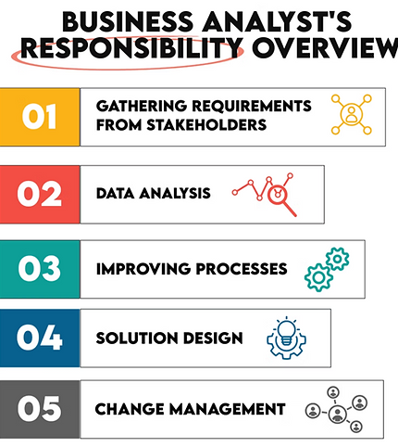
Figure 1: Business Analyst's Responsibility Overview
(Source: [3])
Business Analysts must typically liaise between the technical staff and business managers, and it is necessary to make the information presentable in a simple and clear manner. There is also a need for good communication skills when it comes to writing reports and presenting findings. Another desirable aspect is flexibility since the business tools and technologies are dynamic. Business Analysts will also be able to adapt to new software and new working modes that will render them viable and updated to the emerging scenario [4]. Lastly, the management and organisation of Time Management. This is crucial to be disciplined and schedule deadlines, meetings, and analysis work. The competencies are not only effective in the performance of academic institutions, but also in workplaces. Necessary skills related to the development will assist in managing projects successfully, solving problems, and being capable of being confident in business success [5].

Task 1 (b): Evaluation of Task 1 (a) based on the Similarity report
The similarity score was 41%, which is a low similarity score, which implied that the writing was largely original and there were few overlaps since the phrasings in academics were common. The subsequent submission would be improved because it will be required to paraphrase the content more appropriately, proofread it, and run it through a plagiarism detector to ensure that it is a hundred per cent original.
The work organisation, clarity, and the reflection of the knowledge in the subject make the work dependable, and thus the score should be around 74% out of 100%, yet the work on the critical analysis and the addition of more visual materials could be suggested to enhance the quality of the work, according to the Generic Assessment Criteria.

Task 2: Collaborative Mind Map and Individual Poster

Mind Map (Collaborative)
Mind map of Life is a Team Sport demonstrates the main elements of successful collaboration in academic and professional settings. It emphasises the importance of collaboration, communication, trust, and adaptability in order to complete common sets of objectives. Teamwork is the main theme that leads to success, and its main aspects are communication, which brings about clarity; leadership, which brings about direction; and problem-solving solving which brings about creativity and innovation. Conflict resolution has also been highlighted in the map as a valuable skill that should be used to ensure harmony and productivity. It also has digital teamwork tools such as Microsoft Teams and Google Workspace that facilitate work in virtual teams. The mind map shows how personal strengths can be used in a team to achieve a shared success. It reveals the assumption that well-coordinated teamwork will develop the learning process, create confidence, and prepare individuals to handle the upcoming work-related issues.
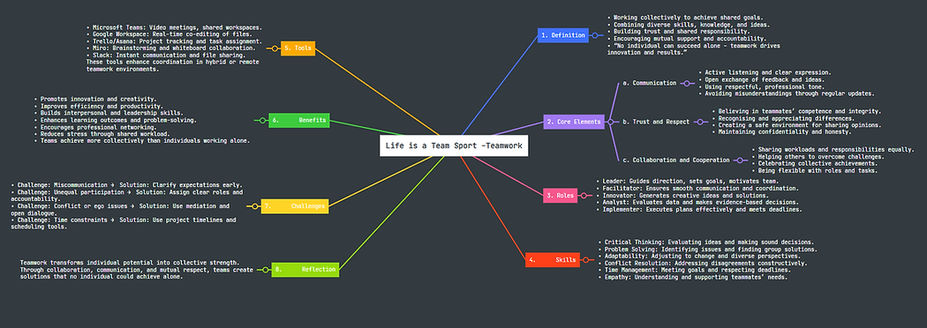
Figure 2: Mind Map

Poster (Individual)
Life is a Team Sport is a poster that attaches importance to the role of teamwork as one of the success factors in academics and work. It brings out the advantages of collaboration in enhancing creativity, solving problems and communication among individuals who endeavour to accomplish similar objectives. The poster gives out the benefits of working in a team, such as improved learning performance, enhanced effectiveness and interpersonal relations. It also describes some of the major skills of teamwork, which include the leadership skills, flexibility, accountability and conflict resolution skills. The visuals support the concept of togetherness and collaboration, because they are supported by the references to the digital collaboration tools like Microsoft Teams and Trello that help teams in virtual teams to collaborate. The mediation between theory and practice that is facilitated by this poster demonstrates that not only is teamwork effective in improving academic performance, but it also equips someone to be prepared to work in their future career. Lastly, it is an indication of a realisation that learning and success are community achievements premised on trust, respect, and purpose.

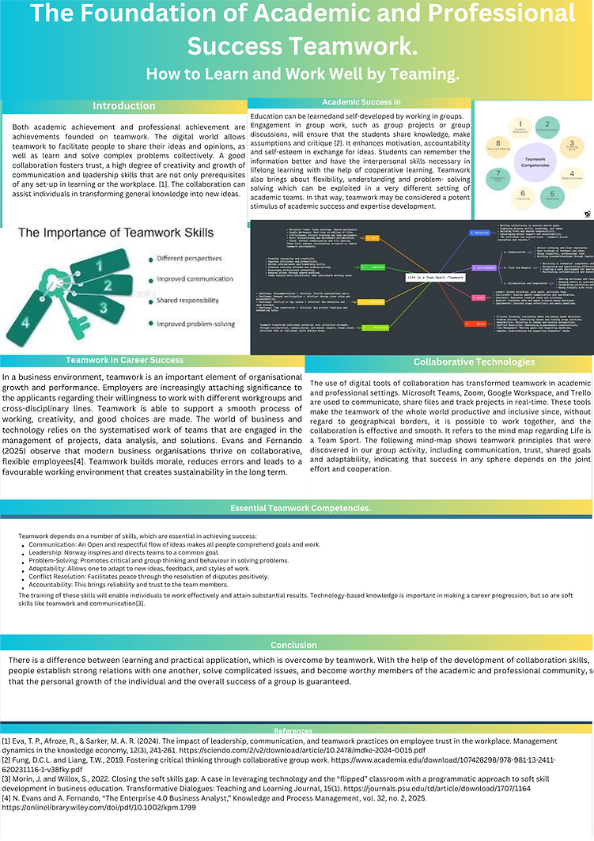
Figure 3: Poster

Task 3: Virtual Collaboration and RefWorks

Report on Virtual Collaboration
In virtual collaboration, distance, communication obstacles and cultural diversity usually pose challenges to the teams. Topic 2: Riding the Storm is the discussion on the nature of conflict as a usual phenomenon in virtual teams and the way to handle it as a process to keep the team functioning and trusting each other. Conflict is not a bad thing; when it is managed positively, it brings creativity, problem-solving solving and a closer relationship among the team members.
The conflict that occurs during the storming stage of the team development model, which is created by Tuckman, is usually seen when members of the group are trying to establish their own ideas and positions in the group. [1]. The latter can easily be addressed by physical workplaces because it is possible to discuss the problem face-to-face and make non-verbal statements. In virtual teams, however, there are communication barriers and the absence of emotion, and the intent is more difficult to read, which causes misunderstanding and tension. Difficulties in responding promptly, lack of clarity in delegation of the tasks, and lack of consistency in participation may also cause frustration among the members.
Conflict avoidance is also harmful as it enables factors to grow unchecked and cause a lack of cohesion in a team. Open communication and psychological safety can help resolve differences that take place in teams early on in an effective virtual team. [2]. Honesty and sincere concern towards co-workers is another principle proposed by Kim Scott, which is called Radical Candour. Any feedback that is delivered in a respectful and empathic manner will block resentment and foster improvement.
Technology is also important in the management of team dynamics. Microsoft Teams, Zoom, and Slack are platforms that allow real-time work and assist in closing the communication divide. [3]. The utilisation of mutual documents, group chats, and frequent video visits will make sure that no voice is ignored and misunderstandings are reduced to a minimum. Having team norms, including expectations of responses, meeting times, and conflict resolution measures, is other provisions that increase transparency and trust.
To summarise, as demonstrated in Riding the Storm, conflict is a certain but controllable aspect of teamwork. Using emotional intelligence, active listening and structured communication, virtual teams can make the friction a step towards progress and make the challenges an experience to grow [4].
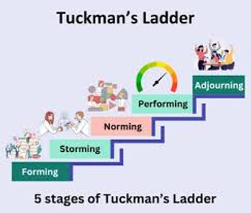
Figure 4: Tuckman's Ladder
(Source: [5])
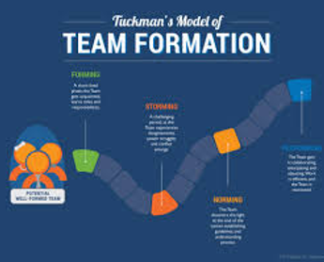
Figure 5: Tuckman's model of team Formation
(Source: [6])

Step-by-step process of using RefWorks with visuals
My experience with using RefWorks was productive and helped me gain a better idea of academic references and citation management. The device simplified the process of gathering, arranging and inserting references in the correct referencing format in IEEE format, with a time-saving factor and uniformity. It also facilitated minimising the mistakes that are usually experienced with manual referencing. The folder system and citation generator came in handy, especially when I needed to keep several sources in various tasks. All in all, RefWorks helped me to become a more professional worker, improve my research skills, and evaluate the significance of academic honesty in the case of utilising external sources in written work.
Step 1: Login:
In step 1, we need to create an account on the RefWorks library to begin with step 1 in citation
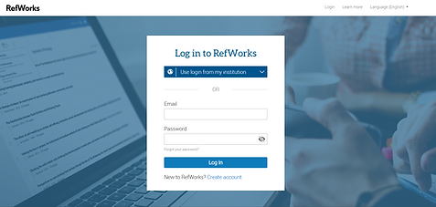
Step 2: Upload Paper
In this step, we need to upload the paper that needs to be cited in the research.
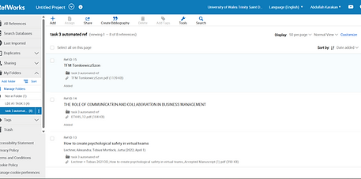
Step 3: Paper Added
In Step 3, after the papers have been successfully uploaded, we can see the research article on the RefWorks site.
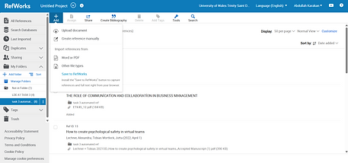
Step 4: Citation: The Last step, where we can see the uploaded paper in the Add-ins section, from there we can cite the paper directly with the correct citation.

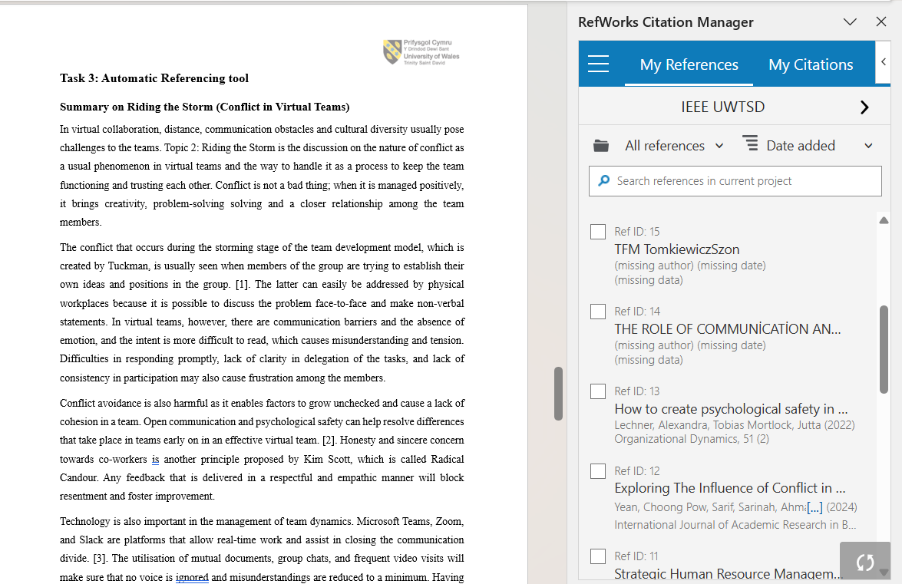
Step 5: Papers cited
In the final step, we can see the citation added, referring to the papers in the RefWorks site.
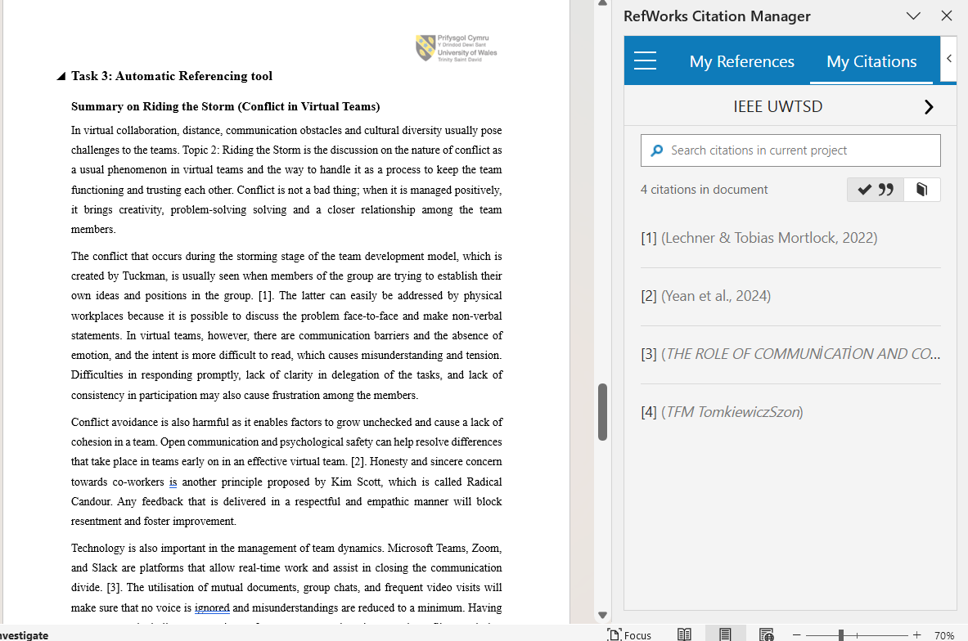
​

Task 4: E-Portfolio Creation and Evaluation

Task 4 (a): E-Portfolio Creation
Wix is a web development program that is based on the cloud; thus, a person can make a professional webpage without being an advanced coder. It also offers a simple drag and drop editor in which the layouts, images and text can be customised easily. An interesting variety of templates is provided by Wix to support portfolios, blogs, businesses, and educational projects, which is why it can be considered a strong tool to express creativity. Also, it offers multimedia integration, mobile optimisation, and integrated SEO to promote online presence. The Wix site proves to be especially valuable to students and professionals who need to create online portfolios, present their work, and comment on their personal learning experience. The site will also have collaboration tools, analytics, and a secure host on the cloud with accessibility and reliability. All in all, Wix allows users to create attractive, practical, and customised websites, which would enable them to showcase their competence and success in the current digital context of learning and working.
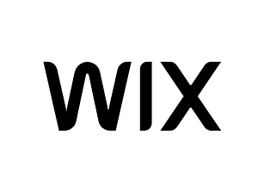
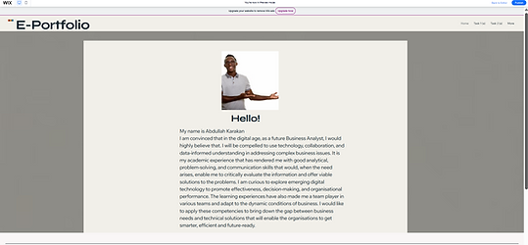

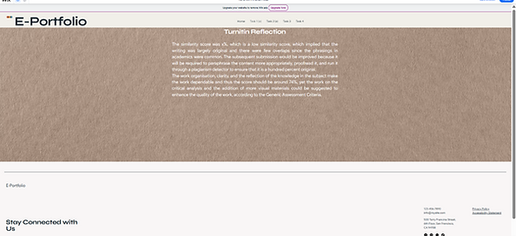
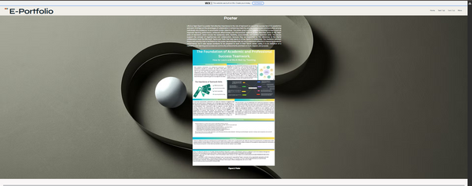
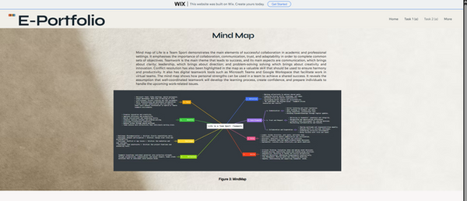
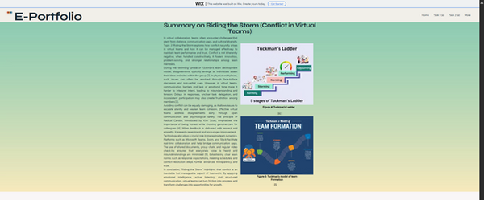
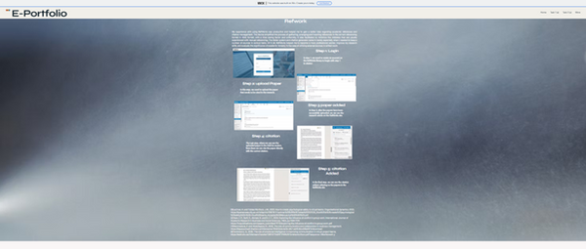

Task 4 (b): Illustrative Review of E-Portfolio Tool Selection
Task 1 - Essential Skills for Study and Employment
The fundamental academic and professional skills that are examined in this task are communication, critical thinking, problem-solving and time management. It describes the role of these skills in achieving success in education and in future occupations, especially in business analysis, with the help of reliable research and sources mentioned in the IEEE.
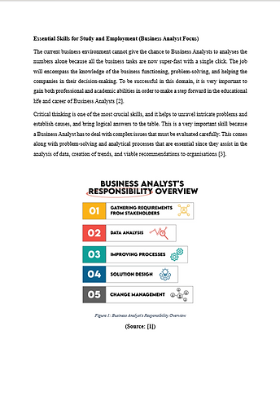
Task 1 A)
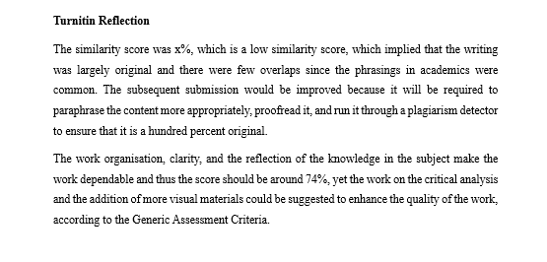
Task 1 B)
Task 2 - Cooperative learning and Academic Poster.
The given task is devoted to the role of teamwork in academic and career success. It carries a poster which is called Life is a Team Sport and a mind map which depicts the aspects of teamwork, such as communication, leadership, and teamwork. The assignment shows that teamwork and mutual objectives result in learning and career development.
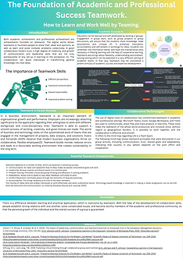
Task 2 A)
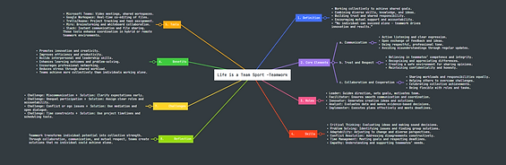
Task 2 B)
Task 3 - RefWorks (Automatic referencing tool)
In this assignment, the author shows how the automatic referencing tool RefWorks can be used to organise and cite references in IEEE format. The topic chosen is called Riding the Storm and it is about managing conflicts within virtual teams and the importance of proper referencing in enhancing academic integrity and professional writing ethics.
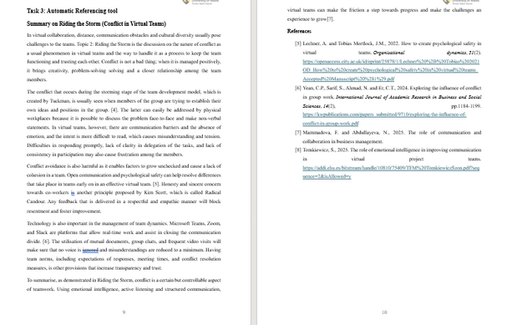
Task 3
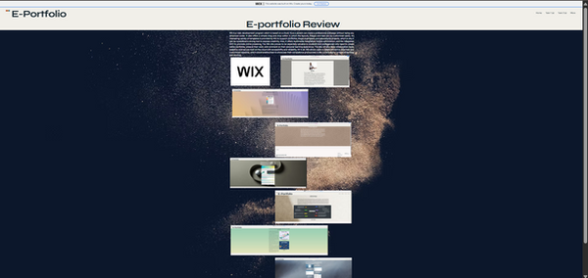
Task 4
Task 4 - Creation and Review of E-Portfolio.
This assignment is the preparation of an online e-portfolio on Wix to demonstrate all the activities done. It also contains screenshots, thoughts, and a review of the site concerning the design options. The assignment reflects digital literacy, creative and the skills to present academic work using contemporary online tools.

Conclusion
Conclusively, the report shows the remarkable development of the student in terms of academic and digital skills development in all assessment tasks. Through the utilisation of different technological applications, the student showed better skills in effective communication, creating powerful visual resources, and reference handling precision. The development of the e-portfolio was used as a key source where the student could display the work that has been done, and also show the capability to present information in a professional and structured manner. The reflective elements stimulated self-criticism, which enabled the student to recognise the strengths, work on the weaknesses, and value the role of digital literacy in academic learning. On the whole, the evaluation procedure boosted the confidence and ability of the student to utilise technology to help him/her with the research, presentation, and learning, and thus, made him/her ready for academic and professional demands in the future.

References

Task 1 References:
[1] A. Kowalska-Styczeń and K. Juszczyk, 2024. “PREPARING BUSINESS ANALYSTS FOR THE MODERN JOB MARKET: A COMPARATIVE ANALYSIS OF SKILLS AND EDUCATION,” Scientific Papers of Silesian University of Technology Organisation and Management Series, vol. 2024, no. 208, pp. 215–231, 2024, doi: https://doi.org/10.29119/1641-3466.2024.208.13.
‌[2] G. Pisoni, Bálint Molnár, and Ádám Tarcsi, 2023. “Knowledge Management and Data Analysis Techniques for Data-Driven Financial Companies,” Journal of the Knowledge Economy, vol. 15, no. 3, pp. 13374–13393, Nov. 2023, doi: https://doi.org/10.1007/s13132-023-01607-z.
[3]“Exploring the Role: What Does a Business Analyst Do and How? - StrataScratch,” Stratascratch.com, Nov. 10, 2023. https://www.stratascratch.com/blog/exploring-the-role-what-does-a-business-analyst-do-and-how/ (accessed Nov. 17, 2025).
[4] N. Evans and A. Fernando, 2025. “The Enterprise 4.0 Business Analyst: Digital Business Transformation Requires a New Mindset,” Knowledge and Process Management, vol. 32, no. 2, pp. 83–96, Mar. 2025, doi: https://doi.org/10.1002/kpm.1799.
‌[5] H. Kerzner, “Project Management,” Google Books, 2025. Available: https://books.google.co.in/books?hl=en&lr=&id=JRlHEQAAQBAJ&oi=fnd&pg=PR1&dq=p+R+OJ+ECT+MANAGEMENT+A+SYSTEMS+APPROACH+TO+PLANNING,+SCHEDULING,+AND+CONTROLLING&ots=eegG-_B5Zn&sig=qN40yCxZKd6v7-eqGCm4TNiNEVk&redir_esc=y#v=onepage&q=p%20R%20OJ%20ECT%20MANAGEMENT%20A%20SYSTEMS%20APPROACH%20TO%20PLANNING%2C%20SCHEDULING%2C%20AND%20CONTROLLING&f=false. [Accessed: Nov. 07, 2025]‌‌

Task 3 References:
[1]Lechner, A. and Tobias Mortlock, J.M., 2022. How to create psychological safety in virtual teams. Organisational dynamics, 51(2). https://openaccess.city.ac.uk/id/eprint/25878/1/Lechner%20%2B%20Tobias%202021OD_How%20to%20create%20psychological%20safety%20in%20virtual%20teams_Accepted%20Manuscript%20%281%29.pdf
[2]Yean, C.P., Sarif, S., Ahmad, N. and Er, C.T., 2024. Exploring the influence of conflict in group work. International Journal of Academic Research in Business and Social Sciences, 14(2), pp.1184-1199. https://kwpublications.com/papers_submitted/9710/exploring-the-influence-of-conflict-in-group-work.pdf
[3]Mammadova, F. and Abdullayeva, N., 2025. The role of communication and collaboration in business management.
[4]Tomkiewicz, S., 2025. The role of emotional intelligence in improving communication in virtual project teams. https://addi.ehu.es/bitstream/handle/10810/75409/TFM%20TomkiewiczSzon.pdf?sequence=2&isAllowed=y
[5] Tarek CHIHI, “Understand the Tuckman Ladder – Stages of Team Development, LinkedIn.com, May 21, 2025. https://www.linkedin.com/posts/tarek-chihi-76680a46_pmp-projectmanagement-teamdevelopment-activity-7330940940733288450-7Axl (accessed Nov. 17, 2025).
[6] I. Andrea, “Al psicólogo Bruce Tuckman se le ocurrió por primera vez la frase memorable ‘formar, asaltar, normar y actuar’ en su artículo de 1965, " Secuencia de desarrollo en grupos pequeños". Lo usó para describir el camino que la mayoría de los equipos siguen en su camino hacia un alto rendimiento.” Linkedin.com, Mar. 13, 2019. https://es.linkedin.com/pulse/modelo-tuckman-ivonne-andrea-ramirez-navarro (accessed Nov. 17, 2025).

