Report on Team Working and Communication within the workplace.
Word Count- 1829.

Module: Effective Team-working and Communication
DATE: 26TH June 2022

Submitted by

Muhammad Rahim
Student ID: 2118650

Executive Summary

In this report

Table of Contents

1.0 Terms of reference ……………………………………………………………………………………… 4

2.0 Procedure …………………………………………………………………………………………………… 4

3.0 Introduction ………………………………………………………………………………………………. 5

4.0 Main Findings ……………………………………………………………………………………………… 5

4.1 …………………………………………………………………………………….…….. 5

4.2 …………………………………………………………………………………………. 6

4.3 ……………………………………………………………… 6

5. Conclusion ………………………………………………………………………………………………….. 11

6. Reference List ……………………………………………………………………………………………… 12

1.0 Terms of reference

This report was requested by Melanie Squire, the lecturer on the skills for workplace of level 4 as part of the effective team work and communication module at University of Wales Trinity Saint David. Purpose of this report is to understanding on effective team and communication between the team members.

2.0 Procedure

To create this report materials accessed are academic articles, books, journals, industrial papers, materials from class lecture and available materials in moodle.

3.0 Introduction

This report is the reflection of effective team working and communication in work place.

In the case study it was observed that Andrea Jones was appointed as new Head of Social Services in the local Council after the last Head of Service resigned, following the poor performance of the department There were a number of issues like employee turnover and absence were high, relationships between social workers were not good, communication between the manager and staff were poor. There was no clear direction for the team and no one addressed their poor performance.

This report enhance understanding on above issues can have an effective solution with Belbin’s team role (Belbin R M, 2010, p23 ) analysis and by practising Tuckman model they can have an effecting and performing Team(Tuckman, B. 1965, p387). Why it is very important to have a two way and effective communication for a successful team also described in this report.

4.0 Main Findings

4.1 How Belbin and Tuckman can help in the case study:

Belbin Model:
A Team Role as defined by Dr Belbin is “A tendency to behave, contribute and interrelate with others in a particular way.” The value of Belbin Team Role theory lies in enabling an individual or team to benefit from self- knowledge and adjust according to the demands being made by the external situation (Aritzeta, A. & Swailes, S. & Senior, B, 2007, p96). From this Belbin’s model (Belbin R M, 2010, p23 ) we understand below team roles:

Action-oriented Roles: | Shaper: Shapers are highly motivated people with a lot of nervous energy and a great need for achievement. | Implementer: have practical common sense and a good deal of self-control and discipline. They favour hard work and tackle problems in a systematic fashion. | Completer Finisher: have a great capacity for follow-through and attention to detail. They are unlikely to start anything that they cannot finish.
People-oriented Roles: | Co Ordinator: The distinguishing feature of Co-ordinators is their ability to cause others to work towards shared goals. | Team worker: are the most supportive members of a team. They are mild, sociable and concerned about others. They have a great capacity for flexibility and adapting | Resource Investigator: are often enthusiastic, quick off the mark extroverts. They are good at communicating with people both inside and outside the company.
Thinking-oriented Roles: | Plant : are innovators and inventors and can be highly creative. They provide the seeds and ideas from which major developments spring. | Monitor Evaluator: are serious-minded, prudent individuals with a built-in immunity from being over-enthusiastic. They are slow in making decisions preferring to think things over. | Specialist: are dedicated individuals who pride themselves on acquiring technical skills and specialist knowledge. Their priorities centre on maintaining professional standards.

This theory can be applied in Andrea jones case by finding out team roles for each social worker and redesigning the teams containing all roles present. This will create sense of identity in team members.

The shaper and coordinator can work and team leaders who can motivate other team members and allocate work.

Team worker and Implementer can handle cases with families as these roles are good at executing tasks. This will help to improve team performance.

Resource investigator can communicate among other groups to seek support and resources. This will build trust and cooperation between teams.

Completer finisher can work projects with deadlines. This will also improve performance.

Plant and Specialist can bring up innovative ways to do a task, advise on methods to achieve target and communicate these ideas to team leaders and managers. This will fill in the communication gap between managers and team members.

Monitor evaluator would be very careful with the work process outcome of the project. This will help the team to be careful to produce reports.

Tuckman Model:
There is always greatest chance of high conflict between members of newly formed Teams.
The model describes how the team participants first come together, welcoming, well-mannered and now no longer a bit wary, how they descend into warfare whilst setting up their positions, how the limits are finally and someday tortuously set up and if all is going well, how the team members reaches to an area of balance where it is able to carry out to perform in their best abilities (Tuckman, B. 1965, p387).
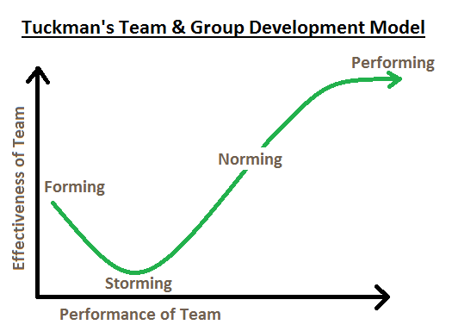

One of the most valuable lessons learned from the team analysis was understanding the need to guide elements of group structure and task to achieve outcomes ( Natvig, D & Stark. L, 2016, p680)

This theory describes that any team development goes through 5 key stages which are

Forming:
- Initial communication.
- participants consider personal and group aims.
- Uncomfortable about working with a new group
Storming:
- Group members initiate conflicting ideas
- Members compete for position
Norming:
- Cooperation developed
- Conflicts are settled
Performing:
- Teamwork achieved.
- Team role becomes flexible
Adjourning:
- When team work finishes.
- Members may reluctant to the change
In Andrea Jones case, teams were formed and stormed but before going to norming or performing stage, team members were changed, new team formed. So team couldn’t perform at its potential.

In order to increase team performance, team forming needs to be done according to Belbin’s theory. Conflicts need to be anticipated and measures need to be taken to reduce conflict.

Dealing With Conflict

A conflict style reflects an individual's preferences, behavioural tendencies, and habits in relation to managing conflict ( Guerrero. K, 2019, p24).

There is two ways to deal with conflict:

- Assertiveness:
- Communication style
- Being able to express feelings, thoughts, beliefs, and opinions in an open manner that doesn't violate the rights of others

2) Cooperativeness:
- Personality trait
- Concerned with the degree to which a person is generally agreeable in their relations with other people, as opposed to aggressively self-centred and hostile

Thomas Kilmann (1970) model is widely used to help evaluate someone might react to a conflict situation (Trippe & Baumoel, 2015, p91).

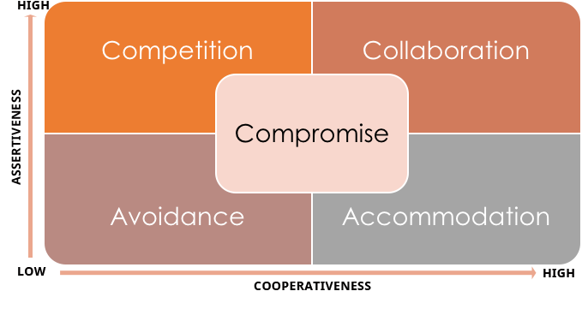
Effective ways to handle conflict based on Furze, D. & Gale, C. (1996, p313):

- Encourage openness
- Model appropriate responses
- Provide summaries and restatements of the position
- Bring in people who are not directly involved
- Encourage people to take time to think and reassess
- Use the strengths of the group
- Focus on shared goals
- Use directions and interests to develop areas of newly gained
- Try to build objectivity into the process
- Adopt an enquiring approach to managing

4.2 The importance of two way communication in the case study:

Two-way communication is a key factor influencing the trust and engagement of employees within an organization. It promotes the free flow of information in both directions and promotes the continuous growth of managers and employees. Two-way communication creates a more democratic environment where people, regardless of corporate hierarchy, can share their thoughts, ideas and opinions and improve relationships throughout the structure. Effective two-way communication is needed to better solve the problem. How an information normally communicated between sender and receiver is shown in below diagram:

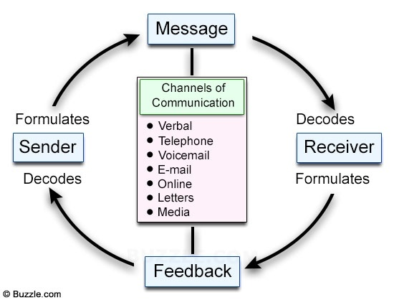

The communication model is the real result of systematically studying different aspects of communication. Communication models provide a comprehensive understanding of a system or structure and enable people to understand similar systems or structures. Three different effective models are:

- The Shannon-Weaver Mathematical Model of Communication(1949)
- The Berlo’s Model of Communication (1960)
- Schramm’s Model of Communication (1954)

The Shannon-Weaver Mathematical Model of Communication(1949)

This model is specially designed to develop effective communication between the sender and the receiver. This model deals with various concepts such as information sources, senders, noise, channels, messages, recipients, channels, destinations of information, encoding, decoding and so on. It is more effective for communication between individuals than for groups and large audiences. It’s linear way of communication, no feedback is involved in this communication model.

The Shannon–Weaver model of communication
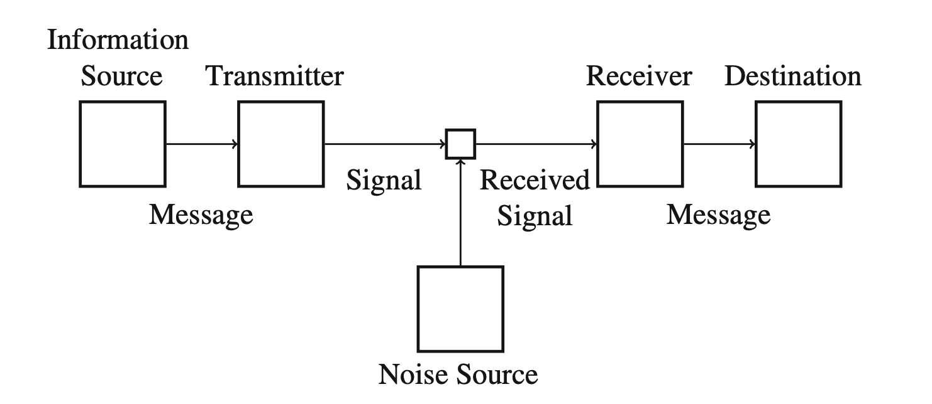
(Benz, 2012, p103)

The Berlo’s Model of Communication (1960)

Berlo's SMCR communication model (1960) describes the various components that make up the basic communication process. This communication tool also focuses on coding and decoding messages, so it can be used for more efficient communication. The acronym SMCR stands for Sender, Message, Channel, and Receiver. He argued that it was the listener who ultimately determined the meaning of a particular message.

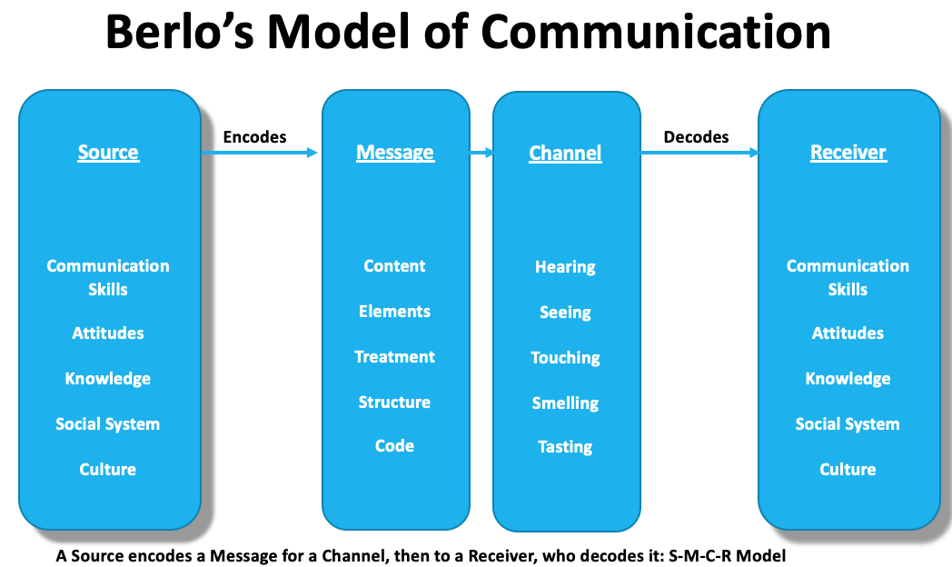
(Stead, 1972, p389)

Schramm’s Model of Communication (1954)

Schramm's communication model was hypothesized by Wilbur Schramm in 1954. So he suggested that communication is a two-way process in which both the sender and the receiver send and receive messages alternately. Information is useless unless it is carefully and clearly expressed and shared with others. The circular communication model is based on the theory and belief that communication is two-way. That is, there is at least one sender and one recipient. The model also contains at least one other element. The message itself. Communication is usually done in the traditional way with useless receivers and senders.

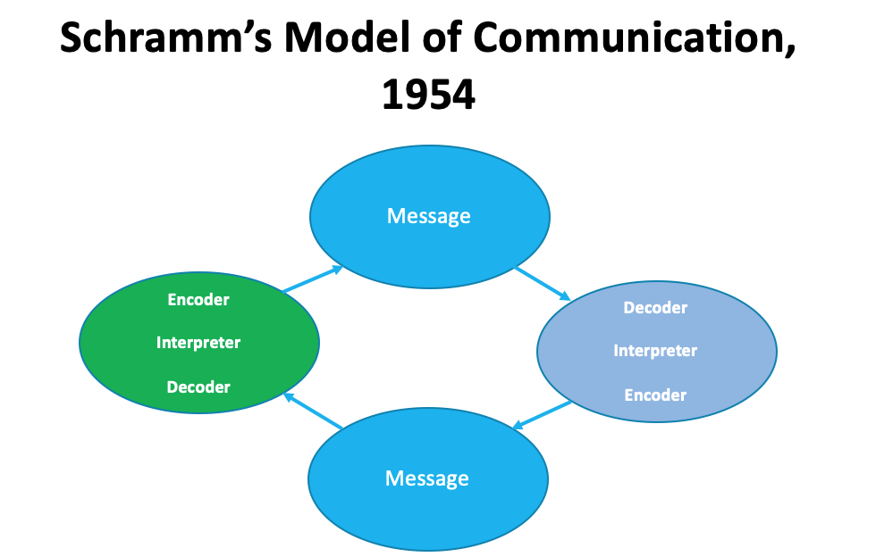
(Blythe, 2009, p2).

In Andrea Jones case study it was observed that new staff were joining frequently, so they had to go through team building again and again. In this scenario communication plays a vital role to make sure everyone has clear goal, two way effective communication can help to reduce conflict and improve the relationship between social workers. This will also avoid making mistakes and everyone gets a constructive feedback. For better performance there is no alternative than a effective two way communication across the entire organisation.

4.3 Why effective communication is important (verbal and non-verbal):

Good communication is an essential tool for achieving productivity and maintaining strong partnerships at all levels of the organization. The way in which we behave through various channels our words, facial expressions, tone of voice, and so on – will create impressions of us in the minds of others. Usually, whether we are successful in communicating what we wish to communicate will be influenced by aspects of communication that we can control. Our body language (non-verbal behaviour), the way we use our voice (para linguistic behaviours/cues), the context of learning from the conversations we had previously. These issues will all affect the way we ‘code’ our messages (Peter Morgan, 2017, p245).

Verbal communication is the things we say and non-verbal communication is the things we don’t say but communicated through body language, facial expressions and so on. Both are important and can say different things. So it is important we are aware of our own and others verbal and non-verbal communication.

Nonverbal communication is any symbolic activity that communicates a message other than words. This definition covers a wide range of topics: facial expression, hand movements, dress, tattoos, jewellery, physical attractiveness, timing of what happens, distance, tone of voice, eye movements, the positioning of furniture to create atmosphere, touch, smell – and that is not an exhaustive list ( Duck, S. & McMahan, D, 2015, p.89 ).

Context of Communication (Peter Morgan, 2017, p246)

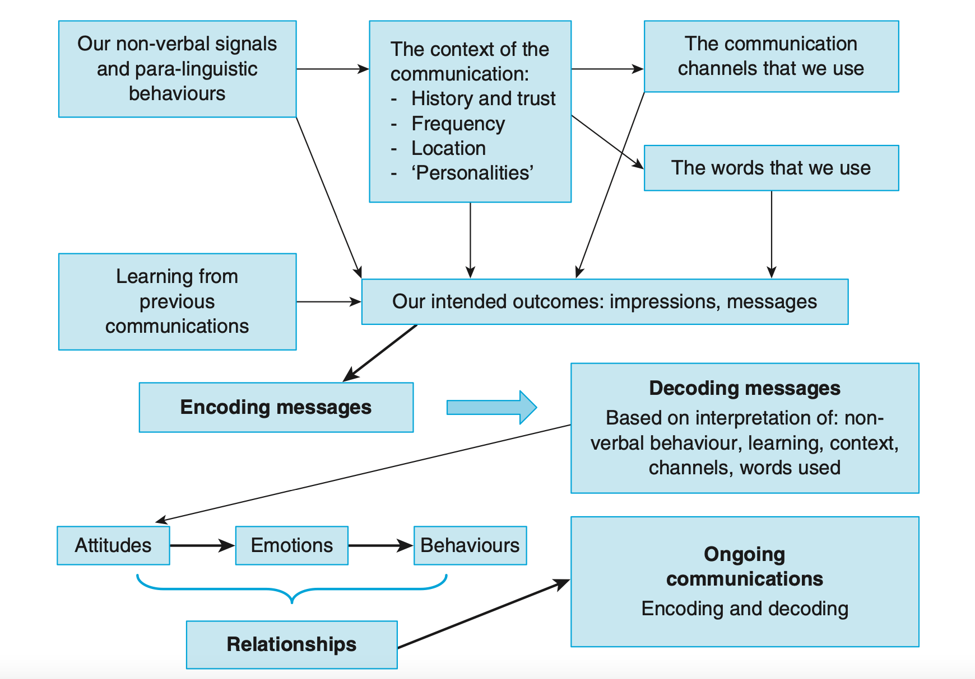
Above model presents that, the process of communication does not take place in isolation and there is a definitive process of communication that requires the ‘coding’ and ‘decoding’ (or translation) of information.

5.0 Conclusion

6.0 References
Aritzeta, A. & Swailes, S. & Senior, B (2007) Belbin’s Team Role Model: Development, Validity and Applications for Team Building Blackwell Publishing Ltd 2007, USA.
Peter Morgan (2017) The Business Student’s Guide to Study and Employability. 1st Ed. London: Sage Publications, Inc.
Blythe, J. (2009). The schramm model of communication. In Key concepts in marketing (pp. 178-180). SAGE Publications Ltd

STEAD, B.A., 1972. Berlo's communication process model as applied to the behavioral theories of Maslow, Herzberg, and McGregor. Academy of Management Journal (pre-1986).

Benz, A. (2012). Errors in Pragmatics. Journal of Logic, Language, and Information.

Belbin R M(2010) Team Roles at Work. 9th edn. London: Routledge

Tuckman, B. (1965). Developmental sequence in small groups. Psychological Bulletin

Natvig, D & Stark, L. (2016) A Project Team Analysis Using Tuckman's Model of Small-Group Development, Journal of Nursing Education

Trippe, B. & Baumoel, D. (2015) Beyond the Thomas-Kilmann Model: Into Extreme Conflict, Negotiation Journal, Oxford.

Guerrero, Laura, K.(2019). Conflict Style Associations with Cooperativeness, Directness and Relational Satisfaction: A Case for a Six-Style Typology John Wiley and Sons Danvers, USA.

Duck, S. & McMahan, D.T. (2015). Communication In Everyday Life. 2nd Ed. California: Sage Publications. Inc.

Furze, D. & Gale, C. (1996) Interpreting Management, Exploring Change and Complexity, Thompson International Press, pp. 312-317

