BA Computer Games Design –Matthew Evans 1707092
Production diary of retopology planning

Introduction
In this module I will be planning and working on a full body retopology from a high poly sculpted character. In my plan I will be marking out the time in which I have to complete this module and setting out specific days and time slots in which I will be completing tasks that I am setting myself.

I will also be making a risk assessment to counter any problems that I may come across when working on this module. This risk assessment will state a problem that could arise and have a way of combating the situation.

I will be documenting everything that I have done for this module in this production diary. I will include images to illustrate the work that I am doing.

Risk assessment
- As a precaution I will be backing up all my work on the computer I am working on, my portable hard drive and also on cloud storage. This is just in case I forget my drive or a file becomes corrupt.
- I will be taking regular breaks, making sure to go for a walk outside to reduce the risk of RSI whilst working on this project and to get some exercise so I’m not sitting down constantly.
- I will set time in my plan for me to do some possible extra work to help me get ahead of schedule just in case a problem does arise, causing me to be behind schedule.

Production Diary

Week 1
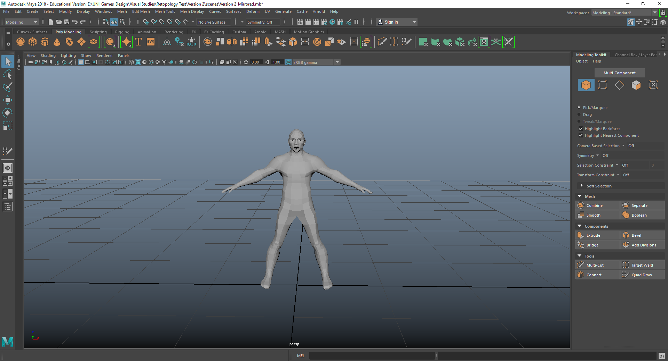
Creative Practice
Learning about modelling on Maya, basics of how to place and manipulate shapes in order to create models and assets. Learnt camera movement and how to use the edge loop tool. Practiced using the manipulation tools to manipulate the objects that were placed into Maya, such as the move, rotate, extrude and scale tools. I created a plan in excel to base my work off and to keep me on track. I will be using this plan to space out my work and to make sure that I am getting everything done by a certain time. I don’t think that I will be sticking to the plan completely as I will probably be ahead on some parts or something could come up and push be behind schedule. I have left room in my plan for adjustments just encase something does occur.

Week 2
Creative Practice
Fundamentals of Maya, learning about the axis within maya and that different engines use different axis, so before modelling can even start you have to know the axis for the engine that you are designing for.

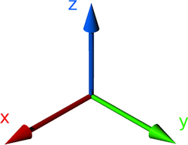
Started to model a basic barrel to develop my skills within Maya. Using the extruding tool to extrude parts of the object to create the basic shape and then using the other tools to manipulate the shape to make it look like the intended design. Used image references in Maya to manipulate a basic cube into the design, In this case I used an image of a blunderbuss and modelled it out of a single cube using the manipulation tools.

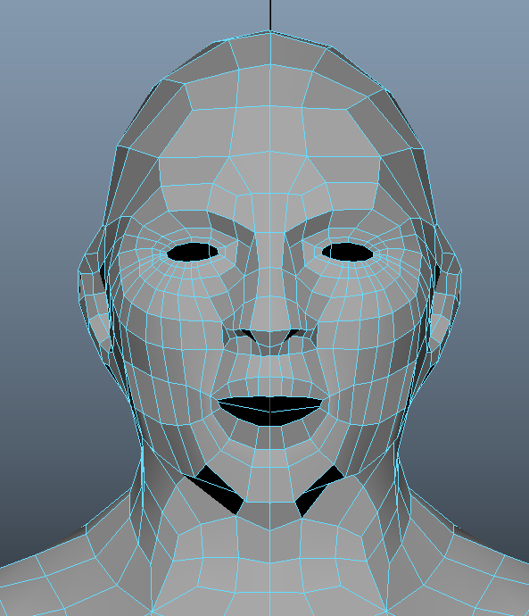
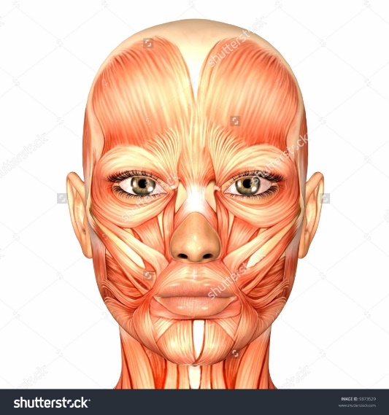
Week 3
Creative Practice
Started retopology, Learning the basics of retopology with tools and creating polygons. Started by making the High-poly model live to make it possible to draw the on polygons, I then started to do research into the facial anatomy to look at the muscle structures of the face to implement this into my retopology edge flow. I believe that this research will help me with my facial retopology. I blocked out the face with big polygons to get the basic structure. The eyes and mouth have 2 rings of polygons so they can open and close without effecting the rest of the facial poly structure in animation. The facial edge flow is based off the facial anatomy to give it the most natural look and movement in animation. I think that I did a good job with the face, I would like to take more time to work on the ears though as they were difficult to do and they connect to the head awkwardly with a lot of small polygons. For research I used the website “Aestheticcare.org (Care, F. (2017). FACIAL ANATOMY)”, on this website there are images and discriptions of what the muscles on the face do. I also used the website “humananatomylesson.com (HUMAN ANATOMY LESSON. (2016). Facial Muscle Anatomy)”.

Week 4
Creative Practice
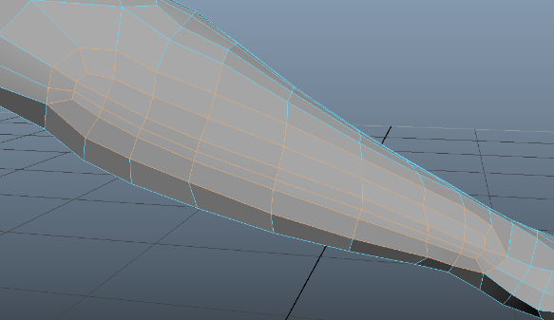
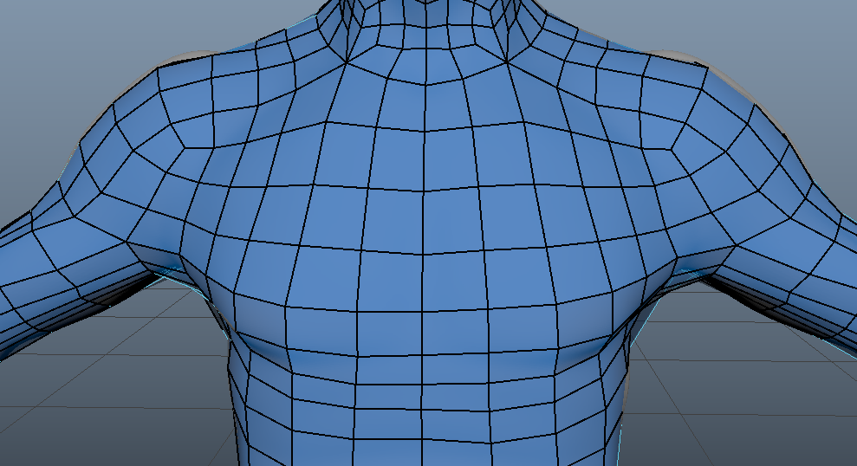
Continuing retopology and working more on the chest, back and arms. To retopologise the chest you start with big polygons and then add subdivisions later on to make it more shaped. The arms connect to the chest through the shoulder. The elbow and the forearm have to have a certain flow to them in order for them to be able to be animated well in later stages of character design. The elbow and forearm have the same edge flow and it consists of a rounded top and bottom to allow the elbow to bend realistically when it is animated, otherwise it would fold and warp the edges. I think I did the arm well as it has the correct edge flow and doesn’t look clustered with polygons. So far I am ahead of my plan, so I can spend more time researching and cleaning up my model. For research I used the website “polycount.com (Wiki.polycount.com. (2015). Limb Topology)”, this website shows images and diagrams of how the edge flow should work.

Week 5
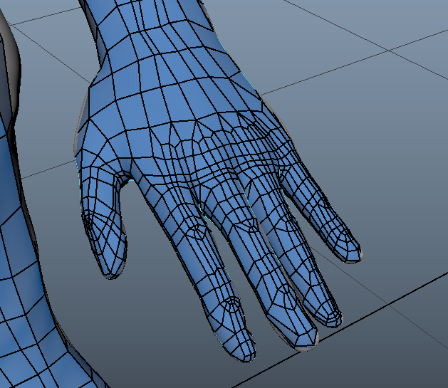
Creative Practice
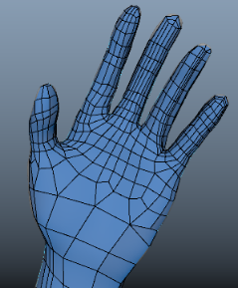
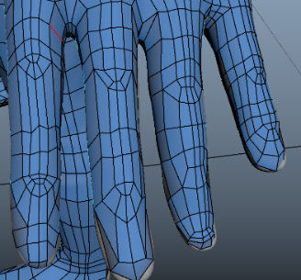
Continued work on retopologising my characters arms and hands. Using the same edge flow for the elbows on each finger to make sure that the mesh will move correctly when animating in the future. I have looked at images online to help with the edge flow of the hand. Each finger needs to have the same knuckle edge flow to make sure that the animations will move correctly. Out of class I continued work on the model by working on the legs and feet, making sure the knees also have the same edge flow as the elbows. For research on the hands I used a YouTube video “Youtube.com (YouTube. (2017). Hand Retopology)”. This video tutorial was a step by step guide to creating the joints on the hands.

Week 6
Creative Practice
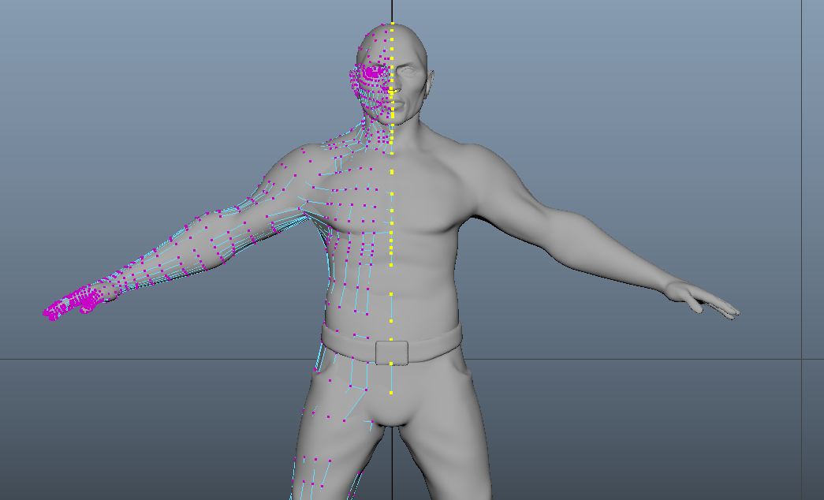
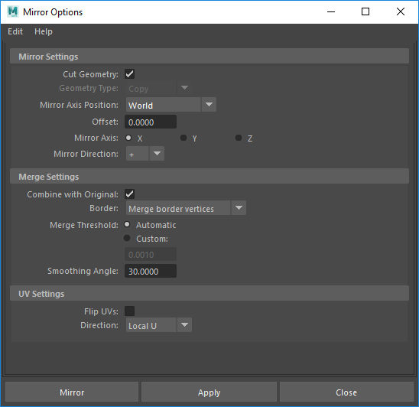
Started edge clean up to make sure all the edge verts on the half of my model are snapped to the grid. This will allow me to mirror my model to complete its other half. To do this I selected all the verts on the edge and used the scale tool to scale up the edges. I then used the move tool to snap all the selected verts to the grid. I then deleted my history and mirrored the model using the mirror tool settings. When the side was mirrored I then checked each vert on the connecting side of the model and checked that all of the verts were connected correctly. I also checked if there were any N-gons or duplicated verts. I am still ahead of my plan as I have been putting in more hours and also finishing the intended work quicker than predicted. To research more into mirroring I used maya’s website directly to see how it is done “autodesk.com (Knowledge.autodesk.com. (2017). Mirror Options)”. I also watched a YouTube video on mirroring to get a step by step guide “Youtube.com (YouTube. (2014). Maya 2014 tutorial)”.
Week 7
Creative Practice
I went through my model doing my final checks on it to make sure that there were no N-gons or triangles. I also checked my edge flow to make sure that I worked well and looked natural. I made a few adjustments to the quads on the back of my model where they were pinching into the middle. I deleted the quads and redrew them to make them fit better. I think that I was good at finding this problem and solving it with ease.

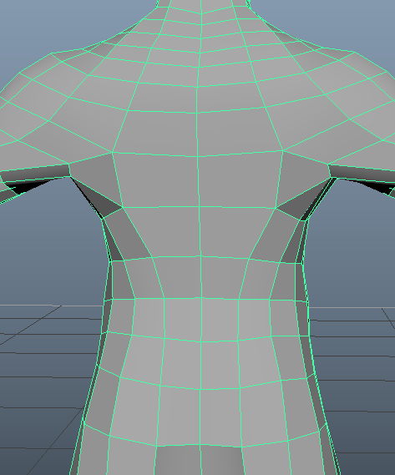
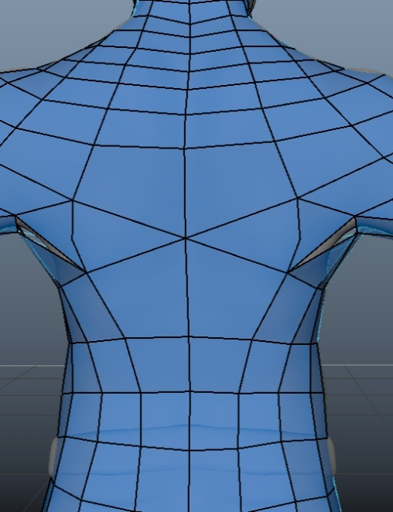

Week 8
Creative practice
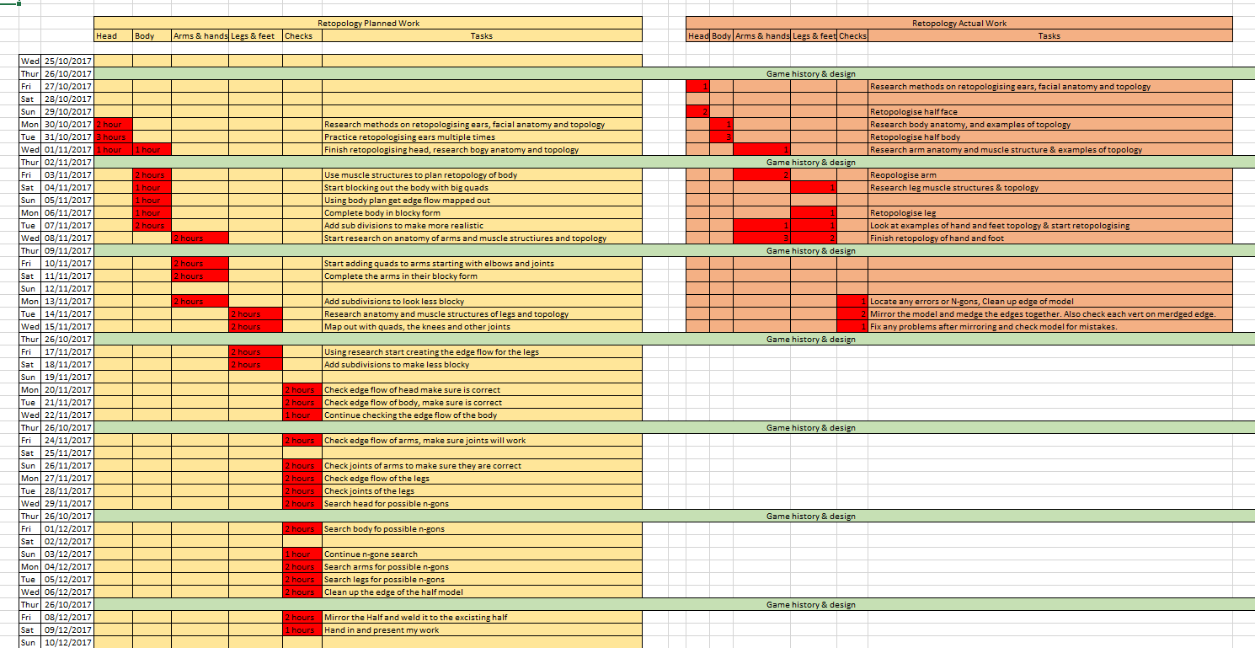
I have updated my production plan to make sure I have documented exactly what and when I did work. I have two versions of my plan, my planned work and what I actually worked, this is to show how I have worked around problems and gone ahead of my predicted schedule to compensate for any future problems.
Week 9
Creative practice
I went over my plan again to make sure that I hadn’t missed anything. I also adjusted my plan slightly to account for some extra work that I did.

Conclusion
To conclude I believe that I have planned my work well. I set targets to achieve and I met them as I worked through the module. I think that my plan was well organised and easy for me to understand, I knew exactly what I was doing on each day. Having a set plan helped me to organise how I was going to complete my work, I did go ahead of my schedule to get more work done in a small amount of time. This was because I thought it would take me longer to do some parts of the retopology. I will know this for next time and I will be able to create a more accurate plan for me to follow. By going ahead of schedule it allowed me to spend more time on researching and finding problems within my model.

Bibliography
Facial anatomy references
Care, F. (2017). FACIAL ANATOMY | Aesthetic Care. [Online] Aestheticcare.org. Available at: http://aestheticcare.org/facial-anatomy/ [Accessed 15 Oct. 2017].
HUMAN ANATOMY LESSON. (2016). Facial Muscle Anatomy - HUMAN ANATOMY LESSON. [Online] Available at: http://humananatomylesson.com/facial-muscle-anatomy/ [Accessed 13 Oct. 2017].

Retopology references
Wiki.polycount.com. (2015). Limb Topology - polycount. [Online] Available at: http://wiki.polycount.com/wiki/Limb_Topology [Accessed 23 Oct. 2017].
YouTube. (2017). Hand Retopology in Maya 2017 update 3. [Online] Available at: https://www.youtube.com/watch?v=bdafGU__lSc [Accessed 29 Oct. 2017].
Knowledge.autodesk.com. (2017). Mirror Options | Maya LT | Autodesk Knowledge Network. [Online] Available at: https://knowledge.autodesk.com/support/maya-lt/learn-explore/caas/CloudHelp/cloudhelp/2017/ENU/MayaLT/files/GUID-E66AE3D8-3B9C-4D4E-9A3E-5BDAFCD67F1D-htm.html [Accessed 4 Nov. 2017].
YouTube. (2014). Maya 2014 tutorial: How to mirror objects while box modelling. [Online] Available at: https://www.youtube.com/watch?v=yaueNw4rATM [Accessed 6 Nov. 2017].

(Word count: 1550)

