

Athlete Experience- Ironman Wales
By
Jennifer Collins
P146958

Jacqui Jones

Slide 1
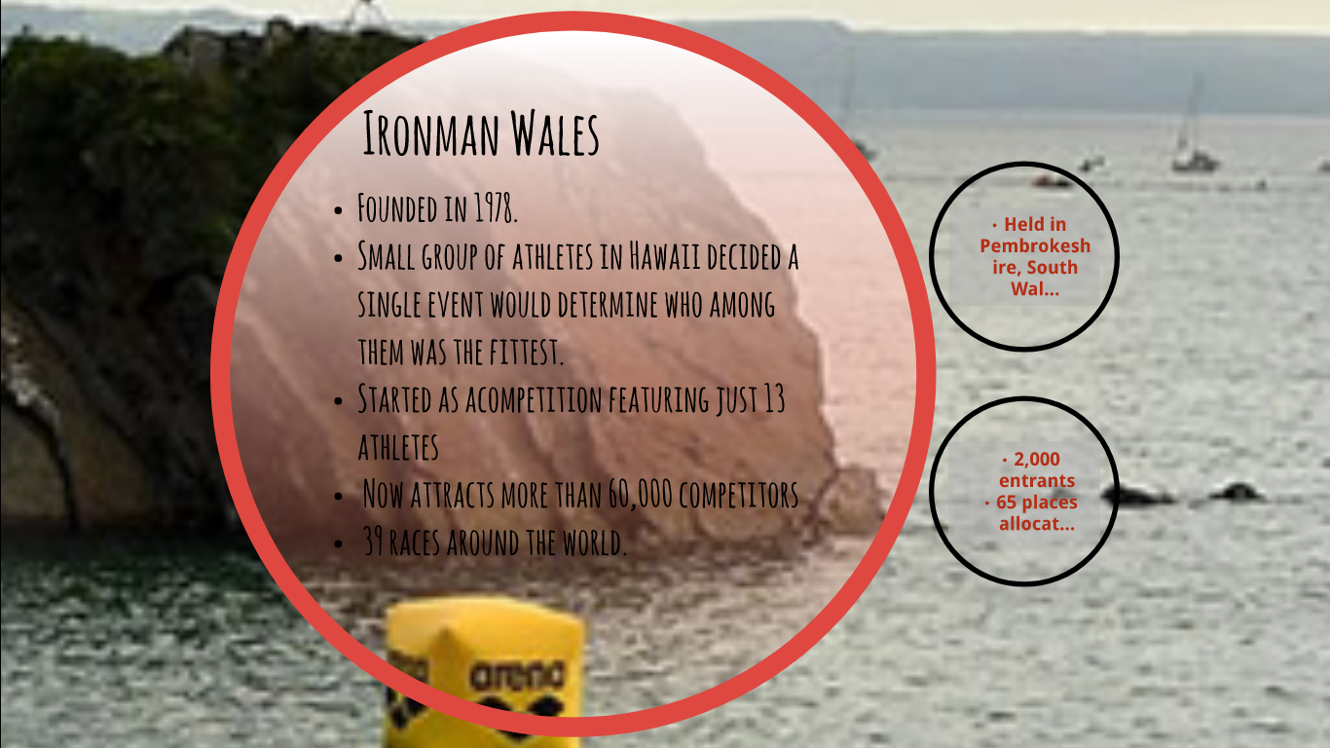
Ironman was founded in 1978 when a small group of athletes in Hawaii decided a single event would determine who among them was the fittest. From a competition featuring just 13 athletes the event now attracts more than 60,000 competitors who take part in 39 races around the world.
Slide 2
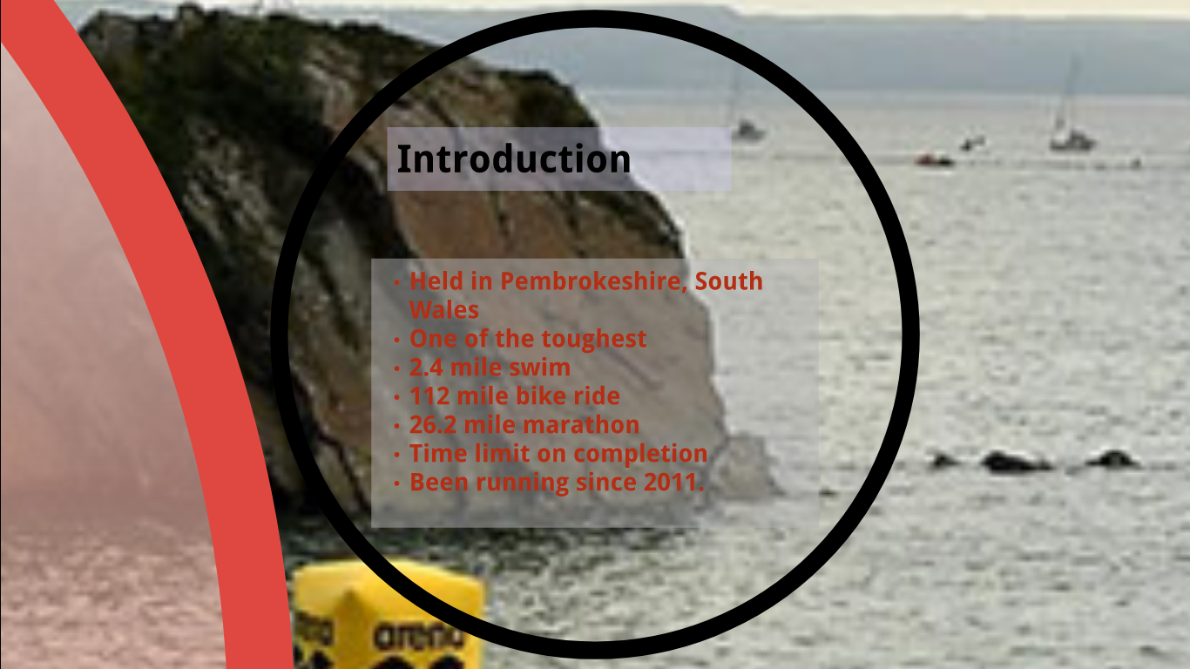
The event in Pembrokeshire is one of the toughest sporting challenges in the Ironman calendar and is made up of a, 2.4 mile swim, 112 mile bike ride, 26.2 mile marathon. The events have to be completed consecutively within 17 hours, with cut-offs for each part of the course. It has been running since 2011, and have signed a contract for a further 5years.
Slide 3
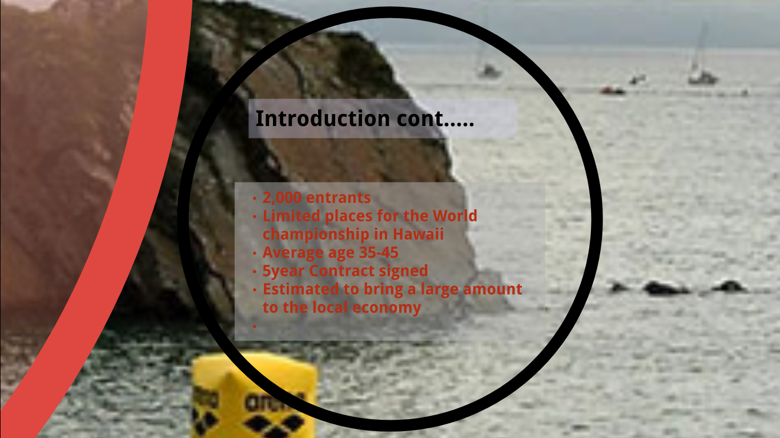
2,000 entrants each year. Only 65 places are allocated for the World championship in Hawaii. The winners from each age category. Average age of 36-45. 10% of entrants are local to the area, with competitors from over 30 different countries. 5year Contract signed between Pembrokeshire Council and Ironman. Estimated to bring £3.5 million to the local economy
Slide 4
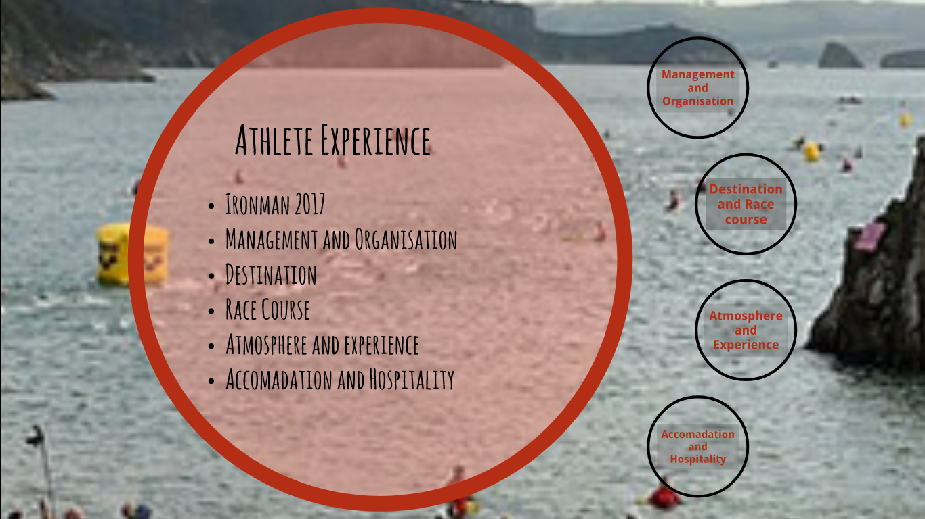
So looking at Athlete experience of the Ironman Wales, 2017 has been looked at as a case study.
Slide 5
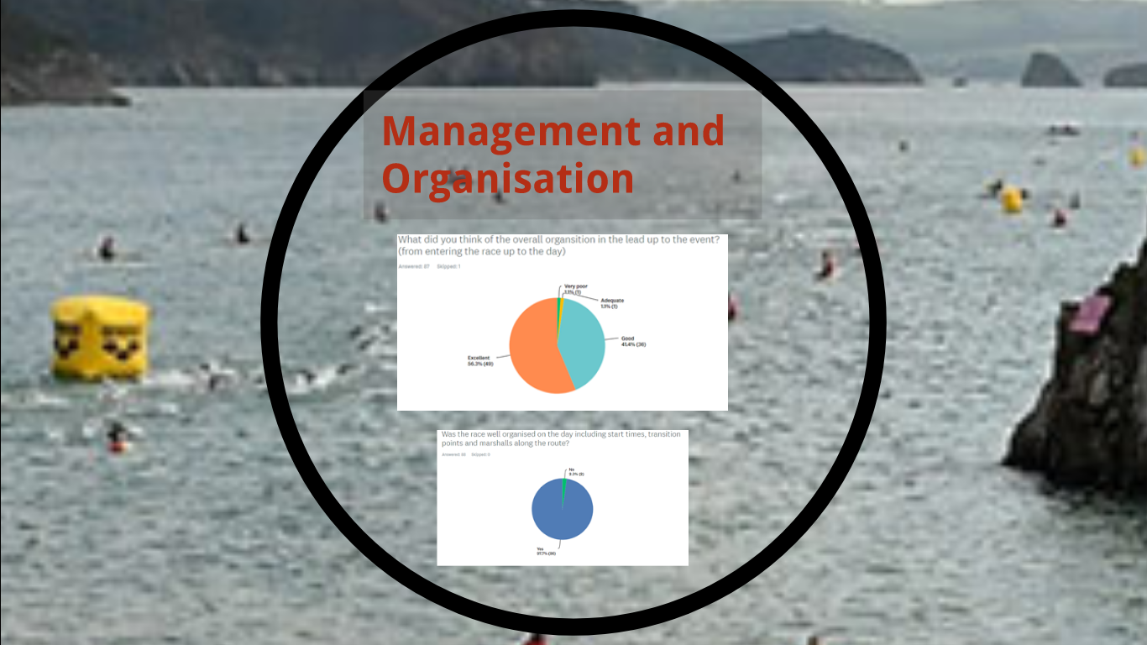
Having asked athletes their views on the management and organisation, very little, only 2% thought the organisation was poor, some comments included how well it was organised from booking to registration, through to the day of the race.
97% felt the race was well organised on the day, with a number saying the whole day ran like clockwork and they felt like they were all working together on the day.
Slide 6
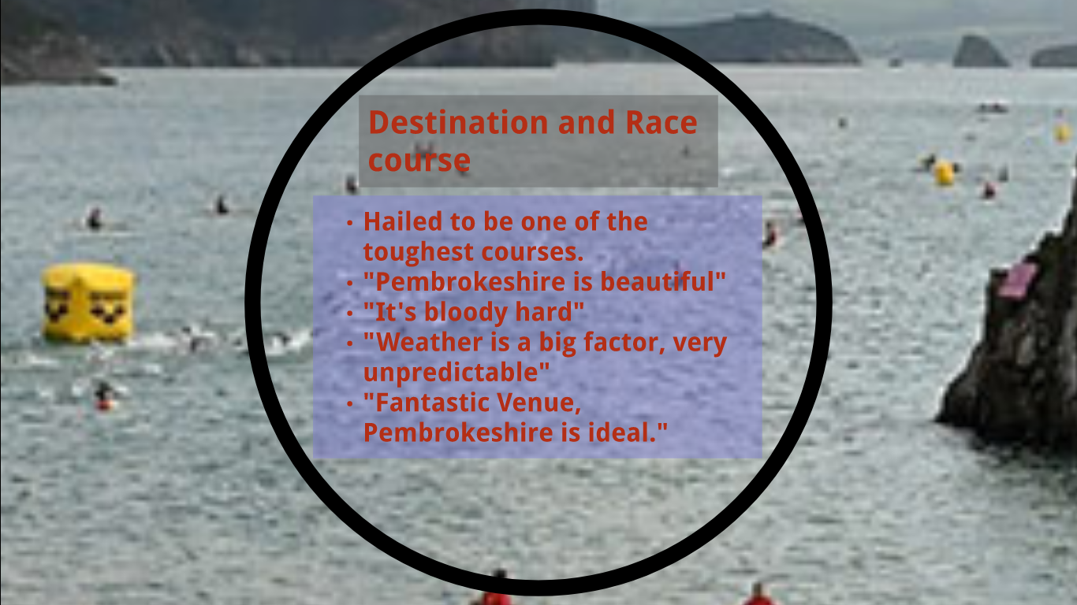
These are some of the comments from the athletes. Pembrokeshire is an ideal location for the race and hailed to be one of the toughest, it draws in more people who want to challenge themselves
Slide 7
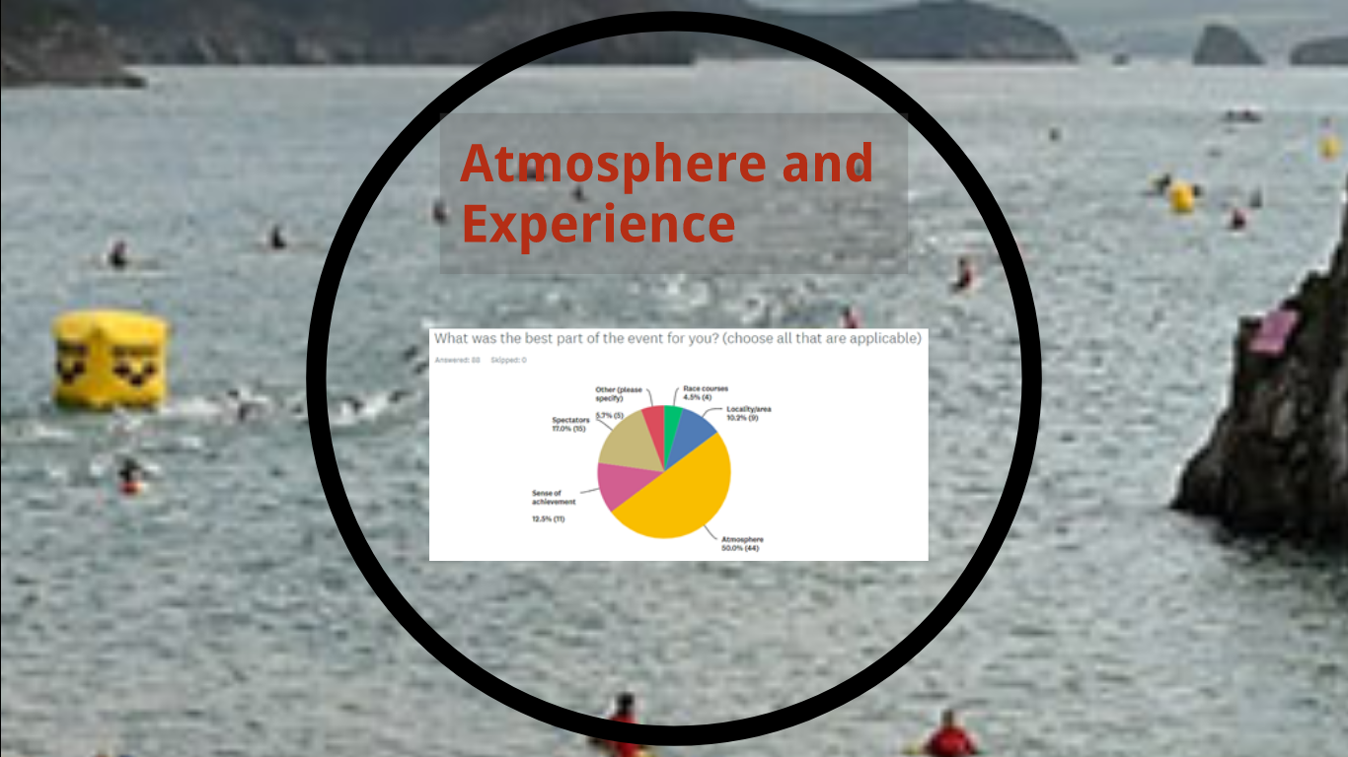
Spectators fared very highly with athletes, and the atmosphere. The race is very hard and a lot of athletes felt that the atmosphere and spectator participation is what spurred them on and gave them the motivation to keep going.
Slide 8
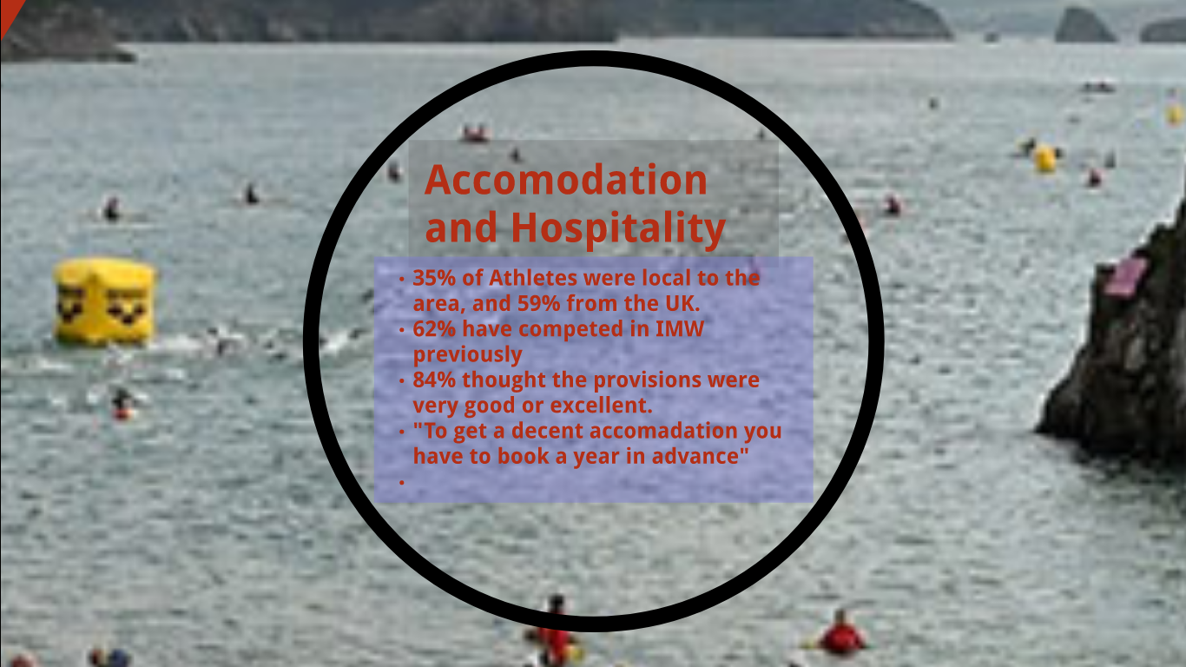
There are a number of people travelling to the area, and on the whole they felt the provisions were very good. Hospitality scored higher than accommodation, as the athletes felt there wasn’t enough accommodation and there was a struggle to get somewhere affordable to stay if not booked very early.

Slide 9
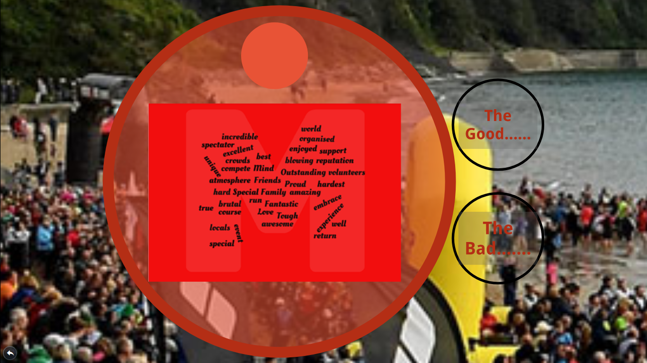
These are some of the words that came up in the comments from the athletes.
Slide 10
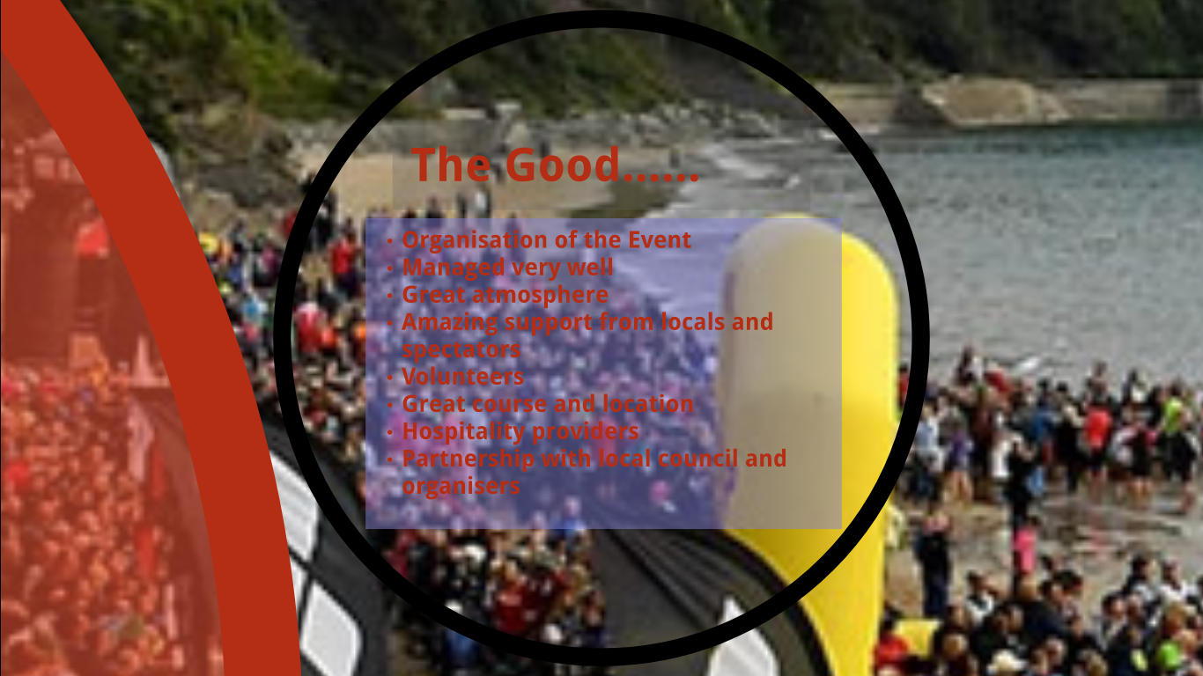
Ironman is a very well organised event, in the lead up and on the day. 97% of athletes felt that the event was well organised. Everything runs with precision, this is helped by the number of volunteers they have, and 98% of athletes felt that the race was well organised on the day including start times, marshals and transition points. There is a great atmosphere on the day, with friends and families supporting, and also the locals get on board and there’s a real buzz in the whole area. The course is ideal as it’s a rural area and they are able to close the roads, this is due to the great partnership they have with the local council. 63% of people asked have previously competed in Ironman Wales, having competed 97% would compete again
Slide 11
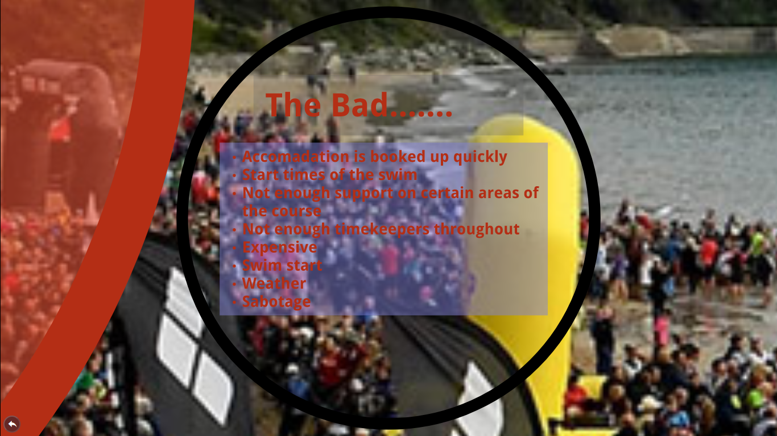
There is not enough accommodation for the thousands that want to stay in the area.
Some athletes felt that there was not enough support on the more rural parts of the race, and not enough timekeepers throughout. The rules of the competition are very strict and they have to complete each section by a set time. One athlete missed the time by 2mins and felt that had there been timekeepers they would maybe have continued the race. At a cost of £400 per entrant it is an expensive hobby, and some would compete more if it wasn’t as costly. Weather will always be a negative in Wales as it is so unpredictable. Although this year’s course was sabotaged with oil, it was dealt with extremely efficiently by the course organisers and not all athletes were aware at the time. There is a staggered start for the swim, 25 athletes enter the water at a time, unfortunately as it’s not a large beach, and a number of athletes who had later start times missed the national anthem at the start of the race as they weren’t on the beach.

Slide 12
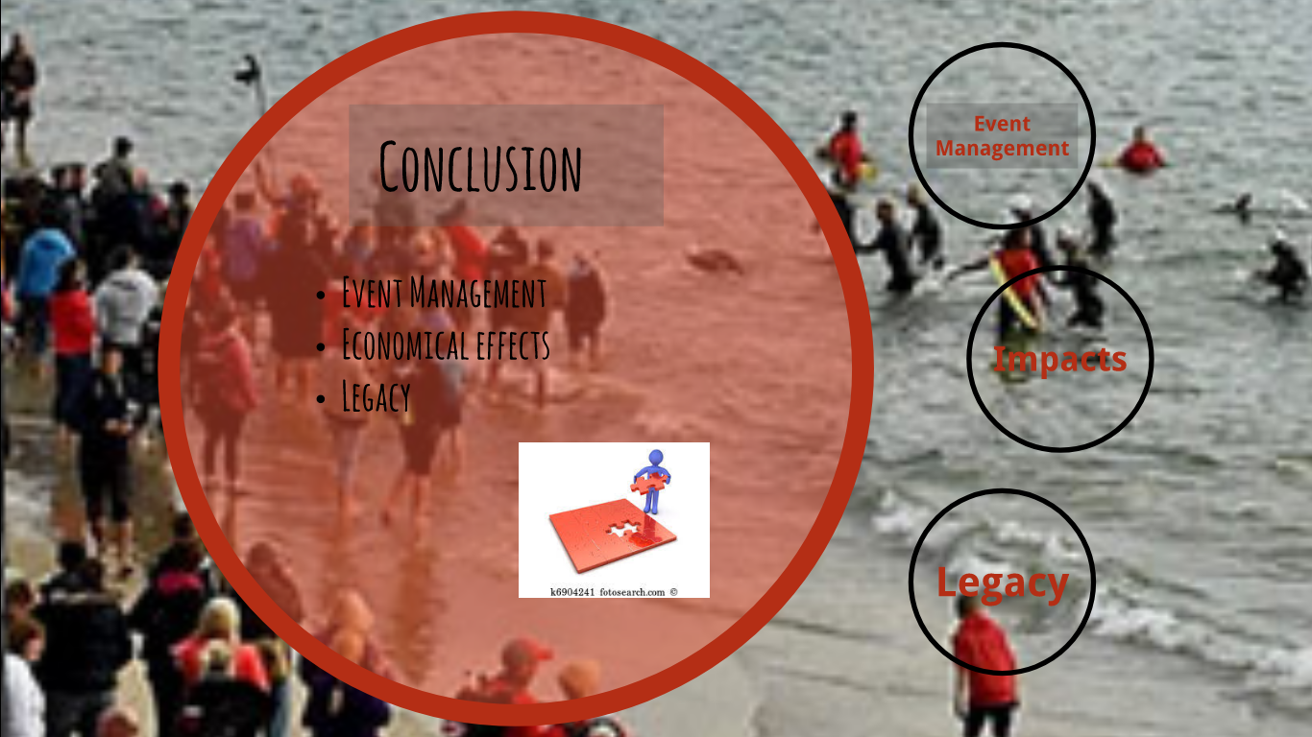
Slide 13
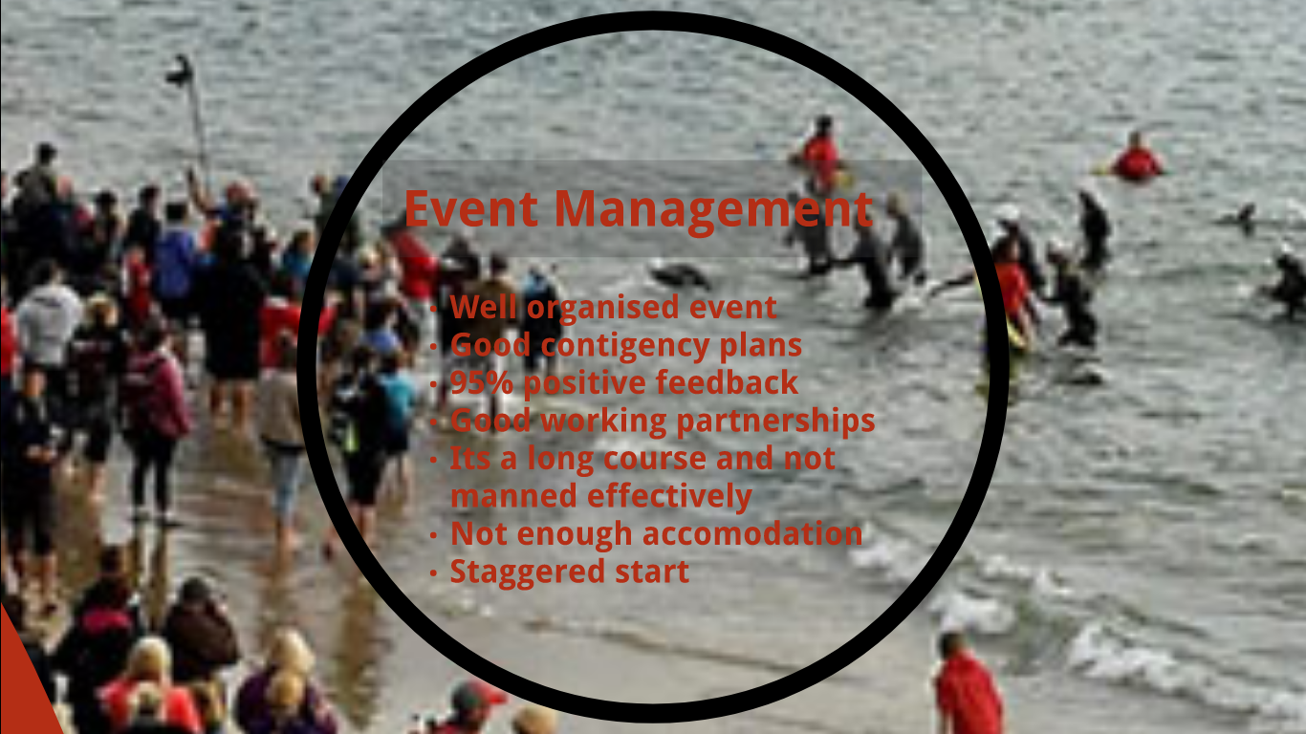
On the whole Ironman Wales is a very well organised event, they have good contingency plans in place to deal with any issues that arise on race day. Following the race the athletes are sent a survey, and received 95% positive feedback from the athletes, having asked a percentage 97% said they would come back and compete again. Ironman Wales have established good working relationships with the local council, police, and hospitality providers and local business and clubs. However there aren’t enough accommodation providers to deal with the demand. The quieter areas of the course do not have enough stewards and spectators for the athletes.
Slide 14
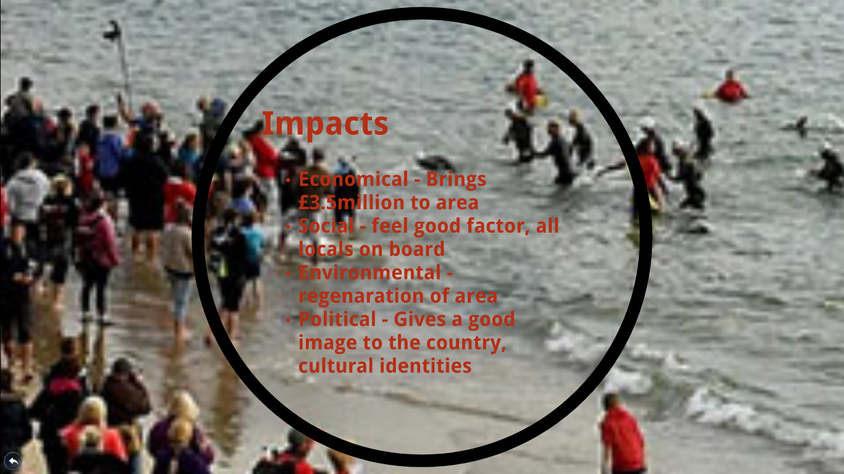
The economic effects of Ironman are huge for the area, it is a small seaside town, and with the new signing of a 5year contract, it is estimated that the event will bring £3.5 million to the area. Socially the event has such a feel good factor, the whole weekend the local businesses are on board with their banners in the windows, there’s a real buzz everywhere. Regeneration of the area is good for the environment, it bringing lots of new opportunities for a number of people. Ironman brings a good image, it’s giving the area a new feel, previously known for the type of people it attracted, families, drinking parties, but now it has attracted a different type of tourist.

Slide 15
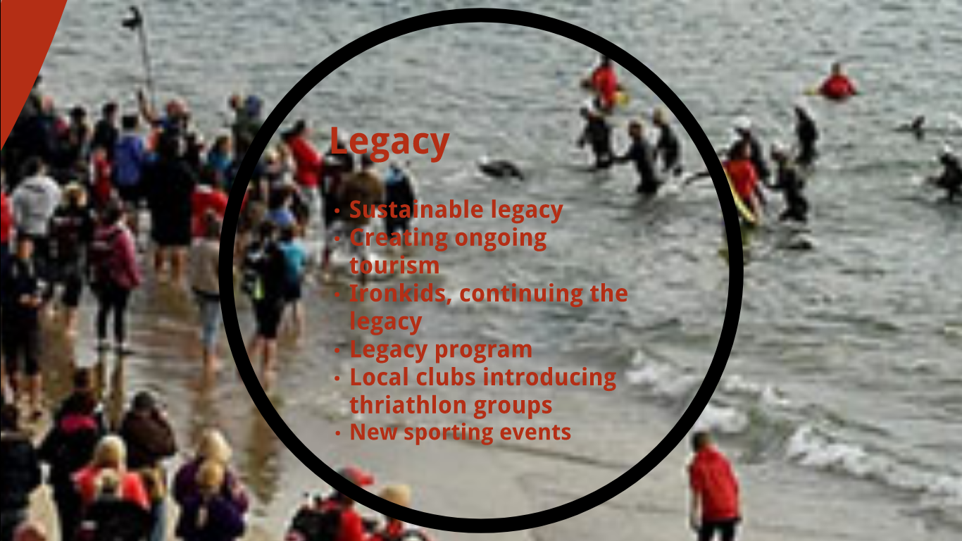
Ironman Wales managed to leave a sustainable legacy behind, the area is rejuvenated, the course is sustainable and Ironman has really improve the tourism industry in Tenby and will continue to do so moving forward. Iron kids, a race for children aged 3-14 is an event organised the day before ironman as part of their legacy, getting kids involved. Ironman begun a legacy programme in 2012, it was a way to recognise and reward repeat athletes, it gives athletes who have never competed in the world championships to do so, by completing 12 full ironman races. Ironman are the ultimate event in sporting events, and have inspired local clubs to do more triathlete focused training and more events such as the long course weekend which takes place in the area.

Slide 16
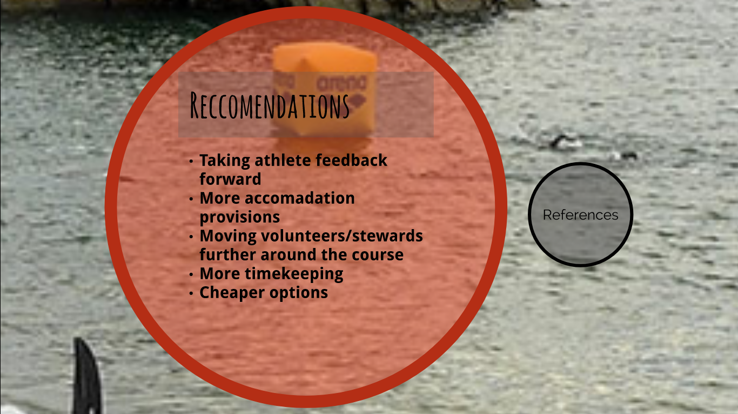
As far as recommendations go, Ironman are a very successful event, but having taken athlete experiences into consideration, some of what they have said is valid and could be addressed. Such as the timekeeping and lighting out on the course. The accommodation provisions could be looked into, being a rural area maybe it’s possible to rent some land and provide glamping/camping facilities. There are a number of stewards and marshals but even more or being more spaced out along the course would be beneficial to the athletes. Some athletes felt it was a look of money and would only do it as a one off, they would like to do it more often but aren’t able to, giving them the option of half ironman for half the money as they do in some other towns might be a good option.

Slide 17
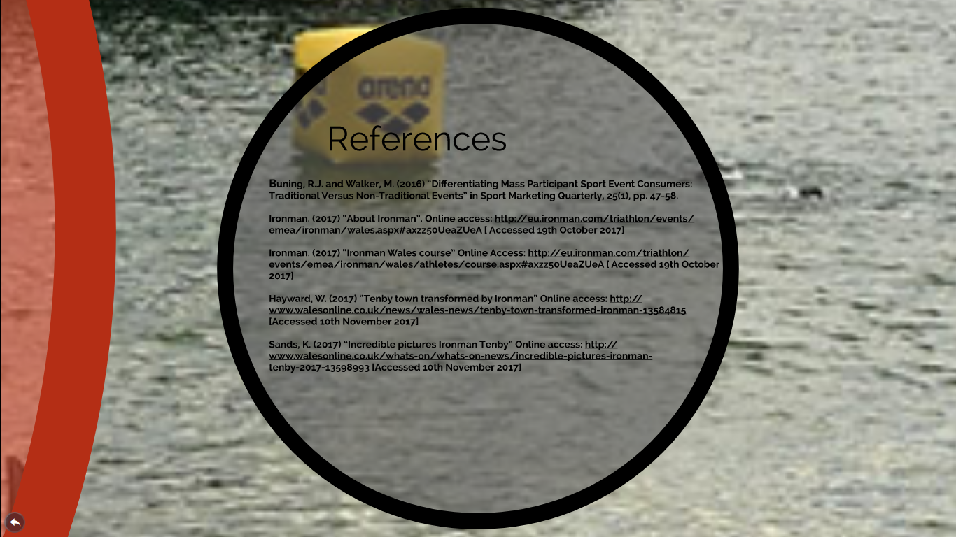

Slide 18
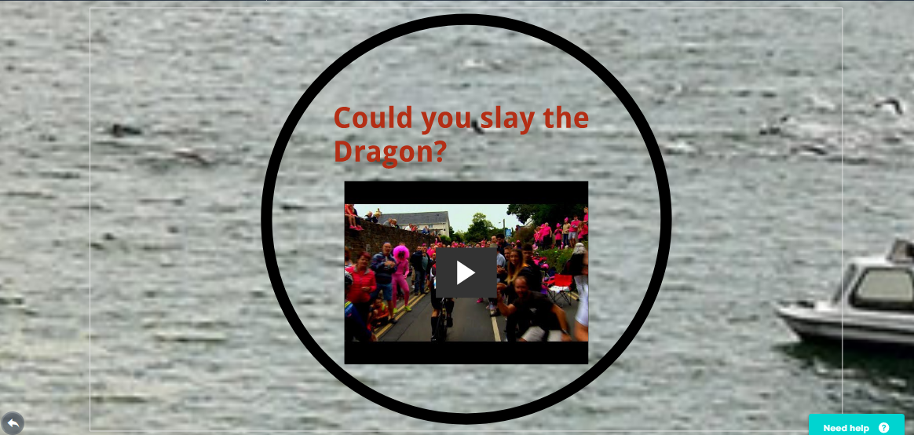
So you’ve seen what the athletes have said, do you think you could take on and slay the dragon?

Slide 19


Athlete responses for Ironman Wales 2017

Having done ironman Wales before I now know that to get decent accommodation you need to book a year in advance. This part of the event if you have family like mine young then you have to prepare for this way in advance. If not it will affect your race enjoyment and add stress to the family. I love ironman Wales.
10/26/2017 5:20 PMView respondent's answers
I think the money they charge is to much for the working man
10/26/2017 6:51 AMView respondent's answers
Finished 2015 (bib 1896) with a split shoulder socket , 4 broken ribs ,broken glenoid bone, cut etc, google Wayne's ironman.
10/26/2017 5:52 AMView respondent's answers
Just gutted there was no red carpet, banners, screen etc. I understand the weather was bad. Plus on tv they made out it was a sunny day which was far from the truth!
10/24/2017 7:06 PMView respondent's answers
Best spectators in the World
he sabotage of the bike course with spilt oil was horrific and I saw some nasty injuries. That put a real dampner on it to be honest as was just glad to finish safely rather than race and go for it.
10/24/2017 6:05 PMView respondent's answers
Superb Town/area/course/local support/accommodation/restaurants and pubs. Very well organised from Team Ironman officials and staff to local Marshall’s. The only thing I would say is not enough ‘first aid help on the run route’ my only negative.
10/24/2017 5:12 PMView respondent's answers
There is something for everyone there. Plenty of eateries and places to spectate.
10/24/2017 2:01 PMView respondent's answers
The weather makes the event so unpredictable - that's a big factor as to whether I'll ever do it again. The atmosphere on the day was absolutely incredible though and kind of makes up for what's an incredibly tough course
10/24/2017 1:15 PMView respondent's answers
Fantastic venue. Pembroke is ideal for this event.

Fantastic would recommend to all. Tenby residents, Fire Bde and spectators all fantastic!!!
10/24/2017 12:00 PMView respondent's answers
It was brutal!
10/24/2017 10:42 AMView respondent's answers
Loved the whole experience
10/24/2017 10:40 AMView respondent's answers
A tough day and the organisers coped well with the issues that arose during the race - oil, weather etc
10/24/2017 9:15 AMView respondent's answers
You have to book accommodation even before registration is open as it goes bloody quick.
10/24/2017 9:05 AMView respondent's answers
Great race great venue great area Far to expensive to enter
It was a race where I experienced my best and worst moments of my Triathlon life. I was unfortunate with 3 x mechanicals, managed to finish, but I'm heading back at some point to teach that beast a lesson.
10/24/2017 8:45 AMView respondent's answers
Outstanding event and will be back next year
10/24/2017 8:22 AMView respondent's answers
It was the best experience of my life. So much goes into training for it when you get to the day it's all a bit overwhelming but in the best possible way. It's an incredible personal experience but also shows just how amazing friends and family are that support along the way. The support around the course was just mind blowing, and totally helped get me round that course. There are so many brilliant people involved in making Ironman Wales such a great event, it's a great bubble to be in!
10/24/2017 8:07 AMView respondent's answers
Love the event and how the locals own it. Makes me very proud to live in Pembs.
10/24/2017 7:57 AMView respondent's answers
Best Ironman race in the world!
10/24/2017 7:40 AM
It's a must to do ironman on the circuit
10/24/2017 7:40 AMView respondent's answers
Awesome course with amazing crowds
10/24/2017 7:31 AMView respondent's answers
Closed road makes it all that more special. Ironman is expensive but they nail the organisation. The people of Pembrokeshire total embrace the event and make it a truest unique experience for all involved
10/24/2017 7:14 AMView respondent's answers
Always is a scramble to find accommodation. Places hold back rooms whilst others give preference to the current year's occupancy. Unnecessary stress!
10/24/2017 7:12 AMView respondent's answers
Excellent really enjoyed the experience and will return next year
10/24/2017 7:08 AM
It is not an obvious location for a big event from a travel point if view but is worth it. Q8 would only permit one answer but I would tick all except value for money
10/24/2017 6:53 AMView respondent's answers
Truly amazing weekend, the atmosphere is incredible and the spectator support just carries you around. A truly amazing event
10/24/2017 6:32 AMView respondent's answers
It's easy to see why it's called one of the hardest on the Ironman calendar but the crowd support make up for all the hills!
10/24/2017 6:29 AMView respondent's answers
Spectators make the day. Support on the whole course is fantastic
10/24/2017 6:23 AMView respondent's answers
Immediately Post race not so good. Food was bad, glad I had club mates to help and sit with me. Best day of my life though
10/24/2017 6:06 AMView respondent's answers
It definitely earns it reputation as one of the hardest courses in the world. It is no walk in the park. If you want that medal and finishers shirt you've gotta earn it. I've done it twice now. And unless you've done it, you wouldn't know why they call it slaying the Dragon!!!
10/24/2017 5:59 AMView respondent's answers
Generally speaking really well run event, just devastating to not get the result I intended to.
10/24/2017 4:58 AM

