Contents
Page 2 – AI acknowledgement
Page 3-4 – Reflective personal development plan
Page 5 – Reference list
Page 6 - Briefing paper exploring the importance of reflective practise within the early years and analyses different reflective models
Page 7-8 – Reference list
Page 9-12 - Written piece recognising and analysing the significance of different aspects of professional practise and why these are important in meeting the individual and inclusive needs of children
Page 13-15 – Reference list

AI acknowledgment

Basic Acknowledgement format of AI tool use
I confirm that I have not presented any AI generated text as my own work. I confirm I have copies of my drafts, notes, and other resources I used before, and after the use of AI tools which I may be asked to provide in evidence.

Reflective personal development plan
 | Improvement and Development Goals | Why I want to achieve this goal | How will it be measured? | Success Criteria  (How I will know when I have made this change) | The actions I will take to achieve the goal | Time-scale | What will this help me to achieve?
1 | Overcome  public  speaking  anxiety | I want to complete this goal as my public speaking anxiety has a negative effect on my wellbeing. Reeves et al. (2021) in a survey of UK University students, found that oral presentations impacted 80% of students’ wellbeing.  I would like to further my career and become a teacher. This role includes a lot of public speaking, and this goal will give me more confidence in pursuing this. | Noting my levels of anxiety before, during and after publicly speaking. | I will feel confident delivering speeches to peers. I will not have such anxious reactions when I am asked to speak publicly. | Complete the Speech and Anxiety plan, developed by Dr Chris Mcdonald, a Cambridge researcher. This is a completely free online programme and claims to reduce anxiety from public speaking in as little as one 30-minute session (Walsh, 2025)  Use graded exposure, as talked about by Iveson (2024). I will ask to participate in assemblies presented to parents of the pupils. | Ongoing | Calming strategies  Grounding techniques
2 | Improve work/life/ university balance | I want to stop feeling as though I am constantly rushing and clear my mind from continuously thinking of my next task.  This is important to me for my wellbeing. According to an article by Hernandez (2025) an imbalance of work/life can lead to physical and mental problems (SNHU, 2025). | Reflecting on accomplishments, emotions, and setbacks on a weekly basis. | I will know when I have achieved this when the anxious feelings, associated with an imbalance of work/life are significantly reduced. | Journaling – on reading a blog entitled, the power of journaling for mental health, (Anxious Minds, n.d.) I have found that journaling has a positive effect on mental health and allows you to reflect in a beneficial way. It can also help reduce stress and anxiety.  Create a weekly timetable specifically for each upcoming week, with manageable tasks, ensuring time for wellbeing activities. This gives a clear view of responsibilities/tasks each week and reduces stress by having a visual representation of your tasks (University of York, n.d.). | Start immediately and review after 1 month. | A journal.  Online timetable.  Mindfulness strategies.
3 | Consistently practice physiotherapy to return to playing rounders | After sustaining an injury to my Achilles tendon earlier this year, I have been unable to compete in weekly rounders league games. Despite completing 6 weeks of physiotherapy, my busy schedule means I have not consistently been completing the daily follow-on exercises prescribed, therefore am not able to physically take part.  Rounders is an important part of my life and significantly enhances my wellbeing. Rounders has improved both the mental and physical health of men and women aged 16 plus in Wales (My Rounders, n.d.) | Marking on my calendar the days I complete the prescribed exercises, creating a visual representation.  Assessing the pain levels. | When I return to competing in weekly league games.  When I am completing physiotherapy exercises daily. | Set aside 30 minutes at the start or end of each day, to complete the exercises.  Print off the images and descriptions of each exercise to ensure accuracy.  Prioritise my physical health. | Start immediately | Being consistent.  Visualising the final goal.

Reference list
Grieve, R., Woodley, J., Hunt, S. E., and McKay, A. (2021) ‘Student fears of oral presentations and public speaking in higher education: a qualitative survey’, Journal of Further and Higher Education, 45(9), pp. 1281-1293. Doi:0.1080/0309877X.2021.1948509
Hernandez, A. (2025) Why is Balancing Work and Life Important? Available at: https://www.snhu.edu/about-us/newsroom/career/balancing-work-and-life (Accessed: 1 October 2026)
Iveson, J. (2024) Facing the fear of public speaking. Available at: https://www.bps.org.uk/psychologist/facing-fear-public-speaking (Accessed: 1 October 2026)
My Rounders (n.d.) Where it began… Available at: https://www.myrounders.co.uk/about (Accessed 1 October 2026)
Walsh, L. (2025) Free tech helps eliminate fear of public speaking. Available at: https://www.cam.ac.uk/stories/AI-VR-eliminates-fear-of-public-speaking (Accessed: 1 October 2026)
University of York, (n.d.) Being organized: a practical guide. Available at: https://subjectguides.york.ac.uk/being-organised/weekly-plan (Accessed: 4 October 2026)

Briefing paper exploring the importance of reflective practise within the early years and analyses different reflective models
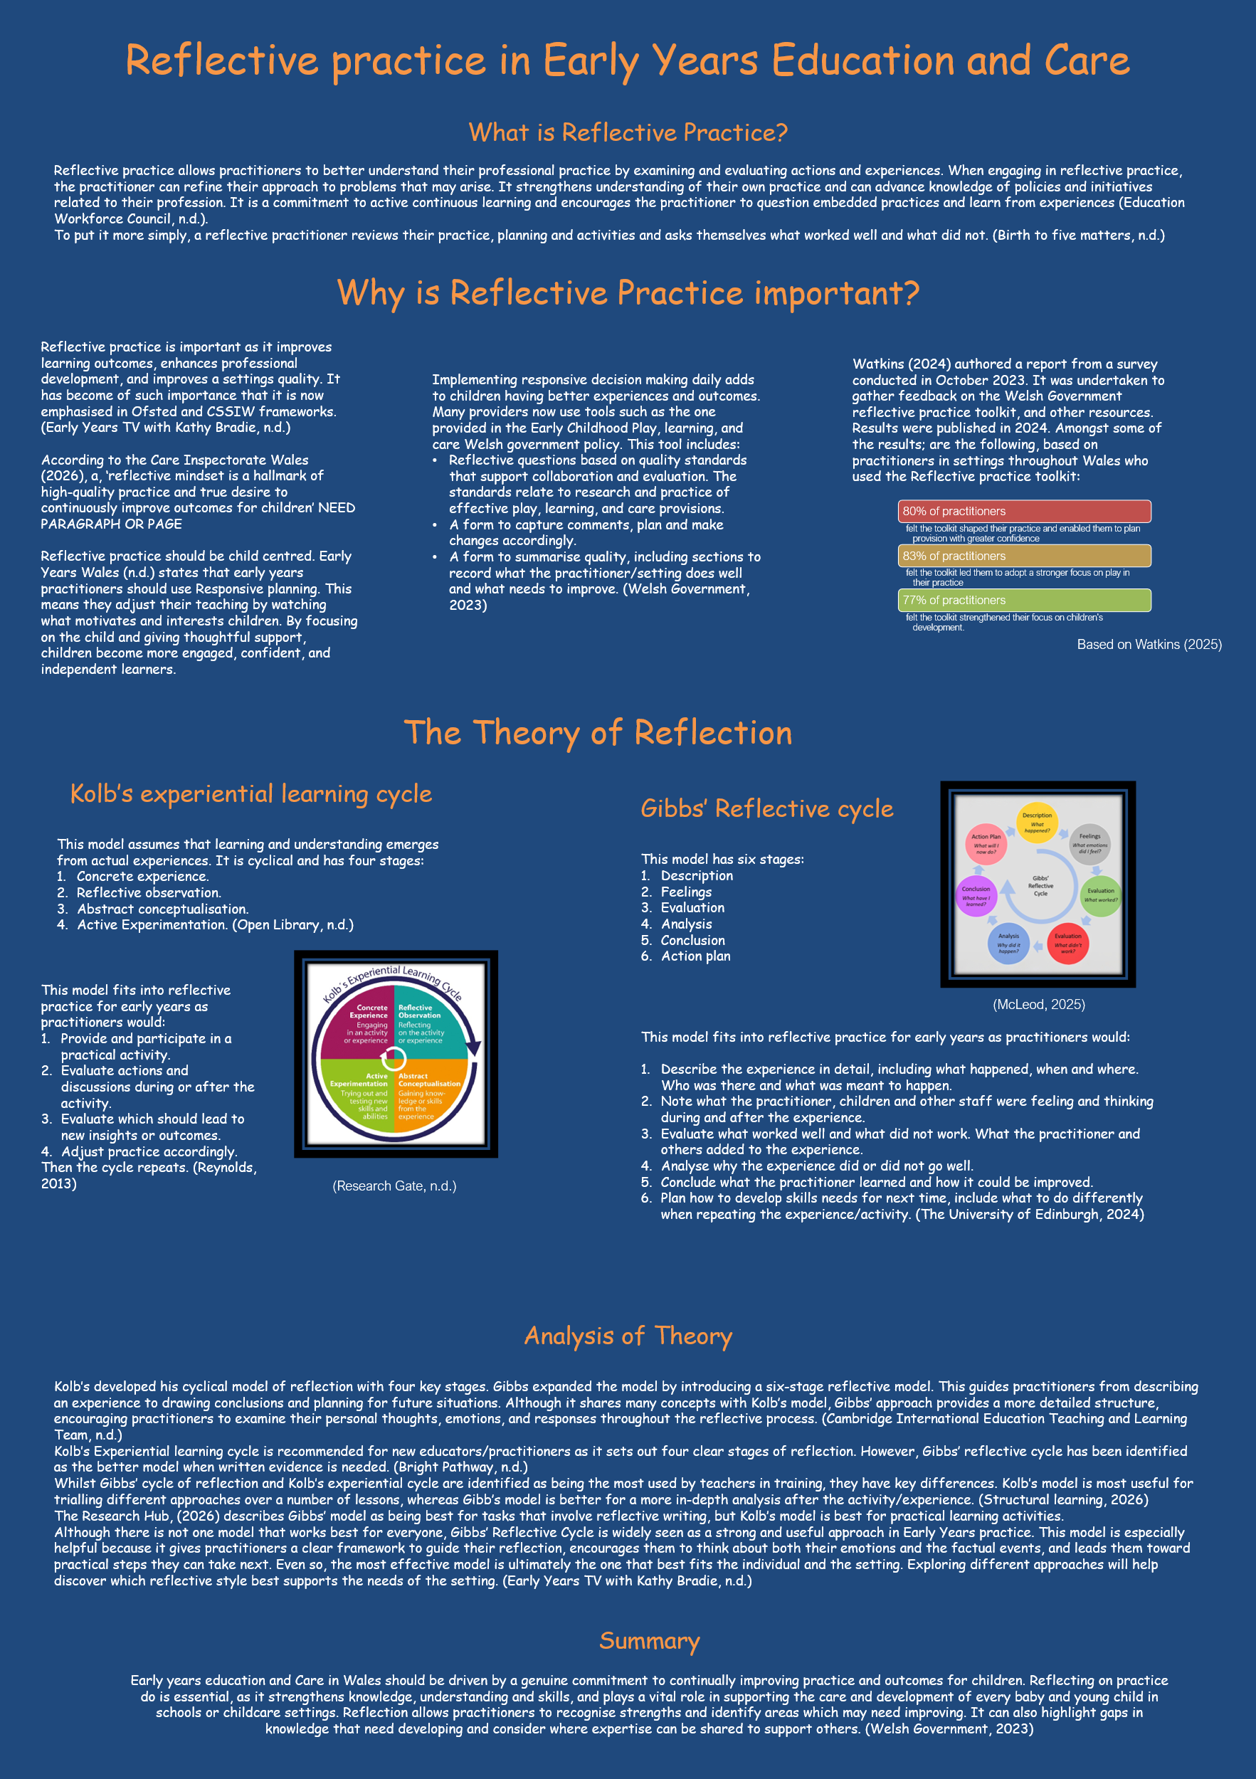

Reference list
Alqinneh, D. (2025) Reflective Practice in Early Years: A Complete Guide for Educators. Available at: https://theearlyyears.academy/blogs/global/reflective-practice-in-early-years (Accessed: 11 October 2026)
Birth to five matters. (n.d.) Learning and Development Observation, assessment and planning. Available at: https://birthto5matters.org.uk/wp-content/uploads/2021/03/PDF-20-Professional-Reflective-Practice-1-1.pdf (Accessed: 11 October 2026)
Bright Pathway. (n.d.) Reflective Practice for Teachers: Models Compared 2026. Available at: https://brightpathway.co.uk/reflective-practice-for-teachers-models-and-examples/ (Accessed: 12 October 2026)
Brodie, K. Reflective Practice Models in the Early Years. Available at: https://www.earlyyears.tv/reflective-practice-models-in-the-early-years/ (Accessed: 11 October 2026)
Early Years Wales. (n.d.) Reflective Practice. Available at: https://www.earlyyears.wales/sites/default/files/reflective_practice_responsive_planning_-_final_eng.pdf (Accessed: 12 October 2026)
Education Workforce Council. (n.d.) Good practice guide: Reflective practice. Available at: https://www.ewc.wales/site/index.php/en/fitness-to-practise/good-practice-guides/good-practice-guide-reflective-practice (Accessed: 8 October 26)
Leeds Safeguarding Children partnership. (n.d.) Kolb’s Cycle of Reflective Practice. Available at: https://www.leedsscp.org.uk/practitioners/working-with-families/practitioners-toolkit/kolbs-cycle (Accessed: 12 October 2026)
McLeod, S. (2025) Gibbs Reflective Cycle. Available at: https://www.simplypsychology.org/gibbs-reflective-cycle.html (Accessed: 13 October 2026)
Open Library. (n.d.) 3.4 Kolb’s Experiential Learning Cycle. Available at https://ecampusontario.pressbooks.pub/reflectivepracticeinearlyyears/chapter/3-4-kAolbs-experiential-learning-cycle/ (Accessed: 11 October 2026)
Research Gate. (n.d.) Kolb's experiential learning cycle. Available at: https://www.researchgate.net/figure/Kolbs-experiential-learning-cycle_fig1_348642768 (Accessed: 13 October 2026)
Reynolds, C. (2013) The 3-minute Kolb. (YouTube video). Available at: https://www.youtube.com/watch?v=ObQ2DheGOKA (Accessed: 11 October 2026)
Structural Learning. (2026) Reflective Practice Examples for Teachers: Gibbs and Kolb. Available at: https://www.structural-learning.com/post/reflective-practice-for-teachers (Accessed: 12 October 2026)
The University of Edinburgh. (2024) Gibbs' Reflective Cycle. Available at: https://reflection.ed.ac.uk/reflectors-toolkit/reflecting-on-experience/gibbs-reflective-cycle (Accessed: 11 October 2026)
Welsh government. (2023) Early Childhood Play, Learning and Care: Reflective Practice Toolkit. Available at: https://hwb.gov.wales/api/storage/a8d10028-25ae-4d94-ad18-0247286ce822/early-childhood-play-learning-and-care-reflective-practice-toolkit-v1.pdf (Accessed: 11 October 2026)

Written piece recognising and analysing the significance of different aspects of professional practise and why these are important in meeting the individual and inclusive needs of children.
A professional is defined as a person in a role that requires specialist knowledge and skills or possesses professional qualities associated with trained and skilled practitioners (Cambridge Dictionary, n.d.).
Professional practice is defined as requiring ongoing reflection on personal and professional values, morals, and ethics, enabling practitioners to make informed decisions, using professional judgement and responding appropriately even during difficult circumstances (Education Workforce council, 2025).
This essay will examine the importance of communication and building relationships, and multi-agency working, paying particular attention to supporting children with Speech, Language and Communication Needs. It will analyse these aspects of professional practice and how they support children’s individual and inclusive needs and contribute to positive outcomes for the child.
Communication and relationships are a significant aspect of professional practice in early years. Communication develops from birth and is fundamental to a child’s wellbeing and development. The All-Wales Induction Framework for early years and childcare set out four parts of communication development; listening and attention, understanding, speech sounds and talk, and social skills (Social Care Wales, 2025). Before the age of five, 90% of a child’s brain growth occurs. Learning to communicate starts from birth with first sounds. Parents and carers being the first educators (Better start in life, n.d.).
The early years practitioner takes a vital role in developing communication further. They should ensure the environment supports communication. It should have quiet spaces for children to think and talk and engaging areas. Background noise should be limited, and resources should be easily accessible and labelled with pictures and words. Early years children are developing their listening skills if the environment is noisy or poorly organised, children may disengage or become distracted. The practitioner should allow the children to lead the conversation, they should model good use of language that is stage appropriate. Poor modelling of language can reinforce incorrect speech patterns. Practitioners should provide adult led, structured activities including; role play, circle and story time and group activities. (Speech and language UK, n.d.) Speech language and communication underpins all areas of learning and development and is the basis for cognitive development. It is argued that the adults around the child are the most important influence in their speech and language development (Buckinghamshire Council, 2026). Therefore, ineffective professional practice will impact all areas of the child’s learning and development.
Building strong relationships between practitioner and child helps the children feel secure and develop trust enabling them to thrive in their environment. Attachments take time and the practitioner needs to regularly consider the child’s needs in order for them to form. The practitioner-child relationship is important to the child’s learning, development, and future success. (Department for Education, n.d.) Conversely, evidence suggests that poor practitioner–child relationships can lead to the child being unable to adapt to the social, emotional, and academic demands of school (Olatunji, 2025). A consequence of the practitioner not developing a positive relationship with the child can present as behavioural issues, acting out and inability to concentrate. This could hinder their learning outcomes (Luo et al., 2025) A lack of strong relationships between the child and practitioner can affect a child’s learning and development. (Cliff, 2022)
There are many barriers to developing effective communication and relationships with children, one being Speech, Language and Communication needs. Children with these needs face many challenges; educational, social, and emotional. Unidentified or unsupported speech, language and communication needs put children at a disadvantage academically, being six times more inclined to be behind peers with no additional needs when they reach the end of primary school. Socially they may be unable to make or maintain friendships and express emotions. This sometimes can be perceived as bad behaviour. This can have a significant long-term impact on the child (Whole School SEND, 2024).
Speech, language, and communication needs can be isolated, or they can be part of other conditions such as Autism Spectrum Disorder or Attention Deficit Hyperactivity Disorder. Identifying these needs early allows targeted help that can significantly reduce or prevent these long-lasting effects, highlighting the importance of supporting children’s communication skills from the start. Some children who initially appear to have speech, language and communication needs can progress naturally when practitioners provide high-quality interactions and a communication rich environment.
Early years practitioners should observe the child and plan accordingly. (Welsh Government, 2023). The Wales Early Intervention and Prevention framework ensures the best possible outcome for children. Early intervention involves detecting problems and putting in interventions before they worsen. According to this framework, early intervention can support speech language and communication skills in a primary way which is available to all or in a targeted way which supports babies, children and families recognised as having a need. (Welsh Government, 2026).
Working in partnership with parents/carers can aid with early intervention and prevention. Birth to Five Matters (n.d.) states that effective communication, including active listening with families and professionals, is a cornerstone for children’s development and promotes a sense of inclusion and belonging. Effective communication with children’s parents or carers to gather views and observations, enables practitioners to provide appropriate support and create inclusive learning opportunities. As a child’s primary care giver, parents and carers can offer valuable information regarding their child’s development and any areas that may require additional support (Department for Education, n.d.). Effective communication between practitioners and families is essential, particularly for a child with needs. Its importance has been recognised as early as 1967 in the Plowman report (Beveridge, 2005). The report suggests that a good relationship between families and practitioners is fundamental to academic progress. It also states that schools should be receptive to critique by parents and not just listen to praise (Department for Education and Science, 1967). Since this report most government reports have promoted the principal that a child's outcome greatly improves when schools/practitioners and parents/carers have effective communication and a positive relationship (Beveridge, 2005).
Multi agency working is another aspect of professional practice that contributes to meeting the individual and inclusive needs of the child. Building a strong relationship with professionals from other agencies involved with a child, including collaborating and developing a trusting relationship, allows for smoother and ongoing communication. All professionals involved with a child need to have open clear communication and effective information sharing. All of this promotes the best outcome for the child (NSPCC, 2025). To put it simply, multi-agency working involves professionals from all agencies working with a child, uniting to support the child’s individual needs and improve the child’s outcomes (Children’s workforce Development Council, n.d.).
Meeting the individual and inclusive needs of the child, particularly those with additional learning needs including, Speech, Language and Communication Needs, requires collaborative work with multi agencies and effective communication between provision staff, particularly with the Additional Learning Needs Coordinator. This ensures the child receives the correct additional learning provision (Care Learning, 2024). The local authority working closely with the Additional Learning Needs Coordinator will prepare an Individual Development plan to support the individual needs of the child and in ensure inclusivity. An individual development plan is a “single plan with common format for learners ages 0-25” (Hwb, n.d. p35). It includes the child's and the parent’s choices and feelings along with information from all professionals involved - a good example of multi-agency working. The individual development plan will set out what additional learning provision the child requires in order to achieve the best possible outcomes (Hwb, n.d.). However, multi-agency working has many barriers such as; time constraints quick turnover of staff, a professional missing key information, GDPR, and unclear roles and responsibilities. These barriers can lead to ineffective multi agency working, which will negatively impact the child, as the practitioner does not have all the relevant information and cannot plan holistically. This will affect the practitioner's ability to meet the inclusive and individual needs of the child (NSPCC, 2025).
To support the individual and inclusive needs of a child, practitioners should take a rights-based approach to all aspects of professional practice, paying particular attention to; “Article 2: non-discrimination, Article 3: the best interests of the child, Article 12: respect the views of the child, Article 23: children with a disability, Article 28: the right to an education, Article 29: goals of education” (UNICEF, n.d. p1)

Reference list
Better Start in Life. (n.d.) Early learning and development. Available at: https://www.nhs.uk/best-start-in-life/early-learning-development/ (Accessed: 21 October 2025)
Beveridge, S. (2005) Children’s families and schools. Developing partnerships for Inclusive Education. Routledge Falmer
Birth to 5 matters. (n.d.) Promoting voice and Inclusion Available at: https://birthto5matters.org.uk/promoting-voice-and-inclusion/ (Accessed: 20 October 2026)
Buckinghamshire Council. (2026) Communication and Language Initiatives and Audits Available at: https://earlyyearsweb.buckinghamshire.gov.uk/eyfs/early-years-foundation-stage/communication-and-language-initiatives-and-audits/ (Accessed: 24 October 2026)

Cambridge Dictionary. (n.d.) Meaning of professional in English. Available at: https://dictionary.cambridge.org/dictionary/english/professional (Accessed: 22 October 2026)
Care Learning. (2024) Identify different working relationships for effective team practice in Early Years settings. Available at: https://carelearning.org.uk/qualifications/level-2-early-years/eyp-1/5-1-identify-different-working-relationships-for-effective-team-practice-in-early-years-settings/ (Accessed: 22 October 2026)
Cliffe. J. (2022) What is it that we still don’t get? – Relational pedagogy and why relationships and connections matter in early childhood Available at: https://journals.sagepub.com/doi/10.1177/17577438221124296
Department of Education and Science (1967) Children and their primary schools. Available at: https://education-uk.org/documents/plowden/plowden1967-1.html (Accessed: 22 October 2026)
Department for Education. (n.d.) Meeting the needs of all children. Available at: https://help-for-early-years-providers.education.gov.uk/support-for-practitioners/meeting-the-needs-of-all-children (Accessed: 20 October 2026)
Department for Education. (n.d.) Relationships. Available at: https://help-for-early-years-providers.education.gov.uk/areas-of-learning/personal-social-and-emotional-development/relationships (Accessed: 21 October 2026)
Education Workforce Council. (2025) Code of Professional Conduct and Practice for registrants. Available at: https://www.ewc.wales/site/index.php/en/fitness-to-practise/code-of-professional-conduct-and-practice/the-code (Accessed: 19 October 2026)
Hwb. (n.d.) Additional Learning Needs principles. Available at: https://hwb.gov.wales/playlists/view/1861e243-7489-4344-b42e-b5f1f703933d/en/1 (Accessed: 22 October 2026)
Luo, L. Fu, X. Jin, S. Xu, Y. (2026) ‘Longitudinal associations between teacher–child relationships, resilience, and behavioural problems among preschool children,’ Frontiers in Psychology, 17. https://doi.org/10.3389/fpsyg.2026.1885244
NSPCC. (2025) What helps to support effective multi-agency working and information sharing? Available at: https://learning.nspcc.org.uk/research-resources/practice-points-series/multi-agency-working-information-sharing (Accessed: 22 October 2026)
NSPCC. (2025) What are the barriers to working with other agencies and sharing information? (Video). Available at: https://learning.nspcc.org.uk/research-resources/expert-insights/multi-agency-working-information-sharing (Accessed: 24 October 2026)

Olatunji, S. (2025) ‘Teacher-Child Relationships and Their Impact on Emotional Growth and Academic Outcomes’ Porta Universorum, 1. DOI:10.69760/portuni.010322
Reed, M. Walker, R. (2014) A Critical Companion to Early Childhood. Sage
Social Care Wales. (2025) All Wales Induction Framework (AWIF) for early years and childcare. Available at: https://socialcare.wales/resources-guidance/learning-modules/all-wales-induction-framework-awif (Accessed: 20 October 2026)
Speech and Language UK. (n.d.) Creating a communication supportive environment: Early years. Available at: https://speechandlanguage.org.uk/educators-and-professionals/resource-library-for-educators/creating-a-communication-supportive-environment-early-years/ (Accessed: 21 October 2026)
Welsh Government. (2026) Early Intervention and Prevention framework to support Babies, Children, Young People and Families in Wales. Available at: https://www.gov.wales/sites/default/files/publications/2026-03/early-intervention-and-prevention-framework.pdf (Accessed: 21 October 2026)
Welsh Government. (2023) Supporting the Development of Speech, Language and Communication in the Early Years. Available at: https://www.gov.wales/sites/default/files/publications/2023-12/slc-guidance-section-1.pdf (Accessed: 21 October 2026)
UNICEF. (n.d.) A summary of the UN Convention on the Rights of the Child. Available at: https://www.unicef.org.uk/wp-content/uploads/2019/10/UNCRC_summary-1_1.pdf (Accessed: 22 October 2026)

