Production Dairy NeoDrive

Nathan Chaplin
1705172

Week 2 - 8th / 14th

This week we were given a game idea which was a hover game and what we did that week was decide on where we were going to take that hover game by decided the style and the theme. We also decided on what assets we could have.
We also focused on what types of jobs people want to do. The choices were unreal, Modelling, concept art and level designer. I would like to go into the unreal team and on the side help with Modelling for different teams.

Week 3 - 15th / 21st

By the end of the week we decided that there would be 4 teams. Engine Group consist of Nathan, Matt and Connor these are the people who will be working on mechanics and making sure all the assets and the level is built in the engine. Group 1 is Jordan and Mitch but will have help from the engine team to model assets. Group 2 is Noah, Harry and Peredur this team will be working on the industrial and then group 3 is joe, Hayden and Gareth this team is thinking on either wasteland or abandoned city.

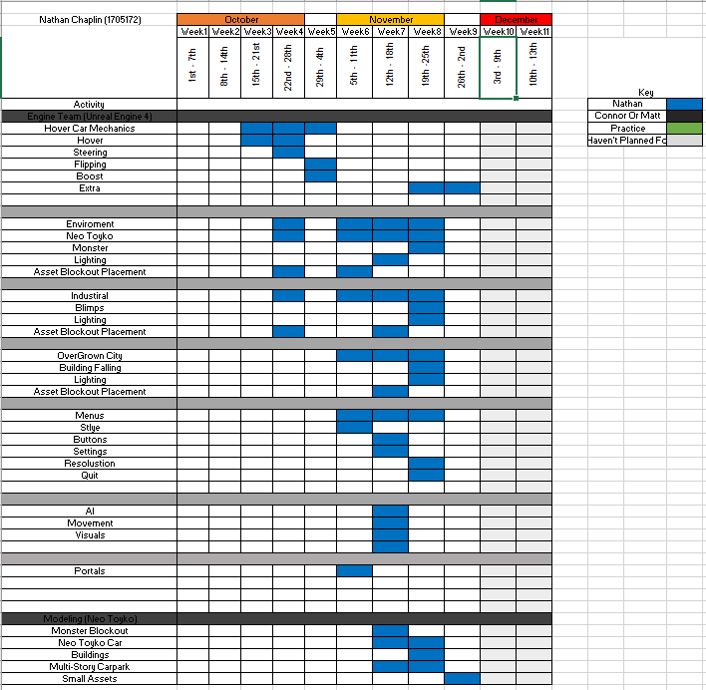
This the plan that I have set myself for the next following weeks. I will be following this plan to get things done on time and be able to see what has and hasn’t been done.
Week 4 – 22nd / 28th
Hover
Me and Connor worked on a hover vehicle which we found on YouTube(https://www.youtube.com/watch?v=ko6lDSSNhV8 ). This was practice as we should get taught by jess about the hover vehicle. So, me and Connor wanted to get use to the engine and get a basic understand on the hover car so when we came to do it with jess we would understand it better.
This Hover car is using ray casting to calculate the distance from the floor to the vehicle. Then it calculates how much force it needs to push the car up to keep the distance that is set. These ray-casts are on each Corner which make it interesting as when you go over an object if one ray cast it going over it will then angle the car depending on which ray cast it getting hit.
The Problems we had with this vehicle was the steering of it. This vehicle has not traction so when turning it will just turn but keep going sideways. This meant that it was very hard to control and no good for the hover game. Sadly, me and Connor couldn’t find a solution in able to fix this. So, when jess teaches us how to build a hover car then we can understand how it work so then we can fix our version of it.
This did not effect out time for gant chart as we were able to do it in a night. So nothing changed.
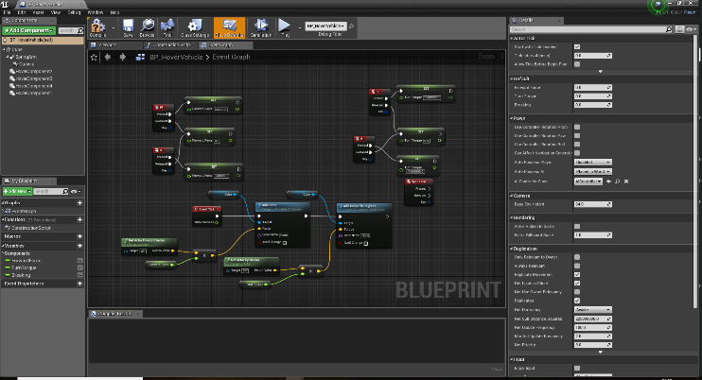
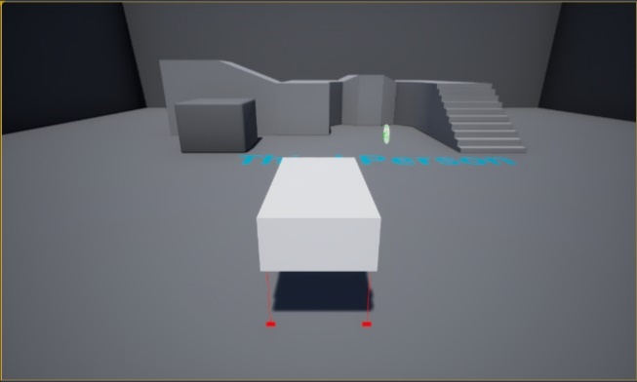
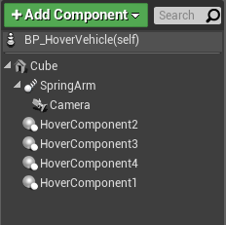

Each Hover Component is a blueprint duplicated and renames on the Pawn. This is the ray cast and is show in game. This is what the red lines are under the hover car is.

The code underneath is the code used for the hover car. This code will calculate how far it is from the floor and how much force to apply depending on the distance it is at.
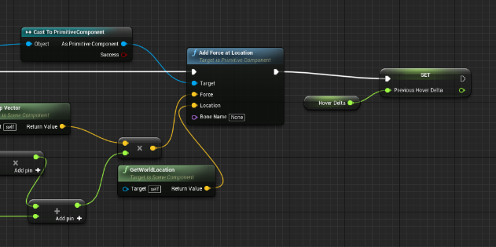
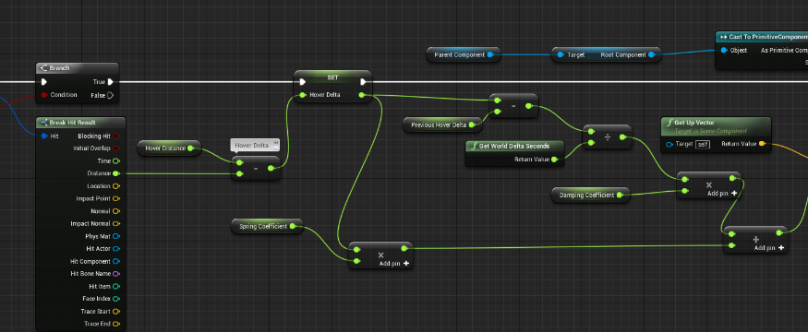
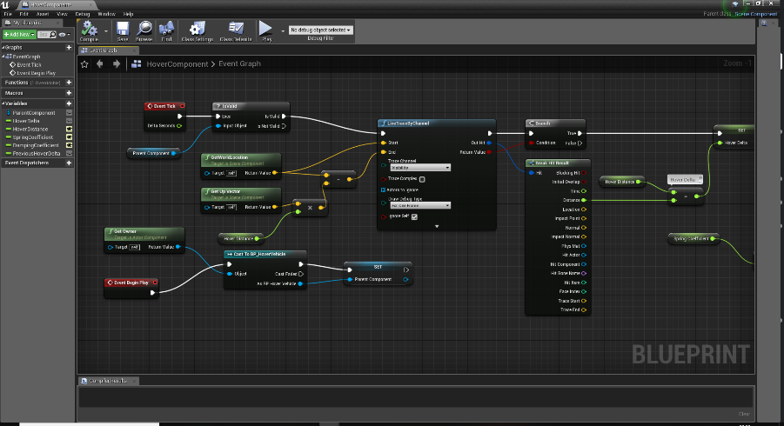
Menus
After class me and Connor worked on menus as we wanted to make the hover game have menus in which you can select levels and select different settings to suit your computer. But to learn menu systems we learnt of unreal website (https://api.unrealengine.com/INT/Engine/UMG/QuickStart/index.html)
What we learnt from this website was how to display Health, Energy and ammo and then displaying the menus and making them functional. We didn’t have any problems with displaying health, energy or ammo but we ran into a problem with the menus. What we found is that the code which is in the level blueprint had to be on the menu level and not the game level. This meant that we had to locate what the problem was which took time. This also taught us how to make a pause button, so we can pause the game and then either go back to the menu or carry on with the game we were playing. But the time didn’t affect the progression in the table. So, nothing had to be moved forward.
Once we finished the tutorial we when back and make it, so the ammo worked with the gun and that you were able to reload ammo and any point. We also made it so when you jumped it took away energy and then when f was pressed it would take away 0.25 of 1 and when your health hit 0 it would take you back to the menu in which you were able to restart. All of this we learn in the lesson with jess before learning menus so that was a big help to understand what was going on.
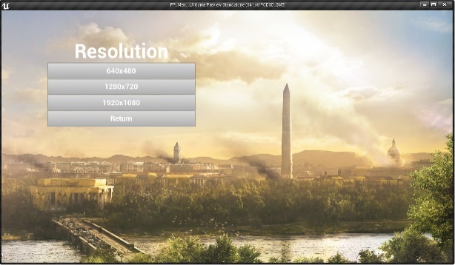
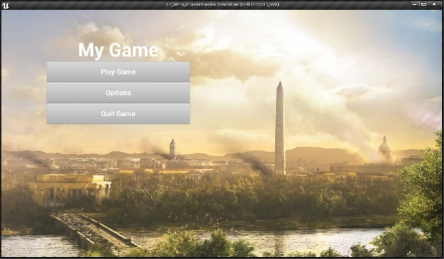

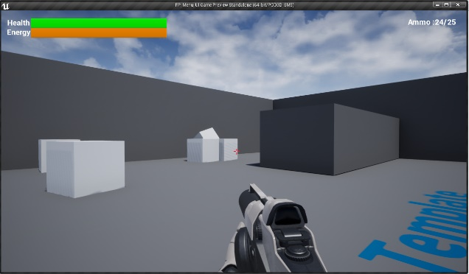

After learning about making a hover and menus this week I have had to push back the timing of things to do by a week as we were not taught the hover which I was hoping we would start
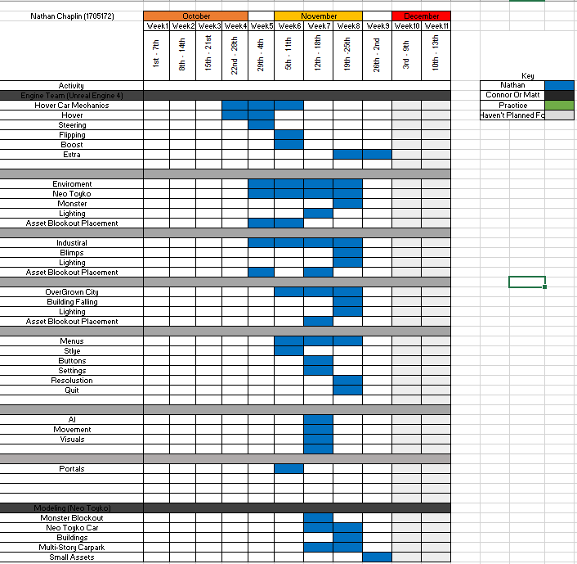

Week 5 - 29th / 4th
Mon-AI bullet doesn’t hit character problem

In lesson we were given a task to use assets and make a hallowed themed map. This is the map I came up with and in this map, we learnt AI but sadly in this lesson we were unable to finish the AI and it wasn’t working. But in lesson also I added in a portal to turn this map into a game. This mini game will make the player go and find a key in the map and once they have picked up the key then they will be able to go through the portal.
To do this it was simple. What I did I made a variable called key. Once you picked up the key it set it too 1 and removed the key from the map.
This meant when you touched the portal it would check if the key = 0 then nothing happened, and it displayed a message saying you need to find a key this message was done by print string. But if the key = 1 then it would open a new level and make you play on the new level.
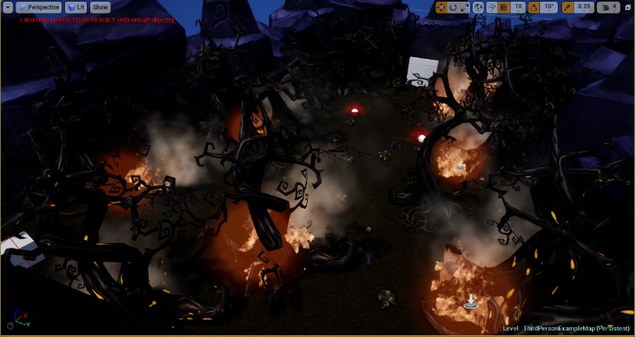
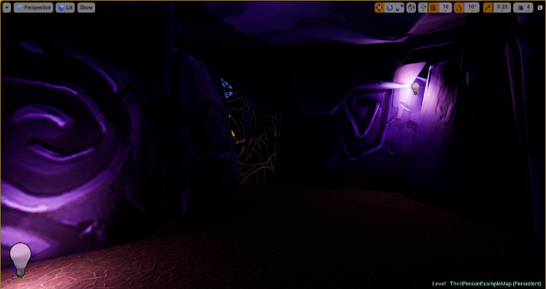
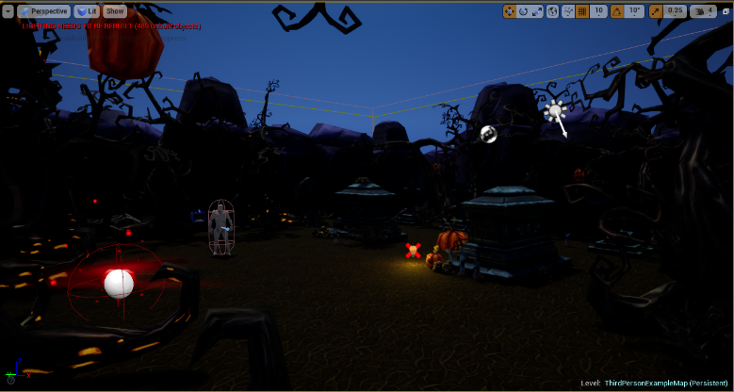
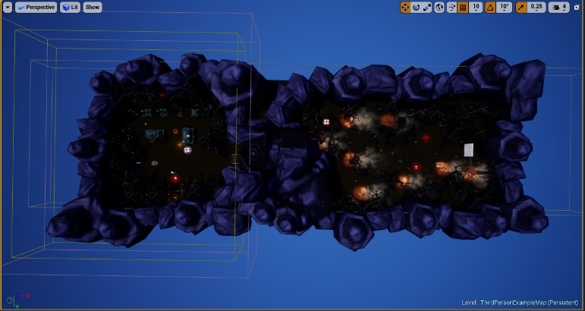
AI
In jess’s Lesson we were learning ai but sadly we didn’t get it work.
So, when I came home me and Connor worked on our project separately such as doing AI research on the work and how to make them. By the end of the night we were able to create 3 AI which was just an expansion of the one before. We were using YouTube and this video (https://www.youtube.com/watch?v=l1tpeVIcaGI )
AI 1 = What this one did was when you were in it field of view it would start to follow you and come towards you. But when you were out of its field of view then it would stop following you. And then when this ai was touching you it would take away health and kill you.
AI 2 = This AI was a turret so what this did was look at you and then fire a bullet at you.
AI 3 = This AI had point in which it can teleport too so after the AI shoot it would move to a new location. And this AI also was able to look at you and start firing bullets.
All of these AI are using pawn sensing. This creates an area from the object that it connected too and if an object was to walk within the radius of that pawn sensing it then would trigger an event.
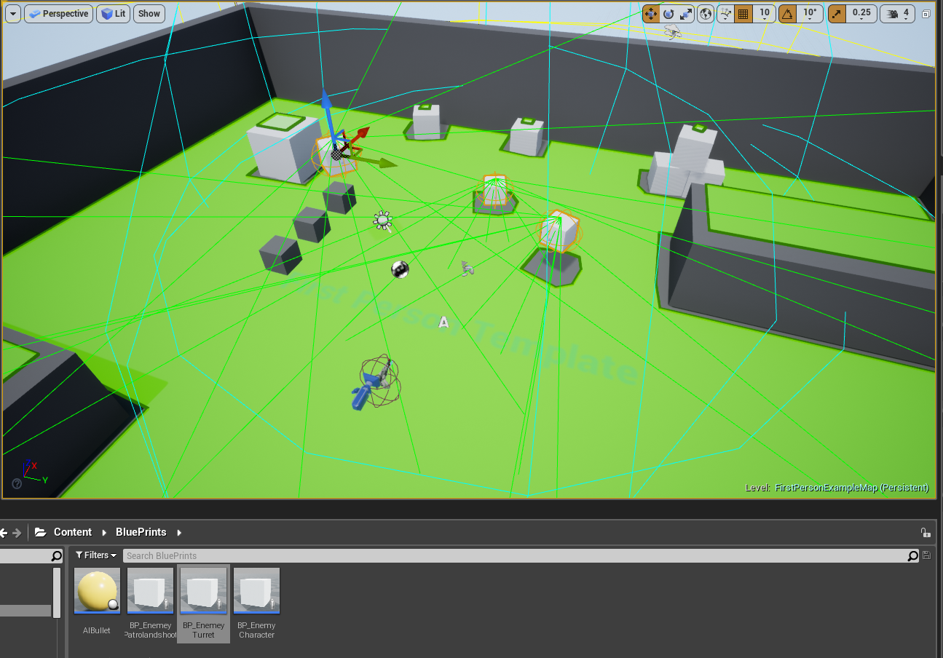
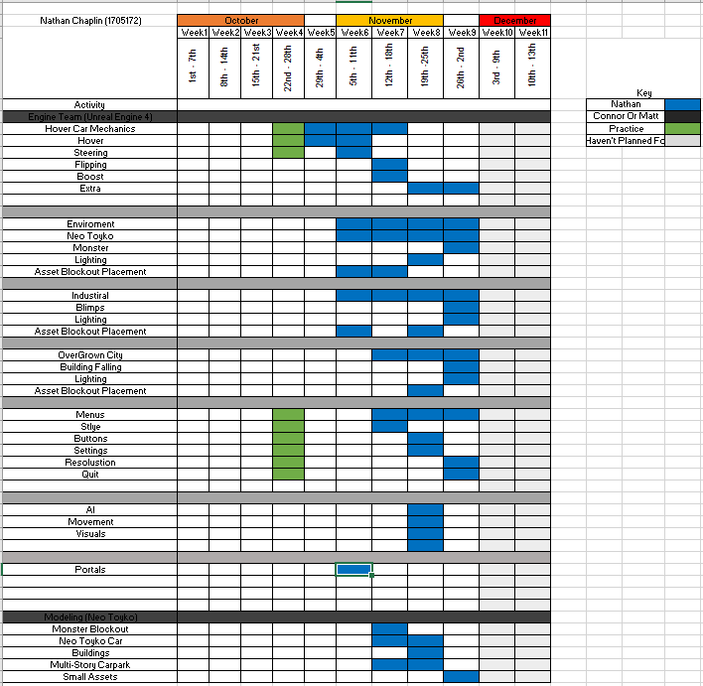
Bullet Problem = Once we made the AI we then worked with the damage and the first AI we didn’t have a problem with but the ones that had a bullet being fired at you we had a problem damaging you. This has not set back out time table but when we have time we will talk to jess and see if we can get this to be fixed.
On My chart I have had to push items back a week as we were still not taught the hover and the problems I am having with my one i can understand where the problem is so I have pushed this back a week. I have also added in the practice I have done to show that my time wasn’t wasted, and it was working on learning unreal so I can get a better understanding on how the engine works.

Week 6 - 5th / 11th
Me and Connor Worked on this blocked out map of the NeoTokyo which is being level designed by Jordan. The images underneath the left one is what Jordan has mapped out and we have taken this and gone into unreal to block the map and get a rough idea on what it’s going to look like. The image on the right is what we finished on in the session that we had. There is a lot more to do and edit but to start with it was a very good block out of the map. We have blocked monster and building in there to represent objects in the world, so we can get a feel on what it going to be like.
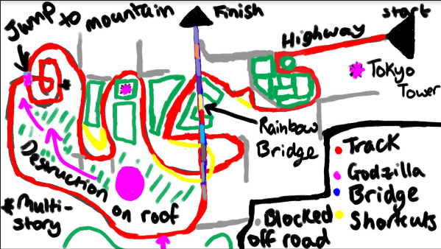
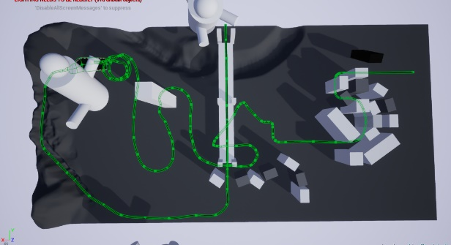

This first problem that we ran into was the splines. We found it difficult to find tutorials on how to use them. We did find the tutorial which was (https://docs.unrealengine.com/en-US/Engine/Landscape/Editing/Splines) This is landscape Spline and took a min or two to get to understand the tool. We then started to make the whole map.
The only other problem we had was that the car that was in the base advanced car project. It couldn’t do any jumps so when it came to the part of the map where there was a jump we had to make the jump small cause otherwise the car will flip over and then you would not be able to play game.
The images underneath is from the car perspective and the multi-storey area in the map. All these images show what we like in the block out so far with the view of the Tokyo tower and the rainbow bridge from the start and then the monster though the building. The multi-storey that need to be worked on, but the idea is something that we like to keep with the spiral.
For time management the we are set back because we must talk to the level designer in order to expand the industrial level. Also talk to the other group who is doing broken down city so upload their map to the google drive because we didn’t have access to it. But in order to gain time back we will do other work planned after the maps, so we are not just waiting around for them to upload.
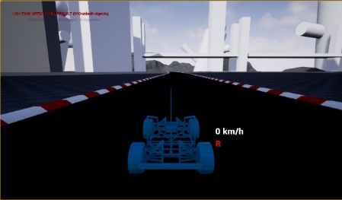
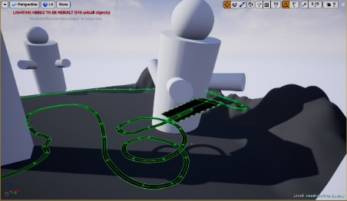
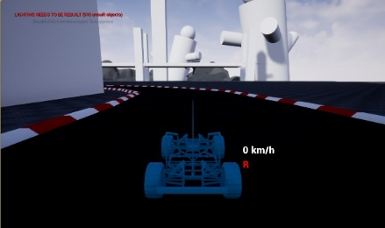
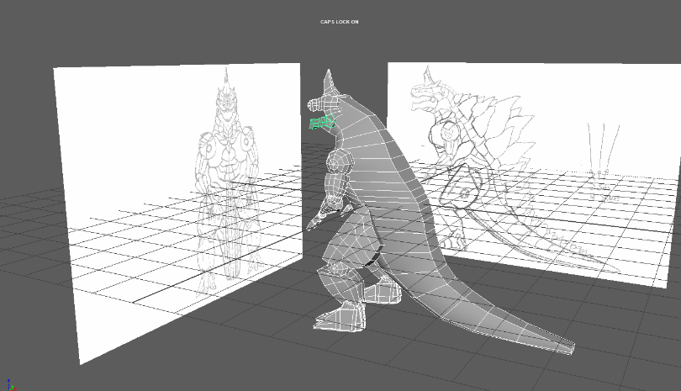
This next thing I did was the block out for the monster. I had orthographic from mitch in which I used to get the size and the anatomy of the monster. When building this I had no problems, but I will have to redo the body on the monster because when talking to the animators they would like the body in cubes not whole. So, this has set my time back, so I will have to move things forward in my Time Table.
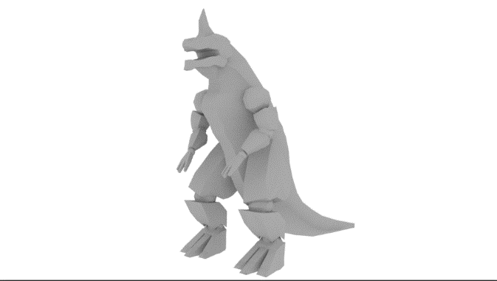

After modelling the monster block out. Me and Connor look at flipbook materials. We looked at this because we want to use it for the portal because we want it to have animation playing on it we found this Youtube video which helped us understand the process on making this (https://www.youtube.com/watch?v=0C2Sj7C0RjE&t=277s ). When trying to make it we started with a gif and using a website called (https://ezgif.com/gif-to-sprite) we were able to turn them into sprite sheets which is needed for the material. But the programs side of it we found not problems with making it. I then researched into making it play slower cause what we found was that it was going through each image every quick which make the portal animation go very quick but we had no problems in this area either so time was not affected.

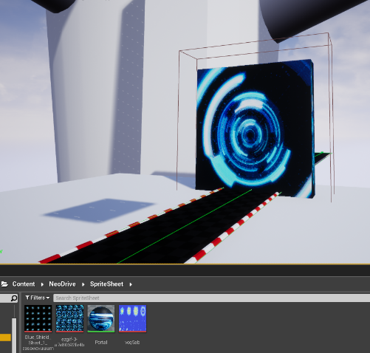
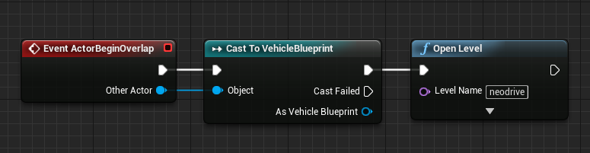
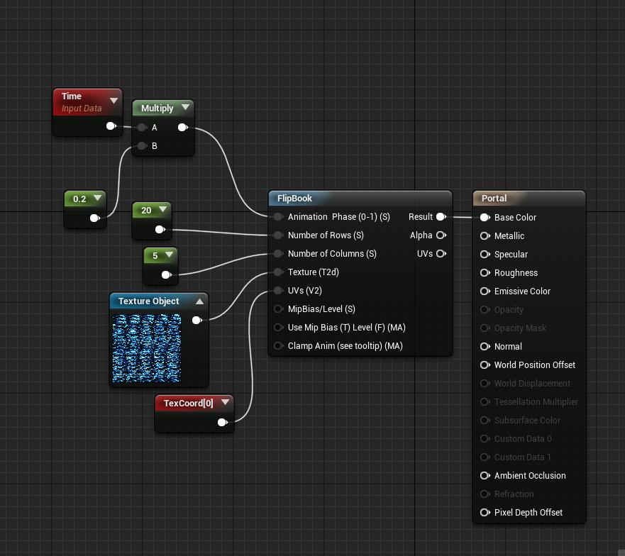

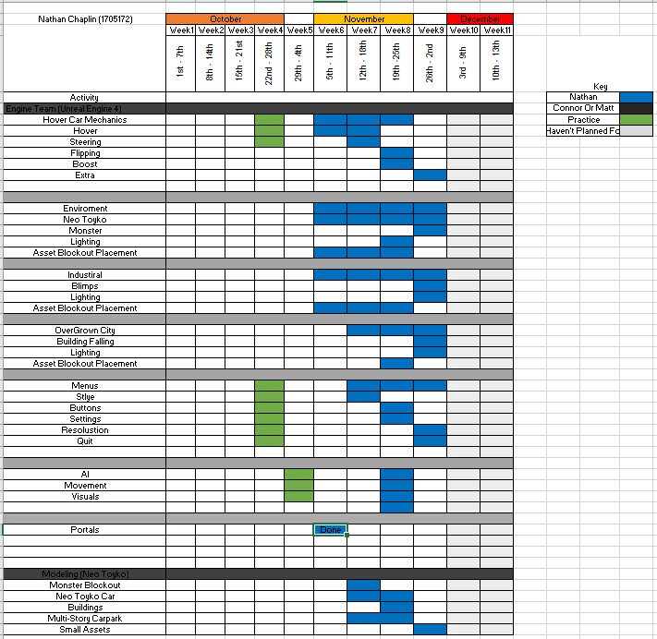
This week I was able to get the block out of the monster done and be able to get the portals working with the vehicle I had in the game. But I have had to move back the mechanics as we have still not be taught this and I have looked at the hover car I have now and I can’t find a solution but I understand how the hover mechanics works so when we get taught it I will have a better understanding of the mechanics and how it works.
Week 7 - 12th / 18th
On Friday we came together to see how the teams where doing and making sure that we all decided on the GGD as there was a lot of different options. So, in the class we all decided what need to be done for the game and by the end of it we all understood what everyone had to do.
In that lesson I was able to change the monster for Jordan, so he can start animating it for next week. What I did I take the body and put them into cubes for weight painting. Then I will be able to give the file to mitch ready to be sculpted in ZBrush.
As I am helping group 1 that is neo Tokyo we came together today do finalize the other assets that needed to be done and by who. I have modelling the multi-story car park, Tokyo Tower, Rainbow bridge and some building and city scape assets.
So, then I made this multi-story when I got home. I decided this is a concept for now and I also made it module, so you will be able to expand the height if nascency if the building is too short without making it stretch. Once I did get a base of a model down I called Jordan to get some feedback. This feedback was that cause you’re not going to see the building whole and that the monster’s foot is going to be though it he said can you make one side broken. So, I took the model and was able to get a base of that it would look like if it was broken by a huge monster.
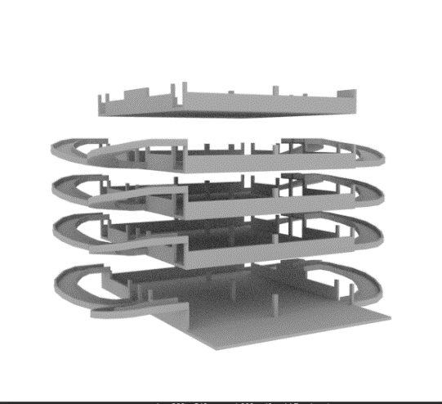
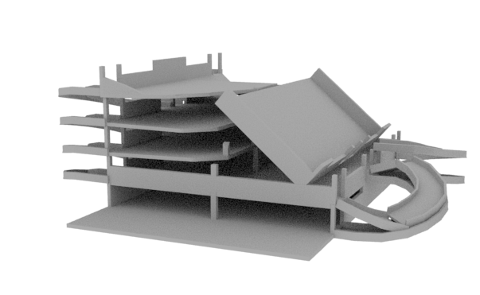
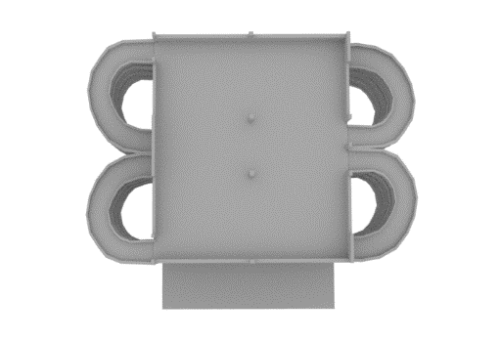
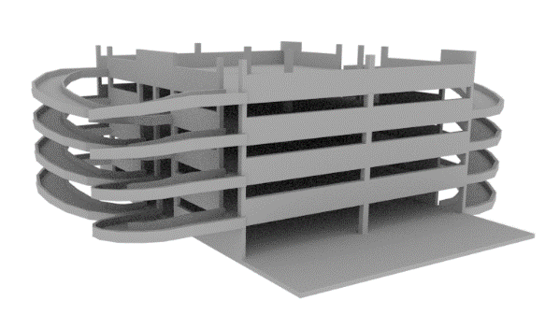
These images below show the non-broken and the broken one and the broken had more work need to be done to it.

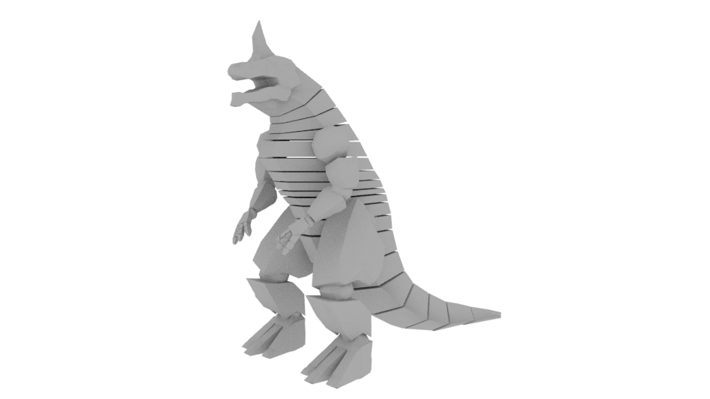
Monster

In This week I took the model I made for Jordan and mitch, and I separated the body into pieces. This is because Jordan asked me as this then would help him in animating. So, when I did this I give Jordan the model I also redid the ZBrush file for mitch the models will match up.

Car
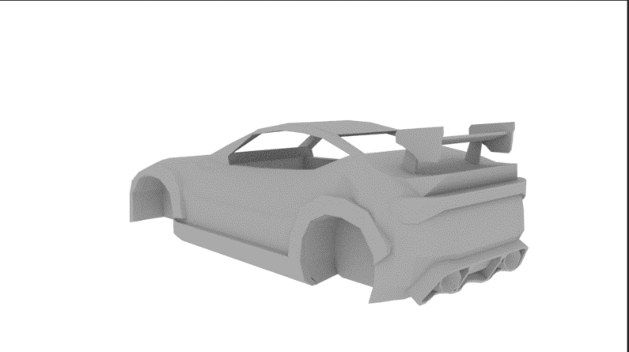
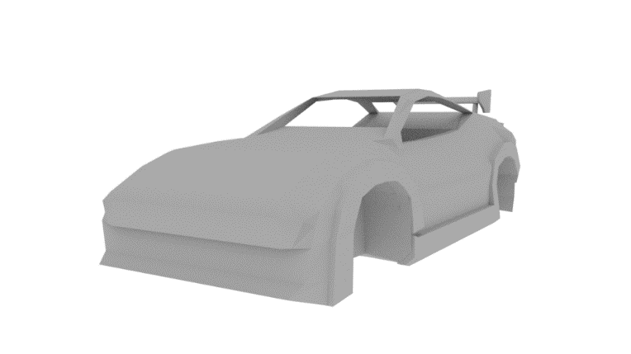

In this week I also started work on the model of the car. Now in my Gant Chart this should take me two week which I am on track for. When I started this car, I had three orthographic they were front, back and the side. When I was modelling this car, I was struggling in getting the shape of the car correct. As you can see by the top images, the back of the car looked ok but the front I couldn’t do right.
So, I did some research and found that a lot of people had top down orthographic so when I found that out I asked Mitch on Friday if he was ok to give me orthographic of top down by the next week. This will then hopefully allow me to be able to get more smoother edges of the car to make it look natural.
This has not set me back on time as I have allocated two weeks for making this car. As it is my first time modelling a vehicle.
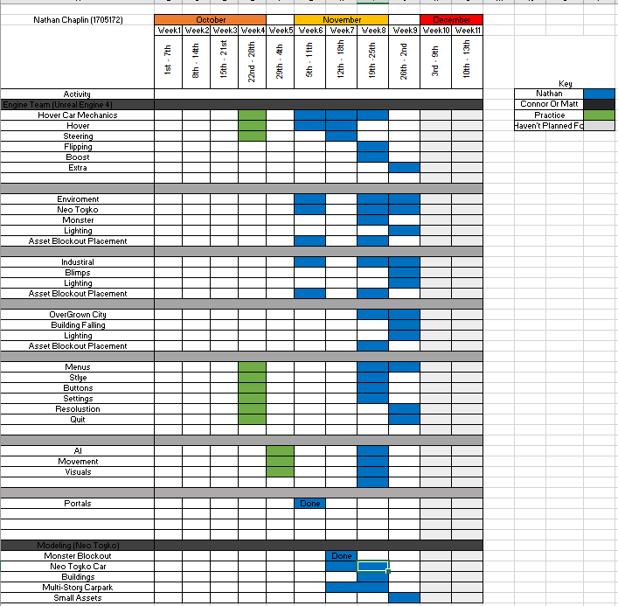
This week I had finished the monster block out as there were some changes that needed to be made to the model as I had talk to Jordan who was rigging it and having the body blocky would be better for rigging than full so once this was done. I had too moved the hover back and take away some plans cause this week I focus on modelling more than the unreal side of the level.
Week 8 - 19th / 25th
Car Model
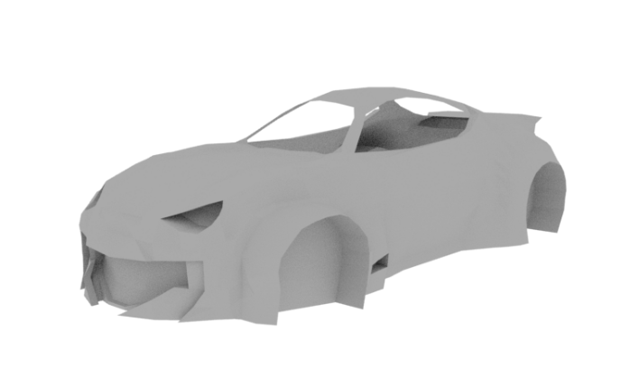
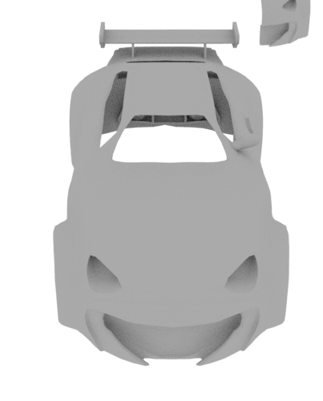

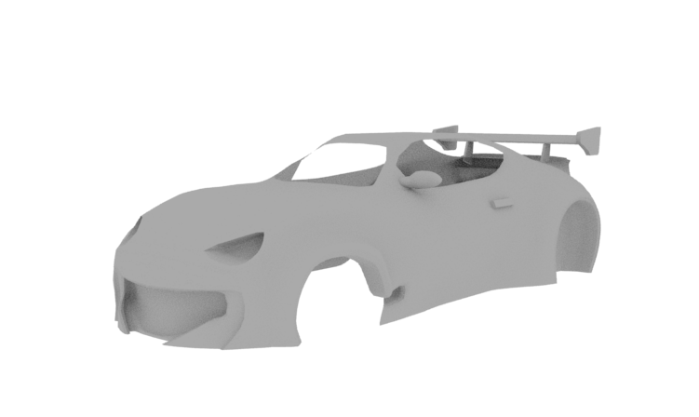

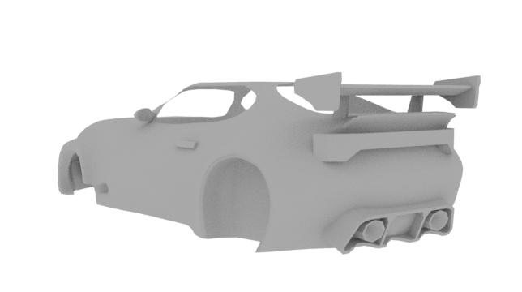

By Wednesday I was able to get this done of the car and using the top down view. For my second attempted I seen that I improved so much just by watching a couple of videos and researching how they did models. I ran into a couple of problems so far with the wide body kit. As I couldn’t get them looking like I wanted but I have 2 days to finish it and get it the way I want it if I want to stick to my time table.
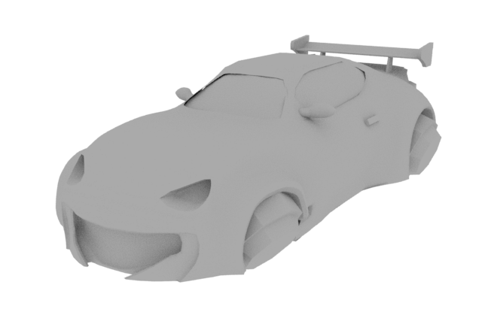

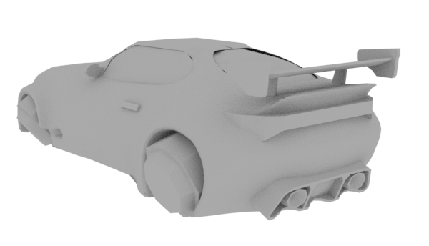

By Saturday I was able to get this car done for a block out of it. Overall, I am happy the way this turned out as for my first time there was a lot of trial and error as I have never modelled a car before.
The things I would do differently next time I model a car is make the top part of the vehicle a bit wider as it looks quite small. Another thing I would change is the windows and there is a slight gap between them and the body.
I took my model to Connor, Jordan and matt to get feedback and they like the block out I did and were happy with what I produced. This is now one of the vehicles in the game in which you can select.

Experimenting with Roads
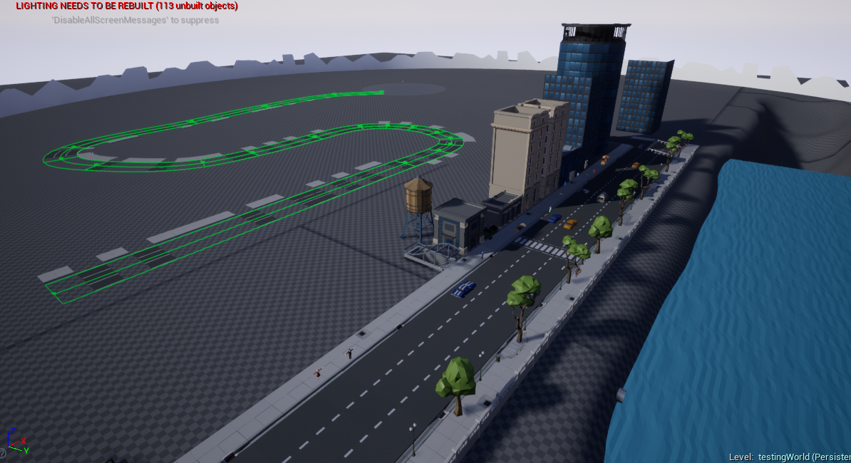

This week I did a little experiment with roads to find out what the best way of doing roads were.
Firstly, I look at a pack on unreal called POLYGON – City Pack. This pack had module road which connected to make city roads. When I started to build the roads, I loved the fact they were module and that you were able to customise them in the way you wanted to build the roads.
The one problem I had was this is when it came to corners they were very sharp and for a racing game this was not ideal as we wanted smooth corners in which the player would be able to smoothly go around. A solution to this problem was to build a long bending round but with the same module system so you can easily add roads and paths two it.
When looking at this pack I when into the building to research how they did there building. What I found was they were module as well and you can customize them and make loads of different types of build with very few models. I like this system, so I will have a work with the group and see what everyone else thinks.
Next, I tried landscape splines this was a good system for roads as it allowed you to make straights and smooth bends with ease. I Quite like this system and I think that we will be using the system in order to build the roads for the racing game.

Checkpoints
This week I also worked on checkpoints. I looked up a tutorial on YouTube (https://www.youtube.com/watch?v=eOnHquxMiWs)
The way this system works is by when the player drives over the checkpoint then it sent where that new checkpoint is as the new respawn location, and then when the player driver over another checkpoint then it set that checkpoint location as the new respawn location. This means when a player get kill or drives off the map there will be a kill switch in the map which then will enable the player to be respawns at their last checkpoint hit.
This is good for the game as this will then allow the player who do drive of the road to get back into the race with ease.
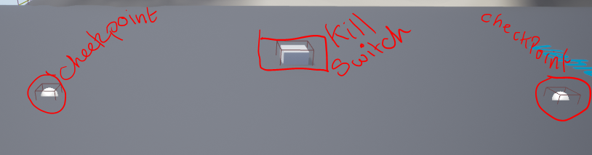

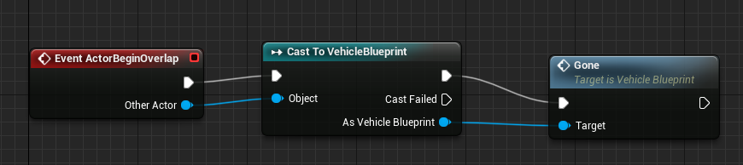
Below is the code which when the player hits the kill switch it will then Cast to the vehicleBlueprint and call Gone.

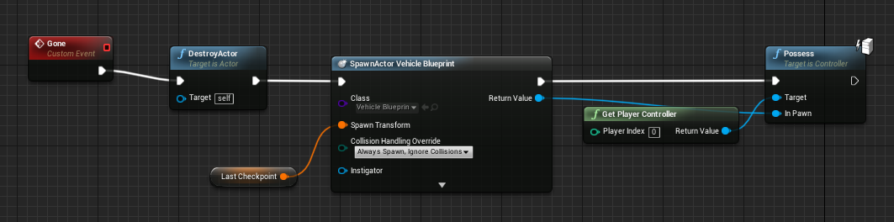
This next bit is where the vehicle blueprint receives Gone and start the event which will kill the players and then respawn that player at there last checkpoint location and then take control of the new vehicle that has just got spawned.
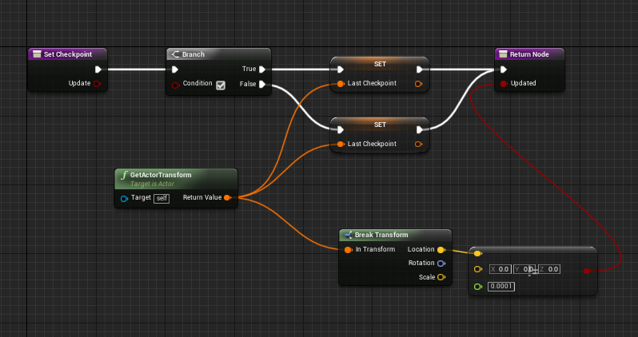
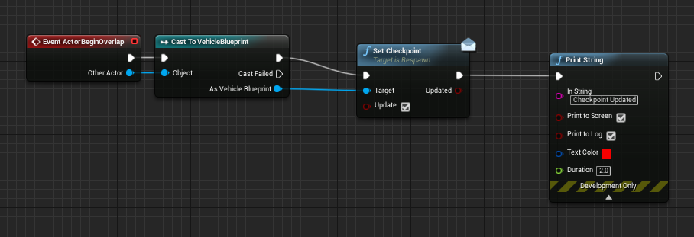
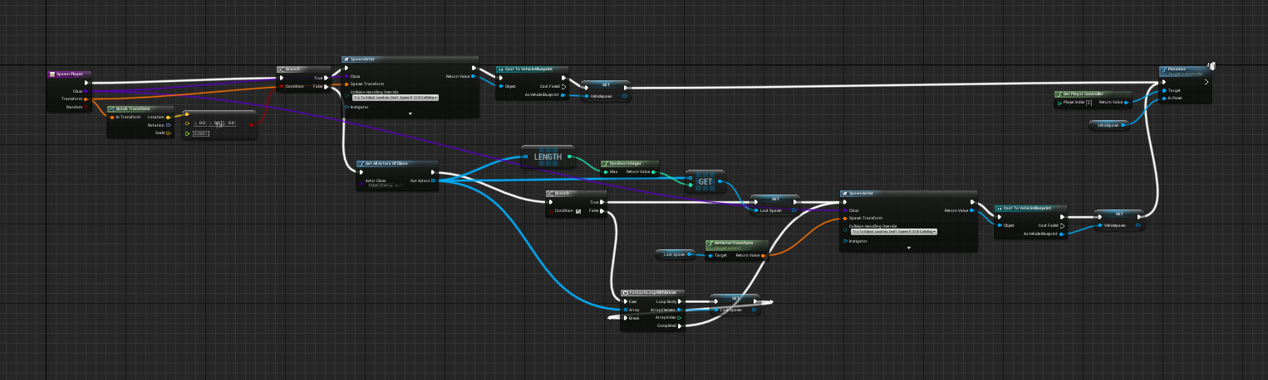
So this code with active when the vehicle has driven though a checkpoint. This will then trigger the set checkpoint node which will then set the new checkpoint

This is the code which gets run when the set checkpoint node has been active. This code will get the location of the checkpoint and set it as last checkpoint and then updated it.

This bit of code will spawn vehicle at the last location calactin the way it was facing so it will spawn you back in the same direction.

This week the hover mechanics were help back again. But menus were taken up by Connor which was nice as he focusses on that so I can focus more on the modelling and unreal side of things as there is still a lot to do. I have also moved back ai as we still don’t have a nice working hover system yet.
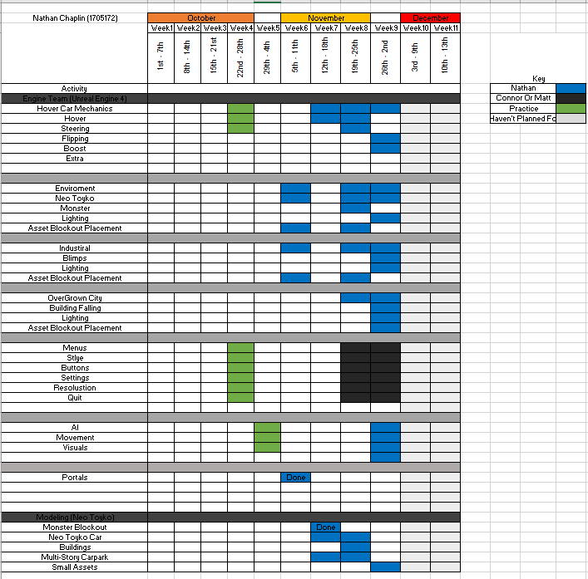
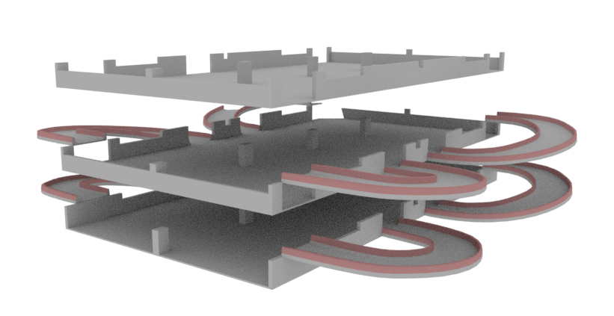
Week 9 - 26th / 2nd
Multi-story
I redid the multi-Story as the sizing was way off and I had to change a few things. Firstly, I had to change the ramps and they were two blocky so when driving on them they weren’t smooth. Next was the Sizing of the whole thing as it was too tight for car to get around the corners.
The whole Is module as well this is because you will be able to edit the height and make different multi-storeys with different number of levels.
Also, There is two different type of Material on the object, this is because when we import it into unreal we want to materials to go on this object. The one is red Will change to a clear material but will stop the player from being able to go over it.

Rainbow Bridge
I had been given a concept of the rainbow bridge that was going to be put in the game. When building this bridge, I didn’t have a problem with it and I got what Mitch wanted though his image.
This image Mitch give me there was neo lights on the bridge it self and the support able so to be able to apply two materials in unreal I selected the faces and objects that needed to be lit up and I give it a new lambert material.
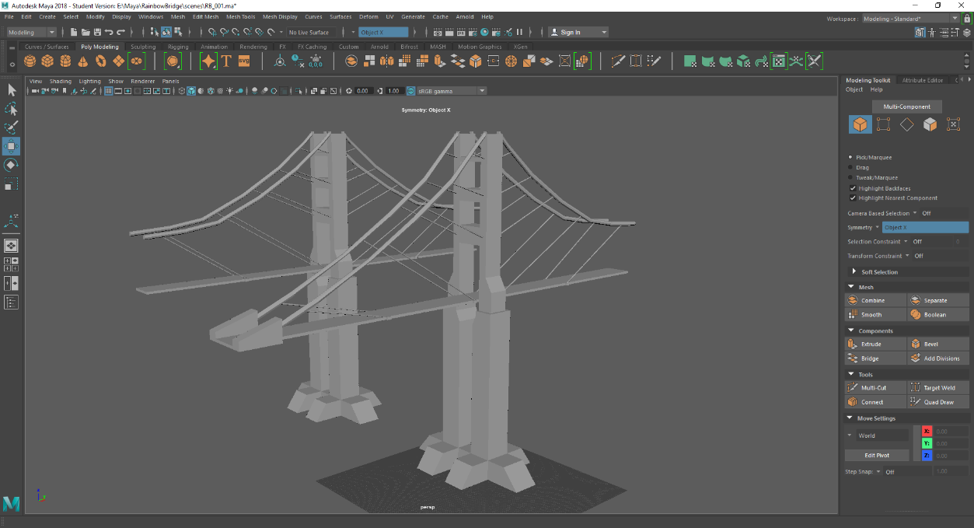
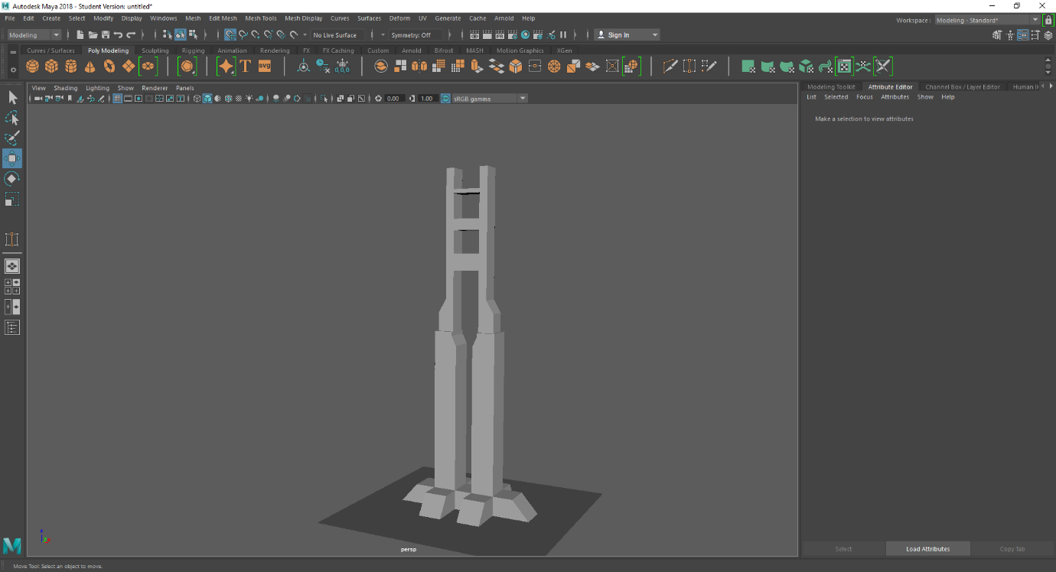
This meant that when I put this object into unreal that I can apply two different materials to it. So I applied a emissive texture which allow it to glow and look like a neon bridge.

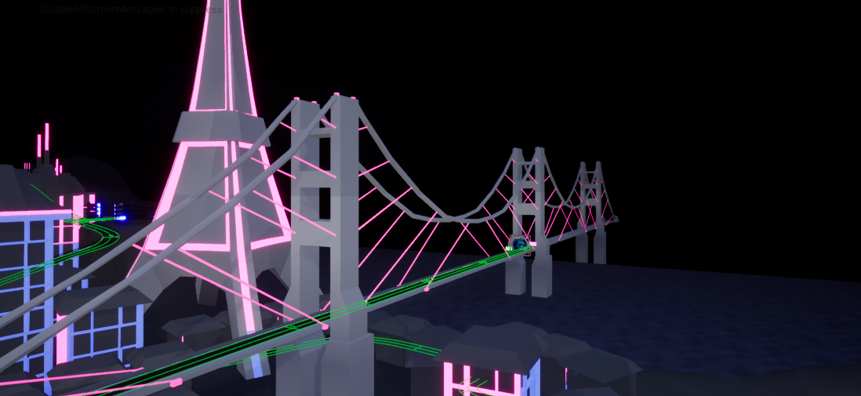
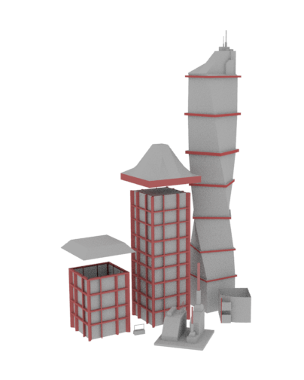
Buildings
These are the building I created for the block out. These types of buildings are tried to make modular so that you can have the same style building but different lengths and with different roofs on them. This meant that you can give loads of different variety without making too many assets.
On these building I wanted the outline to be able to glow and change colour in the engine. This meant that in Maya I applied a different lambert material to the areas in which I wanted to glow this meant that in the engine you’ll be able to apply a new material and make it glow and change colour.

This week me and the other member of the team came together, and we decided that as there were 3 maps that we will be working on 1 map each. So, I was assigned the neo Tokyo map as I have been working closely already with that team and I have already been working on the map and the assets that are in this level. This meant I was able to take away the industrial level and overgrown level out of my plan as the other unreal guys have that covered. What also happened this week is that matt bought a hover system that I had found on the unreal store he did this as we all we worried because we weren’t getting taught the main thing in our game which was the hover car. So, the mechanics on this vehicle was also take out of my plan. This was useful as I can spend more time in the engine and Maya working on the neo Tokyo level and making sure that the level Jordan had drawn I could capture that in game and we have been working closely in order to change and make the map better every day.
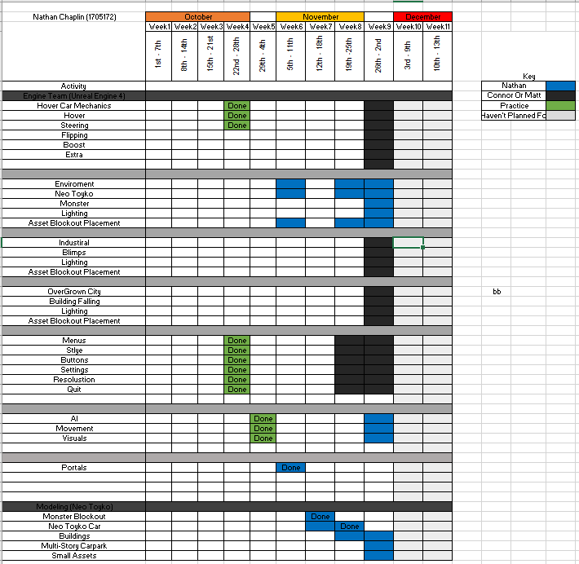
Week 10 – 3rd / 9th
This is the image I have been give off mitch the concept artiest for the portal for the neo Tokyo level.
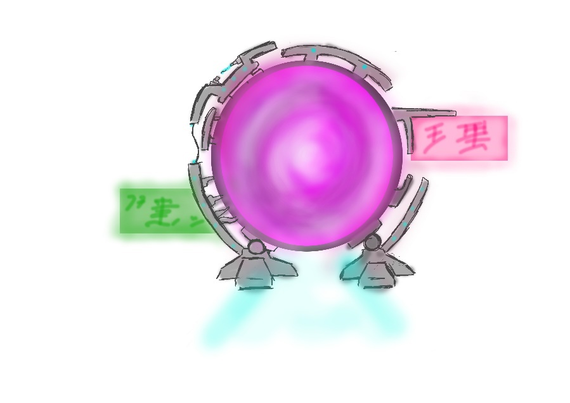

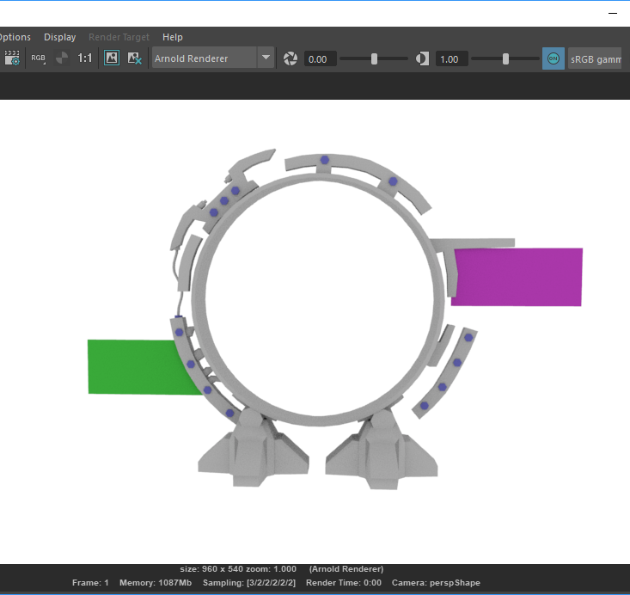
i took this image into Maya and I was able to get the key point out in the 3d model I did, and this model is the image below. What I then did once I was happy with the portal. I though it was a nice touch to add in Neo Drive in Japanese on the portal where mitch put writing.

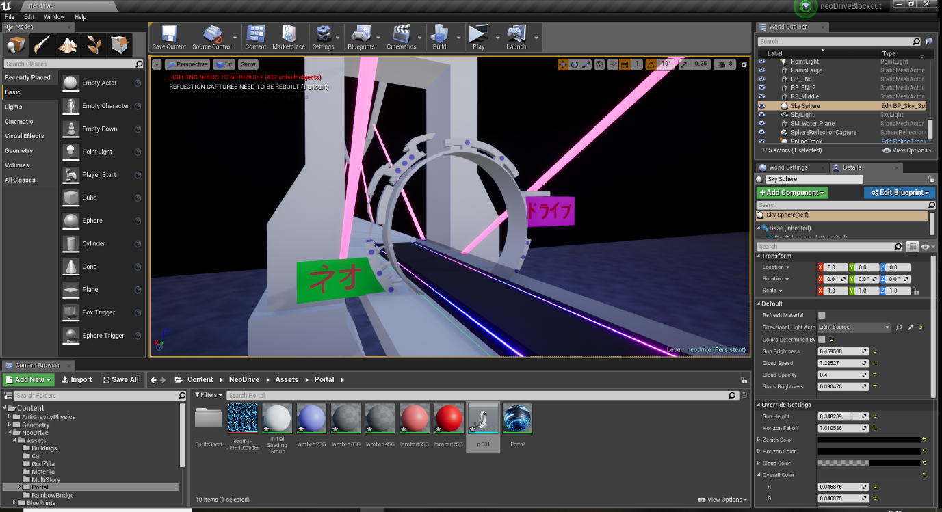
This is what the portal looks like in the engine I had to move it down as the car would have to drive into the centre of it but overall, I am happy with this design and the way it ended out like. In the centre of this portal there will be a animation playing to make it more like a portal and which allows the player to be able to recognise that you have to go into the portal.
Map changes
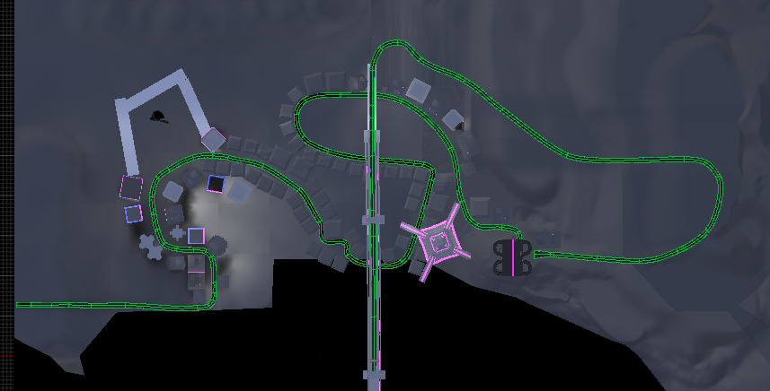
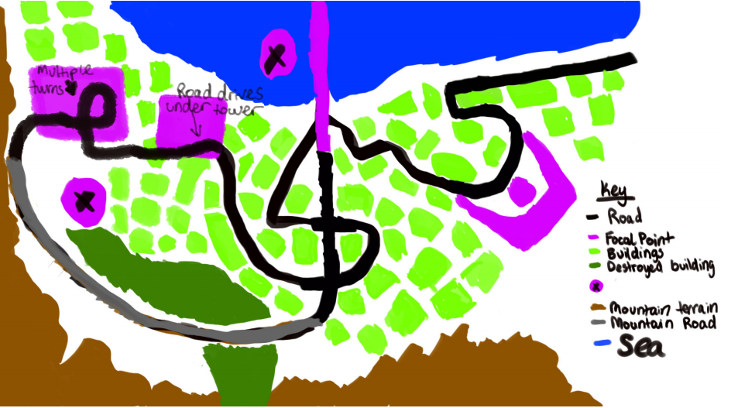
When me and Jordon have been playing the map, we have made changes to the way it works and what feels nice when driving in the world. And what we have come up with is this map. Jordon drew the map out again and was able to easily show me what it looked like and he put in the areas we talked about where it needed to change. So, the top image is the top down view of the world and the bottom image is what it looks like in game. These two images are very close, and Jordon and I are very happy with the way this planned out and how the map flows nicely. We look forward to developing the map.

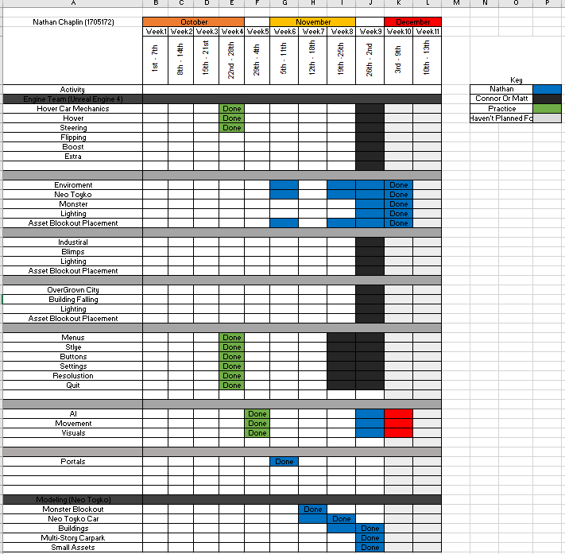
This week I have finished the block out of the neo Tokyo level. And all the modelling I needed to do I have done but it was crunch time this meant that the 2 weeks I was hoping to be done with the block out and when into it by 1 week. The only problem I have had is with AI I didn’t know how long the block out would take so the AI would have to be pushed back until we further develop the game.

Finally, Block out level images
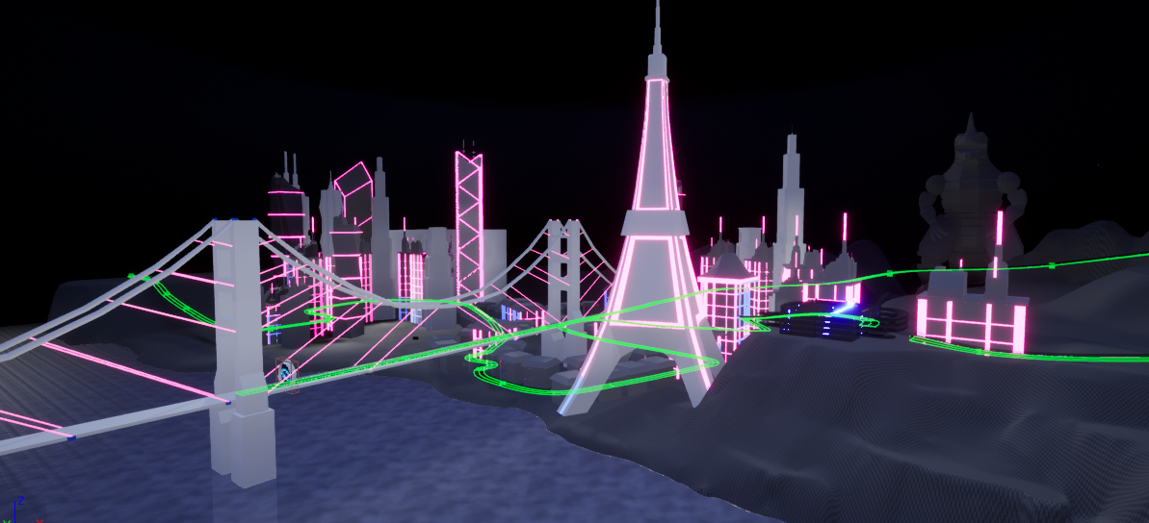
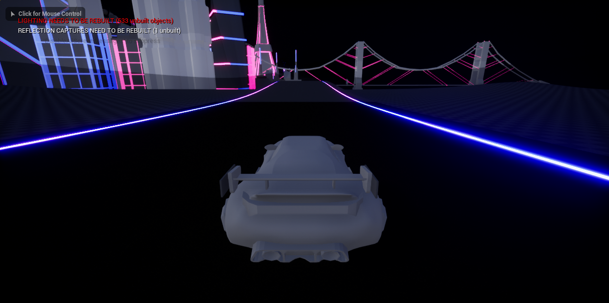

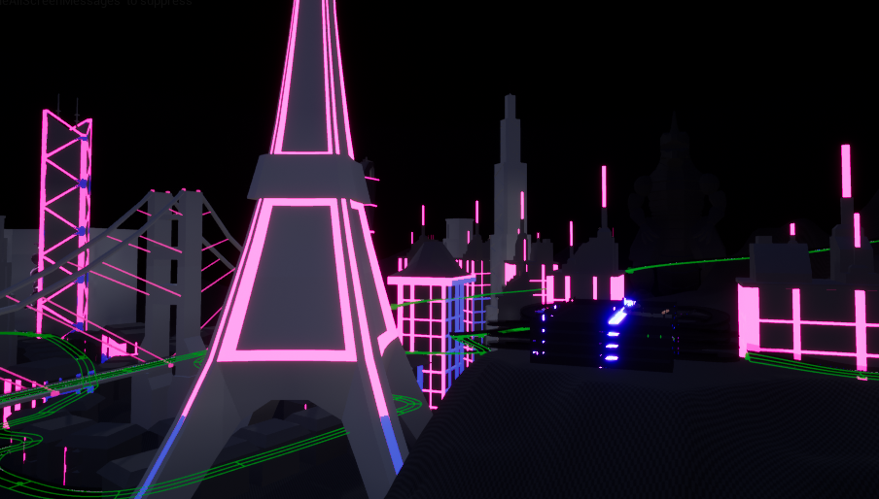
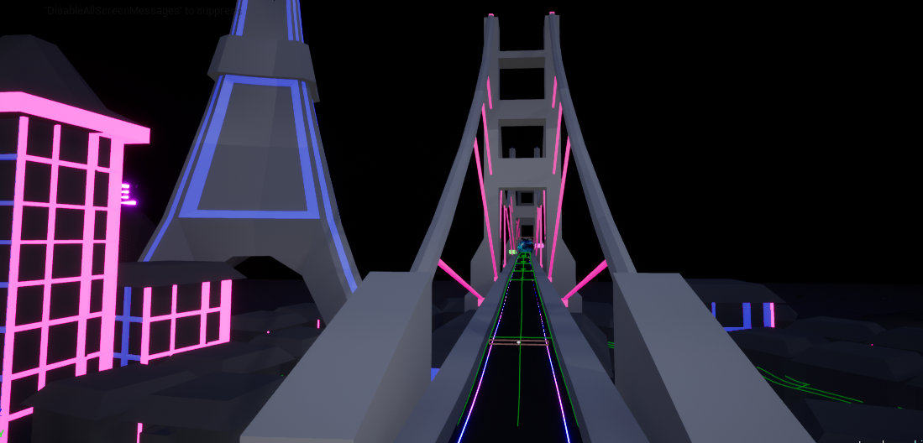
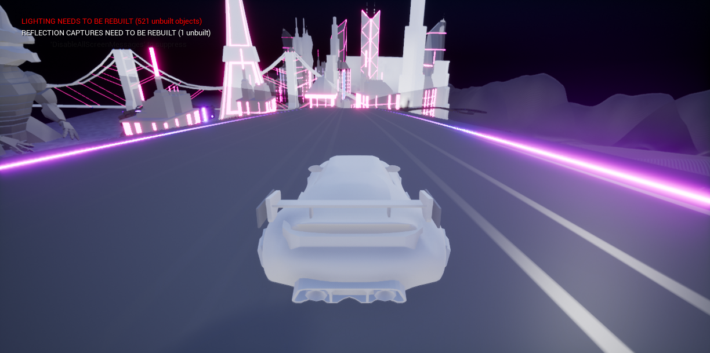
Conclusion
Overall, I really enjoyed this semester I found that the teams that we were in work well and I would like to go in with the same people next time. I enjoyed working with the other teams talking about there ideas of there levels and what they wanted.
The things I didn’t like this semester was how I feel that everything I have learnt has been from home and uni hasn’t taught me enough as the main part of our game we didn’t get taught and we learnt nothing about racing games.
I really look forward in working with the same teams to be able to develop the rest of the game and make the game look fantastic and well as adding AI and other things to the game to make it more interesting.
What I would change and improve on in the work I have done. Firstly, do more research in how long certain models take so then I can improve the way I do my gant chart. I would also improve on doing more research before modelling assets I felt like I didn’t do enough and if I did my models would be at a higher standard but I have set this as a goal for myself, so I can improve.

