

Methods and Search Strategy Academic Poster

Student name: Saima Ijaz
Student ID: 2237202

Module name: Independent Project
Module code: BMHP6020
EXPLORE THE IMPACTS OF ADVERSE CHILDHOOD EXPERIENCES ON SUICIDE RISK AND SELF-HARM BEHAVIOURS IN MALES AGED 18–25 IN ENGLAND

This research used a secondary, desk-based approach to evaluate how adverse childhood experiences (ACE’s) relate to suicide risk and self-harm in men aged 18–25 in England.

Search Strategy
Search Strategy

CRAAP Test Table Screenshot
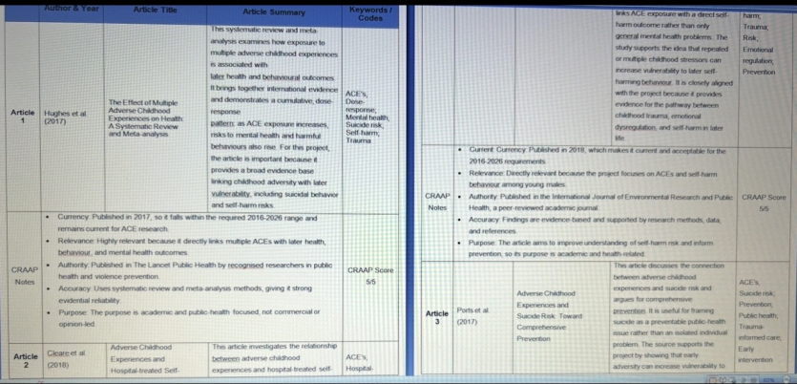

Search Research, Search Research
Search Research
Search Research
Search Research
Search Research

Searching for Information

Search Strategy

Introduction and Research Aim

Picture/Graph/Visual Aid/Statistics

Sources were excluded, such as;
- Not in English language
- Blogs
- Personal opinions
- Websites which cannot be in access
- Not UK based study
- News reports from unreliable sources
- Non peer reviewed
- Publications over 15-20 years old
These rules ensured the relevance, reliability and validity of sources (Esparrago-Kalidas, 2021).

Saima ija z
Saima ijaz

Searching for Information

Result Summary Table
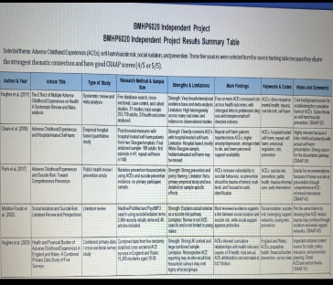

Exclusion Criteria

Inclusion Criteria
Research Validation

The research does not need basic ethical approval because it based entirely on the existing sources which mean it is not involving any participants, interviews or new data collection. Ethical protocols maintained by critically check that the original studies received approvals and fulfilled consent process to protect the vulnerability of ACEs victims. To showing academic integrity, I provided accurate citing of all sources as well as I used Harvard referencing style consistently and tried my best to avoid any misrepresentation. I selected literature fairly and without bias to maintain the transparency and credibility of the research. However, ethical consideration and responsibility were still given due to the sensitivity of the topic of suicide, ACEs, and self-harm.
Ethical consideration
References
Meriam Library, California State University, Chico. (2010) Evaluating information: Applying the CRAAP test. Available at: https://library.csuchico.edu/sites/default/files/craap-test.pdf (Accessed: 23 June 2026).
Esparrago-Kalidas, A. J. (2021) ‘The Effectiveness of CRAAP Test in Evaluating Credibility of Sources’, International Journal of TESOL & Education, 1(2), pp. 1-14. Available at: https://www.i-jte.org/index.php/journel/article/view/25 (Accessed: 23 June 2026).

