Name: Eduardo Polanco Adoka
Student number: 2132108
Module and Code: International Meetings Management BMIH6007
Lecturer: Kathryn Flynn
Title: Planning and delivering an International Meeting/Event.

Table of Contents
1. Introduction 3
2. The Event Cycle 3
3- Event Concept and Itinerary 5
4- Aim and Objectives 6
5- Event Management Considerations 7
6- Event Budget 9
7- Industry Trends / Issues / Impacts 11
8- Situational and Cultural Considerations (SWOT and PESTLE) 12
9- Conclusion 13
References 14

Introduction
The Global Welcome Summit 2025 – Croeso Cymru has been organized as both an international cultural conference and a special tourism event in line with Visit Wales’ Year of Croeso effort. Planned for July 2025 at the Wales Millennium Centre in Cardiff, the event will highlight the best of Welsh cuisine, history and how Welsh tourism works together with international tourism. The event welcomes tourism leaders and representatives from multiple countries, helping to put Wales ahead in MICE (Meetings, Incentives, Conferences and Exhibitions). Event delivery makes sense because the location is strategic, the culture is unique and the events are tied to what the government is promoting.

The Event Cycle
The event management cycle helps ensure events are planned correctly, carried out properly and evaluated afterwards (Bowdin et al., 2023). As mentioned by Bowdin et al. (2023), the cycle goes through stages of research, designing, planning, implementation (coordination) and evaluation.
Research Phase
- Stakeholder analysis using Visit Wales, British Council, UKInbound as examples.
- Assessing our progress by comparing to known events like World Travel Market (London) and IMEX (Frankfurt). The International Passenger Survey (UKInbound, 2023) shows a rise in interests from people wanting cultural and experiential experiences in Wales.
- SMART Framework
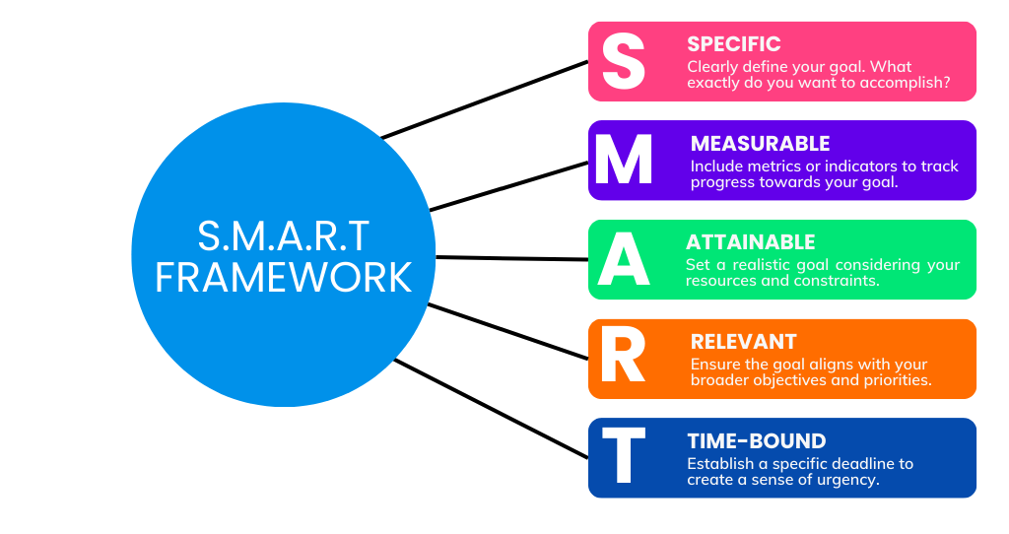
Figure 1: SMART Framework
Design Phase
- A hybrid event offers keynote talks, followups in the form of panels, networking events and cultural highlights.
- Offering networking, learning and involving all senses to promote teamwork globally.

Planning Phase
- Arranging everything for the Wales Millennium Centre, organizing how things are set up, check accessibility issues and consider technical specifications.
- It includes recruiting the right people such as event coordinators, people who facilitate culture and security.
- Promotion strategies: Promote B2B marketing on LinkedIn, Instagram and Visit Wales websites.
- These two methods, critical path method (CPM) (Bishnoi, 2018) and Gantt chart, were designed to order tasks and control time-dependent activities (Evdokimov et al., 2018).
Implementation Phase
- An Event Management System (EMS) can handle both registration and management of delegates (Shah et al., 2023).
- On-demand help is available for all hybrid parts of the event (such as the streaming and virtual fair).
- Handling meetings between media and VIPs in line with all health and safety rules.
- If there are weather problems, health concerns or equipment issues, still, everything is planned for in advance.
Evaluation Phase
- Administer surveys (digital and paper) to collect opinions on whether the materials, processes and networking were effective.
- Reviewing KPIs: Attendance, money returned on sponsorship investments, how much media has presented the event and levels of social media involvement.
- Both formative and summative evaluations are necessary to hold everyone accountable and guarantee improvement (Bhat and Bhat, 2019).
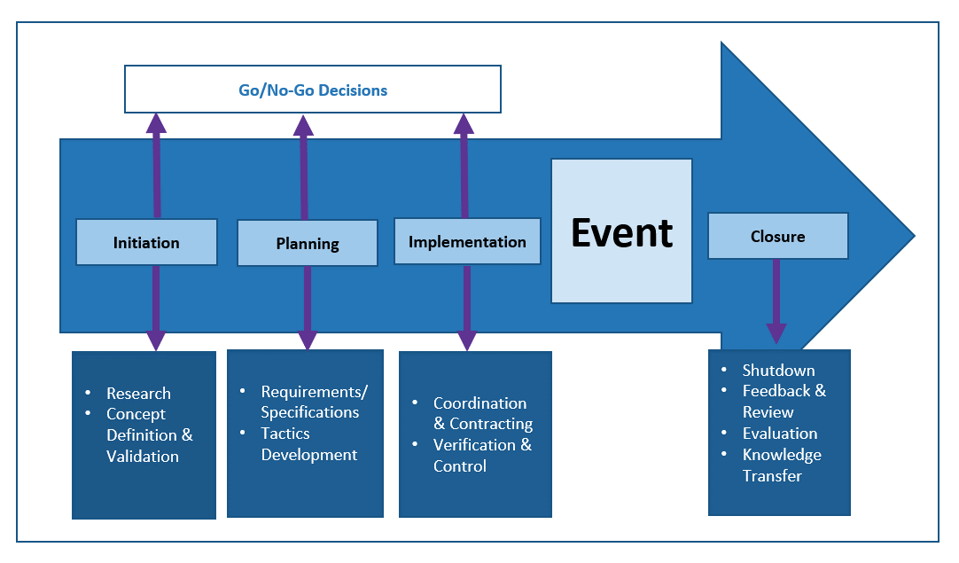
Figure 2: Event Management Cycle

Event Concept and Itinerary
The Global Welcome Summit 2025 will be a two-day festival that links Wales’ strong culture, global cooperation and tourism management. The Wales Millennium Centre is the location for the programme, using the Donald Gordon Theatre and neighboring spaces. Below is the full itinerary:

Event Itinerary Table:
Day | Time | Session Title / Activity | Details
Day 1  (Intercultural Exchange & Policy Panels) | 09:30 – 11:00 | Opening Ceremony | Welsh National Opera performance, welcome addresses by dignitaries
 | 11:15 – 12:30 | Keynote Session | Tourism in a Post-Pandemic World – Global insights by industry experts
 | 13:30 – 15:00 | Cultural Workshops | Language taster sessions, traditional Welsh dance, cuisine demonstrations
 | 15:15 – 16:30 | Panel Discussion | Sustainable MICE Events – Environmental and ethical practices in events
 | 17:00 – 19:00 | Networking Reception | Evening drinks & Welsh gastronomy; informal B2B delegate engagement
Day 2  (Place Branding & Tourism Innovation) | 09:30 – 10:30 | CEO Roundtable | The Future of Destination Marketing – Executive insights and case studies
 | 10:45 – 12:30 | Start-up Showcase | Tourism-tech and heritage innovators exhibit solutions and pitches
 | 13:30 – 15:00 | Welsh Regions Forum | Representatives from North, Mid, and South Wales discuss regional tourism
 | 15:15 – 16:00 | Closing Session & Awards | Summary remarks, cultural awards, future collaboration announcements
 | 16:30 onwards | Guided City Tours | Optional cultural tours of Cardiff’s historic sites and local attractions

Aim and Objectives
Aim:
To build the world’s awareness of Wales as a leading cultural and conference destination at a summit highlighting Welsh hospitality, innovation and diverse ways of thinking.
SMART Objectives:
- By July 2025, aim to invite at least 300 foreign delegates from 20 different countries to participate.
- Goal is to achieve a rating of 85% satisfaction from post-event feedback surveys and engagement online.

Event Management Considerations
Achieving success for the Global Welcome Summit 2025 – Croeso Cymru depends on an event management plan that takes care of operations, plans all aspects upfront, markets the event well, has skilled employees and manages risks (Allen, 2008). All of these parts are important for delivering an international conference that matches the strategic goals of Visit Wales’ “Year of Croeso” campaign.
The EMBOK (Event Management Body of Knowledge) Model (OBM) is also a helpful framework to complete the operational strategy of the Global Welcome Summit 2025. EMBOK model describes five foundational domains which are Administration, Design, Marketing, Operations, and Risk (Allen et al., 2010). The Operations area is of particular interest in the framework of this event since it deals with the site management, logistics, technical production, and the services provided to the attendees. Indicatively, the selection of the Wales Millennium Centre and contingency planning, staffing and hybrid technology incorporation follows the operations principles of EMBOK, which establishes a well-organised and professional delivery of events.
The decision to stage the opera in the Wales Millennium Centre was very well-planned on an operational level. The place is easy to reach, being located near the train and bus stations and the airport. Inside it is the Donald Gordon Theatre with space for 1,897 people, along with attached meeting halls and exhibition areas.
Event planners started organizing the event twelve months ahead and followed a step-by-step plan using Critical Path Analysis (Yang and Miller, 1988) to reach each goal smoothly. The plan divided into phases and scheduled early meetings with stakeholders and sponsors, making sure the event programme was completed, securing suppliers and starting the promotions. Managing suppliers was very important when planning the event and it was key to hire local companies for catering, creating signs, producing the event and performing at the event.
Both marketing and communication efforts were very strong, thinking of the summit as the top cultural diplomacy event for Wales. International tourism boards, top figures from the hospitality sector, MICE specialists and cultural groups are invited to the event. LinkedIn was used for professional advertising, Instagram and X (formerly Twitter) for visual and cultural campaigns and email newsletters were sent to keep in touch with previous contributors. Teamwork with groups like UKInbound, the British Council and the Welsh Government makes the summit recognized and respected by target countries.
Table 1: Marketing Strategy Framework
Marketing Concept | Application to Global Welcome Summit 2025
Product | A two-day hybrid summit combining Welsh cultural experiences with global tourism and MICE industry networking.
Price | £250 per delegate – positioned to reflect value for premium B2B networking, culture, and learning.
Place | Wales Millennium Centre (Cardiff) as the physical venue; hybrid model allows global online participation.
Promotion | Campaigns on LinkedIn (B2B), Instagram/X (cultural outreach), and email newsletters targeting tourism professionals.
Target Marketing | Focused on MICE professionals, tourism boards, cultural organizations, and international stakeholders.
Need Theory (Maslow) | Meets safety (COVID-secure venue), belonging (networking), esteem (awards and recognition), and self-actualization (knowledge sharing, cultural enrichment).

Skilled human resource planning was needed for both the main organizers and the technical staff (Akhigbe, 2013). An event director, operations manager, finance officer and public relations coordinator formed the core team and they all took responsibility for executing the strategies. All staff were volunteers, interpreters, caterers, AV technicians and security and they had learned about cross-cultural communication, security and etiquette for guests. Working on their capabilities made sure that every member of the team was equipped to offer the best service for two days (Hackman, 2002).
Risk and contingency planning happened ahead of time to tackle many different problems (Eriksson and McConnell, 2011). By having duplicate systems, backup tapes and spare parts, technical problems were handled properly. Medical and safety matters were taken care of through sending trained staff and using contactless registration for all participants. Risks from outside, for instance, shutdowns due to transport strikes or bad weather, were handled by insurance and flexible work choices. The risk management system at the summit was based on ISO 31000 (Barafort et al., 2019), so that all likely risks were handled and managed in advance which made the event more steady and gave stakeholders confidence.
Cultural and environmental considerations were a main part of how the event was run. No paper brochures were used; instead, digital versions were provided and recycled materials were used to decorate and put up signs. Dishes were planned with sustainably produced goods and presented vegetarian, vegan and halal dishes for different appetite preferences. Local artists, musicians and storytellers were featured, providing real cultural content and boosting participation in community events. The summit is in line with the core sustainability aims in Welsh tourism and proves to be environmentally and socially responsible.

Event Budget
The organizers have developed a financial plan for the Global Welcome Summit 2025 – Croeso Cymru so the event is affordable, environmentally friendly and likely to finish with gains. A small crowd and responsible budgeting mean the event can give value and be enjoyable without sacrificing standards. The summit’s expected revenue is £88,000, whereas the total estimated costs are £65,000 which means there will be a profit of £23,000. The extra funds can be spent on post-event work, future legacy projects or future summits.
Projected Income
Income Source | Amount (£)
Ticket Sales (300 × £250) | 75,000
Sponsorship (Visit Wales & Welsh Government) | 10,000
Merchandise & Food | 3,000
Total Income | 88,000

Projected Expenditure
Expense Category | Amount (£)
Venue Hire (Wales Millennium Centre) | 20,000
Catering (2 days for 300 guests) | 12,000
AV & Technical Services (incl. hybrid setup) | 10,000
Marketing & Promotion | 8,000
Staff & Volunteer Training | 6,000
Security, Health & Safety | 3,000
Speakers’ Travel & Accommodation | 4,000
Contingency Fund | 2,000
Total Expenditure | 65,000

Financial Summary
The financial planning outlines that the event is possible and it will not cause financial problems. With net surplus of £23,000 , the summit sets an example for other events within the MICE sector. Well-managed income and controlled costs show that the event is well managed financially and reliable for all involved.

Industry Trends / Issues / Impacts
Recently, technological progress, shifts in society and politics, environmental issues and the aftermath of COVID-19 (Disimulacion, 2020) have all changed the worldwide meetings, incentives, conferences and exhibitions (MICE) industry (Schlentrich, 2008). Using hybrid event formats is a significant trend in MICE since it allows people to participate both in person and online (Singh and Deri, 2024), lowers expenses and brings new attendees. Because of this, events such as the Global Welcome Summit 2025 which involve delegates from several regions with travel and sustainability issues, are even more important. Hybridization is needed now for organizations to stay relevant and open in an ever-changing event industry (Rogers and Wynn-Moylan, 2022).
People involved in organizing and attending events are paying more attention to sustainability (Mair and Laing, 2013). Digital materials, buying locally and low-impact catering are no longer seen as add-ons; they are now a standard requirement. To respond to this development, the Global Welcome Summit 2025 will print digital brochures, offer recycling and get products from nearby Welsh shops. It is in line with the tourism sustainability aims for Wales and matches what environmentally responsible participants value.
People are now choosing cultural tourism and local experiences because they want to explore new places by looking into local customs, food, language and culture (Getz and Page, 2019). Now, gatherings like the Global Welcome Summit are usually held as cultural events as well as business conferences, both elements that support tourism in the destination. Using traditional music, language sessions, forums in various regions and tours focused on Welsh culture, the summit matches this trend and uses the “Year of Croeso” to appeal to travellers interested in experiences.
MICE organizations must deal with several ongoing problems and challenges. It is becoming tougher to stick to budgets and strategic prices as event costs increase because of inflation and worldwide supply chain problems. Being financially efficient and yet ensuring the summit gives a memorable experience to delegates is a big challenge for these events. Geopolitical matters and the uncertainty in the economy—mainly because of the Brexit outcome and current wars—have portrayed impacts on travel confidence and cross-border interaction (Smith, 2025). Therefore, event planners must provide strong contingency plans and make remote participation options available.
In addition, there is a growing effort to promote equity, diversity and inclusion (EDI) in the MICE industry. Organizers of events are required more often to ensure their spaces are accessible to people of different cultures, languages and physical abilities. Global Welcome Summit is arranged to reflect these goals by supplying multilingual help, universal accessibility and a programme that respects all cultures while highlighting Welsh heritage. Creating this broad environment enhances what international delegates feel and makes Wales stand out for being progressive and hospitable.

Situational and Cultural Considerations (SWOT and PESTLE)

SWOT Analysis:
Strengths | Weaknesses
Unique cultural theme (Croeso) | New event – limited brand equity
Government and tourism board backing | High initial logistics cost
Iconic venue with top facilities | Seasonality (July may compete with other events)
Opportunities | Threats
Rise in cultural and MICE tourism | Political and economic uncertainty (Brexit, inflation)
Collaboration with global agencies | Health-related disruptions (COVID variants)

PESTLE Analysis – Global Welcome Summit 2025
Factor | Analysis
Political | Welsh Government’s backing through Visit Wales adds official legitimacy and promotional reach.
Economic | A surplus-driven budget strategy helps ensure financial resilience amid inflation concerns.
Social | Emphasis on Welsh culture, hospitality, and inclusivity resonates with global multicultural audiences.
Technological | Integration of Event Management Software (EMS) and hybrid formats improves participation and accessibility.
Legal | Full compliance with GDPR for delegate data, contracts, and health/safety regulations ensures lawful operations.
Environmental | Use of digital brochures, recycled materials, and local suppliers reflects a low-carbon commitment (Dalirazar and Sabzi, 2023).

Conclusion
The Global Welcome Summit 2025 – Croeso Cymru demonstrates how an event can be planned well, carried out smoothly and understood by everyone. Using Wales’ distinctive identity and its focus on worldwide hospitality, the summit supports both the “Year of Croeso” and the country’s competitiveness in MICE. Because of careful planning, teamwork with stakeholders and keeping up with industry trends, the event is likely to bring real results and lasting benefits.
In order to guarantee the progress and the lasting impact, the following recommendations are offered:
- Follow up webinars Online feedback loops where attendees can give feedback on the event and share the event highlights on social media to amplify legacy results.
- Create long-term agreement with the local suppliers and cultural organizations to make the future events sustainable, culturally, and financially beneficial to the Welsh communities.
- Consider investing in improved data analytics and hybrid technologies to enhance delegate experience and to monitor satisfaction levels in real time, as well as to guarantee more comfortable planning of future international conferences.
Such measures will assist in capitalizing on the success of the summit, ensuring its long-term viability, and strengthening the place of Wales within the MICE and cultural tourism markets.

References

AKHIGBE, O. J. 2013. Human resource planning: A key factor in ensuring the effectiveness and efficiency of organization. Journal of Emerging Trends in Economics and Management Sciences, 4, 388-396.
ALLEN, J. 2008. Event planning: The ultimate guide to successful meetings, corporate events, fundraising galas, conferences, conventions, incentives and other special events, John Wiley & Sons.
Allen, J., O’Toole, W., Harris, R. and McDonnell, I., 2010. Festival and special event management. 5th ed. Milton, Queensland: Wiley Australia.
BARAFORT, B., MESQUIDA, A. L. & MAS, A. 2019. ISO 31000‐based integrated risk management process assessment model for IT organizations. Journal of Software: Evolution and Process, 31, e1984.
BHAT, B. & BHAT, G. 2019. Formative and summative evaluation techniques for improvement of learning process. European Journal of Business & Social Sciences, 7, 776-785.
BISHNOI, N. 2018. Critical path method (CPM): A coordinating tool. International Research Journal of Management Science & Technology, 9, 459-467.
BOWDIN, G. A., ALLEN, J., HARRIS, R., JAGO, L., O'TOOLE, W. & MCDONNELL, I. 2023. Events management, Routledge.
DALIRAZAR, S. & SABZI, Z. 2023. Strategic analysis of barriers and solutions to development of sustainable buildings using PESTLE technique. International Journal of Construction Management, 23, 167-181.
DISIMULACION, M. A. T. 2020. MICE tourism during Covid-19 and future directions for the new normal. Asia Pacific International Events Management Journal, 1, 11-17.
ERIKSSON, K. & MCCONNELL, A. 2011. Contingency planning for crisis management: Recipe for success or political fantasy? Policy and Society, 30, 89-99.
EVDOKIMOV, I. V., TSAREV, R. Y., YAMSKIKH, T. N. & PUPKOV, A. N. Using PERT and Gantt charts for planning software projects on the basis of distributed digital ecosystems. Journal of Physics: Conference Series, 2018. IOP Publishing, 012127.
GETZ, D. & PAGE, S. J. 2019. Event studies: Theory, research and policy for planned events, Routledge.
HACKMAN, J. R. 2002. Leading teams: Setting the stage for great performances, Harvard Business Press.
MAIR, J. & LAING, J. H. 2013. Encouraging pro-environmental behaviour: The role of sustainability-focused events. Journal of sustainable tourism, 21, 1113-1128.
ROGERS, T. & WYNN-MOYLAN, P. 2022. Conferences and conventions: A global industry, Routledge.
SCHLENTRICH, U. 2008. The MICE industry: meetings, incentives conventions and exhibitions. The Sage handbook of hospitality management, 400-420.
SHAH, D. A., VASUDAVAN, H. & RAZALI, N. F. 2023. Event Management Systems (EMS). Journal of Applied Technology and Innovation, 7, 45-53.
SINGH, A. & DERI, M. N. 2024. Exploring the Use of Virtual and Hybrid Events for MICE Sector: Trends and Opportunities. New Technologies in Virtual and Hybrid Events. IGI Global.
SMITH, H. 2025. Economic Risk and Uncertainty in Post-Brexit Britain: Challenges and Pathways Forward. Frontline Marketing, Management and Economics Journal, 5, 1-6.
UKInbound (2023). International Passenger Survey – Sept 2023. https://www.ukinbound.org/resources
YANG, C.-Q. & MILLER, B. P. Critical path analysis for the execution of parallel and distributed programs. The 8th International Conference on Distributed, 1988. IEEE Computer Society, 366,367,368,369,370,371,372,373-366,367,368,369,370,371,372,373.

