public health and social care BMHP5002
ASSIGNMENT 2: PERSONAL CENTERED CARE

Student Name: Aidah Becky Namuli
Student Number: 1912621
Submission Date: 06- May-2021
Lecturer: Adesewa Ajayi

Table of Contents
INTRODUCTION 2
Concept of Person-Centred Care: 3
Analysis of Person-Centred Care: 4
Theoretical Underpinning of Person-Centred Care: 5
Respect the Patient values and their PREFERENCES: 6
Coordination with the patient and care integration: 6
Information and Teaching: 6
The corporal comfort of the Patient: 6
Alleviation of the fear and anxiety with emotional support: 6
Family and Friends Involvement: 7
Continuation and Transition: 7
Accessibility towards the care: 7
Ethical Concern in Person-Centred Care: 8
Benefits and Limitation/ Challenges of Person-Centred Care: 9
Application of Theoretical Principles on a Patient: 10
Recommendations: 11
Conclusion: 12
References 13

INTRODUCTION

As the population of the world is increasing the demand for health care is also increasing. One such example is the present Covid’19 pandemic. This was one of the severe epidemics which increased the demand for health care enormously and for this reason, person-centred care is used. Furthermore, as the name describes, it is the care that puts the person at the heart of care (Burton, 2018) furthermore, personal centred care is defined as treating the individuals with their needs and allowing them equal partners in dealing with the healing business (NHS, n.d.).
Eventually, person-centred care is important as it influences on health outcomes of the patient. Also, reports that if the patient-centred care is successfully implanted it will create an impact on the shared decision making. Additionally, person-centred care enables the sharing of information in which all the observations were presented in front of each patient which is collected by the team which also includes the latest relevant condition and the research related to the treatments.
One of the significances of Person-Centred Care is that it makes a personal plan. Regarding this, the essay will be written in which the underlying concept and analyses of person-centred care will be evaluated (Michael, 2012)
The essay will also define the theoretical underpinning of person-centred care; ethical concerns in person-centred care and the benefits, limitation/challenges will also be discussed concerning the dementia patient and how the person-centred care is designed in dealing with the patients of dementia will also be discussed. In the end, some recommendations will also be provided regarding the improvements in person-centred care.

Concept of Person-Centred Care:
According to (Oldham, (2016, p.114-115) the personal-centred care is not a medical model and it should be regarded as multidisciplinary and recognise that a person needs one more professional to support them in their care, it respects and integrates patient values, preferences and choices, goals into the decision making in terms of clinical and assessments of the outcomes. The partnership between the patient and the care providers addresses the conditions of the patient including mental, physical, spiritual, and social determinants. These conditions of the patient are used to achieve better outcomes in terms of the health of the patient. (Catalyst, N. 2017). However, in personal-centred care, the individual's particular health needs and their desired health outcomes are the binding forces behind all the sort of decisions taken in health care and the measurement of the quality. (see diagram below)

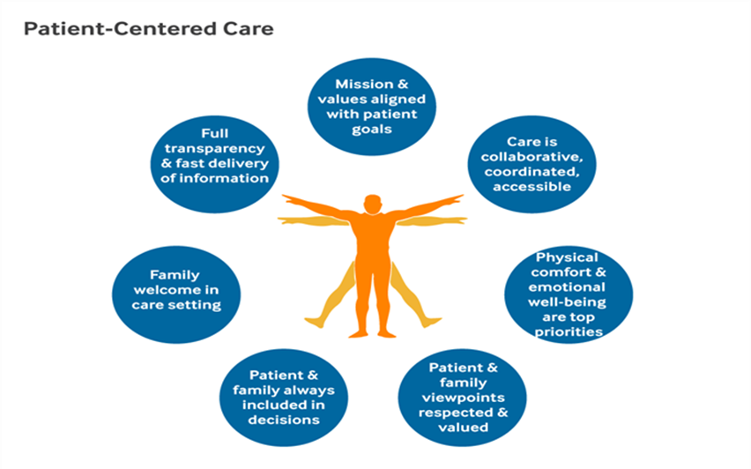
Figure 1 Analysis of personal-centred care Catalyst, 2017

Analysis of Person-Centred Care:

The delivery of Personal Oriented Care includes the care given to the patients which are beyond their reach and stitching their needs and wants (Burton, 2018). Person-Centred Care is all about dealing with the respect that the patient has for their views and having insight about what best suits them. Furthermore, person-centred care enables individuals to have their values and priorities in life. In doing so, the health care provider needs to have a good relationship with the patient. Effective verbal communication is needed in these areas. It is a very common phenomenon that no one appreciates that the decision made for them does not have their input. This makes them mull over that they are a piece of an object or a task rather than a human being that has feelings and thoughts. One of the reasons that this approach is suited best is that it does not make the patient feel hindered by their ailment or disability or make them feel low during their time as a patient, the care provider can help them in living a fulfilling life. This approach is helping people who want to have a geared care environment that ensures them with the skills and knowledge regarding their condition.

Theoretical Underpinning of Person-Centred Care:

The Picker’s Principles of Patient-Oriented Care have explained eight sets of principles that are involved in patient care (Balachandran, 2020). These principles are as follows: Respect the patients’ values and preferences and their expressed needs; coordinating to their individuality and care integration; their information and education, the physical comfort of the individual; the alleviation of fear and anxiety with the emotional support; the family and friends’ involvement in the personal care; continuation and transition and lastly the access towards the care. (see diagram 2 below)
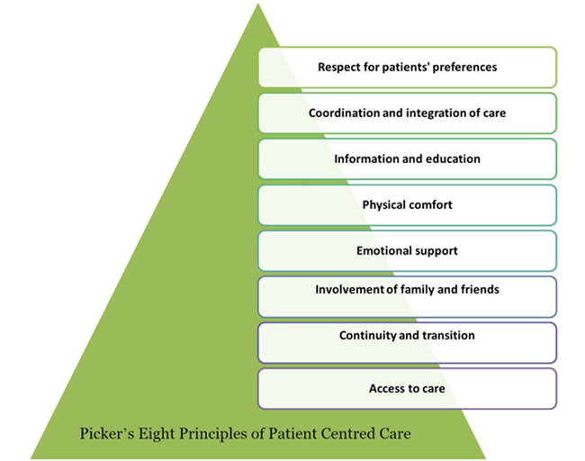
Figure 2 Picker's Eight Principles of patient centred care (Balachandran, 2020)

Respect the Patient values and their PREFERENCES:
This principle deals with the involvement of the patient in making their decision regarding the health (Burton, 2018). Also recognizing them as an individual having their unique values and partialities. Additionally, according to this principle, the patient should be treated with respect and dignity. Furthermore, this principle also leads with another important point that raises the significance of cultural sensitivity in treating the patients.

Coordination with the patient and care integration:
Being in the focus groups, sometimes patients express their feelings of being vulnerable and powerless when facing the illness. For the alleviation of those feelings, proper coordination of care is needed by the patient. According to patients, they are three areas of coordination that can help in reducing their vulnerable feelings (Balachandran, 2020). These areas are: Clinical care coordination; Supplementary and Support service coordination and lastly, coordination of patient care front line.

Information and Teaching:
It is evident that patients during interviews have expressed their worries without them being unaware of their condition and prognosis (Balachandran, 2020). To counter their fears, the hospital can focus on three manifestations of communication which are as follows: information regarding the clinical status, its prognosis and progress; evidence on the care processes and statistics regarding the facilitation of autonomy, self-care, and health promotion respectively.

The corporal comfort of the Patient:
The physical ease and comfort level patients reports have a vital impact on the patient experience respectively (Balachandran, R 2020). It was found that three areas were reported peculiarly vital to patients: management regarding pain; help with the daily activities and living standards; Hospital environment and surroundings.

Alleviation of the fear and anxiety with emotional support:
The association of fear and anxiety with the illness could be the debilitating physical effects (Burton, L. 2018). The care providers should be advised to pay attention to this principle. The areas for attention are as follows: Anxiety upon physical treatment, prognosis, and status; over the impact of illness on the family as well as on themselves; and over the financial outcome of the illness.

Family and Friends Involvement:
This involves the family and friend’s role in the patient experience (Burton, 2018). The patient-centred care dimensions of the family were identified as follows: involvement of the family and the peer friends in the making of the decision; the needs of the family and friends should be recognised and lastly providing accommodation for the family and friends.

Continuation and Transition:
According to (Burton, 2018) after getting discharged from the hospital the patients have expressed concern regarding the ability of the care for themselves. To meet the needs of the patient it requires the following: detailed and understandable information with regards to the medication, limitations, nutritional and dietary needs etc; plan and coordinate with the ongoing treatment and services after being discharged.

Accessibility towards the care:
The patient needs to know regarding the accessibility of the care when they need it. This focuses on ambulatory care mainly (Burton, 2018). The following areas were important to the patient: Accessibility to the location of the hospital, physician offices and clinics; transportation availability; Ease on appointments schedule; the readiness of the appointments when needed; lastly clear and evident instructions provided on when and how to get referrals.

Ethical Concern in Person-Centred Care:

Personal-centred care and ethics are closely interlinked with each other. The main two principles that underpin ethical practice are: teleological (purpose) ethics which anticipates action; knowing good from bad such as not to steal and normative (virtue) ethics which analyses the right and obligation of a person (Price, 2020). The theory which will be suited in terms of ethics and personal centred care is relational ethics (Hansson, 2020). According to the relational ethics theory in the personal centred care it is of great importance as it involves mutual respect. Likewise, this theory is defined as action concerning ethics that is placed within the interpersonal relationship.
According to (Maria Cassar, 2020) the action of ethics includes principles like Mutual Respect; Engagement; an Interdependent environment and Embodiment. Furthermore, the leading and the most important principle of relational ethics is that ethical decisions and actions shall be made in the context of individual relationship.
As per (Cassar, 2020) there is similarity between personal centred care and relation ethics. With the different person-centred care, the relationship between the person and social context of the environment was the most repeated relational ethics that were previously mentioned in various studies. Whatsoever, the personal-centred care has emphasised the role of the patient in comparison to the unique person as the partner in care and co-creator of the health care plan. The relationship of the patient and the caregiver were also observed with regards to relational ethics.
Another ethical conflict in holistic theory and personal-centred care is that the healthcare professionals often find themselves involved in the non-medical aspects of a patient’s well-being which can lead to the “medicalisation” of problems which are otherwise non-medical. For instance, it is not the GP’s mandate to counsel the patient on family conflicts or financial problems that may be the connective factor of a medical issue like heart palpitations (Hansson, 2020)

Benefits and Limitation/ Challenges of Person-Centred Care:
There are different types and symptoms of dementia but the common one is associated with Alzheimer’s disease or referred to as a neurological disorder. This is when a person starts to lose their memory. Apparently, for these individuals, personal-centred care is very vital as they need it more a personal level towards them (NICE, 2018).
The cultural traditions, the values and socioeconomic status must be respected within the family setting (Catalyst, 2017), otherwise it may conflict with the well-being of the person with this illness.
The significance of the person-centred care concerning dementia is of great importance as it involves the 6 C’s that are: compassion, communication, care, competence, commitment, and courage (Medacs, 2012)
- Compassion is vital for the care giver of the individual with as it involves lots of empathy, this can impact the balance and deliverance of care setting (Collier,2020).

- Communication is a core value and a beneficial interpersonal skill when dealing with vulnerable individual with dementia because if it’s misinterpreted it may lead to a disastrous situation for both the individual and the caregiver (Collier, 2020).

- Care must be consistent as when it’s well given to individuals who need it, the results are worthwhile through all the steps of their well-being in life (Collier,2020).

- Competence is the ability to understand the needs of the individual’s health and social welfare, it’s a requirement with personal-centred approach as what may suit one individual might not suit the other.

- Commitment is when action is needed when dealing with dementia individuals, when this assurance is abused that implies that even the trust is gone.

- Courage is needed utmost from caregivers as the people involved in the care setting must get good quality of care they deserve (Collier, 2020).

Above all the 6Cs significance, personal-oriented care also helps individuals with dementia to involve in the decision making as long as they still have their mental capacity, encouragement is of great importance besides their comments and recommendations regarding their care; it provides the individuals and their families with the information which is relevant to the patient circumstances and the stages of this illness; besides, it provides with the early and equal opportunities to understand their well-being or ill-being (Fazio, 2018).
It is very difficult to deal with patients with dementia therefore in patient-oriented care it involves certain limitations and challenges also. The first challenge or limitation is the time constraints. In terms of dementia, the treatment and care require education relating to the care through intensive reading which is a time-consuming method as the patients wanted to have a quick and immediate response (Moore,.2016).

Figure 3 what are the six elements of person-centred care? By Clint Mclean, 2019
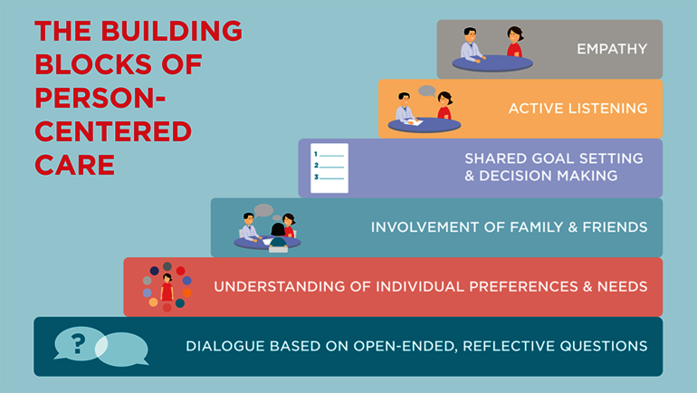

Application of Theoretical Principles on a Patient:

Indeed, dementia is one of the most miserable living conditions that people suffer. Thus, living with dementia is not that easy. Therefore, majority of the individuals with dementia opt for patient-centred care for making their life a little easy (NHS, n.d.). For this reason, in the UK, the National Health Service has provided various kinds of care and the service provider to help the patient of dementia. According to (Fazio, 2018) the key services provided to the patients are individualised care which includes developing and regulating the care plans which reflect the strength and the needs of the patient. Likewise, the service provider enables the patients to apply their possessions, which also includes accommodation regarding individual preferences and choices and the daily routines activities

Recommendations:

Thus, it is highly recommended for the care providers to make sure that the patients with dementia should have a proper focus on person-centred care. Secondly, in providing the care, the caregivers should assess and plan the care effectively (Park, 2017) Third, the symptoms and other medical conditions should be managed entirely. Fourth, the care providers should control the dementia-related behaviours with the help and aid of their support. Fifth, the physician or the health care providers should make sure that the patient is involving themselves in daily life activities. Lastly, the detection and diagnosis of the conditions associated with the dementia patient should be kept in the proper order.

Conclusion:

Overall, person-centred care is one of the best ways of treating patients. This is evident from the findings of the essay. Thus, the centred care is personalised, enabled and with full collaboration. On the contrary, the delivery of Personal Oriented Care includes the care given to the patients which are beyond their reach and stitching their needs and wants. Overall, Picker’s Principles of Patient-Oriented Care have explained eight sets of principles that are involved in patient care. Ergo, patient-centred care and ethics are closely interlinked with each other. The theory of ethics and personal-centred care is relational ethics which plays an important role in dealing with the ethical issues concerned with patient-oriented care. In the nutshell, in overcoming the conditions of the patient, the personal-centred care has played its part. The significance of the six Cs of person-centred care concerning dementia, the importance of patient-oriented care which helps individuals with dementia to get involved in the decision making, encouraging them to give their comments and recommendations regarding their care. Overall, the treatment and care require education relating to the care through intensive reading which is a time-consuming method as the patients wanted to have a quick and immediate response which is a challenge to personal-centred care. Therefore, most of the patients with dementia opt towards patient-centred care for making their life a little easy. However, it is highly recommended for the care providers to make sure that the patients with dementia should have a proper focus on person-centred care.

References

Balachandran, R. 2020. 8 principles of patient centred care hearing health care.
Burton, L., 2018. What is Person-Centred Care and Why is it Important? [Online]
Available at: https://www.highspeedtraining.co.uk/hub/what-is-person-centred-care/
[Accessed 30 March 2021].
Cassar, M. 2020. Person-Centred Care from a Relational Ethics Perspective for the Delivery of High Quality and Safe Healthcare: A Scoping Review. Frontiers in Public Health, Volume 8, p. 44.
Collier, E., 2020. Compassion in Care: What Are the Six Cs?. [Online]
Available at: www.highspeedtraining.co.uk/hub/what-are-the-six-cs/
[Accessed 28 March 2021].
Catalyst, N., 2017. What Is Patient-Centred Care? [Online]
Available at: What Is Patient-Centred Care?
[Accessed 2021 March 2021].
Fazio, S., et. al, 2018. The Fundamentals of Person-Centred Care for Individuals with Dementia. The Gerontological, 58(1), pp. 10-19.
Hansson, S. O., and Froding, B. 2020. Ethical conflicts in patient-centred care. SAGE journals.
Michael, J 2012. Shared Decision Making — The Pinnacle of Patient-Centred Care. The new England Journal of Medicine, Volume 366, pp. 780-781.
Medacs, 2012. The 6Cs. [Online]
Available at: www.medacs.com/the-6cs
[Accessed 23 March 2021].
Moore, L., 2016. Barriers and facilitators to the implementation of person‐centred care in different healthcare contexts. Scandinavian Journal of Caring Sciences, 31(4), pp. 662-673.
NHS, n.d. Personal-centred care. [Online]
Available at: www.hee.nhs.uk/our-work/personal-centred-care
[Accessed 18 March 2021].
NHS, T., n.d. Dementia, social services, and the NHS. [Online]
Available at: https://www.nhs.uk/conditions/dementia/social-services-and-the-nhs/
[Accessed 31 March 2021].
NICE, 2018. Dementia: assessment, management and support for people living with dementia and their carers. [Online]
Available at: https://www.nice.org.uk/guidance/ng97/chapter/Recommendations
[Accessed 31 March 2021].
Oldham, J and Coulter. A., 2016. Person-centred care: what is it and how do we get there? Future Health Care Journal, 3(2), pp. 114-116.
Park, M., 2017. Effectiveness of person-centred care on people with dementia: a systematic review and meta-analysis. Clinical Interventions in Aging, Volume 12, pp. 381-397.
Price, B., 2020. Ethical challenges in delivering person-centred care. Primary Health Care, 30(9).

