DS 1 Template

My Screenshots/Photos
- Please add 4–6 screenshots or photos of your digital life.
- You can use your phone or laptop.
- For each screenshot, write one or two sentences explaining what it shows.

Screenshot/Photo 1
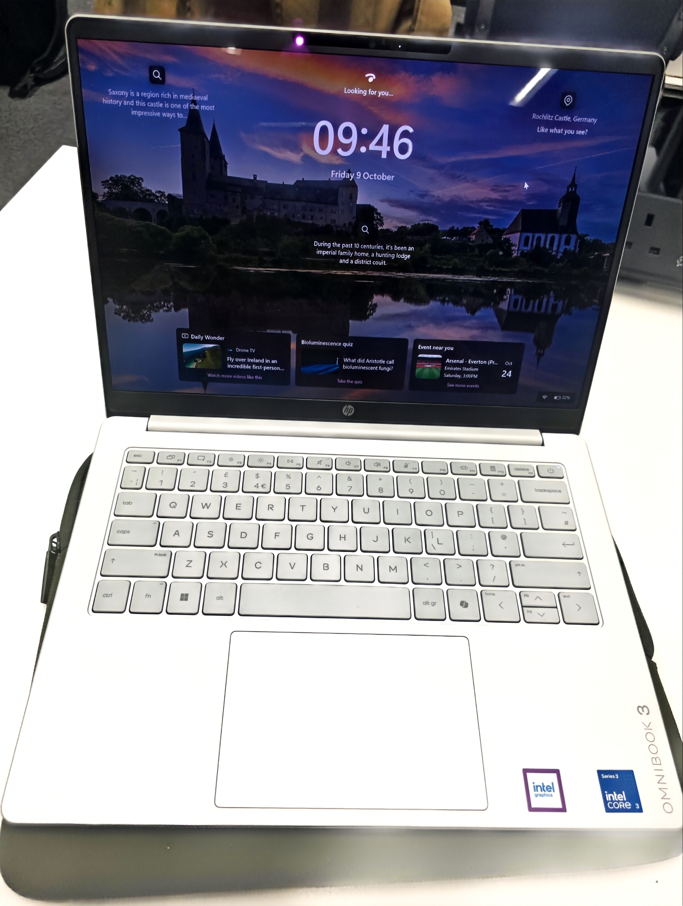
I use laptop for study, it enables to make some research, attend online classes and meetings, I also use it to do and submit my assignments. I also use laptop for online shopping like buying products and services online, I also use it for entertainment like watching movies and listen to music.
The laptop as tool is an important part of my digital life because it enables me to browse and it helps me to learn, communicate and access information about day to day-to-day life activities.
I feel good about using my laptop because it makes my work easier and faster. I can use it to complete assignments, watch videos and learn new skills. It also helps me to stay organised and connected to digital world. It also gives me confident to explore the digital world and work search.
I want to improve my laptop skills by learning how to type faster and accurately, organise my file and protect my personal information. I also want to become more confident in using it for learning and work.
These skill matters because they can help to improve my education, create job opportunity and prepare me for a better future expectation.

.

Screenshot/Photo 2
[Insert Photo/Screenshot below]
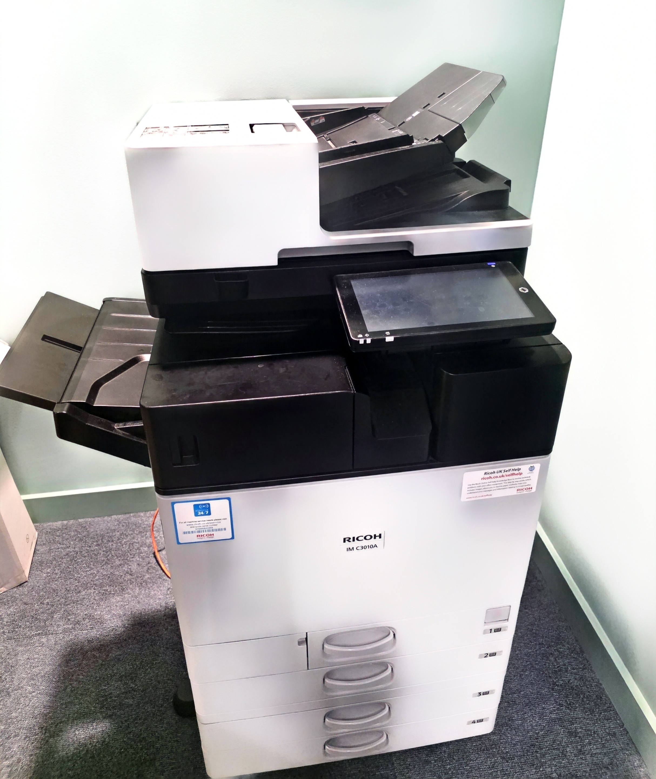
the printer is a digital used to print and scan documents, pictures and other information from the computer or laptop. The printer also helps me to get my documents handy and clear and to have a physical documentation.
I feel good using the printer because it is easy and cheaper to use.
Sometimes I found it difficult to use whenever it is having problems maybe due to ink or printing papers.
I’ll like to improve in knowing how to fix the error whenever there is need to do so.

Screenshot/Photo 3
[Insert Photo/Screenshot below]
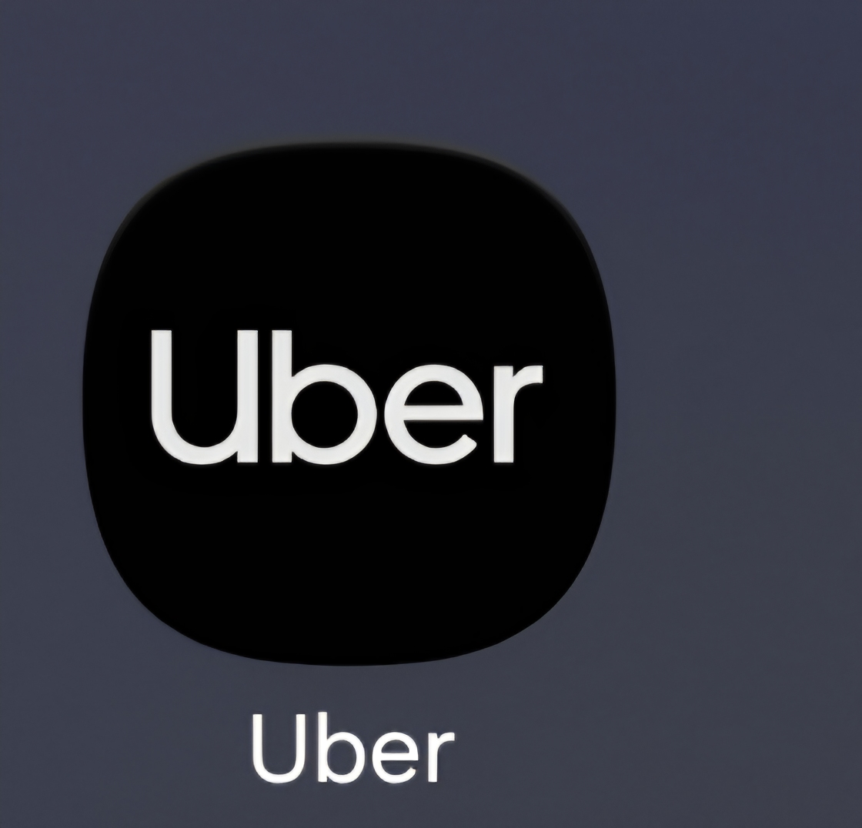
This is an uber app., I use this digital tool for both transportation and food orders. Uber app is so useful because it makes my movement easy and faster. Sometimes I like sleeping on Sunday morning, so I always order my breakfast from Mac Donalds uber eat and that makes it very easy and convenient for me.
I don’t like driving at night because of visibility; I like going to club with the help of uber and it is very convenient especially when I’m tipsy or drowsy.

Screenshot/Photo 4

Screenshot/Photo 5
[Insert Photo/Screenshot below]  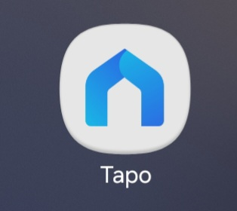  Tapo app is a digital tool; I use this camera security digital tool to control my house when I’m away from home example, I always use it check my children’s activities at home and check if there are intruders while I’m away. It is very useful because it also takes video records of every activity around the house. | [Insert Photo/Screenshot below]

Screenshot/Photo 6
[Insert Photo/Screenshot below]
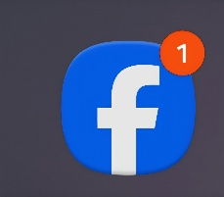
The Facebook app is as a digital skill helps me to meet people online and post pictures and contents online. Ise Facebook app to communicate to people around the world and I use it to browse and search my old friends. I also use Facebook app to buy some cheap product from Facebook marketplace.

My Short Reflection
- Write 5–8 simple sentences abo ut your digital life.
- You can use the sentence starters below if helpful.
I use digital tools to communicate example making calls, writing mails and text messages. I use google map to locate places and find my directions when going to some places, I’m not familiar with.
I also use digital tools like banking app to check my banking activities, transfer funds and make payment online. I use digital tools like printer for printing and scanning documents and converting paper documents into digital files.
We use digital tools to store information; I also use it to learn work and find information and entertain myself.
I feel confident when I us e digital skill is that I feel confident using digital tools to communicate with others learn new skill, use my laptop, access social media, learn digital skills to improve my confidence and independence.
I wish to improve in my digital life by learning how to use my laptop confidently, and improve my typing skills, create document and stay safe online. I also want to know how to use digital tools to make my work and everyday life easier.
I often use these tools to communicate with my family and friends, make video calls, work, use social media and have fun.
I sometimes feel nervous about using unfamiliar tools, solving technical problems and learning some computer skills without help from someone.
I hope this Moodle will enable to improve my digital skill and become more confident using laptop and other digital tools, learn new things and use technology safely and effectively in my day-to-day life.
Digital skills is important to me because they help me to easily communicate with people, learn new things, find information quickly and become more confident and independent when making use of technologies.

Submission Checklist
Before you submit, please check:
​​​ ☒ I added 4–6 screenshots
☒ I wrote short sentences for each screenshot
☒ I wrote my short reflection
☒ My work is my own
☒ My file opens correctly
​​☒ My file opens correctly

