Topic: Strategic Analysis of Hilton Hotels & Resorts: Organisational Structure, Innovation, and Future Growth
Module: Management & Organisational Behaviour
Module code: BMIH5004
Programme: BA International Hotel Management
Lecturer: Daniel Payne
Assignment Title: Written report
Student Name: Cristina Maria Petrache
Student ID Number: 2234360
Word count: 2052 words

Acknowledgement
I certify that the work I sent in for this assignment is entirely original. Credit has been given when my work has been supported by the efforts of others. Every source I utilised for this work has been found, recognised, and cited using the Harvard referencing style. I have reviewed the assignment brief's parts on plagiarism, collusion, and artificial intelligence, and I am aware of the negative effects of plagiarism.

Executive Summary

This report provides an analysis of Hilton Hotels and Resorts case companies, separately and apart from a hotel concerning the structures that constitute it, culture, objectives, recent change initiatives, and strategies, among other things. The top corporate or hierarchical structure of Hilton Hotel is very flexible and runs operationally in all parts of the world efficiently. Such corporate culture, which is intended to establish and provide good customer service and also creativity and innovation, is therefore vital in sustaining the huge corporate brand of Hilton all over the world. Goals, both at corporate and unit-based levels, revolve around the drive for revenue growth, sustainability, and enhancing guest experiences.
Further, the report also provides a discussion of recent change initiatives from Hilton, which include seamless in-room technology, mobile payment, and contactless transactions. It is a completely new kind of loyalty program that uses digital innovation. Access to that customer might allow them to do things more conveniently from their end while gaining significant operational efficiency. It also, however, required a change management investment in changing the workings of Hilton.
Enhancing cyber security, better employee training, the widening scope of sustainability in hospitality practices, usage of artificial intelligence for personalised guest journeys, and broadening aspects in customer loyalty programs would be improvement recommendations. Implementation of these recommendations will, therefore, help Hilton to remain ahead in the competition, meet customer demands better, and further strengthen its standing as one of the global hotel frontiers in the long run.

Table of Contents
1. Introduction 3
2. Organisation Structure, Culture, and Goals 3
2.1 Organisation Structure 3
2.2 Corporate Culture and its Influence on Operations 3
2.3 Organisational Goals 4
3. Recent Change Initiatives 5
3.1 Identification of Recent Changes 5
3.1.1 Seamless In-Room Technology 5
3.1.2 Mobile Payments and Contactless Transactions 5
3.1.3 Enhanced Loyalty Program with Digital Tools 6
3.2 Impact of Change Initiatives 7
3.3 Evaluation of Change Management Strategies 7
4. Strategic Direction 8
5. Conclusion 9
6. Recommendations 9
7. References 10

Introduction
This report contains a strategic assessment and critique of Hilton's multi-divisional structures, corporate culture, objectives, recent change management initiatives, and strategic direction. This core area of focus will offer insights into Hilton's operational strategy and its position in the industry. Relevant theories and recommendations would enhance Hilton's competitive advantage over time in the hospitality environment.
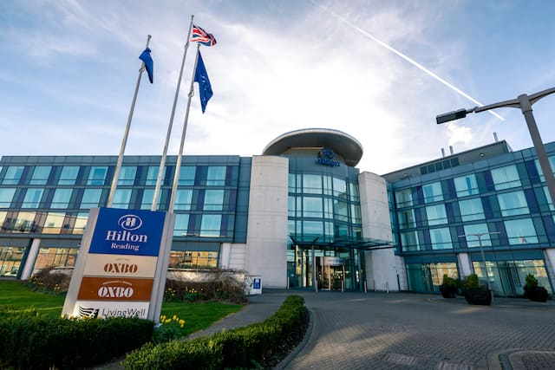
Source: (Hilton Hotel, 2025)

Organisation Structure, Culture, and Goals

Organisation Structure
Hilton Hotels & Resorts maintains a multi-divisional structure, the essence of the corporate level is to make strategic decisions on Hilton Worldwide Holdings Inc. to ensure consistency in branding, service standards, and financial management (Hilton Hotel, 2025b). On the other hand, the regional manager supervises operations in various geographic locations and allows flexibility to respond to the local market demands (Menci and Valarezo, 2024).
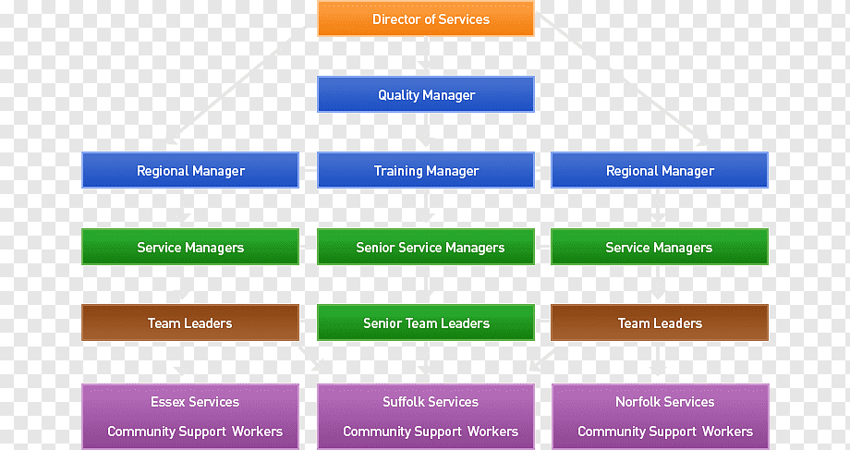
Figure 1: Organisational Structure of Hilton Hotel
Source: ((Hilton Hotel, 2025b)
Ivanov and Webster, (2024) explain that a hotel generally makes decisions by the operation model based on the decision-making independence it has, which may yield specific negative consequences. Managed hotels, for example, are expected to follow Hilton's operational guidelines for every single activity, while franchisees can decide on most aspects of their operations but must comply with a set of brand standards (Zeng, 2021). Such a hierarchical yet flexible structure enhances performance in service delivery and allows for global conforming to local adaptability while posing challenges in coordination between corporate leadership and individual properties (Martinez, 2024).

Corporate Culture and its Influence on Operations
Hilton's corporate culture was established early on with the philosophy of hospitality, great customer service, and empowerment of its employees (Hilton Hotel, 2025c). The people-centred culture stresses inclusivity, diversity, and career development. Hilton's fundamental values of hospitality, integrity, leadership, teamwork, ownership, and now Hilton govern its operations and service delivery at all of its properties (Hilton Hotel, 2025a).
A strong service orientation cultivates engaged and motivated employees, which directly translates into guest satisfaction and brand loyalty (Sofi et al., 2024). Hilton's workplace culture a blessing-has received tributes from Fortune as one of the "Best Companies to Work For," thus increasing employee retention and enhancing operational efficiency (Stories from Hilton, 2025). The company practices environmental sustainability by instituting socially responsible business practices and encouraging green initiatives. According to Ledro et al. (2023) maintaining a unified corporate culture across both managed and franchised properties, however, remains a challenge, necessitating ongoing training and corporate alignment strategies.

Organisational Goals
At the corporate level, Hilton would like to be the most hospitable company in the world and will do this by delivering exceptional guest experiences, driving sustainable growth, and maintaining a strong brand reputation (Hilton Hotel, 2025a). Some of the primary key goals include: expanding footprints around the world, enhancing customer loyalty through Hilton Honors, and integrating technology-driven solutions to improve operational efficiency (Reidhead, 2020). Hilton also puts considerable effort toward being environmentally sustainable, committing itself to reducing gases and water emissions by 2030 (Sinha and Fukey, 2020).
These aims range from customer satisfaction, operational excellence, and revenue growth by hotel. Khalil et al. (2024) claim that each hotel is expected to abide by brand standards for customer satisfaction, optimise occupancy rates, and implement local market strategies as appropriate to the particular competitive market environment. Employee engagement and community involvement are also encouraged for work assignments that are aligned with Hilton's corporate social responsibility programs to have consistency in quality with long-term business success (Hilton Hotel, 2025c).

Recent Change Initiatives

Identification of Recent Changes

Seamless In-Room Technology
To make the guests comfortable or personalise the hotel experience, Hilton introduced technology in its rooms (Bharwani and Mathews, 2021). The Connected Room is a true innovation as it puts control of the room environment-including lighting, temperature, and entertainment in the hands of the customer via the Hilton Honors mobile application (Martinez, 2024). The introduced technology that enhanced comfort-such as energy savings and automatic maintenance alert-feeds into the operational efficiency of Hilton.
Other high-tech access extended to guests includes streaming Smart TVs, voice-activated controls, Amazon Alexa, and keyless room entry. These features are aimed at today's business travellers and should guarantee a personalised and convenient remote experience (Paulauskas et al., 2021).
The greatest benefit of in-room seamless technology to Hilton is customer satisfaction, with operational costs reduced due to efficiency in service delivery and environmental sustainability due to concern for energy use (Zahoor and Lew, 2023). Beyond initial investment costs, challenges include security risks of privacy violation i.e., cyber risks, and also making certain the seamless experience will be incurred across all franchised properties (Skrocki and Ahmed, 2024). Hilton is forever evolving with new updates on its digital spectrum offering to remain ahead in competition in the fast-changing hospitality sector.

Mobile Payments and Contactless Transactions
According to (Arapou and Kapiki, 2023) Hilton has introduced mobile features and contactless payments to enhance convenience, security, and efficiency for the guests. With the Hilton Honors app, guests can check in and out, and access their rooms by digital key technology through their smartphones, foregoing physical key cards (Khalil et al., 2024). This innovation fosters the guest experience by cutting reception wait times and friction during their stay.
Hilton provides various channels for mobile payments: Apple Pay, Google Pay, and contactless credit/debit card payments for the most efficient way to pay for services consumed in restaurants, spas, and other hotel facilities (Galavotti, 2023). This transition supports a preference for cashless transactions, promoting operational efficiency by decreasing risk traditionally associated with cash movements (Ledro et al., 2023).
These advancements are not simply for the guest's convenience; they also promote health and safety, especially after the COVID-19 pandemic, by ensuring minimal touch points (Sofi et al., 2024). However, on the contrary, hacking and cyber security threats, integration challenges against different models across different franchises, and necessary training of hotel staff to help guarantee compliance with user adoption of the technologies are counter-opportunities in this regard (Tariq, 2024).

Enhanced Loyalty Program with Digital Tools
Hilton has significantly elevated its Hilton Honors loyalty program through the application of digital instruments for customer engagement and retention (Bardukova, 2023). The program is such that it can be rewarding in a way that is personalised for an individual, with incentives such as unique discounts and a seamless booking experience through the Hilton Honors mobile app (Arapou and Kapiki, 2023). It allows a member to both earn and redeem points, select a desired room, and use digital key technology that altogether counts toward smooth hotel stays through the mobile app (Zahoor and Lew, 2023).
The primary innovative aspect is dynamic the use of flexible point-based pricing to redeem points for members, making it more attractive for redeeming points (Luo, 2019). In addition to these, Hilton has also employed AI-based personalisation using data analytics to adapt offers according to guest preferences and travels (Reidhead, 2020).
However while all these digital innovations foster greater brand loyalty and more direct bookings, thereby reducing reliance on third-party travel agencies, they challenge data and privacy management, technology-security issues, and consistency in technology across the whole range of properties (García-López et al., 2025). Hilton is continuously reinforcing its loyalty program with AI, blockchain for secure transactions, and gamification to increase engagement (Bardukova, 2023).

Impact of Change Initiatives
Innovation in Technology by Hilton revolutionised all dimensions of the operation related to guest satisfaction and revenue. With seamless in-room technologies guest experience is enhanced by personalising and simplifying it while contributing to the same sustainability goals by smart energy management (Skrocki and Ahmed, 2024).
According to Çeltek, (2023), mobile payments and contactless transaction methods have made very simple the processes of check-in/check-out, reduced queuing time, and heightened security measures, resulting in better customer satisfaction, all this coupled with higher enrolment in loyalty programs. These measures have also eliminated cash handling, thus reducing operational costs and risks and enhancing the productivity of service delivery (Tariq, 2024)).
Having made it larger for retention and self-bookings for most without the use of online travel agencies, digitalisation has made an exemplary course margin profit on customer loyalty programs, particularly Hilton Honors (Bharwani and Mathews, 2021). However conversely, such costs create discouraging challenges to audiences, like high implementation costs and cyber security risks accompanied by staffing seeds for training (Reidhead, 2020).

Evaluation of Change Management Strategies
Hilton has absorbed technological advances through structured and strategic adoption. Kotter's Change Management Model analyses particular changes in creating urgency for a vision, i.e. empowering (Grynko et al., 2024). This is followed by staff training intended to equip employees with the know-how to embrace technological innovations, including mobile payments, in-room technology, and digital loyalty tools (Çeltek, 2023).
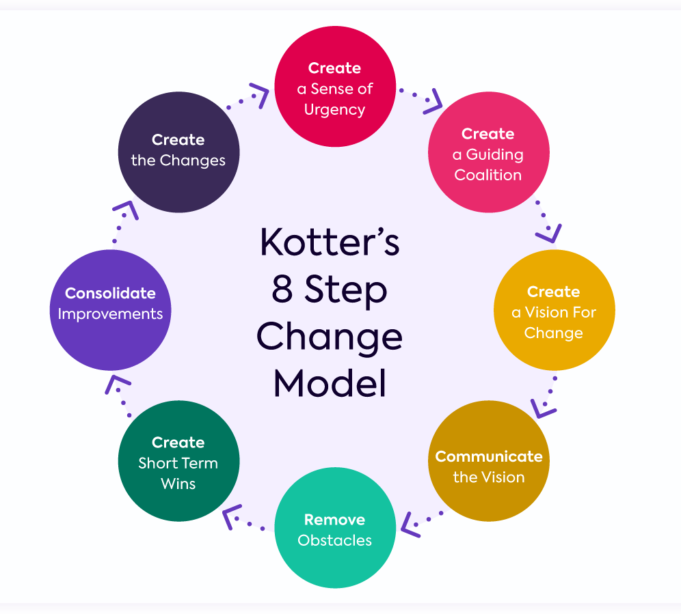
Figure 2: Kotters Change Management Model
Source: (Grynko et al., 2024)
One major factor contributing to Hilton's success would be the phased rollout of the changes, allowing individual properties to adopt the changes as they can mitigate technical problems and get guest feedback (Stringam and Gerdes, 2021). They also incorporated an ongoing improvement concept, putting customer data along with AI-driven insights into action to further refine their digital offers (Ledro et al., 2023).
Some of these challenges are integration through franchise properties, threats from cyber security, and employee resistance to some changes (Galavotti, 2023). Even so, proactive change management, continued investments in digital infrastructure, and a customer-friendly strategy boosted the company's transformational efforts and enabled it to improve operational efficiency and guest satisfaction over time across the globe (Sharabati et al., 2024).

Strategic Direction
The strategic direction of Hilton is for sustainable development, digital innovation, and a customer-centric service approach to ensure that Hilton is one of the world's top global brands in hospitality (Hilton Hotel, 2025c). As it expands into emerging markets, it will keep environmental sustainability and technology at the lead; thus, improving guest experiences and efficiencies within operations. According to Matteucci, (2020), vision 2030 of Hilton is by the UN Sustainable Development Goals (SDGs); with this, the exercise of organisation is committed to decreasing its environmental footprint in areas such as energy efficiency, carbon reduction, and sustainable sourcing.
To gear up towards long-term success, Hilton has put forth some key strategic actions. According to García-López et al. (2025), digital transformation is the central focus of investing in seamless in-room technology, mobile payments, and AI-based personalisation designed for customer convenience and operational efficiency not failing to mention their new Hilton Honors brand, which would also help bring in customer retention by increasing a new direct booking process, thus leading to lower third-party travel agency reliance.
To go global without owning the house, Hilton delivers an asset-light franchising and management-wide expansion strategy. Speeding up the process with this method minimises Hilton’s financial risks (Bardukova, 2023). Sustainability is a critical component of this plan. The hotel is committed to a reduction in the carbon footprint by 2030 and investments in green building technology (Arapou and Kapiki, 2023). Employee development along with diversity initiatives fosters a powerful and committed workforce aligned with Hilton's strategic goals.

Conclusion
At Hilton, technology and customer-facing innovations have strategically directed the company, which now firmly stands as a genuine global leader in hospitality. Through the seamless application of in-room technology, mobile payment, and digital loyalty enhancement, the company achieves even greater guest experience and operational efficiency enhancing its brand loyalty. Innovations at Hilton in many respects, and with most of these developments leading to sustainability and globalisation, including their technology innovations, promise good returns in the long haul amid industry challenges.

Recommendations
- Strengthening cyber security at Hilton improved fraud detection through an AI-supported, advanced encryption system for mobile payments through digitised check-in procedures, and running continuous training programs for all staff members on cyber-security matters (Ivanov and Webster, 2024).
- Improve all employee training programs and delivery methods such as structure and cross-training, by integrating these into an AI-powered learning platform.
- Investing in renewable energy solutions, energy-efficient facade systems, and smart water management can make the internal capacities of the sustainable hospitality business endless while reducing operating costs for those prices under eco-friendly (Martinez, 2024).
- Using personalisation based on AI may give guests chatbots, not offering to deny customer preference analytics but rather online service (Adam et al., 2021).
- It will strengthen loyalty programs by providing unique awards for travelling sustainably and personalised bonuses based on prior stays to facilitate better customer retention and engagement (Menci and Valarezo, 2024).

References
Adam, M., Wessel, M., and Benlian, A. (2021). AI-based chatbots in customer service and their effects on user compliance. Electronic Markets, 31(2), 427-445.
Arapou, D., and Kapiki, S. (2023). Enhancing the Guest Experience in Hospitality Through Technology: An Outlook of the Future. Proceedings http://ceur-ws. org ISSN, 1613, 0073.
Bardukova, L. (2023). Navigating the Hospitality Horizon: Current Trends and Strategies for Customer Attraction and Retention in the Hotel Industry. Economics and computer science, 2, 88-103.
Bharwani, S., and Mathews, D. (2021). Techno-business strategies for enhancing guest experience in luxury hotels: a managerial perspective. Worldwide Hospitality and Tourism Themes, 13(2), 168-185.
Çeltek, E. (2023). Analysis of Smart Technologies Used in Smart Hotels. İşletme Araştırmaları Dergisi, 15(4), 2880-2892.
Galavotti, G. (2023). Transforming the dining experience: a census of innovative payment solutions for restaurants.
García-López, A. M., Galindo-Pérez-de-Azpillaga, L., and Foronda-Robles, C. (2025). The Flow of Digital Transition: The Challenges of Technological Solutions for Hotels. Social Indicators Research, 1-24.
Grynko, T., Hviniashvili, T., Oliinyk, T., Saihak, Y., Yudina, O., and Korneyev, M. (2024). IMPROVEMENT OF THE CHANGE MANAGEMENT MODEL AT THE HOTEL INDUSTRY ENTERPRISES. Financial & Credit Activity: Problems of Theory & Practice, 3(56).
Hilton Hotel. (2025a) [Online Available]: https://www.hilton.com/en/locations/united-kingdom/hilton-hotels/ [Accessed Date]: 15/Feb/2025
Hilton Hotel. (2025b) [Online Available]: https://edrawmind.wondershare.com/org-chart/hilton-hotel-org-structure.html [Accessed Date]: 15/Feb/2025
Hilton Hotel. (2025c) [Online Avaialble]: https://jobs.hilton.com/us/en/culture [Accessed Date]: 15/Feb/2025
Ivanov, S., and Webster, C. (2024). Automated decision-making: Hoteliers’ perceptions. Technology in Society, 76, 102430.
Khalil, N., Che Abdullah, S. N., Haron, S. N., and Hamid, M. Y. (2024). A review of green practices and initiatives from stakeholder’s perspectives towards sustainable hotel operations and performance impact. Journal of Facilities Management, 22(4), 653-682.
Ledro, C., Nosella, A., and Dalla Pozza, I. (2023). Integration of AI in CRM: Challenges and guidelines. Journal of Open Innovation: Technology, Market, and Complexity, 9(4), 100151.
Luo, X. (2019). Load Pattern Categorisation and Dynamic Pricing Based Demand Response in Smart Grid. The University of Liverpool (United Kingdom).
Martinez, O. J. (2024). Adapting to an Economic Crisis: The Market System vs Hierarchical Governance. Journal of Macromarketing, 02761467241234250.
Matteucci, V. (2020). How can the hospitality industry increase corporate value aligned with sustainable development goals? Case examples from Hilton, Meliá and Sun. Worldwide Hospitality and Tourism Themes, 12(5), 509-523.
Menci, S. P., and Valarezo, O. (2024). Decoding design characteristics of local flexibility markets for congestion management with a multi-layered taxonomy. Applied Energy, 357, 122203.
Reidhead, C. (2020). Impact of organizational culture on employee satisfaction: A case of Hilton hotel, United Kingdom. Journal of Economics and Business, 3(1).
Sharabati, A., Ali, A., Allahham, M. I., Hussein, A. A., Alheet, A. F., & Mohammad, A. S. (2024). The Impact of Digital Marketing on the Performance of SMEs: An Analytical Study in Light of Modern Digital Transformations. Sustainability, 16(19), 8667.
Sinha, M., and Fukey, L. N. (2020). Circular Economy: Assessing a Progress of Resources Efficient Practices in Hotel Industry. In Circular Economy for the Management of Operations (pp. 89-117). CRC Press.
Skrocki, M., and Ahmed, A. (2024). Intellectual Property Considerations in Mergers and Acquisitions Transactions. LAW Complying with the New, 34.
Sofi, M. R., Bashir, I., Alshiha, A., Alnasser, E., and Alkhozaim, S. (2024). Creating exceptional guest experiences: the role of engagement and relationship building in hospitality. Journal of Hospitality and Tourism Insights.
Stories from Hilton. (2025) [Online Available]: https://stories.hilton.com/releases/hilton-celebrates-eighth-consecutive-year-as-the-best-hospitality-company-to-work-for-in-the-world-as-recognized-by-great-place-to-work-and-fortune [Accessed Date]: 15/Feb/2025
Stringam, B. B., and Gerdes, J. H. (2021). Hotel and guest room technology. University of South Florida (USF) M3 Publishing, 17(9781732127593), 6.
Tariq, M. U. (2024). Data breach incidents and prevention in the hospitality industry. In Corporate Cybersecurity in the Aviation, Tourism, and Hospitality Sector (pp. 181-199). IGI Global.
Zahoor, N., and Lew, Y. K. (2023). Enhancing international marketing capability and export performance of emerging market SMEs in crises: strategic flexibility and digital technologies. International Marketing Review, 40(5), 1158-1187.
Zeng, L. (2021). Analysis of Hilton Worldwide Hotel Group’s Transnational Operation Strategy. Academic Journal of Business & Management, 3(11), 20-27.

