Information Security Analysis of CoffeeBlend Based on Cloud Services
Weng Xu 2203589
University of Wales Trinity Saint David,
Assignment of Data Security, Governance and Compliance
Abstract
The business of CoffeeBlend mainly provides services to customers online, and as the number of customers grows, the importance of protecting information and data security and the company's intellectual property rights is increasing. Taking the PDCA cycle as the analysis method, this paper first analyzes the multi-dimensional risk characteristics of the company under the current situation, and studies the cloud service safeguard measures.
Keywords: Information Security; Cloud Services; PDCA

Contents
1. Introduction 2
2. Related work 2
3. Methodology 4
3.1. Systems Theory 4
3.2. PDCA Cycle 5
4. Security Analysis 6
4.1. Cloud Service Security Risks 6
4.2. Compliance 9
4.3. Security Management and Practices 9
4.4. Security Policies 10
4.5. Protection Mechanisms 10
5. Solution 11
5.1. Construction Of Information Security Systems 11
5.2. Cloud Security Framework And Security Assurance System 12
5.3. Network Business Management 12
5.4. Company Security Policy 13
5.5. Network Perimeter Protection 14
6. Conclusion 14
References 14

1. Introduction
Cloud services have become the most important service model in Internet services. After entering the 21st century, with the support of the Internet, all kinds of network information service systems have been continuously improved, and computer security, traditional information security, and network security have been inseparable from each other. The number of cybersecurity breaches for companies worldwide has risen by hundreds of millions in recent years, the biggest threat to corporate information security on record [1]. It is essential for companies to establish effective management systems for information security in order to reduce the level of security risk and maintain business continuity [2].
CoffeeBlend is a company that sells coffee and provides IT services to customers through cloud services. Since most of the business of CoffeeBlend is conducted through the Internet, the management of information security such as personal data and intellectual property of the company needs to be improved.
2. Related work
The concept of information security originated in the middle of the last century, when people knew information security as keeping communications secret. Cloud service is an Internet service model developed by relying on cloud computing. Cloud computing is a concept proposed by former Google CEO Schmidt in 2006 [3].
A person's first objective when it comes to information security is to protect the information system, which consists primarily of computer hardware, software and information data. The object of this protection is clearly defined as the information system, including both computer hardware and software. The ultimate goal of information security is to ensure the integrity, confidentiality, and availability of information assets. Additionally, it is critical to ensure that both management and technical measures are taken in order to achieve the effective realization of information security objectives[4].
A study by Dhillon and Backhouse [5] examined how information security developed and connotated, and concluded that with the development of information technology and the advancement of information technology, information security will become a socialization problem and will need to be studied from a sociological perspective. As Siponen [6] divides the evolution of information security into five stages, he asserts that the fifth stage of information security will focus on social science and adaptability. Consequently, as well as taking into account information security technology, information security management, and information security management management, it is also necessary that the research on information security also considers the possible impacts of systems, society, culture, and other fields on information security.
Essentially, cloud service is a network-based value-added service that allows users to allocate computing resources as they see fit regardless of physical limitations or time constraints, and thus realize a flexible business model. The advancement of virtualization technology is vital to the continued development and improvement of cloud services. The efficiency of resource utilization, the variety of service models and the cost advantages of cloud services have far outweighed the traditional node computing model. Users cannot afford to ignore the flexible business service model and the cost advantages of cloud computing[7].
Siani Pearsona proposed cloud security design principles, arguing that user trust and user control are important factors in cloud security design, to protect users' right to use and choose personal information, to clarify and limit the scope of data use, and to provide feedback mechanisms[8].
Hemth T et al. analyze the impact of human behavior in the process of safety management from a humanistic perspective, and his view is that if individuals receive correct safety training, education will help them comply with safety strategies, and clear punishment mechanisms can also help individuals comply with safety policies, proving that people can behave differently because of the influence of the environment[9].
Nonetheless, because cloud services use technologies such as virtualization, distribution, and resource sharing in addition to traditional centralized services, the hidden security threats are far greater than those associated with traditional centralized services[10]. In today's society, enterprises have become increasingly dependent on network services, which means cloud service security is becoming increasingly vulnerable to enterprises and end users, as shown in Figure 1.
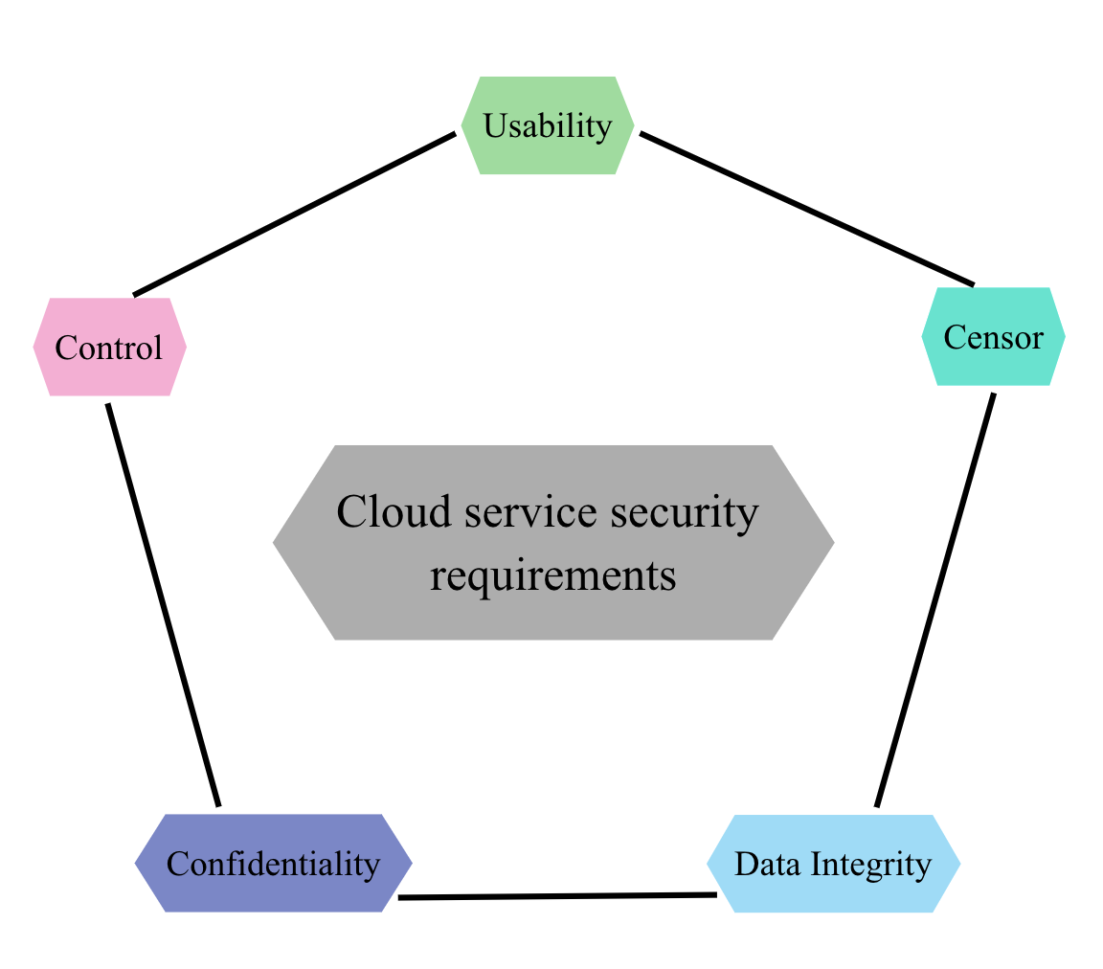
Fig. 1. Security Requirements for Cloud Services
3. Methodology
3.1. Systems Theory
Essentially, systems theory is the philosophy of thinking in terms of systems, meaning all things and objects are systems, and they should be studied holistically and holistically. According to systems theory, the system is a collection of objects, which need to be examined holistically. In addition to having a hierarchical structure, the elements of a system are interrelated, mutually restrictive, and dynamically balanced. The elements all share a hierarchical structure.
It is important to note that the core of systems theory is systems thinking, which is the concept that everything that exists is a system, and that everything needs to be studied as a whole. Basically, system theory states that the system is a collection of elements, and the questions of each element have a hierarchical structure and are interconnected, mutually restrictive, and dynamically balanced. This means that the system is a collection of questions.
System theory believes that systems are composed of many elements. System theory is primarily concerned with solving the characteristics and elements constraints of a subsystem, using these characteristics to create the optimal combination of subfunctions, and completing the process by working together to create a more optimized system capability, which will enable the system to be continuously upgraded in order to meet the social development needs of society in the future. To put it another way, to apply the idea of systems theory to solving problems, it is essential to study and analyze the overall functioning and structure of the system, its subfunctions, interrelationships and change laws of all the constituent elements of it, and build a stronger overall system by combining and coordinating these elements together to make the system more effective. In order to optimize the role of organizational management in real society, the scientific method of systems theory can be used more effectively to study a variety of social phenomena. To be able to effectively implement systematic research and analysis of objective objects, it can be used in conjunction with analysis, induction, reasoning, and other methods in a more comprehensive way[11].
3.2. PDCA Cycle
The PDCA cycle theory is the most basic method for achieving quality management, and its implementation is dividing the management work into four phases: plan, do, check, and action, so that quality management work is continuously improved in a cyclical manner. PDCA is also a key component of the implementation of information security management in organizations. The graded protection standard also uses PDCA as the core idea in its work process as well as IS027001, which directly adopts PDCA as the working method. Using process management, the organization builds its internal information security management system, and through continuous improvement cycle inspection, it realizes the continuous improvement of the level of enterprise information security management.
The key to PDCA is to cycle and improve, and continuously improve in the process of cycle inspection and improvement, so the process of PDCA cycle is the process of finding problems and solving problems[12].
The core idea of PDCA is directly embodied in a process of managing security risks, and the goal of implementing management is to continuously improve security performance in the process of continuous improvement, because of the process of implementing management of information security.
In the information security management system, whether it is ISO27001 or other standard, although there are differences in the methods and processes of implementing management, they are essentially in accordance with the PDCA theory in the Plan, Do, Check, Action cycle to carry out management construction work, as shown in Figure 2.
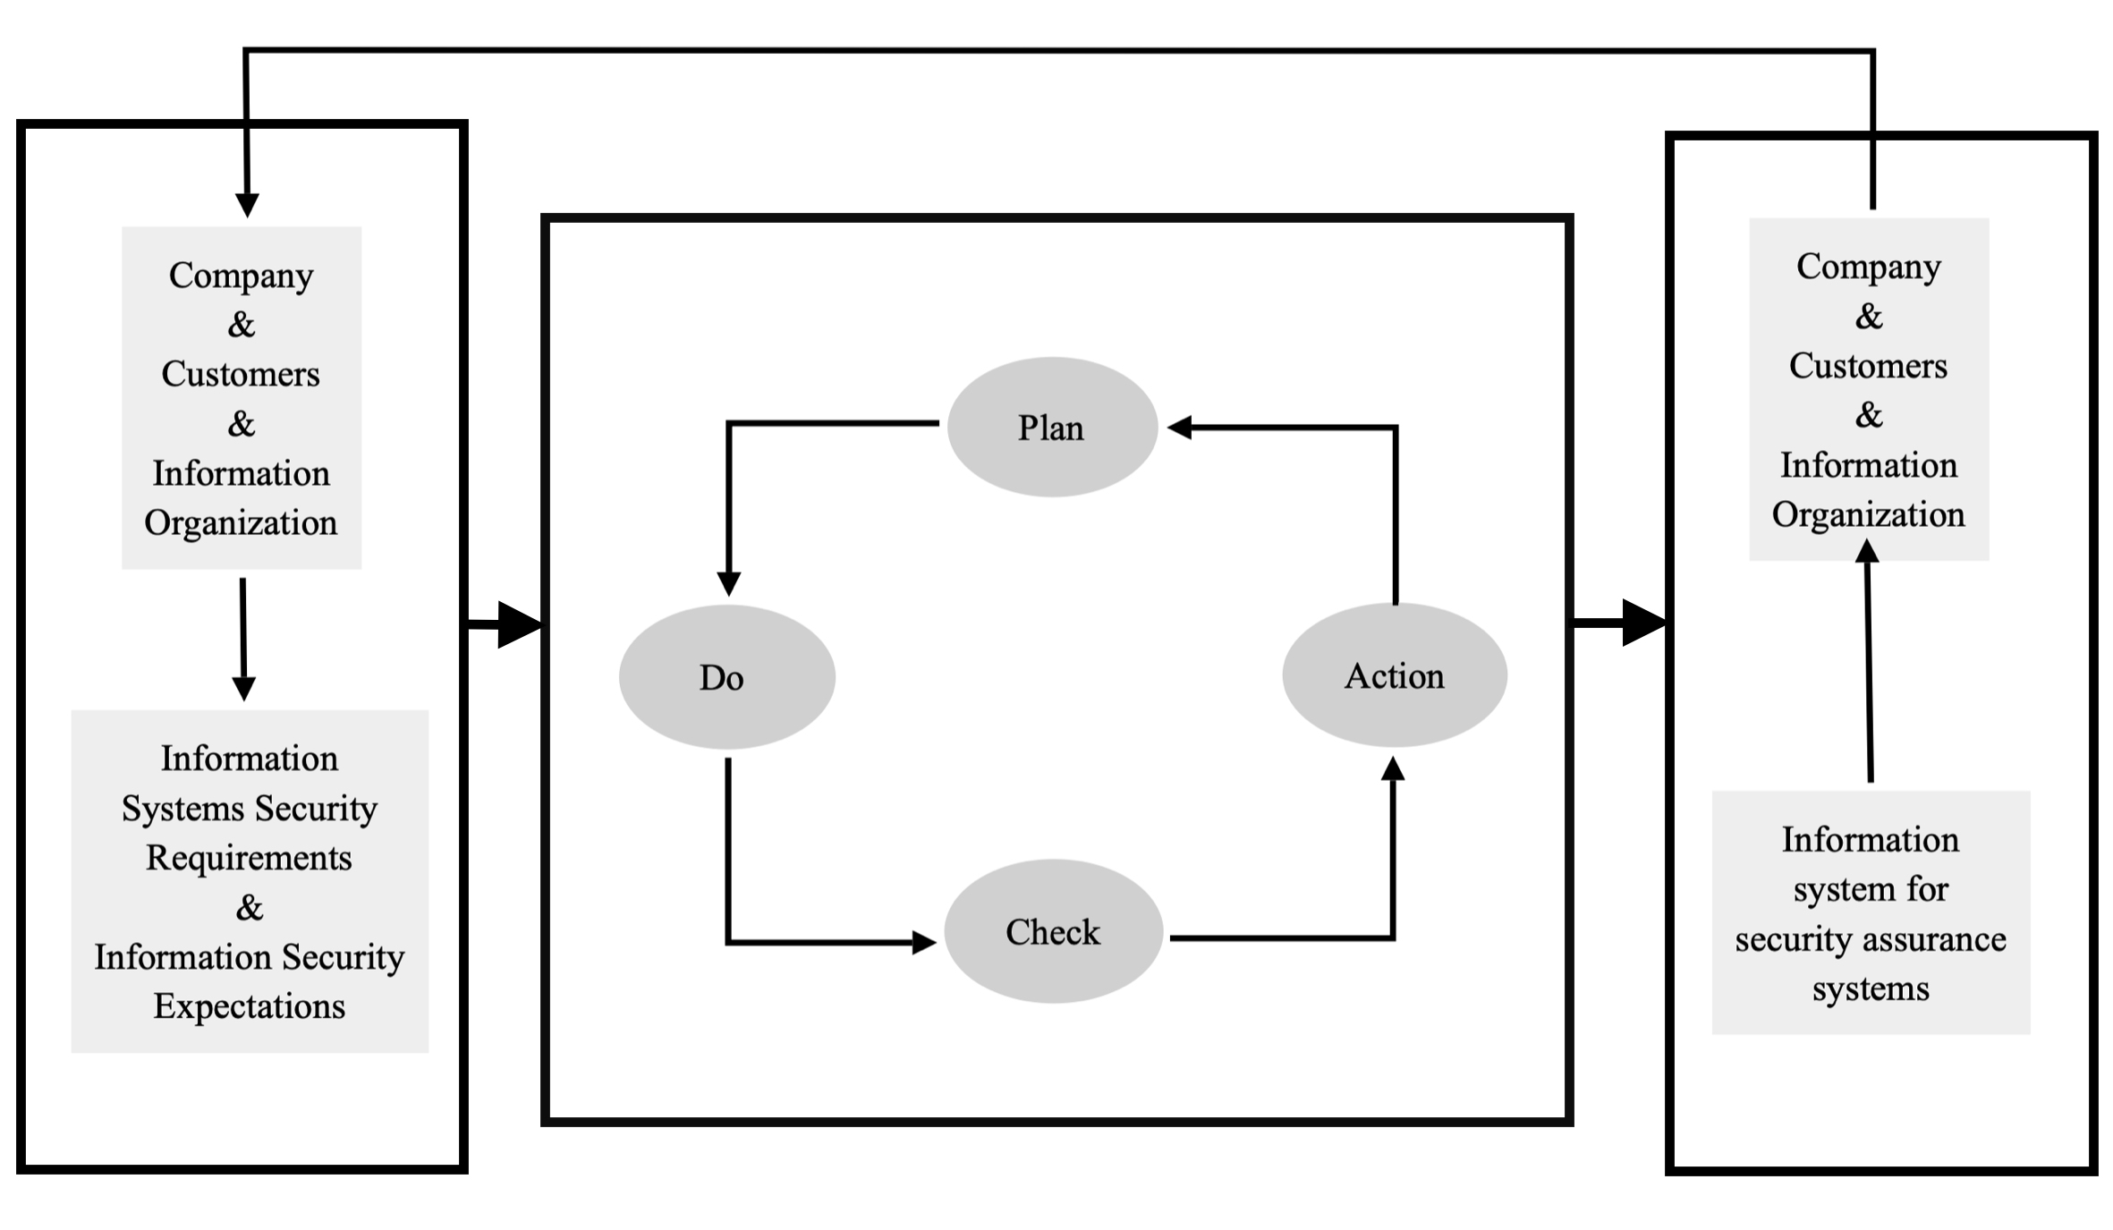
Fig. 2. PDCA Process of Information Security Management
For modern enterprises, in the process of implementing information security management and building an information security management system, it is necessary to have the core idea of continuous improvement of circular improvement, take PDCA theory as a promotion tool to improve information security capabilities, sort out and identify problems and risk points according to the scope and requirements of the theoretical model, and then implement the risk management process to make improvement measures[13]. The level and efficiency of information security management can only be continuously enhanced and improved by continuously improving its own management problems in the process of the cycle so as to continuously improve the level and efficiency of this management system.
4. Security Analysis
4.1. Cloud Service Security Risks
The authors of the study of the vulnerability and security risks associated with cloud services, Dahbur K. and colleagues[14] concluded that implementing security assurances for cloud service environments is not just a technical issue, but also one that requires a holistic approach. As cloud computing has the characteristic of being a globalized technology with no geographical limitations. So to clear up the protection requirements for cloud services security from the level of policies and regulations, it is imperative that effective management measures be implemented by organizations and personnel in order to ensure that cloud security management activities are run efficiently and effectively. Due to the uncertainty of human behavior, it is necessary to implement effective management measures for organizations and personnel[15].
It has been found that cloud services make extensive use of virtualization technologies such as network virtualization, storage virtualization, and computing resource virtualization, and that assets and management permissions are more logically identified based on their logical configuration. If company is unable to clearly determine the extent of information assets in terms of information security management, it cannot effectively implement management and control work, as it lacks inventory and categorical management of information security assets[16].
In order to reduce the security risks associated with cloud service environments, it is necessary to understand the main factors contributing to cloud service security risks, find effective ways to ensure cloud service security through countermeasures and risks, and build cloud service security assurance capabilities so that cloud service security risks can be reduced, as shown in Figure 3.
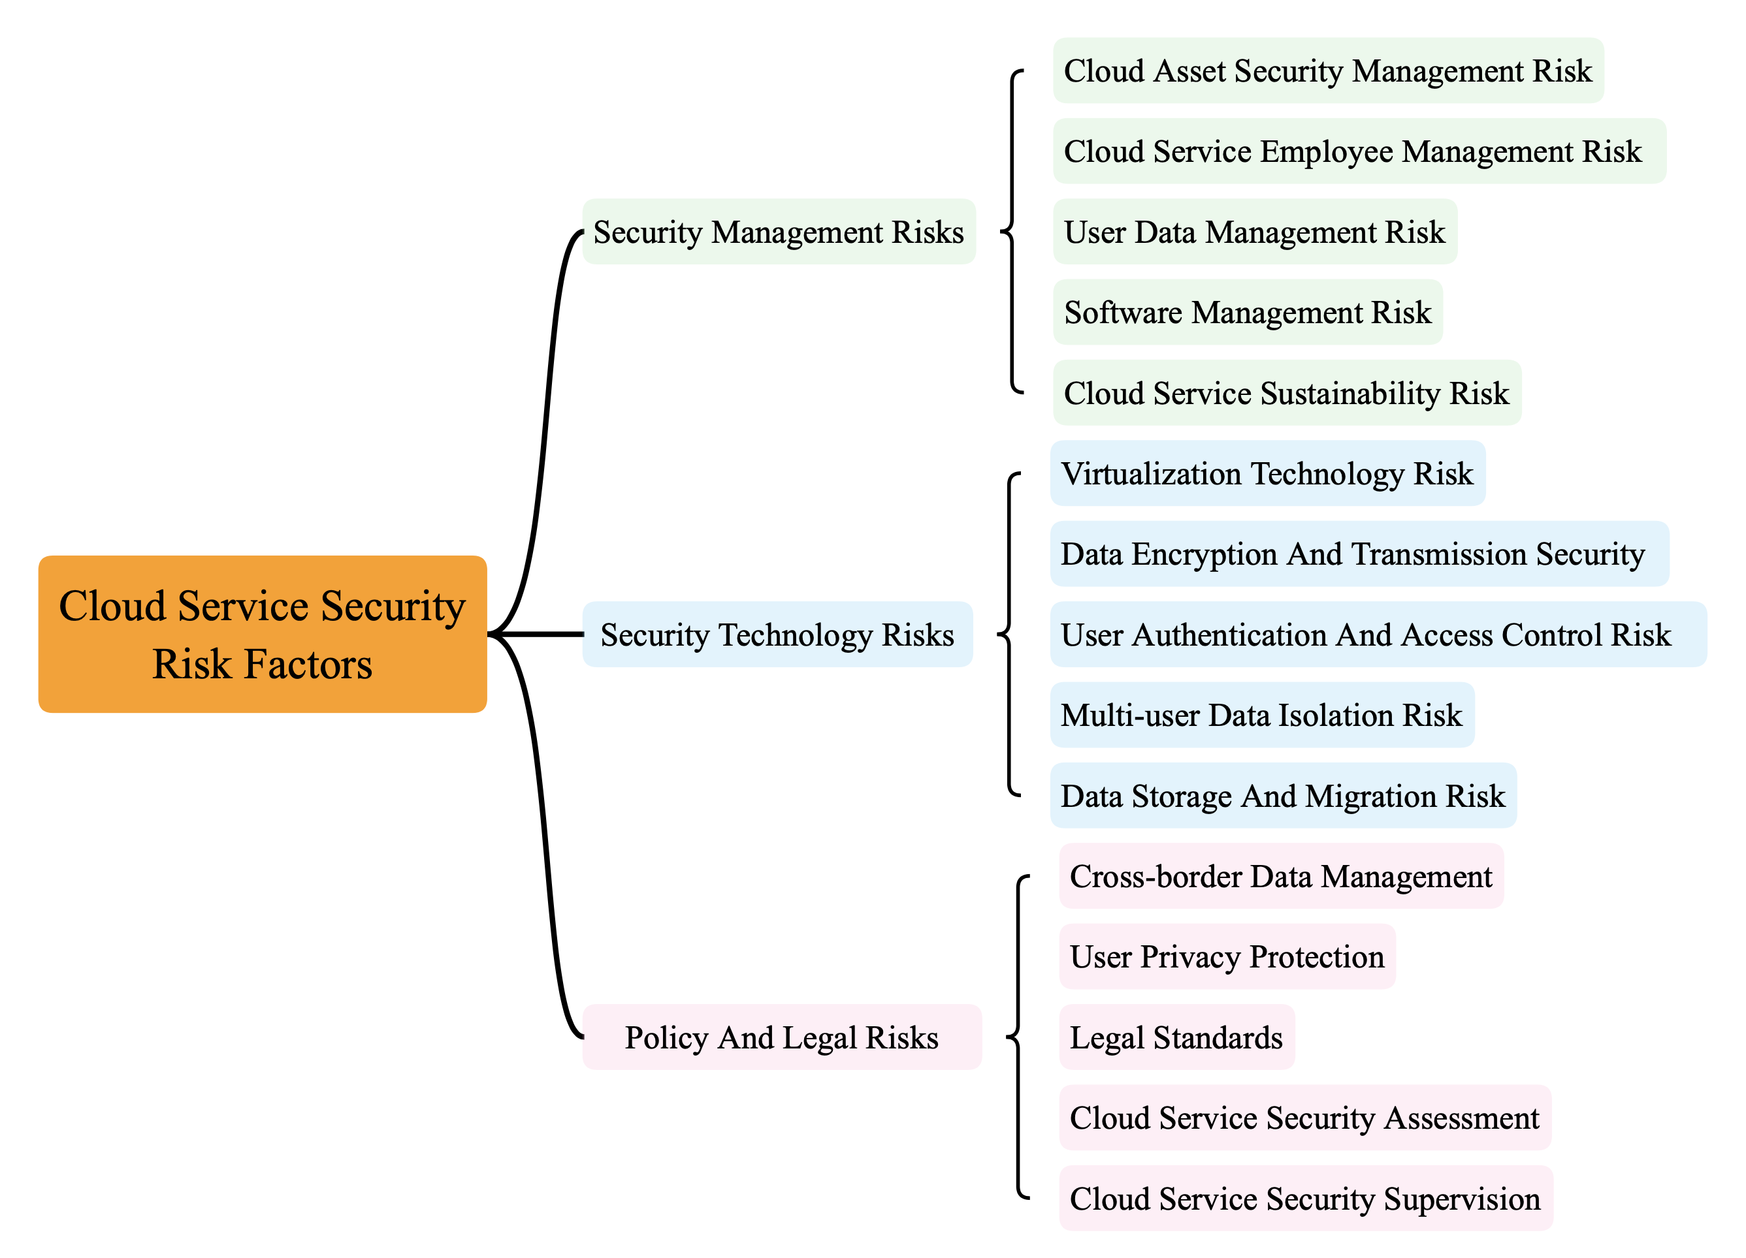
Fig. 3. Cloud Computing Security Risk Factors
Depending on the classification of cloud service security issues and risks, cloud services require an effective security assurance system in order to maintain security capabilities, and for building an effective security management system to ensure the security of cloud service systems according to the classification of cloud service security issues and risks. Feng Dengguo et al. [17]pointed out that to achieve cloud service security assurance, three aspects need to be solved, as shown in Figure 4.
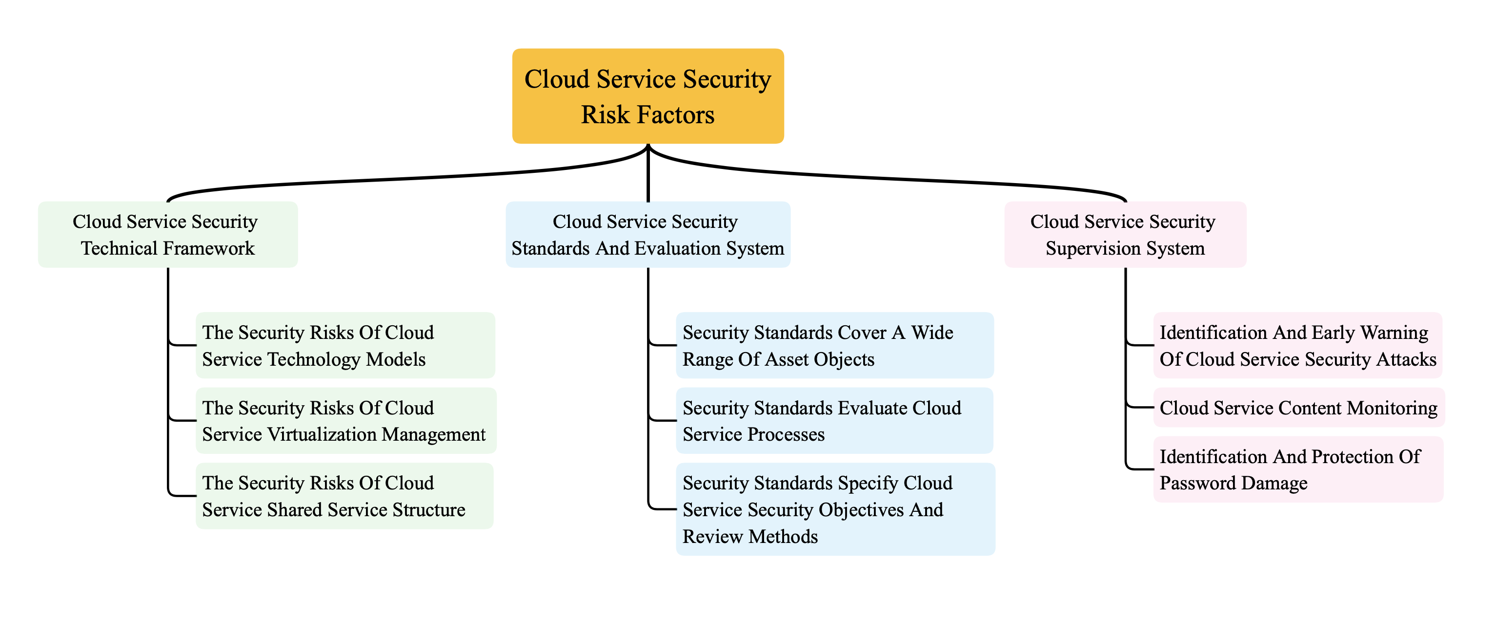
Fig. 4. The Problems Faced by Cloud Computing Security Guarantee
4.2. Compliance
A large portion of the company's customer base has the right to privacy, which includes personal information about the company's customers, such as name, phone number, address, and so forth. In order for the company to provide adequate services to its customers, it must use the personal information of these customers when operating its online business and cloud services.
There is, however, the risk of leakage that will arise if there is no reasonable and secure way to manage these customer privacy, and these risks will also lead to legal risks. Therefore, in order for the company to obtain further and fully apply personal information to the services it provides to its customers, it is necessary to obtain further and reasonable information about it. It is also necessary to formulate corresponding protection measures regarding this information.
4.3. Security Management and Practices
First of all, security documents are managed in a decentralized manner, and there is a lack of an effective information security management system. There is no formal release process for unified security systems, nor is it clear what application and distribution scope the system can be used for.
Moreover, there is no formal mechanism for reviewing and revising the security system, and it is only updated when problems arise that the system is reviewed and revised on an irregular basis, as shown in Figure 5.
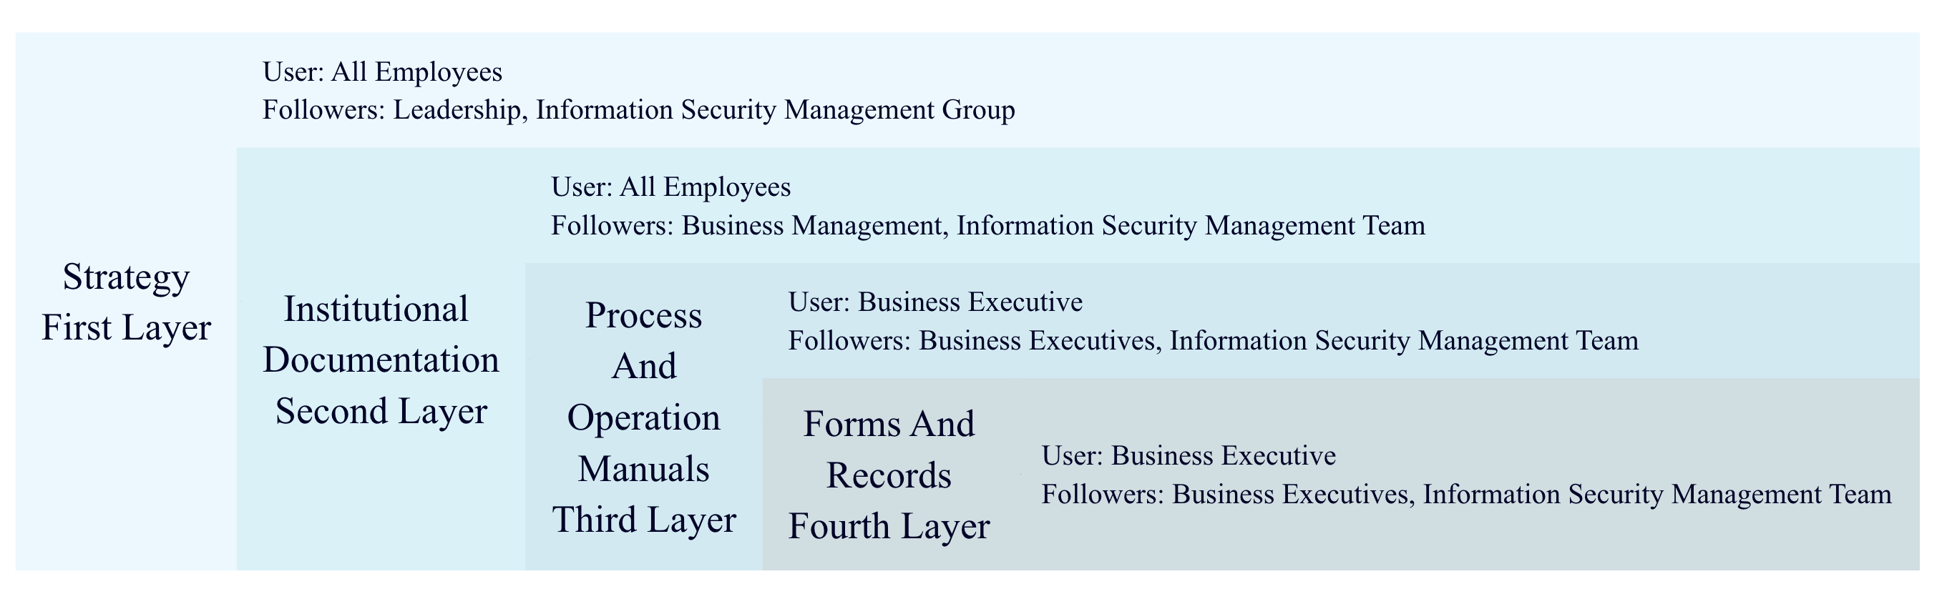
Fig. 5. Company Information Security System Framework
A lack of an information security management organization, a lack of clarification on the information security management department, and a lack of clarity regarding the security function were among the shortcomings of the company.
The facility information security subdivision is lacking, there is no letter of appointment for the security personnel, and the number of security personnel is inadequate. The mechanism of regular review for authorization and approval processes related to information security is not perfect either.
4.4. Security Policies
A decision has not been made by the company concerning its overall security strategy policy, or its security strategy and system, and there is a possibility that information security accidents may cause fatal damage to the organization due to the variety of information produced within the organization. Based on information security management, it has become increasingly apparent that the establishment of a strong and effective information security organization, as well as the formulation of clear information security objectives and policies, are essential requirements for ensuring effective information security management is implemented within an organization.
There is no question that since the company has transformed from a traditional business into a cloud-based one, in the face of the expanding complexity and difficulty of security risks associated with cloud services, insecurity in the workplace, a lack of security strategy and policy systems have rapidly increased the company's operational risks. To reduce the risk of information loss, it is critical that the organization develops an overall information security target policy, an information security strategy, improves the system as soon as possible, implements an information security leadership responsibility system, educates employees about the importance of full participation in information security efforts, and integrates an efficient information management system.
4.5. Protection Mechanisms
As well as having certain capabilities and experience in security technology, the company also has certain weaknesses when it comes to cloud computing technical requirements. Fortunately, there are some solutions available, but there are also some important risks in the following areas as well.
1) There are loopholes in security boundary protection, and it is possible for information leakage in illegal outreach. 2) There is a risk of fraud against user identity because there is no two-factor authentication. The risk of such fraud is high. 3) There is a large risk associated with security audits, whether they involve network communication, data security, or cloud tenants, and the scope of the audit is not comprehensive. 4) Cloud service providers must take very seriously the risk of data leakage due to the insufficient residual data protection of cloud tenants. 5) It is imperative that cloud hosts provide effective protection against viruses and malicious code intrusions. 6) Insufficient technical capabilities and knowledge about data backup and storage disaster recovery pose a security risk for lost or permanently destroyed data.
It is crucial for companies to ensure that cloud computing services are managed properly on a technical management level on account of the fact that they are so complex today. Through continuous improvement and learning, companies will be able to adequately address future information security management needs.
5. Solution
5.1. Construction Of Information Security Systems
It is important to enhance the construction of enterprise information security systems, organize and construct the management systems effectively, improve the technical support structure for the technical systems, and implement the application of new technologies and capability enhancements in the technical systems.
Maintain and optimize the security operation and maintenance levels, plan the centralized security management structure and guarantee capabilities reasonably, optimize and improve the level of operation and maintenance security. Taking into account the overall system theory perspective, it is important for the elements of operation and maintenance management to be optimized, and to integrate and improve the capability of managing operation and maintenance from multiple perspectives, including preventing risks, controlling operations and maintenance, and responding to emergencies.

5.2. Cloud Security Framework And Security Assurance System
Developing a systematic cloud security framework is one of the most important things that can be done to ensure rapid innovation and development of cloud services. The goal of cloud security is to resolve the known security issues associated with cloud services and to minimize the risks associated with cloud services.
It is essential to start building a cloud service security assurance system with a consideration of cloud security issues and cloud service risk analysis in order to build a comprehensive security assurance system that encompasses five aspects: management security, technical security, security assessment, security supervision, and policies and regulations. Among the security technologies that need to be developed, virtualization, shared isolation, and residual data protection should be put at the forefront. To manage the cloud service effectively, it is necessary to implement controls over the personnel management, the sustainability of the cloud service, and the level of service provided by the cloud service, as shown in Table 1.
Table.1. Cloud Computing Security Protection System
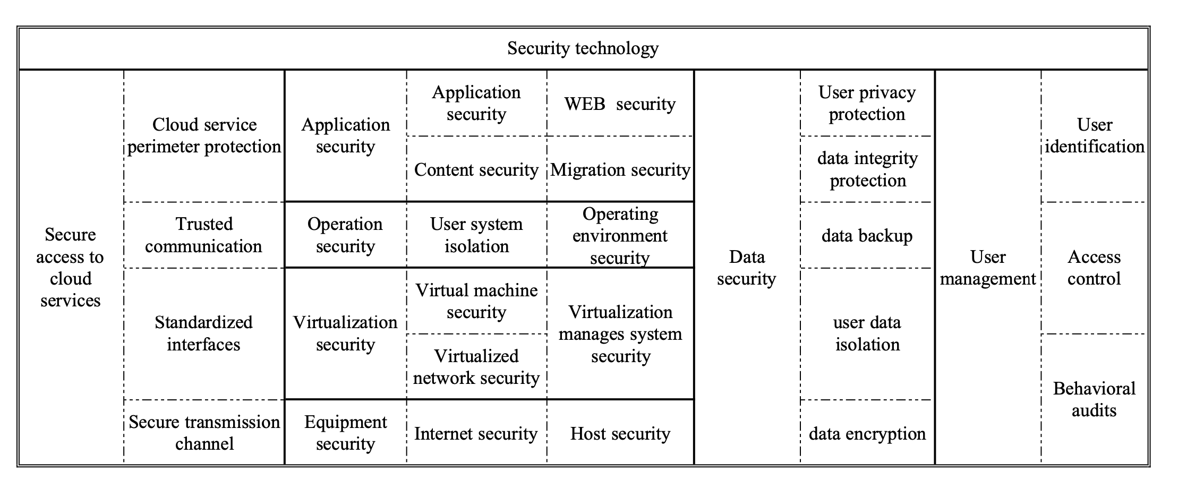
5.3. Network Business Management
A set of network business management processes and supporting management systems can be built by Company, primarily by implementing a closed-loop management mechanism for a business that is based on the electronic order system. In addition, the company must ensure that all relevant control links are implemented, including the application for business, review of the order, approval for the order, execution of the business, and recording of feedback.
5.4. Company Security Policy
In the information security management system specification, whether it is graded protection or ISO27001, it is clearly pointed out that the first task of building an information security management system is that the organization needs to establish a unified information security management policy and a security strategy in order to implement security management. The top of any organization has to have a comprehensive awareness and core ideas of information security, in other words, a comprehensive information security management policy and strategy. As a result of our previous investigation and compliance analysis of the company, we found that the company currently lacks a security strategy at the level of information security management, which leads to unclear security thinking and unclear working methods. Accordingly, the first step should be to formulate the security policy for company, as shown in Table 2.
Table. 2. Company Information Security Policies and Strategies

5.5. Network Perimeter Protection
Depending on the business needs, implement basic network perimeter protection according to your business's needs, as well as configure basic security configurations, such as ACLs, Quality of Service, and Port Security, to ensure the security of your hosts and applications. There are standardized requirements for identity authentication, password strength, login restrictions, system security, anti-virus software, etc., for self-use hosts. It is important to implement governance and protection policies for host vulnerabilities on a regular basis in order to prevent leakage of network security.
Using Vcenter, VMware virtual machines can be managed centralized, and users can be isolated in three tiers with Vswitch. It is possible to implement regular password management, permission management, patch update management, software version update management, and patch patch update management for both virtual and physical machines. Moreover, in order to centralize the management and auditing of logs for network layer devices, security devices, and self-used host devices, a log audit system has also been deployed.
6. Conclusions
The main focus of the coffee company's business is to provide its services online, and as the number of customers increases, the importance of protecting data, information, and intellectual property rights is becoming increasingly vital for the company to remain competitive. As a result of the analysis, the paper uses the PDCA cycle to analyze the multidimensional risk characteristics of the company at present, followed by a study of the safeguard measures, management strategies, and systems available to protect the company's cloud services in the current state.
References
- M.Henriquez, The top 10 data breaches of 2020, Dec. 03, 2020. data-breaches-of-2020 (accessed Feb. 15, 2021).
- E. Y. Yildirim, The importance of risk management in information security, Int. J. Adv. Electron. Comput. Sci., 4(1) (2017) 18–21
- CHEN Chi, YU Jing. Cloud computing security system[M]. Beijing Science Press, 2017.5-6
- ISO/ICE27000.Information technology-security techniques-Information security management systems-Overview and vocabulary[S].2018.
- Dhillon G, Backhouse J. Current directions in IS security research: Towards socio-organizational perspectives[J]. Information Systems Journal, 2001,11:127-153
- Siponen M T. Analysis of modern IS security development approaches: towards the next generation of social and adaptable ISS methods[J]. Information and Organization, 2005,15(4):339-375
- Rchard B. Information securiy in the cloud[J]. Network Security. 2011,4:15-17.
- Siani Pearson.Taking account of privacy when designing cloud computing services[A].2009 ICSE Workshop on Software Engineering Challenges of Cloud Computing. Vancouver[C] , BC, Canada: 2009,5: 23-23.
- Herath T, Rao H R. Encouraging information security behaviors in organizations: Role of penalties, pressures and perceived effectiveness[J]. Decision Support Systems, 2009, 47(2): 154-165.
- Patel A, Taghavi M, Bakhtiyari K, et al.An intrusion detection and prevention system in cloud computing: A systematic review[J]. Journal of Network and Computer Applications, 2013,36(1):25-41.
- Lu von Bertarangfi. WANG Xingcheng. History and Current Situation of General Systems Theory 1.Foreign Social Sciences,1978(02):69-77.
- YANG J. Comprehensive Evaluation of Internal Control Effectiveness Based on PDCA cycle, 2011(04):82-87.
- WANG Xu. Research on information security management of cloud service of S company[D]. Beijing University of Chemical Technology, 2019.DOI:10.26939/d.cnki.gbhgu.2019.001826.
- Dahbur K, Mohammad B, Tarakji A B. A survey of risks, threats and vulnerabilities in cloud computing[C]. Amman, Jordan:International Conference on Intelligent Semantic Web-services & Applications, 2011.12.
- Dimitrios, Dimitrios L. Addressing cloud computing security issues[J]. Future Generation Computer Systems, 2012, 28(3):583-592.
- Tan C,Liu K C,Sun L.A design of evaluation method for SaaS in cloud computing[J]. Journal of Industrial Engineering and Management,2013.6(1):50-72.
- FENG Dengguo,ZHANG Min,ZHANG Yan,XU Zhen. Research on Cloud Computing Security[J]. Journal of Software, 2011, 22(01): 71-83.

