Introduction to Health and Social Care

Name: Rene Bogyah

Student number: 2332913

Programme: Certificate of Higher Education Skills for the Workplace (Health & Social Care)

Module code: LCHS4003

Module Title: Introduction to Health and Social Care

Lecturer’s name: Dr Helen Parsons (Module Lead)

Table of Contents
Task 1:Poster………………………………………………………………………………………3
Task 2: Essay 5
Introduction 5
Origins and Historical Context of Ambulance Services 5
Critical Evaluation of How Ambulance Services Function Today 5
Significance in Enhancing the Quality of Life of Service Users 6
Conclusion 6
References 7

Brief History of the Service
In the past, mental health care used to be provided mostly in the form of large psychiatric hospitals and refuges, especially in the nineteenth century and the first half of the twentieth century. These hospitals tended to alienate patients from the outside community and were linked to the poor living standards and minimal rights to patients (Johnson et.al. 2022). Since the middle of the twentieth century, mental health attitudes started to shift, which was due to progress in the field of psychiatric medication, social reform movements, and an increase in the awareness of human rights.
The government started to shut down the long-stay psychiatric hospitals and encouraged deinstitutionalisation. Such a shift in the community practise brought about Community Mental Health Services, which was designed to offer care to the community closer to home (Schwarz et.al. 2022). As time progressed, the policies were becoming more focused on recovery-based strategies, underlying social care integration, and including the service users in knowledge making.

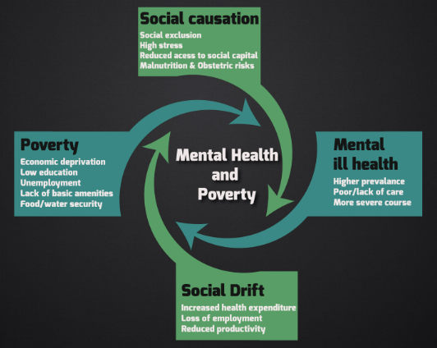

Current Functioning of the Service
In the present-day Community Mental Health Services exist as a subset of a system of health and social care. Mostly access is obtained via general practitioner, hospital, or social service referrals, but there are some locations where self-referral is accepted (Gould, 2022). Upon the referral, he or she is assessed to find his/her needs and risks, and a personalised care plan will be established. Services offer continual assistance by initiating treatments such as periodic check-ups, therapy, medication reviews, and reaching out to the community. Crisis teams contribute to prompt assistance to counter mental health crises to avoid unwanted hospitalisation. Adoption of digital technology has been increasing, and aspects such as telephone consultations and online therapy are adopted to enhance accessibility and continuity of care (Gupta, 2022). It is also through community-based delivery that there is cooperation with the voluntary organisations, family members, and peer support groups. This type of partnership can be used to deal with clinical and social-emotional needs that influence mental health. Frequent reviews enable the care plans to change with a change in needs, facilitating sustainability and avoiding relapse. Focus is put on the protection, risk reduction, and honouring of the service user included consistency and autonomous confidentiality during the entire care delivery.


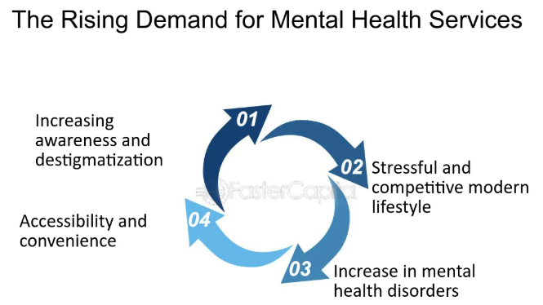
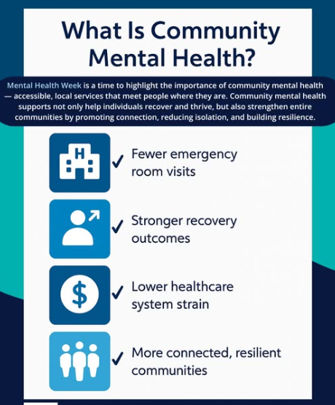
Explanation of the healthcare Service
Community Mental Health Services are meant to help people with mental health challenges live in their own communities instead of having to be established in facilities. These services aim at recovery, independence, and inclusion into society using accessible and person-centred care. Several mental health cases, such as anxiety disorders, depression, bipolar disorder, and schizophrenia, among other long-term psychological cases, are supported (Parker et.al. 2023). Multidisciplinary teams that usually include psychiatrists, mental health nurses, psychologists, social workers, occupational therapists, and support workers are the ones involved in the delivery of services. The interventions can be mental health assessments, counselling, psychological therapies, medication management, crisis intervention, and practical assistance, such as housing, education, and employment (Perez et.al. 2025). The community mental health services are aimed at enhancing the quality of life, lessening hospitalisation, and enabling individuals to handle their mental illnesses effectively in their very familiar surroundings.

Introduction to Health and Social Care


Challenges faced by the service:
Challenge 1
High demand and resource scarcity are among the greatest challenges facing Community Mental Health Services. The emerging mental health awareness and societal trends have caused an increase in the number of people seeking help, and the funding and staffing are not adequate (Shaligram et.al. 2024). This leads to the lengthy queuing periods, heaviness of staff with a number of cases, and the dilution of support. Well-being of the workforce is tightly connected with the quality of the provided services and is another burden of Community Mental Health Services. Employees often have to deal with complex cases that include a substance misuse problem, a physical health issue or a social care problem. Stress, burnout, and staff turnover may also be related to high emotional demands and pressures at work, which, in turn, may affect the continuity of care.
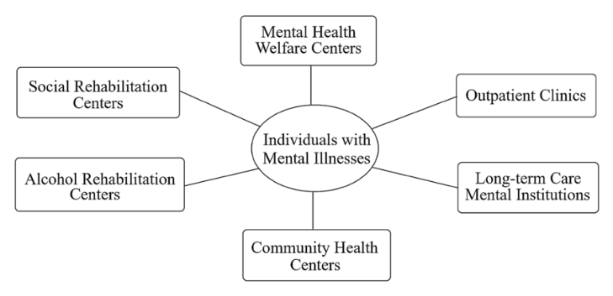
References
Choudhary, A., Jasrotia, A. and Kumar, A. (2024) Mental health: A stigma and neglected public health issue and time to break the barrier. Int J Community Med Public Health, 11, p.1378.
Gould, N. (2022) Mental health social work in context. Routledge.
Gupta, A.D. (2022) Adoption of Digital Healthcare with the Concept of the Patient as an Organisation.
Johnson, S., Dalton‐Locke, C., Baker, J., Hanlon, C., Salisbury, T.T., Fossey, M., Newbigging, K., Carr, S.E., Hensel, J., Carrà, G. and Hepp, U. (2022) Acute psychiatric care: approaches to increasing the range of services and improving access and quality of care. World Psychiatry, 21(2), pp.220-236.
Parker, S.M., Paine, K., Spooner, C. and Harris, M. (2023) Barriers and facilitators to the participation and engagement of primary care in shared-care arrangements with community mental health services for preventive care of people with serious mental illness: a scoping review. BMC Health Services Research, 23(1), p.977.
Perez, L.G., Cardenas, C., Blagg, T. and Wong, E.C. (2025) Partnerships between faith communities and the mental health sector: a scoping review. Psychiatric Services, 76(1), pp.61-81.
Schwarz, J., Hemmerling, J., Kabisch, N., Galbusera, L., Heinze, M., von Peter, S. and Wolff, J. (2022) Equal access to outreach mental health care? Exploring how the place of residence influences the use of intensive home treatment in a rural catchment area in Germany. BMC psychiatry, 22(1), p.826.
Shaligram, D., Sarvet, B. and Straus, J.H. (2024) Optimizing Scarce Resources through Collaboration. Redesigning the US mental health care system, p.181.

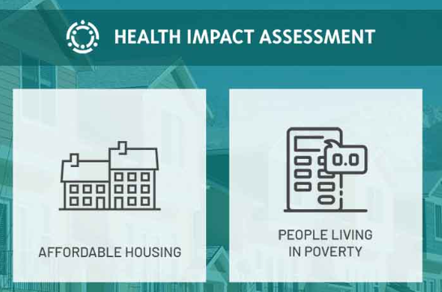



Challenge 2
The other challenge that is important is the legacy of stigma and social inequity. Antipathy towards mental illness may not help those affected access help at an early stage, and challenges like poverty, homelessness, and unemployment may pose difficulties for service users to fully utilise community-based care, resulting in long term recovery (Choudhary et.al. 2024). In spite of these challenges, Community Mental Health Services have continued to play a role in contemporary mental care. The fact that they are still striving to evolve indicates that mental health has gained the same status as physical health and that people are placed in the hands of friends, relatives, and other powerful hands in their communities to assist them whenever they are in need. The solutions will be better in the future based on sustainable funding, further integration of services, and policies that focus on prevention, early intervention, and recovery-oriented support of the various population groups in all communities throughout the country.

Task 2: Essay

Introduction
Ambulance services are the primary need that an individual requires at the time of any medical emergency. This essay will clearly justify the need for ambulance services in the present era, as people are often getting sick as compared to older people. Also, the origin and the history of ambulances will be discussed that how the need and demand grown with time. Also, the current functioning and the significance of these services in an individual's life will be discussed.

Origins and Historical Context of Ambulance Services
The emergence of ambulance services was motivated by the necessity to deliver injured people to their required location promptly and safely, especially in times of war. Flying ambulances were developed in the late eighteenth century by a French military surgeon called Baron Dominique-Jean Larrey, in the Napoleonic Wars. These horse-drawn units quickly moved wounded soldiers off the battlefields, as well as offering instant treatment. This innovation emphasised the relevance of being fast-paced and responding to medical emergencies as soon as possible, after which subsequent emergency response systems were influenced (Khatri et.al. 2023).
In the nineteenth century, with the fast industrialisation and urbanisation, an organised civilian service of ambulances was needed to provide service at the workplace as well as to the population at large. Around the beginning of the 20th century, early services were commonly operated by charities, police, or hospitals and were chiefly centred on transportation but not treatment(An et.al. 2023). These services were further formalised with government involvement and reforms of the health systems of the people, and have become incorporated into the healthcare systems of the countries, developing standards of training, equipment, and response.

Critical Evaluation of How Ambulance Services Function Today
In present-day healthcare systems, an ambulance is a basic provision of the system, offering emergency and immediate health care in the pre-hospital setting. Paramedics and emergency medical technicians are very well-trained specialists who can evaluate and stabilise patients and also give them treatment at the spot of occurrence (Bienstock et.al. 2023). They can early diagnose and provide instant intervention, which is essential in avoiding a further worsening of the situation before one would have been admitted to the hospital due to their clinical knowledge.
A development of the crude patient transportation to sophisticated and mobile clinical care has greatly enhanced the survival of service users and healing results. In spite of this endeavour, there are a number of challenges that the ambulance services have to grapple with (Wolfe et.al. 2023). The growth of demand, which is highly dependent on an ageing population, escalated chronic health conditions, and rising use of emergency services by the population at large, puts too much pressure on the response time, ability, and workforce.

Significance in Enhancing the Quality of Life of Service Users
The ambulance services are vital in improving the quality of life of the service users as a result of the delivery of timely, competent, and life-saving services whenever there is a medical emergency. Emergency response to fast-critical cases of cardiac arrest, stroke, or shortness of breath, or severe injury greatly decreases the mortality rate and the occurrence of long-term disability.
In addition to an emergency response, contemporary ambulance services are also more geared towards providing patient-centred care services. This also involves evaluating, treating, and managing the patients in their respective homes in instances that would be suitable and also placing them in the community services to get long-term assistance (Kidanemariam et.al. 2023).
Moreover, the people attending to the ambulances exhibit empathetic communication and reassurance as well as professionalism, which is crucial in calming the anxiety and distress caused in cases of emergency. Ambulance services help increase the quality-of-service experience of the overall user (Wilson et.al. 2022).

Conclusion
This essay clearly concludes the effectiveness and the need for ambulance services in the present time. Also, this essay stated the origin and the historical enhancement of these services. At the end, it was concluded that these services are very significant in an individual’s life.

References
An, M., Liu, M., An, H. and Ramsey, T.S. (2023) Systematic evaluation of emergency management capacity for rural public health emergencies. International Journal of Disaster Risk Reduction, 85, p.103493. Doi: https://doi.org/10.1016/j.ijdrr.2022.103493
Bienstock, J., Heuer, A. and Zhang, Y. (2023) Simulation-based training and its use amongst practicing paramedics and emergency medical technicians: an evidence-based systematic review. International Journal of Paramedicine, (1), pp.12-28. Doi:https://internationaljournalofparamedicine.com/index.php/ijop/article/view/2334
Khatri, R.B., Endalamaw, A., Erku, D., Wolka, E., Nigatu, F., Zewdie, A. and Assefa, Y. (2023) Preparedness, impacts, and responses of public health emergencies towards health security: qualitative synthesis of evidence. Archives of public health, 81(1), p.208. Doi:https://doi.org/10.1186/s13690-023-01223-y
Kidanemariam, M., Pieterse, A.H., van Staalduinen, D.J., Bos, W.J.W. and Stiggelbout, A.M. (2023) Does value-based healthcare support patient-centred care? A scoping review of the evidence. BMJ open, 13(7), p.e070193. Doi:https://bmjopen.bmj.com/content/13/7/e070193.abstract
Wilson, C., Howell, A.M., Janes, G. and Benn, J. (2022) The role of feedback in emergency ambulance services: a qualitative interview study. BMC health services research, 22(1), p.296. Doi:https://doi.org/10.1186/s12913-022-07676-1
Wolfe, A., Frakes, M. and Nayman, D. eds. (2023) Patient Transport: Principles and Practice-E-book. Elsevier Health Sciences. Doi:https://books.google.com/books?hl=en&lr=&id=u5rxEAAAQBAJ&oi=fnd&pg=PP1&dq=A+development+of+the+crude+patient+transportation+&ots=BuFfZGx1-K&sig=N54OrHlQEHZb3DKHK9e6c5K5yYY

