
Module Name:
Corporate Social Responsibility in the Public Sector (BMPS6004)
Student Name: Wei He
Student Number: 1900504
Research on Reducing Inequality and Discrimination against Indigenous Peoples and Migrants

15/05/2020
Table of Content
1.0 Executive summary 1
2.0 Introduction 2
3.0 Method 2
4.0 Finding 3
5.0 Discussions 5
5.1 Unfair treatment suffered by new migrants 5
5.2 Unfair treatment suffered by indigenous people 6
5.3 Other discrimination 7
6.0 Conclusion 8
7.0 Recommendation 8
8.0 References 10
9.0 Appendixes 12

1.0 Executive summary
This research focuses on the motivation and purpose of the UN public sectors and how to play its role to help solve the problems of reducing inequality and discrimination against indigenous people and migrants. First of all, it discusses the current situation, how indigenous people and migrants are treated unfairly, and then uses a combination of qualitative and quantitative methods to analyze the two aspects and lists tables and charts, which can more clearly and visually demonstrate the topic. The data exposes the big gap between the two groups in the host country and the local people, then discuss and analyze this phenomenon based on these findings, and explain what actions the United Nations and related organizations have taken here, how they coordinate the local government to improve this status and effective progress have been made, and finally concluded that the UN public sector has achieved a certain degree of success, and combined with the importance of disclosure of the transparency of the report, recommendations are given.

2.0 Introduction
All over the world, millions of people face discrimination on a daily basis through social attitudes and prejudices, especially for those indigenous and new migrants groups, suffering unfair treatment(Rivera, 2016). In extreme cases, this discrimination has even led to policies of ethnic cleansing and extinction. However, in recent history, since the establishment of the United Nations, its public sector has been concerned about this issue and played a significant role, and it has revealed the prohibition of racial discrimination in all core international human rights instruments. The United Nations Human Rights Council has played an important role, for example, obliging countries to eliminate racial discrimination in the public and private sectors and supervise their implementation (Hirschman, 2010). The principle of equal rights also stipulates that countries take a series of actions to deal with these conditions that cause or contribute to the continuation of racial discrimination.

The 2001 World Conference against Racism formulated the Durban Declaration and Programme of Action(Jackman, 2018). Undoubtedly, the biggest outcome of the conference was the international community’s reaffirmation of its support for the agenda against racism. There have also been many success stories since then — from the overthrow of the apartheid regime in South Africa, through the United Nations Declaration on the Rights of Indigenous Peoples, to the empowerment of women to vote in many countries, which inspired people not only to oppose but also eliminate inequality and discrimination(James, 2014). Therefore, this report will be focusing on the inequality and discrimination issues existing all the over and how related sectors get involved in dealing with these problems.

3.0 Method
This reports uses a combination of qualitative and quantitative analysis methods to analyze the current situation of inequality and discrimination. First, it analyzes the discrimination encountered by new migrants and indigenous people in some areas and the differential treatment of their nationals by citing some data, tables and charts. Then it figures out the reasons how they are caused and fully discussed the historical factors and government policies. Finally, reasonable suggestions such as how each country improves in this field and UN continues to do are given. As for the data, secondary data is mainly used in the report , which is easier to obtain, mainly from some government official websites, such as the Canadian Immigration Statistics Bureau and UN statistics website.

4.0 Finding
The Durban Declaration stated that the xenophobia of foreigners against foreign migrants is one of the main causes of contemporary racism(Kain, 2012). With the development of economic globalization, more and more people, especially those from developing countries, choose to immigrate to more developed countries or regions. However, when they emigrate to a new country, they are unfairly treated and discriminated, especially being discriminated against jobs, education and many aspects(Tynan, 2016). According to the report of the United Nations Department of Economic and Social Affairs, there are about 200 million people living outside the country of origin, which accounts for 3.1% of the world’s population in 2010 (Massey, 2015). Even though these new migrants can enjoy the same benefits, treatment and even the right to vote as their own residents, due to the persistent anti-migrant psychology and discriminatory psychology in the country, the laws and regulations that restrict migration flows are often caused by government policies, and the trend of convictions for improper migration also illustrates this point. The global economic crisis and increasing unemployment have actually further strengthened these trends.
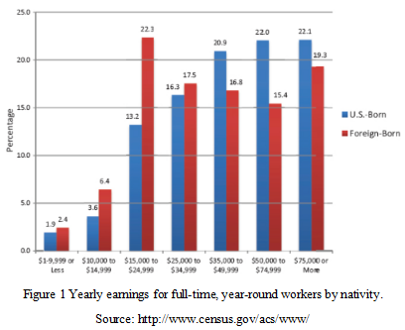
According to Figure 1, it can be clearly seen that on the income level, low income is mainly occupied by these migrants, from $1-9999 to $34999, the ratio of migrants is much higher than that of US residents. The medium and higher-level income people, more than $35,000, $50000-$74999, and $75000 above, American nationals are far larger than migrants, so the income reflects the huge gap between migrants and national residents, such a huge income gap is inevitable. As a result of imbalances in people’s minds, new migrants believe that the same labor cannot receive equal returns, and their residents believe that new migrants have stolen the locals’ job opportunities and this thought has become mainstream in the society, even more and more prominent and obvious(Denton, 2017).

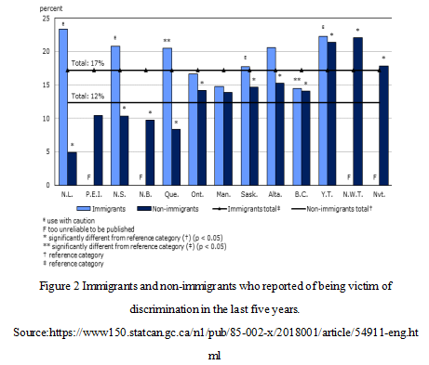
Here people are concerned about security issues caused by discrimination in Canada. The rate of victims reported by new migrants is much higher than that of local residents.The discrimination suffered by new migrants is reflected in many aspects of life and work(Maio, 2017). The discrimination of new migrants at work or in applying for work is obviously about 21%, while that of non-migrants is 16%. In addition, about 23% of migrants are discriminated and non-migrants is only 5% suffered victims in shops, banks or restaurants(Portes, 2018). Similarly, on security issues, immigration threats, including skin color 21%, ethnicity 17%, language 23%, gender, etc. are also much higher than local residents. However, for non-migrants victims are usually less 13%, 8% and 10%, respectively. In addition, 20% of migrants experienced discrimination based on religion, which is much higher than non-migrants discrimination (13%). migrants victims reported far more cases than non-migrants victims, 13% and 7%, respectively.

In addition to above two discrimination, there are actually some other discrimination related to minorities, disabled people, women, races, religions and sexual orientation and gender identity. It has a great psychological and spiritual burden on individuals and families, and it also has an adverse impact on social development. For example, through Figure 3, it can be seen the different kinds of discrimination people usually suffer when recruiting in Europe, with 52% on disability, 30% on gender, 25% on sexual orientation, and 21% on religious beliefs.
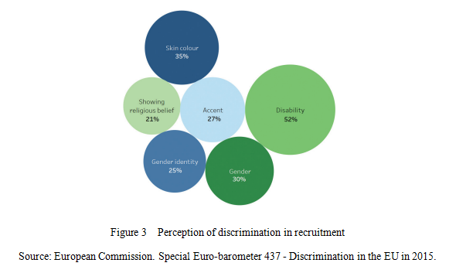

5.0 Discussions

5.1 Unfair treatment suffered by new migrants
According to above data, new migrants who have come to Canada less than 5 years have an unemployment rate as high as 11.5%, which is 2.35 times the unemployment rate of 4.9% for locally born Canadians. The survey shows that the unemployment rate of new migrants in Quebec is less than 5 years(Goldstein, 2017). The unemployment rate is as high as 18.1%, which is 2.8 times that of Canadian-born people.The survey pointed out that the longer the new migrants come, the unemployment rate declines, and the gap with the unemployment rate of native-born Canadians has narrowed. For new migrants who have arrived in the port more than 5 years but less than 10 years, the unemployment rate has dropped to 7.3% .The survey is mainly aimed at the main force of the labor market. New migrants between the ages of 25 and 54 are divided into the latest batch of migrants who arrived in the port from 2011 to 2016, less than 5 years, and another batch that arrived in the port from 2011 to 2016. migrants who have reached 5 years but less than 10 years will investigate their employment and compare them with local people born in Canada.The results of this survey fully illustrate that when new migrants arrived, despite their high academic qualifications and work experience in their place of origin, due to the lack of certification of professional qualifications obtained abroad and lack of local work experience, even language gap, they are not able to quickly get accustomed to the local profession and workplace which could be the biggest barrier for their career(Ruan, 2011).

5.2 Unfair treatment suffered by indigenous people
Indigenous peoples of the world-or "the first inhabitants" have different experiences under colonial rule(Zuo, 2002). In the new world, white European colonists suddenly came to settle, and major changes took place. Indigenous people are driven to the side by the descendants of mainly Europeans and are on the brink of society. Modern estimates suggest that before the 15th century, before Columbus arrived in the Americas, there were between 10 million and 12 million indigenous people in North America(Walder, 2014). But by the 1890s, the number of indigenous people in North America had decreased to about 300,000(Roberts, 2017). In some regions of Latin America, the result is the same but in other regions, the indigenous population is still the majority. In Australia, Canada and the United States, it was only in the second half of the 20th century that it was determined to be discriminatory and destructive, by forcibly removing indigenous children from their homes(Eschbach, 2015). In Australia, this practice is mainly aimed at mixed-race indigenous children of different ethnicities who were forcibly taken away from their parents and handed over to adopted white families(Roux,2002). Also, speaking Indigenous languages is not allowed, and they were actually forced to learn and speak standard English only (Massey, 2013). In the early days, the Indigenous children had lost the chance to improve their opportunities in the current society. The goal of government is to assimilate them. At that time, the value embedded in indigenous culture and knowledge had not been confirmed. In remote regions, some boarding schools have attracted teachers and staff who are torturing children. Records indicate widespread corporal punishment and sexual abuse(Kennedy, 2002). Now in North America, as the abuse is exposed, the victims have been identified and tried to provide remedies and compensation under monitoring of United Nations.

5.3 Other discrimination
These discrimination exist in all countries and occur everyday. Therefore, the United Nations has also taken practical actions in this regard, successively launching Charters such as the United Nations Charter, the Universal Declaration of Human Rights, the International Covenant on Human Rights, and the Programme of Action to restrict the code of conduct of various countries, with the aim of protecting the legality of such groups rights and interests and let these group people have the same rights as others, and provide technical and economic support for the efforts of each country.

From the results, it can be seen that the efforts of the public sectors of the United Nations are still successful. To a certain extent, it is their repeated efforts and negotiations with the national government and the implementation of laws and declarations that have helped the vulnerable groups such as indigenous people and migrants to rescue them from a part of the previous extreme inequality and try yo increase more legal right(Chui , 2013). Although this is a long process, there are still a lot of inequality and discrimination problems in various countries, they have also been working hard to solve any present or future.

6.0 Conclusion
To sum up, through the above analysis, it can conclude: The relationship between the indigenous people and the mainstream society has always been unequal, the conflict between the two sides is far greater than the exchange, and the indigenous people have always been in a passive position. Although the current policy has clear phases and improvements, in some Western-dominated countries, the formulation and implementation of policies are mostly white, with little consideration of the indigenous people. This part of the reason is also to consider the living habits of most indigenous people, their own qualities, the level of education, and the willingness to actively adapt to modern society. On the other hand, for new migrants, although multicultural policies have expanded the inclusiveness of mainstream society, it does not mean that racial discrimination does not exist. On the contrary, with the influx of more and more migrants from all over the world, conflicts and disputes with local people are inevitable, and even worse.

At this time, the UN Human Rights Commission and some non-governmental organizations need to stand up to help countries with such problems around the world to solve this inequality and differences, not only to ease the contradictions between different ethnic groups, but It is of great significance to promote the unity and economic development of a country, and then promote world peace and development.

7.0 Recommendation
At present, 70% of the world‘s people live in countries where income inequality has increased since 1990. Certain inequality indicators based on gender, race, ethnicity, immigration status, and socioeconomic status are still increasing. Opportunities in many other areas Inequality is still increasing. Due to the increasing attention to environmental issues, the activities carried out by the Working Group and other United Nations agencies.

Countries such as Canada, Australia and the United States are trying their best to resolve the land claims of indigenous groups and reached a settlement on previously caused harm, including harm caused in the name of assimilation. In particular in the Americas and Australia, indigenous groups have made significant progress in claiming land claims. The Government of Canada also issued a statement of reconciliation, which called for an updated partnership with indigenous people based on the recognition of previous mistakes and injustices, the promotion of reconciliation, the treatment of trauma and rehabilitation, and the development of future joint plans. In other parts of North America, the United States is also addressing plenty of land declarations. A part of Indian tribes have successfully achieved a certain degree of sovereignty. A few tribes have also set up casinos to become billions dollar industries and provide the work opportunities needed in some areas—not just residents in their settlements.

At the same time, government also realizes the importance of information disclosure transparency and its core evaluation standards, and use this standard to examine the status of information disclosure transparency in those countries to solve inequality and discrimination issues. The main elements of information transparency include timeliness, completeness, and sufficiency. Based on the characteristics of two different forms of information disclosure, periodic reports and interim reports, public sectors of UN can real-time track the dynamics of resolving inequality issues and evaluation and figure out recommendations.

8.0 References
Hirschman, C. (2010). Multilevel Models of Fertility Determination in Four Southeast Asian Countries. Demography, 27(1), pp.369–396.

Jackman, M. (2018). Racial Inequalities in Home Ownership. Social Forces, 58(3), pp,1221–1234.

James, F. (2014). Minorities in the Sunbelt: Segregation. Discrimination and Housing Conditions of Hispanics and Blacks. New Brunswick, NJ: Rutgers University Center for Urban Policy Research.

Kain, J. (2012). Housing Market Discrimination, Home Ownership, and Savings Behavior. American Economic Review, 62(4), pp. 263–277.

Tynan, K.(2016). Home Ownership Differences between Hispanics and Anglos in the United States. Social Problems, 33(5), pp.319–334.

Massey, D. (2015). Explaining the Paradox of Puerto Rican Segregation. Social Forces, 64(7), pp. 306–331.

Denton, A. (2017). Trends in the Residential Segregation of Blacks, Hispanics, and Asians. American Sociological Review, 52(2), pp. 802–825.

Portes, A. (2018). A cross-Atlantic dialogue, the progress of research and theory in the study of international migration. International Migration Review, 38(3), pp. 828-851.

Rivera, L. (2016). Undocumented workers in the labor market, an analysis of the earnings of legal and illegal Mexican migrants in the United States. Journal of Population Economics, 22(1), pp. 91-116.

Roberts, K.(2017). China's tidal wave of migrant labor: what can we learn from Mexican undocumented migration to the United States? International Migration Review, 31(1), pp. 249-293.
Walder, G.(2014). Evolving property rights and their political consequences. St.Martin's Press, Longman Cheshire and New York, pp. 3-18.

Ruan, D.(2011). Markets and inequality in transitional economies: toward testable theories. Journal of Sociology, 101(5), pp. 1060-1073.

Wang, F.(2008). Boundaries and Categories, Rising Inequality in Postsocialist Urban China. Stanford University Press, Stanford.

Zuo, X.( 2002). Rural migrants in Shanghai: living under the shadow of socialism.International Migration Review, 36(2), pp. 467-491.

Eschbach, K. (2015). Immigration and ethnic and racial inequality in the United States. Annual Review of Sociology, 21(3), 419-446.

Massey, D.(2013). Effect of the immigration reform and control act on the wages of Mexican migrants. Social Science Quarterly, 74(6), 523-541.

Chui , T. (2013). Longitudinal survey of migrants to Canada: process, progress and prospects. Ottawa, Canada : Statistics Canada .

Kennedy, S. (2002). The reliability of self-assessed health status. Journal of Health Economics, 21(4), pp. 643–658.

Maio, F. (2017). Health inequalities in Argentina: patterns, contradictions and implications. Health Sociology Review, 16(5), pp. 279–291.

Roux,V.(2002). A glossary for multilevel analysis. Journal of Epidemiology & Community Health, 56(3), pp. 588–594.

Goldstein, H. (2017). Becoming familiar with multilevel modeling. Significance, 4(1), pp.133–135.

9.0 Appendixes


