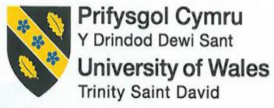

Financial Management for the Hotel Industry
BMIH5007
Business Report
Student: Mirela Mihaela Motohoi
Student ID number: 2206811
Lecturer: Tristan Hawkins
Comparison of Two Hospitality Organizations
[Word Count: 2000]

Contents
1 Introduction: 3
2 Total Revenue: 6
3 Market Position: 8
4 Growth Potential: 10
5 Financial Commitment to CSR (Corporate Social Responsibility): 11
6 Conclusion: 13
6.1 Recommendation: 13
7 References 15

Introduction:
Corinthia is one of the collections of different hotels. It was founded in 1962 through the Pisani family of Malta. Corinthia has a portfolio that runs nine beautiful properties all over the world. Corinthia has a very dynamic group of hotels. In 2021the Corinithia is scheduled to develop five more hotels in Landmark that are opened from London to Lisbon. It structured the hotel in luxury beachfront resorts from city-center landmark hotels. Alfred Pisani was the first Corinthia Group member who began the success of Corinthia. He developed the first deluxe hotel in Malta on his family landmark (The Corinthia London, 2024). In 1968, the original Palace of Corinthia Hotel was opened through HRH. The Duke of Edinburg in Malta. Pssani is the current chairman and also the chief executive officer who has expanded the company to the multinational level so that it becomes a competitive group that comprises four different subsidiary companies (HotelmyPassion, n.d). It operates different multi-national brand hotels. It has a high and exclusive management license that helps to operate the hotel into the Corinthia brand. These licenses can operate hotels in the Middle East, Africa, and Europe. The Pisani family, by their ownership holding in IHI, has full ownership of the corporation (Crowe, 2023).
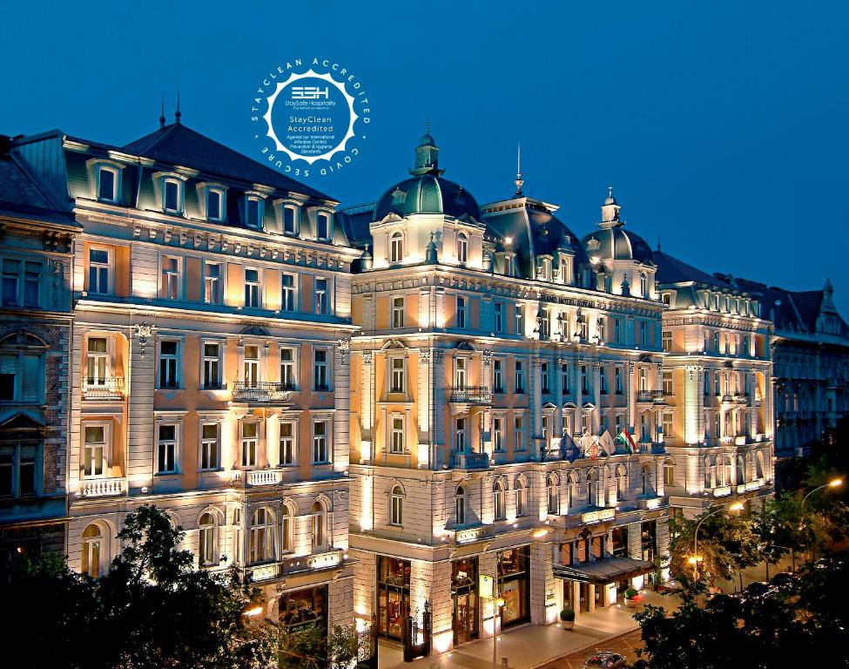
Figure 1: Corinthia Hotel
Source: (Booking, 2024)
The first Ibis hotel was established in Bordeaux in 1974. Accor Group that is formerly Novotel SIEH, established this hotel to create a more cost-effective version of Novotel. In 1988, Ibis managed a total of 182 hotels in France. The very first Ibis hotel in the United States commenced operations in 1983. The company has expanded its presence to Florida, Texas, and Georgia. Nevertheless, Ibis ceased operations in the US market before the end of the 1980s (Ibis Hotel, 2024). By 1995, Ibis had established its presence in the UK with a total of eight hotels under its operation. In 1997, an Ibis hotelier introduced a program called the 15-minute guarantee, whereby customers are provided with lodging if their issue remains unresolved after 15 minutes. By 2004, the hotel chain Ibis has a presence in 36 countries with a total of 700 properties under its operation. Ibis expanded its operations to China, South Korea, and Thailand between 2003 and 2005. In October 2009, Ibis reached a significant milestone of having 100,000 rooms and inaugurated its first hotel in Moscow. This was followed by the opening of its 50th hotel in Brazil and its first hotel in Japan. The biggest hotel in Asia Pacific operated by Ibis was inaugurated in Bandung in 2012. In the year of 2011, September, Accor renamed Every Season as Ibis Styles and Etap as Ibis Budget, so transforming Ibis into the conglomerate's prominent budget-friendly brand. The mattresses, pillows, and internet access have undergone upgrades. Following the reorganization, the Ibis mega brand, which encompasses other hotel chains, emerged as the biggest hotel owner in Europe in 2013, with a total of 1,277 properties. In the year of January 2014, Ibis inaugurated its 1,000th hotel. In September 2012, Ibis conducted a trial of Sleep His Art, a robotic device that creates drawings by analyzing the sleeper's motions, noises, and variations in temperature. Moreover, Sleep Art transformed into his mobile application that caters to all his Ibis consumers after 6 months (Dwi, and Ramdhani, 2023).
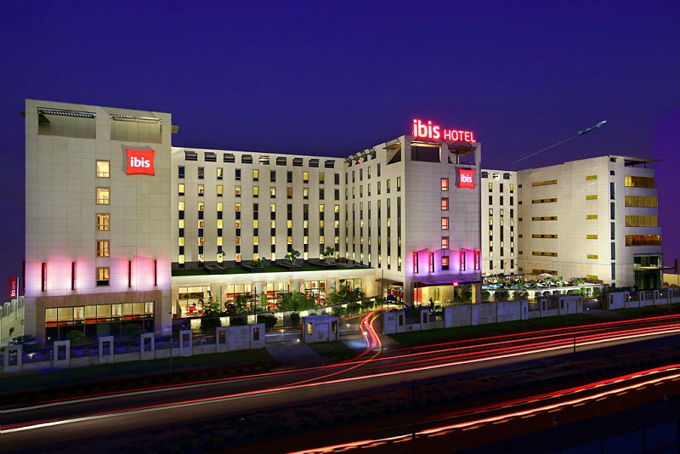
Figure 2: IBIS Hotel
Source: (nehaaa, 2021)
This Business report discusses the two international brand hotels, Corinthia and Ibis. Discuss both two hotels’ total revenue their market position the factors that affect their market share rate, their customer demographic ad also brand perception. In this, it also discusses the growth potential of both two hotels and their financial commitment to CSR. In the end, it concludes the report and recommends both two hotels.

Total Revenue:
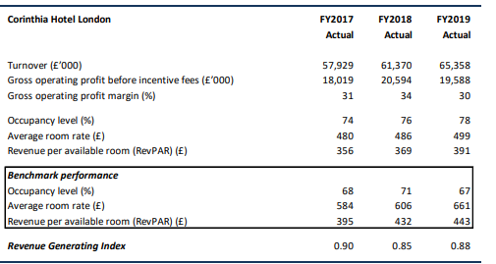
Figure 3: Total revenue of Corinthia Hotel
Source: (FRN, 2020)
In FY2017, the Hotel's performance exceeded its benchmark with an RGI of 0.90 compared to 0.79 in FY2016. This improvement was mainly due to the Hotel's occupancy rate which is 6% more than its competitors. However, there was a negative impact on the average room fee, which decreased by £104. The Hotel surpassed its goal in FY2018 by achieving an occupancy level of 76%, which was higher than 5%. However, the room rate has decreased by an average of £120. It represents a decrease of 20%. The Hotel's Revenue Generating Index (RGI) decreased from 0.90 in the previous year to 0.85 in FY2018. In the fiscal year 2019, the Hotel had a superior availability level in comparison to the benchmark, nevertheless, the average room rate was 25% lower than that of its comparable set (FRN, 2020). As a result, the Revenue Growth Index (RGI) for the fiscal year 2019 rose from 0.85 in the fiscal year 2018 to 0.88.
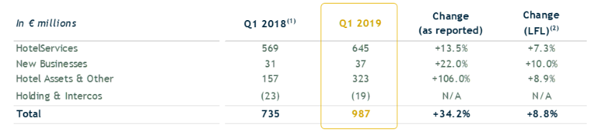
Figure 4: Ibis Hotel’s total revenue
Source: (Accorgroup 2019)
In the year of 2019, the Ibis Hotel’s revenue increased to 8.8%. These revenues are measured using consistent scope and currency rates. This led to a strong growth revenue of hotel services that is more than 7.3% and the assets of the hotel area also increased that is more than 8.9%. This revenue was more than 10.0% from the new business development (accorgroup, 2019).
Both the revenues are compared so that the results show that the Corinthia hotel revenue generating index in 2019 is 0.88% and the Ibis hotel revenue in 2019 is 8.8% it represents that in both revenues there is a significant difference. But from the previous year, the revenue of Corinthia Hotel is more than that of the Ibis Hotel.

Market Position:
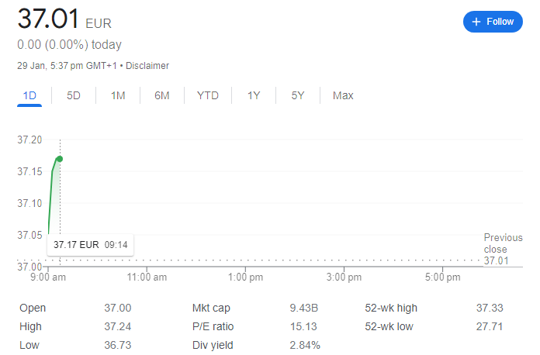
Figure 5: Market position of Ibis hotel
Source: (Accor, 2023).
Ibis Hotel provides promotional discounts through certain seasons and holidays to its clients. They provide promotions like in New Year they give 20% discount for their customers. It also offers discounts on different occasions. Ibis offers a best-price matching guarantee, along with an additional 10% reduction if the consumer discovers a cheaper price elsewhere. Additionally, they offer a bundle of price options that is known as the extra saver package. Furthermore, Ibis has a global presence with over 2000 hotels spanning around 65 countries worldwide. There are several employment prospects and varied levels of staff that together contribute to the seamless operation of Ibis hotels and deliver the finest customer service. Currently, the company offers over 2800 career and internship opportunities and employs more than 250,000 committed individuals who are devoted to delivering exceptional service to customers.
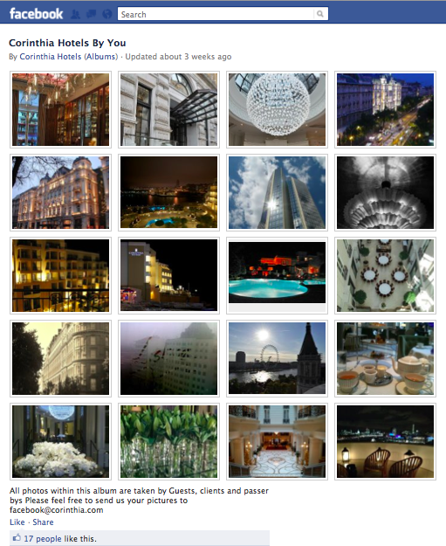
Figure 6: Social media marketing of Corinthia Hotel
Source: (ReviewPro, 2012)
Corinthia Hotel CEO set up strict guidelines for the social strategy. They make rules that they respond to all their customers within an hour. However, customers call them to solve issues or for guidance. Moreover, it is riskier to describe all the customer service on the public website but Corinthia takes these steps, they know it is difficult to be happy with all the customers so they engage customers from social media and build a relationship with them. They become transparent in this sense and react to solve all these issues in front of anyone. Furthermore, they get feedback from their customers on their dashboard. For this, they developed Review Pro which plays a significant role in managing and monitoring their customer services. These review pro global reviews provide the overall summary of the customers and how customers are satisfied. They also provide training for their teams about these review pro tools (ReviewPro, 2012). Therefore, they maintained their market position by satisfying their customers.

Growth Potential:
The Corinthia Hotel markets itself as high-end and commands enormous possibilities for growth due to its status as an upscale brand targeting luxury clientele. The trend of the privileged hospitality market is rising in popularity as travelers choose unique and tailor-made experiences. Corinthia can take advantage of this trend and increase its international reach by focusing on major popular hubs for the luxury traveler’s population (Goffi et al, 2022). Furthermore, tactical collaborations with luxurious travel agencies that organize exclusive events may help to improve Corinthia’s market presence. Investing in new features in innovative amenities and sustainable practices will appeal to luxurious environmentally friendly travelers, consistently realizing the sophisticated change in this market (Zámborský, and Kruesi, 2018).
However, Ibis Hotel as a low-priced and accessible brand solution has the potential to align with the increasing excitement for affordable lodging. To benefit Ibis, as budget-safety travelers are on the lookout for a better base of stay and it should provide them with their essential amenities without compromising on anything else, ibis can work higher in emerging markets and hit tourist spots. Furthermore, Ibis can use technology to simplify their booking process procedures which would result in advanced guest experience innovation that guarantees value for money. What is more, proper strategic cooperation with online travel agencies and using profitable experiential travel in a budget context would help even better improve Ibis’s market position (Ishraq, S. and Zakaria, 2023).
Growing into the Luxury Hospitality market; worldwide presence and flexibility are what make Corinthia Hotel appropriate for such a mission. At the same time, emanating from a rising demand for quality but affordable hotels, Ibis can create more opportunities by focusing on developing and growing its businesses in emerging markets as well as improving its value proposition to meet the needs of the price-conscious clientele (Guzzo et al., 2020). The two brands can grow given their high potential no matter which segment they end up in, the key will be to tap into what is quickly becoming the new normal when it comes to consumer tastes and travel for this millennial age group especially.

Financial Commitment to CSR (Corporate Social Responsibility):
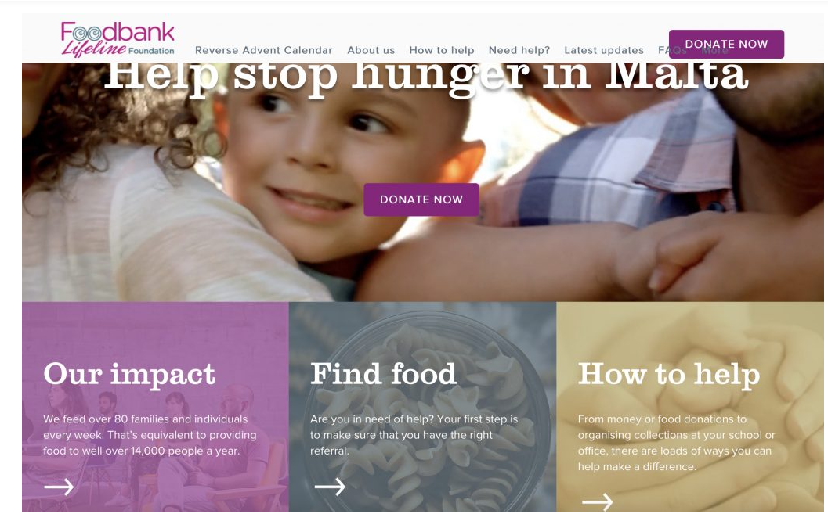
Figure 7: Financial Commitment to CSR
SOURCE: (Group, 2021)
In May 2020, the Corinthia Palace in Malta collaborated with the Cuisine Bank Foundation, contributing 10 percent of the proceeds from all home delivery orders placed at Rickshaw, the Asian cuisine restaurant at Cornithia Palce, for four months. Two further food deliveries were sent to the Food Bank, Consisting of non-perishable items such as cereals, grains, canned food, and pasta. The QP management team also explored other channels of support (Franzoni et al., 2021). The project Charity Begins at Home raised €2,500, which was allocated to workers who had the greatest hardships in 2002. The Food Bank Life Foundation received food contributions valued at over €400. This charity provides assistance to those facing crises resulting from circumstances such as delays in receiving benefits, poor income, homelessness, illness, or housing problems (Group, 2021). This charity is committed to eradicating hunger and strives to provide immediate food assistance to those facing crises, while also working towards sustainable long-term solutions.
Additionally, QP conducted a sequence of webinars titled 'Leading during hard times'. Key takeaways from a limited shutdown and strategies for establishing a long-lasting future. Additionally, it engaged in a partnership with HSBC Foundation's Water Program and conducted presentations as a component of a series organized by HSBC for its workers and prominent customers (Group, 2021).
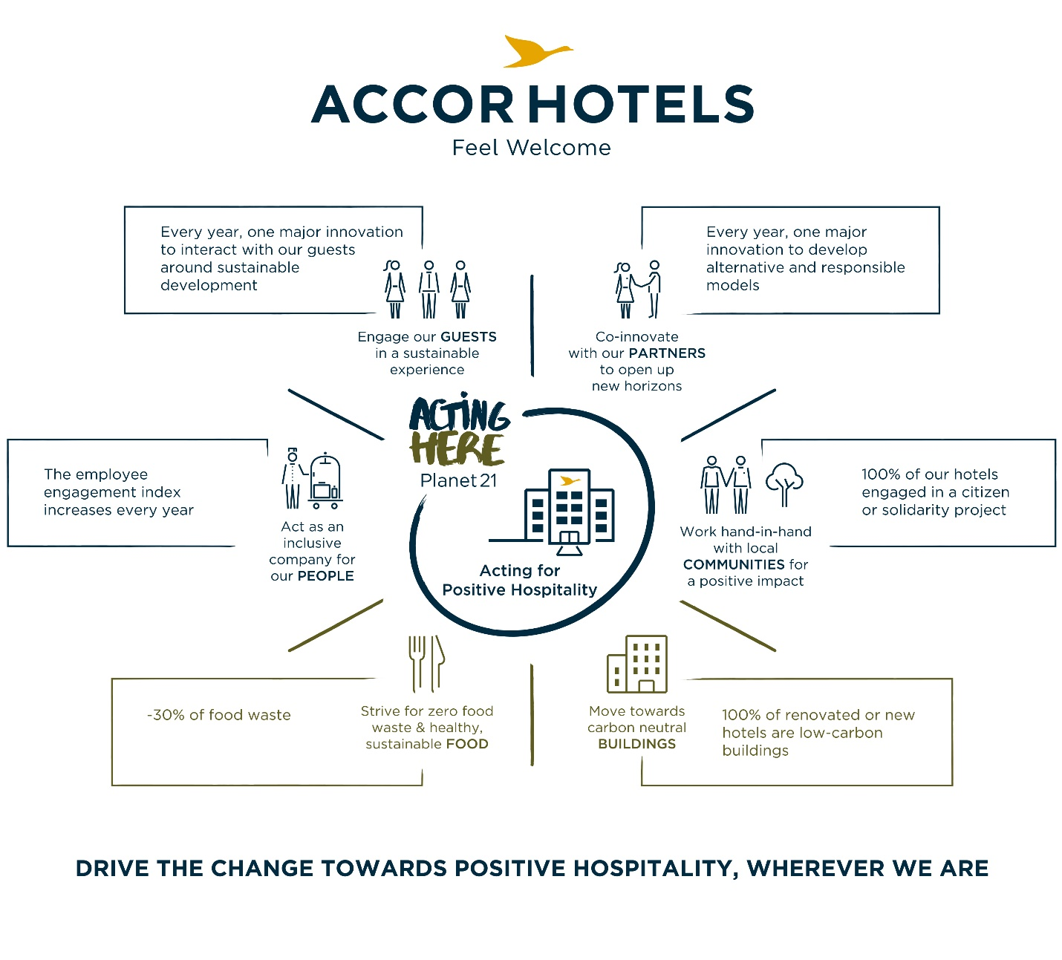
Figure 8: CSR of ibis hotel
Source: (accorgroup 2016)
Accor Hotels, the global leader of the ibis hotel is announcing the outcomes of its sustainable development initiative, Planet 21, and reaffirming its goals for the year 2020. Sébastien Bazin, the Chairman and CEO of the Group, remarked that the dedication and vitality shown by personnel in implementing Planet 21 on a global scale are significant factors in sustainable achievements. The outcomes of the first stage of the strategy are quite promising after five years. Today, they want to increase their aspirations by relying on innovation and responsibility. The objective of Planet 21 Season 2 is to promote sustainable wealth creation and minimize its adverse effects by engaging their workers, visitors, partners, and local communities (accorgroup, 2016). Their goal is to promote good, responsible, and innovative hospitality in all locations.

Conclusion:
This report discusses the Corinthia and Ibis Hotel, Corinthia is one of the collections of different hotels. It was founded in 1962 through the Pisani family of Malta. Corinthia has a portfolio that runs nine beautiful properties all over the world. Corinthia has a very dynamic group of hotels. Ibis Hotel also creates a more cost-effective version of Novotel. Ibis has established its presence in the UK with a total of eight hotels under its operation. In 1997, an Ibis hotelier introduced a program called the 15-minute guarantee, whereby customers are provided with lodging if their issue remains unresolved after 15 minutes. Their goal is to promote good, responsible, and innovative hospitality in all locations.

Recommendation:
It determined that such changes continue in the industry of hospitality are strong desire hence the recommendation of Ibis Hotel and declare that it should just go on improving technological integration for a smooth guest experience. Spending an effort on highlighting sustainable methods and examining eco-friendly plans may as well relate to the emerging concept of ecological vacation, elaborating on Ibis’s attractiveness (Adama, and Michell, 2017).
Innovation, customized service, and a back-to-basics approach should continue to be the hallmarks of Corinthia Hotel. The opportunity to accept technological advances, including virtual concierge services, will lead to a step up in how the guests interact with each other. In addition, addressing broader aspects like widening sustainability initiatives and infusing green elements conform to growing eco-friendly luxury traveling. Being flexible to changing customer expectations and sticking to the super (Bhalla et al, 2023).

References
Accorgroup 2016. Accor – Newsroom. [Online] Available at https://press.accor.com/en/?lang=en [Accessed on 1 February 2024]
Accor, 2023. Ibis. Available at https://group.accor.com/en/brands/economy/ibis. [Accessed on 30th January 2024]
Adama, U.J. and Michell, K.A., 2017. Potential effects of technological innovations on facilities management practice. WELCOME TO DELEGATES IRC 2017, p.211.
Bhalla, A., Singh, P. and Singh, A., 2023. Technological Advancement and Mechanization of the Hotel Industry. In Application and Adoption of Robotic Process Automation for Smart Cities (pp. 57-76). IGI Global.
Booking.com 2024. Corinthia Budapest, Budapest, Hungary, Booking.com, viewed 30 January 2024, <https://www.booking.com/hotel/hu/corinthiaroyal.html>.
Crowe, E. 2023. New US hotels 2024: The openings set to shake up the market. [Online] Available at < https://usa.boutiquehotelier.com/new-us-hotel-openings-to-know-about/> [Accessed on 27th January 2024].
Dwi, I. and Ramdhani, D., 2023. Pengaruh Disiplin Kerja Dan Motivasi Kerja Terhadap Kinerja Karyawan (Studi Kasus: Hotel Ibis Budget Bandung Asia Afrika). Nusantara Journal of Multidisciplinary Science, 1(3), pp.578-592.
Franzoni, S., Sarwar, H. and Ishaq, M.I., 2021. The Mediating Role of HRM in the Relationship between CSR and Performance in the Hospitality Industry. Sustainability, 13(24), p.13699.
First-quarter 2019 revenue of €987 million up 34.2% as reported and 8.8% like-for-like, Accor – Newsroom, viewed 30 January 2024, <https://press.accor.com/first-quarter-2019-revenue-of-e987-million-up-34-2-as-reported-and-8-8-like-for-like/?lang=en>.
FRN, F., 2020. International Hotel Investments p.l.c.. https://www.corinthiagroup.com/wp-content/uploads/2020/08/IHI-Financial-Analysis-Summary-2020.pdf ed. s.l.:s.n.

Goffi, G., Masiero, L. and Pencarelli, T., 2022. Corporate social responsibility and performances of firms operating in the tourism and hospitality industry. The TQM Journal, 34(6), pp.1626-1647.
Group, C 2021, Overview of our recent CSR activities | Corinthia Group - Owners, Developers & Operators of the Corinthia Hotels and Real Estate Brand, www.corinthiagroup.com.
Guzzo, R.F., Abbott, J. and Madera, J.M., 2020. A micro-level view of CSR: A hospitality management systematic literature review. Cornell Hospitality Quarterly, 61(3), pp.332-352.
HotelmyPassion n.d., Corinthia Hotels, HotelmyPassion, viewed 30 January 2024, <https://www.hotelmypassion.com/en/catene-alberghiere/corinthia-hotels/>.
Ibis Hotel, 2024. United Kingdom: all Ibis hotels. [Online] Available at < https://ibis.accor.com/gb/country/hotels-united-kingdom-pgb.shtml [Accessed on 27th January 2024].
Ishraq, S. and Zakaria, A.K.M., 2023. IBIS Hotel's Cultural Pragmatics, Marketing Strategies and Critical Discourse Analysis.
nehaaa 2021, ibis to add over 500 more keys by 2022, expects revenue normalisation in H1 | Hotel Talk, viewed 30 January 2024, <https://hoteltalk.in/hotel-chain-ibis-to-add-over-500-more-keys-by-2022-expects-revenue-normalisation-in-h1/>.
ReviewPro 2012, How Corinthia Hotels Provides 5-Star Service on the Social Web, ReviewPro, viewed 30 January 2024, <https://reviewproblog.shijigroup.com/corinthia-hotels/>.
The Corinthia London, 2024. About us. [Online] Available at < https://www.corinthia.com/en-gb/london/> [Accessed on 27th January 2024].
Zámborský, P. and Kruesi, M.A., 2018. Global Hotel Alliance: Strategy Discovery Moving East. SAGE Publications: SAGE Business Cases Originals.

