

BMHP5010 — Changemakers: Creativity and Value Creation
Component 1 Portfolio of setactivities
Name: Robins Kausar
Student Number: 2407033
Teacher’s Name: TomyAdattuChako
Submission Date: 06th July 2026

Task 1 – Concept Map

The concepts of creativity, value creation and health and social care (HSC) improvement are interlinked and work together to encourage innovation in the sector. Creativity, defined by Boden (1994), as the conceptual ability to generate ideas that are novel and valuable, acts as originating force. It challenges established practice and reframes problems from new perspectives (Care Quality Commission, 2021).The focus in HSC is not limited to art or invention, and is used when practitioners or service designers are looking for new ways of interacting with service users, for example in the design of dementia-friendly environments.
Value creation is the process of turning an idea to use. Porter (2010) defines value in health terms as "the best outcomes at the lowest cost" and then divides the value into allocative, technical, and personalised value. Only ideas that are appropriate for needs of service user and can be implemented within available resources produce value.
This relationship is what leads to the improvement of HSC; measurable improvements in access, quality, efficiency, and person-centered care. A platform for youth on CAMHS waiting lists to moderate and support one another, for instance, MindMates, is a good example of this chain directly. The creative idea, trained peer “champions” filling service gaps, adds value through early intervention and less stigma, reducing the pressure on formal services, improving HSC outcomes and wellbeing (World Health Organization, 1948). Importantly, this is a two-way street; gaps in provision are identified, which encourages more creative thinking, and this process continues with ongoing innovation in health and social care (Amabile et al., 2005).

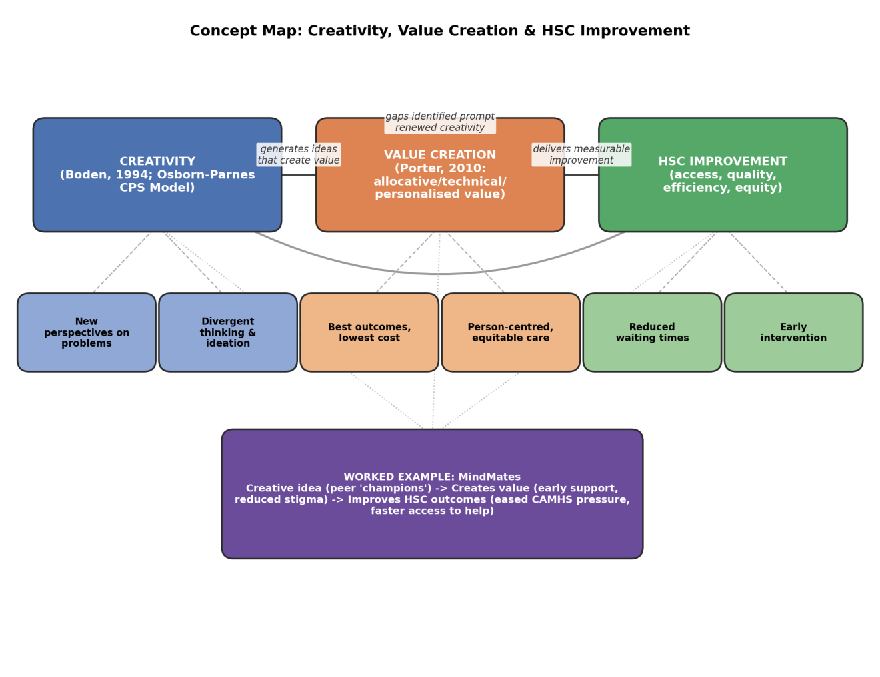

Task 2 - Self-Reflection of Group Activity

Description: During paperclip activity, our group had ten minutes to generate uses for a paperclip as possible, then evaluate which were genuinely feasible. Together we produced some ideas, from practical (bookmark, zip-pull) to abstract (sculpture material). My job was to create ideas and support in the evaluation of which ideas were feasible and should be retained.
Emotions: At start, I was unsure about putting ideas forward that were unusual as exercise could seem impossible, but as the exercise continued it became more confident and involved as I realised there were no right or wrong answers for the idea generation part.
Evaluation: Found the time pressure to be effective in avoiding early filtering of ideas (typical of divergent thinking). Less effective was the fact that after we used convergent thinking to gauge feasibility, many of the imaginative ideas we had were quickly discarded, reflecting a conflict between the two ways of thinking.
Analysis:Convergent thinking leads to logical thinking and a single realistic solution while divergent thinking leads to free, spontaneous exploration that yields a variety of solutions (Guilford, 1967). Together they represent structure required for creative problem solving in health and social care settings where creative ideas have to be realised within practical considerations like safety, cost and resources.
Conclusion: I learned that my instinct was to move toward evaluation quite quickly, which could limit range of solutions I consider professionally. I learned that it's important to differentiate between idea generation and judgement.
Action Plan: I will consciously separate divergent and convergent thinking when problem-solving, fully exploring options before critiquing them, an approach I intend to apply when developing my Component 2 idea, MindMates. (Gibbs, 1988)

Task 3 - Case Study of a UK innovation

Case Study: Kooth – A Peer-Support Innovation in UK Youth Mental Health
Kooth is a mental health online service commissioned by the NHS, LAs and charities in the UK that gives children and young people access to trained counsellors and a peer-supportive community, comprising of discussion boards, articles and guided wellbeing activities, all anonymously and without disclosure (Stevens et al., 2022). It was born out of a well-established issue: the UK Child and Adolescent Mental Health Services (CAMHS) are shifting towards only providing services for the most severe needs, and many young people are not receiving timely help.
The creative part of Kooth is the concept of using a peer support service as an organised, supervised and digital platform, not a casual or unsupervised one. Every user-submitted post is reviewed by trained Emotional Wellbeing Practitioners before publication, allowing the platform to combine the authenticity and relatability of peer conversation with professional safeguarding oversight (Stevens et al., 2022). This creative reframing took into account a real need, that young people are more likely to relate to peers' experiences than to professional advice, but Peer platforms without moderation risk harm. Kooth's innovation was to design a “positive virtual ecosystem” that offered both.
Evidence of the value created for service users is good. In a pilot study of 302 youth, the results showed statistically significant decreases in psychological distress, suicidal ideation, loneliness, and an increase in hope and self-esteem following only 1 month of use (Stevens et al., 2022). Interestingly, those who participated in only the peer-community areas (but not the counselling areas) showed outcomes similar to those who had access to both peer-support and counselling areas, indicating that the peer-support part of the intervention was contributing to the effect, rather than just access to counselling.
Value was created also for service providers. An economic evaluation modelling a cohort of 2,160 children and young people demonstrated that an NHS cost saving of c. £247 per child over 12 months was associated with implementing Kooth, which was primarily due to the reduction in GP appointments and fewer antidepressant prescriptions (Coote et al., 2024). This is the same principle as Porter (2010) would argue, that of 'value'; Kooth both enhanced user wellbeing and reduced pressure on extended NHS services.
Kooth is an example of a directly relevant precedent whereby the gap between demand and capacity in youth mental health services is bridged by the creative service redesign of structured and moderated peer support.

Task 4 - Research Task

Current Issue: Long CAMHS Waiting Times Restricting Young People's Access to Mental Health Support
One of the most important challenges in the UK health and social care system is the delay in young people receiving timely access to Child and Adolescent Mental Health Services (CAMHS), delaying early intervention and potentially exacerbating mental health challenges prior to initiation of treatment.
This issue is primarily due to the lack of adequate capacity to meet the increasing demand, explains Stafford, Aurelio and Shah (2020). The number of referrals for CAMHS nationally has grown significantly and only approximately 25% of young people who require this treatment are receiving it. The authors point out that waiting times have risen in recent years despite an increase in government funding and staffing, which depends on the type of treatment and the capacity of the workforce and socioeconomic factors in some areas. Their case study on East London NHS Foundation Trust showed that the challenge to them is not the number of referrals received as they reported above average waiting times despite having fewer than average.
A complementary explanation is provided by Hickling, Dabrowski and Williams (2023), who look at thresholds for referral, not throughput. They analysed a South London CAMHS and discovered that in one year, just under 1300 young people were referred, and about 25% of these were turned down - often because the young person did not need a service of this level of intensity. This implies that if services have limited capacity, they are focused on those with the most serious problems, while young people with early or emerging problems have no pathway into formal support.
Combined these two findings point to a dual problem: services are too small for the need, and the rationing system in place to deal with this imbalance filters out many young people who could benefit most from early, preventive services.

Task 5 - Podcast

Task 6 - NHS Leadership Framework Analysis

The NHS Leadership Framework, Summary.
The NHS Leadership Framework, produced by the NHS Leadership Academy and NHS Institute for Innovation and Improvement (2011), establishes a common pattern of leadership behaviour that is expected from everyone in the NHS and social care, regardless of their role or position. It is organised into seven domains: Demonstrating Personal Qualities, Working with Others, Managing Services, Improving Services, Setting Direction, Creating the Vision, Delivering the Strategy. The first five domains are regarded as core competencies, which staff should apply to some extent; leadership in health and social care is seen as a shared responsibility and not only the responsibility of managers. The latter two domains, Creating the Vision and Delivering the Strategy, are more directly linked with executive leaders in charge of organising direction. Each domain is further subdivided into 4 elements each of which is further subdivided into descriptive behavioural statements which enable staff to identify their strengths and areas for development. It is important to note that NHS England have started to work on a new 10-year Health Plan Management and Leadership Framework in 2025, but the seven-domain model is still widely cited and is relevant.
Applying “Improving Services” to Encourage Creativity
Creativity is most clearly associated with the Improving Services domain, where one of a leader's four elements is to encourage improvement and innovation. One way for a leader to apply this would be to use a transformational leadership style in which Bass, Avolio and Atwater (1996) state that they inspire staff members to think outside the box and ask questions about current practice and develop new solutions. A leader may hold regular improvement forums for frontline staff and service users, inviting them to propose innovative solutions to service gaps, for example peer-supported service models for young people waiting to be treated by CAMHS. Leaders create opportunities for discussion about new ideas and make decisions in response to suggestions made, demonstrating that they value creativity, a well needed approach to thinking about how to improve health and social care services for people.

Task 7 - Self-Reflection Journal Entry
Prior to beginning this module, I believed that creativity was primarily an artistic quality and limited to design or invention, not like a health and social care skill. This has changed significantly since they began the module. I now know that, creativity is a structured learnable process as evidenced by the 4Ps model and the Osborn-Parnes Creative Problem-Solving process, and one that is immediately connected to the identification and response to unmet needs within the context of services. My understanding of value creation has also shifted. One thing that struck me at first was that, whilst “value” was often seen as synonymous with cost-efficiency, outcomes, equity and person-centred care are also essential to “value” in the field of health and social care, not just spending less. The real-world examples, including Kooth's peer-support model and the issue of CAMHS waiting times, enabled me to witness how creativity and value creation work in practice to meet real challenges to services. This has directly influenced my own idea for my Component 2 MindMates as it was a push to create something that was not only innovative but also useful and feasible in real-world situations with limited resources.

Reference List
Amabile, T.M., Barsade, S.G., Mueller, J.S. and Staw, B.M. (2005) 'Affect and creativity at work', Administrative Science Quarterly, 50(3), pp.367-403.
Bass, B.M., Avolio, B.J. and Atwater, L. (1996) 'The transformational and transactional leadership of men and women', Applied Psychology: An International Review, 45, pp.5–34.
Boden, M.A. (1994) 'What is creativity?', in Boden, M.A. (ed.) Dimensions of Creativity. Cambridge, MA: MIT Press, pp.75–117.
Care Quality Commission (2021) Enabling Innovation and Adoption in Health and Social Care: Developing a Shared View. Available at: https://www.cqc.org.uk/sites/default/files/20210208_InnovationPrinciples_report.pdf (Accessed: 2 July 2026).
Coote, L., Kelly, L., Graham, C., Curtis-Gretton, L., Green, M., Salhi, L., de Ossorno Garcia, S., Sefi, A. and Holmes, H. (2024) 'An early economic evaluation of Kooth, a web-based mental health platform for children and young people with emerging mental health needs', Internet Interventions, 36, 100748. Available at: https://doi.org/10.1016/j.invent.2024.100748 (Accessed: 2 July 2026).
Gibbs, G. (1988) Learning by Doing: A Guide to Teaching and Learning Methods. Oxford: Further Education Unit, Oxford Polytechnic.
Guilford, J.P. (1967) The Nature of Human Intelligence. New York: McGraw-Hill.
Hickling, L.M., Dabrowski, J. and Williams, S. (2023) 'Expanding the early intervention offer: A new care pathway for children's wellbeing practitioners in a south London child and adolescent mental health service', Clinical Child Psychology and Psychiatry, 29(1), pp.155–167. Available at: https://doi.org/10.1177/13591045231201195 (Accessed: 2 July 2026).
NHS Leadership Academy (2011) Leadership Framework: A Summary. Coventry: NHS Institute for Innovation and Improvement.
Porter, M.E. (2010) 'What is value in health care?', New England Journal of Medicine, 363(26), pp.2477–2481.
Stafford, J., Aurelio, M. and Shah, A. (2020) 'Improving access and flow within Child and Adolescent Mental Health Services: a collaborative learning system approach', BMJ Open Quality, 9(4), e000832. Available at: https://doi.org/10.1136/bmjoq-2019-000832 (Accessed: 2 July 2026).
Stevens, M., Cartagena Farías, J., Mindel, C., D'Amico, F. and Evans-Lacko, S. (2022) 'Pilot evaluation to assess the effectiveness of youth peer community support via the Kooth online mental wellbeing website', BMC Public Health, 22, article 1903. Available at: https://doi.org/10.1186/s12889-022-14223-4 (Accessed: 2 July 2026).
World Health Organization (1948) Preamble to the Constitution of the World Health Organization. New York: WHO.

