
Programme: MSc Public Health and Social Care in Practice
Module: Practice-Based Research
Module code: LCHS7008
Lecturer: Oluwadamilola Tayo
Assignment Title: Component 2 Written Research Proposal
Student Name: Fuaansha D. Pimpale
Student ID: 2530082

Topic: A Systematic Review of the Effectiveness of Sleep Interventions in Reducing Insomnia Symptoms among International Students

Table of Contents
1. Introduction 5
1.1 Background 5
1.2 Problem Statement 6
1.3 Research Aim 6
1.4 Research Objectives 6
1.5 Research Questions 7
1.6 Rationale 7
2. Literature Review 8
2.1 Prevalence of Insomnia and sleep disturbance among university students 8
2.2 Unique sleep challenges faced by international students in the UK 8
2.3 Conceptualisation and Components of sleep hygiene programmes 8
2.4 Evidence on the effectiveness of sleep hygiene interventions in student populations 9
2.5 Standard orientation and well-being information in the UK higher education 10
2.6 Critical appraisal of existing reviews and identification of the evidence gaps in programmes 10
2.7 Theoretical and Conceptual framework 11
3. Research Methodology 11
3.1 Research Philosophy 11
3.2 Research Design 11
3.3 Review Question and PICO Framework 11
3.4 Eligibility Criteria 12
3.5 Study Selection and Screening Procedure 12
3.6 Information Sources and Search Strategy 12
3.7 Data Extraction 12
3.8 Quality Assessment and Risk of Bias 12
3.9 Data Synthesis and Analysis 13
4. Ethical considerations 13
5. Implications of research 13
6. Plan of Work and Time Schedule (Gantt Chart) 13

1. Introduction

1.1 Background
Sleep is essential for all aspects of physical health, mental or psychological wellbeing, cognitive functioning and academic performance, and the disturbances of sleep and the problem of insomnia are rapidly emerging as a concern among university populations. The topic is important for the UK Higher Education arena, as there are a significant number of both students and faculty members attending universities from abroad. In 2024/25, a total of 685,565 international students were studying undergraduate or postgraduate in UK HE, of whom 68% were full-time postgraduates (HESA, 2026).
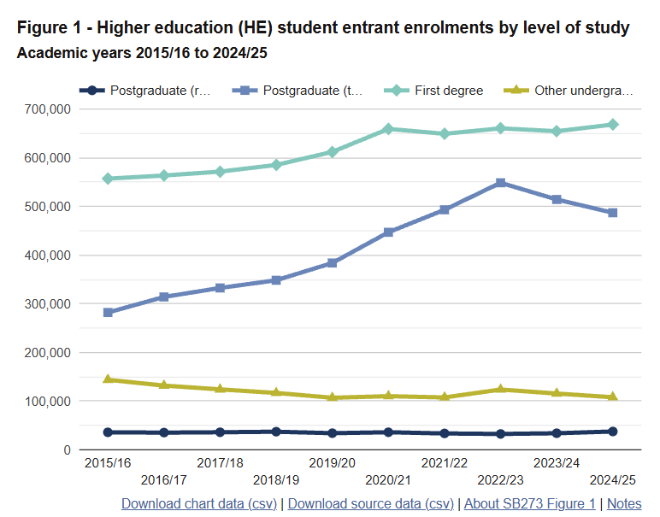
Figure 1: HE student entrant enrollments
(Source: HESA, 2026)
Despite the drop in international student numbers of 6% compared to the previous year, they still make up a significant part of university students in the UK (Studytravel.network, 2025).
The problem with sleeping is also notable on university campuses in the UK. According to Akram et al. (2023), 89% students among 1,408 determined with probable insomnia as per the DSM-5 criteria for insomnia disorder parameter. UK University students reported having moderate-to-severe insomnia symptoms, indicating that sleep disturbance is a significant concern for student wellness in the country. The burdens of sleep can be further for an international student due to the change in study system, social environment and change in time zone (for some students) associated with the move for study purposes. The academic workload, financial issues, loneliness, accommodation issues and adaptation to different cultures may also affect the normal sleep schedule (Hassan, 2025).
Complete Sleep hygiene programmes are a potentially practical and relatively low-resource intervention. These programmes generally promote regular sleep-wake schedules, sleep-friendly bedroom conditions, minimising caffeine consumption, controlling evening screen time, and preventing behaviours that hinder sleep (Alanazi et al. 2023). However, international students are often provided with only general information about health and wellbeing within a university orientation programme. This can help to raise awareness; however, it is not necessarily structured in a sleep-specific manner to offer behavioural support.

1.2 Problem Statement
International students represent and continue to represent a large proportion of the UK higher education population, especially at postgraduate level, but support provided for sleeping throughout the transition to the university can be general, rather than specifically targeting insomnia. Although sleep hygiene interventions have been explored by Corrêa et al. (2024) regarding the effectiveness of such interventions in a specific, international student population studying in the UK, the provision of typical sleep hygiene by universities is scattered. Accordingly, there is not enough evidence to be aggregated to conclude whether targeted sleep hygiene programmes can offer a meaningful reduction in the severity of insomnia in students that goes beyond the information that students are likely to receive routinely at college. Thus, a systematic review is needed to cover this evidence gap.

1.3 Research Aim
To systematically review and synthesise evidence on the effectiveness of sleep interventions in reducing insomnia among international university students.

1.4 Research Objectives
- To identify and critically evaluate studies examining sleep interventions among international university students.
- To synthesise reported changes in insomnia symptoms and/or sleep quality following sleep interventions.
- To examine the short- and, where reported, longer-term effects of sleep interventions.
- To identify intervention, cultural and behavioural factors reported as influencing effectiveness, where available.
- To identify gaps in the evidence and provide recommendations for university health and wellbeing services.

1.5 Research Question
How effective are sleep interventions in reducing insomnia symptoms among international university students?

1.6 Rationale
HESA (2026) showed that 685,565 international students are studying in the UK and that a problem impacting a proportion of this population can have significant implications for student wellbeing and university support services. The review will answer the question ‘do targeted sleep hygiene programmes reduce the severity of insomnia, compared to general orientational information?’ Findings could inform the creation and delivery of culturally and contextually appropriate, evidence-based sleep support that uses relatively low resources for international students at UK universities.

2. Literature Review

2.1 Prevalence of Insomnia and sleep disturbance among university students
Sleep disturbance, more specifically insomnia, has become a ubiquitous aspect of higher-education culture today. Spyridonidis et al. (2025) suggests a prevalence of around 50% of clinically relevant insomnia disturbances among undergraduate students worldwide, with prevalence often being higher in European student samples than in any North American samples. According to Stores et al. (2023) a large number of students at university suffer from moderate to severe insomnia, along with high rates of anxiety, depressive symptoms and impaired student performance. Contrary to common misconceptions of a temporary or normative state of student life, these trends indicate that there is a long-term population-level public health problem at stake that gradually undermines the very cognitive, emotional and behavioural abilities necessary for successful participation at university and for future wellbeing.

2.2 Unique sleep challenges faced by international students in the UK
International students face a unique combination of stressors that often happen at the same time and that disrupt sleep which domestic students may not experience. Acculturative stress which is the disruption of their normal life cycles as a result of migration across continents, and a sudden exposure to an unfamiliar academic calendar, among other stressors, create social isolation and insecurity surrounding tenuous housing and finances (Elizabeth and Raveendran, 2022). Social-ecologically, these distal structural pressures cause proximal behavioural dysregulation such as a disruption in sleep–wake patterning, longer screen time at night and increased pre-sleep cognitive arousal. Further, acculturation theory helps clarify how identity threat and perceived cultural distance can exacerbate the hypervigilance that occurs at night, and thus shift the transient experience of adjustment difficulties to chronic insomnia (Lerias et al. 2024). The sleep vulnerability of this group is therefore not simply an extension of the general group of students at risk, but reflects a complex merging of migratory, cultural and institutional dynamics working in a current context of higher education in the UK.

2.3 Conceptualisation and Components of sleep hygiene programmes
Sleep hygiene programmes are organised behavioural approaches that are based on the principles of classical and operant conditioning and focus on the environmental and lifestyle behaviours which perpetuate insomnia (Boivin and Boudreau, 2025). Typical elements are setting a consistent sleep–wake schedule, optimising bedroom space, limiting coffee and alcohol, decreasing evening screen time and creating a ‘wind-down routine’.
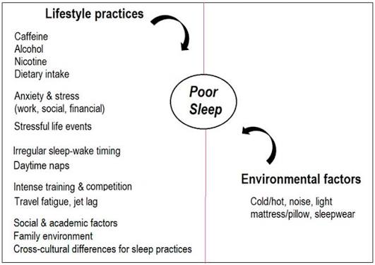
Figure 2: Sleep Hygiene practices
(Source: Chow, 2022)
If these programmes are offered to international students, there needs to be a component related to the culturally different sleep expectations, as well as the lingering consequences of circadian dysregulations. Theoretically, the method is based on a diathesis–stress concept and, practically in resource-limited university environments, targeted behaviour change is possible.

2.4 Evidence on the effectiveness of sleep hygiene interventions in student populations
Among university students, Nowlin et al. (2025) shown that structured sleep hygiene education results in significant but small improvements in subjective sleep quality and a decrease in the severity of insomnia that is statistically significant. These effect sizes are smaller than those seen for multi-component cognitive-behavioural therapy for insomnia, but are clinically meaningful in non-clinical samples. Chan et al. (2024) demonstrating the efficacy of short-term, group and/or digitally delivered hygiene programmes to reduce the Insomnia Severity Index and improve daytime functioning. However, most of these trials were conducted on a mixed or domestic student population and the efficacy of these interventions on a specific sub-group of international students who have to deal with the compounding stressors of migration and culture remains not differentiated enough to confidently extrapolate existing data findings to that sub-group.

2.5 Standard orientation and well-being information in the UK higher education
In the UK, normal orientation and wellbeing provision in universities generally consists of generic information about healthy lifestyles, managing stress and what support is available, provided as part of induction weeks, or on institutional websites (BCES, 2026). When sleep is included in content, often it is only a brief note explaining and or written tips for sleep and not interactive behavioural coaching. From a health promotion viewpoint, this type of informational changes primarily takes place on the level of awareness and not skill learning and/or environment modification. This suggests that they may not have effects of long-term behavioural change in international students with sleep difficulties associated with high multi-level stressors. This passive information model is thus a comparator of theoretical and practical importance to assess incremental effectiveness in relation to structured sleep hygiene programmes.

2.6 Critical appraisal of existing reviews and identification of the evidence gaps in programmes
Although there are existing systematic reviews of psychological sleep interventions for university students confirming the overall positive effect of multi-component and single-component interventions, systematic reviews have two important limitations. First, international students are sometimes treated as a homigeneous blocs duw to underfunding and linguistic barriers (Spencer-Oatey and Dauber, 2019). Second, Ali et al. (2023) compared sleep hygiene programmes to the comparator of regular information provided at the university level. Therefore, the evidence in this study does not yet provide an answer to the question of whether a specific hygiene treatment is more effective for reductions in insomnia severity among international students studying in the UK. This gap is important because if these comparative data were not available, policymakers within an institution would not have the data necessary to support a case for redirecting scarce resources for enhancing wellbeing towards targeted sleep care.

2.7 Theoretical and Conceptual framework
The proposed review is grounded in an integrated theoretical model including the diathesis–stress model of insomnia, Bronfenbrenner’s social-ecological systems and Berry's acculturation framework. The diathesis–stress model is the idea that vulnerabilities pre-date the acute stressors of international transition and interact with these stressors to precipitate and to maintain sleep disturbance (Ungvarsky, 2024). The theory of social-ecology places these individual processes in interacting and nested environmental systems, ranging from the microsystem of the student bedroom all the way up to the macrosystem of the UK higher-education policy. Nocturnal arousal theory also explains the cultural stressors that contribute to the increased risk for developing "nocturnal arousal" and as well as cultural stressors related to identity (Lv et al. 2023). These theories capture the issue of international student vulnerability in a coherent analytical framework and the possible ways in which canned sleep hygiene packages might operate.

3. Research Methodology

3.1 Research Philosophy
This study will use a post-positivist philosophy, where objective measures of evidence will be used to assess the severity of insomnia, and consideration given to the methodological limitations and bias of the studies. This philosophy will allow for systematic comparison and critical interpretation of quantitative outcomes of interventions.

3.2 Research Design
A quantitative systematic review design will be used to assess the effectiveness of sleep hygiene programmes that involve the systematic review of sleep hygiene programmes and their effectiveness compared to standard orientation information. The review will be done with PRISMA 2020 guidance to ensure transparent identification, selection, appraisal and synthesis of eligible intervention studies.

3.3 Review Question and PICO Framework
The review question will use PICO framework. Population will include international higher-education students; Intervention will include structured sleep hygiene programmes; Comparator will include the “usual” orientation information; Outcome will include insomnia severity scale (ISS) measured by validated instruments (such as the Insomnia Severity index (ISI)), etc.

3.4 Eligibility Criteria
Studies will be considered eligible if they include insomnia outcomes for international higher-education students who have undergone structured sleep hygiene interventions. Relevant populations, interventions, comparators and publications that do not have empirical or interventionist methods (randomised and controlled) will be excluded while non-relevant publications will be prioritised.

3.5 Study Selection and Screening Procedure
Records found will be added to reference-management software, and duplicate records will be removed. Titles and abstracts will then be evaluated based on an established set of inclusion criteria and full-text. Exclusion criteria for full text will be documented, and presentation of the selection process will be illustrated in a PRISMA flow diagram.

3.6 Information Sources and Search Strategy
The search for the review will be conducted on PubMed, MEDLINE, PsycINFO, Google Scholar, Scopus and Web of Science. Search terms will include a combination of ideas such as international students, sleep hygiene, sleep education, insomnia and insomnia severity, as well as the use of Boolean operators and database-specific subject headings, where available.
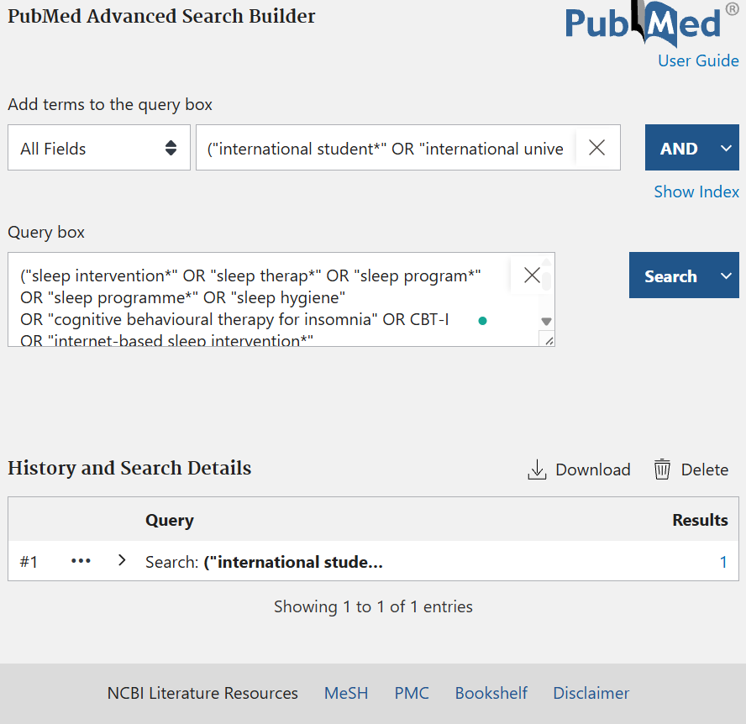
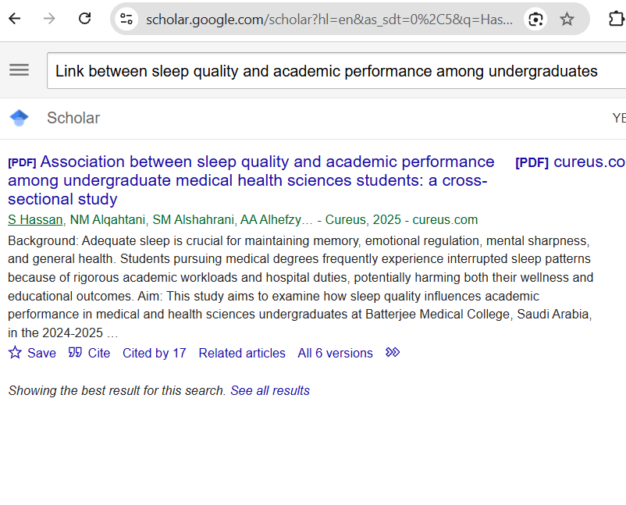
Figure 3: Search processes
(Source: Self-developed)

3.7 Data Extraction
A standardised extraction form will be created to document author, year published, country, study design, sample population and characteristics, intervention components, intervention length, comparator, insomnia measure instrument, results of insomnia measure and follow-up results. Extracted information will be checked systematically and will be used to facilitate accurate comparison and synthesis.

3.8 Quality Assessment and Risk of Bias
Assessment of methodological quality and risk of bias will be done with design-appropriate evaluation tools. Cochrane Risk of Bias 2 (RoB 2) will be used for randomised controlled trials. Potential biases that impact randomisation, deviations from interventions, outcome measurement, selective reporting and missing outcomes will be assessed.

3.9 Data Synthesis and Analysis
Findings will be initially presented narratively by comparing the characteristics of the interventions and insomnia severity changes between groups. Where studies are sufficiently homogeneous regarding populations, interventions, comparators and outcomes, quantitative meta-analysis will be considered. Heterogeneity will be used to determine if statistical pooling is appropriate.

4. Ethical considerations
Evidence to be used in the study will be obtained from previously published models, and no identifiable personal data will be collected as this research will not involve any participant recruitment. Despite this, accurate citing, transparent study selection, avoidance of selective reporting, and faithful reporting of findings and secure data handling of extracted information will be required for ethical practice.

5. Implications of research
The results will help to demonstrate whether there is a difference in the effectiveness of targeted sleep hygiene treatment interventions compared to orientation information. Findings would contribute towards the wellbeing provision for international students in the UK, evidence-based sleep interventions and prioritise future research with a lack of evidence.

6. Plan of Work and Time Schedule (Gantt Chart)
Activity | W1 | W2 | W3 | W4 | W5 | W6 | W7 | W8
Review planning and protocol
Literature search
Study screening and selection
Data extraction and quality assessment
Data synthesis and analysis
Writing, editing and final submission
Table 1: Gantt Chart
(Source: Self-created)

References
Akram, U., Irvine, K., Gardani, M., Allen, S., Akram, A. and Stevenson, J.C. (2023). Prevalence of anxiety, depression, mania, insomnia, stress, suicidal ideation, psychotic experiences, & loneliness in UK university students. Scientific Data, 10(1). doi:10.1038/s41597-023-02520-5.
Alanazi, E.M., Alanazi, A.M.M., Albuhairy, A.H. and Alanazi, A.A.A. (2023). Sleep hygiene practices and its impact on mental health and functional performance among adults in tabuk city: A cross-sectional study. Cureus, 15(3), pp.1–12. doi:10.7759/cureus.36221.
Ali, R.M., Zolezzi, M., Awaisu, A. and Eltorki, Y. (2023). Sleep quality and sleep hygiene behaviours among university students in Qatar. International Journal of General Medicine, Volume 16, pp.2427–2439. doi:10.2147/ijgm.s402399.
BCES (2026). How UK universities support international students. [online] BCES Admissions Abroad | Best Free Study Abroad Consultancy. Available at: https://bces.in/2026/02/07/how-uk-universities-support-international-students/ [Accessed 11 Aug. 2026].
Boivin, D.B. and Boudreau, P. (2025). Circadian rhythm sleep–wake disorders II. The Oxford Handbook of Sleep and Sleep Disorders, pp.856–881. doi:10.1093/oxfordhb/9780197602751.013.44.
Chan, W.S., Cheng, W.Y., Lok, C., Kah, A., Kai, A., Ng, Y. and Kowatsch, T. (2024). Assessing the short-term efficacy of digital cognitive behavioral therapy for insomnia with different types of coaching: Randomized controlled comparative trial. JMIR Mental Health, 11, pp.e51716-e51716. doi:10.2196/51716.
Chow, C.M. (2022). Sleep hygiene practices: Where to now? Hygiene, [online] 2(3), pp.146–151. doi:10.3390/hygiene2030013.
Corrêa, C. de C., Silva, G.N.T.N., Viana, G.R., Lira, A.L., Macedo, G.D. and Weber, S.A.T. (2024). Sleep hygiene intervention improves sleep time and duration in high school students. Sleep Science, 17(03), pp.e297-e303. doi:10.1055/s-0044-1782169.
Elizabeth, J. and Raveendran, N. (2022). ‘Acculturative stress experiences and coping approaches among first-year undergraduate students and fresher working professionals from Bangalore’. Journal of Positive School Psychology, [online] 2022(6), pp.8076–8087. Available at: https://journalppw.com/index.php/jpsp/article/download/9017/5877/10427 [Accessed 11 Aug. 2026].
Hassan, S. (2025). Association between sleep quality and academic performance among undergraduate medical health sciences students: A cross-sectional study. Cureus. [online] doi:10.7759/cureus.91548.
HESA (2026). UK higher education student numbers fall for second year in a row. [online] Available at: https://www.hesa.ac.uk/news/27-01-2026/uk-he-student-numbers-fall-second-year-in-a-row [Accessed 2026].
Lerias, D., Ziaian, T., Miller, E., Arthur, N., Augoustinos, M. and Pir, T. (2024). The role of acculturative stress on the mental health of immigrant youth: A scoping literature review. Community Mental Health Journal, 61(3). doi:10.1007/s10597-024-01351-x.
Lv, R., Liu, X., Zhang, Y., Dong, N., Xiao, W., He, Y.-L., Yue, H. and Yin, Q. (2023). Pathophysiological mechanisms and therapeutic approaches in obstructive sleep apnea syndrome. Signal Transduction and Targeted Therapy, 8(1). doi:10.1038/s41392-023-01496-3.
Nowlin, H., Badin, E. and Shatkin, J.P. (2025). Rest assured: Promoting sleep health in undergraduate education. Sleep Medicine: X, p.100159. doi: 10.1016/j.sleepx.2025.100159.
Spencer-Oatey, H. and Dauber, D. (2019). Internationalisation and student diversity: How far are the opportunity benefits being perceived and exploited? Higher Education, 78(6), pp.1035–1058. doi:10.1007/s10734-019-00386-4.
Spyridonidis, S., Lad, D., Peters, H., Ellis, J. and Robinson, L.J. (2025). Global prevalence of insomnia symptoms in undergraduate university students: A systematic review and meta-analysis. SLEEP Advances. [online] doi:10.1093/sleepadvances/zpaf083.
Stores, R., Linceviciute, S., Pilkington, K. and Ridge, D. (2023). Sleep disturbance, mental health, wellbeing and educational impact in UK university students: A mixed methods study. Journal of Further and Higher Education, [online] 47(8), pp.1–14. doi:10.1080/0309877x.2023.2209777.
Studytravel.network (2025). Decline in international students for UK universities in 2024/25. [online] Studytravel.network. Available at: https://studytravel.network/magazine/news/0/31916 [Accessed 3 Aug. 2026].
Ungvarsky, J. (2024). Diathesis–stress model | EBSCO. [online] EBSCO Information Services, Inc. | www.ebsco.com. Available at: https://www.ebsco.com/research-starters/psychology/diathesis-stress-model [Accessed 11 Aug. 2026].

