Task 1.
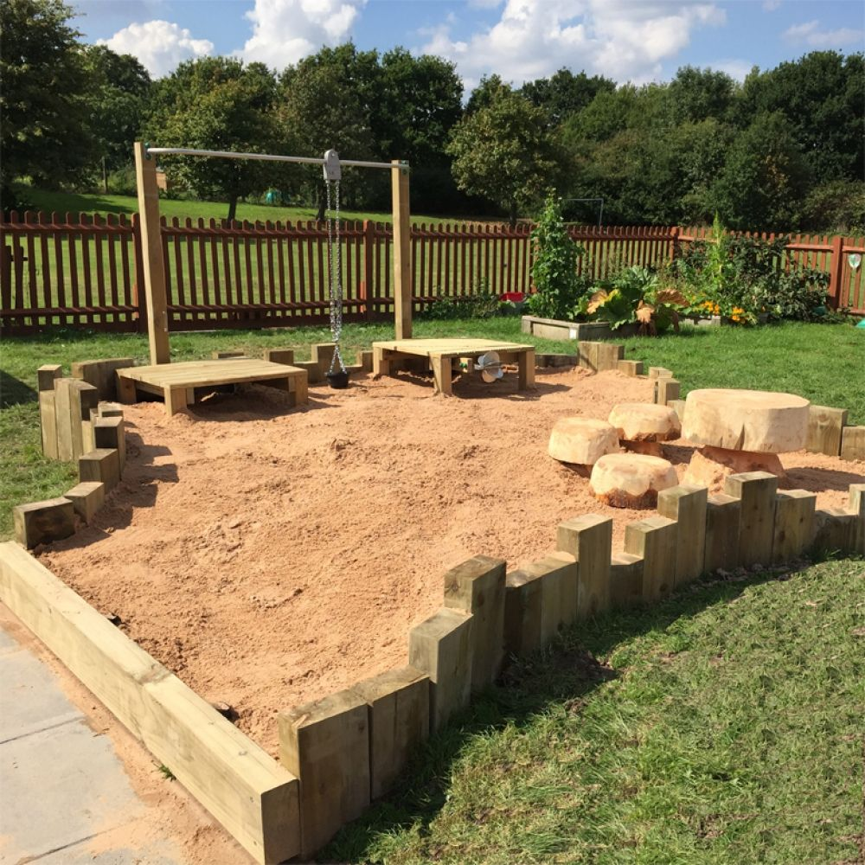
Source: playgroundimagineering.co.uk

Task 2.
Using the Outdoor area.
This photograph shows opportunities for many different kinds of spontaneous child-initiated and adult-guided play. The area is mostly a large sandpit which gives opportunities for conversations about wildlife and motivates the children to explore. Additional resources and experiments can get the most out of this motivation. The outdoors provides ample opportunities to inspire awe and wonder in children and providing age-appropriate science and maths learning experiences can help the child to understand their world, organise information and give them the freedom to apply and test ideas (Welsh Government, 2021). These formative experiences provide a solid foundation for the later development of scientific and mathematical concepts, provide a strong base for the development of scientific language and scientific thinking, and the reinforcement of numeracy skills.
This outdoor area is being used by mixed groups of children aged between 3 and 4 years old. The area is used in both wet and dry weather and the children know that as long as they have sensible clothing and footwear so that they are comfortable it can be used. Playing outdoors supports learning as well as social and emotional development in addition to providing opportunities for children to improve their balance and coordination, develop gross and fine motor skills, and properly explore their potential. Outdoor play gives the opportunity to reinforce the children’s learning and to support the interactions they are making to construct an understanding of how the environment works (Welsh Government, 2021).
The children are familiar with the outdoor environment, they know it is safe and secure and they are free to explore as they wish. It is normal for the children to settle straight into their usual activities (Schemas) when they get outside. It is common practice at the nursery to provide resources to enhance and expand the children’s natural play.
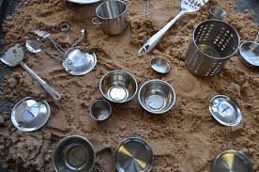
The area is made up of a large sandpit where children can play, scooping and moving sand from place to place. Resources such as tools, pots, pans, shovels, buckets, sieves, rakes, and moulds can be added to this area to enhance and extend play. Children can use their fingers or tools to create patterns in the sand.
Source: Earlyyearscareers.com
Sand is an effective way of supporting children’s natural schematic interests (schemas). Schemas help children to make sense of the world that they inhabit and encourage children to operate as scientists, experimenting and building theories as they go. Children can be seen to bury and discover objects, to fill buckets, pots, pans, and bottles, to create lines and patterns, to collect, sort, and arrange. By doing this the children are naturally exploring scientific concepts such as, empty, full, heavy, and light, deep, and shallow and the play supports mathematical thinking for number, size, shape, and position. In addition to this sand play is effective in promoting the feeling, strength, and dexterity in their hands, fostering imagination and creativity, and encouraging language development through the practice of describing feelings, materials, and what is happening during the play process.
The use of platforms at the rear of the area allows children to explore the concepts of high and low, encouraging children to witness the difference between how high they are compared to their peers down in the sand. It is also possible that they can explore concepts such as under, below, through, and upon as they navigate whether they can fit stones and sticks under and through the slats in the pallets.
The flow of the play can give rise to conversations with practitioners and among the children about the differences between sand that is wet and dry. Practitioners can support these observations by suggesting experiments that help the children measure the differences between receptacles filled with either wet or dry sand. The children may observe that a bucket of wet sand is much harder to lift than a bucket of dry sand but that the wetter sand is easier to build with and sticks together better. It is possible that the practitioner can reinforce and scaffold these observations by explaining how adding water to something can change the way that it looks, feels, and behaves.
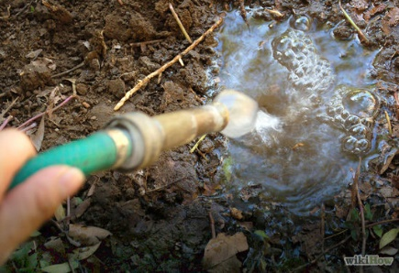
Children may be able to think of other examples where water changes the properties of a material for example with earth becoming mud when water is added, and this helps to reinforce the concept in their minds.
Source: craftsuprint.com

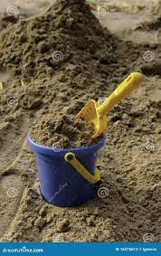
The children can explore numeracy when playing in the sand. From simple counting of the number of buckets set out to play to how many scoops of sand will fill a small versus a big bucket. Children can also explore the concepts of less and more, size, and position.
Source: Dreamstime
The practitioner can extend the play and learning experience by setting challenges such as making a line of five sandcastles and asking the children to add one more or to increase the number to ten, by asking the children to put a flag in the second castle, or the last castle or to put stones between, in front or behind the castles.
The addition of sticks can provide an excellent chance for the children to explore shape and direction, as they discover what patterns they can make. The children learn the difference between what constitutes a line and what makes a shape, and they begin to use shape vocabulary to describe the patterns and shapes they see. These valid opportunities for mark-making also demonstrate a cross-curricular link to literacy and practitioners can draw on this link to provide bilingual instruction, extending and reinforcing vocabulary as children learn. Children also enjoy pressing handprints into the sand and comparing them to see which is bigger or smaller.
Situated between the two raised platforms is a sand transporter and hoist with a rubber bucket. Children can learn about levers and pulleys and how forces work in action in a very simple way. Children can move sand up and down in the bucket, can learn how different amounts of sand weigh heavier or lighter, and can transport sand between the two platforms. This play also helps children to develop their teamwork skills.
It should be noted that while the children are playing and learning Science and Maths through curiosity and exploration, they are also learning many other skills as the play experience is holistic and draws from many areas of the curriculum. Children will naturally learn the skills of problem-solving and how to apply the knowledge they already possess to different scenarios in addition to demonstrating persistence, resilience, and determination. The play experiences offered in the outdoor area ensure children can take a measured degree of risk which in turn will build confidence in addition to knowledge.
To facilitate these valuable and meaningful outdoor play experiences it is also essential that practitioners have a deep understanding of what a child needs to learn and thrive. Welsh Government (2021) states that it is the role of the practitioner to be a skilled professional who is naturally curious and who can provide engaging experiences that stimulate and ignite children’s passions.

RISK-BENEFIT ASSESSMENT

Location / Activity: | Natural Outdoor Environment | Date: | Sept 23
Assessor: | Lindsay Turner - 2216886 | Review date:

The boxes in the table below will expand as you type into them; pre-entered text is simply for illustration. You should delete irrelevant items and replace with text relevant to your circumstances.
Your overall risk rating – Low, medium or high – is based on your judgement about whether the BENEFITS of the activity or opportunity outweigh the RISKS.

Experience exploring outdoor space in photograph | How will young people BENEFIT from this activity? | Hazards and associated risks | Who is at risk? | PRECAUTIONS in place to reduce the risk of injury | Overall risk after precautions  RATING: L/M/H
Sand Area | Assists creative play. Bolsters imagination, independent thinking, teamwork, and cooperation.  Helps to develop problem-solving and critical thinking.  Provides solid groundwork for Mathematical and Scientific experimentation and exploration.  Provides sensory play opportunities.  Exposure to germs helps to support a good immune system.  Development of proprioceptive sense.  Development language skills and communication. | Children may ingest sand which could lead to choking/illness.  Children may throw sand causing injury to the eyes.  Sand could enter existing wounds causing infection.  Sand could be attractive to animals and be used as a defecation site.  Insects may live in damp sand and could bite/sting. | All | Children should be appropriately supervised.  Staff should be properly trained in First Aid.  Correct rules for play should be explained properly to children i.e., no throwing sand, putting sand in the mouths, etc.  The area should be checked thoroughly for signs of animal use before play and covered when not in use.  Staff should double check allergies and sensitivities prior to use.  Sand should be regularly turned to avoid insects becoming embedded. | L
Raised Platforms | Assists creative play.  Provides a solid base for mathematical experimentation, high, low, on, through, under.  Enhances awareness of surrounding areas  Develops proprioceptive awareness. | Slips, Trips, and Falls | All | Children should be appropriately supervised.  Staff should be properly trained in First Aid  Rules should be explained regarding pushing, taking care, etc.  Appropriate footwear should be worn to ensure stability. | L
Seating area | Small table and seating area on the sandpit can encourage role play and imaginative play which can aid social and emotional development and improve language and communication skills.  Can also provide a rest area for the children providing support for their well-being.  Provides a social area to gather and communicate and to help develop social and emotional skills. | Splinters  Fall injuries | Children | First Aid kit should be close to hand at all times.  Staff should check the area for loose wood or broken edges regularly to prevent splinters.  Rules of play should be explained and reinforced to ensure that children understand how to take care at the area and not jump off the tables and chairs.  Staff should be properly trained. | L
Resources – utensils, pots, pans, buckets | Exploration and Experimentation with materials of different shapes and sizes.  Objects are used to develop children’s open-ended play.  Developing an understanding of mathematical concepts such as volume, size, shape, weight, under, on, and in. | Sharp edges, splinters, and broken pieces can cause injury.  Injuries can be caused by lifting and dropping heavy items.  Children may put dirty tools in their mouths | All | All staff should have proper training in all areas.  First Aid kit should be close at hand at all times.  Rules of play should be explained and reinforced at all times i.e., taking care when lifting/carrying. Items should not be used as weapons.  Utensils should be checked regularly, and broken pieces removed.  Children should be reminded not to put utensils and tools in their mouths.  Equipment should be stored safely and dryly to avoid fungus and mould growing. | L
Sand transporter and hoist | Development of hand-eye coordination  Exploring the concepts of gravity and friction.  Development of rules, sharing, turn-taking.  Forces in action, push, pull. | Trapping fingers in the chain.  Ingesting Sand  Sand flying about  Rubber bucket being at head level. | Children | The hoist and associated platforms should be close to the ground.  All staff should have proper training.  First Aid kit should be close at hand at all times.  Rules of play should be explained and reinforced.  The area should be properly supervised.  The hoist should be regularly checked for faults and damages.  Children should be reminded to take care with the rubber bucket. | L

Task 4.
According to the Welsh Government (2021), the role of the adult within Early Years is to create emotionally safe environments that support children and to demonstrate and encourage a joyful approach to learning and the natural curiosity of children as they play.
This way of thinking is based heavily on the work of Vygotsky (cited in Bradbury and Swales, 2022) who believed that learning was a social exchange and that young children learn through interactions with the adults around them in addition to their peers. Vygotsky coined the term zone of proximal development to describe how important the role of the adult, or more capable peer was, to the child's learning (McGrath, 2014). It is within this zone that all new learning takes place (Montague-Smith and Price, 2012). This theory remains a cornerstone in present-day pedagogy when children work together and when adults model and scaffold learning opportunities (Page, Clare & Nutbrown, 2013). It is the role of the practitioner to observe what a child can already do unaided and to find ways to scaffold what they will learn next (Montague-Smith and Price, 2012).
Lee and Bailie (2020) state that children are naturally curious and will constantly ask questions like How does it work? Why does it happen? What happens if? Practitioners must support the children’s quest for knowledge by helping them discover and search for answers in the natural world. Bruner (cited in Bradbury and Swales, 2022), believed that children can be taught any subject at any stage of their development as long as it is presented in an appropriate way. This way of learning can be described as constructivism and is based on the theory that learners construct knowledge through experiences and by reflecting on those experiences (Tucker, 2005). According to Bruner, (cited in Tucker, 2005), the role of the practitioner is crucial in creating interesting and challenging environments and quality interactions which act as a scaffold for children’s learning.
Froebel (cited in Tovey, 2013) stated that adults have a critical role in Early Years care through the provision of play materials and via informed observations and interactions. Froebel believed that everyday routines are significant learning experiences and children’s involvement was an important way that they can learn alongside adults.
According to Malaguzzi (cited in Bradbury and Swales, 2022), the environment should be considered to be the third teacher. Malaguzzi believed that the environment was an active participant in the learning process and that children engage with three teachers; adults, their peers, and the physical environment that they inhabit. Malaguzzi’s learning approach was enquiry based and constructivist and had several links with the work of Bruner.
Moreover, the environments created should be enabling and welcoming and should offer the opportunity of experiencing awe and wonder to the child which will ignite a curiosity about the world. Children should be motivated to explore, solve problems, and develop creativity and critical thinking (Welsh Government, 2021).
McClennan (2017) describes the outdoors as a place filled with rich opportunities for maths and science teaching, whilst Lee and Bailie (2020) state that the natural environment is a dynamic living school, packed full of wonders. It is an excellent educational setting for young children to explore and learn about the natural world. According to Edgington (2014), topics such as the weather and nature are ideally taught in an outdoor space where learning can be experienced and consolidated in real time. Ernst, Johnson and Burcak (2018) show evidence that various domains of children’s development are enhanced if they have more exposure to nature, in particular, physical activity, cognitive development and resilience. Campbell and Speldewinde (2020) agree stating that the outdoor environment also enables children to experience and improve their understanding of a range of scientific ideas and mathematical concepts.
The play environment should have the ability to scaffold the development of children’s understanding of mathematical concepts through visual and practical opportunities to explore shape, number, and pattern, especially in an outdoor space (Welsh Government, 2021).
Furthermore, Lee and Bailie (2020) state that the unpredictable nature of the outdoors provides opportunities for children to engage in critical thinking and problem solving. Science and Maths are supported through exploration such as searching to find interesting things, predicting what will happen to the leaves in autumn, or hypothesising what may be found in puddles of water. The natural world is a scientific laboratory full of natural resources that can be used as a vehicle for children’s development.
McLennan (2019) agrees, concentrating more on the patterns found in nature and how these can be complex and can steer children’s thinking to be more abstract and to therefore interpret their surroundings in different ways. A child observing the leaf growth on a tree for the first time may make connections with maths, science, and literacy. Exploring natural patters encourages children to think more deeply about what they are seeing. Tools such as microscopes and magnifying glasses can be used to extend the play for children to examine rocks and spiderwebs.
Larrea et al (2019), directs us to consider that the same outdoor environment may offer each child different possibilities. One child may perceive an element as climbable while another sees it as for sliding on. The play which occurs in a given space will differ from one child to the next depending on the affordances. James Gibson, an influential American psychologist believed that the world is perceived not only in terms of object shapes but also in terms of object possibilities which he named affordances. Gibson’s theory suggests that the way that we perceive an object will inevitably lead to a course of action. In the context of Early Years, affordances refer to the possibilities of action that objects or environments offer to children during play. Physical environments that provide a wide range of potential affordances can create more opportunities for learning through play.
According to Campbell and Speldewinde (2020) an affordance is a resource the environment offers to anyone who has the capabilities to perceive and use it. As a person acts, moves, and interacts with an environment new affordances become apparent. Outdoor education emphasises direct experience with the environment.
Additionally, Froebel (cited in Maynard and Waters, 2014) believed self-activity and adult support were not sufficient on their own. It was important for children to represent their ideas in some form so that they could understand something in a deeper way. Froebel believed that resources such as sticks, stones, leaves, chalk, water, and sand were valuable materials that children could use to represent their ideas and to further innovate, imagine and create.
McClennan (2017) agrees with this and adds that providing children with tools such as tubes, buckets, pots, cups, and spoons will encourage children to use maths when talking about their actions. Children can engage in conversations using maths terminology as they explore quantity and movement. Adding maths tools to play encourages children to play in complex and unexpected ways. Nicholson (cited in Maynard and Waters, 2014) agreed, stating that children particularly enjoy interacting with loose parts which he described as variables in the child’s play environment that can be moved and manipulated in any way.
Such play activities also contribute towards the understanding of concepts such as quantity, distance, weight, and capacity (Maynard and Waters, 2014). Vygotsky (cited in Tucker, 2005) believed that encouraging children to talk about mathematics and relating the teaching to a child’s own experiences was a successful method for consolidating the learning in a child’s mind.
The use of open-ended materials is significant as they can be transformed into a myriad of uses and the less tangible an object the greater its creative expression (White, 2014). McClennan (2017) suggests adding loose natural materials to play like stones and acorns can encourage counting, sorting, and organisation.
Community Playthings (2015) discusses this further when they say that when children are encouraged to try loose parts and to make their own ideas they are driven to learn. Children are driven to not only ask questions but to find their own answers and to create new possibilities. Indeed, resources that are heavy and awkward support the development of body awareness and control through the stimulation of the proprioceptive sensory system while mobile materials can provide rich content for developing big ideas about space through schemas such as transporting, enclosing, connecting, and going through. Schemas describe the strong drive that some children have towards repeating certain actions (Welsh Government, 2021).
Campbell, Jobling, and Howitt (2021) describe schemas as the mental constructs that connect ideas within a child’s mind. Children construct meaning from experience so the practitioner can expand and extend a child’s schema therefore producing a new linked experience and a more complex and sophisticated understanding. Welsh Government (2021) says that schemas play a key role in laying the foundations for future mathematical and scientific understanding by providing physical opportunities to encourage problem-solving and creative thinking. Children’s innate exploratory drive strengthens the neural pathways within their brains and makes it easier for future connections to be made and understood.
According to McClennan (2017) when children have access to recycled and repurposed objects such as log slices, tree stumps and tyres their imaginations will guide their activities. Complex learning occurs through children’s authentic planning and problem solving, for example, they can line up tree stumps by size to make steps, roll them to location and use them to define space or use them as platforms to jump from, maybe even combine them with other resources to make an obstacle course. Vygotsky (1986) said that everyday learning is a foundation for scientific learning.
Tovey (2013) suggests that a Froebelian environment provides a rich array of genuine real-world experiences and offers exciting opportunities for learning. Froebel believed in focusing on the benefits rather than the risks of experiences. He recognised the joy experienced in pushing boundaries and the opportunities to learn about such things as height and perspective by experimentation.
Children can learn about how their bodies work within a safe but challenging environment and can test their nerve, skills, and strength (Tovey, 2013). Practitioners must understand that children benefit from chances to repeat and consolidate learning and that children should be supported to develop resilience, independence, and confidence through risk and challenge (Welsh Government, 2021).
White (2014) discusses the importance of balancing risk and challenge in the outdoor environment and suggests that when practitioners view the outside as a place where children can learn to keep themselves safe by recognising potential harm and realising how to deal with it, they can start to see the proper potential that exists there.
Furthermore, the Northern Council for Further Education (2023) suggests that sustainability discourse must be considered in the context of Early Years. Practitioners should be committed to teach children about their responsibilities to each other and to the world in which we live. This aligns with the Government Sustainability and Climate Change Strategy (DfE, 2022), which asks practitioners to be better connected to nature and understand the impacts of climate change. Practitioners must harness children’s passions and enable them to develop the knowledge and skills required in Science, Technology, Engineering and Maths (STEM) and provide practical opportunities to increase climate resilience, reduce carbon impact and enhance biodiversity. Early Childhood is in a unique environmental position with its origins of outdoor pedagogical play deeply embedded within it.
Consideration of the natural world and the child’s position within it is perhaps a final point to consider. It is crucial that the practitioner is aware of their place within the world and can demonstrate to children how they can feel connected to the world in which they live. The child should understand that they are also a part of nature and that all elements of the natural world have value and are able to affect and direct the play experience in their own right (White, 2014).

