

Student name: | Eric Lerouge ANGWE NZE
Student ID: | 2417255
Programme: | BSc (Hons) Health and Social Care
Module name and code: | BMHP5014 - Creativity and Value Creation
Lecture's name: | Brian MASHUMBA

Table of content
Poster 2
Pitch 3
Introduction 3
Background and need 4
Innovation (SafeSignal) 4
Technology 4
Implementation 5
Policy and legislation 5
Benefits and conclusion 5
References 5

Poster
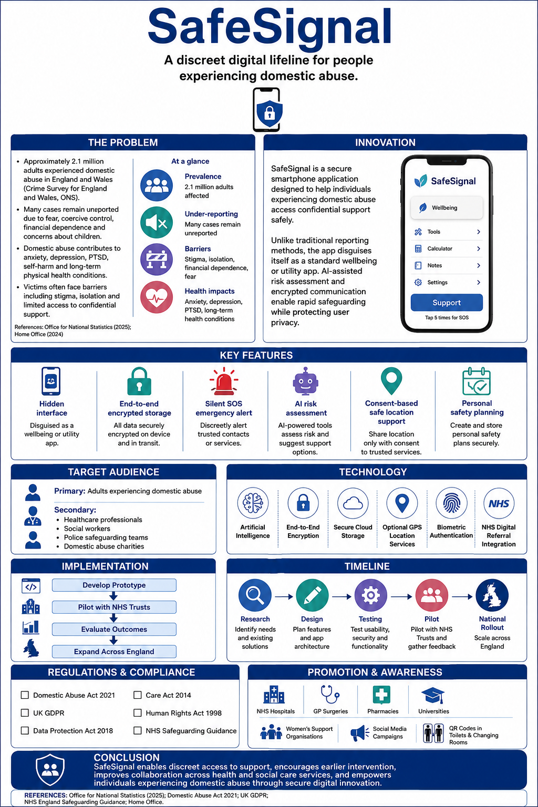

Pitch

Introduction
Domestic abuse is a significant health and social care problem in the UK that impacts millions of people and results in significant physical, psychological and emotional harm. Fear and/or coercive control and concerns about victim safety prevent many victims from seeking assistance. The pitch suggests a mobile app that allows users to access support services confidentially and out of the reach of their abusers, called SafeSignal. SafeSignal will seek to enhance victim safety, better facilitate coordinated support in the UK and encourage early intervention through secure technology and AI-driven risk assessment and direct connections with health and social care professionals.

Background and need
Domestic abuse is a leading public health and social care problem in the UK. The ONS (2024) estimates that in England and Wales there were about 2.3 million adults who experienced domestic abuse in the 12 months to March 2024. Even with the help of the support services available, there are still many incidents that go unreported because of a fear of retaliation, coercive control, or a financial or emotional dependence on the abuser. These barriers frequently make it difficult for people to get timely health, social, and legal services.
Domestic abuse can have an impact on more than just physical health. Victims may be more susceptible to anxiety, depression, post-traumatic stress disorder (PTSD), substance abuse and chronic health problems. Children exposed to domestic violence can also suffer emotional trauma and/or negative developmental effects. The NHS, police and specialist charities make vital contributions, but it can be difficult for victims to access help safely when their communications are monitored. This shows the necessity of a new, confidential and technology-driven solution that will allow confidential access to support with minimal risk of abuse reporting.

Innovation (SafeSignal)
SafeSignal is an innovative mobile application designed to provide a safe, discreet and accessible way for individuals experiencing domestic abuse to seek support. The app is disguised as a regular wellness or lifestyle app, so that users can access its features without raising suspicion. A safe authentication system opens the concealed assistance platform, enabling only the intended user to access delicate information.
A silent emergency alert is also included in the application, which allows users to make a visible emergency call or contact a person they may trust in an instant. It also offers an encrypted digital log to record incidents, upload images and store evidence which could be important for future legal or safeguarding proceedings. The AI assisted risk assessment tool asks a series of evidence based questions to determine the level of risk and directs to the most suitable support services. SafeSignal also provides customised safety planning, such as on how to set up emergency contacts, where to go for safety and how to create an escape plan. A built-in support directory provides verified details of local domestic abuse services, NHS support, counselling and emergency accommodation to users.
Secure technology and health and social care services together with SafeSignal eliminate many of the barriers for victims to seek help. The innovation ensures that early intervention is facilitated, access to professional support is enhanced, and there is greater collaboration between health, social work and domestic abuse organisations, resulting in better safety, wellbeing and long-term recovery for individuals impacted by domestic abuse.

Technology
SafeSignal is a digitally secure and confidential service and uses secure digital technology to ensure privacy. Biometric authentication or a personalized PIN secures the application, and it is disguised as an ordinary application to minimize the possibility of detection by an abuser. All personal information and evidence uploaded is encrypted and stored securely, in line with UK data protection requirements. A risk assessment is completed using AI technology to assess the risk level from users' responses and suggest appropriate support services. The app itself can securely link the user to NHS services, domestic abuse services and emergency contacts with their consent to access safeguarding, health and specialist services more quickly.

Implementation
SafeSignal would be a collaborative project involving NHS, domestic abuse charities, technology developers and safeguarding professionals. The application would first be trialled in specific NHS Trusts, GP practices and local authority services to assess its effectiveness and obtain feedback from users. After successful evaluation, the app would be disseminated nationally in the UK and training for healthcare professionals, social workers and support organisations would be introduced to help ensure consistency of use and pathways for referring the app. Ongoing monitoring and regular updates will enhance security, accessibility and functionality. Such a staged deployment strategy would help facilitate the safe adoption of the innovation, foster multi-agency partnerships and ensure that the innovation is responsive to the needs of those impacted by domestic abuse.

Policy and legislation
SafeSignal would function in line with the essential legislation and professional standards in the UK to provide users with safe, ethical and legal support. The innovation is in line with the Domestic Abuse Act 2021, which increases protection for victims and encourages a multi-agency approach to tackling domestic abuse. Personal data will be handled with confidentiality and security in accordance with the UK General Data Protection Regulation (UK GDPR) and the Data Protection Act 2018. The app would also support duties under the Care Act 2014 and adhere to relevant NHS safeguarding guidance and would allow for timely and person-centred interventions for people who are suffering from domestic abuse, by healthcare professionals and support services.

Benefits and conclusion
SafeSignal offers a discreet, secure and accessible way for victims of domestic abuse to seek help, promoting earlier intervention and improving health and wellbeing. By connecting users with healthcare professionals, social workers and specialist support services, it strengthens multi-agency collaboration and enhances safeguarding. Overall, SafeSignal has the potential to reduce barriers to reporting, improve victim safety and contribute to a more responsive and effective health and social care system.

References
Department of Health and Social Care (2022) Women’s Health Strategy for England. London: DHSC. Available at: https://www.gov.uk/government/publications/womens-health-strategy-for-england (Accessed: 3 August 2026).
Home Office (2022) Domestic Abuse Act 2021: Statutory Guidance. London: Home Office. Available at: https://www.gov.uk/government/publications/domestic-abuse-act-2021-statutory-guidance (Accessed: 3 August 2026).
Home Office (2024) Domestic Abuse Plan. London: Home Office. Available at: https://www.gov.uk/government/publications/domestic-abuse-plan (Accessed: 3 August 2026).
National Institute for Health and Care Excellence (NICE) (2014) Domestic violence and abuse: Multi-agency working (PH50). London: NICE. Available at: https://www.nice.org.uk/guidance/ph50 (Accessed: 3 August 2026).
NHS England (2023) NHS Safeguarding. Available at: https://www.england.nhs.uk/safeguarding/ (Accessed: 3 August 2026).
Office for National Statistics (2024) Domestic abuse in England and Wales overview: November 2024. Newport: ONS. Available at: https://www.ons.gov.uk/ (Accessed: 3 August 2026).
Refuge (2024) The Facts About Domestic Abuse. Available at: https://refuge.org.uk/ (Accessed: 3 August 2026).
SafeLives (2023) SafeLives Insights. Bristol: SafeLives. Available at: https://safelives.org.uk/ (Accessed: 3 August 2026).
The British Psychological Society (2022) Domestic Abuse: Psychological Perspectives. Leicester: BPS. Available at: https://www.bps.org.uk/ (Accessed: 3 August 2026).
UK Government (2018) Data Protection Act 2018. Available at: https://www.legislation.gov.uk/ukpga/2018/12/contents (Accessed: 3 August 2026).
UK Government (2021) Domestic Abuse Act 2021. Available at: https://www.legislation.gov.uk/ukpga/2021/17/contents (Accessed: 3 August 2026).
UK Government (2014) Care Act 2014. Available at: https://www.legislation.gov.uk/ukpga/2014/23/contents (Accessed: 3 August 2026).
UK Government (2018) Guide to the UK General Data Protection Regulation (UK GDPR). Available at: https://ico.org.uk/for-organisations/uk-gdpr-guidance-and-resources/ (Accessed: 3 August 2026).
World Health Organization (2021) Violence Against Women Prevalence Estimates, 2018. Geneva: WHO. Available at: https://www.who.int/publications/i/item/9789240022256 (Accessed: 3 August 2026).
Women's Aid (2024) Domestic Abuse Statistics. Available at: https://www.womensaid.org.uk/ (Accessed: 3 August 2026).

