Sensing Relationships: Attending to Human and More-than-Human Bodies through a ‘Non-stylised’ Movement Practice.

By Sian Davies
University of Saint David Wales
Lampeter
2020

Declaration
This work has not previously been accepted in substance for any degree and is not being concurrently submitted for candidature for any degree

Singed…Sian Elizabeth Davies… (candidate)
Date…………12/3/20……………

Statement
This thesis is the result of my own investigation, except where otherwise stated.
Other sources are acknowledged by explicit references and a Reference List is appended.

Singed……Sian Elizabeth Davies…… (candidate)
Date……………12/3/20………………

Abstract
This dissertation offers a lived, sensory understanding of a ‘Non-stylised’ Movement Practice named the ‘Walk of Life’, which is recognised as an ‘Environmental movement’ practice that is influenced by various fields such as Eco-psychology, Dance, Somatics and Dance Movement Therapy. The practice involves an exploration of moving with and amongst more-than-human bodies and various outdoor landscapes, with my research focus being on understanding what the movement practice is, and what it does in regards to one’s way of being, perceiving and relating with oneself as a body in relation to the more-than-human world. Undertaking a Sensory ethnography which focuses on my personal engagement participating in the practice, I offer my research process and analysis partly through story-telling to emphasise the sensory and lived bodily experiences from a first-person perspective. My findings demonstrate that the Walk of Life Practice trains the participant to utilise their senses to access a different way of experiencing themselves as a body, and relating with the more-than-human bodies in which they are always in relationship with.

Acknowledgments
I would like to say a huge thank you to my tutors Ann Bevan and Luci Attala. Ann, Thank you for your interesting and exciting take on delivering classes, and for all the support & encouragement you have given over the years. Luci, Thank you for your engaging and out-of-the-ordinary classes that challenged us yet also allowed space for growth and creativity. This research would not have taken place without the approval of Helen Poynor. Helen, Thank you so much for allowing me the opportunity to undertake research with you and explore the practice that you offer. It has been a great privilege to learn from you, both professionally and personally, and I am certain that this is only the beginning of my movement journey. A joyful jump of gratitude goes to all the fellow workshop participants who I had the honour of working and moving with, our interactions resulted in much learning. A special thank you however has to go to Josie Padfield, Judy Hicks and Scott Hurtson, for all your contributions in the form of shared movement and the in-depth and fascinating conversations we exchanged; it has been a privilege to hear, feel and see your stories. I Mam a Dad, Thank you for always supporting me as I follow my path, even when it randomly decides to take me to do a degree three weeks before the course start date! I am grateful that you have given me such possibilities in life, Diolch o fy nghalon. To Giulio, thank you for listening to my ponderings, questions and ramblings over my years of university, and for always supporting me in my life and learning and helping me get through it! To my colleague and friend Kal, we made it (hopefully!), I feel very lucky to have spent the last three years getting to know you, and witness your thinking and chill swim adventure unfolding. Thank you for all the support during our lockdown exchanges, it was very comforting to know that we were there for each other during this strange period and writing process. To my housemates; Bec, Allan and Hatty, thank you for your support in the form of shoulder massages, care, yummy food, and answering all sorts of questions relating with this diss! A big thank you also to my lovely friends Steph and Laurence, you have both been wonderful in offering your services to help aid me with writing. And lastly, a bow of gratitude to the ever-shifting more-than-human world, for the teachings, the healing, and for the constant reminder whenever I’m willing to listen, that this is all sacred.

Table of Contents
Declaration 2
Abstract 3
Acknowledgments 4
A note to you, the reader 8
Introduction 9
The First Meeting 9
Research Motivation 11
Defining ‘Movement’ 12
The Walk of Life Practice 13
Contextualising the Practice 14
Research Approach & Focus 15
Sensory Ethnography 15
Defining Sensory Ethnography 15
Reviewing the Field 17
The Ethnographic process 19
Participant Observation (Sensing) 21
The Methodology 21
Accessing Research 22
A Question of Ethics 22
Utilising the Method in the Field 25
A Call for ‘Participant Sensing’ 27
Unstructured Interviews 30
The methodology 30
Undertaking the Interviews 31
In the Field 33
An Auto-biographical story 33
Discussion 37
Sensing the Body 38
Awakening the Bones 38
Attending to the body 38
Attending to Relationships 41
“Here I Am, There You Are” 41
Conclusion 43
References 45
Appendix 50

A note to you, the reader

This research text documents an embodied, sensory journey.
It contains numerous ways of ‘knowing’, the primary in which I regard as sensorial. I thus invite you as a reader to experiment engaging with this text in various ways; encouraging you to begin by tuning into sensing your body and the environment you’re in.
My hope is that as a reader you will be able to engage with the text by receiving it with your whole bodily intelligence, rather than reading with your eyes only.
I encourage you to pause and take regular breaks if necessary, move your body, stretch or go outdoors and follow any intuitive calls that may aid you in connecting with this piece of writing.
And when you’re ready to re/join me, I invite you to journey into the WOL movement practice alongside me.

***
Unless stated otherwise, all photographs in this document are my own and have been taken by me personally.

Introduction
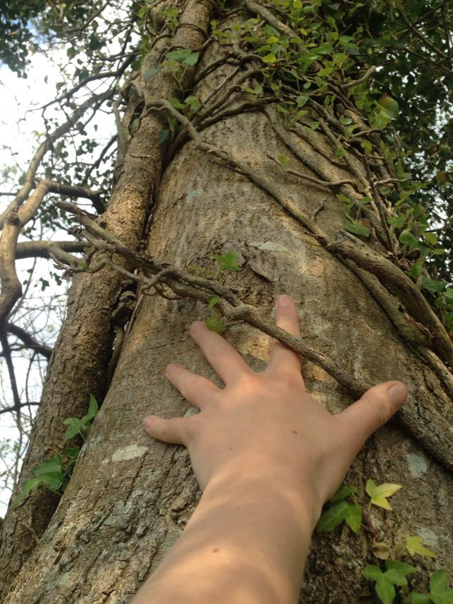

The First Meeting
I remember the first time it happened. I was in a woodland in North Wales with some friends, it was April 2018 and we’d been sharing a ‘retreat’ day, held mostly in silence with each of us doing our own thing; drawing, writing, pondering and meditating, generally taking some time to slow down from the fast-paced rhythm and non-stop stimulation of our daily lives, living in a capitalist society. We were finishing the afternoon off with some walking in the woods, each of us following our own pathway and heading off in various directions. The tree wasn’t particularly aesthetically attractive, but for some reason it pulled at my attention. I moved towards it, admiring its bodily shape in closer detail, when I felt a sudden urge move through me, willing me to imitate the posture of the tree. I had no rational way of explaining the impulse of feeling, though upon reading Barrett, (2013, p.417) I wondered if the silence of the day had quietened my mind in such a way that I was more open and attuned to what she calls the ‘Porosity’ of the animate environment; sensitive to receiving information from the more-than-human in the form of images, dreams, out of the ordinary thoughts or feelings (Barrett, 2013, p.419). Succumbing to the pull within my body, I stood there hands up in the air, and the flow of bodily movement just appeared to continue developing from there. There were moments of intense presence where only the tree and I existed in this duet unfolding, hand to branch, back to trunk, fingertips flittering through the air. I felt I glimpsed upon what Ingold (2011, p.10) identifies as the ‘Dwelling Perspective’, where the dance between the tree and I was forming not from an idea that I had already pre-conceived and in which I was imposing onto the tree, but rather a process of making that was emerging as an improvisational response out of my practical and attentive engagement with the environment in which I was situated in. In this meeting I felt all sorts of things; embarrassment, confusion, shame and self-judgment at the thought of being caught in the act, behaving ‘weirdly’ dancing with a tree. Short moments of self-consciousness interrupted where I’d glance around quickly to make sure no one was watching. Once re-assured, I continued, taken aback by the sense of sensual aliveness and the fullness that I experienced of being a body, alongside the sense of connection and deep intimacy that I had shared with the tree. I didn’t rationally know what I was doing, but I felt in my bodily experience that there was something to it.

Research Motivation
This event opened up a new sphere in my life, metaphorically speaking; it was as if a dormant seed within me had just started sprouting, with new life emerging from the dark unknown of my psyche and preparing to take root in my body. Until now, I hadn’t considered moving with the more-than-human world beyond walking, cycling, and swimming, but the movement I shared with the tree seemed to open up a whole new area of possibility of different ways of relating. It didn’t go on to motivate me to pursue moving with trees as a hobby, but the alive memory and embodied feelings did stay with me, from time to time tugging at my curiosity. What had happened between the tree and me? Why had moving in that way transformed how I felt in myself as a body, and towards the tree? Had I simply experienced what Milton (2002) calls ‘Biophillia’? An emotional connection to the more-than-human world? I didn’t have the answers, but considering that we’re currently living in ‘The Age of the Anthropocene’; a socio-ecological concept which recognises that the human species are collectively (though not equally responsible for) (Latour, 2014) modifying the Earth’s systems and contributing to the climate crisis (Chua & Fair, 2019), it has felt increasingly important to engage with the questions that arose from that first meeting. This led me wanting to enquire further into exploring different ways of relating with the more-than-human world through movement, and prompted me to undertake this research studying the ‘Walk of Life’(WOL) practice; a physical movement practice that explores moving with the more-than-human world in a ‘non-stylised’ and creative way (WOL website, n.d).

Defining ‘Movement’
At this stage, before I define the Walk of Life practice in further detail, I will first clarify my use of the term ‘Movement’ as I refer to the WOL practice as a ‘Movement’ practice throughout this document. The term ‘Movement’ is vague and has various meanings in the social sciences. Here I am referring to ‘Movement’ in regards to the physical movement of human beings, in regards to how we physically move around in relation to the world, as studied within the ‘Anthropology of Human Movement’ (Farnell, 1999), and ‘Physical Culture’ as used mostly within the Sociological spheres (Sparkes, 2017). The term ‘Human Movement’ however is also vague, often used as an umbrella term to cover a wide range of physical practices, performances, dance and sport exercises (Sparkes, 2017). In this document the type of movement I am referring to could be regarded closely to the Euro-American notion of ‘Dance’ (in a non-choreographed, improvisational sense), however, I have chosen not to use this term as I feel it could be misleading considering all the connotations that come along with it. ‘Dance’ as a Euro-American concept is often portrayed in a certain way, based on the dominant ideas of ‘dance’ that are defined by Euro-American cultures (Blacking, 2018), for example, dance is considered as; movement that is structured and rhythmic, involves music and has an aim of being aesthetically pleasing (Blacking, 2018). Such notions do not fit the practice that I have been researching. The movement I am referring to is creative in a sense that it improvised and expressive, but it is not confined by narrow definitions of ‘dance’. It may be described as a type of movement that is ‘free form’, which could involve lying still for the whole duration of the practice and only moving one’s little finger, or it may involve moving the whole of the body, wildly shifting in speed across the entire landscape. The vagueness of the term is thus embraced here, in that it allows any form of physical movement to be possible, without adding layers of pre-conceived ideas to what that movement should be. Thus, I use the term ‘movement’ throughout this document to describe the creative physical movement available (which differs in range and ability) to each and every unique and individual human being.

The Walk of Life Practice
The WOL practice labels itself as an ‘Environmental movement’ practice, exploring improvisational bodily movement as a form of enhancing one’s awareness of the body in motion and in relation to the more-than-human environment, with an aim of aiding creative expression. Founded in 1991 in West Dorset and East Devon, the workshops still take place across various sites within these locations to this day (Walk of Life, n.d). The founder of the practice is also the workshop facilitator, offering several workshops per year to small groups of around 10-12 people, with participants travelling from all over the country as well as internationally, to attend. The immersions involve verbal guidance and ‘scores’ from the facilitator, inviting participants to experiment moving in new and creative ways; with themselves as well as other human and ‘more-than-human’(Abram, 1997) bodies, such as the rocks, seaweed, soil and trees. Working with the more-than-human environment, the practice encourages a sensory exploration into understanding how one perceives and relates with human and more-than-human entities, with an aim of expanding ones sense of self as being in relationship (Roszak, 1995)(Walk of Life, n.d).

Contextualising the Practice
The social sciences have often overlooked human movement practices such as dance viewing it to be of little importance (Williams, 2004), though when scholars did start studying dance performances and rituals they often focused on the exotic practices of distant countries (see; Ness, 1992; Csordas, 1995), utilising observational approaches and studying choreographed behaviour in seeking to find cultural meanings (Farnell, 1999). More recently however, scholars within the social sciences have turned their attention closer to home, with some focusing on performative practices such as dance in their own culture (Kieft, 2013) as well as ‘ordinary’ daily life practices such as walking (Ingold & Vergunst, 2008), cycling and swimming (Sparkes, 2017). The approaches to studying Human movement have also shifted, with interest slowly leaning towards the experience of human movement (Ingold & Vergunst, 2008; Sparkes, 2017; Csordas, 1993), rather than a preoccupation with studying movement practices through a semiotic lens (Farnell, 1999).
As the practice is rather ‘niche’, I found it difficult to neatly categorise or simply ‘box in’, as I found it to have many influences such as Dance, Somatics, Body/Movement Psychotherapy, Eco-psychology and Earth based Spirituality, to name just a few. However, I position the practice primarily within the field of ‘Somatics’, following Eddy’s (2009, p.6) metaphorical description of the Somatic ‘field’ as one “of wildflowers with unique species randomly popping up across wide expanses”. Eco-Somatics as a sub-field of Somatic Movement, incorporated various elements of all of these influences, adopting an ecological lens to the Somatic enquiry of ‘listening deeply to the body’ by expanding the focus to include the environment that the body is a part of and in relationship with (Bauer, 2008).I thus position the practice within this grouping.

Sensory Ethnography
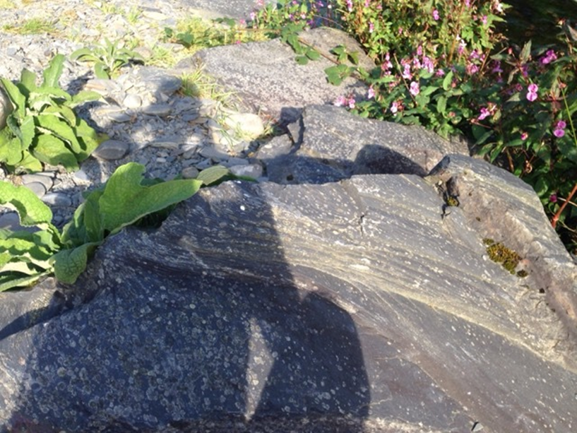

Defining Sensory Ethnography
Ethnography as a term is considered as both the research process and final document that reports the process and findings, often in text (Chang, 2008). Although traditionally ethnographic research was perceived as a research method to study ‘others’ in distant countries, contemporary ethnography is often conducted closer to the home of the researcher (Amit, 2000). There is now no one set way of undertaking Ethnography (Pink, 2009), as it is a research process that is utilised in different ways across various disciplines (Chang, 2008). The central approaches in conducting Ethnographic research in Anthropology however are ‘Participant observation’ and ‘Unstructured Interviews’, which go alongside other qualitative practices that are selected in relation to one’s area of study (Pink, 2009). In this sense, ethnography is a flexible process where the researcher selects the approaches that best fit the context of their subject area (Pink, 2009). In the case of this research I have chosen to undertake a Sensory approach to Ethnography, a methodology proposed by Pink, (2009) that emphasises an engagement with and focus on the sensory aspects of the field-work that the ethnographer participates in. In Sensory Ethnography, multisensory experiences and perception are seen as the starting point in which to undertake research (Pink, 2009), which is a similar notion to Csordas’ (1995) emphasis on placing ‘Embodiment’ and lived experiences as the existential ground for understanding culture (see; Csordas, 1995), though it develops upon this to emphasise the sensory engagement of the body to practice sensory ways of knowing (Pink, 2009). The process thus involves attending to the senses throughout the process of undertaking research, utilising the senses to engage with one’s enquiry (Pink, 2009). Attending to the sensory experiences in this way, offers a different lens of engaging with research that can tune in to ‘other ways of knowing’ that would otherwise potentially go unrecognised (Barrett, 2013). In the first meeting with the tree that I mention in the Introduction of this document, my experience was shaped by the felt, sensory and emotional qualities which were heightened through the movement of my body in relation to the solidity of the tree, the warmth of the sun, the birds singing and the air surrounding. I felt that the senses were an important factor in shaping that event and my bodily experience and perception, although I wasn’t sure in what way, it motivated me to want to explore these qualities as valuable elements to aid my intellectual enquiry (Okely, 2007). Thus, I felt that it was necessary to undertake a sensory approach to ethnography, as Bendix, (2000) argues that if a researcher wants to study sensory reception and perception, then they must utilise methods that are capable of grasping such knowledge (Pink, 2009). I go on to demonstrate my experience of utilising these sensory approaches, in the chapter on Participant Observation/sensation.

Reviewing the Field
Sensory Ethnography as a methodology has grown out of what Howes, (2003, 2019) identifies as the ‘Sensory Revolution’ that has occurred within Anthropology and amongst other disciplines in the social sciences. Traditionally in western frameworks of knowledge, the sensory capacities of the body were not regarded as valid routes to knowledge (Sparkes, 2017) in comparison to the rational and objective systems of thought that arose from the European Enlightenment (Okely, 2007). However, as a focus on the Body made its way into the academe in the 1980’s, by the 21st century the senses were being approached with curiosity in a period of moving away from the ‘linguistic turn’ and the abstract theories that claimed to account for daily life, without engaging with the sensory, lived experiences (Sparkes, 2017). Sensory research however was not to be studied as a purely biological phenomenon, with the revolution rooted in Anthropology (Howes, 2003) the senses were to be investigated in relation to how they were shaped by culture (Sparkes, 2017). With scholars such as Howes, (2003) investigating into how the senses are culturally constructed, questioning if they work together or separate, and if some are privileged over others. Pink, (2010) however has classified that such enquiries are specialised and come under the study of the ‘Anthropology of the senses’, which she distinguishes from the inter-disciplinary enquiry that she advocates as ‘Sensory Anthropology’, which is rooted in understanding the role of Sensory Perception (Pink, 2010). The ‘Anthropology of the senses’ in which Howes, (2003) advocates for, explores how the senses are socially constructed by comparing their dominant uses cross-culturally, an approach which has been criticised by both Pink (2010) and Ingold (2000) for being rooted in dis-embodied systems of thinking that are void of the actually lived experiences of the senses. Thus it appears that two branches have formed from the Sensory Revolution, the first studies how the senses are shaped by culture and thus how culture shapes the experiences of the senses (see; Howes, 2003, Le Breton, 2017) , whilst the other is utilised as a methodology for undertaking ethnography that is focused on exploring sensory perception and ways of knowing (Pink, 2010), which can been explored by physically engaged practices such as walking (see; Ingold & Vergunst, 2008) or as demonstrated within this research in studying a physical movement practice. Although both strands branch out in different directions, they both have the capacity to complement each other. Howes, (2018) considered both branches to fall under the umbrella term of ‘sensory studies’ in which involves a cultural approach towards the study of the senses (which he engages in), and the study of culture through engaging with the senses which Pink, 2009 and Ingold, 2000 advocate for. Some scholars (see; Sklar, 2009, Potter, 2008) however have critiqued the sensory studies for having an ethnocentric approach in focusing on the five dominant senses as recognised by Western Culture, without considering the lesser known senses such as the kinaesthetic, proprioceptive and introceptive (Sklar, 2009). Particularly in the fields of Dance and physical movement studies, scholars (Potter, 2008; Sklar, 2009; Spinney, 2006) are advocating for sensory studies to fill the gap in research and further explore the less acknowledged senses that involve the whole body. As my research is based on a Somatic Movement Practice that also involves the less acknowledged senses that involve ‘whole body listening’ (Enghauser, 2007), I hope my research can contribute to this.

The Ethnographic process
The process of this research involved my participation in two WOL workshops in 2019 that covered a total of six and a half days. The first occurred in the village of Charmouth, over four gloriously sunny July days, whilst the second took place in Branscombe over two and a half days, amongst the colder winds and light October rain. The workshops themselves involved indoor and outdoor movement activities, with site-specific practices taking place in the local woodlands, hill tops and cliff beaches (Walk of Life, n.d). Before entering the field, I was required to consider any ethical issues that may harm myself or the participants that I’d be studying alongside with and comply with the most recent AAA statement on Anthropological ethical practice (AAA, 2012). Having done this, I chose to utilise the qualitative research practices of ‘Participant Observation, with an emphasis on ‘Participant sensing’ to utilise a Sensory approach (Howes, 2018) and ‘Unstructured interviews’; both of which I explore in more detail in the following chapters. In undertaking these practices, I used note-taking as a form of recording my data in the field (Participant observation) and after leaving the field (Unstructured interviews). To analyse these notes upon returning home, I utilised the Grounded theory method (GMT) (see; Zarif, 2012) as a means of identifying the main themes that were emerging out of the data that I had collected and help form my research findings. As the WOL workshops were only taking place between the months of March-October in 2019 (the year in which I was conducting research), due to time and financial constraints I was only able to attend two workshops as part of conducting research. I had planned to attend a workshop in March 2020 but due to the current global pandemic, this workshop was cancelled. This meant that my immersion in the practice was for the short period of six and a half days. Duration within the field is considered a critical aspect of ethnography (Okely, 2007), and I think would have to agree that I needed a longer period of immersion to gain a deeper understanding of the WOL practice. However, having said that, I felt that my short period of immersion did allow me to glimpse upon what the movement practice entails, and my findings perhaps represent a ‘beginners’ perspective to the practice, rather than a long-term follower. If I was to do the research again, I would attempt to attend more workshops to gain a deeper and fuller understanding of the practice over time, and see how it affected my way of being, relating and perceiving in my daily life, outside of the workshop context.

Participant Observation (Sensing)
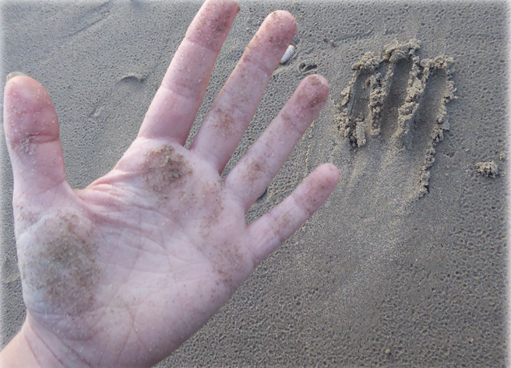

The Methodology
As part of undertaking this Ethnographic research, one of my main methods for collecting data was using ‘Participant Observation’, a methodology that is considered central to undertaking Anthropological field-work (Kawulich, 2005). Participant Observation requires a researcher to gain access into participating in the activities with the group of people they’re studying with, which requires a form of learning through doing, whilst simultaneously observing what is happening in their participation (DeWalt & DeWalt, 2002). In the immersion of undertaking Participant Observation, the method draws upon the researcher’s whole bodily experience to draw upon ones lived experience, as well as observing behaviours, events and interactions, in an attempt of gaining a holistic understanding of the context in which they’re studying (Kawulich, 2005).

Accessing Research
In this study, I found that the first step of gaining access to undertaking participant observation in my area of interest was more challenging than I had expected. At the very start of my research journey when I was still searching for a group to study with, I had contacted several Movement Practitioners that explored movement with the more-than-human, to enquire whether it would be possible for me to do ethnographic research with them. Interestingly, each person came back to me with a “no” explaining that due to the nature of the work they offered, they didn’t feel it would be appropriate for me to attend as a researcher, as they were concerned that my participation and observation could be felt as intrusive by their participants. As the responses I received brought up similar issues around participants privacy, I realised that I had two issues to work with; the first regarding my difficulty in gaining approval to access a SMP to undertake participant observation, and the second issue regarding ethical practice and how I could conduct research without harming the participants in my study (Baker, 2008). These issues prompted me to gain a better understanding of what areas of SMPs may require a higher degree of sensitivity, so that I could select and adapt my methodology appropriately (Pink, 2009).

A Question of Ethics
Enquiring into what various SMPs involved (see; Eddy, 2009), I found there was generally a focus on health and healing with a therapeutic component linked to many of the practices either directly or indirectly (see; Eddy, 2009; Ibbetson, 2010; McClure, 2015). Although I didn’t have a specific SMP to research at this point, this felt like an important factor to consider as it meant that my fieldwork environment could be potentially classed as a ‘therapeutic’ environment, and I could potentially be researching a practice with participants who had therapeutic needs (Eddy, 2009; Ibbetson, 2010). In this case my presence as a researcher could potentially disturb the ‘safe holding environment’ that the facilitator would be cultivating (Ibbetson, 2010), and in which the participants would be presumably expecting (and paying for). This would mean that my presence could potentially obstruct a participant’s ability to express themselves freely and hinder their personal reasons for attending the workshop, as well as have repercussions for the Facilitator if my presence impeded on the service they were supposed to be offering. Although one could argue that ‘participant observation’ as a method is likely to impede on the participants in the field, to a small degree, it is imperative for researchers to engage with questioning the degree of their intrusion (see; Ellis, 2007) to understand whether it can becomes harmful or obstructive (Baker, 2008). In this case, I didn’t know whether I would be studying alongside participants who were utilising the workshop for therapeutic reasons, and it was likely that I wouldn’t have this information, but I felt that it had to be taken as a serious consideration following my previous replies from my enquiries with the Movement Practitioners. This was not the only factor that caused me to question whether my research could verge on being obstructive however, as I read that in SMPs the lived, felt bodily experience of a participant (otherwise known as ‘Soma’) (see; Hanna, 1986) is emphasised as a primary exploration, which encourages participants to explore moving from a first-person perspective (Hanna, 1986; Eddy, 2009). As one of the main aims of SMP, Reeve (2011) regards this as coming to know the ‘Body as subject’, in contrast to the ‘Body as an Object’ which is often emphasised in mainstream movement practices that explore moving from a third-person perspective, which focuses on the aesthetic qualities of the movement as it appears to an external observer/audience (as in many choreographed dance practices) (Omega, 2018). As this is regarded as one of the main aims of SMP (Hanna, 1986; Eddy, 2009), I considered that my presence if perceived as an observer, could hinder the participants ability to move freely from a the first-person perspective if they became self-conscious of their appearance in relation to my observation. These were the conclusions that I formed following my rejection from several Movement Practitioners, and seeking to understand why access to my area of research may be difficult, and why my presence could be intrusive. Following this, I realised that if I was going to pursue research in the area of SMP, I would need to consider changing or adapting my way of Participating and Observing, depending on the particular practice.
When I finally came across the WOL practice and contacted the Facilitator to enquire about undertaking research, similar privacy concerns arose as we discussed the other 10-12 paying participants that I would be working alongside with. The Facilitator clearly expressed that she did not feel it would be appropriate for me to observe the participation of the other people in the workshop, but she was willing to work with me on the condition that I primarily observed my own experience of participation; a method that is often utilised by ethnographers that are researching areas that are often difficult to access in regards to privacy concerns (Chang, 2008). I thus decided to utilise Participant Observation alone in this way, without observing or recording any experiences of the people I was participating alongside with. Although the process felt long, and at times I was fearful that I would have to change my research study, it made me value the flexibility in conducting ethnographic research, as Pink, (2009) states it is an important factor for researchers to select their methods appropriately and adapt them in relation to the needs of one’s area of study, rather than having a pre-fixed, standard methodology that is universally practiced as Atkinson, Delamont and Housley (2007) seem to advocate for (Pink, 2009). Having the ability to adapt my method of Participant observation in this way solved both my concerns in regards to accessing the field and also reducing (yet not guaranteeing to eliminate entirely) the risk of intruding on other participants individual processes and privacy.

Utilising the Method in the Field
When undertaking Participant Observation, ethnographers are encouraged to cultivate a non-judgmental attitude towards welcoming the unknown (DeWalt & DeWalt, 2002), as they often (but not always) participate in unfamiliar contexts with different social customs (DeWalt & DeWalt, 2002). In the case of participating in the WOL practice, my experience of the workshop environment felt both familiar and unfamiliar, as I had personally participated in somatic movement workshops previously in the UK, but I hadn’t specifically engaged in the WOL practice or SMPs that explored moving with more-than-human entities. Ethnographers often have to navigate the dual-identity of being both an ‘insider’ and an ‘outsider’ when undertaking participant observation (Kawulich, 2005), as they participate alongside the people they study with and thus hold the stance of an ‘insider’ to some degree, yet they’re also considered as an ‘outsider’ as their primary role there is as a researcher (Kawulich, 2005). It is thus deemed ‘ordinary’ for ethnographers to feel some sense of exclusion in undertaking field-work, especially when first entering the field when their ‘outsider’ position is emphasised more strongly (Schensul, Schensul & LeCompte, 1999), however I found that this was surprisingly not the case for me. Although I had been slightly concerned about being excluded from the rest of the workshop participants, I had also read that I should prepare myself to expect this (see; Kawulich, 2005). However, as I was familiar with the social customs of SMP environments, I felt that I blended in with the other participants rather easily. My role as a researcher in the particular context of the WOL workshop didn’t seem to noticeably set me apart from the other participants, and I understood that this may be because many of the participants were attending the workshop with their own personal enquiry looking into their bodily experiences in participating in the practice. It felt as if they too were partaking in a form of research alongside me, and the WOL practice seemed to encourage this. Thus considering that I was only observing my own experiences (in relation), the only large difference amongst us appeared to be that my research enquiry was academically motivated. However, over time I realised that gravitating towards the ‘insider’ role within the group was not always preferable or easy to navigate, as I realised that the aspects of being an ‘outsider’ brought some distance to bring some objectivity to balance with the subjective participation (Kawulich, 2005). Considering that I was already familiar with SMP, and that I felt I blended in with the group as a participant, I was aware that I needed to stay alert as an observer and not become too absorbed in the act of participation, as Kawulich, (2005) suggests that this would instead be a position of a ‘complete participant’ which lacks a sense of objectivity, and would thus affect my ability to observe and analyse the context well.

A Call for ‘Participant Sensing’
With an intention to stay alert to observing what was happening in the practice, I attempted to stay acutely aware of all that I was experiencing. However, it wasn’t long until I noticed the difficulty in trying to navigate a dual-identity regarding the roles of both Participant and Observer (Kawulich, 2005). As a participant I felt I needed to fully surrender to the experiential aspects of the practice, yet as an observer I felt I needed to maintain a sense of distance to analyse what was happening. The context of the practice in particular emphasised this dualism, as the Facilitator was asking me as a participant to give up observing, thinking about or analysing what was happening (which came from a detached third-person perspective) and instead invited me to sense into and feel what was happening in the moment, so that I could know it by simply being with it (Farnell & Varella, 2008). Interestingly, I found it very difficult to do this, as I seemed to have a pre-conceived idea that to be a researcher meant that I needed to be observant of every little thing that was happening within and around me, yet to fully understand the nature of the WOL practice, I needed to do the opposite! I felt as if I was being asked to surrender my stance on observation and enter into a space of welcoming the unknown. Thinking about what I was participating in and constantly watching over what was happening seemed to restrict my ability from being able to listen fully with my whole body, and sense into what was being offered. Howes, (2019) suggests that in research contexts like this where one is undertaking sensory ethnography and engaging in sensory ways of knowing, one must place the role of sensing as primary, naming the methodology; ‘Participant Sensing’. This adaptation of ‘Participant Observation’ does not eradicate observation from the methodology, as that aspect was still needed to analyse and reflect upon the field experiences and note what’s happening, but it doesn’t utilise observation as a dominant role (Howes, 2019). Although as time went on, I managed to let go of my need to hold on to constantly observing everything, and began to accustom to the mode of sensing my participation as a form of collecting data, I felt it was important to engage with questioning why I had experienced a difficult time to begin with. I realised that I had resisted loosening the reign on my observation as I had a lot of fear that I would end up with no data if I was to relinquish it. This was interesting to note, as it highlighted the lack of trust I had towards my ability to engage in ‘other ways of knowing’ that did not require my rational thinking. It seemed to suggest that I believed that I would not be able to come to ‘know’ the WOL practice without thinking about and observing my participation in it. This highlighted the dominant western perspective of ‘knowledge’ that prevails in the culture I was born into and have been educated in, where other ways of knowing are disregarded or deemed invalid if they cannot be rationalised (Barrett, 2013). This for example could be identified in my preparatory skills for undertaking participant observation; As I had read what observational skills were needed to undertake the methodology, yet did not consider working with my sensory skills which would be a main aspect of collecting data. This emphasises the disregard of the body and the senses that prevails in the role of undertaking ethnographic research. As participant observation involves the whole body (Okely, 2007), it would seem wise to enskill ethnographers to learn to attune to their sensory capacities so that one can tune into other ways of knowing. However, social scientists Ben Spatz & Eliene Kieft have founded a online programme named the ‘Somatic Toolkit’ to help aid ethnographers with preparing themselves to utilise their sensory capacities when undertaking research (Somatic Toolkit), so perhaps things are slowly moving in this direction.

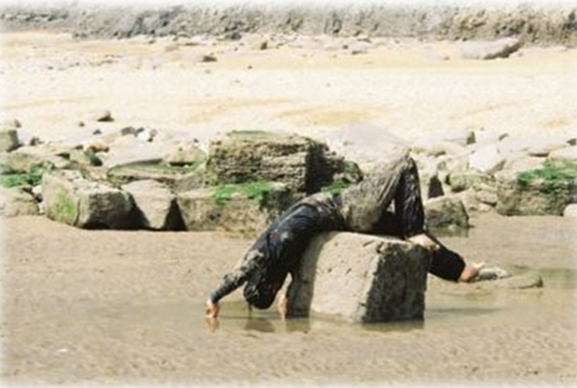
Participant in the WOL Practice, Image from; Walk of Life website, http://walkoflife.co.uk/main.htm, Accessed 25/11/19

Unstructured Interviews
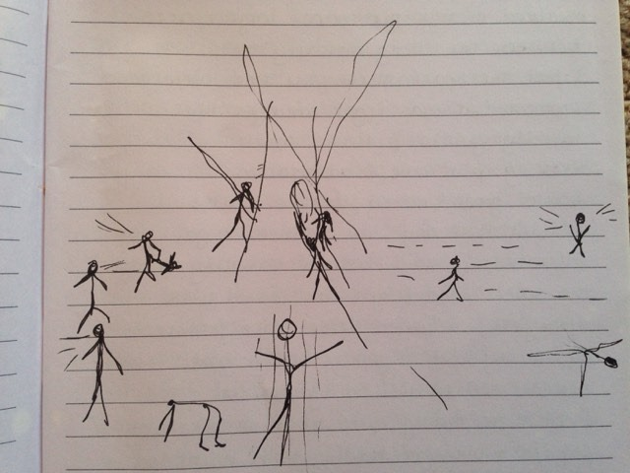

The methodology
Unstructured Interviews are often used as a qualitative research method in ethnographic practice to collect data, by conversing with research participants in an informal, casual manner (Bernard, 2006). As I wasn’t able to observe or write up on any of the other participant’s experiences participating in the WOL practice, I thought that undertaking unstructured interviews could be a way of connecting with participants and hearing about their participation, without it being obstructive. The WOL Facilitator agreed that I could ask the workshop participants to participate in my research study, if I agreed to only speak with them after the workshop was over, so that it wouldn’t intervene during the workshop period for reasons. I ended up conducting interviews with three of the workshop participants; Josie, Judy and Scott (two female, one male). I’d met the three of them in the first 4 day workshop in July, and met Josie and Judy again the following October workshop. Having signed the consent forms (view in the Appendix), I conducted the interviews with the three of them within the weeks and months following the July and October workshop. All interviews were conducted via phone-call, with each one ranging in the time frame of 30-90 minutes. I interviewed Judy once, and Josie and Scott a couple of times. All three participants were experienced movement practitioners, though their experience with the WOL practice ranged; Judy had explored the WOL practice for many years, Josie had attended a couple already during that year, whilst for Scott the July workshop was his first.

Undertaking the Interviews
During the workshops the participants and I had socialised and shared many conversations as well as partner and group movement activities, so by the time it came to undertaking the interviews I felt that the casual nature that was desired, had already been cultivated. As the interviews were unstructured, I didn’t have any set questions to ask the participants, as I wanted the conversations to have a life of their own. It was an interesting process to hear the thoughts, experiences, reflections and stories of the participants in regards to their participation in the WOL movement practice, and analyse them alongside mine. Through the interviews I found that similar themes emerged in regards to why participants partook in the WOL workshops and what it brought to their life. The core themes that emerged focused on the attending to the felt experience of being a body, which they felt were lost in everyday culture, as well as the feeling of having an intimate sense of connection with the more-than-human world, where they viewed their interactions and the thoughts, images and experiences that arose in the practice, as ‘teachings’. The core themes that were identified as shared by the participants and I, have been incorporated into the final discussion and research findings.

In the Field
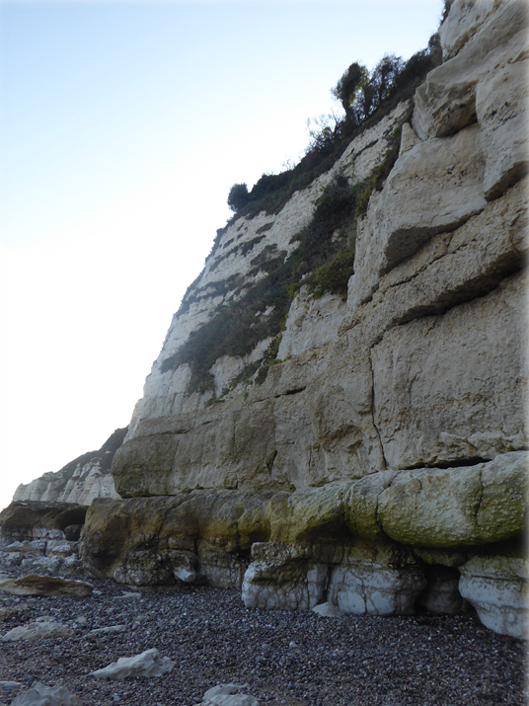

An Auto-biographical story
Utilising the format of story-telling as a means of writing from the body and inviting the reader to imagine the sensuous experience (Tuinamuana & Yoo, 2020) of participating in the WOL practice, I weave in the summary of my field findings, which I will extract and de-construct more fully in the following sub-sections. The story is a non-fictional account which aims to show what the WOL practice entails, by describing one of my most memorable movement experiences that took place in the October workshop, at Beer Beach, in East Devon.
***
We arrive at the last site for the day, scheduled in time with the waning of the tide as it slowly creeps away to reveal the softly shaped round pebbles that glisten underfoot, still wet from the frothy kiss of the sea, as the sun attempts to come out. The site is only available to us for as long as the tide allows, a symbolic lesson for us to learn to work with and respect the boundaries and limitations of the more-than-human world we live in (Roszak, 1995). Here, we are invited to explore a different way of being in relationship with the rocky formations that lie beneath the cliff, the Facilitator offers a score which encourages us to resist moving ‘on top’ of the boulders, instead inviting us to explore being in or amongst them, three-dimensionally. The crashing waves of the sea have sculpted miniature caves and hollow openings within the rock bodies, I note that I am excited to explore the hidden nooks and crannies. A thought comes to me, realising that my preference when hiking has tended to be towards exploring caves and gorges; landscapes that accentuate a feeling of immersion in and amongst more-than-human bodies, in which I can see things up close in detail and come to know them through touch and smell, in contrast to high mountain tops and vast open vistas which I often find to be overwhelming (Roszak, 1995). It seems that my body had registered the affect that various landscapes had on me, but it was only now that I was attentively awake to my bodily experience in relation to the landscape through engaging in the WOL practice, that I came to integrate this information consciously. Perhaps it is this same sensory knowledge that I called upon to choose my area to work with amongst these rocks, as we are encouraged to listen with our whole body and ‘follow’ any feeling that guides us (Enghauser, 2007). Sensing into my body, I feel a pull to move towards the left of the boulders, I cannot rationally describe what draws me towards that direction, other than describing it as a feeling in my body. Barrett, (2013) states that ways of knowing through Porosity cannot be understood through western intellectual frameworks of knowing, as it often appears through an image or feeling. I know my place of arrival as I feel a sense of my weight drop down, it just feels ‘right’, again, there is no rational way of explaining it (Barrett, 2013). I allow myself to land, placing myself front body onto the eroding rock. I lie on a lumpy pillar that faces out towards the sea, guarding the entrance to a tiny cavern where the sea has washed away some of the rock body. I shift and turn, I have ended up in a mode of observational thinking, and any attempt of movement from this alert state just feels false and awkward. My thoughts appear to take me away from being present and attentive to sensing my body and the environment which I’m in. I have been struggling this whole workshop, continuously trying to get it ‘right’, with the trying implying force and effort on my behalf. I have learnt by now that it doesn’t work that way, and so I give up the trying and just allow myself to receive the physicality of the rock body beneath me. My head is rested but my eyes are seeking information, and so I rationally decide to look less and feel more, stroking the inner layer of the tiny cavern. By now, my state of being has shifted, were I feel I am primarily sensing myself as a body, in relation to the rock body, relaxed and meeting it through the senses. Attuned to myself and my environment, I am reunited with the urge of sensation to move. My eyes are open, but they’re no longer guiding, my arms and legs move outwards exploring a new territory. I don’t see where my hands or feet land, my sensing body guides the way. The movement that unfolds between the rock body and I appears to be synchronised, I don’t know how or why but our movement just seems to combine. At times it feels like a trance, yet simultaneously I am here, grounded in the sensory and material domains of the body. The smell of seaweed, the pressure of the rock and my muscles, my feet sliding over pebbles. I crawl into the tiny cavern that cannot house the whole length of my body, sprawled upside down, I’m half in and half out. I allow myself to land in this position, sighs arise from the depths of my belly, and there is relief in this timeless state of being. After a while, I am drawn to the ground, dragging myself along the pebbles, for a moment I consider how I must appear to an observer (I think I must look ridiculous). Listening to the pull of my body, I follow anyway. I’m led to another rock body with a narrow crevice, I stick my head into its darkness and follow my urge to stroke it. I’m suddenly overcome by emotion, tears arise and a thought accompanies it; in my act of stroking the darkness of the crevice, I am simultaneously caressing the dark unacknowledged crevices that lie within my body (Roszak, 1995). These thoughts just arise, I don’t go out looking for them, they to come to me (Barrett, 2013). I’m on the move again, but this time I get up legs strong and leading. Seaweed drapes in my hair, the sun shines on my body, my back flat on a rock facing the open sea. I feel so alive! The bell rings and the work is done. The tide has crept in, and water surrounds me, lapping up to wet my body. I laugh, washing my face in the sea. What just happened? My senses are heightened and I feel so intimately connected to all the textures, smells, sounds and shapes that surround me. My perception of the world is brighter, clearer and I feel connected to myself as a sensual bodily being. I am not surprised to find that I am not the only one that uses the words ‘intimate’, ‘sensual’ and ‘alive’ to describe our movement experience, in the closing circle. The words of the Facilitator stays with me, “The World Needs More Wild Women”.

Discussion
If I have one word to describe the Walk of Life practice, it would be ‘Relationship’, as during my participation in the practice the word kept coming to me over and over again, whether I was moving with a tree or a human, it arose in various contexts. It is a complex and rich practice that I would consider ‘Ecological’ as it allows the participant to explore how they are in relationship with other human, and more-than-human entities (Roszak, 1995), on a holistic level, drawing upon one’s psychological, spiritual and physical being. I could’ve explored the practice through a different lens of any of the aspects I just mentioned, but as I was conducting a sensory ethnography, I felt pulled towards understanding how the sensory aspects of the practice could shape ones sense of self as being in relationship. In my attempt to understand the WOL practice, my primary findings are made up of two components which I have named; “Attending to the Body” and “Sensing Relationships”, both of which are linked but I consider Attending to the body to be a preliminary to “Sensing Relationships”.

“Attending to the Body, Sensing Relationship”
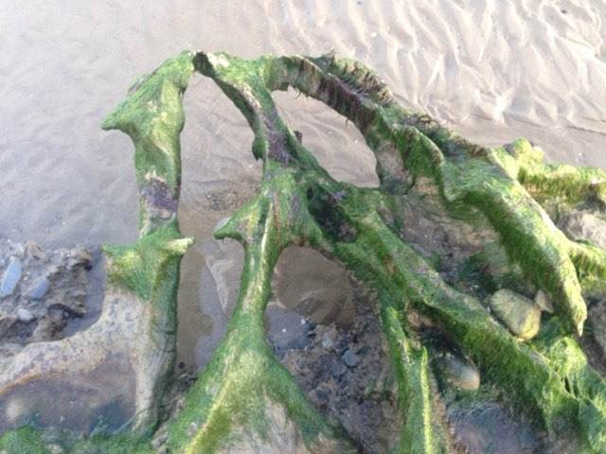

Conclusion

To conclude, in an attempt to answer my research question of “What is the Walk of Life Movement practice?” and “what does it do?”, my understanding of it through a sensory lens is that is a form of ‘sensory training’ that educates participants to learn to attend to the sensory experiences of the world

Boundaries
The universe does not revolve around you.
The stars and planets spinning
through the ballroom of space
dance with one another
quite outside of your small life.
You cannot hold gravity
or seasons; even air and water
inevitably evade your grasp.
Why not, then, let go?
You could move through time
like a shark through water,
neither restless or ceasing,
absorbed in and absorbing
the native element.
Why pretend you can do otherwise?
The world comes in at every pore,
mixes in your blood before
breath releases you into
the world again. Did you think
the fragile boundary of your skin
could build a wall?
Listen. Every molecule is humming
its particular pitch.
Of course you are a symphony.
Whose tune do you think
the planets are singing
as they dance?
(Ungar, 2012)

References
AAA Ethics Forum, (2012). Ethics statement, http://ethics.americananthro.org/category/statement/ (Accessed 23/7/20)
Abram, D. (1997). The Spell of the Sensuous: Perception and Language in a More-Than-Human World, Vintage Books, 1st Ed.
Atkinson, M, P. Delamont, S. Housley, W. (2007). Contours of Culture: Complex Ethnography and the Ethnography of Complexity, AltaMira Press, 1st Ed.
Baker, M, L. (2008). Unobtrusive Research, in L. M. Given (Ed.) The SAGE Encyclopaedia of Qualitative Research Methods, Vol 1&2, SAGE publications US, p. 904-905.
Barrett, M. (2013). Researching through methodology: an animist research methodology, The Handbook of Contemporary Animism.
Bernard, R. (2006). Research Methods in Anthropology, Qualitative and Quantitative Approaches, 4th Ed, AltaMira Press UK.
Blacking, J. (2018). Movement and Meaning: Dance in Social Anthropological Perspective, Dance Research: The Journal of the Society for Dance Research, Vol. 1, No. 1, Edinburgh University Press
Chang, H. (2008). Autoethnography, in: Autoethnography as Method (Developing Qualitative Inquiry), Routledge, Ch.3, p. 43-57.
Csordas, T. (1995). Embodiment and Experience: The Existential Ground of Culture and Self, Cambridge University Press.
Csordas, T. (1993). Somatic Modes of Attention, Cultural Anthropology, Vol. 8, No. 2 , p. 135-156, Wiley, American Anthropological Association.
DeWalt, R, B. DeWalt, M, K. (2002). Participant Observation: A Guide for Fieldworkers, Information and Interdisciplinary Subjects Series, AltaMira.
Eddy, M (2009). A brief history of somatic practices and dance: historical development of the field of somatic education and its relationship to dance, Journal of Dance and Somatic Practices Vol. 1, No. 1, Intellect Ltd
Enghauser, R. (2007). Developing Listening Bodies in the Dance Technique Class, Journal of Physical Education, Recreation and Dance, Vol. 78, No. 6.
Farnell, B. (1999). Moving Bodies, Acting Selves, Annual Review of Anthropology, Vol. 28, p. 341-373.
Farnell, B. Varela, R, C. (2008). The Second Somatic Revolution, Journal for the Theory of Social Behaviour.
Howes, D. (2019). Multisensory Anthropology, Annual Reviews of Anthropology.
Howes, D. (2003). Sensual Relations: Engaging the Senses in Culture and Social Theory, University of Michigan Press.
Howes, D. (2018). The Skinscape: Reflections on the Dermalogical Turn, Body & Society, Vol. 24, p. 225–239, SAGE Publications.
Ibbetson, S. (2010). ‘To Be Free To Be Myself’: The inclusion of Dance Movement Psychotherapy within a specialist day service for people meeting the criteria for personality disorder, Association for Dance Movement Psychotherapy (ADMP) U.K. Quarterly e-motion, Autumn 2010.
Ingold, T. (1992). Culture and the perception of the environment, in: Parkin, D. & Croll, E, J. (Eds) Bush Base, Forest Farm: Culture, Environment, and Development, Routledge 1st Ed, Ch. 3.
Ingold, T. (2011).Being Alive: Essays on Movement, Knowledge and Description, Routledge 1st Ed.
Ingold, T. Vergunst, L, J. (2008). Ways of Walking: Ethnography and Practice on Foot, Ashgate Publishing Ltd, UK & USA.
Jensen, D. (2008). ‘Access’, in L. M. Given (Ed.) The SAGE Encyclopaedia of Qualitative Research Methods, Vol 1&2, SAGE publications US, p. 1-2.
Karampoula, E. (2016). The Circle in Dance Movement Therapy: A literature review, Universitat Autònoma de Barcelona.
Kieft, E. (2013). Dance, Empowerment and Spirituality. An ethnography of Movement Medicine, Roehampton University
Latour, B. (2017). Anthropology at the Time of the Anthropocene: a personal view of what is to be studied, in: Brightman, M., Lewis J. (Eds) The Anthropology of Sustainability. Palgrave Studies in Anthropology of Sustainability, Palgrave Macmillan, New York.
Le Breton, D. (2017). Sensing the World: An Anthropology of the Senses, Sensory Studies, 1st Ed, Routledge.
McClure, B. (2015). Perspectives and Issues in Yoga Therapy, Yoga Therapy: Building a Holding Environment for Somatic and Psyche Change, International Journal of Yoga Therapy — No. 25, p21-26.
Milton, K. (2002). Loving Nature: Towards an Ecology of Emotion, Routledge, 1st Ed.
Myers, N. (2020). Anthropologist as Transducer in a Field of Affects, In: Loveless, N. (Ed)’s, Knowings & Knots: Methodologies and Ecologies of Research –Creation.
Ness, A, S. (1992). Body, Movement and Culture: Kinesthetic and visual symbolism in a Philippine community. University of Pennsylvania Press, USA.
Okely, J. (2007). Fieldwork Embodied, Sociological Review, Blackwell Publishing Ltd.
Omega Institute, (2018). The Growing Popularity of Somatic Practices; New Approaches for Mind, Body & Spirit, Online article: https://www.eomega.org/article/the-growing-popularity-of-somatic-practices (Accessed on 16/7/20)
Palmer, T. C. (2017). Culture and Sustainability: Environmental Anthropology in the Anthropocene, in: Brown, N., Tubelle de Gonzalez, L., McIlwraith, T. (Eds) Perspectives: An Open Invitation to Cultural Anthropology, Centre for Open Education, American Anthropological Association.
Pink, S. (2009). Doing Sensory Ethnography, SAGE Publications Ltd, London.
Pink, S. (2010). The future of sensory anthropology/the anthropology of the senses, Social Anthropology, Vol. 18, No. 3, P. 331-333.
Reeve, S. (2011). Nine Ways of Seeing a Body, Triarchy Press Ltd.
Roszak, T. Gomes, E, M. Kanner, D, A. Brown, R, L. Hillman, J. (1995). Ecopsychology: Restoring the Earth, Healing the mind, Counterpoint, 1st Ed.
Schensul, S. Schensul, J. LeCompte, D, M. (1999). Essential Ethnographic Methods: Observations, Interviews, and Questionnaires (Ethnographer's Toolkit Book 2), AltaMira.
Shildrick, M. Price, J. (1999). Feminist Theory and the Body: A Reader, Routledge.
Sklar, D. (2009). Reflecting on Words and Letters from the Perspective of Embodiment, with Commentary on Essays by Daphne Lei, Susan Phillips, and Sohini Ray, Anthropological Quarterly, Vol. 82, No. 1, George Washington University Institute for Ethnographic Research.
Somatic Tool Kit, (n.d) Somatic tool kit for ethnographers, online website, http://somaticstoolkit.coventry.ac.uk/ (Accessed 8/6/20)
Sparkes, C, A. (2017). Seeking the senses in physical culture: sensuous scholarship in action, Research in sport, culture and society, Routledge.
Spatz, B. (2017). Embodied Research: A Methodology, Liminalities: A Journal of Performance Studies, Vol. 13, No. 2.
Spinney, J. (2006). A Place of Sense: A Kinaesthetic Ethnography of Cyclists on Mont Ventoux, Environment and Planning D: Society and Space, Vol. 24, Issue 5, p. 709-732, SAGE Publications.
Totton, N. (2015). Embodied Relating: The Ground of Psychotherapy, Routledge.
Tuinamuana, K. Yoo, J. (2020). Reading Autoethnography: The Impact of Writing through the Body, The Qualitative Report, Vol. 25, No. 4, Article 6.
Ungar, L. (2012). Boundaries, Bread and Other Miracles, AuthorHouse.
Walk of Life (n.d). online website, http://walkoflife.co.uk/main.htm (Accessed 8/6/20)
Williams, D. (2004). Anthropology and the Dance: Ten lectures, University of Illinois Press, 2nd Ed.
Zarif, T. (2012). Grounded Theory Method: An Overview, Interdisciplinary of Contemporary Research in Business, Vol. 4, No. 5.

Appendix
1. Signed consent forms by Workshop Facilitator and Participants



