

LCBB 6015
Strategic Management and Sustainability
Component 1

Student Name: Alex Andrei Perca
Student ID: 2020362

Executive Summary
This report is an analysis of the strategic position of Jaguar Land Rover in the UK automotive industry. It explores external factors, including regulation of the electric vehicles, competition and customer demand and internal capabilities like brand value and engineering. The research concludes that Jaguar Land Rover needs to hasten their electric vehicle investments, enhance their business performance, and enter new markets. These policies can assist the firm to grow sustainably, lowering risk, and preserving its competitiveness in the international luxury automobile market.

Contents
Executive Summary 2
Introduction 4
Strategy Analysis 4
External Environment Audit 5
PESTLE Analysis 5
Porter’s Five Forces 6
Internal Environment Audit 7
Value Chain Analysis 7
Resource-Based View (RBV) 7
VRIO Analysis 8
SWOT Analysis 9
Strategy Formulation 10
Conclusion and Recommendations 11
References 12

Introduction
Strategic management assists organisations to understand their environment and make improved decisions as well as succeed in the long run. Strategic planning is quite important in the automotive industry due to the dynamic nature of the environment, technology and customer preferences. Jaguar Land Rover is a large luxury vehicle producer in the United Kingdom of the Tata Motors group. The brands of vehicles sold by the company include Jaguar, Range Rover, Defender and Discovery, and the company sells its vehicles in numerous markets around the world. The vision of Jaguar Land Rover is modern luxury and sustainability, and the mission is to create innovative and high-quality cars that are less harmful to the environment. The key targets of the company are to increase the number of electric vehicles manufactured, become carbon-neutral by 2039, and enhance its position in the world market (Jaguar Land Rover, 2023). Realisation of these objectives is required to analyse the impact of internal resources and external forces on the future strategy of Jaguar Land Rover.
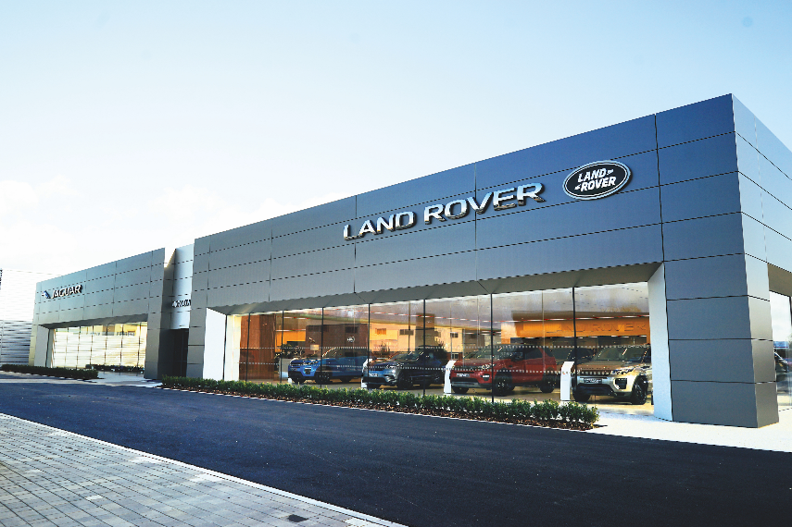
Figure 1: (Jaguar Land Rover, 2024)

Strategy Analysis
Jaguar Land Rover (JLR) faces a dynamic automotive environment worldwide; this is due to the rapid shift in technology (electric vehicle (EV)) and new environmental regulations, supply chain interruption, and shifting customer requirements. External and internal environment analysis is significant to know the impact of the forces on the long-term strategy of JLR and its competitive advantage.

External Environment Audit

PESTLE Analysis
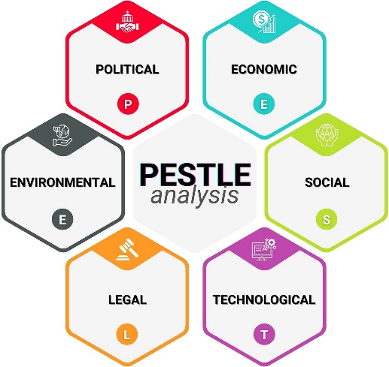
Figure 2: PESTLE Analysis (Ibrahim et al., 2021)
Factor | Impact on Jaguar Land Rover
Political | The UK and European governments are seeking to stop selling petrol and diesel cars by 2030-2035. This policy compels businesses to spend a lot of money on EV technology and charging infrastructure (SMMT, 2024).
Economic | High interest rates, inflation, and uncertainty in the world slow down the demand for luxury cars. Production costs have also been increased by shortages of semiconductors and the prices of raw materials.
Social | There is an escalated interest in sustainable and connected cars among customers. Luxury SUVs are also in demand in China, the US and the Middle East markets (ACEA, 2024).
Technological | Emerging fast-growing trends in battery technology, artificial intelligence, and autonomous driving demand a significant amount of research. The quicker the innovation, the better placated the firms are.
Legal | The adoption of stringent emission laws in the UK and EU drives up compliance costs but paves the way for clean vehicles being developed (Lawson, Salanitri and Waterfield, 2016).
Environmental | The stress on carbon emission reduction has motivated JLR to pursue the goal of net-zero carbon in its supply chain by 2039, as part of its strategy on reimagine, which is termed as Reimagine (Jaguar Land Rover, 2024).

In this analysis, it has been revealed that the environmental and technological factors have the greatest impact on the strategy of JLR. Firms that do not embrace EV technology will fail to get market share and may be penalised in the courts of law.

Porter’s Five Forces
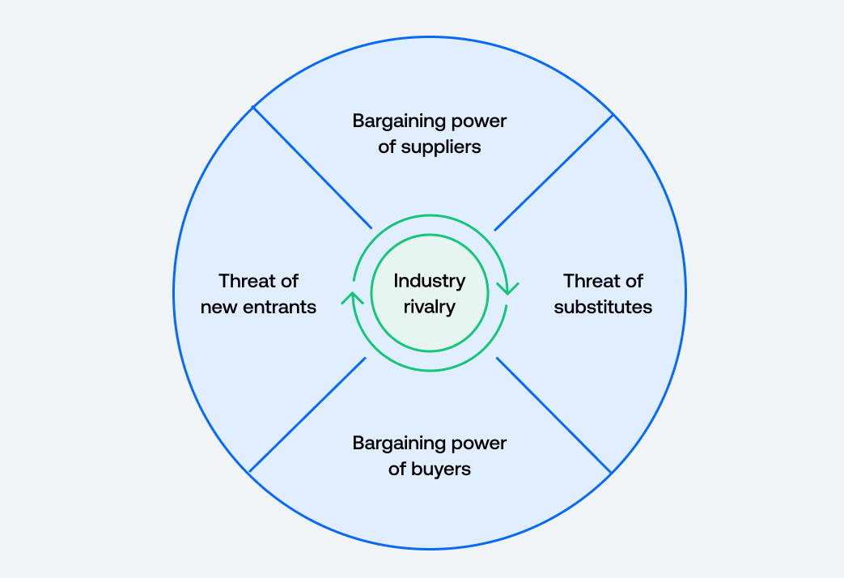
Figure 3: Porter’s Five Forces (David and David, 2017)
The level of competition within the high-end motor vehicle industry is extremely intense due to the presence of other companies like BMW, Mercedes-Benz, Audi, Lexus, and Tesla within the comparable market segments. These companies invest heavily in electric and digital technology that puts pressure on JLR. New entrants have a medium threat. It takes huge amounts of capital and good engineering skills to operate in the automotive industry, yet the new EV businesses are coming into China and the US with government financing. The power of suppliers is also high since there is a shortage of battery manufacturers and semiconductor suppliers. Recent years have witnessed shortages in supply, which lowered vehicle production in the UK automotive industry (SMMT, 2024). The buyer power is moderate, as luxury customers demand quality and can compare prices on the internet with the help of the brands. Nonetheless, Range Rover and Defender have high brand loyalty, which decreases switching. Risks of substitutes are moderate as well due to the fact that the ownership of private cars can decrease with the influence of such services as public transport, car-sharing, and future autonomous mobility.
On balance, the analysis conducted by Porter reveals that JLR is situated in a very competitive and risky business where innovation should be constant.

Internal Environment Audit

Value Chain Analysis
The value chain of Jaguar Land Rover brings out a number of strengths. The inbound logistics possess the advantage of a wide network of suppliers at a global level and deep collaboration within the Tata Motors group, which contributes to the acquisition of components and technical expertise (Tata Motors, 2025). The company has high-technology UK production facilities like Solihull and Halewood, where it is investing in EV technology and digital systems. It has a global network of dealers that supports outbound logistics in over 100 countries to enhance access for customers. The strong luxury brands like Range Rover, Defender, and Jaguar enhance marketing and sales. High-quality after-sales services also raise customer loyalty and brand image (Keith and Gubellini, 2020). Nevertheless, JLR has a poor value chain. The UK has high production costs when compared to the Asian competitors, and due to the complications in the supply chains, it becomes risky during global disruption. JLR is also later to get into the EV market, compared to competitors, and this creates technological pressure.

Resource-Based View (RBV)
The RBV theory states that valuable, rare, and difficult-to-imitate resources give a competitive advantage to firms (Barney, 1991). The main resources of JLR are: good global brands, British design, engineering, access to the Tata Group finance and supply system, and employee competency. Some resources enable the company to remain in the luxury SUV market. Nonetheless, EV software capability and battery technology are not scarce resources for JLR at the moment since the rivals have already designed powerful systems. Thus, the firm should be persistent in its innovations to guard its competitive edge.

VRIO Analysis
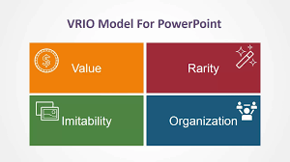
Figure 4: VRIO Framework (Schermerhorn et al., 2020)
Resource | Valuable | Rare | Hard to Copy | Organised | Result
Range Rover Brand | Yes | Yes | Yes | Yes | Sustained advantage
Engineering Expertise | Yes | Medium | Medium | Yes | Temporary advantage
Global Dealer Network | Yes | No | No | Yes | Competitive parity
EV Technology | Yes | No | No | Improving | Future advantage

SWOT Analysis
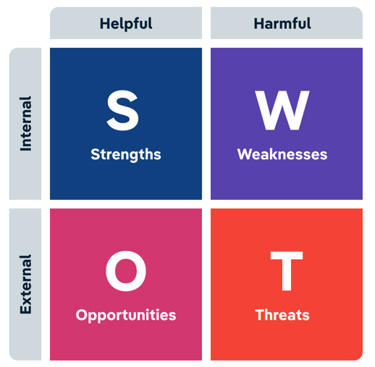
Figure 5: SWOT Analysis (Shubin, 2019)
Strengths | Weaknesses
Strong luxury brands | Late EV development
Engineering capability | High production cost
Global presence | Supply chain disruption
Tata Group support | Limited small EV range
Opportunities | Threats
Growing EV demand | Tesla and Chinese EV firms
Emerging markets growth | Economic slowdown
Digital vehicle services | Strict emission regulation
Sustainability branding | Rapid technology change

Critical Evaluation
The environmental regulation, high rate of EV innovation and intense global competition are among the external environmental forces that are felt. The internal analysis reveals that JLR possesses an appreciable asset like a brand name and engineering skills, yet poor cost engineering and EV preparedness should be improved. As such, the successful future of the company relies on its ability to integrate its robust brand in luxury with rapid technological change. The current investment of JLR in electric vehicles and sustainable production proves that the company realizes such challenges and allows remaining competitive in the long-term strategy (Jaguar Land Rover, 2024).

Strategy Formulation
Jaguar Land Rover (JLR) requires strategies that enhance its competitive advantage and sustainability in the long run based on the external and internal analysis. Environmental regulation, the fast innovation of EVs, and the intense competition in the world are already pressing the company to the highest level. Thus, there are three primary strategic options which can be applied to JLR.
To begin with, JLR must expedite the process of transforming into an electric car by investing more in battery technology and strategic alliances. The company is declaring its Reimagine strategy, according to which all Jaguar models will go fully electric and numerous electric Land Rover cars will be launched in the next few years (Jaguar Land Rover, 2024). Nonetheless, Tesla and BMW competitors have already acquired a good experience in EVs. To reduce this gap, JLR can work together with battery manufacturers and software developers to increase the range, charging rate, and digital services. The automotive industry is also associated with strategic alliances as EV creation is an expensive research process that needs to be conducted with collaboration (Johnson et al., 2011). This strategy can minimise risk and enhance the rate of innovation.
Second, JLR ought to enhance the efficiency of its operations by means of digital production and supply chains localisation. The problem of high costs and inadequate semiconductor supply in the UK automotive industry decreased the level of production over the past several years (SMMT, 2024). JLR has an opportunity to invest in smart factories, artificial intelligence planning of production, and local networks of suppliers in the UK and Europe. Such a plan can minimise the delays, decrease the transport cost and enhance the sustainability performance. Porter (1985) states that product differentiation coupled with cost efficiency is a more competitive advantage. JLR has a good luxury brand that can have access to a cost structure that is less costly but does not compromise on quality.
Third, JLR ought to consider venturing into the emerging markets cautiously with electric luxury SUVs. The premium vehicle segment is in high demand in countries like India, the Middle East and Southeast Asia (ACEA, 2025). Being a subsidiary of Tata Motors, JLR already has the knowledge of the market in India. Local assembling and localised marketing are capable of generating more sales and also lowering the import tax. This is in line with the Ansoff market development strategy, whereby companies expand through offering current products in new markets (Ansoff, 1957).
In general, the following strategies can be considered as realistic since they are based on the major strengths of JLR, including good brand recognition and engineering, and the weaknesses, such as the late entry into the EV market and the high cost of production, are addressed. EV investment, digital operations, and new market expansion can make JLR grow sustainably and stay in the international luxury automotive sector.

Conclusion and Recommendations
This report has studied the strategic position of Jaguar Land Rover in terms of the external and internal environment. It was seen that the key external pressures are the high level of environmental regulation, the rapid development of electric vehicles, and the competitive environment created by the world of luxury brands. Meanwhile, the strong brand name, engineering ability, international network of dealers, and the Tata Motors Group support are the internal strengths which can be valued by Jaguar Land Rover. Nevertheless, such weaknesses as high cost of production, difficulties with supply chains, and lateness in entering the market of electric vehicles pose a strategic risk.
In order to be competitive and attain sustainable growth, there are some practical measures that can be suggested. To begin with, Jaguar Land Rover must proceed with increasing the investment in electric vehicles and establish alliances with battery and software providers to enhance the pace of innovation. Second, the company ought to digitalise the manufacturing process by adopting digital manufacturing and localise more to minimise costs and supply disruptions. Third, Jaguar Land Rover must diversify cautiously into the high-growth emerging markets with electric luxury SUVs to gain market share in the world. To sum up, Jaguar Land Rover can continue to be successful over the long term, provided that the company can incorporate its rich luxury tradition with swift electrification, high efficiency of work, and effective globalisation. Such moves will assist the firm to react to the industry changes and, at the same time, guard its competitive advantage.

References
ACEA (2025) Economic and Market Report: Global and EU Auto Industry – Full Year 2024. Brussels: European Automobile Manufacturers’ Association. Available at: https://www.acea.auto/publication/economic-and-market-report-global-and-eu-auto-industry-full-year-2024/
Ansoff, H.I. (1957) ‘Strategies for diversification’, Harvard Business Review, 35(5), pp. 113–124.
Barney, J. (1991) ‘Firm resources and sustained competitive advantage’, Journal of Management, 17(1), pp. 99–120. doi:10.1177/014920639101700108.
David, F.R. and David, F.R. (2017) Strategic Management: A Competitive Advantage Approach, Concepts. 16th edn. Boston: Prentice Hall.
Ibrahim, N., Cox, S., Mills, R., Aftelak, A. and Shah, H. (2021) ‘Multi-objective decision-making methods for optimising CO₂ decisions in the automotive industry’, Journal of Cleaner Production, 314, p.128037. doi:10.1016/j.jclepro.2021.128037.
Jaguar Land Rover (2023) JLR to Invest £15 Billion Over Next Five Years as Its Modern Luxury Electric-First Future Accelerates. Available at: https://www.jlr.com/news/2023/04/jlr-invest-ps15-billion-over-next-five-years-its-modern-luxury-electric-first-future
Jaguar Land Rover (2024) Annual Report 2024. Available at: https://www.jlr.com/annual-report-2024
Johnson, G., Whittington, R., Scholes, K., Angwin, D. and Regnér, P. (2011) Exploring Strategy. London: Financial Times Prentice Hall.
Keith, L.A. and Gubellini, C.E. (2020) Business Management. New York: McGraw-Hill.
Lawson, G., Salanitri, D. and Waterfield, B. (2016) ‘Future directions for the development of virtual reality within an automotive manufacturer’, Applied Ergonomics, 53, pp. 323–330. doi: 10.1016/j.apergo.2015.06.024.
Porter, M.E. (1985) Competitive Advantage: Creating and Sustaining Superior Performance. New York: Free Press.
Schermerhorn, J.R., Davidson, P., Woods, P., Simon, A., McBarron, E. and Junaid, F. (2020) Management. 7th Asia-Pacific edn. Milton, Qld: John Wiley & Sons Australia.
Shubin, J.A. (2019) Business Management. New York: Barnes & Noble.
SMMT (2024) SMMT Motor Industry Facts 2024. London: Society of Motor Manufacturers and Traders. Available at: https://www.smmt.co.uk/wp-content/uploads/2024/11/SMMT-Motor-Industry-Facts-2024-August.pdf
Tata Motors (2025) 80th Integrated Annual Report 2024–25. Mumbai: Tata Motors Limited. Available at: https://www.tatamotors.com/wp-content/uploads/2024/05/tata-motor-IAR-2024-25.pdf

