Foreign Languages and Cultural Awareness

Student Name:Rezwana laboni
Student ID:2242894
Lecturer: Giulia Chifari
Module code: BMIH5003
Table of Contents
Component 1: Professional Reflection 3
Component 2: Training Plan 4
Component 3: Student Self-Reflection 6
Component 4: Training Presentation 8
References 10

Component 1: Professional Reflection
Introduction
In a crowded and busy hotel restaurant during dinner time, I witnessed a situation that represents well the reason why things go wrong between different societies. Maria is an F&B staff who has worked here for many years; she uses Italian as her mother tongue. She was engaged in conversation with Mr. Chen, a Chinese visitor. This setting exemplifies the chaotic nature of hotel dinners and allows for intercultural communication to happen at the same time.
Description of the Scenario
To begin with, the event was initiated by Mr Chen who tried to make an order mixing English and Mandarin which he used to describe his dietary requirements that consist of being severely allergic to shellfish. Having misunderstood his accent and not known specific terms in Mandarin, Maria thought he wanted to know what were the seafood specials of the day. In addition to this confusion, she also observed him shaking his head while using non-verbal communication — a move that she took for assent instead of understanding that he could not eat some things.
Analysis
Cultural Dimensions:
Hofstede’s cultural dimensions theory provides a useful model for explaining the effects of diversity on communication in a hospitality context. Two dimensions are particularly relevant to Maria and Mr Chen’s situation — Uncertainty Avoidance and Long-Term Orientation.
Uncertainty Avoidance: This index measures how much people try to minimize ambiguous or uncertain situations when they are anxious. Hofstede et al., (2010) state that Italian culture is associated with high levels of ambiguity tolerance and informal communication due to its low ranking on Uncertainty Avoidance. Therefore, it might be that Maria was more relaxed at first because she expected some little challenges as they went along.
Long-Term Orientation: This dimension looks at how societies deal with the past while planning for the future. In a long-term oriented culture, timing is everything; events must be planned within precise periods so different service providers can communicate consistently enough to prevent future problems especially among Chinese guests where(Guo & Sanchez-Hernandez, 2017). For this reason, an employee from Italy may change details on the go but a client from China will require exact service confirmations if room orders or check-ins are not to create any confusion later(Hofstede et al., 2010).
Language Barriers: The power of language cannot be underestimated in such scenarios. If only Maria knew how to speak Mandarin fluently or Mr Chen had better English vocabulary then their conversation would have been smoother(Bird & Osland, 2004). Hence there should always be language training programs offered by hotels where employees can learn few phrases of various languages related to health and safety precautions during food service(Les Roches, no date).
In summary, it has been realized through this reflection paper that international hotel workers need cultural sensitivity besides linguistic competence. From these findings therefore there should be trainings conducted in future which will take care of both elements since failure may lead not only unsatisfied guests but also compromised dining experiences that may affect their health(Keating et al., 2018).

Component 2: Training Plan
Introduction
The New Steine Hotel is a vibrant place. People from all over the world come to us with different cultural experiences and this requires that we provide all-rounded cultural awareness trainings coupled with communication skills. Our commitment to excellent customer service means that every employee should be able to identify and deal with language and culture diversity related complications. The aim of this program is equipping workers with knowledge necessary for establishing more effective relationships with clients leading to increased satisfaction levels among them and creating an inclusive environment for everyone. We need not only meet but also exceed expectations by understanding each other better as hosts while dealing with visitors (Jin, 2023).
Objectives of the Training
To accomplish this, our training program needs to teach many different skills to our employees. Here are a few of them:
- Cultural sensitivity: The main aim is to foster in them an open-mindedness and respect for other peoples’ ways of life so that they can deal with every customer interaction from a place of empathy and appropriateness.
- Semantics: They also need improvement on this area seeing that some clients may not be fluent in English as their first language; it will help them know how to put across their points clearly when communicating with such people.
- Conflict resolution: This can be done by informing them about the various ways through which they may handle disagreements arising from diverse cultures leading to peaceful and positive outcomes (Li & Wang, 2023).
Training Content
Our training will be varied and loaded with synonyms, consisting of numerous interesting and informative modules:
- Scenarios for Role Play: In this case, employees will have to act out various kinds of service encounters with people coming from different cultures so as to rehearse their reactions in a safe environment.
- Linguistic Entertainments: Engaging activities are designed for teaching well-used expressions in languages spoken by our clients thus making learning process more fun.
- Cultural Etiquette Lessons: This involves teachings on what is considered good or bad manners when interacting with individuals from other nations; these include common greetings and customs.
- Technology and Materials: Use of language learning software and cultural guides to enhance learning flexibility and provide ongoing support in the workplace.
- (De-La-Cruz-Diaz et al., 2023).
Implementation Strategy
- Timeline: The initial rollout of the training program will last for three months, with sessions held bi-weekly. Each session will last approximately two hours, designed to fit within the staff’s regular working schedules without causing disruption to our service delivery.
- Participant Grouping: Staff will be grouped cross-departmentally to promote diverse interactions and learning experiences. This strategy will not only enhance the training impact through varied perspectives but also strengthen team cohesion across different operational areas of the hotel (Adekola and Sergi, no date).
Evaluation
To measure the success and impact of our training, we will implement a multi-faceted evaluation approach:
- Feedback Forms: Immediately after each training session, participants will be asked to complete a detailed feedback form. This form will gather insights into the staff's perceptions of the training's relevance and effectiveness.
- Practical Tests: To assess knowledge retention and practical application, staff will undergo periodic assessments that simulate real-life scenarios they are likely to encounter in their daily interactions with guests.
- Follow-up Observations: Supervisors and managers will conduct regular follow-up evaluations through direct observation during normal operations. These observations will focus on how well staff are integrating their new skills into everyday guest interactions. To write the most efficient method of continuously improving training materials and delivery systems is the purpose of this study (Spencer-Oatey & Franklin, 2009).
Our teaching system covers everyone, it is not just about giving information; it empowers our staffs so that New Steine Hotel can remain as a hospitality leader by fostering an environment where people have respect for one another and value diversity.

Component 3: Student Self-Reflection
Introduction
In the field of hospitality where everything is constantly altering, it is necessary for one to become acquainted with different cultures not only because it is polite but also because it determines success. When I look back at my time spent working in this sector, I realise that I have always used Gibbs Reflective Cycle to reflect on how much more understanding I gained towards cultural awareness and its effects on my professional relationships (Spencer-Oatey & Franklin, 2009).
Description
Once upon a time, while I was still a novice in this trade, there took place in my life an incident which coincided with the time we were having an international convention at our hotel where I had been given the task of arranging for food to be served during sessions. The program ran into unforeseen problems because of certain dietary restrictions resulting from cultural beliefs that were alien to me; this oversight made many powerful individuals who graced the occasion very angry with us and showed how ignorant I was about other cultures in those early days.
Feelings
Never in my life had I been more devastated and ashamed of myself than at that moment. Until then, I didn’t know what cultural competence meant so now I want to know everything there is about it. The thing that struck me most was how quickly we fixed whatever disappointed our guests; this taught me the greatest lesson ever.
Evaluation
As a member of staff at this institution, one thing has become clear to me after these events which is just how much effort our organization puts into dealing with cultures from different parts of the world. It wasn’t easy because some mistakes were made in the beginning but they were rectified immediately thus showing the importance of being culturally aware in a hotel environment. Additionally, positive outcomes included learning from mistakes committed during such occasions as well as amending relevant areas in light of subsequent operational changes (Alvesson & Sveningsson, 2015).
Analysis
Looking back on it now using things like Hofstede’s dimensions of culture approach I can see that there should be more education given around other cultures within hotels (Hofstede et al., 2010). Furthermore, reflecting upon what happened here has helped me realize that besides knowing how to work with people from different backgrounds; cultural intelligence needs to be incorporated throughout management positions held by employees so as they can adequately respond various client needs (Schein, 2010).
Conclusion
This has been a turning point for me in terms of where institutions offering services to strangers should stand when it comes to cultural awareness. I now understand that it is important not only knowing what can be done while dealing with persons of dissimilar customs but also taking steps towards ingraining this knowledge into every level hospitality management
Action Plan
I have done a few things to prevent this from happening again:
- Ongoing training programs: This means arranging ongoing cultural awareness trainings for all staffs on how to deal with different cultures using real life examples and role plays to foster understanding (Gelfand, Erez & Aycan, 2007).
- Groups for Cultural Resources: Establish groups within the organization that will keep learning about different traditions and updating operational methods where necessary.
- Feedback Loops: Creating avenues through which visitors can air their views on whether their social needs have been met or not so as to trigger more training among employees.
In the hotel industry, there are certain things that need to be done in order to create a culturally sensitive atmosphere that fosters guest satisfaction and employee competence. Having reviewed the above findings, it can be said that a lot can be changed through studying diverse cultures. This applies not only in terms of career growth but also personal growth and ethical standards in business. There is one idea I always have every time I look back at my previous beliefs or actions: Understanding culture is endless – it is an ongoing process; and this has a big impact on building careers in the hospitality industry. Each encounter with another human being gives me a chance to understand more about myself and everything else there is around me so that we can create inclusive communities for all irrespective of their faiths or geographical origin.”

Component 4: Training Presentation
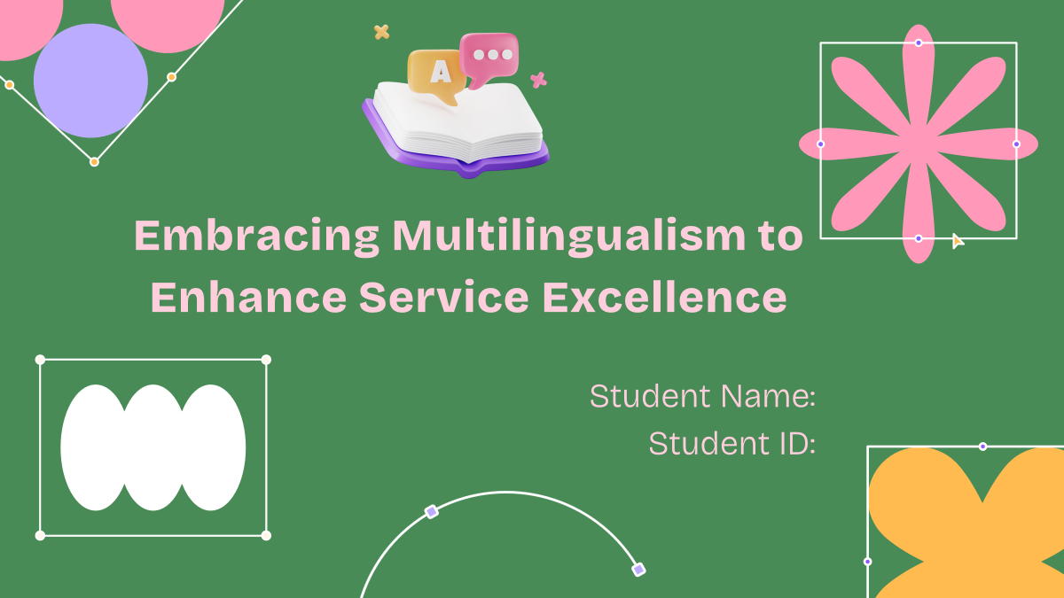
Slide 1: Introduction
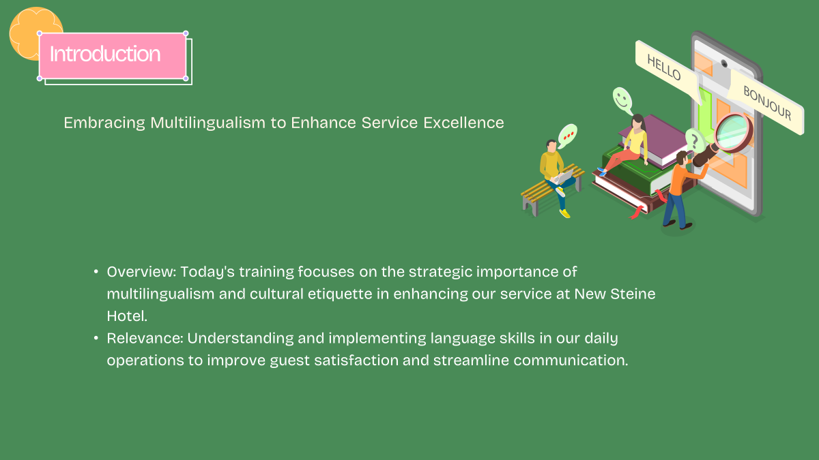
Hello all! Good morning to you all. I am glad we are gathered here this morning for a session that goes by the name ‘Embracing Different Dialects to Enhance Service Delivery’.” At New Steine Hotel, we have always strived to provide excellent customer care to people from various parts of the globe; I must admit that speaking many tongues is not just a gift but a way of making someone feel taken care of and loved because you can relate with them at personal levels which also creates an environment where each person feels valued. Today let us talk about why we need language variety in our operations today and its effects on customer satisfaction as well as efficiency improvement.
Slide 2: Benefits of Multilingualism
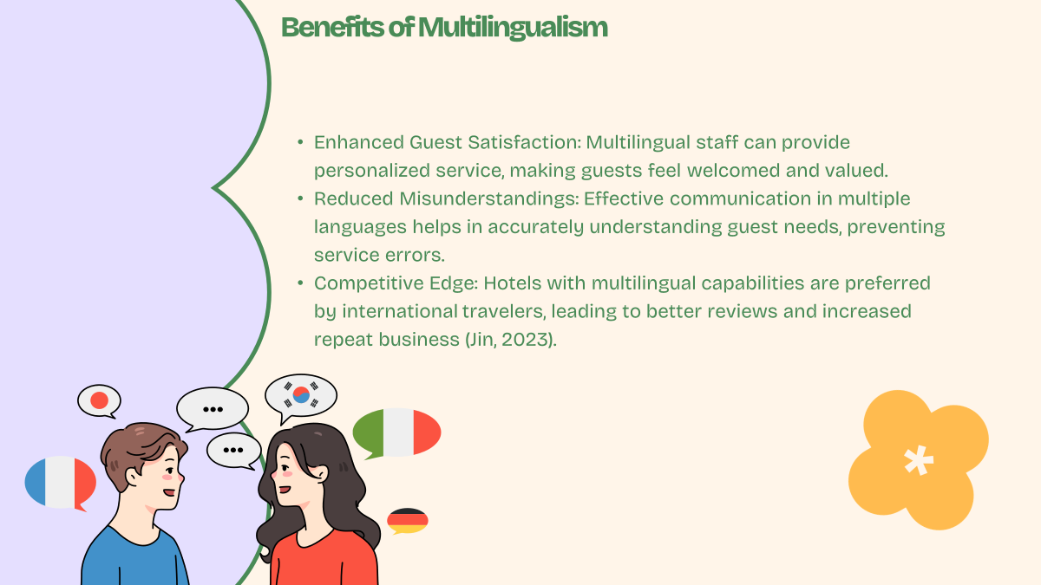
Let us now look at what are the benefits that come with knowing more than one language? First and foremost, it enables us to establish strong bonds among ourselves and those who use our services most especially visitors. When they see that we mind about their well-being by using the same language(s) as theirs’, they become happier. Secondly, multiple dialects help in avoiding misunderstandings since accurate communication is important in such industry like when reserving rooms or ordering meals among others.” Lastly, multilingual capabilities give us a competitive edge. International travelers often seek out hotels that cater to their language needs, leading to better reviews and repeat business. According to Jin (2023), hotels with staff proficient in multiple languages tend to have higher guest retention rates.
Slide 3: Language Awareness Skills
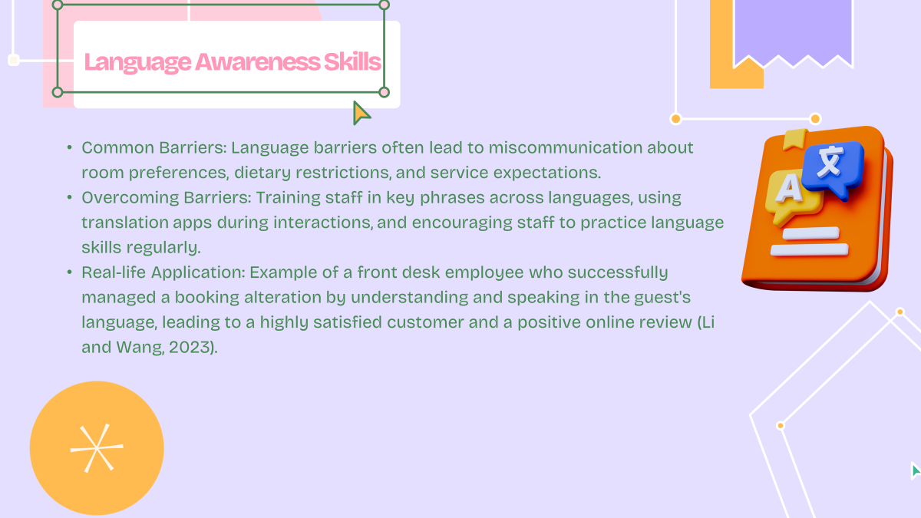
Communication barriers are a common challenge in hospitality. Misunderstandings about room preferences or dietary needs can lead to guest dissatisfaction. How do we overcome these barriers? By training our staff in key phrases across the most common languages of our guests and employing technology like translation apps during interactions. For example, consider a front desk employee who used their language skills to adjust a booking for a non-English-speaking guest. The guest not only left a positive review but also highlighted the exceptional service in our monthly feedback survey (Li and Wang, 2023).
Slide 4: Cultural Etiquette
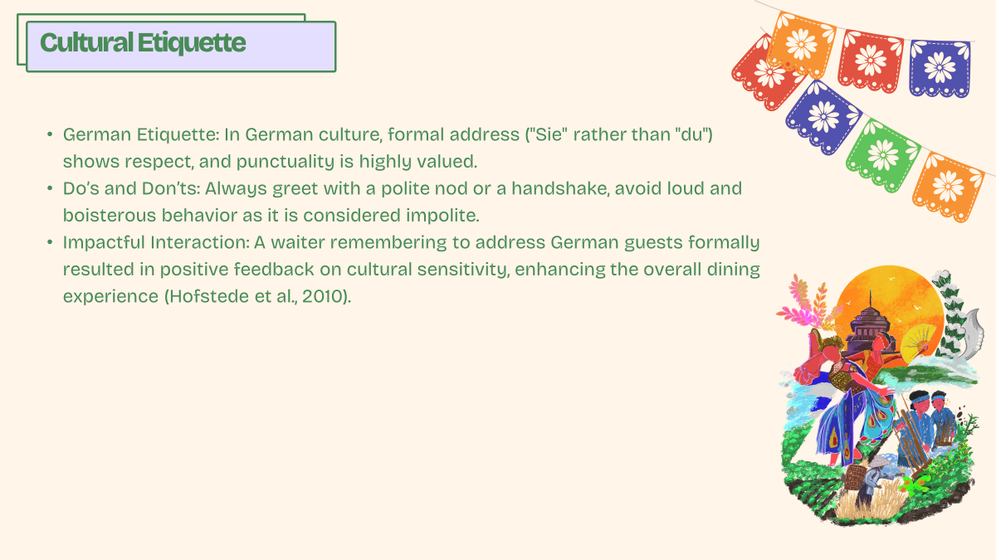
Understanding cultural etiquette is just as crucial as language skills. For instance, in German culture, which is one of our frequent guest demographics, a formal greeting is appreciated and punctuality is revered. Simple actions, like using the formal 'Sie' instead of 'du', and greeting with a polite nod, can make a significant difference in how our service is perceived. Such attentiveness to cultural details can lead to enhanced guest experiences, as evidenced by positive feedback from German guests who have appreciated these small yet significant gestures (Hofstede et al., 2010).
Slide 5: Conclusion
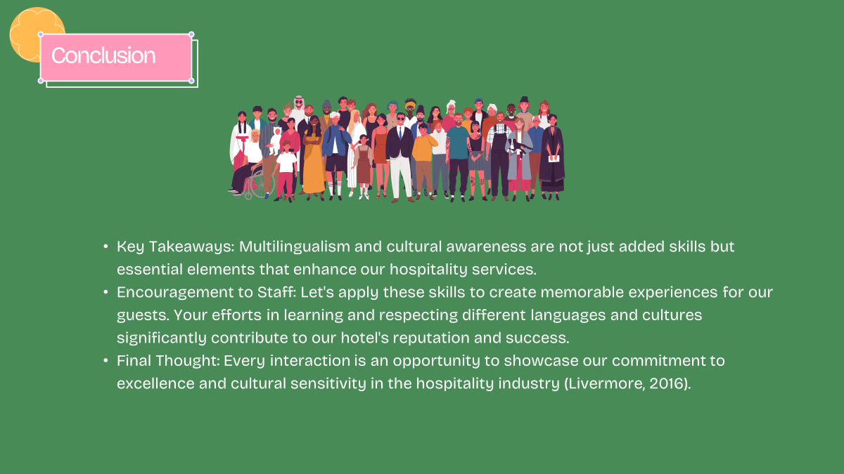
As we wrap up today's session, I encourage each of you to see every guest interaction as an opportunity to practice and improve your multilingual and cultural etiquette skills. These efforts are not just about avoiding misunderstandings; they're about creating memorable experiences that guests will cherish and share with others. Remember, your ability to adapt and respect different cultures greatly contributes to our reputation and success in the competitive hospitality market. Let's continue to learn and grow together, ensuring that the New Steine Hotel remains a leader in hospitality excellence (Livermore, 2016).


References
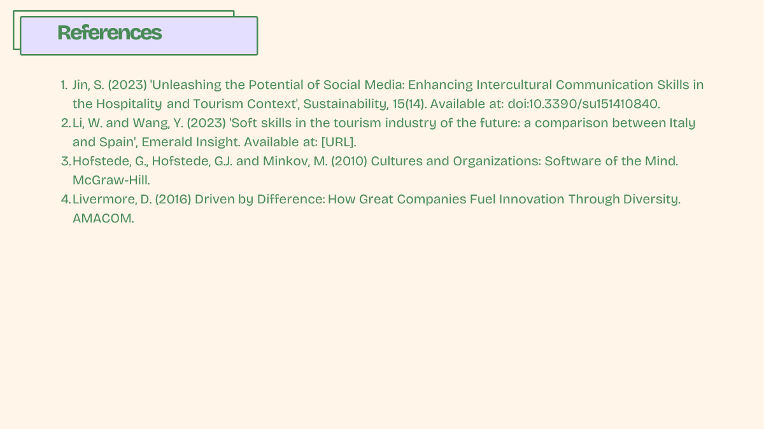
Adekola, A. and Sergi, B.S. (No date) 'The Impact of Cross–Cultural Training on Employee Performance in the Hospitality Industry', SpringerLink. Available at: [URL].
Bird, A. and Osland, J. (2004) 'Making sense of intercultural collaboration', International Studies of Management & Organization, 34(2).
De-La-Cruz-Diaz, M. et al. (2023) 'Cross-Cultural Impacts on Tourism, Hospitality, and Recreation', Emerald Insight. Available at: doi:10.1108/S1877-636120230000030034.
Earley, P.C. and Ang, S. (2003) Cultural Intelligence: Individual Interactions Across Cultures. Stanford University Press.
'Employee perceptions of diversity management in the hospitality industry' (No date), Emerald Insight. Available at: [URL].
Hofstede, G., Hofstede, G.J. and Minkov, M. (2010) Cultures and Organizations: Software of the Mind. McGraw-Hill.
Holden, N.J. (2002) Cross-Cultural Management: A Knowledge Management Perspective. Financial Times/Prentice Hall.
'How Cultural Intelligence Facilitates Employee Voice in the Hospitality Industry' (2023), Sustainability, 15(11). Available at: doi:10.3390/su15118851.
Jin, S. (2023) 'Unleashing the Potential of Social Media: Enhancing Intercultural Communication Skills in the Hospitality and Tourism Context', Sustainability, 15(14). Available at: doi:10.3390/su151410840.
Les Roches (No date) 'Cross-cultural communication skills for excellence in hospitality', Les Roches. Available at: [URL].
Li, W. and Wang, Y. (2023) 'Soft skills in the tourism industry of the future: a comparison between Italy and Spain', Emerald Insight. Available at: [URL].
Livermore, D. (2016) Driven by Difference: How Great Companies Fuel Innovation Through Diversity. AMACOM.
Spencer-Oatey, H. and Franklin, P. (2009) Intercultural Interaction: A Multidisciplinary Approach to Intercultural Communication. Palgrave Macmillan.
Thomas, D.C. and Peterson, M.F. (2014) Cross-Cultural Management: Essential Concepts. Sage Publications.
Ting-Toomey, S. (2012) Communicating Across Cultures. Guilford Press.

