Student Name: Xuya Li
Student ID Number: 1651110
Lecturer: Dr Abdullah Promise Opute
Internal Verifier: Dr Caroline Jawad
Submission Date : 29 November 2021
Word account: 2855

Applied quantitative business research

Content
Blog1: Reflect on my first-week study in Applied Quantitative Business Research. (word count: 585) 3
Blog 2: How can I use digital numbers to describe a more subjective item? (word count: 325 ) 6
Blog 3: Sample, the important factors in quantitative research (word count: 334 ) 8
Blog 4: Should ethics need to be considered in big data? (word count: 374 ) 11
Blog 5: Be a detective in statistically significant findings. (word count: 389) 14
Blog 6: Thinking about the Big Data (word count: 445) 17
Blog 7: An impressive journey of quantitative research (word count: 403) 20
Bibliography: 23
Appendix: 32
Appendix1: Links to my WordPress 32

Blog1: Reflect on my first-week study in Applied Quantitative Business Research. (word count: 585)
“Reflective practice is the ability to reflect on one's actions so as to engage in a process of continuous learning”
(Schon, 1983)
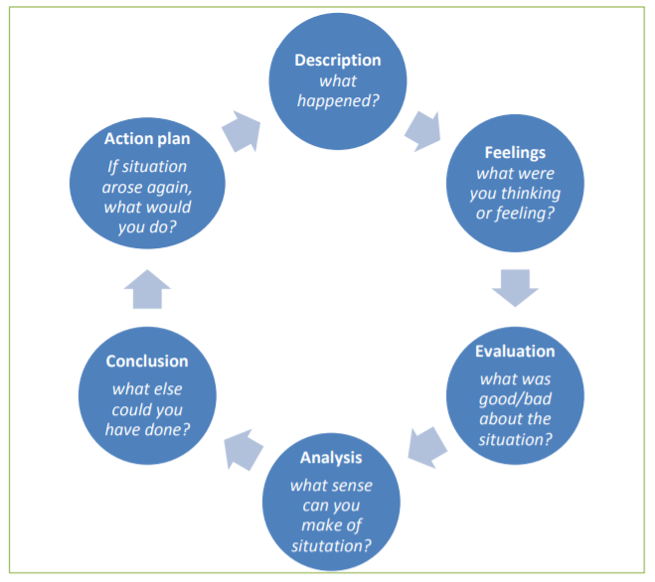

Figure 1: Gibbs' Reflective Cycle (sources from Dye, 2011, p230)
Description: On 5th October, this is the first week of Applied Quantitative Business Research, and Dr Promise introduce some key concepts of quantitative research. For instance, the study of some knowledge and theory about research Paradigm, the study of different types of quantitative research, and the study of reliability and validity in quantitative research. What Dr Promise show this knowledge is to make sure we can understand whether quantitative research is fit in our research, and help us to use quantitative to assist ourselves to address the underlying research questions in our research.
Feeling: Applied Quantitative Business Research is my fifth module of my DBA stage1, although I have learned some knowledge and theory about research methods, such as I learned some knowledge and content about research Epistemology and Ontology, and some theory about research reliability, validity and research ethics from last modules. I still feel interested in learning quantitative research due to not only does it play an important role in many research, but also it is one research strategy that has the characteristics of numerical data collection and analysis, I wish what I learn some new things from this module especially the digital analyze will bring an assistant to my DBA dissertation at last.
Evaluation: On the one hand, what I learn from my last few modules and my master degree such as data collection used in qualitative research, different research methods and research ethics will bring a basic foundation for me to learn a new research method. On the other hand, I have some disadvantages: I have not used the quantitative research method before, which means I have no experience in quantitative research, and it may bring some difficulty to me to learn quantitative research. Moreover, I have not done some deep research on some key factors of quantitative research such as sample, SPSS and Statistical Analyses, which means I may need more time to understand these factors when I study these new factors.
Analysis: In my opinion, to improve the efficiency to learn quantitative research and obtain more knowledge from this module, what I should do at first is follow the leading of Dr Promise and understand each knowledge and theory in each class, for example, in week2, I may need to know more about the content of sampling, population and questionnaire design, Not only about studying in the class, but also review what I learn in this week is also important, I can do it by reviewing the weekly PowerPoint and watch the video recording in Teams, moreover, I also can use University E-mail to contact to Dr Promise to ask relevant questions.
Conclusion:From what Dr promise said in the first week, Y= a+b+c + algebraic e. I should do more to improve my understanding of this module. Therefore, the third method for me to improve my understanding of this module is doing more readings. For example, I can learn more quantitative research design from module recommend reading materials and watching some relevant videos to obtain a more differentiated understanding of each important factor. Moreover, I also can read some other articles to enhance my understanding of each important factor.
Action Plan: Overall, in the future study, I will not only focus on the class materials but also obtain more knowledge from other resources, this will help me to overcome some of my disadvantages in learning this module. Learning from different places also will help me to overcome my bias and improve my performance in my dissertation in the future.

Blog 2: How can I use digital numbers to describe a more subjective item? (word count: 325 )

(Source from islamfact)

In my own opinion, I think the biggest challenge for me at present is to use the quantitative research method to do research on subjective items (topics).

Compared to qualitative research, quantitative research is focusing more on the factors such as Breadt, determination and numerical summaries. Quantitative research also focuses on data analysis and quantitative collection with showing by a numerical form such as numbers, percentages and statistics. Therefore, in my opinion, quantitative research may more suitable to analyze in some objective items, because numerical data such as numbers and percentages can show objective items result better in a research

For example, if I wish to do research in culture or relevant cultural research areas like cultural distance (or cultural diversity), using quantitative research may be a big challenge to me. Because from the definition of cultural area, Spencer-Oatey conclude that it is difficult to have a common definition of culture due to the fact that different people and different organizations will have different descriptions of what is culture, and culture also can be considered as one influence with one description or different behaviour. Even at present, because of the influence from different factors, the definition of culture still needs to be rethought. Therefore, in my opinion, items such as culture or other relevant cultural areas, which are close to subjective research area may not too suitable to use quantitative research because numerical data may not show a subjective research item accurately, and because different people may have their own thinking or even bias on a subjective research item. Therefore, although I may provide a result by using quantitative research, at last, it is also a challenge to me to make most readers trust its validity.

Fortunately, Dr Promise is a professional researcher in culture and he is my teacher for this module, therefore, it will be a good opportunity for me to learn how to face this challenge from his doctoral thesis and class

Blog 3: Sample, the important factors in quantitative research (word count: 334 )
“A sample is a proportion or subset of a larger group called a population...A good sample is a miniature version of the population of which it is a part – just like it, only smaller”
(Fink, 2003)
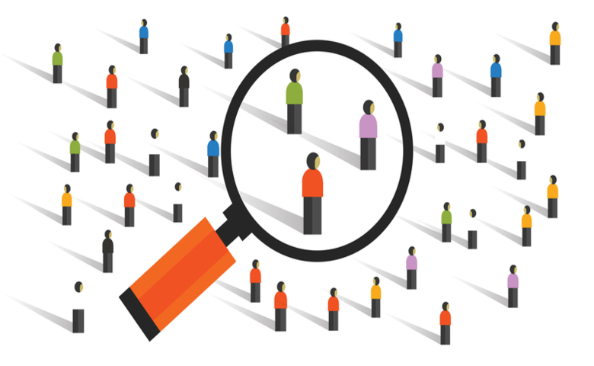
(Source from Displayr)
To understand what role played by the sample in quantitative research, we can consider some characteristics of quantitative research at first. Quantitative research is one research strategy that has the characteristics of numerical data collect and quantifying collection. Moreover, quantitative research will have more Generalisation to Populations than qualitative, therefore, reliable data is a basic and important part of quantitative research. and Sample will be a good method for researchers to use in quantitative research.

Because of needing doing research in population, which can be described as any group of people having common characteristics that may attract researcher, and usually, this population has a large number, therefore, it is necessary to sample people from this large population. For example, if one researcher needs to do research in one school, and this school has over 9,000 students, the researcher almost cannot have enough time to do a detailed investigation to all students in this school, even sending 9,000 questionnaires. Because doing all numbers interview or questionnaire will have much time-consuming and high expensive. Therefore, in the same situation, the most likely way that can be picked by this researcher is to sample students from all populations of students in this school.
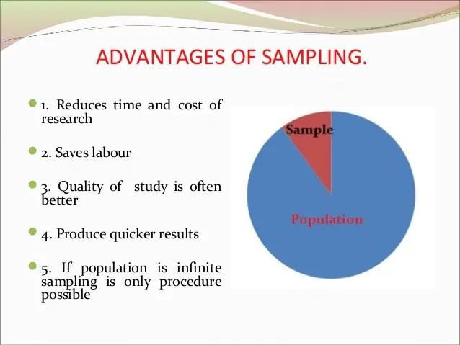
Figure 2: Advantages of Sampling (sources from ANCYBS, 2019)

For the sample, from the characteristics of the sample itself, such as Fink proposed that sample is coming from a large population, the obvious difference is sample is a smaller part of the population. Because the sample is one part of the population, the sample can seem representative of the larger population. Therefore, because by taking a representative of the large population, simple not only will help research to reduce the cost such as time, money and labour during the research process but also improve the quality of research and make the large population quantitative research become possible to be completed by a few researchers. Overall, because sample increase the possibility of a large population quantitative research and data relates to the last findings, Sample is one important fundamental and process in quantitative research

Blog 4: Should ethics need to be considered in big data? (word count: 374 )
“Big data usage has significantly increased in the past ten years and ethical guidelines are still in development.”
(White and Ariyachandra, 2016)
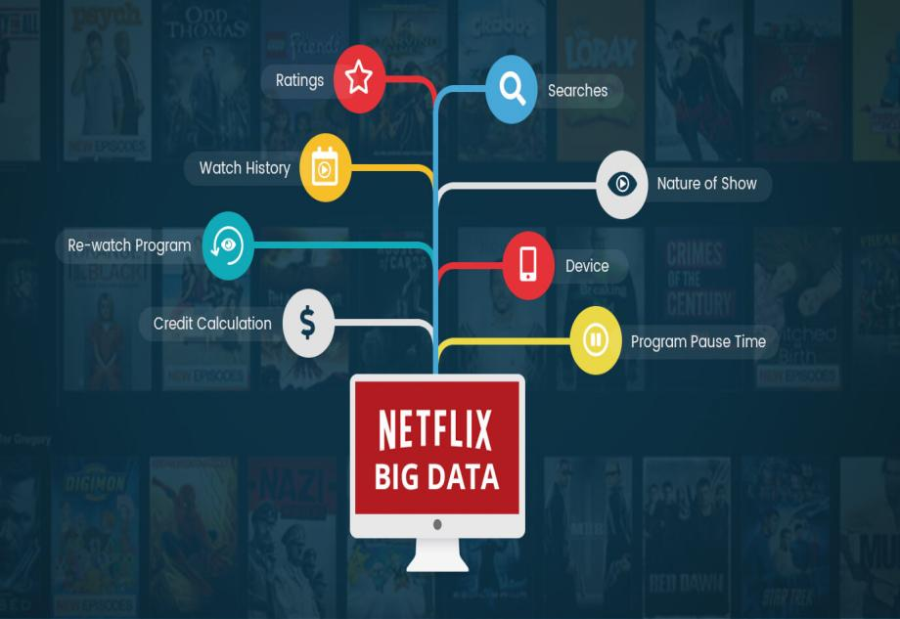

(Source from Muvi)

Netflix is one company that provides one of the highest entertainment services with almost 204 million premium paid members from over 190 countries. What Netflix provides are different feature films, documentaries and TV series in different languages and different types. Of course, they also provide a DVD by-mail service in the US. Actually, what Netflix did before 2007 was DVD selling and by-mail service but online service, and now, the secret weapon that pushes Netflix to become one of the largest online entertainment corporate is big data.

Big data can be imaged and defined as the big large numbers of data that come from using the website. Because traditional econometrics does not find a good solution for big data, therefore, different people or organizations start to think of a new method to calculate and analyze large numbers of data from the internet. Netflix also obtain their own technology for handling big data, and they create their recommendation system, which can be considered as one part of the information analyzing system. Recommendation system and relevant big data system increase the click rates, stabilize the online video stream and assess members’ preference, which plays an important role in assisting Netflix to transit from providing DVD to providing digital service.

(Sources from Enterra)

However, using big data is not always a perfect method without any issues. Because big data always company to the ethical questions even distrust emotion. one of the big data main ethics questions is personal privacy, because big data not only cover the functions of data analysis, but also conclude the ability of data collection, users may do not know what they click on each text, image and video will provide their preference and relevant personal information to the platform, and During the process of collecting data, it may caused the questions of leakage of personal information and bring damage to users privacy. Netflix needs to think highly of ethics questions and how to use customers’ personal data to avoid the case between Facebook and Cambridge Analytica happening on itself. Because if that happened on Netflix itself, not only Netflix will suffer a high punishment from personal privacy issues, but also Netflix may meet a larges decrease of their premium users because of losing trust.

Blog 5: Be a detective in statistically significant findings. (word count: 389)
“A statistically significant finding gives you a clue, suggesting a promising place to focus your research energy. The significance test is the detective, not the judge”
(Ellenberg, 2015)



(Sources from Elder Research, 2018)

Statistically significant findings are achieved when null hypotheses are not very likely to occur in a statistical hypotheses test. Before I saw the quote from Ellenberg, I may main follow the statistical hypotheses test process, such as setting up the hypotheses, making a significant (P-valueα), collecting statistics from the sample, calculating the P-value and making decisions. But after I read the quote from Ellenberg, I think I need to think more after calculating my P-value.

For example, let’s imagine a situation. If I am working in a market department, and now our company create a new product and wish to know how people think of it before manufacturing. What I will plan to do is do a survey to collect feedback from the population. What I set for the P valueαis 0.05, my null hypothesis is people will have negative feedback to our new product, and on the other hand, my hypothesis one is people will have positive feedback to our new product. After the survey, from the normal hypotheses test process, if my findings of P-value is 0.03, which is less than 0.05 and the result is statistically significant, then I may feel confident to tell my leaders that our new product is welcomed. And if my findings of P-value is 0.3 which is higher than 0.05 and the result is statistically insignificant, then I may tell my leaders that our new product may have some places that need to be changed.

However, research may find out that it has statistical significance but it may not have a practical significance. therefore, in the example, even if I find out the P-value is 0.03 with a statistically significant, I still need to be a detective to find out whether there are other external influence factors to influence new products. Back to Ellenberg’s quote, statistically significant findings should show us a good way to continue research but make a decision at present. Such as Carver proposed that, if the researcher only focuses on whether their last findings are statistically significant, his or her result may not be substantive or even replicable. Therefore, in the future study, I should not make decisions immediately after obtain a statistically significant finding, because this result may not be the best one I that can dig out.

Blog 6: Thinking about the Big Data (word count: 445)

(Sources from The Korea Herald, 2018)
Inspired by Blog4 and news stories about modern technology and big data, it is obvious that we are surrounded by the big data world and people would like to start to admit the data and obtain different values by analyzing the data. therefore, Blog6 will focus on big data and analyze the performance.

For the meaning of big data, simply, big data can be defined as a field or one term that is used for collecting different variables, big structure and high complex massive data, which is difficult to hand by the normal tools but can be used by big data’ data sets. In detail, big data can analyze these complex data to make them become visual data, so that people can do more further perform.

For the performance of big data, on the one hand, it includes the behave of collecting complex data for the business company, such as Nexflix can use it in recommendation system to increase the click, help E-bay in searching, customer recommendation and selling, and handing millions of back-end operation for Amazon each day. Moreover, for big data performance in the government, in the UK, using the big data relates to the weather make the local government avoid the delay of the weather information, in Israel, the government used big data to assist the treatment of diabetes. and in China, Because of the highly contagious of the Covid19, the government use big data to track people who touch the Covid19 infected people and the areas they arrived before to control The spread of the Covid19. it seems that big data provides a lot of help to personal and organizations.

On the other hand, with characteristics of needing a collect quantity of data, big data’s performance starts to be doubted by others because of ethics problems. As Quasim and Meraj proposed that because the process of using data such as exchanging information, the process of analyzing the data and the outsourced database all have the potential risk for personal privacy and personal security, especially some social media platforms. Big data also will bring bad influence in the political event such as the trade between Facebook and Cambridge Analytica bring a bad influence on business ethics, personal privacy and even political event. Overall, although big data play an important role in pushing the improvement of this world, we still need to have critical thinking for everything that seems “perfect”, after that, we can try to avoid some potential risk such as the break of good standard and principle of the behave in the corporate and bring the risk to personal privacy and life in the future.

Blog 7: An impressive journey of quantitative research (word count: 403)
“We are reviewing everything to see how we can do it better, faster and more efficiently”
(David Neeleman)
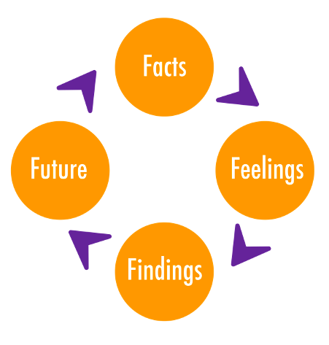

Figure 2: Active Reviewing Cycle (sources from SCOUTS)
Facts: This is the end journey of this module, thanks to Dr Promise six weeks lectures, review the knowledge that I learn, there are different parts but all relate to quantitative research: for instance, we have learned the research paradigms, general thinking, validity and reliability of quantitative research approach, how to use sample and questionnaire during the process of survey, understanding what is SPSS and how to use SPSS to input our data and then do some data analysis such as correlation analysis and factor analysis.

Feelings: Overall, in my own opinion, six weeks of lectures is a full and harvested knowledge studying journey. For instance, comparing quantitative research to qualitative research let me know the difference between two different research approaches so that I can consider more about using quantitative research in my DBA journey. Knowledge of the process to do a survey let me know different types of sample and how important to run a pilot test. And the knowledge of how to use SPSS also increase my confidence to do a statistical analysis and data description in the DBA future research.

Findings: Over six weeks of study, not only did I learn much knowledge about quantitative research, but also other content such as mixed-method also leave me a deep impression. For instance, I renew my thinking for mix-method about what is not a mixed-methods and what is the rigorous methods in mixed method, this enhances a right understanding for mixed-method for my future DBA journey. Moreover, from the communication with Dr Promise, I also obtain some methods to face the research in subjective areas and bias of researcher subjectively, which will assist my DBA dissertation in the future.

Future: In the future, I would like to consider using quantitative research, such as using mixed-method in my final DBA dissertation. Thanks to Dr Promise and my classmates’ help in the class, this provide me with more confidence to keep moving in this BDA journey. However, six weeks of study is not an end of learning in quantitative research, I just complete the changes from a beginner to an experienced learner, and there will be more challenges waiting for me, such as research approaches’ reliability and validity for my picking research topic in my DBA journey, and I will use the knowledge that I learn and keep working on it to face them in the future.

Bibliography:
Acharya, A. S., Prakash, A., Saxena, P., & Nigam, A. (2013). Sampling: Why and how of it. Indian Journal of Medical Specialties, 4(2), 330-333.

Al-Ababneh, M. (2020). Linking ontology, epistemology and research methodology. Science & Philosophy, 8(1), 75-91.

Amrhein, V., Korner-Nievergelt, F., & Roth, T. (2017). The earth is flat (p> 0.05): significance thresholds and the crisis of unreplicable research. PeerJ, 5, e3544.

ANCYBS (2019). Sampling. Slideshare. [Online]. Available at:https://www.slideshare.net/ANCYBS/sampling-149918252[Accessed 16th October 2021].

Anshari, M., & Sumardi, W. H. (2020). Employing big data in business organisation and business ethics. International Journal of Business Governance and Ethics, 14(2), 181-205.

Apuke, O. D. (2017). Quantitative research methods: A synopsis approach. Kuwait Chapter of Arabian Journal of Business and Management Review, 33(5471), 1-8.

Barrett, D., & Twycross, A. (2018). Data collection in qualitative research.

Bryman, A. (2017). Quantitative and qualitative research: further reflections on their integration. In Mixing methods: Qualitative and quantitative research (pp. 57-78).

Routledge.Creswell, J. W., & Creswell, J. D. (2017). Research design: Qualitative, quantitative, and mixed methods approaches. Sage publications.;

Baškarada, S., & Koronios, A. (2018). A philosophical discussion of qualitative, quantitative, and mixed methods research in social science. Qualitative Research Journal.

Bell, E., Bryman, A., & Harley, B. (2018). Business research methods. Oxford university press.

Bloomfield, J., & Fisher, M. J. (2019). Quantitative research design. Journal of the Australasian Rehabilitation Nurses Association, 22(2), 27-30.

Bryman, A. (2003). Quantity and quality in social research (Vol. 18). Routledge.;

Bryman, A. (2016). Social research methods. Oxford university press.

Burgess, T. F. (2001). Guide to the Design of Questionnaires. A general introduction to the design of questionnaires for survey research, 30(4), 411-432.

Carver, R. (1978). The case against statistical significance testing. Harvard Educational Review, 48(3), 378-399.

Connelly, L. M. (2015). Research questions and hypotheses. Medsurg Nursing, 24(6), 435-436

Crawford, K., Gray, M. L., & Miltner, K. (2014). Big Data| critiquing Big Data: Politics, ethics, epistemology| special section introduction. International Journal of Communication, 8, 10.

Creswell, J. W., & Creswell, J. D. (2017). Research design: Qualitative, quantitative, and mixed methods approaches. Sage publications.;

Creswell. J. (2013). What is Mixed Methods Research. Youtube. [Online]. Available at:https://www.youtube.com/watch?v=1OaNiTlpyX8[Accessed 13th November 2021].

CRQ (2015). Overview of Quantitative Research Methods. [Online]. Youtube. Available at: https://www.youtube.com/watch?v=cwU8as9ZNlA. [Accessed 5th October 2021].

Currivan, D. B. (2004). Sampling frame. TL Futing, A. Bryman, & MS Lewis-Beck. Social Science and Research Methods. New York, NY: SAGE Publications.

David N. (n.d.). David Neeleman Quotes. AZQUOTES.[Online]. Available at: https://www.azquotes.com/quote/1001713[Accessed 13th November 2021].

David R. (2021) Enter Questionnaire/Survey Data into SPSS. Youtube. [Online]. Available at：https://www.youtube.com/watch?v=el9TQSZ_6yE[Accessed 13th November 2021].

Dawson, B., & Trapp, R. G. (2001). Probability & related topics for making inferences about data. Basic and clinical biostatistics. 3rd ed. New York: Lange Medical Books/McGraw-Hill, 82-4.

Elder Research (2018). Be a Data Detective. [Online]. Available at:https://elderresearch.medium.com/be-a-data-detective-8634f7cfa898[Accessed 21st October 2021].

Elkatawneh, H. (2016). Comparing Qualitative and Quantitative Approaches. SSRN Electronic Journal, 10.

Ellenberg, J. (2015). How not to be wrong: The power of mathematical thinking. Penguin.

Emmert-Streib, F., & Dehmer, M. (2019). Understanding statistical hypothesis testing: The logic of statistical inference. Machine Learning and Knowledge Extraction, 1(3), 945-961.

Field, A. (2009). Discovering statistics using SPSS. Sage publications.

Fink, A. (2003). How to sample in surveys (Vol. 7). Sage.

Gordon L. (2011). Sampling. UWTSD Module. [Online]. Available at: https://www.kent.ac.uk/religionmethods/documents/Sampling.pdf[Accessed 13th November 2021].

Guba, E. G., & Lincoln, Y. S. (1994). Competing paradigms in qualitative research. Handbook of qualitative research, 2(163-194), 105.

Hallinan, B., & Striphas, T (2016). Recommended for you: The Netflix Prize and the production of algorithmic culture. New media & society, 18(1), 117-137.

Harding, M. H. (2018). Big Data in economics. IZA World of Labor.

Heale, R., & Twycross, A. (2015). Validity and reliability in quantitative studies. Evidence-based nursing, 18(3), 66-67.

Hofstede, G. (1991). Cultures and Organizations. Software of the Mind. London: McGraw Hili. Culture's Consequences. Comparing Values, Behaviors, Institutions, and Organizations Across Nations.

Hojat, M., & Xu, G. (2004). A visitor's guide to effect sizes–statistical significance versus practical (clinical) importance of research findings. Advances in health sciences education, 9(3), 241-249.

Hu, Z., Ge, Q., Li, S., Jin, L., & Xiong, M. (2020). Artificial intelligence forecasting of Covid-19 in China. arXiv preprint arXiv:2002.07112.

Islamfact （2021）. Challenge. [Online]. Available at: https://www.islamfact.com/islamfactvideos/effective-ways-to-deal-with-difficulties/challenge/. [Accessed 8th October 2021].

Julia Layton (2021). How Amazon Works. [Online]. HowStuffworks. Available at: https://money.howstuffworks.com/amazon.htm#pt1[Accessed 24th October 2021].

Khatiban, M., Saeed, J. A., & Ashtari, I. (2007). Sampling in quantitative research. Advances in Nursing & Midwifery, 17(56), 61-69.

Kshetri, N. (2014). Big data׳ s impact on privacy, security and consumer welfare. Telecommunications Policy, 38(11), 1134-1145.

Labrinidis, A., & Jagadish, H. V. (2012). Challenges and opportunities with big data. Proceedings of the VLDB Endowment, 5(12), 2032-2033.

Lincoln, Y. S., & Guba, E. G. (1985). Establishing trustworthiness. Naturalistic inquiry, 289(331), 289-327.

Liz Tay (2013). Inside eBay’s 90PB data warehouse. [Online]. Itnews. Available at: https://www.itnews.com.au/news/inside-ebay8217s-90pb-data-warehouse-342615[Accessed 24th October 2021].

Luke Tress (2017). Israeli startup uses big data, minimal hardware to treat diabetes. [Online]. The Times of ISRAEL. Available at: https://www.timesofisrael.com/israeli-startup-uses-big-data-minimal-hardware-to-treat-diabetes/[Accessed 24th October 2021].

Majid, U. (2018). Research fundamentals: Study design, population, and sample size. Undergraduate research in natural and clinical science and technology journal, 2, 1-7.

McGregor, D., & Cartwright, L. (2011). Developing Reflective Practice: A Guide For Beginning Teachers: A Guide for Beginning Teachers. McGraw-Hill Education (UK). (pp. 217-234).

Myers, J. L., Well, A. D., & Lorch, J. R. (2010). Developing the fundamentals of hypothesis testing using the binomial distribution. Research Design and Statistical Analysis, 65-90.

Netflix Help center (2021). Recommendation system. Netflix. [Online]. Available at:https://help.netflix.com/en/node/100639[Accessed 17th October 2021].

Pink, S. (2001). More visualising, more methodologies: on video, reflexivity and qualitative research. The sociological review, 49(4), 586-599.

Popescu, D. (2019). Culture as factor of economic development. Revista Economică, 71(4).

Quasim, M. T., & Meraj, M. (2017). BIG DATA SECURITY AND PRIVACY: A SHORT. Technology, 8(4), 408-412.

Reyment, R. A., & Jvreskog, K. G. (1996). Applied factor analysis in the natural sciences. Cambridge University Press.

Rietveld, T., & Van Hout, R. (2011). Statistical techniques for the study of language and language behaviour. De Gruyter Mouton

Romano, M., & Onesti, T. (2016). Earnings quality in an ethics perspective. International Journal of Business Governance and Ethics, 11(1), 52-67.

Rosalie C. (2019). The Cambridge Analytica whistleblower explains how the firm used Facebook data to sway elections. INSIDER. [Online]. Available at: https://www.businessinsider.com/cambridge-analytica-whistleblower-christopher-wylie-facebook-data-2019-10?r=US&IR=T[Accessed 17th October 2021].

Roshan, D (2018). Deciphering the unstoppable Netflix and the role of Big Data. Muvi. [Online]. Available at:https://www.muvi.com/blogs/deciphering-the-unstoppable-netflix-and-the-role-of-big-data.html[Accessed 17th October 2021].

Rutberg, S., & Bouikidis, C. D. (2018). Focusing on the fundamentals: A simplistic differentiation between qualitative and quantitative research. Nephrology Nursing Journal, 45(2), 209-213.

Sagiroglu, S., & Sinanc, D. (2013, May). Big data: A review. In 2013 international conference on collaboration technologies and systems (CTS) (pp. 42-47). IEEE.;

Sara Windom (2021). Tech's ethical quandary. [Online]. The State Press. Available at:https://www.statepress.com/article/2021/10/spmagazine-techs-ethical-quandary[Accessed 24th October 2021].

Schein, E. H. (1990). Organizational culture. American Psychologist, 45(2), 109–119.

Schon, D. A. (2008). The reflective practitioner: How professionals think in action. Hachette UK

SCOUTS. (n.d.). Active Reviewing Cycle. SCOUTS. [Online]. Available at: https://scoutship.scout.org/fr/handbook/active-review-cycle/[Accessed 13th November 2021].

Sheppard, M. (2019). The impact of quantitative research in social work. European Journal of Social Work, 22(1), 4-15.

Sirkin, R. M. (2006). Statistics for the social sciences. Sage.

Snijders, C., Matzat, U., & Reips, U. D. (2012). " Big Data": big gaps of knowledge in the field of internet science. International journal of internet science, 7(1), 1-5.

Spencer-Oatey, H. (2012) What is culture? A compilation of quotations. GlobalPAD Core Concepts. [Online]. Available at: http://www2.warwick.ac.uk/fac/soc/al/globalpad/interculturalskills/.[Accessed 8th October 2021]

Stephan, D (2016). Big Data and Ethics. Enterra. [Online]. Available at:https://enterrasolutions.com/blog/big-data-ethics/[Accessed 17th October 2021].

Stergiou, C., & Psannis, K. E. (2017). Recent advances delivered by Mobile Cloud Computing and Internet of Things for Big Data applications: a survey. International Journal of Network Management, 27(3), e1930.

Thornhill, A., & Bristow, A. (2015). Understanding research philosophy and approaches to theory development.

Tim, B (2021). What is Random Sampling? Dispayr. [Online]. Available at:https://www.displayr.com/what-is-random-sampling/[Accessed 16th October 2021].

Waters, D., & Waters, C. D. J. (2008). Quantitative methods for business. Pearson Education.

Wu, J. T., Leung, K., & Leung, G. M. (2020). Nowcasting and forecasting the potential domestic and international spread of the 2019-nCoV outbreak originating in Wuhan, China: a modelling study. The Lancet, 395(10225), 689-697.

Xu, L., Jiang, C., Wang, J., Yuan, J., & Ren, Y. (2014). Information security in big data: privacy and data mining. Ieee Access, 2, 1149-1176.

Yang Sung-jin (2021). Using big data analysis to chart a new course. [Online]. The Korea Herald. Available at: http://www.koreaherald.com/view.php?ud=20210901001000[Accessed 24th October 2021].

Appendix:

Appendix1: Links to my WordPress
https://ericlee668022805.wordpress.com/2021/11/11/7blogs-for-my-quantitative-study-experience/
(Password: 000000)

Schon, D. A. (2008). The reflective practitioner: How professionals think in action. Hachette UK..
McGregor, D., & Cartwright, L. (2011). Developing Reflective Practice: A Guide For Beginning Teachers: A Guide for Beginning Teachers. McGraw-Hill Education (UK). (pp. 217-234).
Bloomfield, J., & Fisher, M. J. (2019). Quantitative research design. Journal of the Australasian Rehabilitation Nurses Association, 22(2), 27-30.; Guba, E. G., & Lincoln, Y. S. (1994). Competing paradigms in qualitative research. Handbook of qualitative research, 2(163-194), 105.
Rutberg, S., & Bouikidis, C. D. (2018). Focusing on the fundamentals: A simplistic differentiation between qualitative and quantitative research. Nephrology Nursing Journal, 45(2), 209-213.
Field, A. (2009). Discovering statistics using SPSS. Sage publications.
Al-Ababneh, M. (2020). Linking ontology, epistemology and research methodology. Science & Philosophy, 8(1), 75-91. ; Baškarada, S., & Koronios, A. (2018). A philosophical discussion of qualitative, quantitative, and mixed methods research in social science. Qualitative Research Journal.
Lincoln, Y. S., & Guba, E. G. (1985). Establishing trustworthiness. Naturalistic inquiry, 289(331), 289-327.; Bryman, A. (2003). Quantity and quality in social research (Vol. 18). Routledge.; Pink, S. (2001). More visualising, more methodologies: on video, reflexivity and qualitative research. The sociological review, 49(4), 586-599.
Sheppard, M. (2019). The impact of quantitative research in social work. European Journal of Social Work, 22(1), 4-15.
Bryman, A. (2016). Social research methods. Oxford university press.
Barrett, D., & Twycross, A. (2018). Data collection in qualitative research.
Bryman, A. (2017). Quantitative and qualitative research: further reflections on their integration. In Mixing methods: Qualitative and quantitative research (pp. 57-78). Routledge.
Creswell, J. W., & Creswell, J. D. (2017). Research design: Qualitative, quantitative, and mixed methods approaches. Sage publications.; Field, A. (2009). Discovering statistics using SPSS. Sage publications.
CRQ (2015). Overview of Quantitative Research Methods. [Online]. Youtube. Available at: https://www.youtube.com/watch?v=cwU8as9ZNlA. [Accessed 5th October 2021].
Islamfact （2021）. Challenge. [Online]. Available at: https://www.islamfact.com/islamfactvideos/effective-ways-to-deal-with-difficulties/challenge/. [Accessed 8th October 2021].
Field, A. (2009). Discovering statistics using SPSS. Sage publications.; Creswell, J. W., & Creswell, J. D. (2017). Research design: Qualitative, quantitative, and mixed methods approaches. Sage publications.; Elkatawneh, H. (2016). Comparing Qualitative and Quantitative Approaches. SSRN Electronic Journal, 10.
Apuke, O. D. (2017). Quantitative research methods: A synopsis approach. Kuwait Chapter of Arabian Journal of Business and Management Review, 33(5471), 1-8.
Spencer-Oatey, H. (2012) What is culture? A compilation of quotations. GlobalPAD Core Concepts. [Online]. Available at: http://www2.warwick.ac.uk/fac/soc/al/globalpad/interculturalskills/.[Accessed 8th October 2021].
Schein, E. H. (1990). Organizational culture. American Psychologist, 45(2), 109–119.
Hofstede, G. (1991). Cultures and Organizations. Software of the Mind. London: McGraw Hili. Culture's Consequences. Comparing Values, Behaviors, Institutions, and Organizations Across Nations.
Popescu, D. (2019). Culture as factor of economic development. Revista Economică, 71(4).
Fink, A. (2003). How to sample in surveys (Vol. 7). Sage.
Tim, B (2021). What is Random Sampling? Dispayr. [Online]. Available at: https://www.displayr.com/what-is-random-sampling/[Accessed 16th October 2021].
Bryman, A. (2016). Social research methods. Oxford: Oxford university press.; Currivan, D. B. (2004). Sampling frame. TL Futing, A. Bryman, & MS Lewis-Beck. Social Science and Research Methods. New York, NY: SAGE Publications.
Field, A. (2009). Discovering statistics using SPSS. Sage publications.
Waters, D., & Waters, C. D. J. (2008). Quantitative methods for business. Pearson Education.
Majid, U. (2018). Research fundamentals: Study design, population, and sample size. Undergraduate research in natural and clinical science and technology journal, 2, 1-7.
Bell, E., Bryman, A., & Harley, B. (2018). Business research methods. Oxford university press.
ANCYBS (2019). Sampling. Slideshare. [Online]. Available at: https://www.slideshare.net/ANCYBS/sampling-149918252[Accessed 16th October 2021].
Fink, A. (2003). How to sample in surveys (Vol. 7). Sage.
Dawson, B., & Trapp, R. G. (2001). Probability & related topics for making inferences about data. Basic and clinical biostatistics. 3rd ed. New York: Lange Medical Books/McGraw-Hill, 82-4.
Acharya, A. S., Prakash, A., Saxena, P., & Nigam, A. (2013). Sampling: Why and how of it. Indian Journal of Medical Specialties, 4(2), 330-333.
Khatiban, M., Saeed, J. A., & Ashtari, I. (2007). Sampling in quantitative research. Advances in Nursing & Midwifery, 17(56), 61-69.
White, G., & Ariyachandra, T. (2016). Big Data and ethics: examining the grey areas of big data analytics. Issues in Information Systems, 17(4).
Roshan, D (2018). Deciphering the unstoppable Netflix and the role of Big Data. Muvi. [Online]. Available at: https://www.muvi.com/blogs/deciphering-the-unstoppable-netflix-and-the-role-of-big-data.html[Accessed 17th October 2021].
Netflix Annual Report (2020). 2020 Annual report. Netflix. [Online]. Available at: https://s22.q4cdn.com/959853165/files/doc_financials/2020/ar/8f311d9b-787d-45db-a6ea-38335ede9d47.pdf[Accessed 17th October 2021].
Roshan, D (2018). Deciphering the unstoppable Netflix and the role of Big Data. Muvi. [Online]. Available at: https://www.muvi.com/blogs/deciphering-the-unstoppable-netflix-and-the-role-of-big-data.html[Accessed 17th October 2021].
Harding, M. H. (2018). Big Data in economics. IZA World of Labor.
Netflix Help center (2021). Recommendation system. Netflix. [Online]. Available at: https://help.netflix.com/en/node/100639[Accessed 17th October 2021].
Hallinan, B., & Striphas, T (2016). Recommended for you: The Netflix Prize and the production of algorithmic culture. New media & society, 18(1), 117-137.
Stephan, D (2016). Big Data and Ethics. Enterra. [Online]. Available at: https://enterrasolutions.com/blog/big-data-ethics/[Accessed 17th October 2021].
Anshari, M., & Sumardi, W. H. (2020). Employing big data in business organisation and business ethics. International Journal of Business Governance and Ethics, 14(2), 181-205.
Xu, L., Jiang, C., Wang, J., Yuan, J., & Ren, Y. (2014). Information security in big data: privacy and data mining. Ieee Access, 2, 1149-1176.; Kshetri, N. (2014). Big data׳ s impact on privacy, security and consumer welfare. Telecommunications Policy, 38(11), 1134-1145.
Rosalie C. (2019). The Cambridge Analytica whistleblower explains how the firm used Facebook data to sway elections. INSIDER. [Online]. Available at: https://www.businessinsider.com/cambridge-analytica-whistleblower-christopher-wylie-facebook-data-2019-10?r=US&IR=T[Accessed 17th October 2021].
Ellenberg, J. (2015). How not to be wrong: The power of mathematical thinking. Penguin.
Elder Research (2018). Be a Data Detective. [Online]. Available at: https://elderresearch.medium.com/be-a-data-detective-8634f7cfa898 [Accessed 21st October 2021].
Sirkin, R. M. (2006). Statistics for the social sciences. Sage.; Myers, J. L., Well, A. D., & Lorch, J. R. (2010). Developing the fundamentals of hypothesis testing using the binomial distribution. Research Design and Statistical Analysis, 65-90.
Ellenberg, J. (2015). How not to be wrong: The power of mathematical thinking. Penguin.
Emmert-Streib, F., & Dehmer, M. (2019). Understanding statistical hypothesis testing: The logic of statistical inference. Machine Learning and Knowledge Extraction, 1(3), 945-961.
Field, A. (2009). Discovering statistics using SPSS. Sage publications.
Hojat, M., & Xu, G. (2004). A visitor's guide to effect sizes–statistical significance versus practical (clinical) importance of research findings. Advances in health sciences education, 9(3), 241-249.
Carver, R. (1978). The case against statistical significance testing. Harvard Educational Review, 48(3), 378-399.
Amrhein, V., Korner-Nievergelt, F., & Roth, T. (2017). The earth is flat (p> 0.05): significance thresholds and the crisis of unreplicable research. PeerJ, 5, e3544.
Yang Sung-jin (2021). Using big data analysis to chart a new course. [Online]. The Korea Herald. Available at: http://www.koreaherald.com/view.php?ud=20210901001000[Accessed 24th October 2021].
Sara Windom (2021). Tech's ethical quandary. [Online]. The State Press. Available at: https://www.statepress.com/article/2021/10/spmagazine-techs-ethical-quandary[Accessed 24th October 2021].
Labrinidis, A., & Jagadish, H. V. (2012). Challenges and opportunities with big data. Proceedings of the VLDB Endowment, 5(12), 2032-2033.
Sagiroglu, S., & Sinanc, D. (2013, May). Big data: A review. In 2013 international conference on collaboration technologies and systems (CTS) (pp. 42-47). IEEE.; Snijders, C., Matzat, U., & Reips, U. D. (2012). " Big Data": big gaps of knowledge in the field of internet science. International journal of internet science, 7(1), 1-5.
Hallinan, B., & Striphas, T (2016). Recommended for you: The Netflix Prize and the production of algorithmic culture. New media & society, 18(1), 117-137.
Liz Tay (2013). Inside eBay’s 90PB data warehouse. [Online]. Itnews. Available at: https://www.itnews.com.au/news/inside-ebay8217s-90pb-data-warehouse-342615[Accessed 24th October 2021].
Julia Layton (2021). How Amazon Works. [Online]. HowStuffworks. Available at: https://money.howstuffworks.com/amazon.htm#pt1[Accessed 24th October 2021].
Stergiou, C., & Psannis, K. E. (2017). Recent advances delivered by Mobile Cloud Computing and Internet of Things for Big Data applications: a survey. International Journal of Network Management, 27(3), e1930.
Luke Tress (2017). Israeli startup uses big data, minimal hardware to treat diabetes. [Online]. The Times of ISRAEL. Available at: https://www.timesofisrael.com/israeli-startup-uses-big-data-minimal-hardware-to-treat-diabetes/[Accessed 24th October 2021].
Hu, Z., Ge, Q., Li, S., Jin, L., & Xiong, M. (2020). Artificial intelligence forecasting of Covid-19 in China. arXiv preprint arXiv:2002.07112.; Wu, J. T., Leung, K., & Leung, G. M. (2020). Nowcasting and forecasting the potential domestic and international spread of the 2019-nCoV outbreak originating in Wuhan, China: a modelling study. The Lancet, 395(10225), 689-697.
Quasim, M. T., & Meraj, M. (2017). BIG DATA SECURITY AND PRIVACY: A SHORT. Technology, 8(4), 408-412.
Anshari, M., & Sumardi, W. H. (2020). Employing big data in business organisation and business ethics. International Journal of Business Governance and Ethics, 14(2), 181-205.
Crawford, K., Gray, M. L., & Miltner, K. (2014). Big Data| critiquing Big Data: Politics, ethics, epistemology| special section introduction. International Journal of Communication, 8, 10.; Rosalie C. (2019). The Cambridge Analytica whistleblower explains how the firm used Facebook data to sway elections. INSIDER. [Online]. Available at: https://www.businessinsider.com/cambridge-analytica-whistleblower-christopher-wylie-facebook-data-2019-10?r=US&IR=T[Accessed 17th October 2021].
Romano, M., & Onesti, T. (2016). Earnings quality in an ethics perspective. International Journal of Business Governance and Ethics, 11(1), 52-67.
David N. (n.d.). David Neeleman Quotes. AZQUOTES.[Online]. Available at: https://www.azquotes.com/quote/1001713[Accessed 13th November 2021].
SCOUTS. (n.d.). Active Reviewing Cycle. SCOUTS. [Online]. Available at: https://scoutship.scout.org/fr/handbook/active-review-cycle/[Accessed 13th November 2021].
Guba, E. G., & Lincoln, Y. S. (1994). Competing paradigms in qualitative research. Handbook of qualitative research, 2(163-194), 105.; Saunders, M. N., Lewis, P., Thornhill, A., & Bristow, A. (2015). Understanding research philosophy and approaches to theory development.
Connelly, L. M. (2015). Research questions and hypotheses. Medsurg Nursing, 24(6), 435-436; Heale, R., & Twycross, A. (2015). Validity and reliability in quantitative studies. Evidence-based nursing, 18(3), 66-67.
Field, A. (2009). Discovering statistics using SPSS. Sage publications.
Rietveld, T., & Van Hout, R. (2011). Statistical techniques for the study of language and language behaviour. De Gruyter Mouton.
Reyment, R. A., & Jvreskog, K. G. (1996). Applied factor analysis in the natural sciences. Cambridge University Press.
Creswell, J. W., & Creswell, J. D. (2017). Research design: Qualitative, quantitative, and mixed methods approaches. Sage publications.
Gordon L. (2011). Sampling. UWTSD Module. [Online]. Available at: https://www.kent.ac.uk/religionmethods/documents/Sampling.pdf[Accessed 13th November 2021].; Burgess, T. F. (2001). Guide to the Design of Questionnaires. A general introduction to the design of questionnaires for survey research, 30(4), 411-432.
David R. (2021) Enter Questionnaire/Survey Data into SPSS. Youtube. [Online]. Available at： https://www.youtube.com/watch?v=el9TQSZ_6yE[Accessed 13th November 2021].
Creswell. J. (2013). What is Mixed Methods Research. Youtube. [Online]. Available at: https://www.youtube.com/watch?v=1OaNiTlpyX8[Accessed 13th November 2021].

