

Programme: Master of Business Administration
Module Code: LCMB7002
Module Name: Financial Management
Title of the assignment: Financial performance and management
Lecturer name: Patrick Yeboah
Student name: Md Abdur Roshid
Student ID: 2436449
Word Count: 6700
Date of submission: 24th November 2025

Table of Contents
Introduction 1
Overview of Financial Position and Performance 1
Analytical Framework for Assessing Financial Efficiency 1
Comprehensive Ratio Analysis of General Electronics 2
Key Financial Trends: Strengths, Weaknesses, and Emerging Risks 9
Corporate Stability Assessment through Altman Z-Score Model 10
Evaluation of Working Capital Effectiveness 12
Analysis of Cash Conversion and Operational Efficiency 12
Liquidity Enhancement and Financial Flexibility Strategies 13
Comparison of Short-Term and Long-Term Financing Instruments 14
Assessment of Financing Alternatives and Capital Structure Choices 14
Strategic Financial Recovery and Optimisation Plan 15
Exploring Options for Financial Restructuring and Capital Realignment 15
Global Financial Context and Ethical Decision-Making Considerations 17
Recommended Strategic Pathway for Sustainable Growth 18
Capital Investment Decisions and Project Appraisal Techniques 18
Recommendations 28
Conclusion 29
References 30
Appendices 32

Introduction
This is a financial analysis and strategic assessment report of General Electronics, an international company that has had a severe financial crisis and operational inefficiency over the past years. This paper will analyse the economic health of the company using ratio analysis, management of working capital, and profitability analysis (Vu et al., 2020). A detailed analysis of investment opportunities will be made thereupon, considering a capital constraint of £60 million. Also, it includes a systematic financial restructuring to regain liquidity and profitability, focusing on long-term sustainable development. The general objective is to seek sustainable solutions that will make General Electronics financially stronger and ensure future success.

Overview of Financial Position and Performance

Analytical Framework for Assessing Financial Efficiency
General Electronics is a global company that has been recording a healthy financial status. Nevertheless, the lack of economic stability has been lowering its profitability over the last five years, from 2020 to 2024. It is reported in its financial statements that the net sales of the company have been decreasing steadily since 2020 (when it was 614.68 million and now they are just 394.88 million). This indicates the increased intensity of market competition and the low demand for its products (Vu et al., 2020). The cost of sales has been decreasing relative to sales, but it still fell to 280.89 million from 438.42 million, which was not high enough to maintain profitability. Consequently, the gross profit reduced in 2024 to 113.99 million, as compared to 176.26 million in 2020, indicating increasing inefficiency and inflexibility in production and operation expenses (Ahmad et al., 2022).
The general result of the operations is that, although the company managed to contain some expenses, there is an overall decrease in operational performance. The operating income shows a loss of 15.30 million in 2023, 27 million in 2020 and 37 million in 2024. In the same way, the net income initially amounted to 38.57 million and has been transformed into a loss of 24.03 million, indicating a significant loss in profitability (Brealey et al., 2019). This was also reflected in the shareholder value and low investor confidence, as the earnings per share (EPS) declined drastically from 2.78 to -1.85.

Comprehensive Ratio Analysis of General Electronics
Below all the key ratios related to general electronics have calculated and showed in the below table which are analysed in the later section with the help of visual representations,
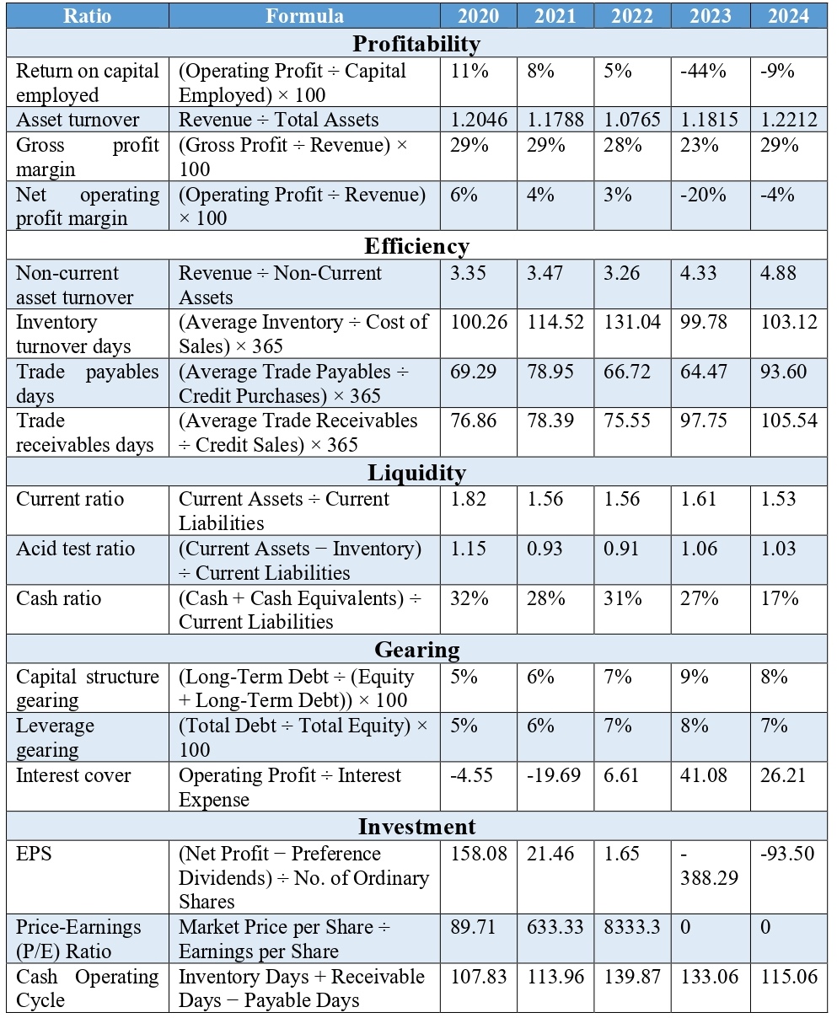
Profitability Ratios

Figure: Comparative profitability ratio data of General Electronics
Source: Author
The percentage of profitability indicates that the company's ability to generate profit has been significantly reduced. It dropped to 11 per cent in 2020 and -9 per cent in 2024, marking a loss of control in capital utilisation and declining returns on investment. It was not a strong fluctuator as the Gross Profit Margin remained at around 29 per cent in 2020, 2021 and 2024. However, it was also not spared and fell to 23% in 2023, indicating rising costs and a decline in sales volume. The Net Operating Profit Margin, in turn, has been decreasing to -4 per cent over the same period, indicating that administrative and operating expenses are increasing faster than revenue (A. Brealey et al., 2019). All in all, profitability ratios that exceed the industry average (which is between 15 and 20) will be a sign of good financial health and low-cost resource management as compared to declines below the industry average, which will reflect poor cost control, low productivity, and poor utilisation of the available assets (Aldboush et al., 2023). Growth in profitability is a sign of how efficient the operations are, as well as the security of investors; a decline is a sign that the business is not competitive and needs to undergo a strategic reorganisation.
Liquidity Ratios

Figure: Comparative liquidity ratio data of General Electronics
Source: Author
According to the liquidity analysis, the short-term solvency is declining. In 2024, the Current Ratio declined by 0.29 to 1.53; it remains above the one standard, which is a more stringent strategy for working capital management. The Quick Ratio, excluding inventory from current assets, declined from 1.15 to 1.03, refuting the claim of greater immediate liquidity. More importantly, the Cash Ratio decreased from 32% to 17%, indicating a dwindling of cash reserves and an increased reliance on short-term debt (Aldboush et al., 2023). The numbers all indicate increasing liquidity strains and possible restrictions on fulfilling short-term financial obligations (Aldboush et al., 2023). A liquidity ratio above the standard level (current ratio greater than 2.0, quick ratio greater than 1.0) was considered an indication that the company is financially stable and can easily meet its short-term goals (Asman et al., 2022). When these ratios are below the normal level, it indicates a restraint on cash flow, a possible need for short-term financing, and an increased risk of expenses not being paid.
Efficiency Ratios
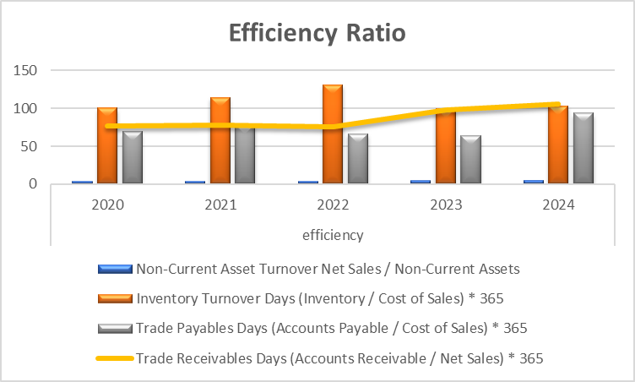
Figure: Comparative efficiency ratio data of General Electronics
Source: Author
Mixed performance is presented in efficiency ratios (Asman et al., 2022). The total Asset Turnover remained stable at 1.2 times, indicating stable yet low asset productivity. Non-current asset turnover also increased in 2024 to 4.88, compared to 3.35 in 2020, which may indicate a more efficient use of long-term assets, whether due to the sale of some of them or increased utilisation of existing capacity. On the other hand, the Inventory Turnover Days increased to 103 days from 100 days, while the Receivables Turnover rose to 105 days from 76 days, indicating lower rates of inventory turnover and slower collection of due payments (Damodaran, 2012). The payables Days have risen to 94 from 69, indicating an increase in supplier credit, which helps cushion an otherwise considerable strain on cash flow. Improvement in efficiency ratios, such as reducing inventory or receivable days, implies that the company is converting resources into sales at a faster rate, thereby enhancing cash flow and profitability. Reduced growth or size of days implies missing operational schedules, reduced asset exploitation and liquidity pressure.

Gearing Ratios

Figure: Comparative gearing ratio data of General Electronics
Source: Author
The solvency risk also increased moderately when the business's financial leverage was increased. The debt-to-equity ratio was also unbelievable, as borrowings increased relative to equity, compromising the balance sheet. This was, however, negative in 2023 and 2024, and it was found that the company is not efficient enough to pay its interest with profits (Asman et al., 2022). This also results in squandering equity and unfavourable coverage; financial stability in the long run becomes a problem. Gearing ratios which are higher than the permissible level (typically 50-60 per cent) indicate that they have over-borrowed, paid a higher interest and are limited in their financial freedom (Benfetter, 2025). Conversely, a gearing ratio that is below normal is an indicator of a higher equity position, less exposure to risks and greater financial shock-absorbing propensity.

Interest Cover

Figure: Comparative interest cover ratio data of General Electronics
Source: Author
The pie chart displays the interest cover ratios of General Electronics between the years 2020 and 2024. The loss of 2021 and 2022 negative coverages shows that the interest debt cannot be repaid by the company. It reached 41.08 in 2023 and dropped to 26.21 in 2024, which means a negative change in sustainability (Chen et al., 2019). A higher interest cover ratio compared to the standard coverage (normally three times and above) indicates that it can easily meet the liabilities imposed on the debt and will not face the risk of default. A decline to a value below this, or negative values, will be taxing on the characteristics of finances and will result in a loss of investor confidence, and it potentially might become difficult to borrow in the future (Brigham, 2020).

Key Financial Trends: Strengths, Weaknesses, and Emerging Risks
A financial analysis of the financial performance of General Electronics over 2020-24 indicates that the economic indicators of the company have been reporting low profitability, low liquidity, and long working capital cycles, although its operations have been identified to have strengths.
Key Trends:
Profitability of the firm has been on a downward trend, with Return on Capital Employed (ROCE) and Net Operating Profit Margin also registering tremendous declines, especially in 2023 and 2024, where the company has recorded successive losses. Overall margins were weak, although the gross profit margin was already 29 per cent in 2020, 2021 and 2024 because the direct cost of production has stayed low due to low sales volumes (Altman et al., 2017). The ratio of asset turnover was also nearly 1.2 times, which shows that all the assets were continuously used to earn revenue. But the non-current asset turnover has increased by 3.35 in 2020-24, and the main validation of this improvement is that the fixed assets are utilised to some extent, possibly due to the rationalisation of the poor-performing operations (Puji Lestari et al., 2022).
Emerging stress is expressed in the liquidity indicators. Both current and quick ratios had a slow decrease, and the cash ratio decreased significantly by 17 percentage points to 32, and this is a sign of a low liquidity buffer.
Strengths:
At the production level, the firm strongly manages costs under the pressure of financial needs because it does not impact the gross margin (Kaushik and Chauhan, 2019). An increase in the use of non-current assets is also an indication of efficient use of capital-intensive assets.

Weaknesses and Threats:
The weaknesses are the most important, and they include a lack of profitability and lower liquidity. The declining ROCE, unfavourable net margins, and declining cash ratios indicate the declining financial position (Allen, Brealey and Myers, 2019). The long collection and holding of inventory increase the liquidity risks. It shows that general electronics should focus on making operations less expensive, a tight credit policy, and cash flow control, as they are the sole remedies that would ensure operations are funded and investor confidence is restored (Ahmad et al., 2022).

Corporate Stability Assessment through Altman Z-Score Model
The Altman Z-Score model is an acceptable analytical model which detects the likelihood of a company being in a state of bankruptcy based on the financial performance metrics reflected in a single predictive model (Altman, 2018). This model is used in determining the solvency of a firm by evaluating the liquidity, profitability, leverage, and asset efficiency of a firm. The formula that is used is the following:
$$Z=1.2X_{1}+1.4X_{2}+3.3X_{3}+0.6X_{4}+1.0X_{5}$$
Where:
- X₁ = Working Capital / Total Assets
- X₂ = Retained Earnings / Total Assets
- X₃ = Earnings Before Interest and Taxes (EBIT) / Total Assets
- X₄ = Market Value of Equity / Total Liabilities
- X₅ = Sales / Total Assets

Using the financial data of General Electronics for 2020–2024, the following Z-Scores were computed:
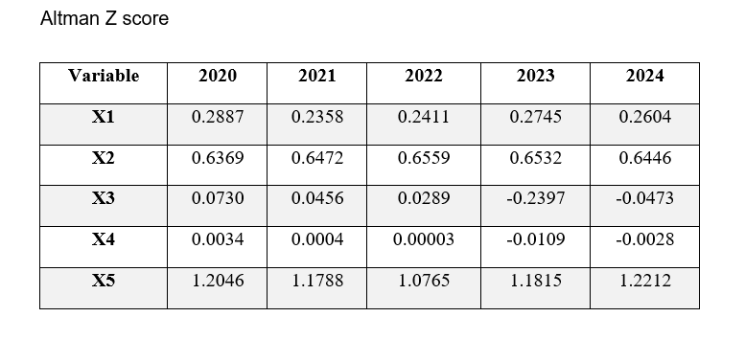
Table 1 Altman Z Score
Year | X₁ | X₂ | X₃ | X₄ | X₅ | Z-Score
2020 | 0.2887 | 0.6369 | 0.0730 | 0.0034 | 1.2046 | 1.55
2021 | 0.2358 | 0.6472 | 0.0456 | 0.0004 | 1.1788 | 1.54
2022 | 0.2411 | 0.6559 | 0.0289 | 0.0000 | 1.0765 | 1.57
2023 | 0.2745 | 0.6532 | −0.2397 | −0.0109 | 1.1815 | 1.30
2024 | 0.2604 | 0.6446 | −0.0473 | −0.0028 | 1.2212 | 1.33

Note:
X₁= (Working Capital / Total Assets)
X₂ = (Retained Earnings / Total Assets)
X₃ = (EBIT / Total Assets)
X₄ = (Market Value of Equity / Total Liabilities)
X₅ = (Sales / Total Assets)

Interpretation
According to Altman’s classification:
- Z > 3.0: Financially sound and low bankruptcy risk
- 1.8 < Z < 3.0: Grey zone (moderate risk)
- Z < 1.8: High probability of financial distress
General Electronics had consistently been below 1.8 in terms of rating, in the span of five years, which reflects financial vulnerability. The Z-score of the company improved in 2020 and 2022 (1.551.57), but declined in 2023 (1.30) due to operating losses and low profitability (negative EBIT). The slight increase of 0.33 in 2024 indicates a slight improvement in operations, though they are still in the distress zone.
The continuous decrease in the Z-score signifies the deteriorating financial position of the company and the imminent risk of default in case nothing is done to put the company back on track (Altman, 2018). These results indicate that General Electronics is currently in a major solvency crisis.

Evaluation of Working Capital Effectiveness

Analysis of Cash Conversion and Operational Efficiency
Cash Operating Cycle (COC) is one of the most critical measures of the efficiency with which General Electronics uses the working capital. It is the time interval between the payment of raw materials and the receipt of cash from customer sales (Kaushik and Chauhan, 2019). The COC of the company did not remain the same between 2020 and 2024, which indicated the imbalanced results in cash flow and liquidity management.
In 2020, the COC of the firm was 107.83 days. In 2021, it improved to 113.96 days, and in 2022, it peaked at 139.87 days. These were high in comparison with the efficient industries figures, although it was marginally higher in 2023, at 133.06 days, and 2024, at 115.06 days. The growth of the cash cycle means that the company will have to keep its investments in stock and its debts in the form of cash, which will exert pressure on the liquidity level and cause excessive dependence on external financing (Puji Lestari et al., 2022).
The primary reasons for the spike in 2022 were the slow movement of inventory and the slow collection of receivables, which obstructed cash flows and operational flexibility (Brigham, 2020). The decrease in 2024 is not a panacea; therefore, the COC suggests eliminating inefficiencies through a clever approach. Reduction of the cycle would provide more liquidity and cash flows to ensure that the company has sufficient money to pay back the short-term debts.

Liquidity Enhancement and Financial Flexibility Strategies
The working capital elements, such as inventory, debtors, and creditors, will need to be adjusted to enhance liquidity.
1. Reducing Inventory Days:
General Electronics can resolve its inventory problems by adopting lean production and making an accurate forecast of demand (Vu et al., 2020). The lean operations assist the firm in reducing the unwanted inventory, hence cutting down storage and handling costs. The other feasible strategy is to build strong and cooperative relationships with the suppliers. Such a collaboration would help the company to make speedier and more confident replenishment, would lessen the time involved in storing the inventory, and the company would operate with more flexibility, and less capital would be tied up in the inventory (Ahmad et al., 2022).
2. Rapid Collection of Receivables:
The speeding of the receivables will significantly assist in giving liquidity. Another factor that should be considered by the company is its credit policies; only customers with the highest credit quality should be given long payment terms (Vu et al., 2020). Early-payment discounts, automated billing, and impending reminders are some of the incentive strategies that can be used to promote timely payments (Damodaran, 2012).
3. Efficient Payables Management:
Even though it is crucial to pay suppliers promptly to maintain a healthy relationship, General Electronics must plan how to extend the time suppliers allow for their dues. Scheduling payments can be discussed flexibly so that the money can stay longer in the business (Ahmad et al., 2022). The firm can compensate for this by avoiding fines on late payments and creating contented suppliers, which would positively impact the supply chain.

Comparison of Short-Term and Long-Term Financing Instruments
The processes of short-term and long-term financing are significant concerns of liquidity management and financial stability.
Short-Term Financing:
Short-term financing is typically used to meet short-term working capital needs, including overdrafts, trade credits, and short-term loans (Benfetter, 2025). They are readily available with such facilities and offer the opportunity to resolve temporary cash crunches. However, they may have to be charged a much higher interest rate, and the company would be at risk of refinancing risks unless it is done properly. Excessive use of short-term borrowing would also result in a cash flow crunch, particularly where the repayments coincide with slow sales.
Long-Term Financing:
Long-term financing is typically done on capital investments like the development of infrastructure or the expansion of a product. The interest rate of this kind of financing is lower, and the payment period is spread over several years, decreasing the short-term impact on liquidity (A. Brealey et al., 2019). It also helps the firm access more funds for strategic endeavours. However, long-term debts lead to high leverage and reduced financial flexibility if future profits are insufficient to cover interest payments.

Assessment of Financing Alternatives and Capital Structure Choices
The balanced financing strategy would favour General Electronics, given the financial status of the company at the given time. The short-term operations are to focus on enhancing internal cash production by improving working capital management, i.e., reducing the days of inventory, decreasing the turnover of receivables, and maximising payables. This would limit the use of short-term borrowing and improve natural liquidity (Aldboush et al., 2023).
The company may address its short-term liquidity needs by using short-term loans or revolving credit facilities in case of liquidity gaps. Strategic investments, including technological upgrades, automation of processes, and market expansion, can be financed by long-term borrowing or equity injection (Aldboush et al., 2023). The company is expected to control its debt levels; however, to avoid over-leveraging.

Strategic Financial Recovery and Optimisation Plan
Over the last year or two, General Electronics has experienced severe financial degeneration, which is typified by constant losses, low profitability, and insufficient liquidity. This has impacted the shareholder value, since reduced sales, high operating expenses, and low utilisation of assets have weakened the competitiveness of the firm (Aldboush et al., 2023). In the quest to deal with these challenges, General Electronics needs a good financial restructuring strategy to restore economic stability, enhance liquidity and sustainable long-term growth (Ahmad, Bashir and Waqas, 2022).

Exploring Options for Financial Restructuring and Capital Realignment
a) Non-Core Assets Divestiture.
One viable strategy for starting General Electronics is the sale or spin-off of non-core or under-performing business units (Asman et al., 2022). The company is present in several markets, yet not all the divisions align with its future strategy or provide profitable returns. Dividing non-essential assets will enable General Electronics to acquire instant cash flows, which can be utilised to pay off the debt and enhance working capital (Brigham, 2020).
To make things easier and more effective, it would be best to put resources into the core profitable sectors, e.g., advanced home electronics or innovative technology. Divestitures are also effective in lowering the management complexities and enhancing strategic clarity.
- Impact on Shareholder Value: Selling non-core assets would provide a short-term payoff and enhance the company's valuation because it indicates a higher level of financial discipline (Altman et al., 2017). Nevertheless, the management should not ruin long-term growth prospects by selling off good strategic assets.
- There will be an impact on Debt and Flexibility: Asset sales may be used to decrease leverage by lowering interest charges and increasing the debt-to-equity ratio (Benfetter, 2025). This creates future-based capital space and flexibility in operations. The first risk is the lack of diversification, which could increase exposure to market fluctuations in the primary markets.
b) Strategy of Merger or Acquisition
Both an acquisition and a merger would provide a source of expansion and stability due to increased market coverage and operational synergies. The acquisition of a financially stable or technologically advanced business can help General Electronics find a new distribution channel and enhance its productivity and innovation.
- Impact on Shareholder Value: When done well, mergers may enhance shareholder wealth due to synergy benefits and future financial success. Teams that favour business acquisition deals usually bring positive reactions to the market (Aldboush et al., 2023). Nonetheless, new uncertainty and costs are also involved in mergers, necessitating short-term restructuring and integration expenses.
- Debt and Flexibility Impact: In the case of being financed by means of borrowing, mergers can temporarily raise the leverage levels. However, the joint operations are likely to increase the cash flow and the financial capacity of the new organisation in the long run (Ahmad et al., 2022). The problems of integration may hamper short-term flexibility, but the actualisation of the synergy would lead to increased efficiency and toughness.
c) Equity Injection
Equity injection involves introducing new capital through the issuance of new shares to investors. The solution will provide the liquidity the company needs to reduce its debt and invest in the modernisation or development of the product.
On the one hand, new shares will help stabilise the capital base and raise the company's financial strength, whereas on the other hand, they will most likely lead to dilution. The capital infusion would help reduce reliance on expensive, short-term funds and improve investors' willingness regarding the company's chances of recovery.
- Implication to Shareholder Value: Dilution might be an issue for the existing shareholders, yet equity financing can equally increase shareholder value in the long run by increasing financial viability and reducing insolvency risk (Altman et al., 2017). A clear communication plan will be required, and an investor confidence plan will be important in showing how the collected funds will be invested to enhance performance.
- Debt and Flexibility Impact: Equity injection effects on the company include a significant increase in the financial flexibility of the company (Puji Lestari et al., 2022). Reduced debt will translate to reduced interest and more allowances by the lending institutions, resulting in the management making the strategic decisions independently. This will enhance the aptitude to reinvest in the processes of innovation and expansion.

Global Financial Context and Ethical Decision-Making Considerations
As General Electronics is a multinational organisation, any restructuring should have the international monetary conditions and the business ethics in mind.
a) Tax Implications:
The restructuring of operations, such as divestitures or mergers, can impose taxation on other jurisdictions. To reduce taxation and meet the domestic regulations, the company must ensure that it organises its transactions in ways that will reduce taxation (Aldboush et al., 2023). Good tax planning will help to save cash flows and prevent an unfortunate image in the event of non-observance.
b) Currency and Exchange rate risks:
It is also trading in more than one currency and therefore it is exposed to exchange rate changes. The restructuring can include the assets and financial liabilities, which can be influenced by the exchange rates (Aldboush et al., 2023). General Electronics ought to apply the hedging strategy as a means of removing this risk and concentrate on trading in those markets whose currencies are stable.
c) Inflationary Pressures:
Inflation affects the cost of production, especially in the manufacturing and labour-intensive markets (Brealey et al., 2019). The company should also consider renegotiating its supplier contracts, improving the operational aspects of its business, and addressing areas where inflationary trends are seriously affecting its profitability.

Recommended Strategic Pathway for Sustainable Growth
The best approach for General Electronics to adopt in restructuring is a combination of strategies to be implemented in phases. Firstly, the company has to work out a selective divestiture to increase liquidity and reduce debt (Grozdanovska et al., 2017). This will give room to stabilise financial operations.
Having done that, equity injection must be raised with the perspective of raising the capital base and funding expansion plans, like product development and technology innovations (Berk et al., 2013). In the event of a balance sheet improvement, the firm may focus on a strategic merger or partnership to achieve scale, new market entry, and competitive advancement (Altman et al., 2017). The entire process must be carried out transparently, with communication with stakeholders and financial discipline to ensure success. Regular performance appraisal, cost control and governance control will be significant in the process.

Capital Investment Decisions and Project Appraisal Techniques
General Electronics is a multinational firm that deals in consumer electronics and is considering three investment projects, namely, Project A, Project B and Project C, with a minimal capital budget of £60 million to select the most valuable one. The decision is critical to the company because it has been facing financial challenges in the recent past, including a liquidity crisis and declining profitability (Brigham, 2020). The different methods of investment appraisal have been used to review the projects as a way of ensuring that the resource allocation of the project is the best; they include Payback Period (PBP), Average rate of return (ARR), net present value (NPV), profitability index (PI) and internal rate of Return (IRR).
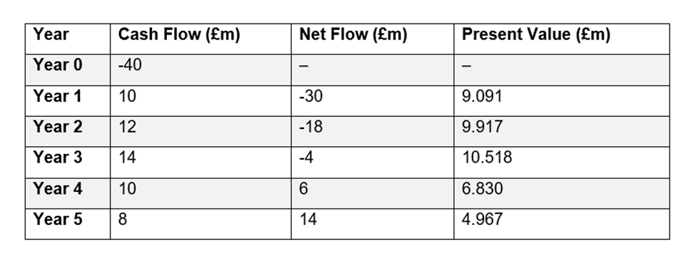
Table 2 Cash Flow Summary
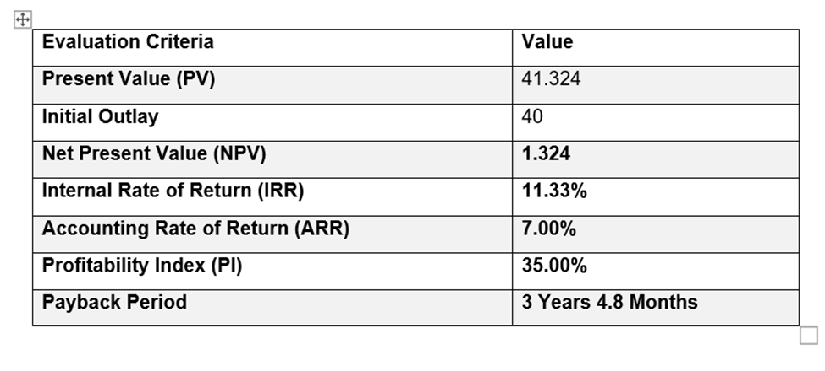
Table 3 Investment Evaluation Metrics

Project | Pay Back Period | Accounting Rate of Return | Net Present Value (£m) | PI (%) | Internal Rate of Return (%)
Project A | 3 Years 4.8 Months | 7.00% | 1.324 | 35.00% | 11.33%

Table 4 Project A Evaluation
Project A Evaluation
Project A shows moderate financial performance, which is a good but not exceptional investment decision. The NPV stands at 1.324 million, indicating that the project will be profitable for the company and yield profits above the cost of capital. The IRR of 11.33 per cent is above the majority of corporate hurdle rates, which means that the investment will be more profitable than the minimum acceptable rate (Altman et al., 2017). The investment can be recovered within a reasonable time, increasing short-term liquidity as indicated by the PBP of approximately 3 years and 5 months.
The ARR value of 7.00% demonstrates high profitability, and the PI of 35 indicates that a pound investment in the company will yield a pound and a half. These indicators would ensure that Project A would not only increase the company's profitability and cash position but also remain within acceptable risk levels.
Project A, on the other hand, is compared to other options that are financially weak. It has good returns; however, the profit margin and the returns are not quite justifiable compared to Project C (Ahmad et al., 2022). Additionally, since General Electric is currently financially unstable, intermediate projects like A cannot provide the transformational growth or liquidity recovery that the current organisation needs. It is, however, a reasonable investment, as it is pretty safe and practical, offering stable returns that are manageable and controlled.
Project | Pay Back Period | Accounting Rate of Return | Net Present Value (£m) | PI (%) | Internal Rate of Return (%)
Project B | 5 Years | 0.00% | -7.255 | 0.00% | 0.00%
Table 5 Project B Evaluation
Project B
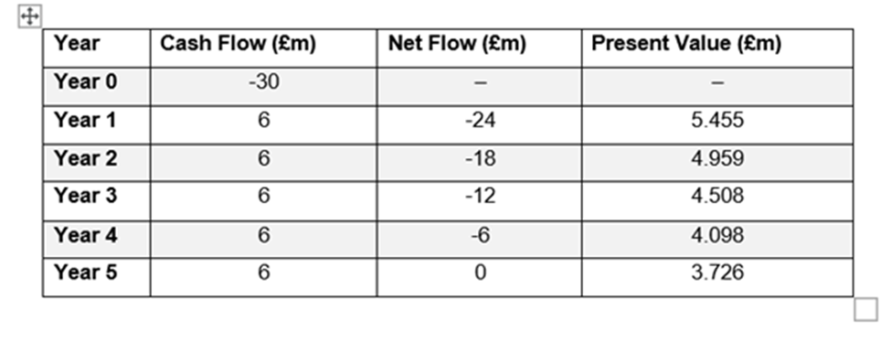
Table 6 Cash Flow Summary
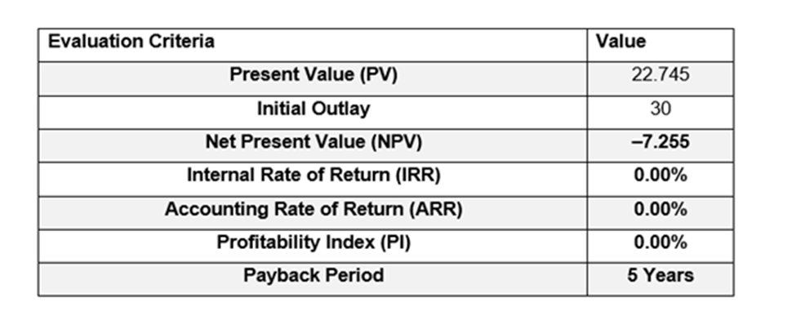
Table 7 Investment Evaluation Metrics
Project B Evaluation
The investment in project B will be the worst of the three alternatives. The NPV of -7.255 million indicates a value-destroying proposal, as the project's future cash inflows will not suffice to repay the initial investment when discounted at the company's cost of capital. There is no IRR and ARR, indicating that the project does not offer a high rate of investment (Puji Lestari et al., 2022). The 5-year PBP also means that the investment will not be met at the right time, making it unsuitable for a company that is liquidity-strained.
It could further be argued, according to the PI of 0%, that Project B will not bring any monetary profit but will instead drain the business's resources. A capital-strained environment will cause devastating impacts to the financials of General Electronics since the project will have a negative NPV and zero IRR (Aldboush et al., 2023). Project B does not meet the minimum investment requirements, but it poses an immense financial risk. Such a project deployment would put a strain on the capital available in a nonperforming asset, restrict the autonomy to invest, and even result in a future loss.
Project B is, hence, not a viable project and should be abandoned. There would be no interest for the company to invest in this venture, as it would increase profitability and shareholder value.
Project | Pay Back Period | Accounting Rate of Return | Net Present Value (£m) | PI (%) | Internal Rate of Return (%)
Project C | 3 Years 7.2 Months | 10.00% | 4.225 | 50.00% | 12.72%
Table 8 Project C Evaluation
Project C – Cash Flow Summary
Year | Cash Flow (£m) | Net Flow (£m) | Present Value (£m)
Year 0 | -50 | – | –
Year 1 | 5 | -45 | 4.545
Year 2 | 10 | -35 | 8.264
Year 3 | 20 | -15 | 15.026
Year 4 | 25 | 10 | 17.075
Year 5 | 15 | 25 | 9.314
Table 9 Cash Flow Summary
Project C – Investment Evaluation Metrics
Evaluation Criteria | Value
Present Value (PV) | 54.225
Initial Outlay | 50
Net Present Value (NPV) | 4.225
Internal Rate of Return (IRR) | 12.72%
Accounting Rate of Return (ARR) | 10.00%
Profitability Index (PI) | 50.00%
Payback Period | 3 Years 7.2 Months
Table 10 Investment Evaluation Metrics
Project C Evaluation
Project C is the best financial performer (of General Electronics). Its Net Present Value (NPV) is the highest of all the projects at $ 4.225 million, which is a good indication that the amount of future cash inflow is significantly more than the initial outlay (Vu et al., 2020).
This project would yield a substantial return, based on an internal rate of return (IRR) of 12.72% and an average rate of return (ARR) of 10%, which is very favourable in terms of profitability.
Its quickness could be taken as one of its strongest sides: the payback period is three years and seven months. The ability to settle the initial investment in such a brief time is immensely beneficial to the company's liquidity needs at the time (Puji Lestari et al., 2022).
Project C is also an appropriate utilisation of resources. In this instance, its Profitability Index (PI) is Economic Value Added (EVA) of 1.5, which means it is generating a significant amount of value per dollar invested.
Project C in itself is an enormous success. It satisfies the two major financial recuperation objectives of the company: short-term alleviation of cash and liquidity, and long-term economic stability.

Net Present Value (NPV)

Figure: NPV data of three projects
Source: Author
The pie chart shows the comparison in profitability of three investment projects. Project B presents a -24 per cent payback, which represents a loss, whereas projects A and C present 3 per cent and 8 per cent, respectively (Puji Lestari et al., 2022). These results are a pointer to show that Project C is the cheapest alternative that will provide the highest profit, yet there is an improvement in profit relative to the investment.
Internal rate of return (IRR)

Figure: IRR data of three projects
Source: Author
The figure presents the profitability results of three investment projects. Project B presents a negative value of -24 per cent, which translates to a loss, whereas Project A has a 3 per cent return, and Project C has an 8 per cent return. Project C offers the most profitability among them, which confirms its naturalness to be chosen as an investment project and has the potential to recover in the long run (Kaushik and Chauhan, 2019).
Accounting rate of return (ARR)

Figure: ARR data of three projects
Source: Author
The chart gives the Accounting Rate of Return (ARR) of three projects. Project A recorded a humble status of 3 per cent return, and Project B had a huge depreciation of -24 per cent. Project C, in contrast, was able to increase its profit by 8 per cent, and this means that it is more profitable and is able to increase its financial performance.
Capital Rationing and Decision Analysis.
General Electronics has a maximum investment ceiling of £ 60 million; therefore, they have to find out those projects that can maximise value within the market limit of the budget (Kaushik and Chauhan, 2019). The limit implies that the company holds an opportunity to choose from among the three projects due to the excess combination of all three projects, as it would restrict the capital available.
- Project A will have an approximate cost of approximately £40 million and a small positive NPV.
- Project B requires a sum of money just like Project A, but destroys value.
- Project C, which encompasses a cost of £50million, has the highest NPV, IRR, ARR, and PI.
In the case of such results, it is clear that Project C is a superior choice. Even though most of the available capital is tied up in it, it has the highest total payback, a relatively high payback time, and low risk. It has a direct bearing on providing the liquidity needs of General Electronics, regaining the investor's faith, and raising the profitability.
Rationalisation on the Ground of the Financial Position of the Company.
General Electronics has, over the last few years, suffered a triple blow of falling sales and profits, on top of massive cash flow problems. The company must be retaliating; thus, projects that can bring large revenue in the short run are an urgent need of the company (Ahmad et al., 2022). That is where Project C comes in (it is the obvious financial winner of all options). Its short payback period suits the company's urgent cash requirements perfectly, allowing it to address liquidity problems promptly. Concurrently, its positive Net Present Value (NPV) and Internal Rate of Return (IRR) indicate that it will add actual value, and that is good news for our shareholders.
General Electronics can afford to settle debts in the short term much more effectively by opting for Project C, as it can significantly stabilise its cash flow and utilise the returns to pay off such debts (Altman et al., 2017). The funds added are not only to pay the debts, but they also put us in a position to invest in innovation and operational improvement that would allow the company to be able to, in the long run, again realise its competitive advantage.
Simply put, Project C is the most appropriate solution. This is done in a direct manner, which concentrates on the challenges currently affecting the company financially and, simultaneously, creates the revenue and versatility needed for the future of General Electric.

Considered risk and strategy
The risk profile of project C is most favourable as well. Liquidity risk and earnings volatility are reduced through the liquidity cash flows, high NPV, and low payback. The performance rates of the project are high, which makes it less susceptible to changes in the market and offers a consistent foundation to invest in the project (Ahmad et al., 2022). The insignificant payback period contributes to the financial versatility of the company as well because it will be able to invest funds in new projects earlier.

Recommendations
The analysis shows that General Electronics should have a combined financial recovery agenda, but not ad hoc actions. As it is recommended, the company should work on securing the liquidity through tightening its working capital management, shorter receivables turnover, lower inventory, and new terms with suppliers (Vu et al., 2020). The management will be recommended to strategically dispose of minor asset portions not core towards raising momentous cash flows and elevated leverage. Given the poor Z-score and a declining profitability of the company, the infusion of capital would offer a strong capital base and minimize the use of costly short-term borrowings (Altman et al., 2017). In regard to the decisions pertaining to the investment, Project C is suggested as the best option to offer the best NPV, IRR, and payback profile, offering payback and liquidity based on the short-term set of reasons and the long-term value creation. Finally, the company should consider an explicit financial message policy whereby there is an attempt to revive investor trust, besides embracing continuous performance control, whereby the recovery objectives are reached.

Conclusion
The financial analysis of General Electronics shows that the company is in dire need of a sophisticated recovery. The debate reckons that liquidity constraints, a shrinking profitability, and poor use of assets necessitate restructuring and decisions on investment discipline in the company. Among all the suggested projects, project C is most acceptable due to the fact that it has the largest NPV, IRR, and profitability potential. Under these actions, and under asset divestiture that is parametric, equity funding, and working capital productivity, financial stabilisation can be revived, and long-term shareholder value can be established. Under this plan, General Electronics can restore its competitiveness and enjoy long-term global growth.

References
Ahmad, M., Bashir, R. and Waqas, H., 2022. Working capital management and firm performance: are their effects same in covid 19 compared to financial crisis 2008?. Cogent Economics & Finance, 10(1), p.2101224.
Aldboush, H.H., Almasria, N.A. and Ferdous, M., 2023. Determinants of firm profitability: empirical evidence from Jordan’s service sector. Business: Theory and Practice, 24(2), pp.438-446.
Allen, F., Brealey, R.A. and Myers, S.C., 2019. Principles of corporate finance (p. 1043). New York: McGraw-Hill/Irwin.
Altman, E.I., 2018. A fifty-year retrospective on credit risk models, the Altman Z-score family of models and their applications to financial markets and managerial strategies. Journal of Credit Risk, 14(4).
Altman, E.I., Iwanicz‐Drozdowska, M., Laitinen, E.K. and Suvas, A., 2017. Financial distress prediction in an international context: A review and empirical analysis of Altman's Z‐score model. Journal of international financial management & accounting, 28(2), pp.131-171.
Asman, F.N., Fernandez, D., Jamaludin, N.A., Omar Zaki, H. and Ghazali, A.W., 2022. Cash conversion cycle and firm’s performance. International Journal of Academic Research in Business and Social Sciences, 12(11), pp.2682-2692.
Berk, J., DeMarzo, P., Harford, J., Ford, G., Mollica, V., and Finch, N. 2013. Fundamentals of corporate finance. Pearson Higher Education AU.
Brigham, E.F., 2020. Financial management: Theory & practice.
Chen, Y., Mueller, A., Novak, B., Sensini, L. and Vazquez, M., 2019. Relationship between Liquidity and Profitability: Evidence from an Emergent Market. Entrepreneurship and performance in emerging economies, pp.297-311.
Damodaran, A., 2012. Investment valuation: Tools and techniques for determining the value of any asset. John Wiley & Sons.
Grozdanovska, V., Bojkovska, K. and Jankulovski, N., 2017. Financial management and financial planning in the organizations. European Journal of Business and Management, 9(02).
Kaushik, N. and Chauhan, S., 2019. The role of financial constraints in the relationship between working capital management and firm performance. IUP Journal of Applied Finance, 25(1), pp.60-82.
VU, T.M.T., Van Truong, T. and DINH, D.T., 2020. Determinants of liquidity in manufacturing firms. The Journal of Asian Finance, Economics and Business, 7(12), pp.11-19.

Appendices
Financial Statement:
Consolidated Income Statement (£m)
Particulars | 2024 | 2023 | 2022 | 2021 | 2020
Net sales | 394,879 | 420,457 | 542,751 | 601,602 | 614,680
Cost of sales | (280,885) | (322,897) | (390,459) | (428,586) | (438,424)
Gross profit | 113,994 | 97,560 | 152,292 | 173,016 | 176,256
Operating expenses | 129,291 | 182,861 | 137,744 | 149,763 | 138,989
Operating income (loss) | (15,297) | (85,301) | 14,548 | 23,253 | 37,267
Interest income (expenses) | (3,361) | (4,332) | (2,200) | (566) | (1,422)
Other income (expenses) | 60 | (2,621) | (955) | (6,607) | 8,060
Income (loss) before provision for income taxes | (18,598) | (92,254) | 11,393 | 16,080 | 43,905
Income taxes | (5,431) | (5,984) | (10,986) | (10,779) | (5,333)
Net income (loss) | (24,029) | (98,238) | 407 | 5,301 | 38,572
Earnings (loss) per share
Basic (£) | -1.85 | -7.64 | 0.03 | 0.39 | 2.78
Diluted (£) | -1.85 | -7.64 | 0.03 | 0.39 | 2.72
Shares used in computing earnings (loss) per share
Basic | 12,959 | 12,855 | 12,703 | 13,465 | 13,893
Diluted | 12,959 | 12,855 | 12,779 | 13,742 | 14,166

Consolidated Financial Position (£m)
 | 2024 | 2023 | 2022 | 2021 | 2020
Assets
Current assets
Cash and cash equivalents | 26,783 | 42,751 | 66,740 | 60,813 | 57,153
Accounts receivable | 114,182 | 112,596 | 112,346 | 129,215 | 129,433
Contract assets | 10,346 | 4,240 | 7,996 | 5,012 | 9,685
Inventories | 79,355 | 88,273 | 140,181 | 134,469 | 120,430
Other current assets | 9,478 | 7,325
Income tax receivable | 2,350 | 3,666 | 4,130 | 348 | 3,314
Total current assets | 242,494 | 258,851 | 338,040 | 337,146 | 326,843
Property, plant, and equipment, net | 34,207 | 44,619 | 62,791 | 74,647 | 87,285
Intangible assets | 24,038 | 25,349 | 24,470 | 20,169 | 19,710
Operating lease right-of-use assets | 14,322 | 18,693 | 21,599 | 19,847 | 19,522
Deferred income taxes | 6,425 | 6,787 | 6,242 | 7,729 | 5,564
Other assets | 1,868 | 1,573 | 1,936 | 2,347 | 2,752
Total assets | 323,354 | 355,872 | 504,163 | 510,348 | 510,290
Liabilities and Equity
Current liabilities
Accounts payable | 72,031 | 57,033 | 71,373 | 92,707 | 83,229
Lines of credit | 36,960 | 55,000 | 88,000 | 56,000 | 20,000
Accrued compensation | 20,927 | 20,305 | 20,904 | 24,217 | 28,931
Accrued sales discounts, rebates and royalties | 5,204 | 5,796 | 6,477 | 9,286 | 10,758
Other accrued liabilities | 21,008 | 21,181 | 24,134 | 30,840 | 33,057
Total current liabilities | 158,291 | 161,148 | 216,473 | 216,787 | 179,510
Long-term liabilities
Operating lease obligations | 9,232 | 12,560 | 15,027 | 14,266 | 13,681
Deferred income taxes | 1,931 | 1,992 | 2,724 | 2,394 | 1,913
Income tax payable | 72 | 435 | 723 | 939 | 1,054
Other long-term liabilities | 723 | 817 | 810 | 13 | 539
Total liabilities | 170,249 | 176,952 | 235,757 | 234,399 | 196,989
Shareholders' equity
Preferred stock
Common stock | 257 | 253 | 250 | 247 | 244
Paid-in capital | 344,697 | 336,938 | 326,839 | 314,094 | 302,084
Treasury stock | (371,930) | (369,973) | (368,194) | (355,159) | (295,495)
Accumulated other comprehensive income (loss) | (28,350) | (20,758) | (21,187) | (13,524) | (18,522)
Retained earnings | 208,431 | 232,460 | 330,698 | 330,291 | 324,990
Total shareholders' equity | 153,105 | 178,920 | 268,406 | 275,949 | 313,301
Total liabilities and equity | 323,354 | 355,872 | 504,163 | 510,348 | 510,290

Consolidated Cash Flow Statement (£m)
 | 2024 | 2023 | 2022 | 2021 | 2020
Cash flows from operating activities
Net income (loss) | (24,029) | (98,238) | 407 | 5,301 | 38,572
Adjustments to reconcile net income (loss) to net cash provided by (used for) operating activities
Depreciation and amortization | 18,058 | 22,927 | 24,033 | 26,747 | 29,735
Provision for credit losses | 1,081 | 70 | (182) |  | 332
Deferred income taxes | (256) | (1,149) | 1,377 | (1,560) | (478)
Shares issued for employee benefit plan | 1,063 | 1,293 | 1,199 | 1,092 | 1,136
Employee and director stock-based compensation | 6,700 | 8,809 | 10,013 | 9,969 | 9,122
Impairment of goodwill |  | 49,075
Impairment of long-lived assets | 333 | 7,963 | 2,888 | 3,338 | 134
Changes in operating assets and liabilities
Accounts receivable and contract assets | (12,174) | 5,040 | 12,765 | 2,007 | 14,884
Inventories | 6,239 | 51,458 | (9,913) | (14,985) | 28,295
Prepaid expenses and other assets | 764 | 2,860 | (917) | (630) | (245)
Accounts payable and accrued liabilities | 15,733 | (21,379) | (28,670) | 870 | (33,543)
Accrued income taxes | 1,310 | (3,539) | (2,074) | 2,860 | (6,486)
Net cash provided by (used for) operating activities | 14,822 | 25,190 | 10,926 | 40,283 | 73,392
Cash flows from investing activities
Purchase of term deposit |  |  | (7,487)
Redemption of term deposit |  |  | 7,803
Acquisition of the net assets |  |  | (939)
Acquisition of property, plant and equipment | (4,572) | (8,116) | (14,006) | (12,586) | (16,862)
Acquisition of intangible assets | (3,856) | (5,761) | (6,579) | (4,455) | (6,372)
Net cash provided by (used for) investing activities | (8,428) | (13,877) | (21,208) | (17,041) | (23,734)
Cash flows from financing activities
Borrowings under lines of credit | 102,193 | 78,000 | 133,000 | 112,000 | 75,000
Repayments on lines of credit | (120,000) | (111,000) | (101,000) | (76,000) | (123,000)
Proceeds from stock option exercised |  |  | 1,536 | 1,638 | 2,805
Treasury stock purchased | (1,957) | (1,779) | (13,035) | (59,664) | (17,678)
Net cash provided by (used for) financing activities | (19,764) | (34,779) | 20,501 | (22,026) | 65,964
Effect of foreign currency exchange rate changes on cash and cash equivalents | (2,598) | (523) | (4,292) | 2,444 | (843)
Net increase (decrease) in cash and cash equivalents | (15,968) | (23,989) | 5,927 | 3,660 | (17,149)
Cash and cash equivalents at the beginning of period | 42,751 | 66,740 | 60,813 | 57,153 | 74,302
Cash and cash equivalents at the end of period | 26,783 | 42,751 | 66,740 | 60,813 | 57,153

