Anna Bruce

Mdes Surface Pattern

Research Methods
And
Communication

Project Proposal

I am a final year student and very eager to consolidate all I have learnt whist studying Surface Pattern Design at UWTSD and would like to display this through my end of year exhibition and portfolio. I would like to be a successful designer either by gaining employment, freelancing or setting up my own company.
I ultimately see myself as a printmaker and textiles designer, these are the areas in which I feel most creative and from where I gather my inspiration. I am primarily inspired by mid-century textiles designers, illustrators and print makers like Barbara Jones (1912-1978), Enid Marx (1902-1988) Edward Bawden (1903-1989), Eric Ravilious (1903-1942), Sheila Robinson (1925-1988) Bernard Cheese (1925-2013), John Piper (1903-1992) Kenneth Rowntree (1915-1997) and Barnette Freedman (1901-1958). This along with my own illustrative drawing skills, are the foundations of my practise and form the base from which I can then create my own designs. I like to create designs that have a longevity and British sentiment.
I intend the outcome of my creative venture to be a diverse and interesting body of textiles and print, along with a strong portfolio, I want to use my interpretation of British popular art as the theme for this project. This may be expressed as wallpaper or fabrics that could be used in the home or commercially. I would like my portfolio and end of year exhibition to show the range of skills I have and act as part of my promotion. I am interested in telling a story through my imagery and will call on extensive research that I have accumulated during my 3 previous years of study.

Proposed Theme for My Creative Venture

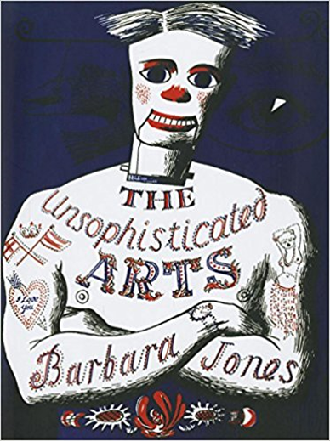
Figure 1. Barbara Jones Cover Art for ‘The unsophisticated Arts’

The theme of British popular art is best described by the artist Barbara Jones (1912-1978). Jones wrote and illustrated many books about British popular or vernacular art. ‘The Unsophisticated Arts’ (Jones, 2013) describes the everyday vernacular art that can be found through-out Britain and Jones sort to recognise the beauty of the untrained artist. In 1951 The Black Eyes and Lemonade exhibition, curated by Jones, opened at the Whitechapel Gallery (Gallery, 2013). It was part of the Festival of Britain and housed, for example, ships’ figureheads, oversized trade signs, corn dolls, horse brasses and canal boat art. The exhibition had a live element in that a pavement artist, Mr McErnean, who’s usual pitch was outside the British Museum was brought in daily to create performances on the Whitechapel floor. Jones herself had a substantial personal collection from which many of the pieces for this exhibition came (Artmonsky, 2008, p. 67). Jones struggled to define the art that was on display and wrote ‘we have not been able to find a satisfactory brief and epigrammatic definition of popular art’ (Jones, 2013, p. 10). She set up a ‘cabinet of folkloric curiosities’ (Jones, 2013, p. 11) and placed these aside present-day advertisements like the Idris Talking Lemon, pest control adverts ,beer mats and shop posters. (Jones, 2013) The Tate held a major exhibition of folk art on 10th June -31st August 2014. Curator, Jeff McMillan described it as ‘ultimately an exhibition of strange and exquisite objects, created mostly by unknown makers, the reminder of the handmade object, with its brilliant imperfections and anomalies, is something to celebrate’. (McMillan, 2014) The exhibition challenged the viewer to think about what art is or isn’t. Although much of the work on display showed a high level of skill and variety of aesthetic values, the pieces themselves were of the type more likely to be found in a museum rather than a gallery (Myrone, 2014). The term Folk Art often makes us think of modest and crude creations, along with the term craft, and can strip recognition and respect form the maker. The untrained artist Alfred Wallis, was plucked out of relative obscurity by the modernist elite artworld and subsequently became a celebrated artist, yet the Tate exhibition showed that he was one of many typical maritime painters. The display went on to show the ordinary person as they saw themselves, celebrating their lives and trades through joyful self-expression and not merely as laborers in fields or factories as was often depicted by academy artists (Jones, 2014). In galleries, we are shown repeatedly how Britain was and is shaped by the elite, these small exhibitions remind us how much of the culture and heritage of Britain belongs to the common man.
According to Jones there is a moving line between folk and vernacular art, folk art being more the art of smocking, Morris dancing, weaving, quilting and corn dollies etc. These traditions are rarely practiced and mostly remembered by Societies. Fireworks, toy theatres, waxworks and shop signs might be thought of as vernacular arts as they tend to be bolder, brighter and ‘less tasteful’ (Jones, 2013, p. 16) than folk arts. Still, the vernacular art with its often-perishable materials seems to be on the whole more embellished and complex as though to make up for a simpler way of life, ‘complexity is obviously the legacy of the illiteracy; only those who cannot read and write remember long ballads, or elaborate smoking pattern’ (Jones, 2013, p. 16). Jones identified a pattern as to how the popular of today becomes the collectable of tomorrow. When our own current popular/vernacular art becomes dull and falls out of taste, eventually, after enough time has passed, we will begin to see it in the homes of the rich and refined as collectable items, then in antique shops and lastly museum collections – in this way we begin to see what we were and what we have lost (Jones, 2013). Popular art is all around us today and comes in the form of the latest toys, electronic gadgets and apps but unlike the past, these are mass produced and lack a unique touch. Jones watched as the hand-made was gradually disappearing. For example, hand painted trade signs gave way to vinyl stickers whilst hand painted wooden merry-go-round funfair rides gave way to plastic moulding (Jones, 2013). Thankfully in my lifetime we are seeing a resurgence in the handmade and the pride involved in both the making and purchasing of uniquely crafted items. The Committee for the Employment of Wartime Artists decided to commission artists to record vanishing or changing aspects of Britain in 1939 and these commissions filled 4 volumes of a book originally published in 1946 (Saunders, 2011). Most of the focus was on buildings and land but with Jones as a commissioned artist, a much broader documentation was made that ‘included subjects so familiar that they were unremarkable-but were all the more vulnerable for that reason’ (Saunders, 2011, p. 153). Jones recorded many things from follies to topiary, she saw these as much a part of a national identity as perhaps more obvious monuments and believed that they should be as treasured. The time and effort in planting and maintaining topiary can be seen as symbolising the spirit of the British, at a time when the future was uncertain, there was a faith to been seen in the heritage, lastingness and persistence (Saunders, 2011).
Through my exploration of this proposed theme I intend on creating intriguing, entertaining and amusing imagery that contains with-in it a sense of storytelling. I want my textiles and prints to show a well-researched and executed design ideal and for my intended audience to feel as though they have returned to a period of nostalgia that they never fully left.

Researching Contemporary Artist

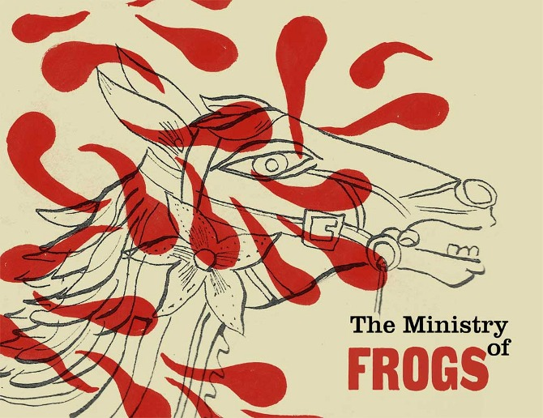
Figure 2. Desdemona, ‘The Ministry of Frogs’

Many contemporary artists whom I find motivating are also influenced by British popular art. The Ministry of Frogs, a small zine published by Desdemona McCannon, showcases some of the work by Emily Sutton, Jonny Hannah, Alice Patullo and John Broadley. McCannon states ‘I am interested in how illustrators think through images, and how a ‘folk’ sensibility might be expressed for personal or commercial reasons today. The artists represented in these pages are involved in making and using forms of expression that are influenced and inspired by the folk heritage of traditional popular art’ (McCannon, 2010, p. 2)

St. Jude’s
St. Jude’s are a contemporary online art gallery that sell limited edition original prints, fabrics and wallpapers. They showcase many contemporary designers that I follow with much interest.
Johnny Hannah is an illustrator and printmaker whose work is colourful, unique, vibrant, fun and echoes much of the nature of Jones and her ideas of vernacular art. Hannah often depicts folkloric stories and character that are ‘drawn from past decades of packaging, styling, decoration and advertising, from shop signs to beer-bottle labels, from scrimshaw to psalters, from vintage toys to dead men’s suits’ (Hoare, 2014, p. 15) Hannah has captured elements of British popular art in his work through the use of texture, layering and typography and is able to communicate an exuberant energy that appears to be for its own sake. Some of Hannah’s work has been successfully translated into wallpapers and textiles for the company St. Jude’s. For the wallpaper ‘The captain’s Pattern’ shown in figure 3, Hannah uses simple popular art symbols that easily communicate ideas of an ocean going narrative. Along with a light hearted whimsical style these motifs are playful and fun.

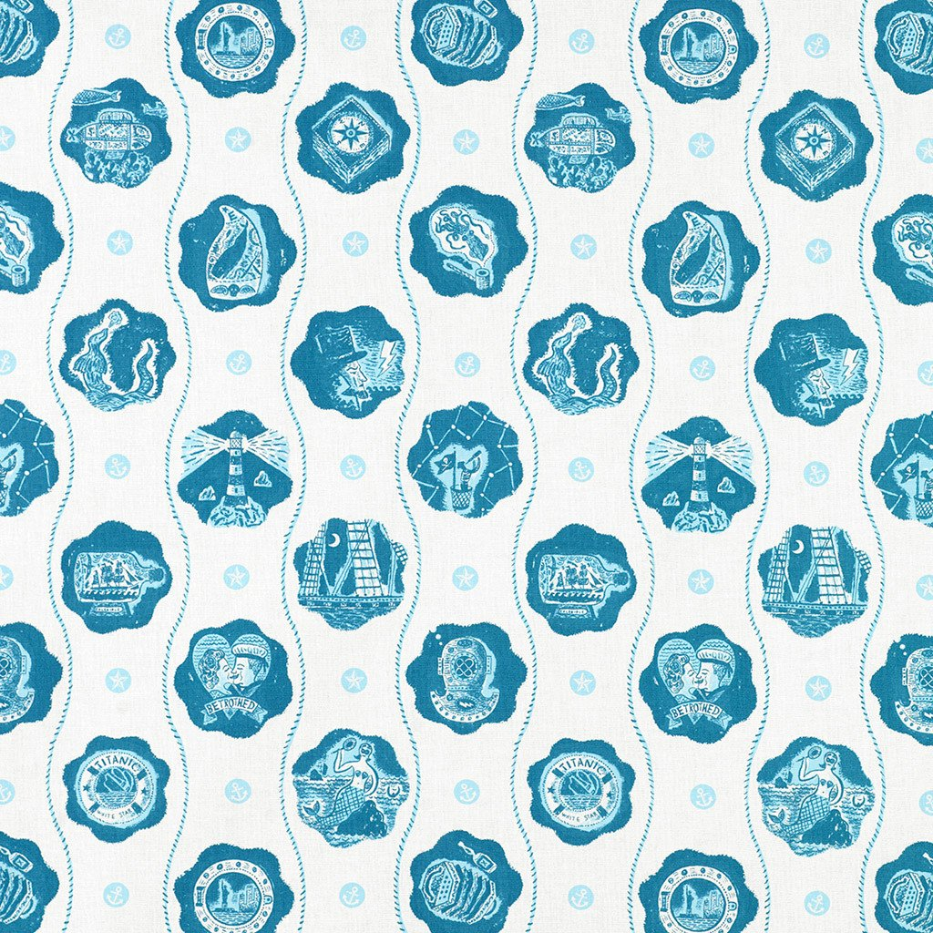
Figure 3. Johnny Hannah ‘The Captain’s Pattern’

Christopher Brown is an illustrator and print maker whose book ‘An alphabet of London’ (Brown, 2012) celebrates, through a series of lino cuts, the city and is comparable to popular art. It draws on traditional London scenes and observes the sometimes-minor aspects, something that is akin to Jones and her attention to the seemingly unimportant. It does this is a cheeky almost tourist fashion as though it takes for an outsider to truly see the beauty and curiosity of a city that its residents might miss. Browns wallpaper for St. Jude’s titled ‘Albion’ (Jude's, 2018), see figure 4, is also an honouring of Britishness, it depicts scenes from British literature, history, architecture, seafaring and nature.

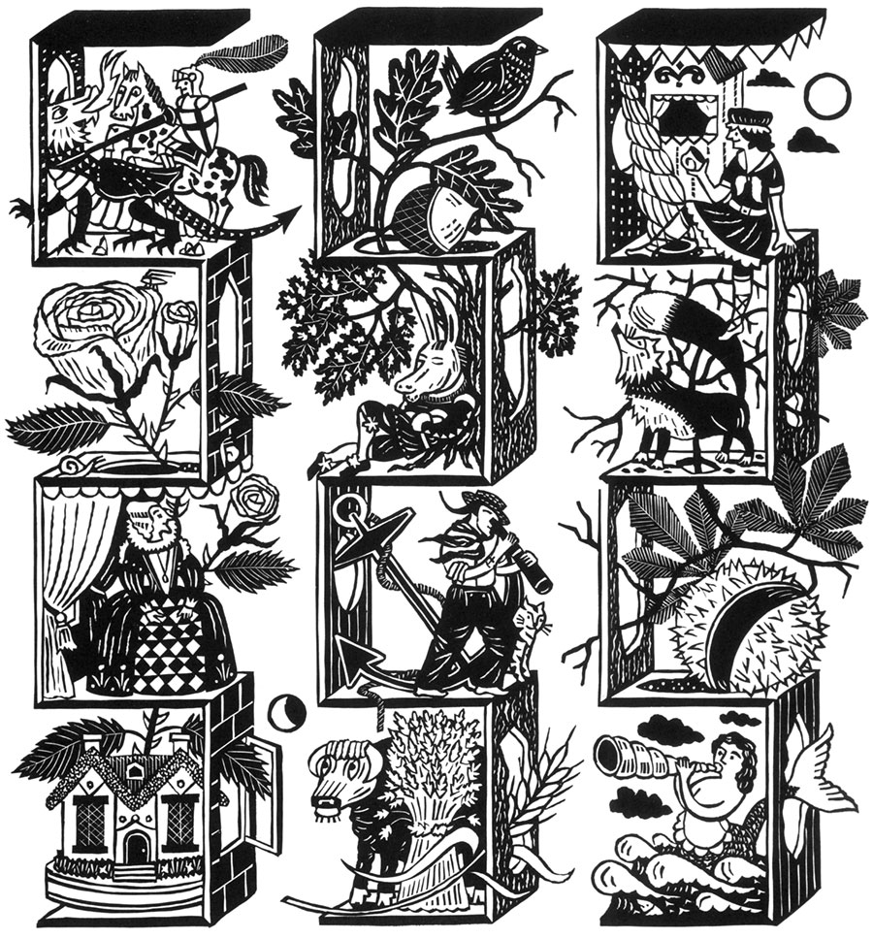
Figure 4. Christopher Brown ‘Albion’

Other St. Jude’s designers include;
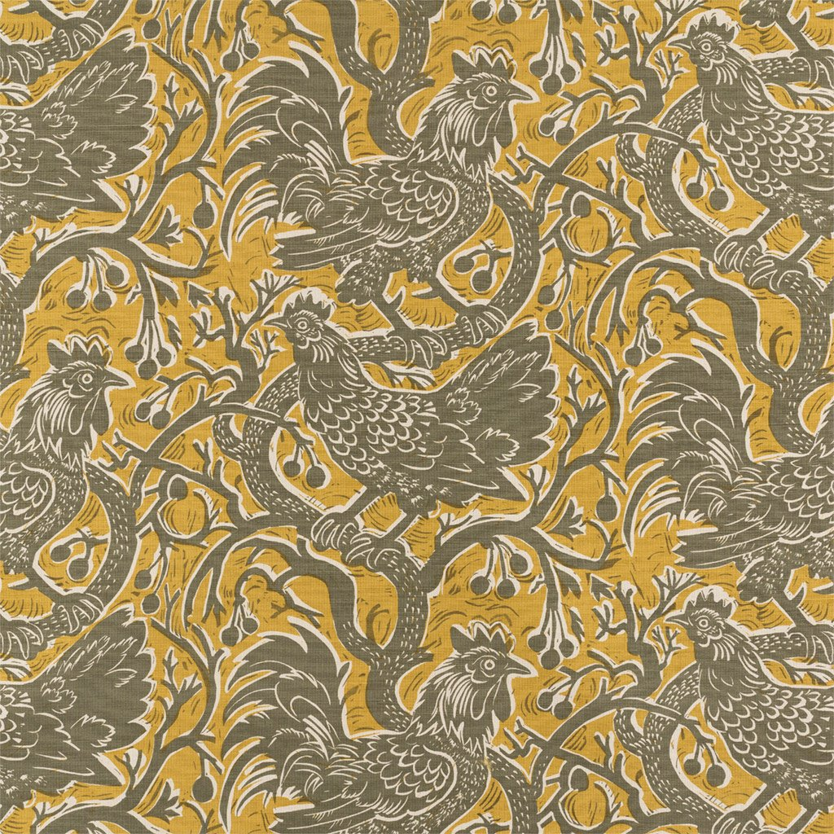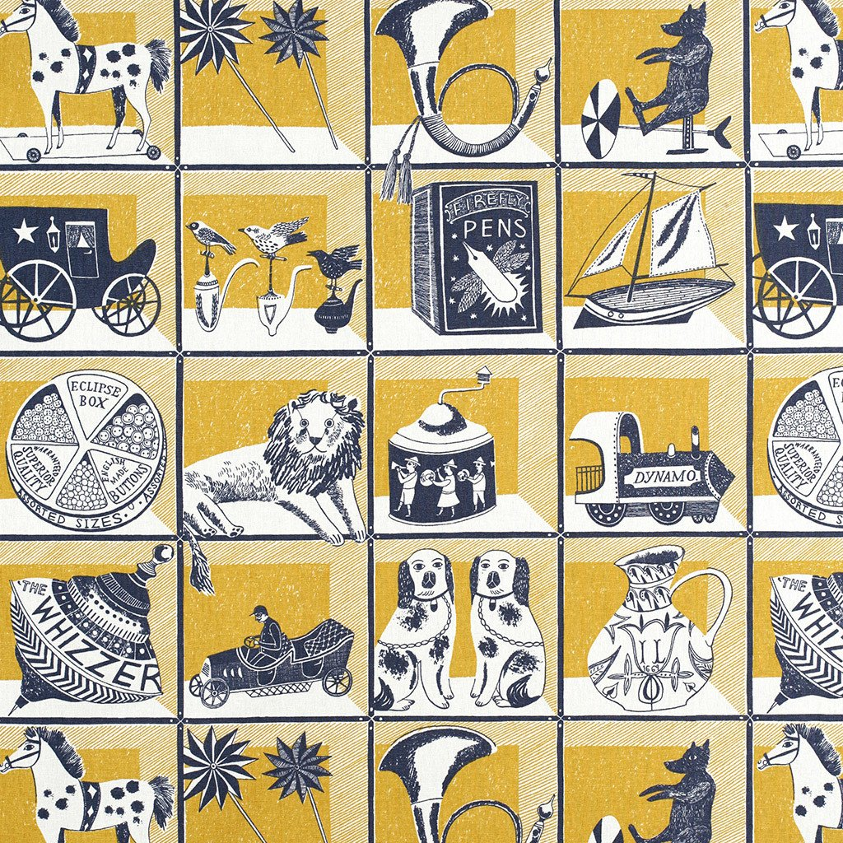
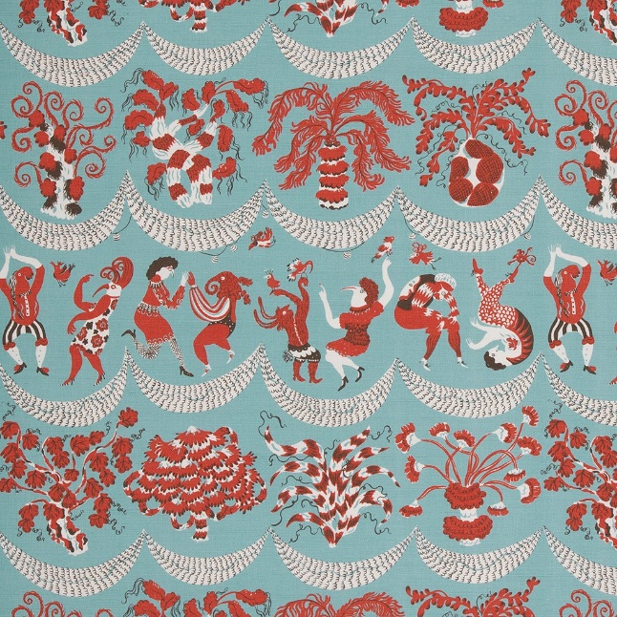
Figure 5. Mark Hearld ‘Bantam Bough’ Figure 6. Emily Sutton ‘Curiosity Shop’
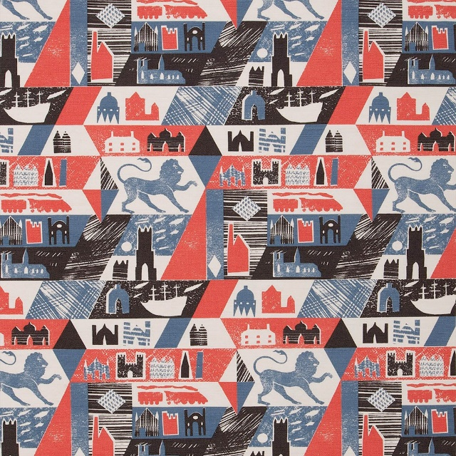
Figure 7. Ed Kluz ‘Lionheart’ Figure 8. Elle Curtis ‘Forest Jig’

I aspire to the same creative and professional level, in terms of what has been achieved by a company like St. Jude’s and hope that my end of year show and portfolio will be another step towards my personal goals. The whole aesthetic of St. Jude’s seems to be almost lifted from the pages of ‘The Unsophisticated Arts’ and so in this way I feel encouraged that there is a large and engaged market for the research and designs I intend to demonstrate.

The illustrator and print maker Ed Kluz’s fabric ‘Lino heart’, Figure 7, “depicts the simplified forms of castles, follies, pavilions, cottages, cathedrals, mills, a steam train and a sailing ship with the lion rampant at the core” (Kluz, 2017). This simplified imagery is akin to the subjects Jones detailed in her quest to record the vanishing provincial art and scenes of British life. In his Book, ‘The Lost Houses Revisited’ (Knox & Kluz, 2017) Kluz traces the history of grand building lost to ruin and using mixed media paper collage, recreates them to their original condition. Through his pieces we can see the houses reimagined from the perspective of a contemporary maker.

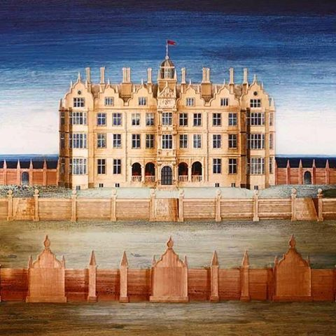
Figure 9. Ed Kluz, Campden House 'The Lost House Revisited'

These striking images and atmospheric works are constructed in such a way that gives them a beautiful 3d quality that is unique and fascinating. With their isolated placement, they look as though they have been lifted from past times and placed in a reimagined setting to add to their ethereal look. Kluz’s exploration into these ruins is suggestive of Jones and ‘a feeling of the past within the present’ (Knox & Kluz, 2017, p. 49) evokes a strong connection with what came before and this link is an aspect I would like to include in my work

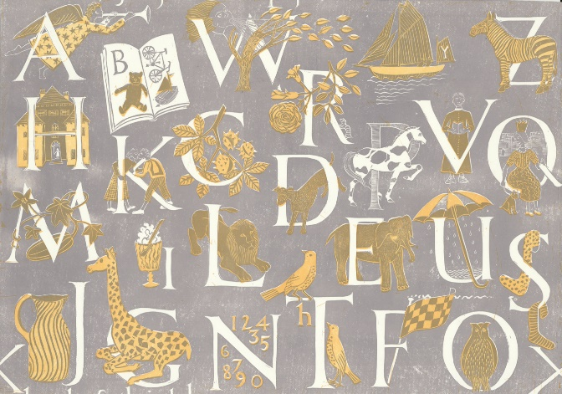
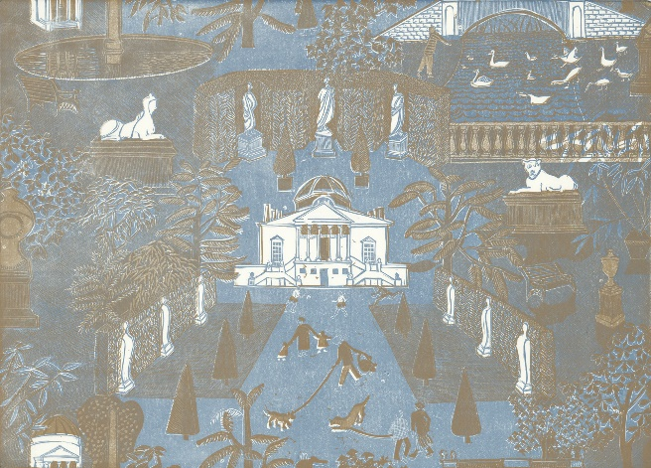
Figure 10. Marthe Armitage ‘Alphabet’ Figure 11. Marthe Armitage ‘Chiswick House’
Marthe Armitage is a wallpaper designer who uses traditional lino printing to create beautiful and unique interiors. They are printed on a lithographic proofing press with the help of her daughter Joanna Broadhurst. (West, 2018) The subject, colour and texture, created by the hand printed method, join to forge an individual style. Armitage has an extensive portfolio of designs that are extremely inspirational to me, they don’t appear to follow the current mainstream trends, and again there emerges a feeling of creating for the sake of creating. I would like to have a style as different, unique and effortless as hers. I greatly admire the simplicity of colour, imagery and composition that she utilizes and these are all elements that I strive for in my own practice.
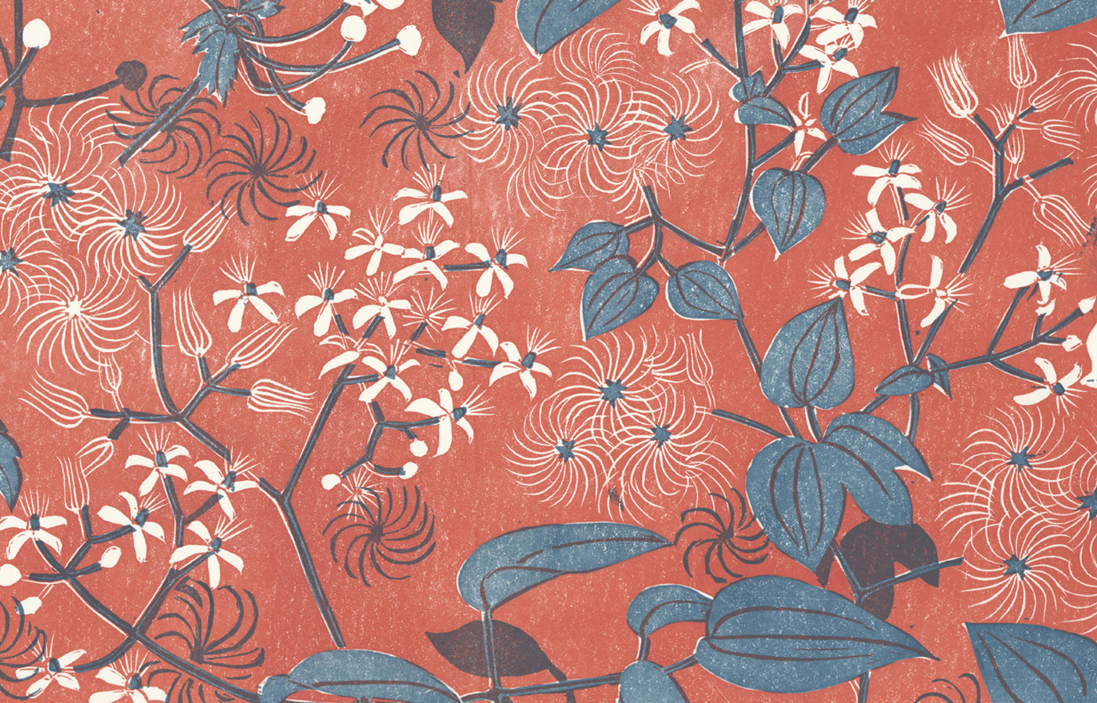
Figure 12. Marthe Armitage ‘Old Man’s Beard’

Compton Verney Art Gallery

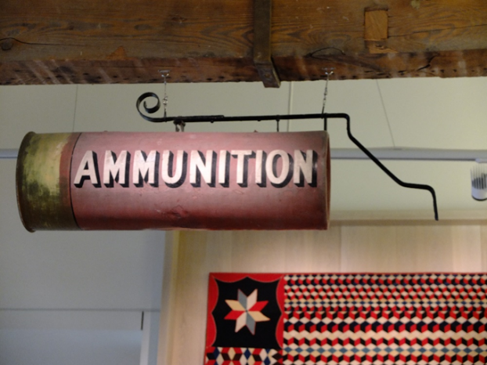
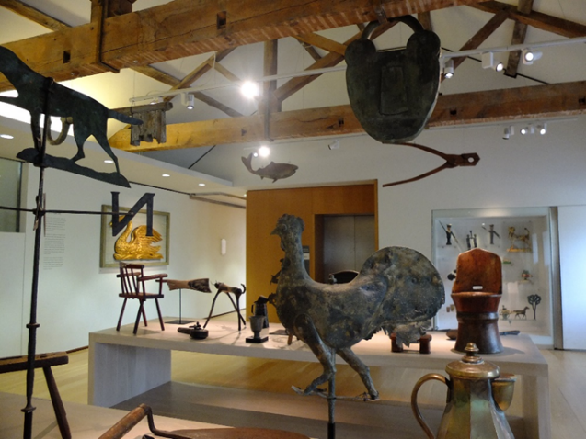
I visited Compton Verney Art Gallery to see the permanent exhibition of British Folk art housed there and the collected items of Enid Marx (1902-1998) and Margaret Lambert (1906-1995). The designer and illustrator Enid Marx was also a collector of British vernacular art and along with Margaret Lambert wrote ‘English Popular Art’ published in 1946. Marx was a textiles designer and is particularly well known for the fabrics she designed for the London transport. She was a prolific print maker who block printed wallpapers and fabrics. Marx also illustrated many books. The exhibition brought together objects and folk-art pieces that were collected over a period by Marx and Lambert and demonstrates a similar understanding of their value in much the same way as Barbara Jones had expressed in the Black Eyes and Lemonade exhibition. Marx was greatly influenced by her collection, sometimes exactly, as in the case of her Cornucopia block printed repeat fabric design. The collection housed all manner of objects that included a cup and saucer collection that featured her contemporary, Eric Ravilious, vanished plaster models taken from gingerbread moulds, furniture, ships in bottles, corn dollies, hand painted Easter eggs and many of her own painting, lino prints, textiles and wallpapers. (Parissien & Sexton, 2013) Seeing this exhibition really helped in understanding the design process of Marx and how these collected items translated into her designs. From a personal view point I found this exhibition deeply emotional because it contained a life’s work and formed everything I aspire to. Critically therefore, to visit galleries containing work by artists that I admire far supersedes any other form of research since a tangible connection is made which brings me closer to the artist.
Figure 13 Figure 14
Marx, Lambert Collection at Compton Verney

Primary Research

My primary research consists of a large collection of books, internet research and many trips to museums and exhibitions, where I have gathered a large bank of experiences and imagery from which to draw inspiration.
The Victoria and Albert museum of childhood and the National Trust’s Sudbury Hall Museum of Childhood have both been fantastic for influence as for me they house collections that can be easily associated with the theme of British popular art. The toys, models and games on display are suggestive of the notion that in the ‘vintage’ and through nostalgia, we see what has been loss (Jones, 2013).
I have visited the Pitt Rivers museum in Oxford many times and have found it very inspirational as it houses oddities along with archaeological and anthological collections.
‘Bygones’ is a nostalgic museum in Torquay I visited last summer and it consists of a collection of themed Victorian era shops, each is filled with vintage goods, packaging and ephemera, all of which are visually appealing and thought provoking in relation to my chosen theme.
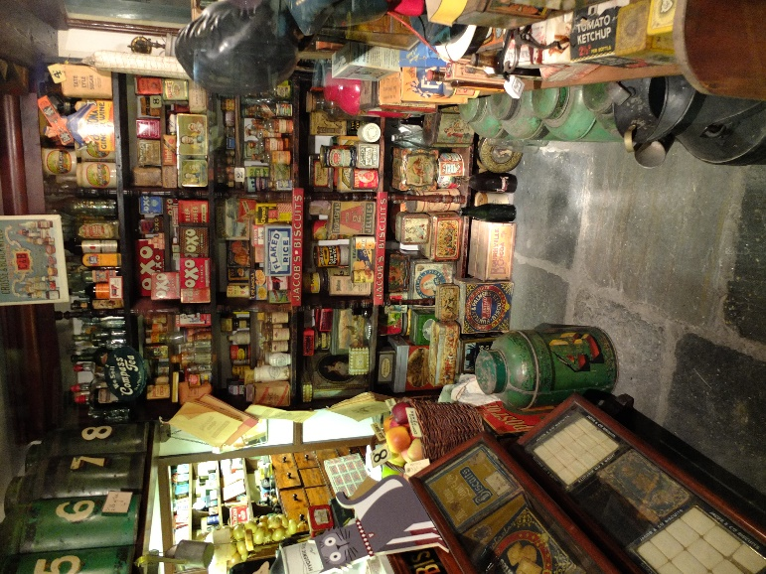
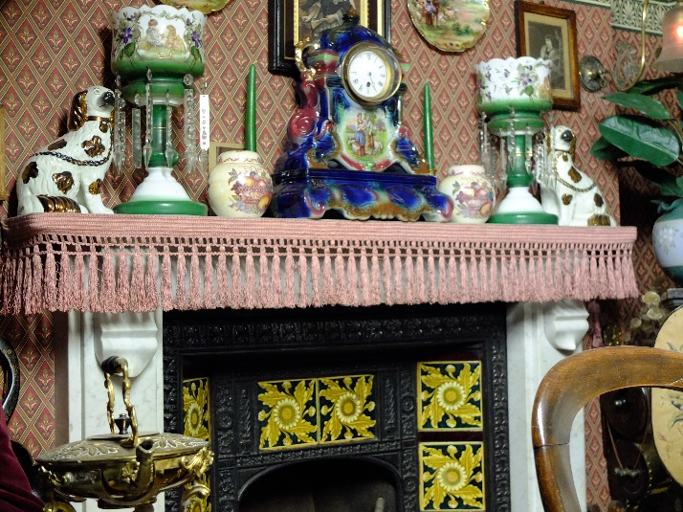
Figure 16. Bygones Museum Torquay

Figure 15. Bygones Museum Torquay

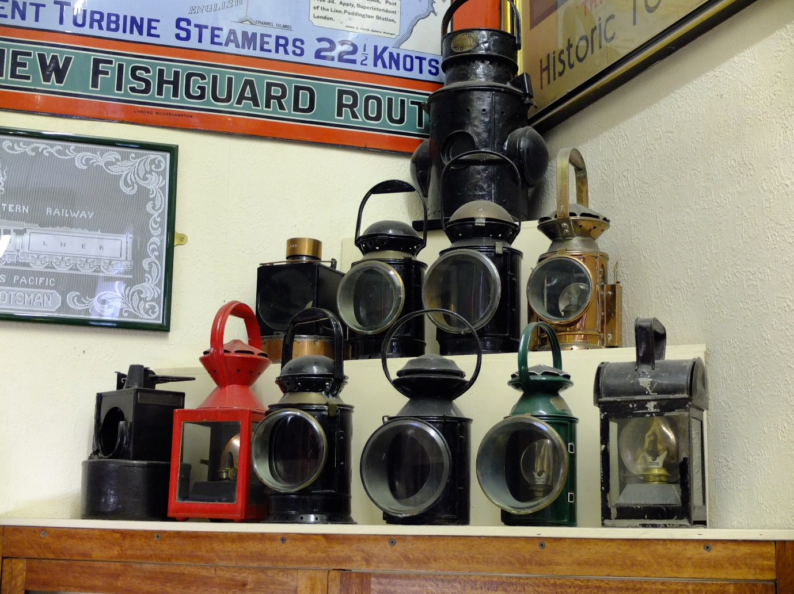
Figure 17. Bygone’s Museum, Torquay.

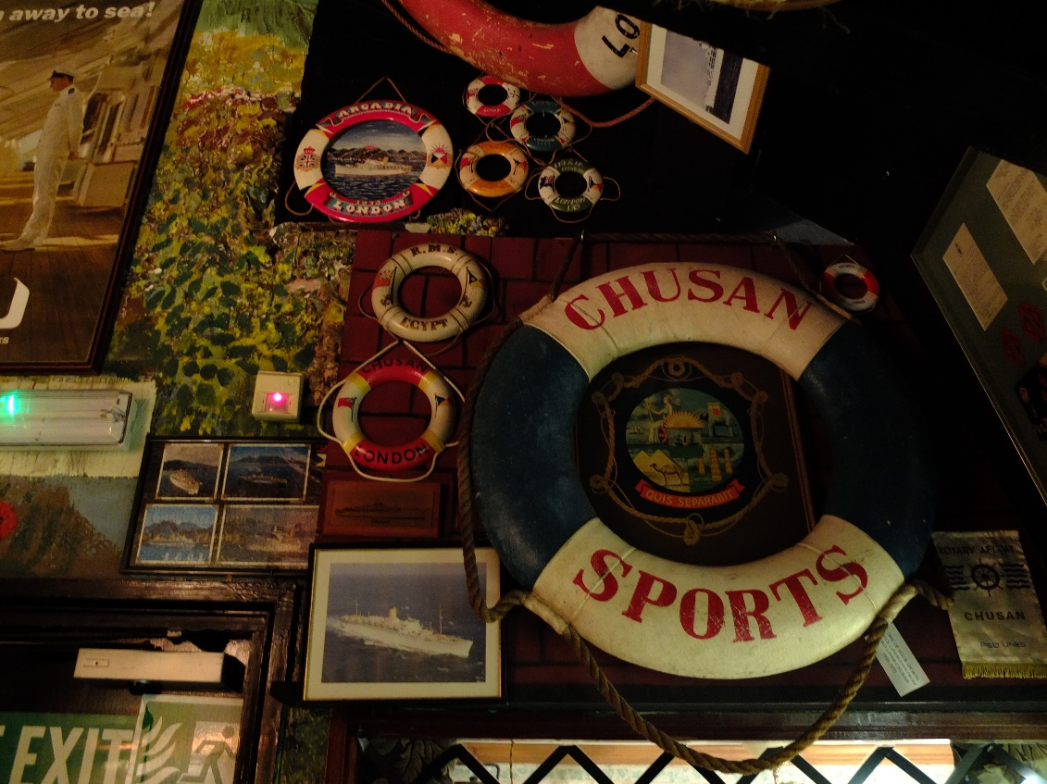
Figure 18. Bygone’s Museum, Torquay

I have visited the historic dock yards of Portsmouth and Chatham, and the National Maritime Museum at Falmouth and Greenwich. I used these visits as research for my final major project in the 3rd year but have more ideas and would like a new nautical element in my creative venture. Chatham was excellent as it has a historic lifeboat collection.
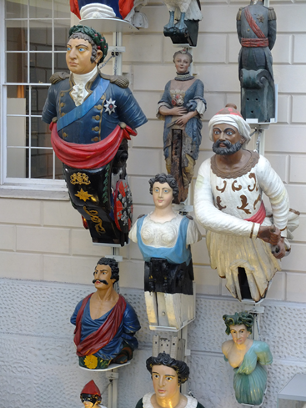
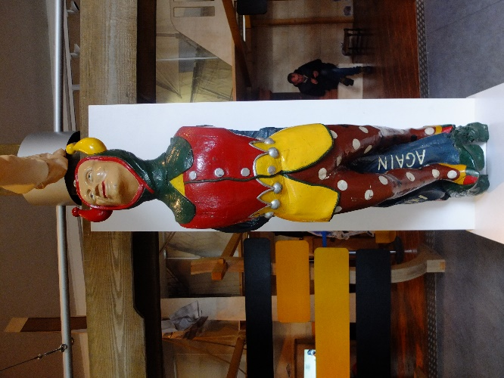

figure 19. Figure 20.
Figure Heads at Greenwich Museum Figure Head at Chatham Historic Boat Yard
The American Museum in Bath has a permanent exhibit of folk art which I found fascinating and from it could further identify my own understanding of the theme and how I might interpret it into my own designs.
I plan to visit Compton Verney again this year to see ‘The Pattern of Friendship’ exhibition which will show work by many of the Great Bardsfeild artists, I’m very excited to see this one and am hopeful that it will inspire me more so with my theme. The book ‘Bawden, Ravilious and The Artist of Great Bardfield’ which contains some of my most influential designers has further helped me define a sense on the theme of British popular arts. Great Bardfield became the home of Edward Bawden, Eric Ravilious, Walter Hoyle, Kenneth Rowntree, Bernard Cheese and Sheila Robinson, among others. They, like the Bloomsbury group, created a working collective and drew upon inspiration from the surrounding Essex countryside to create a very defined and distinctive mid-century style (Yorke & Saunders, 2015)
The Fry gallery in Saffron Walden has a permanent collection of work by Edward Bawden, Walter Hoyle, Bernard and Chloe Cheese, Kenneth Rowntree, Sheila Robinson, and Peggy Angus. I hope very much to visit this museum also in connection to my creative venture.
Dulwich Museum of Art + Craft will soon have an exhibition of Elizabeth Friedlander’s work which I also plan to visit.

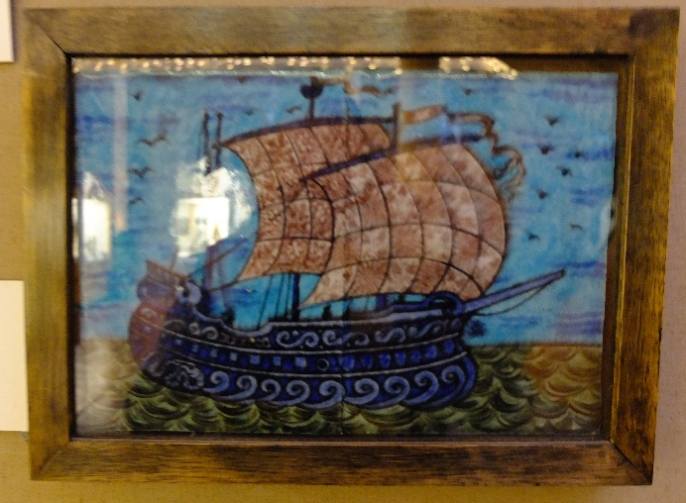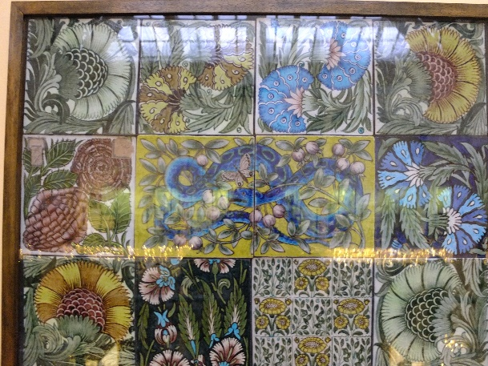
Figure 21. Figure 22

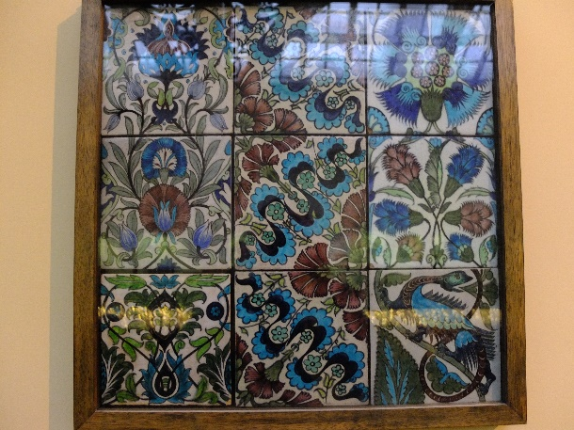
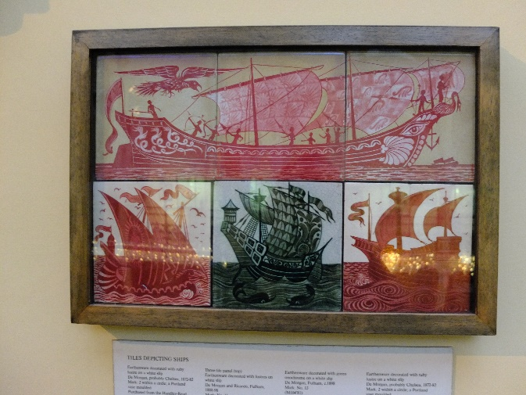
Figure 23. Figure 24.
William De Morgan Tile Collection at Birmingham Museum

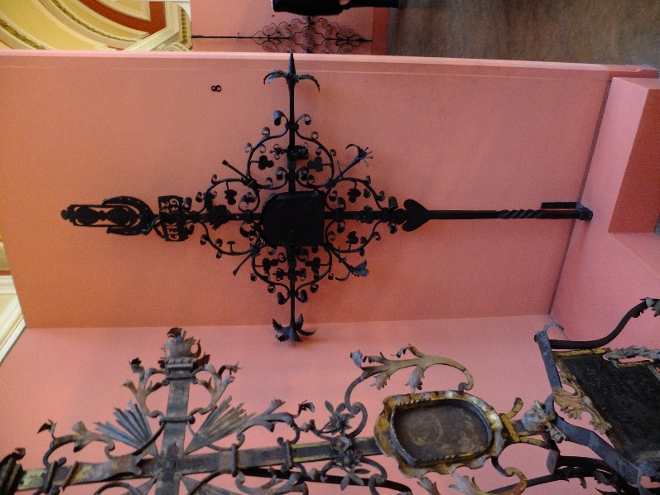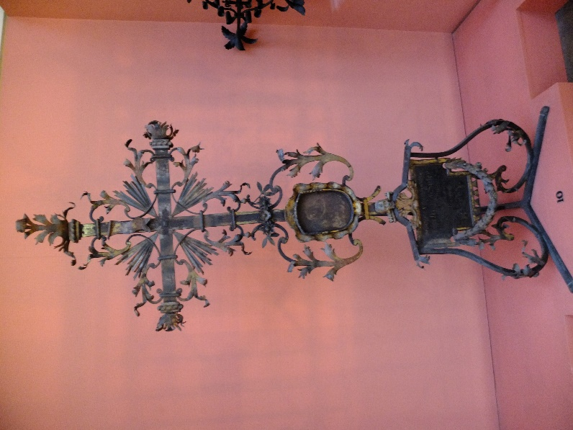
Figure 25. Figure 26.
Wrought Iron at Birmingham Museum

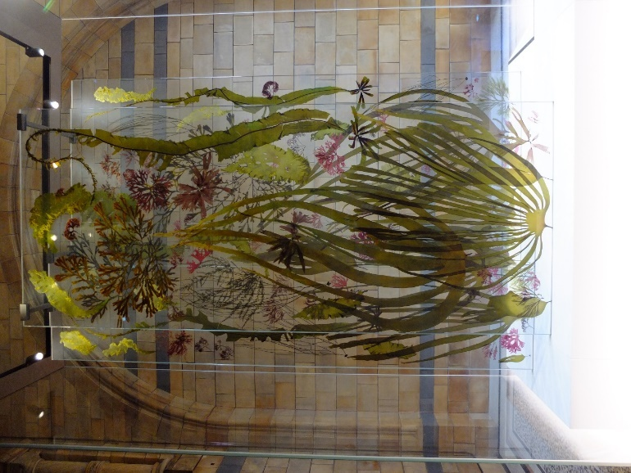
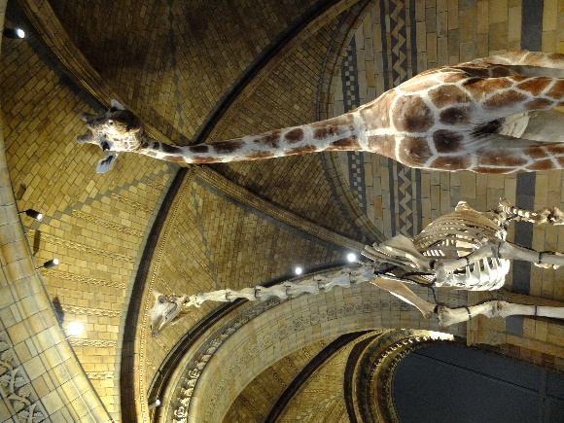

Figure 27. Figure 28.
Images taken at The Natural History Museum, London.

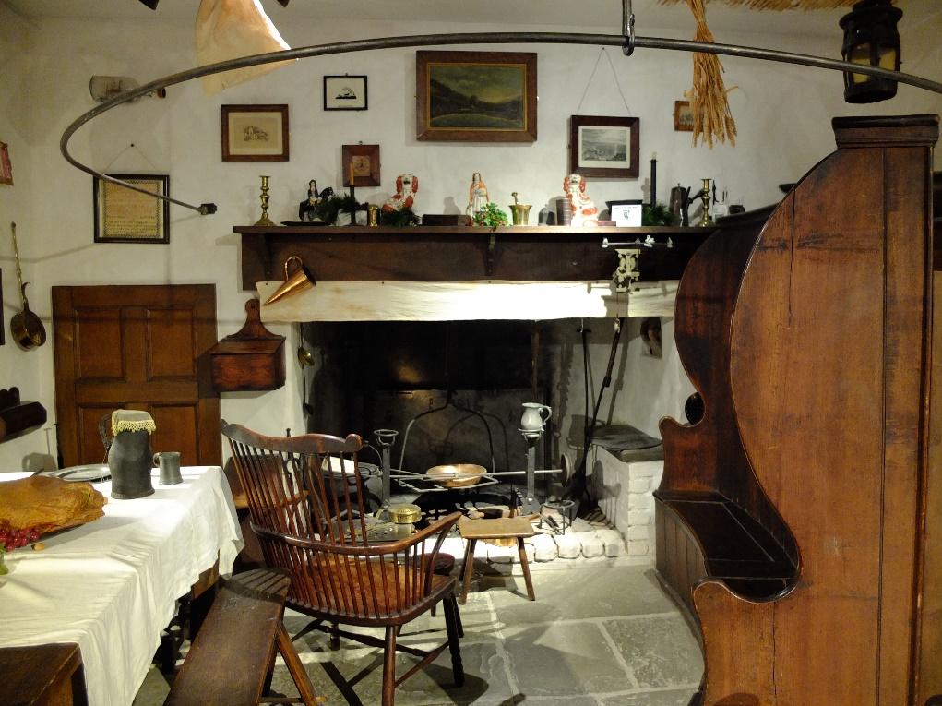
Figure 29.
Torquay Museum

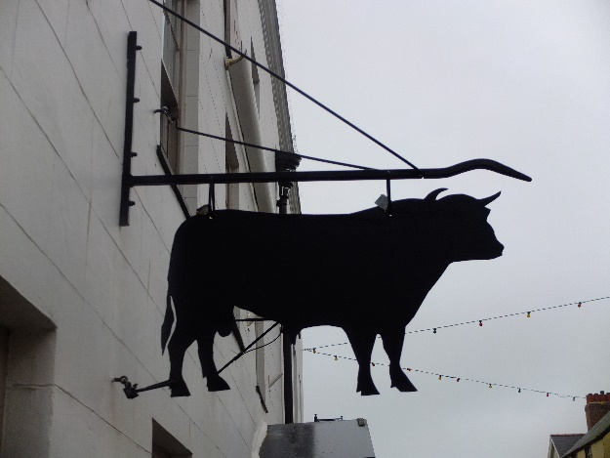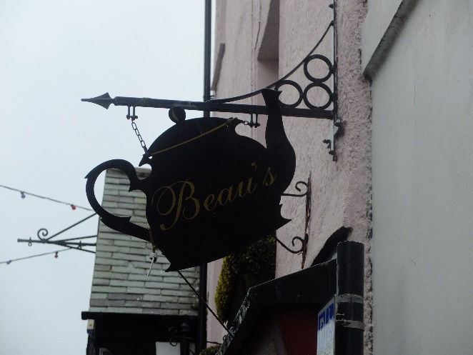
Figure 30. Figure 31.
Street Signs in Beaumaris

Theoretical Outcomes
For this project, I would like to produce three textile collections each consisting of four main designs from the theme, British popular art I will choose tree sub-category; nautical, rural living and miscellaneous.

- Nautical;
For this collection, I will build on my previous end of year exhibition and portfolio work. I intend to refine my pallet and improve the overall harmony and focus of the imagery. I will use my maritime museum trips and the research I have done into the nautical aspect of British popular art to create imagery that is whimsical, fun and interesting.
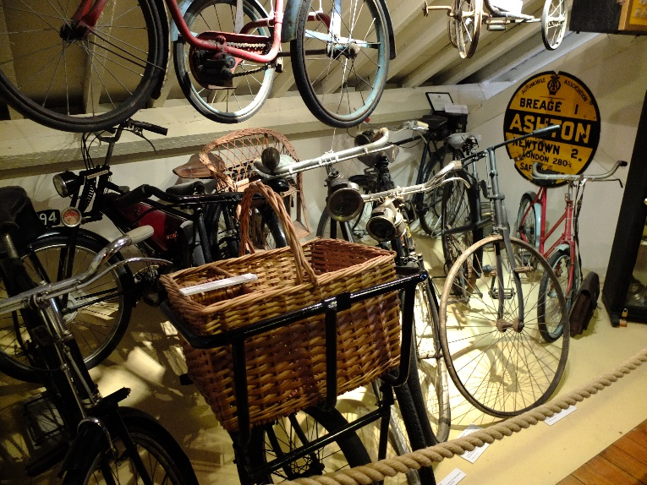
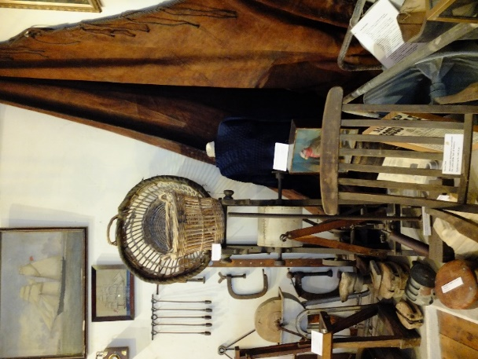

Figure 32. Figure 33.
Helston Museum, Cornwall

- Rural Living;
For this collection, I intend to use research from visits to St. Fagins, Torquay Museum, and Helston Museum. I would like this collection to consist of imagery associated with nostalgic country fairs, furniture, architecture and a slow, rustic and provincial way of life

- Miscellaneous;
In this collection, I hope to create an all-embracing image of British life, with the use of iconic and easily identifiable imagery.

Conclusion

I was delighted with the designs I created for my 3rd year exhibition. The confidence I gained from increasing my skill set has encouraged the belief I have in myself to be able to achieve my goal in becoming a professional designer. I feel assured that I understand and will be able to interpret the theme of popular art into well translated and interesting executed prints.
Mark Hearld’s ‘The Lumber Room, Unimagined Treasures’ exhibition at The York Art Gallery is a wonderful reference as it gathered together a number of popular art pieces by a contemporary artist. In describing how Hearld came upon the tile, he referred to a story called ‘the Lumber Room’ (Saki, 1998) he was told as a child by his school teacher. It recounts the tale of a child’s attempts to escape his dominating aunt and gain access to the lumber room. When he finally achieves this, he is met with a room filled with all manner of object, Indian hangings, twisted candle sticks, brass figures, carved sandal-wood boxes, pictures painted with exotic birds and one with the seen of wolves and a huntsman. The child is filled with curiosity and longs to return to discover more of the hidden treasures within (Hearld & Powers, 2016).
This description of a room filled with unused curios and collected nostalgic items is one I can relate to and become excited about. I would like for my creative venture to be almost a lumber room of imagery as though I am the curator of my own exhibit, Wunderkammer or cabinet of curiosities. I think this proposed translation in to textiles will be an interesting challenge for me and a testament to the admiration I have for the artist Barbara Jones.

Bibliography
Artmonsky, R., 2008. A Snapper Up Of Uncosidered Trifles. 1st ed. London: Artmonsky Arts.
Brown, C., 2012. An alphabet of London. 1st ed. London: Merrell Publishers.
Gallery, W., 2013. Whitechapel Gallery. [Online]
Available at: http://www.whitechapelgallery.org/exhibitions/black-eyes-and-lemonade/
[Accessed 22 11 2017].
Hearld, M. & Powers, A., 2016. The Lumber Room, Unimagined Treasures. 1st ed. Norwich: St. Judes.
Hoare, P., 2014. Jhonny Hannah, Greetings From Darktown. 1st ed. London: Merrell Publishers Limited.
J.M.Richards, 2012. High Street. 1st ed. London: V and A Publishing.
J.M.Richards, 2012. Hight Street. 1st ed. London: V and A Publishing.
Jones, B., 2013. The Unsophisticated Arts. 1st ed. Italy: Little Toller Books.
Jones, J., 2014. The Guargian. [Online]
Available at: https://www.theguardian.com/artanddesign/2014/jun/09/british-folk-art-review-tate-britain
[Accessed 27 11 2017].
Jude's, S., 2018. St Jude's. [Online]
Available at: https://www.stjudesfabrics.co.uk/collections/christopher-brown/products/albion-wallpaper-christopher-brown-linocut
[Accessed 26 11 2017].
Kluz, E., 2017. tinsmiths. [Online]
Available at: https://www.tinsmiths.co.uk/ed-kluz-lionheart-blue-red.html
[Accessed 23 11 2017].
Knox, T. & Kluz, E., 2017. The Lost houses Revisited. 1st ed. London: Merrell.
McCannon, D., 2010. The Minestry of Frogs Issue 1. 1st ed. London: MIRIAD.
McMillan, J., 2014. Tate. [Online]
Available at: http://www.tate.org.uk/context-comment/articles/brilliant-imperfections
[Accessed 27 11 2017].
Myrone, M., 2014. Tate. [Online]
Available at: http://www.tate.org.uk/context-comment/video/tateshots-british-folk-art
[Accessed 27 11 2017].
Parissien, D. S. & Sexton, P., 2013. Gallery Guide Marx-Lambert Collection Compton Verney. 1st ed. London: O-SB Design Compton Verney.
Press, I., 2005. Peggy Angus: Influence and Inspiration. 1st ed. Oldham: Incline Press.
Saki, 1998. The Lumber Room. 1st ed. London: Travelman Short Stories.
Saunders, G., 2011. Recording Britain. 1st ed. London: V&A Publishing.
West, H., 2018. Hamilton West Wallpaper. [Online]
Available at: http://hamiltonweston.com/collection/marthe-armitage/
[Accessed 23 11 2017].
Yorke, M. & Saunders, G., 2015. Bawden,Ravilious and The Artists of Great Bardfield. 1st ed. London: V & A Publishing.
Images

Figure 1. Book cover for ‘The unsophisticated arts’. Jones, B., 2013. The Unsophisticated Arts. 1st ed. Italy: Little Toller Books. Authors own image
Figure 2. Book cover for ‘The Ministry of Frogs’. McCannon, D., 2010. The Minestry of Frogs Issue 1. 1st ed. London: MIRIAD. Author own image.
Figure 3. Wallpaper and fabric design by Johnny Hannah, ‘The Captain’s Pattern’, image available at https://www.stjudesfabrics.co.uk/collections/jonny-hannah/products/the-captains-pattern
Figure 4. Wallpaper design by Christopher Brown, ‘Albion’, image available at https://allthingsconsidered.co.uk/2016/09/albion-celebration-britain.html
Figure 5. Fabric design by Mark Hearld, ‘Bantam Bough’, image available at https://www.stjudesfabrics.co.uk/collections/mark-hearld/products/bantam-bough-1
Figure 6. Fabric design by Emily Sutton, ‘Curiosity Shop’, image available at https://www.stjudesfabrics.co.uk/collections/emily-sutton/products/curiosity-shop
Figure 7. Fabric design by Ed Kluz ‘Lionheart’, image available at https://www.stjudesfabrics.co.uk/collections/ed-kluz/products/lionheart
Figure 8. Fabrice design by Elle Curtis, ‘Forest Jig’, image available at https://www.stjudesfabrics.co.uk/collections/ellie-curtis/products/forest-jig
Figure 9. Ed Kluz, Campden House, from 'The Lost House Revisited', authors own image
Figure 10. Wallpaper design by Marthe Armitage ‘Alphabet’ image available at http://hamiltonweston.com/design/alphabet/
Figure 11. Wallpaper design by Marthe Armitage ‘Chiswick House’ image available at http://hamiltonweston.com/design/chiswick-house/
Figure 12. Wallpaper design by Marthe Armitage ‘Old Man’s Beard’ image available at http://hamiltonweston.com/design/old-mans-beard/
Figure 13, 14, Images of Marx, Lambert Collection, taken at Compton Verney, authors own image
Figure 15, 16, 17, 18. Images taken at Bygones Museum Torquay, authors own image
Figure 19. Image of Figure Heads taken at Greenwich Museum, authors own image
Figure 20.Image of Figure Head taken at Chatham Historic Boat Yard, authors own image
Figure 21,22, 23,24. Image of William De Morgan Tile Collection taken at Birmingham Museum, authors own image.
Figure 25, 26. Image of Wrought Iron taken at Birmingham Museum, authors own image.
Figure 27, 28. Images taken at The Natural History Museum, London, authors own.
Figure 29. Image of rural life taken a Torquay Museum, authors own.
Figure 30, 31. Image of Street Signs in Beaumaris, authors own.
Figure 32, 33. Image of miscellaneous objects take at Helston Museum, Cornwall, authors own.

