
APPENDIX GA36c

LEVEL 6 ASSESSMENT SPECIFICATION

Student name: | Gethin Jennings | Student ID number: | 1800325
Programme: | Primary
Module: | Principles of Pedagogy
Module code: | M6X01438/C | Contribution to Overall Module Assessment (%): | 100%
Lecturer: | Siân Brooks | Internal Verifier: | Siân Brooks
Assignment Title: | ‘Describe a learning event which has happened during your recent school experience. Reflect upon what took place, connecting events to theories of learning and teaching. Make recommendations about how you could improve your own practice in the light of this. Produce a poster to illustrate how you would develop the elements of an effective learning environment.’ | Word count (or equivalent): | 5,000 or equivalent.
Submission deadline: | 17/10/18 (23.59) | Return date of provisional marks & written feedback: | 14/11/18
Submission method: | All written assessments, where practical and possible, must be submitted via Turnitin unless otherwise instructed by the Lecturer. (Please DO NOT put this assessment specification into Turnitin or it will match many similarities with other students’ submissions.)  Alternative submission method (if applicable):  Late submission of the assessment will result in a late penalty mark. Penalties for late submission: Up to one week late, maximum mark of 40%. Over one week late, 0%. Only the Extenuating Circumstances Panel may approve a change to submission dates.
Academic honesty / referencing: | Academic honesty is required. In the main body of your submission you must give credit to authors on whose research and ideas your work is based. Append to your submission a reference list that indicates the books, articles, etc. that you have used, cited or quoted in order to complete this assessment.

Module Learning Outcomes
(from module syllabus)
1. understand, synthesise and evaluate the main theories that underpinning learning, behaviour and assessment in the primary school
2. reflect critically on how learning theories inform the planning and provision of high quality learning environments, demonstrating a clear understanding of how theory and practice are interrelated
3. organise knowledge and learning through the use of a range of information sources, and present work appropriately.

Module Learning Outcomes
(from module syllabus)
1. understand, synthesise and evaluate the main theories that underpinning learning, behaviour and assessment in the primary school
2. reflect critically on how learning theories inform the planning and provision of high quality learning environments, demonstrating a clear understanding of how theory and practice are interrelated
3. organise knowledge and learning through the use of a range of information sources, and present work appropriately.

‘Describe a learning event which has happened during your recent school experience. Reflect upon what took place, connecting events to theories of learning and teaching. Make recommendations about how you could improve your own practice in the light of this. Produce a poster to illustrate how you would develop the elements of an effective learning environment.’
On average a teacher asks four hundred questions per day which is a rough average of sixty six questions an hour (Ho, 2005). During a bridging day in a large city centre primary school in a deprived area of Wales, the observer witnessed an interaction between the teacher and the pupils which interested the observer; questioning. Questioning is a vital part of children’s education as it shapes the role teachers play in promoting pupils’ interaction and understanding (Chen, Hand and Norton-Meier, 2016). There are many questioning strategies that practitioners use to obtain different results from learners. This essay will expand on the types of questioning used during an observation, the responses from the learners and how successful the questioning process was for both the teacher and the learners. It is also important to consider a child’s self-esteem when using different questioning strategies. As a result of the observation, the questioning strategies will be evaluated by using theorist’s views and current literature towards questioning and how children learn. The evidence obtained from a closer look into current literature may then help develop an ideal learning environment. Furthermore, the information gained from all aspects of this essay will help develop of the knowledge of the practitioner for future practice.
The school where the observation occurred has just over four hundred pupils’ ranging from nursery to year six. During the school’s most recent ESTYN report the setting scored adequate for current performance and prospects for learning. The percentage of children within the school who qualified for free school meals was significantly above the national average of 17.4% (Gov.wales, 2018). A reason for this could be due to the deprived location of the school. The observation took place in an upper key stage two class who were more able and talented. Within the classroom where the observation took place there were twenty four pupils, with one child with autism who had no 1:1 adult support. The class teacher had support from a learning support assistant who helped prepare resources and work with groups of children.

Observation:
The observation that I carried out was during the morning session. The teacher prompted the children to find their space on the carpet following guided reading activities, the lesson that was about to begin was topic work. The setting that I carried out the observation in was a pioneer school for the new curriculum that will become statutory for all schools in Wales in 2020. This new curriculum that has been designed by Graham Donaldson focuses on topic work to be used across all areas of the curriculum and places an emphasis on pupil voices and EPIC planning (Everyone Plans In the Classroom). The observation that I carried out was during the morning session. The teacher prompted the children to find their space on the carpet following guided reading activities, the lesson that was about to begin was a Literacy lesson based on the class topic. The topic for this class was rollercoasters that had been chosen by the children and the parents during an Immersion day (Figure 1).
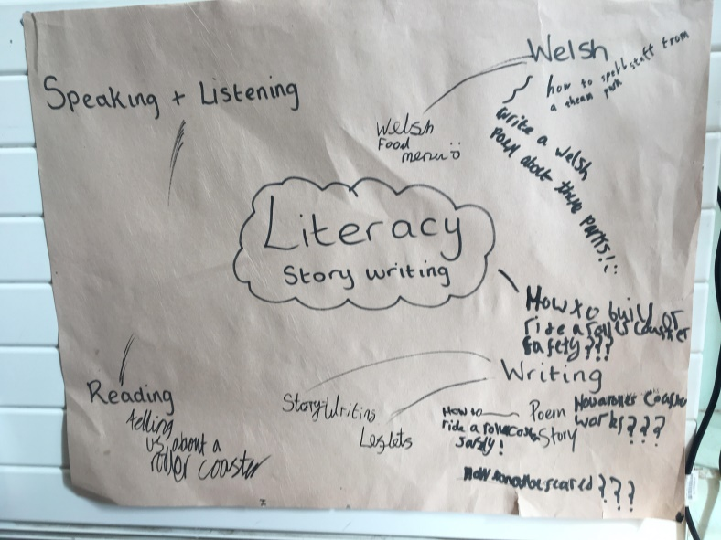
(Figure 1, bridging activity, 2018)
After researching different rollercoasters during the days prior to this lesson, one of the things the children wanted to discover were other famous inventions throughout time (Figure 2). Prior to the lesson being delivered, the teacher had explained that the research gained from the lesson may help to develop knowledge of different inventions and help the children justify why they will use certain things when designing their own theme parks, in the weeks following. Also it would give the children a deeper understanding of how old inventions are, how they were made and what part of the world different inventions came from.
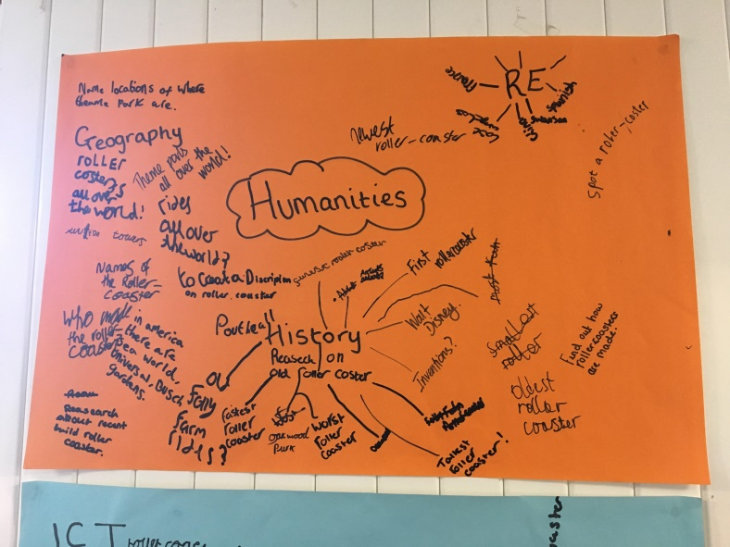
(Figure 2, bridging activity, 2018)
The teacher had already carried out the lesson the day before with two groups so this lesson would be for the remaining two groups. The part of the bridging day that caught my eye and interested me was the questioning methods used by the class teacher. The first strategy used by the teacher was using lollipops with children’s names on to decide on who would answer the question. It was interesting to observe the children’s facial expressions as the teacher brought forward the lollipops. Some children appeared disinterested until the teacher moved to the whiteboard to get the lollipops. The use of lollipop questioning appeared to make some children anxious and I could see in some children’s body language that they were trying to hide away. I was fascinated by this as it demonstrated a learnt behaviour amongst some children and they associated fear of questioning with the lollipops. However, the teacher then eased those fears by asking children to pair up and try to think of some of the inventions they discovered the previous days. Sampsel (2013) supports the use of this strategy by suggesting that think, pair share improves pupil’s confidence to answer questions and also increases participation of all learners. Not all children paired up to discuss the question; the child with autism sat slightly away from the other children and was fiddling with a pencil sharpener. Other children were chatting in groups and as the noise level increased the teacher intervened. The teacher then decided who would share with the class their ideas by selecting from the lollipop sticks. Figure 3 is a transcript of the teachers’ questioning strategy in a group discussion with the class.
Teacher: First of all can you tell groups three and four what the learning objective for the lesson is?
Pupil 1: We have to choose inventions from a timeline.
Teacher: Ok, can you elaborate on this? (the teacher pulled his hands apart to demonstrate elaborate).
Pupil 1: It has to be eight and it can’t go up and down.
Teacher: What do we mean by up and down?
Silence.
Teacher: Remember I said chronological order?
Pupil 2: You have to put them in order.
Teacher: What needs to be in order?
Pupil 2: As a timeline.
Teacher: Good.
The teacher then pulled out another lollipop for another child.
Teacher: Can you tell me one invention that you picked yesterday?
Pupil 3: I chose photography.
Teacher: Why?
Pupil 3: I like taking photos.
Teacher: Ok lovely, but how does it link to our topic?
Pupil 3: You need photos of rollercoasters to show on a website.
Teacher: Fantastic! So if you can justify how it links to rollercoasters then I am happy for to pick whatever inventions you like. Let’s have one more example, who would like to share their example?
The children appeared to be more relaxed following the teachers comments and quite a few hands shot up.
Pupil 4: I chose the invention of lights. Some rollercoasters are at night and they need lights to see.
Teacher: Brilliant, not only did you tell us your explanation but you justified why it related to rollercoasters.
I found this particular interaction between the teacher and the pupils’ fascinating as I had just learnt about different questioning strategies. Children shine in different situations so being flexible in teaching styles can help all children learn through different experiences. Reeve (2006) suggests that pupils classroom engagement depends on the classroom climate in which they learn, if this climate is rigid and predictable then children can become passive and reactive as opposed to proactive and fully engaged. The change in some of the children’s behaviours during the different types of questioning was something that I did not expect to see. I could see the anxiety spread across some children’s faces and then lift as that moment of worry ended. The mental health of a child is vitally important; if a child encounters any difficulties then it may lead to poorer academic achievement (Wolpert et al., 2015). I can see why the teacher opted for this questioning strategy, to ensure that all children remain actively involved and engaged in the lesson. However, the use of think, pair, share was a clever approach from the teacher as it allowed the children the opportunity thinking time and a chance to discuss with a partner. Perry (2016) suggests that giving children appropriate thinking time allows them greater opportunities to be able to not only answer questions, but develop higher order thinking skills.
Another interesting part of the observation was the way in which the teacher delivered the questions. First of all the teacher used an open ended question which enabled the children to independently think for themselves. Also it presented the children with an opportunity to develop their oracy skills through discussion and all children were engaged with the learning. I enjoyed observing this moment as the children were not just sitting on the carpet listening to the teacher speak, the whole class were involved in the learning. Harlen and Qualter (2004) suggest that open questioning give teachers access to a child’s own feelings, views, ideas and reasoning and therefore encourages a child to investigate. The next question was ‘remember I said chronological order?’ This is a leading question and reduced the chance the children have to think for themselves (Schwarz, 2014). As soon as the teacher asked this question the pupil responded instantly. Towards the end of the questioning, the teacher asked if anyone would like to share with the class to which several of the children responded. I felt as though the teacher had helped prompt the children which resulted in greater engagement.
For me to be able to discuss this moment I used an unstructured written recording observation method. The justification for using this method was that I felt it would be the most discrete way of recording the lesson. I felt that this would be the least distracting to the pupils in the class; the children were already curious as to why there were two extra adults in the classroom. Ideally I would have liked to film the lesson to ensure I did not miss anything. The downside of the unstructured observation is that it may be difficult to record and evaluate because the observation usually comes about as a result of something interesting or unexpected happening (Sharman, Cross and Vennis, 2004). To ensure that I did not miss anything and increase reliability I recorded the interaction between the teacher and the pupils’ instantly when the information was fresh in my mind. Also I double checked with my fellow trainee teacher who was also observing the lesson to see if I had missed anything. This turned out to be an effective technique as we helped each other fill in gaps of dialogue from the observation and it also ensured that I had enough of a sample to reflect on.

Learning theories:
Questioning is regarded as an essential and crucial element of pedagogy as questioning provides children with opportunities to access higher order thinking (Pehmer, Groschner and Seidel, 2015). Meyer (2011) agrees by suggesting that the underlying notion is that teacher questions stimulate student thought process. Archer and Hughes (2011) discuss the use of socratic questioning and answers challenge assumptions, expose contradictions, and lead to new knowledge and wisdom is an undeniably powerful teaching approach. However in some classrooms the type of questioning does not enable children to reach higher order thinking. Closed questioning are consistently of the same kind and usually fall into the low level questions bracket, whose answers require mainly memory (Almeida, 2012). However, Tofade, Elsner and Haines (2013) ague that does not mean that there is no value in asking low level questions, it may be appropriate to these questions to address all cognitive domains as long as the teacher uses a good mix of questions throughout the lesson.
Much of the work on questioning came from Lev Vygotsky’s concept of locating the Zone of Proximal Development (ZPD). Vygotsky suggests that there are three zones; what I can do, what I can’t do and what I can do with help which is what he label’s the ZPD. The ZPD is the distance between the actual development level as determined by independent problem solving and the development as determined through problem solving under adult guidance or a more knowledgeable other (Vygotsky, 1978). A more knowledgeable other refers to someone who has a better understanding than the learner which is usually the teacher or learning support assistant (LSA), however in some instances learners peers can act as a more knowledgeable other in different activities.
Jerome Bruner developed Vygotsky’s ideas of the zone of proximal development by introducing the theory of scaffolding learning. The concept of scaffolding is very similar and emphasised the social nature of learning, claiming that other people should help a child develop skills with the support of scaffolding. Bruner believed that scaffolding involves helpful, structured interaction between an adult and a child to develop certain skills (Bruner, 1979). Referring to figure 3, the teacher adopted this questioning strategy when interacting with the children. The teacher provided a scaffolding technique by hinting at the answer which enabled the children to answer the question. Cazden (1983) adopted the term scaffolding but suggesting that there were different types; vertical and sequential scaffolding. He claimed that vertical scaffolding involves the teacher extending the child’s language and learning by asking further questions.
When thinking about the different types of questioning techniques that teachers use, it is important to know that each style has their benefits and negatives. In the observation (figure 3) the teacher may have missed an opportunity to extend the dialogue when timelines were mentioned; at this point the children’s knowledge of timelines could have been explored. Cazden (1983) suggests that extending the oracy within the classroom can lead to children thinking independently and developing oracy skills. Singer and Couper (2017) support this theory by suggesting that extending questions allow the teacher to discover if learners have understood the new concepts, formed an opinion and what has influenced that opinion. However Hunter et al (2015) suggest that classroom chat can often be off topic and unproductive. Despite this theory Hadjioannou and Townsend (2015) argues that classroom discussion is beneficial as it develops children’s vocabulary through different subjects and scenarios.
Another technique that the teacher could have adopted during the observation was the chance to bounce from pupil to pupil when questioning. This technique is called pose, pause, pounce, bounce. The teacher poses a question, pauses to allow children thinking time, pounces by asking a child to answer and then bounces to other children to gain their thoughts. This technique allows the teacher to tease out the learning in class and helps differentiate objectives and learning experiences (Sida- Nicholls, 2017). Pose, pause, pounce, bounce keeps children alert and ready to respond and fully engaged in the learning (Clemente, 2018).
A point to consider using this strategy is the mental health of the child. Children can feel nervous and worried when they know that they may be nominated to answer a question, these thoughts may act as a barrier to learning and engagement (Wangru, 2016). During the observation the teacher adopted the lollipop stick questioning technique. Some of the children’s body language changed at this point as they were worried about being chosen. Wall and Hall (2017) argue that lollipop stick questioning is an effective strategy to ensure that there is greater involvement during classroom discussion. Harries (2017), supports this theory by suggesting that lollipop stick questioning will improve communicating, listening and sharing ideas within the classroom.
A different strategy that the teacher could have used during the observation is called think, pair, share. Think, pair, share is a strategy that allows children thinking time about the question that the teacher has asked; discuss their answers with a partner and then share their opinions with the teacher and class. The foundations of this model was to make the children more active in the teaching and learning process (Kagen, 2009) Think, pair, share can be implemented quickly and it is beneficial for actively involving all children during lessons (Bennet, Rolheiser-Bennett and Stevahn, 1991). Knight (2009) suggests that this type of learning enables children to think and teach themselves new content; this pupil centred approach is an approach that allows the teacher to become the facilitator and motivator, not the main source. Sumekto (2018) suggests that think, pair, share improves pupils’ literacy skills but in order for this to happen it requires a patient teacher.
From the different questioning strategies discussed it is important to think about the thinking time allowed to children when answering questions. Ted Wragg believes that teachers leave very little time for children to answer after posing a question. On average, teachers only wait between 0.7 and 1.4 seconds after posing a question (Stahl, 1994). During the observation, the teacher gave roughly two seconds before prompting a child to answer the question. The child found it difficult to answer in such a short space of time. By allowing more time for the child to answer a question, the chances of children answering teacher questions increases and in turn will boost pupils’ confidence to answer teacher questions (Rowe, 1974). Another potential problem with teacher questioning is the type of response and language used, Norton (2004) suggests that teachers nearly always reuse the simple phrases; good or well done, Yang argues that these phrases do not increase students learning motivation and enthusiasm. However, encouraging students when answering a question despite whether the answer was right or wrong, will give children confidence that their teacher values their efforts and will be more likely to attempt to answer next time (Yang, 2017).
During the above observation, the teacher used different questioning techniques which evoked engagement of different types. The teacher prompted higher order thinking by challenging using open questions. Using open questions invite opinions, hypotheses and imaginings, or process questions, which invite children to articulate their understanding (Myhill and Dunkin, 2005). However, Donaldson (1978) argues that children aged seven and under are confused by open ended questions and argues that teacher can make it unnecessarily difficult for them. The observation took place in an upper key stage two class which may point to the use of open questioning strategies. Despite this, Harlen and Qualter (2004) suggest that open questions give children the ability to express feelings, views, ideas and reasoning and therefore encourage the child to investigate.
During the observation that took place, the teacher’s strategies suggested a constructivist approach. A constructivist approach allows children who construct meaning independently in the process of exploring or solving problems (Bhattacharjee, 2015). Education is used to develop the mind, not just to recall what is learned and teaching should be build based on what learners already knew and applying that knowledge to different scenarios (Yang, 2017). The constructivist approach links into Vygotsky’s ZPD as children are recalling prior knowledge and applying it to a different situation. The theory of constructivism is generally attributed to Jean Piaget who believed that children constructed new knowledge from previous experiences. He suggested that children learn through experiences which are generated through experiences and a base of prior knowledge (Piaget and Cook, 1998). However, Kirschner, Sweller and Clark (2006) suggest that that are pitfalls with constructivist learning claiming that this approach is only beneficial when learners has sufficiently high prior knowledge to build on. Despite this, Howard and Brady (2015) argue that constructivist teaching improves children’s engagement with lesson content and are able to develop their own perspectives on new content. A constructivist approach appears to encourage independent thinking amongst learners, which would appear to support the new curriculum that is being introduced in Wales.

Conclusion:
To sum up from the observation and the research into different learning theorists, questioning is a vital part of teaching and learning. Teachers ask many questions throughout the day to check understanding and to try to challenge children to think and give their views. However, the type of questions asked by teachers is important in a number of ways. Vygotsky developed the ZPD which suggests that children learn when they are challenged with support from a more knowledgeable other, in terms of questioning; teachers can help children access this by asking open questions that may relate to prior knowledge. Using open questions offer children opportunities to think and give their own views and opinions. This is called higher order thinking. Leading questions and closed questions do not enable children to access higher order thinking and therefore are not developing their knowledge.
One of the questioning strategies that was successfully used was called think, pair, share. This method allows children the chance to think and share their opinions with a partner which may give children the chance to enhance their knowledge on certain subjects. This method points to a constructivist approach where children independently build on prior knowledge and apply it to new situations. Another key point that was discovered was the amount of thinking time on average that children were given to answer questions. Children are generally not given enough time to answer questions which may act as a barrier to higher order thinking and also reduce the opportunities for children to voice their views and opinions. However, the think, pair, share questioning strategy that has been discussed, did allow children that thinking time.

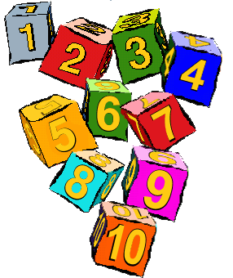
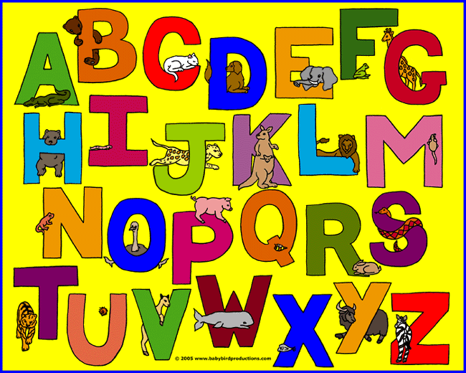

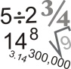
3. Reading area

4. Book shelf
2. Children’s books
1. Teacher focused task table

26. Main classroom

25. Maths
resources
1
2
4
3

5. Interactive whiteboard

6. Children’s trays
25
26
5
6

24. Computer corner
7
24

8
9

7. Workstation 8. window to cooking and science area 9. Walkway in-between rooms

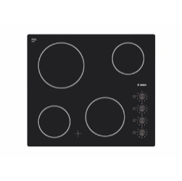


23. Cooking area

22. Work station with stools

21. Sink

20. Oven

19. Fridge

18. Cupboard

17. Vegetable
Patch
8
10. Science
area

11. Science
resources

12. Workstation
9
11
21
22

16. Climbing wall
15. Outdoor learning area and expressive arts area
13. Anderson shelter

14. Role play area
10
12
15
13 and 14
16
17
18
19
20
23

Learning environment:
Upon designing my ideal learning environment I took into consideration the new curriculum that is being introduced throughout schools in Wales by 2022. This new curriculum has been designed by Graham Donaldson who suggests that the curriculum should have four purposes so that children will be; ambitious, capable learners; enterprising, creative contributors; healthy, Confident individuals; ethical, informed citizens. Donaldson suggests that children should be taught through six areas of learning and experience. The six areas of learning are; expressive arts; health and wellbeing; humanities; languages, literacy and communication; mathematics and numeracy; science and technology (Donaldson, 2015). My ideal learning environment has taken these areas of learning into consideration and has specific areas where learning can take place.
The classroom that has been designed is for a year five class, as that is where the observation took place as discussed previously. The first area of my learning environment is the main part of the classroom (number 26). This part of the classroom is where many of the daily routines will take place and classroom resources will be stored. I have decided not to overload the room with tables for each pupil to sit and instead to opt for two focus tables. The rationale for this is the carousel learning nature of the new curriculum where two groups will be sitting at the tables to complete focused task while the other children will be engaged in independent activities. Carousel activities benefit learners as the fast paced nature of the lessons do not allow children to become used to and disengage from the lesson (Gardner, 2011). Carousel activities enable children to make connections or open doors from prior knowledge to new knowledge as each child brings something new to the learning process. This theory links back to the constructivist learning theory discussed previously, about children building on existing knowledge to construct new thoughts and ideas. Thomas (2015) suggests another benefit of carousel activities is that it encourages creative thinking and input from less talkative children.
Another theory that Yusmanto, Soetjipto and Djatmika (2017) suggest is that carousel learning helps increase children’s higher order thinking skills, this theory links back to the questioning strategies evaluated throughout the essay. For children to increase their higher order thinking skills, it requires a certain level of independence. It is important for children to be able to undertake independent learning experiences so that they do not become too reliant on support from teachers or teaching assistants (Field, Duffy and Huggins, 2015). Bruner (1978) does suggest that scaffolding can help children develop skills, but scaffolding does not necessarily mean an adult supporting a child. Sometimes other children can support each other’s learning through discussion. The carousel activities support this theory as half of the class will be involved in independent activities, therefore the only support that they have will be each other.
A final benefit of the carousel activities is that children are moving between different activities and not positioned in the same seat at the table throughout each lesson. Movement is one of the most important aspects of a child’s life; it can help keep children engaged and prevent a child from becoming disinterested in an activity (Davis, 1997). The movement aspects would benefit a child with additional learning needs such as autistic spectrum disorder (ASD) or Attention Deficit Hyperactivity Disorder (ADHD). Providing opportunities for additional sensory inputs through movement breaks or exercise can be used to extend participation of the learner (Millis and Chapparo, 2018). The movements gained from a carousel activity may help obtain greater interaction from all learners.
Another key feature within my classroom is the ICT corner. One of the new frameworks within Welsh education is the digital competence framework (DCF). The DCF is designed to encapsulate the skills that will help learners thrive in an increasingly digital world (Government, 2018). With more emphasis placed on children’s ICT due to the ever expanding digital world, I felt the need to have an area dedicated to this. Again the design of my ICT area only allows for five children at a time which is in keeping with the carousel learning that the new curriculum is demanding. Hammond (2013) suggests that children should have plenty of opportunities to access ICT due to the ever expanding curriculum and to show a higher degree of correspondence with a wider world where the use of technology is increasing at a rapid rate. It is important for children to have access to ICT within a safe learning environment; most children are using some form of social media outside of school so being taught to be digitally competent should play a key role in education. However, on the flip side of this, some children who may live in deprived areas may not have access to the use of technology so it is important to provide children with as many opportunities as possible within school.
It is likely that further developments in ICT will continue to accelerate changes in society in the future and some children may end up working in professions that do not yet exist (Oshima and Muramatsu, 2015). This suggests that daily exposure of ICT and the new DCF framework is a vital part of the curriculum for the future of children. Also the use of computers forms part of the daily lives of children and to them using a computer can be far more enjoyable that using a pen and paper (Pérez-Sanagustín et al., 2017). Livingstone (2012) supports this theory by suggesting that computers help create a more exciting, rewarding and successful experience for learners of all ages and abilities, which helps children to achieve their potential. Not only is the DCF important for the future of the children, but it can have positive affect on the motor development of children. By using computers either the mouse or keyboard, children are developing their hand-eye coordination. As well as this, ICT can improve the quality of teaching and learning and help raise standards due to the variety of information and programs available on computers (Livingstone, 2012).
Moving on to the final part of my learning environment the outside learning area and expressive arts area (15). With an emphasis placed on outdoors learning in our modern curriculum I felt that this would be an important area to include. Langston (2014) suggests that a major part of children’s learning comes from their active investigation of the physical world both indoors and outdoors. Woods (2016) supports this theory by suggesting that what children have learned from being outdoors will fuel their beliefs about the outdoor environment and their approaches to new and challenging situations. A different perspective is children are increasingly transported in cars or public transport; engage in sedentary activities within the man-made environment, using bought toys and electronic equipment so therefore a greater emphasis on outdoor learning can help to create a healthier balance (Waite, 2017). With another of the six areas of learning from the Donaldson curriculum being health and wellbeing, I believe that the outdoor learning area will help promote this.
I have labelled this area expressive arts as well as the outside learning area because I feel that children can be free from the classroom to express themselves and be creative. One of Donaldson’s six areas of learning is expressive arts and for an example of what type of activities could be carried out I have added an Anderson shelter (13) to my learning environment. If the termly topic was World War two, one of the areas children could research could be Anderson shelters and why they were used. The children could design and make their own shelter using outdoor materials which could open up a variety of different lessons pre and post construction of the Anderson shelter. Examples of these lessons could be testing waterproof materials, insulating materials, strength of materials, compare and contrast to materials used during the war compared to now, writing activities about what it would be like to use an Anderson shelter and role play opportunities. Another potential link to this topic is the vegetable patch (17). Not only could the children plant and grow their own vegetables but they could learn about lifecycles and could also relate this to rationing during the war and the Dig for Victory Campaign. Again there are many potential pre and post lessons plans and role play opportunities for children. Johns, Crowley and Guetzloe (2017) suggest that role play is a vital part of education as it allows children to be creative and adapt to different roles and it also allows children to learn off each other. I feel that the outdoor learning area and expressive arts area can be easily adapted to suit any topic and will provide children with the outdoor learning environment that is part of the curriculum.

Reference list:

Almeida, P. (2012). Can I ask a question? the importance of classroom questioning. Procedia - Social and Behavioral Sciences, 31(1), pp.634-638.

Archer, A. and Hughes, C. (2011). Explicit instruction. New York: Guilford Press, pp.109- 200.

Bennett, B., Rolheiser-Bennett, N. and Stevahn, L. (1991). Cooperative learning. Toronto: Educational Connections.

Bhattacharjee, J. (2015). Constructivist Approach to Learning– An Effective Approach of Teaching Learning. International Research Journal of Interdisciplinary & Multidisciplinary Studies (IRJIMS), 1(6), pp.65-74.

Bruner, J. S. (1978). The role of dialogue in language acquisition. In A. Sinclair, R., J. Jarvelle, and W. J.M. Levelt (eds.) The Child's Concept of Language. New York: Springer-Verlag.

Cazden, C. (1983). Peekaboo as an instructional model. New York: Plenum.

Chen, Y., Hand, B. and Norton-Meier, L. (2016). Teacher Roles of Questioning in Early Elementary Science Classrooms: A Framework Promoting Student Cognitive Complexities in Argumentation. Research in Science Education, 47(2), pp.373-405.

Clemente, R. (2018). Hands Down: Pose, pause, bounce, and pounce | CENTER FOR TEACHING AND LEARNING. [online] Ctl.byu.edu. Available at: https://ctl.byu.edu/tip/hands-down-pose-pause-bounce-and-pounce [Accessed 4 Oct. 2018].

Davis, K. (1997). The value of movement activities for young children. The Reporter, 2(3), pp.1-3.

Donaldson, G. (2015). [online] Gov.wales. Available at: https://gov.wales/docs/dcells/publications/150225-successful-futures-en.pdf [Accessed 15 Oct. 2018].

Donaldson. M. (1978) Children’s Minds. London: Fontana Press.

Field, R., Duffy, J. and Huggins, A. (2015). Teaching independent learning skills in the first year: A positive psychology strategy for promoting law student well-being. Journal of Learning Design, 8(2), p.1.

Gardner, H. (2011). The unschooled mind : how children think and how schools should teach. New York, NY: Basic Books.

Government, W. (2018). Learning Wales. [online] Learning.gov.wales. Available at: http://learning.gov.wales/resources/browse-all/digital-competence-framework/?lang=en [Accessed 15 Oct. 2018].

Gov.wales. (2018). Welsh Government|Schools' census results. [online] Available at: https://gov.wales/statistics-and-research/schools-census/?lang=en [Accessed 24 Sep. 2018].

Hadjioannou, X. and Townsend, J. (2015). Examining booktalks to shed light on authentic classroom discussion. Classroom Discourse, 6(3), pp.198-220.

Hammond, M. (2013). Introducing ICT in schools in England: Rationale and consequences. British Journal of Educational Technology, 45(2), pp.191-201.

Harlen, W. and Qualter, A. (2004) The Teaching of Science in Primary Schools. London: David Fulton Publishers.

Harris, J. (2017). One-to-one time. Practical Pre-School, 3(4).

Ho, D. (2005). Why Do Teachers Ask the Questions They Ask?. RELC Journal, 36(3), pp.297-310.

Howard, C. and Brady, M. (2015). Teaching social research methods after the critical turn: challenges and benefits of a constructivist pedagogy. International Journal of Social Research Methodology, 18(5), pp.511-525.

Hunter, J., Avramides, K., Gray, B. and Rosch, J. (2015). Talking in Class’: School-based approaches to enhance the impact of teacher inquiry across an organisation. The Teacher’s Role in Educational Innovation, 44(1).

Johns, B., Crowley, E. and Guetzloe, E. (2017). The Central Role of Teaching Social Skills. Focus on Exceptional Children, 37(8).

Kagan, S. and Kagan, M. (2009). Kagan Cooperative Learning. San Clemente: Kagan Publishing.

Kirschner, P., Sweller, J. and Clark, R. (2006). Why Minimal Guidance During Instruction Does Not Work: An Analysis of the Failure of Constructivist, Discovery, Problem-Based, Experiential, and Inquiry-Based Teaching. Educational Psychologist, 41(2), pp.75-86.

Knight, J. (2009). Cooperative Learning. Kansas: Instructional Coaching Group.

Langston, A. (2013). Facilitating children's learning in the EYFS. Maidenhead: McGraw-Hill Education.

Livingstone, Sonia (2012) Critical reflections on the benefits of ICT in education. Oxford review of education, 38 (1). pp. 9-24

Meyer, M. (2011). Questions and Questioning. Berlin: Walter de Gruyter, pp.98-110.

Mills, C. and Chapparo, C. (2017). Listening to teachers: Views on delivery of a classroom based sensory intervention for students with autism. Australian Occupational Therapy Journal, 65(1), pp.15-24.

Myhill, D. and Dunkin, F. (2005). Questioning Learning. Language and Education, 19(5), pp.415-427.

Norton, D. (2004). The effective teaching of language arts. Upper Saddle River, N.J.: Pearson/Merrill/Prentice Hall, pp.23-26.

Oshima, K. and Muramatsu, Y. (2015). Current Situation and Issues Related to ICT Utilization in Primary and Secondary Education. FUJITSU Science and Technology Journal, 51(1), pp.3-8.

Pehmer, A., Gröschner, A. and Seidel, T. (2015). How teacher professional development regarding classroom dialogue affects students' higher-order learning. Teaching and Teacher Education, 47(1), pp.108-119.

Pérez-Sanagustín, M., Nussbaum, M., Hilliger, I., Alario-Hoyos, C., Heller, R., Twining, P. and Tsai, C. (2017). Research on ICT in K-12 schools – A review of experimental and survey-based studies in computers & education 2011 to 2015. Computers & Education, 104, pp.A1-A15.

Perry, A. (2016). 'What's the next question'?: A self-study in extending children's thinking. Early Education, 60(1), pp.22-25.

Piaget, J. and Cook, M. (1998). The origins of intelligence in children. Madison, Conn.: International Universities Press.

Reeve, J. (2006). Teachers as Facilitators: What Autonomy‐Supportive Teachers Do and Why Their Students Benefit. The Elementary School Journal, 106(3), pp.225-236.

Row, M. (1974). Wait-time and rewards as instructional variables, their influence on language, logic, and fate control: Part one-wait-time. Journal of Research in Science Teaching, 11(2), pp.81-94.

Sampsel, A. (2013). Finding the Effects of Think-Pair-Share on Student Confidence and Participation. Honors Projects, 28(1).

Schwarz, N. (2014). Cognition and Communication. New York: Psychology Press.

Sharman, C., Cross, W. and Vennis, D. (2004). Observing children. London: Continuum, pp.33-80.

Sida-Nicholls, K. (2017). Becoming an outstanding English teacher. New York: Routledge.

Simonds, C. (2014). Communication for the classroom teacher. Glenview: Allyn & Bacon of Pearson Education Ltd.

Singer, E. and Couper, M. (2017). Some Methodological Uses of Responses to Open Questions and Other Verbatim Comments in Quantitative Surveys. methods, data, analyses, 1(2), pp.115-134.

Sumekto, D. (2018). Investigating the Influence of Think-Pair-Share Approach toward Students’ Reading Achievement. Lingua Cultura, 12(2), p.195.

Thomas, L. (2015). Thinking on Their Feet: Instructional Carousels | Edutopia. [online] Edutopia. Available at: https://www.edutopia.org/discussion/thinking-their-feet-instructional-carousels [Accessed 15 Oct. 2018].

Tofade, T., Elsner, J. and Haines, S. (2013). Best Practice Strategies for Effective Use of Questions as a Teaching Tool. American Journal of Pharmaceutical Education, 77(7), p.155.

Vygotsky, L. S. (1978). Mind in society: The development of higher psychological processes. Cambridge, MA: Harvard University Press.

Waite, S. (2017). Children learning outside the classroom. London: SAGE, pp.67-69.

Wall, K. and Hall, E. (2017) The Teacher in Teacher-Practitioner Research: Three Principles of Inquiry. Wydawnictwo Attyka, Krakow, pp. 35-62.

Wangru, C. (2016). The Research on Strategies of College English Teachers Classroom Questioning. International Education Studies, 9(8), p.144.

Wolpert, M., Humphrey, N., Deighton, J., Patalay, P., Fugard, A., Fonagy, P., Belsky, J. and Panos, V. (2015). An Evaluation of the Implementation and Impact of England's Mandated School-Based Mental Health Initiative in Elementary Schools. School Psychology Review, 44(1), pp.117-138.

Woods, A. (2016). Books on Google Play Elemental Play and Outdoor Learning: Young children's playful connections with people, places and things. New York: Taylor & Francis.

Yang, H. (2017). A Research on the Effective Questioning Strategies in Class. Science Journal of Education, 5(4), p.158.

Yusmanto, H., Soetjipto, B. and Djatmika, E. (2017). The Application of Carousel Feedback and Round Table Cooperative Learning Models to Improve Student’s Higher Order Thinking Skills (HOTS) and Social Studies Learning Outcomes. International Education Studies, 10(10), p.39.

