ESSAY ON THE HEALTHCARE OF THE UK OLDER PEOPLE

Student name: Shaid Saleem
Student ID: 1715440
Module name: Living with Care: The Older Person
Module code: BMHP6009_BIRM
Lecturer: Joanne Davies

Table of Contents
Introduction 2
Discussion 2
Definition of ‘Old Age’ 2
Discussion on how and why the ageing population has changed in the UK 3
Analysis of different issues faced by the UK's older people including the Covid-19 impacts 5
Critically evaluation of the current Health and Social Care sector of the UK 7
Considering the social impacts on the ageing people of the UK 7
Analysis of responses of the UK government and health service provider 8
Theoretical underpinning 8
Recommendations 9
Conclusion 10
Reference list 11

Introduction
After the outbreak of the Covid-19 virus, elderly people have faced major challenges to develop their both physical and mental health with major positive development. It has found major potential to adopt several strategic developments in order to increase the growth and development of elderly people so efficiently and effectively. The present discussion aims to the analysis of different aspects of older people such as proportion, the importance of good health and social care provision and more. Utilization of this discussion would help to understand what kind of issues the older people have faced during the pandemic situation and how the post-pandemic situation has affected the well-being of the elderly people's social, emotional and medical and more states.
Thesis statement: The present discussion has majorly focused on exploring the increasing of older people in the UK population and considering its means or impacts for the whole society as well as the Health and Social Care sector more efficiently.

Discussion

Definition of ‘Old Age’
Old age is considered one of the most important and essential chapters in the lives of every human being as it has been majorly defined as a natural and gradual as the well physiological process of every humankind (Age UK, 2022). It has consisted of the last period of the life of a person that usually starts after 65 years of age. Old age is defined as the stage that has majorly followed maturity. This stage has also related to the fact of being retired from their previous schedule. This stage has been also called the third stage of one person's life as it has referred to the last three decades of the life of a person (Age UK, 2022). From the age of 65 years, people have been called older adults and from the age of 80 people are majorly considered elderly people. At this stage the people, due to lack of physical activities they have faced major challenges and that is the reason they should involve in performing major mental as well as physical activities. This performance has helped older people to stimulate the functions of cognitive skills and it has also helped to avoid major cognitive deterioration (Age UK, 2022).
In old age, losing skin elasticity and hydration has become a major common but significant factor that has defined them as older people based on their wrinkled skin. Despite this fact, there are major characteristics of older people that have helped to define older people significantly (Age UK, 2022). The gradual decrease in physical strength and loss of major fat mass and muscle has made me weak rather than my previous muscle strength. At this age, "their skin becomes increasingly wrinkled with a loss of hydration and elasticity, due to the fact that the body‘s cells regenerate more slowly" which has found as one of the most significant characteristics of elderly people (Crgsoft, 2022). Decreasing in mental activity, and bone mass are other effective features that have been found in older people that have directly impacted their cognitive learning skills due to the slow metabolism rate. At this stage, hormonal changes have been recognised as the common but the most significant factor that has affected the various aspects of older people such as muscle strength, mood, sexual desire, skin and more (Age UK, 2022). Moreover, decreasing nature in social activity and sensory abilities have been found in older people due to major decreasing senses interfering with major communication skills.

Discussion on how and why the ageing population has changed in the UK
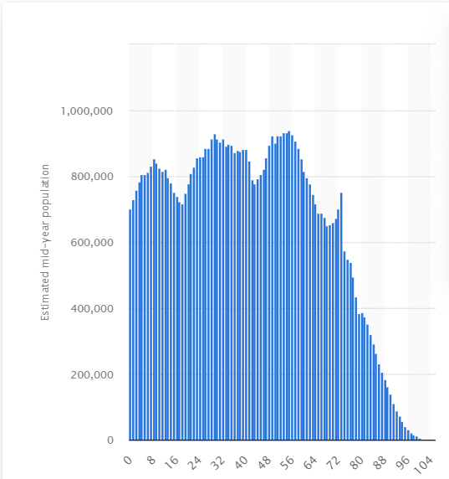
Figure 1: Ageing population in the UK
(Source: Clark, 2022)
Based on the above-mentioned figure, it can be stated that “there were approximately 938.7 thousand people who were aged 55 in the United Kingdom, the most of any age” in 2020 (Clark, 2022). In 2020, the most common age was 53 and 54 that has consisted of 934.7 thousand and 932.6 thousand people respectively (Clark, 2022). Moreover, it has also been forecasted that “the population of the United Kingdom is ageing at a substantial rate, with the median age of the population expected to reach 44.5 years by 2050" which has clearly defined the changes in the proportion of the older people in the UK (Clark, 2022). In comparison with the global people, it has found major changes in the population of the UK.
In the UK, “At age 65, men in England can expect to live on average another 8.9 years in good health, and women another 9.8 years in good health" which clearly defined the major decreasing nature of the expected remaining life span of the older people (Mha.org.uk, 2022). On the other hand in the UK, the 65 and above years aged older people have faced major challenges due to limiting the long-term disability or illnesses that have found around 4 million people (Age UK, 2022). This proportion can be increased by more than 6 million people by 2030 (Mha.org.uk, 2022). It has majorly depicted the major changes in the older people in the UK total population. Moreover, in the UK “Around 850,000 people (most of whom are aged 50 or over) are living with dementia in the UK” as it has also predicted by Alzheimer’s UK that this situation “…will rise to 1 million people by 2025" that has to define other parts of the UK older people (Mha.org.uk, 2022).
Increasing the life expectancy rate has been recognized as one of the main reasons behind the increasing nature of elder people in the UK. There are several factors in the life expectancy rate that has majorly influenced the rate of elder people such as free health care, medical technology, decreasing nature of manual employment, increased wealth, awareness of healthy living, safety measures and more (BBC.co.uk, 2022). The major outbreak of the Covid-19 virus has directly impacted the growth of older people, increasing the nature of vaccination development and reducing deaths such as measles and TB and more due to major potential health services by the National Health Service of the UK. This improvement has majorly been found in 65 and more years aged people in the UK (NHS, 2022). Increasing several innovations and technological advancement such as the development of new drugs has helped to "treat cancer and other degenerative diseases such as Alzheimer's has increased life expectancy and so increased the number of people aged 65 and over” (BBC.co.uk, 2022). On the other hand, decreasing the nature of several primary as well as secondary jobs such as steel making, coal mining and more have found majorly helped to increase the life expectancy rate. It has been found due to the increasing nature of office-based jobs. Moreover, following improved healthier diets and living conditions has helped to maintain major safety protocols to increase the life expectancy rate of the UK people (Age UK, 2022).

Analysis of different issues faced by the UK's older people including the Covid-19 impacts
It has been clearly seen that the major outbreak of the Covid-19 virus has majorly impacted the growth and development of older people globally. The prolonged pandemic situation has been recognised as one of the significant factors as it has directly impacted the physical and mental well-being of older people (Age UK, 2022). In that context, it has been majorly found that "there is a large cohort of older people - 1.4 million according to the Care Quality Commission (CQC) - found not to be receiving the care and support they need even before this pandemic” (Mha.org.uk, 2022). This situation clearly defined that they have never faced this type of conflicted and social-isolated situation ever before.
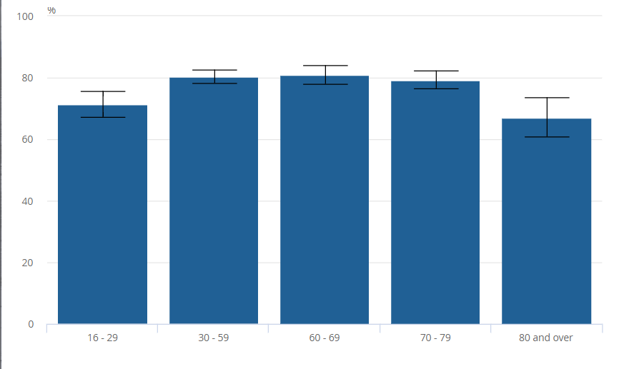
Figure 2: Major impacts of the Covid-19 virus on the well-being of UK older people
(Source: Ons.gov.uk, 2022)
Based on the above-mentioned figure, it has been majorly found that the breakdown of the Covid-19 situation has adversely impacted the living conditions and major three aspects of older people's living styles such as "being unable to make plans in general (64.5%), personal travel plans such as holidays (53.4%) and their own well-being (51.4%)” (Ons.gov.uk, 20220). In that context, it has also been found that 60 and more years aged people has faced major challenges such as "struggled to get the groceries and toiletries that they wanted (27.5%) than those aged under 60 years (39.1%)” (Ons.gov.uk, 20220).
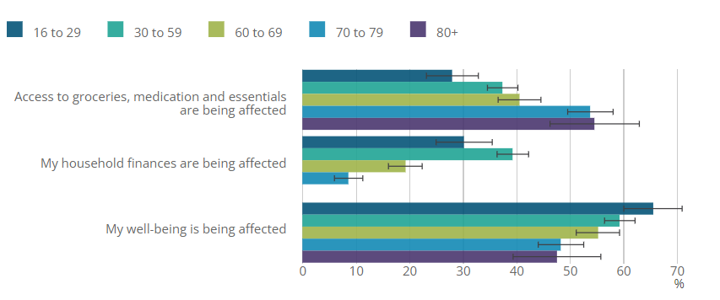
Figure 3: Major impacts of the Covid-19 virus on the financial well-being of UK older people in comparison with the younger one
(Source: Ons.gov.uk, 2022)
Based on the above-mentioned figure, it can be stated that 60 and over years old people have faced major issues in "finances have been affected (26.8%) than older people who were economically inactive (9.6%) but were less likely to say this than those economically active aged under 60 years (39.3%)” (Ons.gov.uk, 2022). It has clearly depicted the adverse impacts of the pandemic situation on the growth and development of older people (Age UK, 2022).
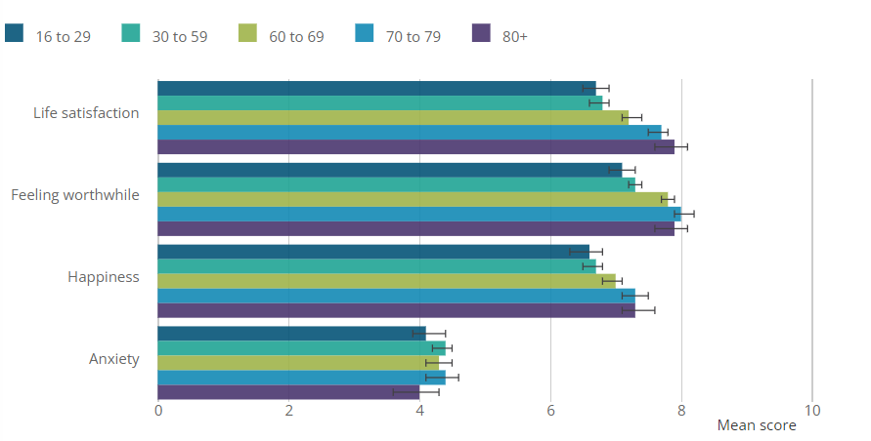
Figure 4: Increasing nature of anxiety among older people due to adverse impacts of the Covid-19 virus
(Source: Ons.gov.uk, 2022)
According to the above-mentioned figure, it has clearly been seen that the pandemic situation has not only impacted the well-being of older people but also adversely affected their mental wealth competency and increased anxiety among them. In comparison with the younger population in the UK, the anxiety level of 60 and over years aged people have found to major the highest. The present figure stated that "being worried about the future (70%), feeling stressed or anxious (54.1%) and being bored (43.3%)” (Ons.gov.uk, 2022).
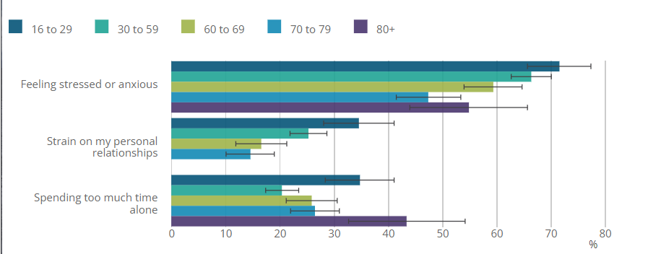
Figure 5: Increasing nature of stress among the older people
(Source: Ons.gov.uk, 2022)
It is visible from the above-mentioned figure that maximum older people from the UK has faced major challenges due to increasing nature stress, and anxiety level. It has found due to spending too much time is lonely due to the pandemic situation and it has also impacted their personal relationship more efficiently and effectively (Ons.gov.uk, 2022).

Critically evaluation of the current Health and Social Care sector of the UK
The Health and Social care sector of the UK has majorly focused on the utilisation of the concept of sustainability as it has been recognised as one of the most significant factors to develop the growth of the business organisation so efficiently. The sector has ensured that "able to meet our Greening Government Commitments and continue to monitor and track their delivery" which has helped to maintain all policies and activities to track the resilience in the sustainable approach more efficiently (Gov.UK, 2022). The organisation has majorly focused on improving the Public Sector Equality Duty that has majorly ensured the policy development process more efficiently (Assets.publishing.service.gov.uk, 2022). In that context, the major involvement of stakeholders has helped to promote and encourage the senior staff to tacking equality issues in the development of the healthcare of the UK citizens.

Considering the social impacts on the ageing people of the UK
There are several factors that have majorly impacted the growth and development of older people such as social, economic and political and more. Despite this fact, the UK's older people have faced major challenges due to falling fertility rates, and the opportunity to live longer and work harder and more (Age UK, 2022). The utilisation of all factors has helped to understand how the different social aspects have impacted the well-being of the UK's older people more efficiently. "In 2018, the UK's fertility rate was just 1.86" which has majorly reflected major changes in the UK's older people's lives due to "technological and medical advances in recent years have allowed healthcare to improve significantly (Sites.manchester.ac. the UK, 2022). That has clearly mentioned that the meaning of innovation and technological advancement has played a major pivotal role in developing the major well-being of the UK's global people. Despite this fact, investment by the UK government in improving the major well-being of older people is more efficiently.

Analysis of responses of the UK government and health service provider
As the UK's older people have faced major issues in gaining major potentiality in the improvement of their living conditions, there are several strategic actions that have been adopted such as the following:
- Fuller Working Lives: a framework for action
- Dr Ros Altmann CBE as Business Champion for Older Workers (ONS, 2022)
- A new vision for older workers: retain, retrain, recruit
- Employer toolkit: guidance for managers of older workers (NHS, 2022)
- Removing the default retirement age and more.

Theoretical underpinning
The utilisation of different theories has helped to gain major deep insights regarding the core content as it is majorly required to derive potential information. Analysis of all information has been recognised as one of the most significant manners to deliver major in-depth evaluated knowledge to discuss the topic more efficiently. There are several theories such as DNA damage theory, information theory of ageing and more. Among all these theories, the DNA damage theory of ageing has found as one of the most potential and significant theories as it has helped to understand the changes in the DNA structure of older people more efficiently. It has majorly consisted of the concept of “the cellular repair machinery that usually fixes DNA strand breaks, cross-linkages, and transcription errors stop working" with our ageing (Longevityadvice, 2022).
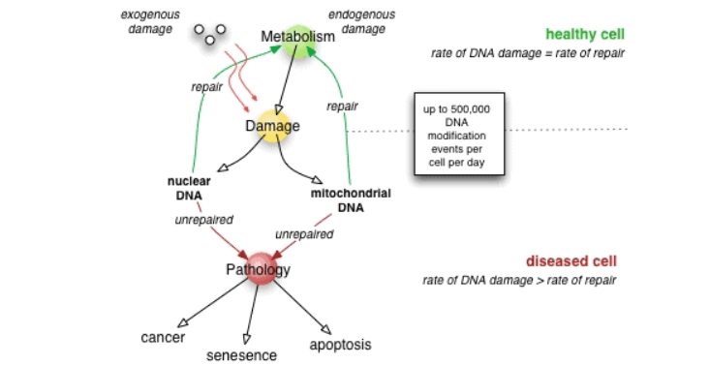
Figure 6: The DNA damage theory of ageing
(Source: Longevityadvice, 2022)
Based on the above-mentioned figure, it has clearly been found that damage to nuclear and mitochondrial DNA has led to major pathological aspects such as cancer, senescence and apoptosis (Longevityadvice, 2022). The utilisation of these aspects has helped to understand different types of damages in ageing such as Extracellular aggregates (Alzheimer's), accumulation of senescent cells, tissue atrophy, cell loss, intracellular aggregates, DNA mutations that have led to cancerous cells and more (UNECE, 2022). Critically evaluating all these features has helped to determine major factors in the growth, changes and development of older people more efficiently.

Recommendations
For better results in order to enhance the growth and development of the major well-being of UK older people, the utilisation of AI technologies has helped to increase all facilities more efficiently. Cloud computation, Machine Learning (ML), automated services, medicine booking applications and appointments of doctors from smartphones and more have helped to increase all facilities more efficiently (News.un.org, 2022). It has helped to provide all facilities at the doorstep and ensure all beneficial impacts on the health of older people more efficiently. The utilisation of AI technologies has not only helped to improve the major well-being of the UK's older people but also help to fight with adverse impacts of ageism more efficiently (Assets.publishing.service.gov.uk, 2022).

Conclusion
Based on the above-mentioned discussion, it can be concluded that the present discussion has become successful to deliver all detailed information regarding the UK's older people. In that context, the present discussion will look into the responses from the UK government and health service providers with a major delineation of the beneficial contribution of AI technologies in future development. Moreover, the utilization of specific theories on ageing would help to determine several aspects of the growth and development of ageing people in the UK. Moreover, AI technologies have helped to gain major performance efficiency to improve the growth of older people more suitably.

Reference list
Age UK, 2022. Age UK Loneliness Evidence Review Evidence Review: Loneliness in Later Life. [Online]. Available at: https://www.ageuk.org.uk/globalassets/age-uk/documents/reports-andpublications/reports-and-briefings/health-- wellbeing/rb_june15_lonelines_in_later_life_evidence_review.pdf [Accessed on 10th October 2022].
Age UK, 2022. Care in Crisis | Age UK. [Online]. Available at: https://www.ageuk.org.uk/our-impact/campaigning/care-in-crisis/ [Accessed on 10th October 2022].
Age UK, 2022. Policy Position Paper Employment (United Kingdom). [Online]. Available at: www.ageuk.org.uk Age UK. (2018a). All the Lonely People: Loneliness in Later Life. Retrieved from https://www.ageuk.org.uk/globalassets/age-uk/documents/reports-andpublications/reports-and-briefings/loneliness/loneliness-report.pdf [Accessed on 10th October 2022].
Age UK, 2022. Poverty in later life. [Online]. Available at: https://www.ageuk.org.uk/globalassets/ageuk/documents/reports-and-publications/reports-and-briefings/moneymatters/rb_apr18_poverty_in_later_life [Accessed on 10th October 2022].
Age UK, 2022. Response to new excess winter death figures | Age UK. [Online]. Available at: https://www.ageuk.org.uk/latest-press/articles/2018/november/response-tonew-excess-winter-death-figures/ [Accessed on 10th October 2022].
Age UK, 2022. The difference between loneliness and isolation - and why it matters. [Online]. Available at: https://www.ageuk.org.uk/our-impact/policy-research/lonelinessresearch-and-resources/loneliness-isolation-understanding-the-difference-why-it-matters/ [Accessed on 10th October 2022].
Ageuk.org.uk, 2022. Later Life in the United Kingdom 2019. [Online]. Available at: https://www.ageuk.org.uk/globalassets/age-uk/documents/reports-and-publications/later_life_uk_factsheet.pdf?dtrk=true+ [Accessed on 10th October 2022].
Assets.publishing.service.gov.uk, 2022. Wider impacts of COVID-19 on physical activity, deconditioning and falls in older adults. [Online]. Available at: https://assets.publishing.service.gov.uk/government/uploads/system/uploads/attachment_data/file/1010501/HEMT_Wider_Impacts_Falls.pdf [Accessed on 10th October 2022].
BBC.co.uk, 2022. Population change in the UK and Wales. [Online]. Available at: https://www.bbc.co.uk/bitesize/guides/z8k9ng8/revision/2 [Accessed on 10th October 2022].
BBC.co.uk, 2022. The ageing population of the UK. [Online]. Available at: https://www.bbc.co.uk/bitesize/guides/z8k9ng8/revision/3 [Accessed on 10th October 2022].
Clark, D., 2022. Population of the United Kingdom in 2020, by age. Statista. [Online]. Available at: https://www.statista.com/statistics/281174/uk-population-by-age/ [Accessed on 10th October 2022].
Crgsoft, 2022. Old age: Information, Characteristics, Gerontology And Geriatrics. [Online]. Available at: https://crgsoft.com/old-age-information-characteristics-gerontology-and-geriatrics/ [Accessed on 10th October 2022].
Gov.uk, 2022. 2010 to 2015 government policy: older people. [Online]. Available at: https://www.gov.uk/government/publications/2010-to-2015-government-policy-older-people/2010-to-2015-government-policy-older-people [Accessed on 10th October 2022].
Gov.uk, 2022. Department of Health and Social Care Outcome Delivery Plan: 2021 to 2022. [Online]. Available at: https://www.gov.uk/government/publications/department-of-health-and-social-care-outcome-delivery-plan/department-of-health-and-social-care-outcome-delivery-plan-2021-to-2022#d-strategic-enablers [Accessed on 10th October 2022].
Longevityadvice, 2022. The DNA damage theory of aging. [Online]. Available at: https://www.longevityadvice.com/aging-theories/ [Accessed on 10th October 2022].
Mha.org.uk, 2022. How many older people are there in the UK? [Online]. Available at: https://www.mha.org.uk/get-involved/policy-influencing/facts-stats/ [Accessed on 10th October 2022].
Mha.org.uk, 2022. Statistics about older people in the UK. [Online]. Available at: https://www.mha.org.uk/get-involved/policy-influencing/facts-stats/ [Accessed on 10th October 2022].
Mha.org.uk, 2022. What are the “big issues” for older people? [Online]. Available at: https://www.mha.org.uk/get-involved/policy-influencing/facts-stats/ [Accessed on 10th October 2022].
News.un.org, 2022. WHO highlights benefits and dangers of artificial intelligence for older people. [Online]. Available at: https://news.un.org/en/story/2022/02/1111562 [Accessed on 10th October 2022].
NHS, 2022. Health Survey for England 2016 Social care for older adults Health Survey for England 2016: Social care for older adults. [Online]. Available at: www.statisticsauthority.gov.uk/assessment/code-of-practice [Accessed on 10th October 2022].
NHS, 2022. Physical activity guidelines for older adults - NHS. [Online]. Available at: https://www.nhs.uk/live-well/exercise/physical-activity-guidelines-older-adults/ [Accessed on 10th October 2022].
ONS, 2022. Living longer - Office for National Statistics. [Online]. Available at: https://www.ons.gov.uk/peoplepopulationandcommunity/birthsdeathsandmarriages/ageing /articles/livinglongerhowourpopulationischangingandwhyitmatters/2018-08-1 [Accessed on 10th October 2022].
Ons.gov.uk, 2022. Coronavirus and the social impacts on older people in Great Britain: 3 April to 10 May 2020. [Online]. Available at: https://www.ons.gov.uk/peoplepopulationandcommunity/birthsdeathsandmarriages/ageing/articles/coronavirusandthesocialimpactsonolderpeopleingreatbritain/3aprilto10may2020 [Accessed on 10th October 2022].
Sites.manchester.ac.uk, 2022. How big an issue is the UK’s ageing population? Global Social challenges. [Online]. Available at: https://sites.manchester.ac.uk/global-social-challenges/2019/06/05/how-big-an-issue-is-the-uks-ageing-population/#:~:text=As%20well%20as%20advances%20in%20healthcare%2C%20the%20social,residential%20care%20homes%20in%20the%20UK%20%28Age%20UK%29. [Accessed on 10th October 2022].
UNECE, 2022. Older persons in rural and remote areas Policy Policy brief. [Online]. Available at: www.unece.org/pau/welcome.html [Accessed on 10th October 2022].

