

Programme Name: Master of Business Administration

Name and Code of the Module: International Marketing- Principles and Practices LCMB7026

Title: Report - BMW
Lecturer’s Name: Tushara Balendran
Student Name: Trupil Rajeshbhai Kumbhani
Student ID: 2431306
Term 2
Submission Date: 19th December, 2025
Table of Contents
1. Introduction 3
2. Brand overview 3
3. Comparison of the socio-cultural context of Germany and China 5
PESTLE 5
Similarity and Differences 11
Social Factor Advantage and Disadvantage 11
Cultural Factors based on Hofstede’s six dimensions 12
Similarity and Differences 13
Advantages and Disadvantages of the model 13
4. Comparison of Brand’s STP strategies in Germany and China 14
5. Comparison of Marketing Mix Strategies in Germany and China 18
6. Evaluation of the performance of marketing strategies 28
7. Evaluation of marketing ethics practice 31
8. Recommendation & Conclusion 33
References 35
Appendices 40
Appendix 1: PESTLE 40
Appendix 2: STP Table 41
Appendix 3: 7Ps Marketing Mix 42
Appendix 4: Marketing strategies 43
Appendix 5: Performance of marketing strategies 44
Appendix 6: Marketing ethics practice 45
Appendix 7: BMW Store 46

1. Introduction
BMW is a suitable brand for this report because it is one of the world’s leading premium automotive companies and has a strong presence in both mature and fast-growing markets. Another significant change that the brand is currently experiencing is the global trend in electric mobility redefining competition and consumer expectations (BMW Group, 2025). China and Germany were chosen as they are two highly different yet equally significant markets for BMW. China is the biggest car market globally and a major site in the electric vehicle expansion of BMW, yet it is very competitive owing to the presence of powerful domestic brands of electric vehicles and fast digitisation. In Germany, where BMW is its home market, the business environment is stable, brand loyalty is high, and the technology level is high, which makes this country a significant hub of innovations and premium positioning.
This report is aimed at analysing how BMW is adjusting its international marketing strategies in these opposite contexts. It evaluates the macroenvironment using the PESTLE and evaluates the STP strategies of BMW, its 7Ps marketing mix, evaluates performance results, ethical concerns and offers recommendations to the two markets.

2. Brand overview
Brand History, Home Country and Competitors
BMW (Bayerische Motoren Werke AG) is a German automotive company founded in 1916 and recognised worldwide for luxury vehicles, engineering accuracy, and technological innovation (BMW Group, 2025). It has four large brands that include BMW, MINI, Rolls-Royce and BMW Motorrad and has over 30 manufacturing locations around the globe and sells its products in more than 140 countries. The research, engineering and global strategy planning of BMW is also centred on Germany, its home country. BMW is a conventional multi-national company, as opposed to a born-global company; the company has grown over several decades out of its base country to the international markets. BMW’s mission is to move people by creating innovative, premium mobility solutions that inspire emotion, deliver exceptional experiences, and connect customers to dynamic, sustainable driving.
Competitors of the firm include Mercedes-Benz, Audi, Lexus, Tesla and emerging brands of electric vehicles (EVs), including BYD and NIO. Despite a positive history of operations, BMW is threatened by disruptions in the global supply chain, the escalating costs of raw materials, and the growing competitive pressure in the EV markets. The 2024 earnings before tax declined by 35.8%, as it dropped to 11.0billion in 2024 compared to 17.1 billion the year before (BMW Group Annual Report, 2024). This is an indication of the pressure of fast electrification and competition between local EV producers, particularly in China.


Figure 1: Logo of BMW
(Source: BMW Group, 2025)

Overview of Germany and China: Internationalisation and Market Entry
Germany, BMW’s home country, is among the developed automotive markets with a high level of consumer purchasing power and high demand for high-end cars. The country is not a host market but the origin market from which BMW built its international expansion. China, in its turn, is among the most significant host countries of BMW. It is the largest automotive market globally, and the luxury car market is also recording sales of 1.2 million units in the year 2024, with a 6.8% growth over the year (Grandviewresearch.com, 2025). China is a good market with high demand in EVs, digital mobility services and high-tech vehicles.
BMW ventured into China via a joint venture, BMW Brilliance Automotive (BBA) which aids in local production, subsidy of tariffs on imports and compliance with the Chinese regulatory conditions. The decision to approach China was based on the market size, high economic growth rate, and high governmental interest in EVs. Germany was retained as the centre of engineering and developing brands, and China was retained as the centre of long-term international growth.
BMW’s entry pattern aligns with the Uppsala model because it initially entered its home country and then the European markets closest to it, and only entered far-flung complex markets such as China after obtaining more international experience. This is gradual internationalisation and portrays learning, minimisation of risk, and commitment of resources in the long run.

3. Comparison of the socio-cultural context of Germany and China

PESTLE
Using a PESTLE analysis, one can compare the macroenvironment of BMW in Germany and China structured and offer an idea of the challenges and opportunities of the company in both markets. (refer to Appendix 1)
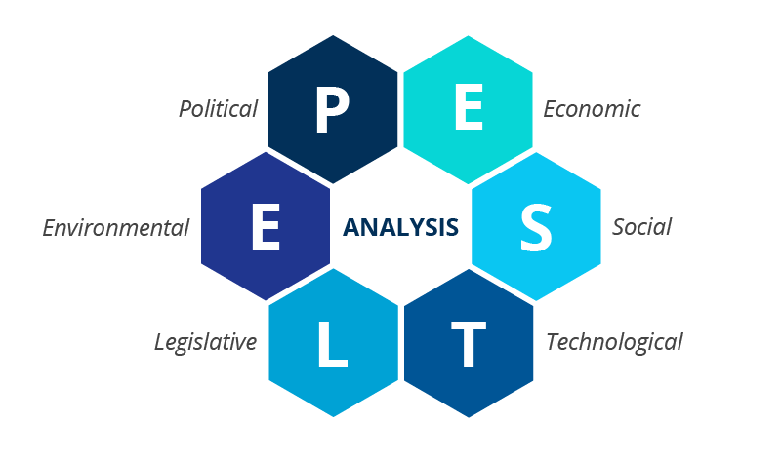
Figure 2: PESTLE
(Source: Ormston, 2025)

PESTLE of Germany and China :-
- Political:

Germany : Germany’s political landscape is very stable for the business operations of MNCs like BMW. Emission regulations which are stipulated in the EU Green Deal mandate automotive companies to focus on electric mobility. A response to this is offered by BMW investing in EVs and hybrid vehicles, making sure that they comply with the regulations, meaning that they contribute not only to sustainability but also to innovation and government policy that facilitates the use of low-emission transportation.

China : The political situation in China supports local EV producers, and the foreign brands face difficulties in the form of tariffs and bonuses. BMW solutions include joint venturing with local firms, like BMW Brilliance Automotive (BBA), so that it can have access to the market, be in line with local regulations and enhanced cooperation, and use the government policies to establish increased production and distribution in one of the fastest growing car markets in the world.

Favourable and Unfavourable
Based on assessment of political factors, stable political landscape is favourable for the organisation as it creates a secure environment to carry out business environment and make long-term investments (Biehl, 2021). However, unfavourable factor complying with EU green deal emission regulations as it will require BMW make heavy investment in hybrid and electric vehicles (Zhao et al., 2022).

- Economic:
Germany : The developed automotive market in Germany enjoys the advantage of high consumer purchasing power and stable economies. The Germany PP compound for automotive market is forecasted to expand from USD 1.31 billion in 2025 to USD 1.93 billion by 2034, growing at a CAGR of 4.43% from 2025 to 2034 (Towards Automotive, 2025). Although the market is saturated, BMW is always in profit and premium cars, particularly, have a constant demand, so the company is in a strong position in the luxury market, and the domestic wealth and stable economic growth can benefit the company.
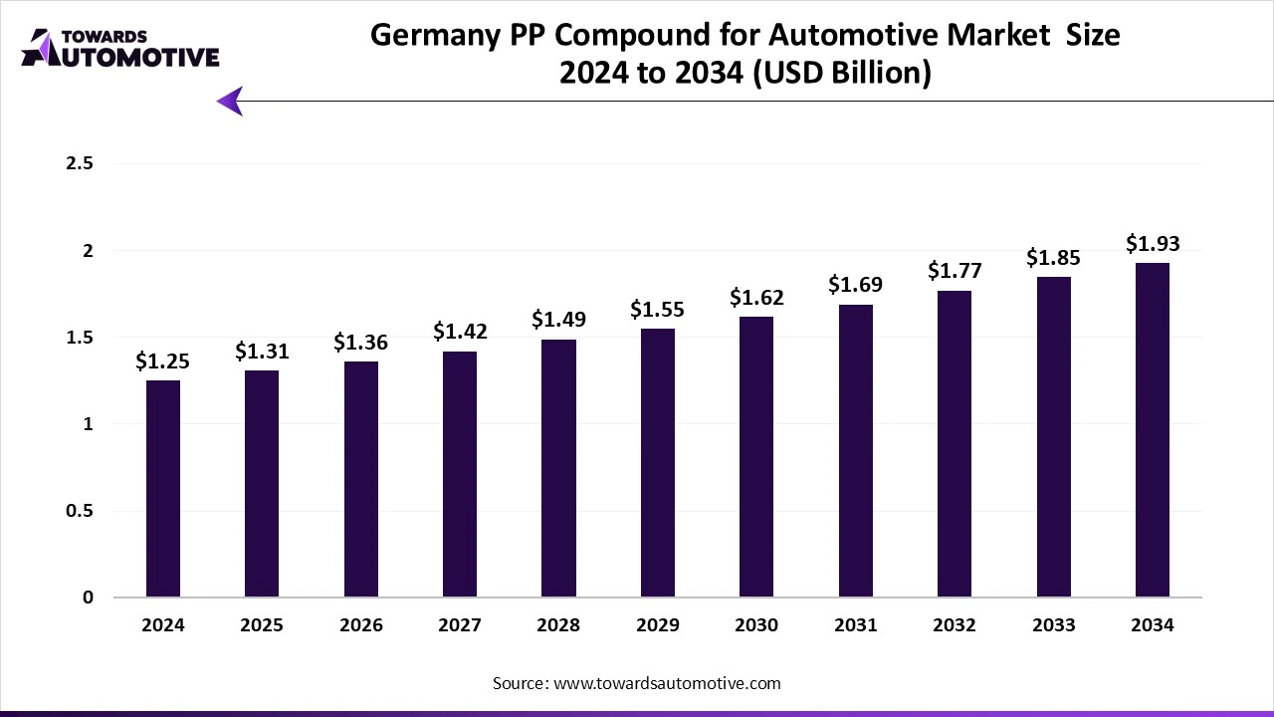
Figure 3: Automobile Market size in Germany
(Source: Towards Automotive, 2025)
China : The China luxury car market generated a revenue of USD 97,711.4 million in 2024 and is expected to reach USD 156,206.6 million by 2030 (Grandviewresearch.com, 2025). Increased disposable income, the increasing middle income, and the booming economy are the factors contributing to the demand for high end cars. BMW is taking advantage of these trends to gain market share, modify pricing policies, and grow products that would be offered to a high-end and tech-oriented segment of consumers.

Favourable and Unfavourable
High consumer purchasing power is favourable to the company as it will help it to attract a wealthy domestic consumer base, thereby, will support in increasing profit. Further, intense competition in the luxury segment is unfavourable because it can affect the customer base as customers can switch to other brands.

- Social:
Germany : German consumers are highly competitive in terms of brand loyalty particularly to their local manufacturers. Social factors in Germany support BMW because consumers value education, technical skill, and environmental responsibility (Boermans et al., 2024). German consumers are meticulous when shopping and demand cars of quality, safety, and long-term viability, and this suits the engineering-oriented image of BMW. The mature luxury market is also contributing to the demand for luxury cars, despite saturation in the market (Biehl, 2021). German customers prefer to make rational decisions, and technical and sustainability-driven communications are popular. Emotional or status-based promotions are minimised by this behaviour. The expectation of sustainability and high EU standards also put a strain on BMW to keep on updating technology, which escalates the R&D and operating expenses.

China :Chinese buyers are focusing more on luxury, technology, and modernity in cars. China’s social environment creates strong opportunities for BMW. The luxury car market has increased due to the increase in income and the development of the middle class, where people are highly interested in luxury brands (Grandviewresearch.com, 2025). Chinese consumers consider luxury, technological advances, and modern life, and this aspect is in line with the EV models and online capabilities of BMW. Smart mobility and connected experiences are demanded, a solution that BMW can use in its innovation strategy (Chun et al., 2021). However, the trends also expand competition on the local EV brands such as BYD and NIO. The collectivist culture and pressure of social approval in China lead to short-lived preferences and compel BMW to make changes within a short time in an effort to keep pace. BMW markets its products by adjusting the marketing campaigns to include younger and more tech-savvy customers and distinguishing itself among local competitors such as NIO and BYD, focusing on innovation, prestige, and advanced capabilities.

Favourable and Unfavourable
It is identified that consumers have strong value for engineering excellence, which is favourable for BMW as it helps to attract customers towards premium products and also support to strongly position in the market. Apart from that, rapidly shifting preference is unfavourable because it will require the company to continuously make heavy investment on R&D and innovation to stay relevant in the market.

3.1 Cultural Factors based on Hofstede’s six dimensions
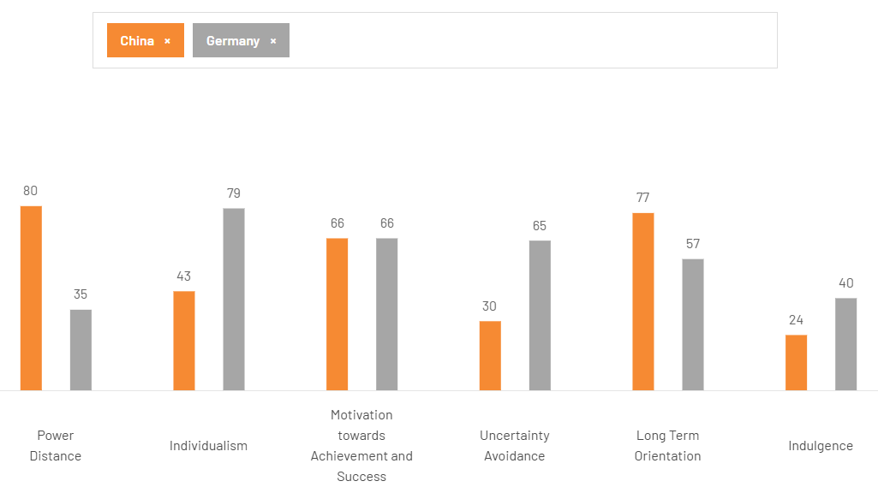
Figure 4: Hofstede’s Country Comparison: Germany vs China
(Source: The Culture Factor Group, 2025)
According to Hofstede’s model, China and Germany show strong cultural differences that shape BMW’s marketing strategies. China is a high-Power Distance country (80), which means that it is tolerant of hierarchy and centralised power, whereas Germany is a low-Power Distance country (35), meaning that the country embraces equality. This implies that BMW should adopt a more formal communication style in China and a participative style in Germany. Germany is an individualist with 79, and values personal independence, whereas China has a 43 score which is a collectivist. BMW must emphasise the individual accomplishment in Germany and the social position or family advantage in China.
Both countries score 66 in Masculinity, indicating that they are both focused on success and ambition, which justifies BMW being focused on performance and engineering. Germany has a higher Uncertainty Avoidance (65) and its consumers prefer to have clear information and reliability. The fact that China scored less (30) indicates that it is more open to new ideas, and BMW can encourage innovation and new technologies. In Long-Term Orientation, China has a score of 77 and Germany 57, indicating that these two cultures have a strong planning behaviour. Lastly, Indulgence in China (24) is lower than in Germany (40) and this implies that BMW should employ lifestyle-oriented messages in Germany and social responsibility luxury messages in China.

Similarity and Differences
High Masculinity in both countries supports BMW because consumers value success and premium performance, which contributes to the high demand of luxury cars. The Chinese and Germans have a strong Long-Term Orientation, which would support BMW’s future EVs and technology. The low Uncertainty Avoidance in China will promote the adoption of digital and innovative features at BMW. Individualism in Germany is high and therefore promotes personal success, self-image and branding based on performance as perceived by BMW.
China’s high Power Distance limits open customer interaction, requiring more formal communication, which reduces flexibility for BMW. High Uncertainty Avoidance adopted in Germany compels BMW to provide information in detail and strong guarantees, increasing the marketing and services expenses. The low Individualism of China amplifies the need to seek group approval, and therefore, BMW is susceptible to social trends and formidable competitors in the local EV markets. The low Indulgence in China is a restraint towards the lifestyle-based luxury selling and lowers the chances of Prospero in terms of emotional appeal on the part of BMW.

Advantages and Disadvantages of the model
Advantages
The model developed by Hofstede can assist BMW in adjusting marketing, leadership and product approaches to the cultural inclinations to enhance the relevance of messages, employee congruency and universal brand attractiveness. It informs the choices regarding the communication style, consumer motivation and risk-related expectations, which help to position the BMW premium engineering and EV technologies in a better way. In various markets, cultural alignment improves the accuracy of segmentation, customer trust and strategy in general effectiveness.
Disadvantages
The model proposed by Hofstede has the potential of simplifying consumer behaviour by generalising a whole population and ignoring regional, generational and lifestyle variations in markets. It is also dependent on past cultural trends that stand the chance of misaligning with fast evolving tastes, particularly the digital-savvy luxurious customer. Excessive reliance can limit strategic inventiveness whereby BMW failed to pay attention to real-time information, emerging trends and innovative marketing prospects that play vital roles in the dynamic high-end automobile industry.

- Technological:
Germany : Germany has good technological infrastructure that supports innovation and efficiency. BMW has AI-powered production, Industry 4.0 technologies, and the latest EV battery solutions, in order to ensure its presence in the global scene. Research and development are an investment of this nature that enhances performance of vehicles, their digital connectivity, and production efficiency that keep BMW on the vanguard of automotive technology in its home market and helps it in its global innovation strategy.

China : China has swift technology improvements in EV technology and digital infrastructure that require local development. BMW dedicates connected car technology, optimized battery, and autonomous driving R&D, that is localized. Collaboration with technological companies will lead to increased digitalization, which will allow BMW to stay competitive with other players in the local market and respond to the increasingly high consumer demand towards smart and technologically advanced cars in the Chinese market that is highly competitive.

Favourable and Unfavourable
The growth of advanced technological infrastructure is favourable as it can enable BMW to implement AI-powered production, Industry 4.0 technologies and cutting-edge EV battery solutions. The need for constant high R&D investment is unfavourable as it can increase financial pressure and operational expenses of the organisation.

- Legal:
Germany : The German automotive industry is regulated by strict laws and regulations which govern the country. This is because the legal requirements of EU Reg. 2019/ 631 are on the maximum amount of CO2 which a passenger car should produce and this affects the production and marketing decisions of BMW. By following these legal requirements, BMW will be able to evade fines, achieve its environmental objectives, and assist the company to reinforce its reputation of a responsible and sustainable manufacturer in the local and international market.

China : The regulatory environment in China is not simple and some provinces have different requirements concerning safety, emissions, and imports. BMW is in line with the Road Traffic Safety Law of the People Republic of China that regulates the safety and functioning of vehicles. By complying with these laws, BMW can continue to act within the confines of the law, and prevent fines, as well as do so without losing the confidence of its audience in a highly enforced and regulatory diverse market.

Favourable and Unfavourable
Adhering to EU regulation is favourable for the organisation as it can significantly support in creating strong brand image, who prioritises to control and reduces CO2 emissions. However, too stringent legal standards can be unfavourable for BMW as well as it will require making continuous adjustments in marketing and productions, thereby, adding regulatory pressure.

- Environmental:
Germany : Germany possesses the automotive market the core focus of which is on sustainability. The BMW iX is the first step of BMW to sustainable luxury with a focus on electric mobility. This case study highlights the integration of user experience design principles in creating a futuristic and environmentally conscious vehicle. The BMW iX stands out as one of the best cars in terms of merging luxury with sustainable innovation in UX design (Ahmad, 2024). Such activities exhibit that BMW is not only environmentally responsible, but it also targets the environmentally minded consumers and is in line with the national environmental sustainability objectives.

China : China focuses on green technology and reduction of emissions. BMW advertises electric cars like the iX3 to emphasize on energy-saving and sustainable manufacturing. The useful case in point is the cooperation between BMW and Chinese utility companies to increase the number of EV charging stations to ease the uptake and build the brand image among customers who are environmentally aware and meet the national strategies to decrease carbon emissions and encourage sustainability. In the focus area of sustainability, the Board of Management presented the decarbonisation measures being taken in respect of our production and sites, as well as in the supply chain and during the vehicle usage phase.

Favourable and Unfavourable
The development of green technology and EV infrastructure is favourable for the organisation as it can enable BMW to focus more eco-friendly vehicle production and develop carbon reduction strategies. On the other hand, a significant pressure to continuously attain high environment standards is unfavourable for BMW to certain extent as it will require the company to constantly upgrade their technologies, thereby, increase operational and R&D costs.

Similarity and Differences
Both Germany and China support BMW’s move towards electric mobility with strong environmental and technological progress. Sustainability is promoted in each country, and this prompts BMW to increase its EVs and hybrids (Khaleel et al., 2024). Innovation, digitalisation and high-tech production methods are also appreciated by both markets, which is also related to the global strategy of BMW. Regulations are politically used in both countries to influence the automotive industry by forcing BMW to adhere to the emission regulations and invest in cleaner technology. Socially, both markets show interest in modern, high-quality vehicles.
Germany has political stability, high purchasing power, and a mature luxury market, whereas China has high growth, competition with price, and high government support of domestic EV brands. The German customers are also quality-conscious and rational, compared to the Chinese buyers, who are status-oriented and tech-savvy. The Chinese regulatory environment is more intricate and provincial by difference, whereas Germany is also strict EU-wide. China is aggressive on digital shopping and quick innovation, but Germany is more dependent on structured, technology-driven, but stable market behaviour.

4. Comparison of Brand’s STP strategies in Germany and China
(refer to appendix 2)
Germany
- Segmentation: BMW employs the explicit multi-dimensional segmentation approach to appeal to its high-end clientele in Germany. Demographic segmentation is an emphasis on high-income professionals, executives, and entrepreneurs between 30 and 55 years old that have the ability to afford luxury vehicles and can appreciate the value of engineering. Psychographic segmentation focuses on consumers that value status, innovation, hi-tech and environmental awareness, which fits in VALS Innovators and Achievers. Geographic segmentation focuses on the key urban areas with the highest demand niches in premium cars like Munich, Frankfurt and Hamburg where there are the BMW dealerships (Schmacke and Vogt, 2023). The behavioural segmentation focuses on the brand loyal drivers, who consider performance, safety and sustainable choices like hybrid and efficient ICE choices. The positive side to this strategy is that it enables BMW to attract a lucrative and loyal niche that has close relationship with its luxury brand name.

- Targeting: BMW targets the high-end automotive market in Germany, focusing on consumers aged 30–55 who appreciate technology, comfort, and performance. It targets primarily two segments: high-income, executive buyers that would favor premium and reliable models such as the BMW 5 Series and the X5 hybrid and young professionals who are techno-savvy and require advanced features and plug-in hybrid models. Such targeted advertising will give BMW more loyalty and a stronger luxury image. In Germany, BMW has a Concentrated Targeting, which targets the high-income professionals, executives, and tech-savvy consumers between the ages of 30 and 55 years in such cities as Munich, Frankfurt, and Hamburg. Personalised products such as ICE, hybrid and EVs focus on engineering, safety and sustainability with high regards to loyalty and high positioning in this niche segment.

- Positioning: In Germany, BMW is marketed as an engineering excellence brand, one that is high-performance and a modern luxury brand. The high demand of its high-end and electric vehicles has helped the company to achieve increasing profit margins of 9.8 percent in the third quarter (Financial Times, 2023). On the positioning map, BMW is positioned between high luxury and high performance as the car does not share its position with the comfort orientation of Audi and the traditional prestige that is embodied by Mercedes-Benz. However, the increasing investment in EVs and digital innovation by the competitors can undermine the differentiation of BMW unless it also does so.
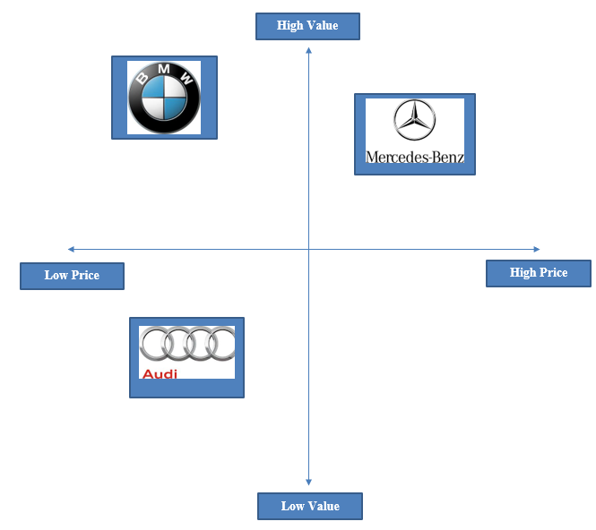
Figure 5: Positioning Map for Germany
(Source: Self-created)

China
- Segmentation: The multi-dimensional segmentation strategy used by BMW is based on the Chinese automotive segment that is competitive and fast-growing. Demographic segmentation is focused on young wealthy consumers, executives and urban professionals between the age of 28-45 years whose disposable income levels are on the rise and are very keen on luxury brands. The psychographic segmentation targets technology-advanced, status oriented, and innovation-oriented customers that attach importance to contemporary features, digital connectivity, and social recognition. Geographic segmentation will focus on major cities like Shanghai, Beijing, and Guangzhou which are first and second tier cities where ownership of premium cars is aspirational and associated with social prestige. The behavioural segmentation will focus on those consumers who are fond of high-performance vehicles, high-tech EV models, and sustainable ways of movement. One of the positive sides of this strategy is that it will enable BMW to tap into the growing upper-middle-income demographic in China that heavily favours technologies and luxury, which fits perfectly well with the BMW brand image.

- Targeting: BMW is focusing on the fast-growing and luxury automotive and EV market in China (Berezina, 2024). It has major target markets that include young professionals in the age bracket of 28-35 years, who are sensitive to technology, prestigious and established executives in the age group of 36-45 years, which are sensitive to comfort, sensitivity to performance, and sensitivity to brand. Some of the models that BMW markets are iX3, i4, and i7, which correspond to the augmented need of sustainable mobility and government subsidies of EVs (BBC News, 2023). At the high-end EVs like iX3, i4, and i7, it will serve these various segments, allowing BMW to compete with local EV brands in Tier 1 and Tier 2 cities.

- Positioning: BMW brand in China is a high-end, luxury, and technologically advanced product. Its marketing emphasizes the autopilot features, internet connectivity and green design to appeal to status-conscious and technology-driven consumers. Collaboration with the Chinese technological companies also reinforces the modern and progressive image of BMW. This puts BMW literally in opposition to high-end EV rivals such as Tesla, which has advanced autonomous technology, and NIO, which wins the local market with its progressive battery-swap technology and attractive prices. BMW should strike a balance between high luxurious standards and constant technological innovations to be competitive.
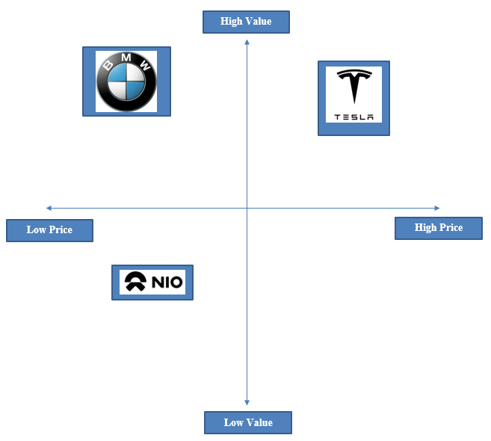
Figure 6: Positioning Map for China
(Source: Self-created)

Similarities and Differences
Similarities
The STP strategy of BMW in both Germany and China is similar because it consistently focuses on premium positioning and advanced technology. BMW is targeting status-oriented consumers in the high-income, high-performance, quality-engineered, and sustainable mobility in both markets. The strategy helps BMW to maintain its luxury image in the world and brand-uniform perception across the nations. Innovation, EV technology, and modern design also focus as per the need of the demanding customers in both markets. This is an accurate similarity because a consistent premium image would enhance brand equity on a global level and customer loyalty across the world.
Differences
The main difference between BMW’s STP strategy in Germany and China lies in the level of segmentation breadth. In Germany, BMW aims at a smaller segment of professionals with high incomes and technologically oriented consumers who appreciate precision in engineering and reliability. The approach in China is more differentiated, with young wealthy professionals, status-oriented buyers, and longstanding executives as the target to align with the various and rapidly expanding EV market (Hecht et al., 2022). This distinction is valid due to the fact that the dynamic, competitive situation in China demands wider targeting than the market in Germany which is a mature luxury market and responds to specialised segmentation.

5. Comparison of Marketing Mix Strategies in Germany and China
The marketing mix is a model, which assists companies to strategize how to sell a good by employing four essential factors, which include product, price, place, and promotion as a means of meeting client demands and competing favourably (Othman et al. 2021).
(refer to appendix 3)
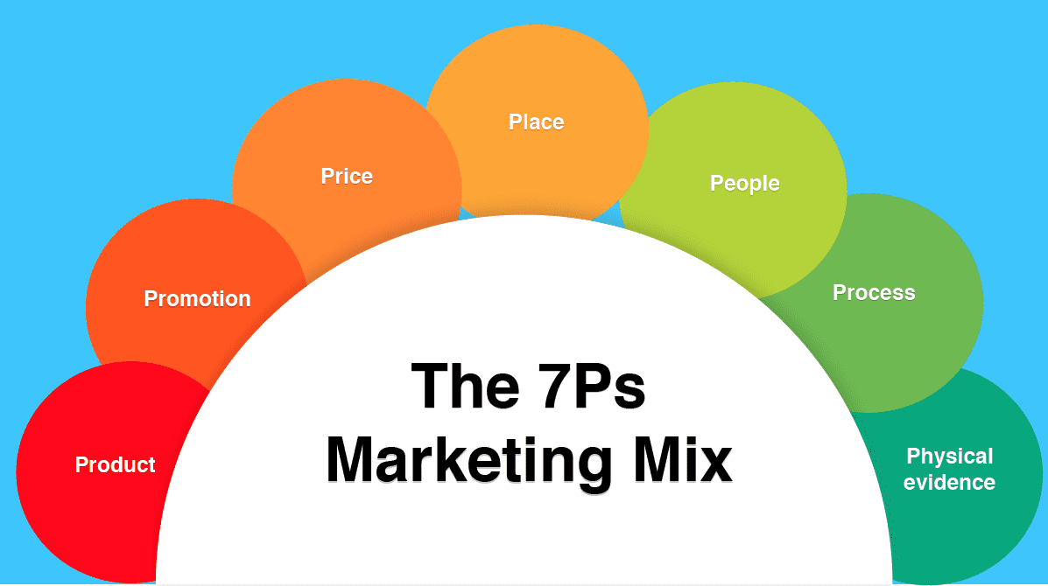
Figure 7: Marketing Mix 7ps
(Source: Hanlon, 2023)
Product:
Germany
The branding of BMW in Germany is oriented towards engineering quality, accuracy, security, and high-level performance, with the emphasis on high-technology and reliability of German workmanship to benefit the loyalty. Its core product is driving experience, and the real dimensions consist of hybrid engines, quality materials and safety features. Long-term maintenance is a part of the auxiliary services.

Product Width
BMW in this country provides a range of product lines (width) such as Sedans, coupes & convertibles, SUVs/SAVs, electric vehicles, performance models and motorcycles. Therefore, 6 major product lines are considered as total width.

Product Depth
In context to depth, which indicate number of products per line, includes multiple models and variants such as 3 Series (Sedan, M340i, Touring), X5 (Petrol, Diesel, M Performance, Plug-in Hybrid), i4 (eDrive40, eDrive35, M50).
Technical, precise, and safety-oriented information is applied to standardised packaging and labelling to suit the expectations of Germans. The branding strategy of BMW in Germany is oriented towards engineering quality, accuracy, security, and high-level performance, with the emphasis on high-technology and reliability of German workmanship to benefit the loyalty.
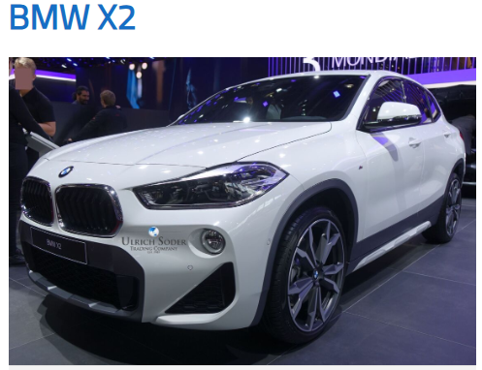
Figure 8: BMW X2 in Germany
(Source: BMW X2, 2025)

China
BMW in China places emphasis on brand strategy, which puts emphasis on innovation, EV leadership and prestige. The main product takes the focus at electric mobility, with true dimensions being digital interfaces, long-wheelbase comfort and advanced battery systems. Such auxiliary services are digital after-sales services.
Product Width
BMW in China offers few product lines (width), tailored to local preferences. It comprises Sedans, Electric Vehicles, SUVs and Luxury & Performance. Therefore, 4-5 product lines are available in China.
Product Depth
Considering the depth of product lines, it is identified that BMW has 3 Series, i3 and X3 in China Technology, sustainability and status are also emphasised, adaptive packaging, and labelling to meet the preferences of Chinese culture.
BMW’s branding strategy in China highlights innovation, electric mobility, digital experience, luxury status, and locally tailored models to attract tech-driven, prestige-seeking consumers.
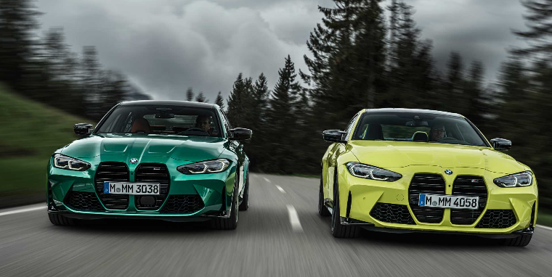
Figure 9: BMW Product in China
(Source: BMW, 2020)

Price
Germany
BMW’s pricing objective in Germany is to maintain its premium image. The pricing strategy is principally competitor-based and is worth Audi and Mercedes to maintain the market balance. Germany applies the standardised pricing, and the discounts are few to safeguard the residual value and brand equity. To illustrate, the lowest-priced BMW X3 in Germany costs approximately 59,400 Euro (around US 62,250).

China
BMW’s pricing objective in China is to stay competitive in a strong EV market. The competitive pricing strategy combines both competitor-based pricing and value pricing; it responds to local competitors such as BYD and NIO. BMW employs modified pricing with finance plans and rewards. A case in point is that the base model of the BMW X3 xDrive 25L is priced at 349,900 yuan (approximately US $48,000) in China.

Place (Distribution)
Germany
BMW has a high channel intensity and heavy network of dealerships by saturating major regions and dealerships and providing various touchpoints. Length of channels is short through authorised dealers. The deals with intermediaries include trained sales teams with consultations and after sales services. Physical distribution is based on orderly and transparent showroom experiences in accordance to the German expectations. In addition, direct channels include BMW-owned dealerships, online sales platform, BMW financial services and corporate fleet sales where indirect channels include authorised resellers, service centres and used car networks.

BMW
Intensive
Consumers
Consumers
INDIRECT
DIRECT
Dealerships
Figure 10: Channel Distribution- BMW, Germany
(Source: Self Developed)
China
BMW integrates dealerships that are selective and powerful online outlets. Digital intermediaries are channel length, which covers WeChat and Tmall. In between arrangements sustain online research, set up and fund. The physical distribution is quicker and mobile-based, which is fitting the digital retailing patterns in China. However, it is identified that direct channels for BMW in China include BMW Brilliance Automotive, BMW Dealerships, corporate fleet sales and online platforms and indirect channels include distributors, third-party galleries and authorised service centres. Moreover, direct channel intensity of BMW in this country emphasises on providing localised models, penetrating Tier 2 and Tier 1 cities with branded leaderships.

BMW
Intensive
Consumers
Consumers
INDIRECT
DIRECT
Dealerships/Distributors
Figure 11: Channel Distribution- BMW, China
(Source: Self Developed)

Market Entry Method :-
BMW can penetrate the Chinese market by joint ventures with the local partners. BMW relies on joint venture as the strategy facilitates the company to penetrate China with local information, regulatory assistance and direct access to markets. Such a plan helps to overcome the risk in a complicated market because the partner knows the regulations and wants of the consumer (Loehde et al. 2020). However, the common control can cause conflicts, profits should be shared, and the partnership structure can slow down the decision-making process. Advantages are that it has a common investment, less market risk and more responsive to the consumers. However, disadvantages are shared control, slow decision-making, profit-sharing and potential conflicts with local partner.

Promotion
Germany
The purpose of the promotion that BMW will have in Germany is to educate buyers on engineering, safety and sustainability. Media advertising incorporates the conventional media, auto magazines and motorsport sponsorship. This is an appeal that is factual and logical. Promotion is more or less standardised and has little emotion. BMW can implement a single, factual IMC strategy with technical advertising, PR, events, motorsport sponsorships and regular and consistent messages on the subject of safety, engineering excellence and sustainability, to resonate with the rational consumer attitude of Germany.

China
The promotion goal of BMW in China will be to influence and entice tech-savvy, status-conscious customers. Douyin, WeChat and Xiaohongshu are ways of advertising that are used in the media. The advertising is emotional with a display of lifestyle, modernity and prestige. The process of promotion is highly customised and relies on influencers, virtual launch and digital storytelling. BMW can employ a tailored and digital-first IMC approach, whereby influencers, social media channels, virtual-launches, online-storytelling and luxury-based messages reach out to the tech-driven and prestige-oriented consumers in China through various touch points.

People
Germany
BMW staff in Germany offer strong technical expertise, open communication and product knowledge. It is found that around 89490 numbers of staff are currently employed in the company (BMW Group, 2024). The customers count on the professional advice, long-term and detailed explanations and support of the services, which corresponds to the rational and information-oriented buying behaviour in Germany. On the other hand, training programs are offered by the company to German employees, which includes BMW Group Academy, which provides virtual and on-site training and MOVE program which enables young professionals to gain cross-functional learning and knowledge on international projects. Further, the company uses different motivation strategies such as transparent career paths, promotes diversity and inclusion to engage employees (BMW Group, 2024). Uniform of BMW staff in Germany are designed for ease, sturdiness, and brand consistency. The colour of the dress is mainly navy blue, white and grey.

China
BMW staff in China focus on luxury service, personalised delivery and constant relevant online communication. In China, there are approx. 20000 staff and 460 suppliers working in BMW (BMW Brilliance, 2024). CRM engagement and high-status experiences are developed through one-to-one interactions and establishing a high status expected by Chinese luxury customers. Apart from that, BMW in China focuses on various training programs like future talent programs, which comprises ProMotion, SpeedUp China for training young professionals and graduates; Onboarding and mentorship and Global leader development. Further, motivation strategies considered by BMW in the country includes competitive benefits such as insurance, allowances and localised career growth. BMW staff uniform in China has white, black and red accents colour.

Process
Germany
In Germany, BMW has a structured process that includes consultations, test drives, physical documentation, and after-sales services that are planned to be done. The customers believe in transparency, serviceability and durability, which favours high service loyalty. In context to the customer complaint process, it can be pointed out that customers can resolve their issues by contacting BMW Dealer or contact BMW Germany by filling an online form at BMW Group Contact Page.

China
The Chinese process used by BMW is digital first, which means that one can conduct online research, create a configuration, finance the car, and book the service. Visits to dealerships are low as China has a fast and mobile-driven retail setting and likes to take convenient buying trips. On the other hand, Chinese customers have the option to contact BMW Dealership or BMW Brilliance for filing complaints. Also, the company provides round-the-clock assistance, where customers can dial 400-800-6666 or email at servicecenter_CN@bmw.com.

Physical Evidence
(refer to appendix 7)
Germany
German dealerships employ minimalistic and advanced design, vehicle showrooms and service desks that are engineered. This supports the accuracy, technical and high-quality reliability of the BMW. The organisation has its website in Germany as well.
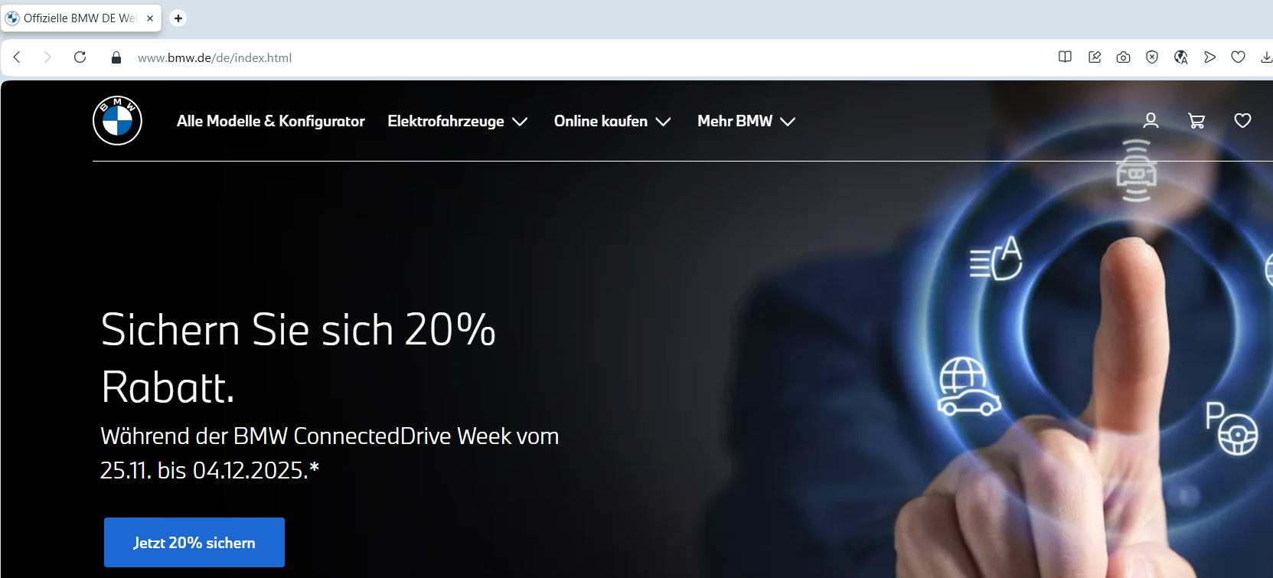
Figure 12: Official Website of BMW Germany
(Source: BMW Germany, 2025)
BMW's website in Germany offers technical specifications, safety information, sustainability information and configurators. The uniforms used by service employees are clean and professional with dark colours; this depicts precision, reliability and BMW engineering-oriented brand image (BMW Germany, 2025).

China
China has BMW City Studios, digital lounges and EV experience zones, which have AR tools. These contemporary spaces enhance the innovative and technology-driven high-end image of BMW. The organisation has its website in China, which is developed in Chinese language.
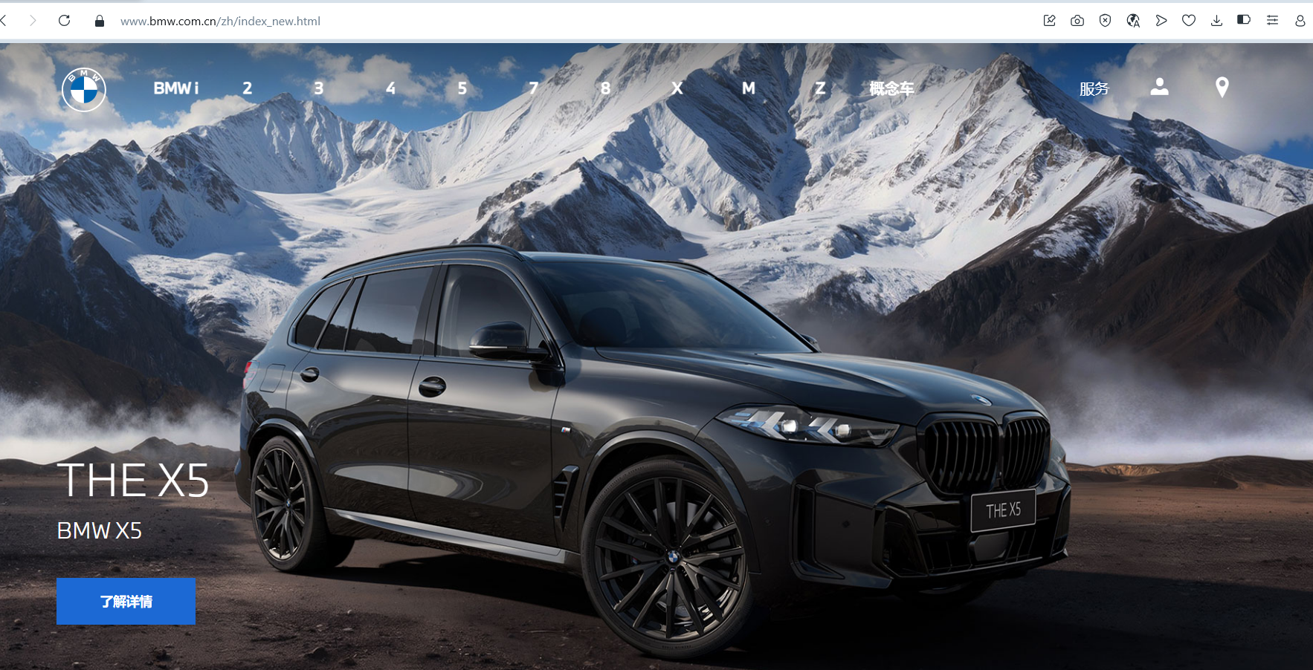
Figure 13: Website of BMW China
(Source: BMW China, 2025)
The Chinese website focuses on EV features, digital services, luxury image and interactive tools. Modern and high-end uniforms are worn by the service staff, with a sleek styling to suit the brand demands in China, which are technology-driven, high-end and innovation-related (BMW China, 2025).

Similarities and Differences
Similarities
BMW’s marketing mixes in both Germany and China follow a premium, innovation-oriented approach that will ensure that its international luxury brand is preserved. The product strategy in both markets emphasises advanced technology, good performance and sustainability and pricing is positioned on a high value and is anchored by competitor-based approaches. Distribution is a combination of professional dealerships and organised service processes. The aspect of promotion in the two countries focuses on high-quality engineering and brand reputation. Such parallels can be explained by the fact that BMW has to ensure the presence of consistent global brand equity, premium perception, and trust in its key foreign markets.

Differences
Key differences arise from cultural expectations, market maturity, and digital behaviours. Germany employs standardised products, pricing and promotion with technical appeal, rational appeal, and China demands modifications like long wheelbase models, flexible pricing and digital-first promotion. The distribution is also different since Germany has dealership-based distribution and China has hybrid online distribution to reach the entire nation. Individuals, operations and tangible reality are also more adaptable in China to add luxury and customised service. Such discrepancies are well-grounded due to high localisation being needed by the fast-growing EV market in China, digital shopping habits, and the high intensity of local rivalry. Also, there is a difference in the websites of each nation. Both have BMW websites in their own language.

6. Evaluation of the performance of marketing strategies
(refer to appendix 4 and 5)

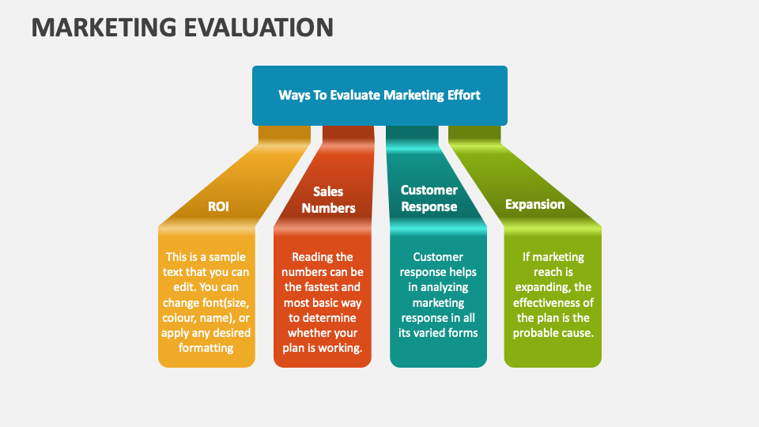
Figure 14: Marketing Evaluation
(Source: Collidu, 2024)

- Profit and Sales Performance
Germany: The performance in Germany was steady with a high brand loyalty and a premium pricing strategy which was maintained by MW. Germany alone in the BMW Group Annual Report 2024 had 265,700 deliveries in 2024, compared to 272,600 in 2023 (BMW Group Annual Report, 2024). Although it decreased slightly, Germany is the largest market of BMW in Europe, where the demand on hybrid and ICE models is stable. In 2024, the Automotive EBIT margin of the company was also reported to be 6.3%, which is indicative of the pressure on the industry as a whole and yet good profitability of the segment.

China: In 2024, BMW delivered 715,200 vehicles in China, although this represents a decline from 826,300 in 2023 due to intense EV competition and market slowdowns (BMW Group Annual Report, 2024). The annual report further reports that the difficult market environment in China has been a major cause of the decline of BMW global delivery in addition to pressuring profitability in the Automotive segment. However, the localised manufacturing at BMW Brilliance Automotive minimised the tariff costs and enhanced the competitiveness of costs. High EV demand, as one of the segments of the policy-based market in China, contributed to the increase in BEV sales at BMW, which strengthens the strategic compatibility of the technology-intensive models offered by the company.

- Social Media and Digital Interactions
Germany: The results of the digital engagement between the two markets vary significantly because of the differences in consumer behaviour in both markets and the media environment (Guan, 2023). Digital presence in Germany is assisted in brand reinforcement and not emotional appeal. BMW has been utilising online platforms in terms of technical information, new models, and sustainability news. The level of engagement is stable yet average, which indicates the information-seeking nature of the purchase decision of German consumers, instead of social media as the driver of influence. BMW online outputs thus appear to be basically research support tools, which is consistent with the rational brand evaluation norms.
China: The digital performance has been much higher in China as digital marketing is one of the initial channels of brand interaction, especially with young luxury consumers (Diaz Ruiz and Cruz, 2023). Strong visibility has been achieved through interactive campaigns on sites like Douyin and WeChat when it comes to launching EVs and technological advances. Live product events, influencer partnerships, and VR-based experiences enhance the experience and represent the mobile-first buying culture in China.

- Customer Experience and Customer Feedback
Germany: The effectiveness of BMW strategies can also be seen through the customer reviews (Kukkamalla et al, 2021). Customer satisfaction with driving performance, technical quality and organised dealership service processes is high in Germany, as shown by customer reviews. The high rate of loyalty is supported by professional consultation and lifetime maintenance support being a key element in showing that the service model proposed by BMW meets the expectations of the consumers when it comes to credibility, transparency and continuity.

China: In China, the customers note that they highly appreciate personalized service, convenience in digital purchasing and modern in-car technology. The perceived luxury value is increased by the utilisation of CRM systems, ceremonial vehicle deliveries and in-store luxurious experiences (Pantano et al., 2022). Yet, customer feedback on recurrent patterns indicates pricing sensitivity as compared to other local EV competitors with identical technological experiences at a lower price. It means that BMW will have to reaffirm differentiated value every time to support premium positioning.

Similarity and Differences
The two markets are similar in the way BMW is strategically oriented towards premium positioning, constant technological development and improvement of brand experience. BMW also uses national consumer values in both countries, engineering rationality in Germany and digital lifestyle aspiration in China, which proves successful market-led adaptation according to the modern international marketing principles. However, there are obvious differences in markets. Germany is indicative of a mature, rational and product engineering-based environment backed up by organised physical distribution and high brand loyalty. China is a highly dynamic market with an innovation-driven market that is driven by digital promotion, fast electrification, and high pricing competition. The mechanisms of engagement are also different: German customers rely on the offline approach, and Chinese consumers rely on social and digital feedback.

7. Evaluation of marketing ethics practice

Product-Related Ethical Issues
BMW positions its electric cars like iX3, i4, and i7 as the environmentally friendly cars that do not emit any emissions during driving and use and possess the developed clean technologies. Cultural relativism is one of the factors that should not be ignored when it comes to expectations of environmental transparency in China, BMW should alter the level of disclosure to account to local ethical standards.
- Risk of greenwashing: The marketing focus has been moved on the sustainability aspect, although BMW does not disclose excessive information about the overall effect of battery manufacturing on the environment, including production emissions and the carbon-heavy nature of the Chinese power generation (Muller et al., 2023).
- Supply-chain Transparency: EV Supply chain deals with lithium, cobalt, and rare earths. The information regarding sourcing and traceability is also not also disclosed by BMW, and it is a question of ethics of responsible mining, as well as the general information disclosure of the products that might influence the consumer confidence.
Price-Related Ethical Issues
- Price discrimination: A number of BMW models are assembled locally, but they cost a lot more than similar domestic EVs. As production and logistics costs in China are cheaper, this trend gives rise to ethical concerns of whether pricing is based on actual value or exploiting brand-envy and consumer-dream.
- Bundled pricing: BMW tends to package major technological appeals, performance enhancements, and digital offerings at a high cost (Weiss et al., 2021). This restricts consumer options and can pressure the buyers to more expensive options that can raise the question of fairness and price transparency.
Promotion-Related Ethical Issues
According to the justice approach (procedural justice), the lack of visibility of disclosed influencers is also a failure of fairness since consumers are unable to rate the authenticity of endorsements appropriately.

- Strengthening social inequality: Advertisements representing BMW ownership as a success symbol can unwittingly encourage elitism and materialism in an already polarizing income distribution society, which could turn off some consumer groups.
- Influencer marketing transparency: Cooperation with digital influencers do not always include clear disclosures of the sponsorship, leaving the question about whether the endorsements are genuine or not and misleading the consumers.
- Targeted online marketing: BMW uses personalised advertising based on the information on the platforms such as WeChat and Weibo, which can be questioned, in terms of ethical considerations, in terms of consent, the lack of transparency about using these data, and the potential manipulation of consumer behaviour (Yang, 2022).
Place & People-Related Ethical Issues
- Regional inequality: The regions are characterized by the concentration of service quality and dealership support in Tier 1 cities, and limited access to after sales service in lower tier cities, with different regions experiencing a disparity, and raising concerns about fairness to consumers across regions.
- Pressure on sales and employee behaviour: Salespeople at the dealership have high performance expectations, this may lead to aggressive selling of financing packages, optional packages or add-on sales to unsophisticated customers (Loponen, 2025). These practices can pose a danger on the exploitation of consumer vulnerability and undermine the integrity of ethical practices in the interaction with customers and open sales procedures.
Process & Physical Evidence Ethical Issues
- Risks to data privacy: It is optional to the extent that the Chinese regulatory framework allows the wider use of corporate data and some access by the government, thus, revealing sensitive information of the customer to third parties without their explicit consent.
- Opaque data policies: Customers can be inadequately informed about the manner in which in-car telemetry and mobile app interaction as well as showroom interaction data are collected, stored, and used. This is untransparent and this aspect questions the morals as this may erode trust in the digitalisation of consumer information in the BMW digital processes.
Overall Ethical Judgement
BMW expresses the desire to act ethically, particularly regarding sustainability and digital responsibility, although there are serious gaps. The lack of transparency in supply chains, fairness of prices, irregular promotional disclosures, inequalities in service to regions and imbalanced data-privacy treatment show that ethical practices are not entirely met and equally executed throughout the Chinese market (Wu, 2023).

8. Recommendation & Conclusion
Recommendations for Germany
Enhance transparency and sustainability communication
BMW ought to report in more detail about its electric vehicle impact on the environment such as battery manufacturing, energy sourcing, and supply-chain practices. Viable transparency of sustainability efforts will minimize the chances of greenwashing, and be more effective in boosting consumer confidence, especially in markets such as Germany that are more environmentally conscious.
Strengthen customer experience and data governance
BMW needs to invest in consistent service quality in all regions, making customers fairer in the cities of lower tier (Micus et al., 2025). Moreover, ethical risks will be reduced by strengthening data privacy policies, providing a clear notification of data collection and use, and ensuring its digital channels, which will be vital in developing long-term confidence in its more digitalized international marketing practices.

Recommendations for China
Implement fair and flexible pricing strategies
To solve the ethical issues concerning the premium pricing and bundling, BMW may come up with more flexible prices of the core features and provide the optional upgrades on a separate basis (Weiss et al., 2021). This would offer more consumer options, better price equity and access younger or aspirational clientele in the emerging markets without diluting brand image.
Responsible and culturally sensitive promotion
BMW must make sure marketing campaigns support social inequality or elitism. Open cooperations with influencers and ethically focused digital advertising with explicit permission to use data will enhance brand trust without violating the cultural and regulatory environment.

Conclusion
In conclusion, this report demonstrated how BMW can adjust its international marketing to the various circumstances in Germany and China. The PESTLE analysis has indicated the high-value and consistent market of Germany and the rapidly developing yet competitive EV market of China. The STP and 7ps analysis established that BMW has effective segmentation and tailored marketing mix strategies to meet the expectations of the two markets. Ethical issues in China such as transparency of prices, practices of influencing and privacy of information are also a major challenge. In general, the balance between luxury and innovativeness and the enhancement of the ethical conduct and the flexibility to the cultural, technological, and regulatory variations will make BMW successful in the long-term.

References
Adekanmbi, O., 2023. Alternative Channels of Luxury Consumption by the Low-Income Segment (Doctoral dissertation, City, University of London). https://openaccess.city.ac.uk/id/eprint/31722/
BBC News (2023). The ambience of modern luxury. [online] Available at: https://www.bbc.com/storyworks/specials/the-ambience-of-modern-luxury/
Berezina, P., 2024. The Electric Revolution from China: Impact of Chinese Electric vehicles on Logistics and Market in Europe. https://www.theseus.fi/handle/10024/876983
Biehl, B., (2021). Luxury in Germany: Sick cars and healthy bodies. Society, 58(5), pp.385-391. https://link.springer.com/content/pdf/10.1007/s12115-021-00610-x.pdf
BMW (2020). BMW at the 16th Auto China Beijing 2020. [online] BMW Group PressClub. Available at: https://www.press.bmwgroup.com/global/article/detail/T0317774EN/bmw-at-the-16th-auto-china-beijing-2020?language=en [Accessed 20 Nov. 2025].
BMW Brilliance (2024). Company information. Available at: http://www.bmw-brilliance.cn/cn/en/pr/index.html [Accessed 28 November 2025].
BMW China (2025). BMW. Available at: https://www.bmw.com.cn/zh/index_new.html [Accessed 28 November 2025].
BMW Germany (2025). BMW. Available at: https://www.bmw.de/de/index.html [Accessed 28 November 2025].
BMW Group (2024). Combined management report. Available at: https://www.bmwgroup.com/en/report/2024/downloads/BMW-Group-Management-Report-2024-en.pdf [Accessed 28 November 2025].
BMW Group (2025). BMW Group. [online] Bmwgroup.com. Available at: https://www.bmwgroup.com/en.html.
BMW Group Annual Report (2024). BMW Group Report 2024. Munich: BMW Group. Available at: https://www.bmwgroup.com/en/report/2024/downloads/BMW-Group-Report-2024-en.pdf (Accessed: 27 October 2025).
BMW X2 (2025). BMW X2 - Luxury Cars | Export Germany. [online] Soder.com. Available at: https://www.soder.com/bmw-x2.html [Accessed 20 Nov. 2025].
Boermans, D.D., Jagoda, A., Lemiski, D., Wegener, J. and Krzywonos, M. (2024). Environmental awareness and sustainable behavior of respondents in Germany, the Netherlands and Poland: A qualitative focus group study. Journal of Environmental Management, 370, p.122515. https://www.sciencedirect.com/science/article/pii/S0301479724025015
Brabbu (2025). Design News: New BMW Store in China. Available at: https://www.brabbu.com/en/news-events/interior-design/design-news-new-bmw-store-china (Accessed 28 November 2025).
Chun, D., Zhang, Z., Cohen, E., Florea, L. and Genc, O.F. (2021). Long-term orientation and the passage of time: Is it time to revisit Hofstede’s cultural dimensions?. International Journal of Cross Cultural Management, 21(2), pp.353-371. https://www.researchgate.net/profile/Eric-Cohen-3/publication/343371923_LTO_and_the_Passage_of_Time_Time_to_Revisit_Hofstede's_Cultural_Dimensions/links/61f2c37e9a753545e2fe8e9f/LTO-and-the-Passage-of-Time-Time-to-Revisit-Hofstedes-Cultural-Dimensions.pdf
Collidu (2024). Marketing Evaluation. [online] Collidu.com. Available at: https://www.collidu.com/presentation-marketing-evaluation.
Diaz Ruiz, C. and Cruz, A.G.B. (2023). Unconventional luxury brand collaborations: a new form of luxury consumption among young adults in China. International Marketing Review, 40(7), pp.1-21. https://www.emerald.com/insight/content/doi/10.1108/IMR-04-2022-0099/full/html
Financial Times (2023). BMW defies car market gloom with higher margins. Financial Times. [online] 3 Nov. Available at: https://www.ft.com/content/8ca4fe71-d018-4783-9663-a9c226240e8c.
Grandviewresearch.com. (2025). China Luxury Car Market Size & Outlook, 2030. [online] Available at: https://www.grandviewresearch.com/horizon/outlook/luxury-car-market/china.
Guan, Y. (2023). Consumer behaviour analysis and marketing strategy optimisation in the digital media environment. Industrial Engineering and Innovation Management, 6(10), pp.87-94. http://166.62.7.99/assets/default/article/2023/10/25/article_1698247927.pdf
Hanlon, A. (2023). How to Use the 7Ps Marketing Mix. [online] Smart Insights. Available at: https://www.smartinsights.com/marketing-planning/marketing-models/how-to-use-the-7ps-marketing-mix/.
Hecht, C., Spreuer, K.G., Figgener, J. and Sauer, D.U. (2022). Market review and technical properties of electric vehicles in germany. Vehicles, 4(4), pp.903-916. https://www.mdpi.com/2624-8921/4/4/49
https://scientiamoralitas.com/index.php/sm/article/view/250
Khaleel, M., Nassar, Y., El-Khozondar, H.J., Elmnifi, M., Rajab, Z., Yaghoubi, E. and Yaghoubi, E. (2024). Electric vehicles in China, Europe, and the United States: Current trend and market comparison. Int. J. Electr. Eng. and Sustain., pp.1-20. https://ijees.org/index.php/ijees/article/download/70/36
Khaleel, M., Nassar, Y., El-Khozondar, H.J., Elmnifi, M., Rajab, Z., Yaghoubi, E. and Yaghoubi, E. (2024). Electric vehicles in China, Europe, and the United States: Current trend and market comparison. Int. J. Electr. Eng. and Sustain., pp.1-20.https://ijees.org/index.php/ijees/article/download/70/36
Kukkamalla, P.K., Bikfalvi, A. and Arbussa, A. (2021). The new BMW: business model innovation transforms an automotive leader. Journal of Business Strategy, 42(4), pp.268-277.
Loehde, A.S.K., Calabro, A., Torchia, M. and Kraus, S. (2020). Joint (Ad) ventures—Family firms' international entry mode choices for emerging markets. International Journal of Entrepreneurial Behavior & Research, 26(6), pp.1235-1258. https://durham-repository.worktribe.com/OutputFile/1273954
Loponen, L.N. (2025). Key Sales and Persuasion Methods for Car Dealership Success. https://www.theseus.fi/bitstream/handle/10024/890685/THESIS%20%28Correct%20version%29.pdf?sequence=2
Micus, C., Homola, D., Prommegger, B., Thaetz, J. and Krcmar, H., 2025. Leveraging Bmw Fleet Data for Customer Integration in Product Development. Results in Engineering, p.105498. https://www.sciencedirect.com/science/article/pii/S2590123025015683
Müller, J., Schade, M. and Burmann, C. (2023). Should brands talk about environmental sustainability aspects that “really hurt”? Exploring the consequences of disclosing highly relevant negative CSR information. Sustainability, 15(22), p.15909. https://www.mdpi.com/2071-1050/15/22/15909
NO Destinations (2025). Behind the Scenes with BMW in Munich. Available at: https://www.nodestinations.com/blog/bmw-tour-munich-germany (Accessed 28 November 2025).
Ormston, A. (2025). PESTLE Analysis: Understanding Market Influences for Better Decision-Making. Available at: https://www.b2binternational.com/2025/04/03/pestle-analysis/ (Accessed 1 December 2025).
Othman, B.A., Harun, A., De Almeida, N.M. and Sadq, Z.M. (2021). The effects on customer satisfaction and customer loyalty by integrating marketing communication and after sale service into the traditional marketing mix model of Umrah travel services in Malaysia. Journal of islamic marketing, 12(2), pp.363-388. https://www.researchgate.net/profile/Bestoon-Othman/publication/339949661_The_effects_on_customer_satisfaction_and_customer_loyalty_by_integrating_marketing_communication_and_after_sale_service_into_the_traditional_marketing_mix_model_of_Umrah_travel_services_in_Malaysia/links/5e86f54a4585150839b96a0c/The-effects-on-customer-satisfaction-and-customer-loyalty-by-integrating-marketing-communication-and-after-sale-service-into-the-traditional-marketing-mix-model-of-Umrah-travel-services-in-Malaysia.pdf
Pantano, E., Pedeliento, G. and Christodoulides, G. (2022). A strategic framework for technological innovations in support of the customer experience: A focus on luxury retailers. Journal of Retailing and Consumer Services, 66, p.102959. https://www.sciencedirect.com/science/article/abs/pii/S0969698922000522
Paudel, R., Sherm, A. and Tehrani, S. (2024). Strategic For Direct Investment: Market Entry Dynamics And Policy Implications For Multinational Corporations. Jurnal Ilmiah Multidisiplin Indonesia (JIM-ID), 3(02), pp.89-102. https://ejournal.seaninstitute.or.id/index.php/esaprom/article/download/4602/5219
Schmacke, T.C. and Vogt, R., 2023. Trends of Current and Future Retail Formats Based on Customer Personas. Implications on the Example of the Premium Automotive Retail. SCIENTIA MORALITAS-International Journal of Multidisciplinary Research, 8(2), pp.191-219.
The Culture Factor Group (2025). Country comparison tool. [online] Theculturefactor.com. Available at: https://www.theculturefactor.com/country-comparison-tool?countries=china%2Cgermany [Accessed 27 October 2025].
Towards Automotive (2025). Germany PP Compound for Automotive Market Surges USD 1.93 Bn by 2034. [online] Towardsautomotive.com. Available at: https://www.towardsautomotive.com/insights/germany-pp-compound-for-automotive-market-sizing [Accessed 27 October 2025].
Weiss, N., Schreieck, M., Wiesche, M. and Krcmar, H. (2021). From product to platform: How can BMW compete with platform giants?. Journal of Information Technology Teaching Cases, 11(2), pp.90-100. https://journals.sagepub.com/doi/abs/10.1177/2043886920944185
Wu, Y. (2023). Data Governance and Human Rights: An Algorithm Discrimination Literature Review and Bibliometric Analysis. Journal of Humanities, Arts and Social Science, 7(1). https://www.hillpublisher.com/UpFile/202302/20230209181923.pdf
Yang, J. (2022). Application Analysis of Social Media Platforms in Automobile Brand Marketing. https://webofproceedings.org/proceedings_series/ESSP/EIEMSS%202022/E009.pdf
Zhao, F., Bai, F., Liu, X. and Liu, Z. (2022). A review on renewable energy transition under China’s carbon neutrality target. Sustainability, 14(22), p.15006. https://www.mdpi.com/2071-1050/14/22/15006

Appendices

Appendix 1: PESTLE
Factor | Germany | China
Political | - A stable political environment supports long-term planning  - EU Green Deal promotes EV adoption  - Predictable policies aid strategic investments | - Policies favour domestic EV manufacturers  - Tariffs challenge foreign brands  - Joint ventures, like BMW Brilliance Automotive, mitigate risk
Economic | - Mature automotive market with high purchasing power  - Premium vehicle demand remains strong  - Germany accounted for ~10.2% of BMW’s global sales | - Largest automotive market globally  - Rising disposable incomes drive luxury car demand  - Luxury car sales reached 1.2M units in 2024, +6.8% YoY
Sociocultural | - Strong brand loyalty for domestic brands  - Preference for high-quality, technologically advanced vehicles  - Cars viewed as status symbols | - Urban professionals and youth value luxury and tech  - Early adopters of EV and connected car tech  - Brand consciousness influences purchase decisions
Technological | - Advanced manufacturing capabilities  - Industry 4.0 and AI-driven production  - Innovation in EV battery technology | - Rapid EV and digital technology adoption  - Localized R&D critical for competitiveness  - Connected car infrastructure development
Legal | - EU Regulation 2019/631 on CO₂ emissions  - Strict automotive compliance standards  - Safety and emissions laws guide production | - Road Traffic Safety Law compliance required  - Regional variations in standards  - Legal adherence essential for market access
Environmental | - Government EV subsidies and incentives  - Promotion of sustainable vehicle production  - Eco-friendly models like i4/iX highlighted | - Emphasis on green technologies  - EV adoption promoted through incentives  - Collaboration on charging infrastructure improves sustainability

Appendix 2: STP Table
STP Element | Germany | China
Segmentation | - Demographic: High-income professionals, executives, 30-55 years  - Psychographic: Luxury, status, innovation, “Innovators/Achievers” (VALS)  - Geographic: Urban/suburban, e.g., Munich, Frankfurt | - Demographic: Urban professionals, young tech-savvy consumers, 28-45 years  - Psychographic: Brand-conscious, early adopters, luxury seekers  - Geographic: First- and second-tier cities, e.g., Beijing, Shanghai
Targeting | - Premium segment  - ICE and hybrid vehicle buyers  - Affluent professionals & tech enthusiasts | - Luxury segment  - EV and connected car buyers  - Urban professionals and younger aspirants
Positioning | - German engineering, performance, and luxury  - Heritage and reliability  - “The Ultimate Driving Machine” branding | - Innovation, status, and advanced technology  - Connected and autonomous features  - Sustainable and aspirational branding

Appendix 3: 7Ps Marketing Mix
7Ps Element | Germany | China
Product | - ICE, hybrid, and EV models.  - Focus on performance, engineering, and luxury. | - EV models: iX3, i4, i7.  - Focus on technology, innovation, and sustainability.
Price | - Premium pricing reflects brand prestige.  - Targets high-income and luxury segments. | - Premium pricing above domestic EVs.  - Bundled tech and performance packages.
Promotion | - Traditional + digital campaigns.  - Highlights quality, engineering, and heritage. | - Digital campaigns, influencer marketing.  - Emphasizes luxury, status, and technology.
Place | - Strong dealer network in urban centers.  - Online presence for convenience. | - Joint venture (BMW Brilliance Automotive).  - Focus on Tier 1 & 2 cities.
People | - Trained sales staff with technical knowledge. | - Local sales teams aligned with joint ventures.  - Tech-savvy support for EVs.
Process | - Efficient, AI-driven production and service. | - Digitalised customer journey with apps and telematics.
Physical Evidence | - Premium showrooms, test drives, touchpoints. | - Premium showrooms, digital interfaces, virtual experiences.

Appendix 4: Marketing strategies
Aspect | Germany | China
Profit & Sales | - Stable margins  - Mature market  - Brand loyalty | - Price pressure  - Fast growth  - High EV demand
Social Media Engagement | - Moderate use  - Informational content  - Research oriented | - High activity  - Influencer-led  - Mobile-first
Customer Reviews | - Quality praised  - Reliability of the service  - Loyal customers | - Tech praised.  - Individualised service  - Value sensitivity
Differences Similarities | - Mature and dynamic  - Less competition  - Rational buying | - High brand equity.  - Premium positioning.  - Innovation orientation.

Appendix 5: Performance of marketing strategies
Aspect | Germany | China
Profit & Sales | - Consistent revenue in a saturated market.  - Strong demand for hybrids and ICE models.  - Premium pricing aligns with brand value and reliability. | - High sales volume in the EV segment.  - Profitability is pressured by local EV competitors.  - Local production (BMW Brilliance Automotive) reduces tariffs and improves competitiveness.
Digital & social media | - Moderate engagement.  - Platforms used for technical info, new models, and sustainability news.  - Digital supports rational decision-making. | - High engagement via Douyin, WeChat, and influencer campaigns.  - Interactive events and VR experiences enhance brand appeal.  - Mobile-first culture leveraged effectively.
Customer Experience | - High satisfaction with performance, technical quality, and service.  - Strong brand loyalty supported by professional consultation and maintenance. | - Appreciated personalised service, CRM integration, and luxurious experiences.  - Pricing sensitivity noted; premium positioning requires constant value reinforcement.
Market Characteristics | - Mature, rational, product-focused.  - Offline engagement is dominant. | - Dynamic, innovation-driven, digital-first.  - Fast EV adoption, intense competition.

Appendix 6: Marketing ethics practice
Marketing Mix Element | Ethical Issues (China)
Product-Related Ethical Issues | - Greenwashing: Overstating EV sustainability without full disclosure of battery emissions.  - Limited supply-chain transparency for lithium, cobalt, and rare earths.
Price-Related Ethical Issues | - Price discrimination: Locally assembled models cost more than domestic EVs.  - Bundled pricing restricts choice and pressures buyers into expensive options.
Promotion-Related Ethical Issues | - Luxury campaigns may reinforce elitism.  - Influencer sponsorships lack clear disclosure.  - Targeted ads raise consent and transparency concerns.
Place & People-Related Ethical Issues | - Service concentrated in Tier 1 cities.  - Aggressive sales may exploit customers with finance/add-on products.
Process & Physical Evidence Ethical Issues | - Data privacy risks.  - Unclear policies on the collection, storage, and use of customer data.

Appendix 7: BMW Store
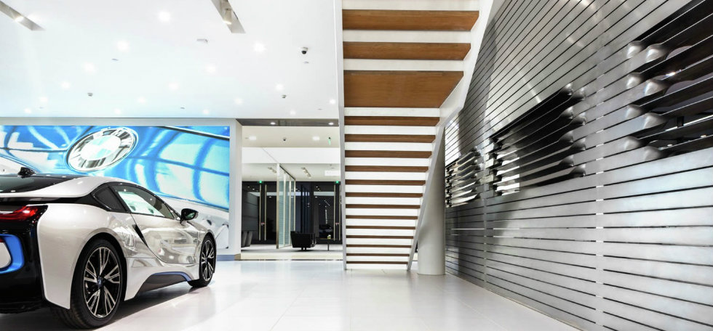
Figure 15: BMW Store, China
(Source: Brabbu, 2025)
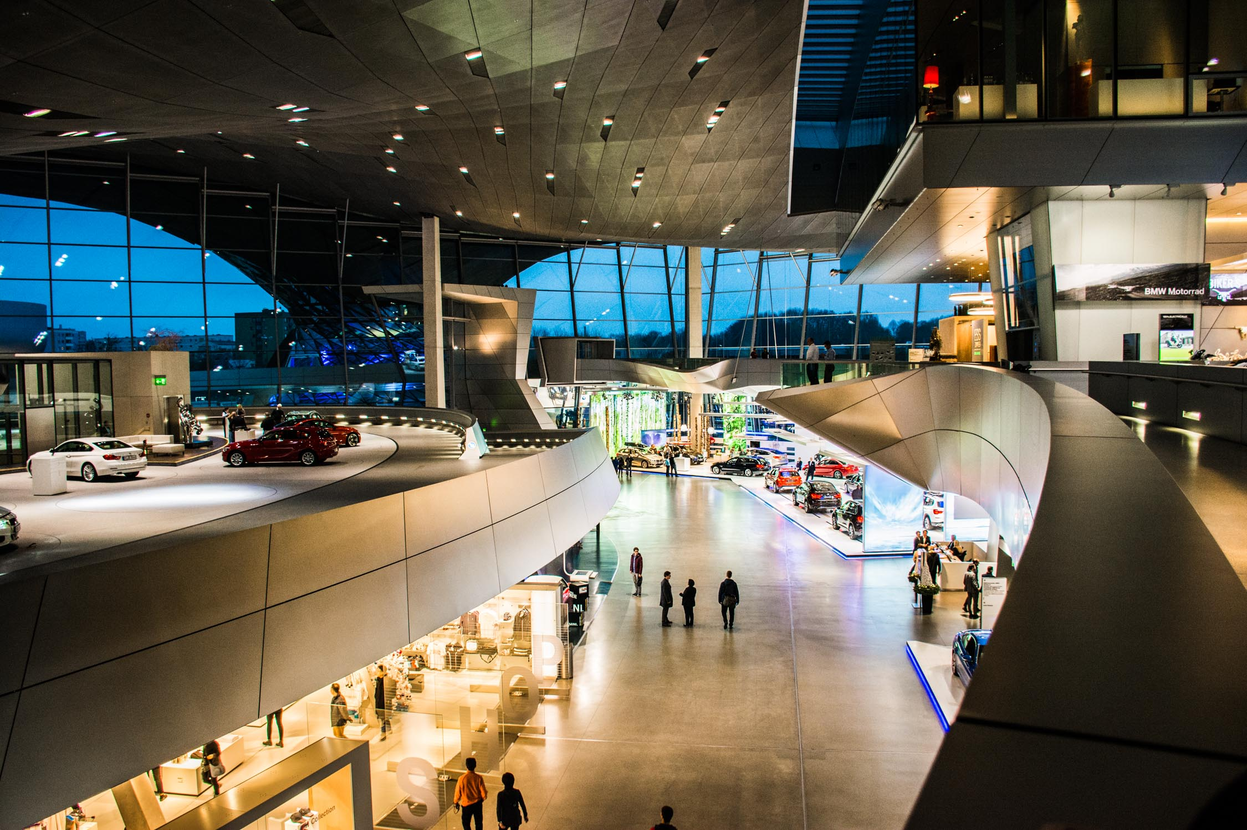
Figure 16: BMW Store, Germany
(Source: NO Destination, 2025)

