Marine Litter: problems and recommendations

Adam Davies (P145643)
Tutor – Lara Hopkins
Module code – M7X01257

Contents

The Route Plastic Takes ……………………………………………………………….1

The Ocean Gyres………………………………………………………………………… 2-3

The Different Plastics That Are In The Oceans …………………………….3-5

Solutions To Marine Plastic………………………………………………………… 5-7

Summary ……………………………………………………………………………………..8

References …………………………………………………………………………………9-10

Marine litter: problems and recommendations

With increasing awareness of environmental issues, one aspect that is growing in importance is the issue of marine litter in oceans, waterways and on the world coasts.
Marine litter is defined as:

‘Any persistent, manufactured or processed solid material discarded, disposed or abandoned in the marine and coastal environment,’ (UNEP, n.d.)

Studies find that the majority of this litter that is entering the oceans is in fact different forms of plastic. This can be viewed in a positive and negative way; on the positive side, it is easy to reduce the amount of single use plastic society uses on a regular bases and reduce the amount that is thrown away. However, on the negative side, we as a global society are highly reliant on plastics and this is projected to increase dramatically.
With this being said, Andrady (2015) states that the predominance of plastics in the oceans isn’t necessarily due to more plastics being littered compared to other components of marine litter, but due to the ‘exceptional durability or persistence of plastics in the environment’.

As is widely accepted, most litter does not originate in the ocean, this report will highlight the different ways in which plastics make their way into the ocean. It is also believed that different plastics have different impacts, some more toxic than other but others more problematic, therefore this will be outlined and case studies will be used in order to show some of the various impacts on marine life, the natural environment and humans.
Understanding and accepting the causes and impacts are the first step to combating the issue of marine litter, the second step is to build knowledge of the various different ways to reduce and even cut out plastic from day to day life. Therefore the second part of this report will focus on the solutions at public/local, Business/Corporate and governmental level.

The route plastic takes

Litter, in general, can be linked to over-production, over-consumption and inefficient waste management programmes throughout the world. The different ways in which litter can enter into the world’s oceans are;

Land based – It is believe that around 49% of plastic in the ocean derives from land based sources. These sources include public littering, poor waste management and industrial processes; all this waste accumulate in storm drains and other water ways which all end up in the worlds oceans.

Ocean Based – this source concerns plastics that enter the ocean from shipping or fishing boats. They may enter accidentally or deliberate, through falling over board or being thrown overboard. (Francisco, 2017)
The Ocean Gyres

Annually, over 6 million tonnes of marine litter is dispersed into the ocean, with 8 million pieces of plastic entering daily. This litter is not isolated to certain areas as it has been documented that plastic has been found from Artic Ice (Doward, 2017) to Henderson Island, in the South Pacific (Hunt, 2017)

Case Study – Henderson Island

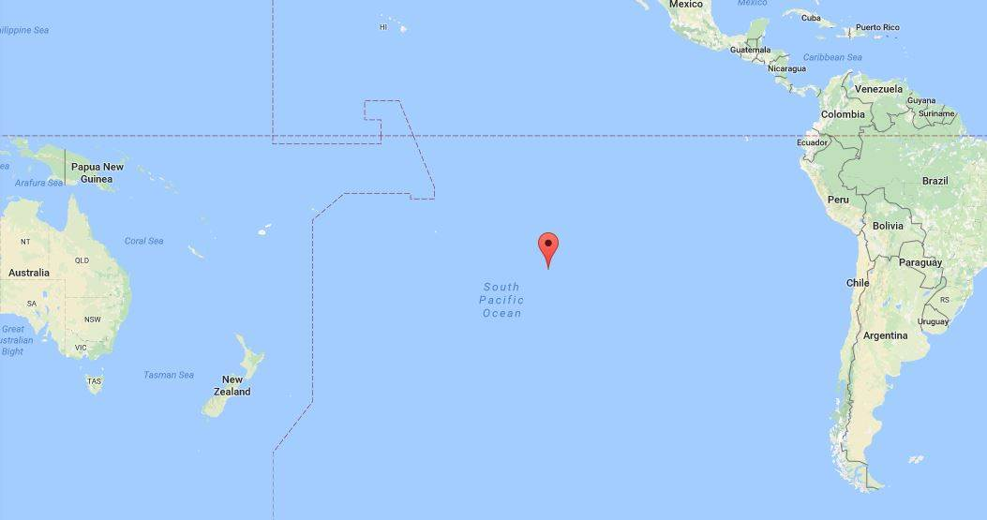
Image from - (Google.co.uk, 2018)

Henderson Island is an island in the South Pacific Ocean in between New Zealand and the West coast of South America. It is documented that Henderson Island has the highest density of waste in the world, this is surprising as it is uninhabited and many miles from any major civilisation.
A report for National Geographic by Parker (2015) showed the true extent of the impact marine litter is having on Henderson Island. The article states that 3,500 pieces of plastic end up on the shores of Henderson Island per day and 18 tons of plastic had already built up over the years, this excludes ‘Items buried 10 cm below the surface and particles less than 2 mm and debris along cliff areas and rocky coastlines’ that were unable to be sampled, therefore the true figure is significantly more. Although 18 tons of plastic does not seem a vast amount, when compared to the size of the island, a mere 3,700 hectares (UNESCO, n.d) or 14 square miles, the problem is put into context.

The reason for the accumulation of plastic on Henderson Island, and in the Artic, are Ocean Gyres.
An Ocean Gyre ‘is a large system of circular ocean currents formed by global wind patterns and forces created by Earth’s rotation.’ (National Geographic Society, n.d.).There are different types of gyre; Subtropical Gyres, Subpolar gyres and Tropical Gyres, but the five most notable are:

- The North Pacific Gyre
- The South Pacific Gyre
- The Indian Ocean Gyre
- The North Atlantic Gyre
- The South Atlantic Gyre

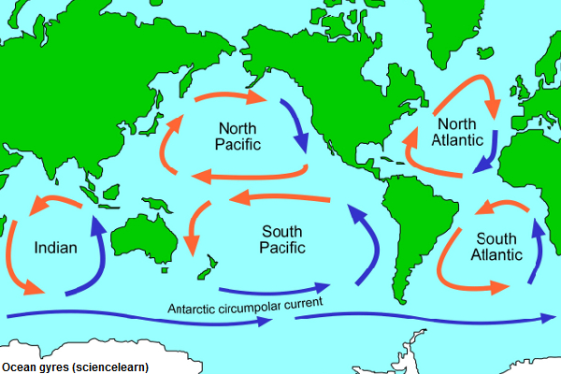
Image from - (EcoGo.org, n.d.)

These ocean gyres act as a transporting device for all the plastic that enters the oceans from land and sea. In the case of Henderson Island, it lies within the path of the South Pacific Gyre which explains why vast amounts of plastic is being deposited on its beaches.

Although the gyres are known for their currents and the movement of plastic, a key characteristic of the gyres is that their centres tends to be calm and stable, this cases plastic to remain stationary within the currents. Due to the fact that plastic is mostly non-biodegradable, the ocean gyres have acquired the name of Ocean Garbage Patches, with the Great Pacific Garbage Patch being the most famous.

The Different Plastics That Are In The Oceans

When the topic of plastics in the ocean arises, most people will instantly think of plastic bottles, plastic bags, straws etc. Although these larger plastics are a major problem, studies show that it is in fact the smaller plastics, micro-plastic particles that are more harmful to animal and human health.

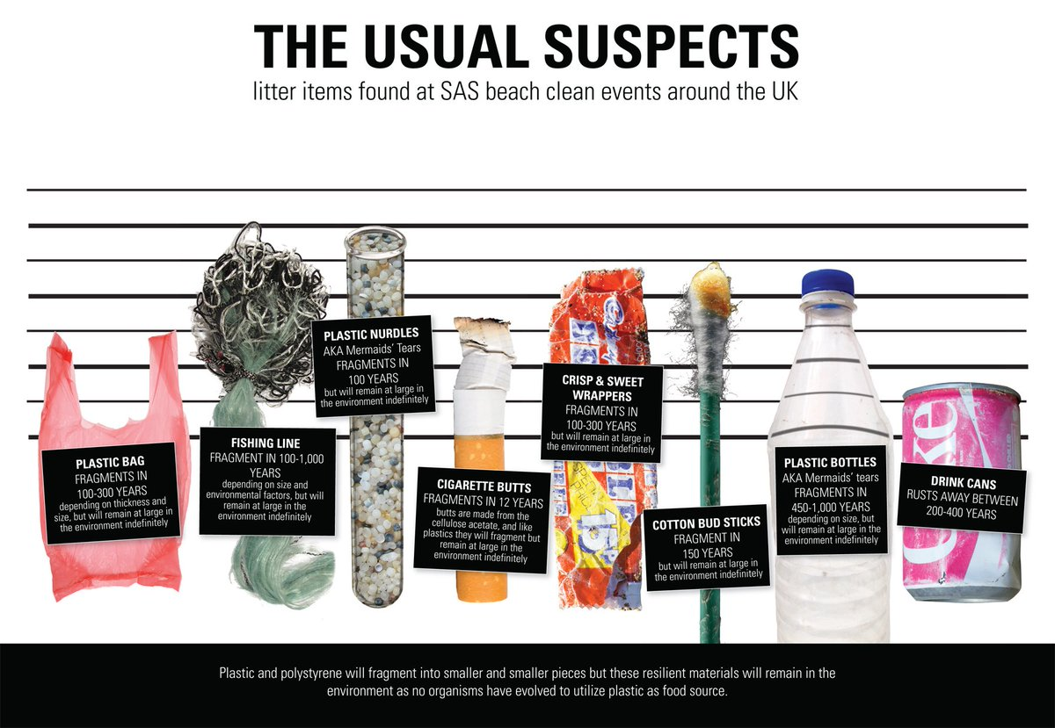
Image from - (SAS, 2017)

What has been noticed is the fact that the bigger plastics cause animals to get stuck in them, for example; animals getting stuck in fishing nets or ingesting and choking on bits of debris.
However, the major issue is the breakdown of these bigger plastics into micro plastics. These microplastics are ingested by smaller animals, notably, fish and other small mammals.
As soon as the plastic, which contains different toxins, is ingested; it enters the food chain. The main sources of toxicity are from lead, cadmium, and mercury; along with Diethyhexyl phthalate (DEHP). These toxins have links to many different problems concerning human health; links to cancer, birth defects, immune system problems, and childhood developmental issues. (Andrews, 2012)

It is also understood that plastic debris attracts and concentrates other toxins from the ocean such as Dichlorodiphenyldichlorothylene (DDE) and polychlorinated biphenyls (PCB’s) which enter the food chain. All of these toxins will build up to higher concentrations as they move up the food chain.

With the impacts on life having been discussed, Surfers against Sewage (SAS, 2012) raise the topic of financial loss due to marine litter. They believe that money is lost through beach cleans and loss of tourism from unclean beaches; on the other hand, they believe that the environment is being negatively impacted due to mechanical beach cleaning. Therefore if the problem was tackled before the plastic was able to reach the beaches, it would have a positive impact on the environment and the economy. UNEP (2014) believes that at least $8 billion a year is being lost a year from activities such as tourism and shipping due to marine litter

Solutions To Marine Plastic

The section above has discussed the important points in regards to implications of plastic dumping and how the plastic enters the world’s seas and oceans. This next section will discuss the different ways in which plastic use can be minimised but also be used in a smarter way. The section will be split into three sub categories; Personal, industrial and governmental. We as a global population are in the best position we’ve ever been in regards to reducing marine litter, most notably plastics. (Rochman, Cook and Koelmans, 2016) state that ’Current knowledge on the main causes of marine litter and about possible solutions offers a solid basis for effective actions’

Personal

This sub category is in relation to the actions and behaviours that we as a population can adopt to combat the growing problem of marine litter.
The first way in which we can make a positive impact is through; Refuse, Reduce, Reuse, Repurpose and Recycle
We as a population need to be more conscious about the waste we create, for example, using bags for life as opposed to normal plastic bags or using reusable water bottles in place of plastic bottles, stopping and thinking of the effects our lifestyle is having on the environment is the first step in reducing the impacts we are having.

Refuse- refers to saying no to things like single use plastics, plastic bags, and harmful wastes to name a few
Reduce- if you’re unable to refuse certain plastics, try your hardest to reduce the amount you are using them
Reuse – Instead of using single use plastics, use reusable ones, e.g. bags of life, reusable plastic bottles/ coffee cups
Repurpose – Instead of throwing waste away, are you able to use it for something completely different to the original purpose
Recycle- If all else fails, the items that can be, should be recycled. By recycling waste, it reduces the chances of waste being blown from landfill into waterways.

This can be achieved through educational programmes that aim to provide a basis for environmental competency. In Britain, schools have the option to take part in forest schools due to the fact that there tends to be an area of green space in the near vicinity, however, not every village, town or city is near an ocean therefore there may be a disconnection from the problems of marine litter due to the fact they do not see the problems. Educational programme should aim to educate children on the avenues of which plastic enters the ocean, the harms plastic has and the ways in which the children can reduce their impact.

As discussed, marine litter derives from different sources, one being from coastal areas; one way of combatting this is organising regular beach cleans in order to reduce the amounts of waste on the beaches. Not only will this improve the health of the environment but it can also increase the amount of tourism to coastal areas. A study by Leggett et al (2014) shows that litter had a massive impact on the beach tourism on selected beaches in California. It showed that six beaches benefitted from an additional €40 million with a 75% reduction in marine litter.

Industrial

When looking at corporations and industry, they play a major role in the reduction of plastics in the water systems. In a report by Browne (2015) draws upon his findings to produce some ways in which companies can reduce their micro plastic waste.

- Establishing and controlling inventories that detail the use and emissions of micro plastics in products.

- Modifying the process of production and redesigning products so that they contain less hazardous substances.
- Novel equipment and technology to reduce pathways of microplastic. Filters for washing machines are a promising prospect for reducing emissions of fibres to sewage

Industry is a big problem due to the fact that industries and businesses not only contribute to the build-up of plastics but they actually make the materials that we as a society waste. If less packaging and plastic was used, there would be less plastic for the populations to waste.

Case Study – The Ocean Clean Up

The Ocean Clean up is an organisation that is developing technologies in order to reduce the amount of plastics in the ocean. They believe that with their technology, they will be able to reduce the plastic in the great pacific garbage patch by 50% in 5 years. (The Ocean Cleanup, n.d. A)
The main concept in testing is a large un-fixed, durable, U-shaped pipe that holds a net below. The idea is that plastics as small as 1cm will be caught within the net and will stay until shipped back to shore.
(The Ocean Cleanup, n.d. B)
While the main positive of reducing plastic in the Great Pacific Garbage Patch by half in 5 years is something that would be a massive achievement in the fight against marine litter, some sceptics have questioned the project.

Governmental

World governments have vast amounts of power in regards to plastic waste when it comes to Corporate/Industrial and publicbehaviours. In Britain, over the years, we have seen different laws being passed to combat single use plastics;

- 5p plastic bags (Gov.uk, 2015), 25p Latte Levy (Cowburn, 2018), and a ban on plastic cotton buds (Brooks, 2018)

- Ban on Micro beads in cosmetic products - (Gov.uk, 2018)

However, more can be done; Surfers against Sewage (SAS, 2017) highlights different ways in which governments can step in to encourage attitude change but also create policies that help change behaviour:

- Surfers Against Sewage believe that the British Government should ‘support more research into the toxicity of marine plastics and reclassify them as a hazardous waste
- They also call for legislation that forces shipping companies to mitigate any loss of marine litter by recovering the same amount
- Another suggestion is container-deposit. Glass/plastic bottles and other containers are found all over the world in places they shouldn’t be. SAS suggest a small deposit to be paid on such items in order for them to be returned and reused, repurposed or recycled.

A study by (Schmidt et al., 2017) states that, globally, 39000 tons of plastic debris enters the ocean from rivers across the world. Interestingly, 75% of the total debris comes from rivers predominantly in Asia. The report also suggests that the rivers surround countries with ‘a large population and high economic growth’ but more importantly, ‘an insufficient waste infrastructure’
Interestingly, Jambeck et al (2015) draw upon studies that show ‘that if waste management does not improve profoundly in the coming years, by 2025 the amount of plastic waste entering the ocean from land is predicted to increase by an order of magnitude’

Summary

In conclusion, the evidence regarding not only the shear volume of plastics that are entering the worlds oceans, but the impacts it has on marine and human health, the world economy and social factors is conclusive. With plastics being the cause of deaths of animal species, and links to human health and the economy it is apparent that more needs to be done in order to reduce the increasing problem. This can be done on three levels, Public/Local; Business/Corporate; and Governmental.

- Public/Locally we need to change attitudes and behaviours towards a plastic-free lifestyle, which can be achieved through education; and by respecting our local environment through beach cleans and encouragement to take litter home or bin it.
- Business/Corporate – Businesses need to update their policies on packaging and their supply chain in order to minimise the amount of plastic that is being used during manufacturing but also how much is being discarded by the public. Less packaging means less thrown away.

- Governmental - Governments hold the most power. Britain has introduced the 5p plastic bag charge, ban on micro beads and the potential 25p latte levy; these changes on a policy level can have massive positive effects on the amount of plastic that is entering the world’s oceans. If populations see the governments taking a proactive stance towards, not only plastic waste but any environmental issue, more will be done on a foundation level.

At the 2015 G7 summit the protection of the Marine Environment was high on the agenda too and it was acknowledged that marine litter, in particular plastic litter, poses a global threat (Löhr et al., 2017). The important word here is acknowledge, with the increasing amount of evidence around marine litter and the problems it is causing, the time for acknowledging is long gone and more actually needs to be done in order to reduce, not only plastics, but all litter that is entering the ocean.

References

Andrews, G. (2012). Plastics in the Ocean Affecting Human Health. [online] Case Studies. Available at: https://serc.carleton.edu/NAGTWorkshops/health/case_studies/plastics.html [Accessed 22 Jan. 2018].

Andrady A.L. (2015) Persistence of Plastic Litter in the Oceans. In: Bergmann M., Gutow L., Klages M. (eds) Marine Anthropogenic Litter. Springer, Cham

Brooks, L. (2018). Scotland to become first UK country to ban plastic cotton buds. [online] The Guardian. Available at: https://www.theguardian.com/uk-news/2018/jan/11/scotland-to-become-first-uk-ban-plastic-cotton-buds [Accessed 23 Jan. 2018].

Cowburn, A. (2018). Government told to introduce tax on disposable coffee cups. [online] The Independent. Available at: http://www.independent.co.uk/environment/latte-levy-disposable-coffee-cup-tax-25p-cut-waste-environment-mps-committee-landfill-incinerate-a8141856.html [Accessed 20 Jan. 2018].

Doward, J. (2017). How did that get there? Plastic chunks on Arctic ice show how far pollution has spread. [online] The Guardian. Available at: https://www.theguardian.com/world/2017/sep/24/arctic-plastic-pollution-polystyrene-wildlife-threat [Accessed 20 Jan. 2018].

EcoGo.org. (n.d.). Plastic ocean gyres - EcoGo.org. [online] Available at: http://www.ecogo.org/dispatches/plastic-ocean-gyres/ [Accessed 22 Jan. 2018].

Francisco, J. (2017). How Plastic Ends Up In The Ocean. [online] Coastal Angels. Available at: http://coastalangels.org/blog/2017/1/11/how-plastic-ends-up-in-the-ocean [Accessed 12 Jan. 2018].

Gov.uk. (2015). Carrier bags: why there's a charge - GOV.UK. [online] Available at: https://www.gov.uk/government/publications/single-use-plastic-carrier-bags-why-were-introducing-the-charge/carrier-bags-why-theres-a-5p-charge [Accessed 20 Jan. 2018].

Gov.uk. (2018). World-leading microbeads ban takes effect - GOV.UK. [online] Available at: https://www.gov.uk/government/news/world-leading-microbeads-ban-takes-effect [Accessed 24 Jan. 2018].

Google.co.uk. (2018) [online] Available at: https://www.google.co.uk/maps/place/Henderson+Island/@-15.249779,-148.6892443,3.38z/data=!4m5!3m4!1s0x9e43f2cfaa5822c5:0x58ba891a3ed4565f!8m2!3d-24.3743769!4d-128.3271112 [Accessed 25 Jan. 2018].

Hunt, E. (2017). 38 million pieces of plastic waste found on uninhabited South Pacific island. [online] The Guardian. Available at: https://www.theguardian.com/environment/2017/may/15/38-million-pieces-of-plastic-waste-found-on-uninhabited-south-pacific-island [Accessed 17 Jan. 2018].

Jambeck, J. R., R. Geyer, C. Wilcox, T. R. Siegler, M. Perryman, A. Andrady, R. Narayan, and K. L. Law (2015), Plastic waste inputs from land into the ocean, Science, 347(6223), 768–771, doi:10.1126/science.1260352.

Löhr, A., Savelli, H., Beunen, R., Kalz, M., Ragas, A. and Van Belleghem, F. (2017). Solutions for global marine litter pollution. Current Opinion in Environmental Sustainability, 28, pp.90-99.

National Geographic Society (n.d.). Ocean gyre. [online] National Geographic Society. Available at: https://www.nationalgeographic.org/encyclopedia/ocean-gyre/ [Accessed 21 Jan. 2018].

Parker, L. (2017). How an Uninhabited Island Got the World’s Highest Density of Trash. [online] News.nationalgeographic.com. Available at: https://news.nationalgeographic.com/2017/05/henderson-island-pitcairn-trash-plastic-pollution/ [Accessed 25 Jan. 2018].

UNESCO (2018). Henderson Island. [online] Whc.unesco.org. Available at: http://whc.unesco.org/en/list/487 [Accessed 19 Jan. 2018].

UNEP (n.d.). Marine Litter | Regional Seas. [online] Available at: http://web.unep.org/regionalseas/what-we-do/marine-litter [Accessed 22 Jan. 2018].
Rochman, C., Cook, A. and Koelmans, A. (2016). Plastic debris and policy: Using current scientific understanding to invoke positive change. Environmental Toxicology and Chemistry, 35(7), pp.1617-1626.

SAS (2017). SurfersAgainstSewage on Twitter. [online] Twitter. Available at: https://twitter.com/sascampaigns/status/819272672634867712 [Accessed 20 Jan. 2018].

Schmidt, C., Krauth, T., Klöckner, P., Römer, M., Stier, B., Reemtsma, T. and Wagner, S. (2017). Estimation of global plastic loads delivered by rivers into the sea. [online] Meetingorganizer.copernicus.org. Available at: http://meetingorganizer.copernicus.org/EGU2017/EGU2017-12171.pdf [Accessed 25 Jan. 2018].
The Ocean Cleanup (n.d. A). About. [online] The Ocean Cleanup. Available at: https://www.theoceancleanup.com/about/ [Accessed 21 Jan. 2018].

The Ocean Cleanup (n.d. B). The Ocean Cleanup - Technology. [online] The Ocean Cleanup. Available at: https://www.theoceancleanup.com/technology/ [Accessed 25 Jan. 2018].

