Application Development (Games)
  - Lecture 5 Lab Tutorial Exercise

Perky Penguin Game Part IV

Objectives
The aim of this lab exercise is to create a simple Heads-up Display (HUD) for the Perky Penguin game. Hopefully, yours will be a lot better than mine.
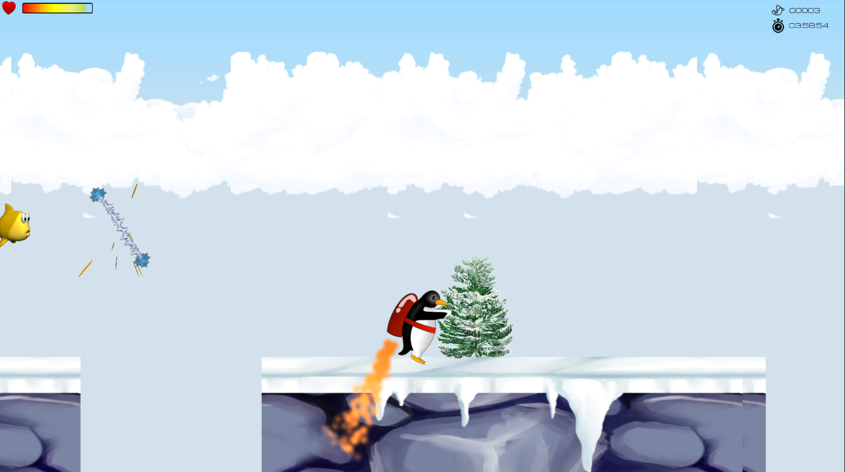

Getting Started
- Download the UI assets I have provided on Moodle and import into your project.
- You can either:
  - Use the UI assets I have provided.
  - OR go to Google and search for images representing the following. Note: the images should be small images like icon images.
    - The player character's health
    - The number of fish Perky has eaten.
    - A timer
- Save your downloaded images to your graphics folder.

The Canvas Game Object
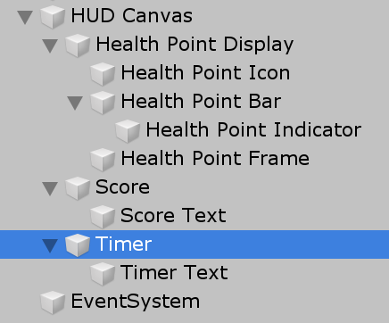
- Right click in the hierarchy window and select UI Canvas. This should add a canvas UI game object to the scene.
- Rename the canvas game object to HUD Canvas or whatever you like. The default settings should be fine.
- Note:
  - All UI elements you are going to add will be children of the HUD canvas game object (see image above).
  - The order in which you add elements is important – elements towards the bottom of the hierarchy appear on top.

The Health Point Display
The health point display should be similar to the following when you are done (albeit different images).
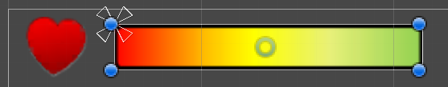
- Add an empty game object – make it a child of the HUD Canvas
- Rename it to Health Point Display
Note: the following game objects will be children of the Health Point Display game object
- Position the object as follows:
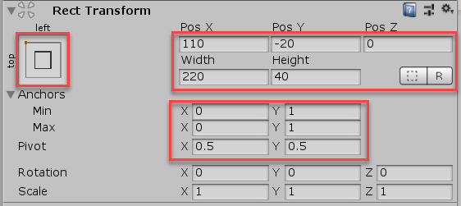

Health Point Icon
- Add a new GameObject UI Image – make it a child of the Health Point Display
  - Rename to Health Point Icon
  - Under Image, set the Source image to the icon image representing your health
  - Under Rect Transform (see previous image), set
    - Anchor to Top Left
    - Pos X: 25 Pos Y: -20
    - Width: 32 Height: 32
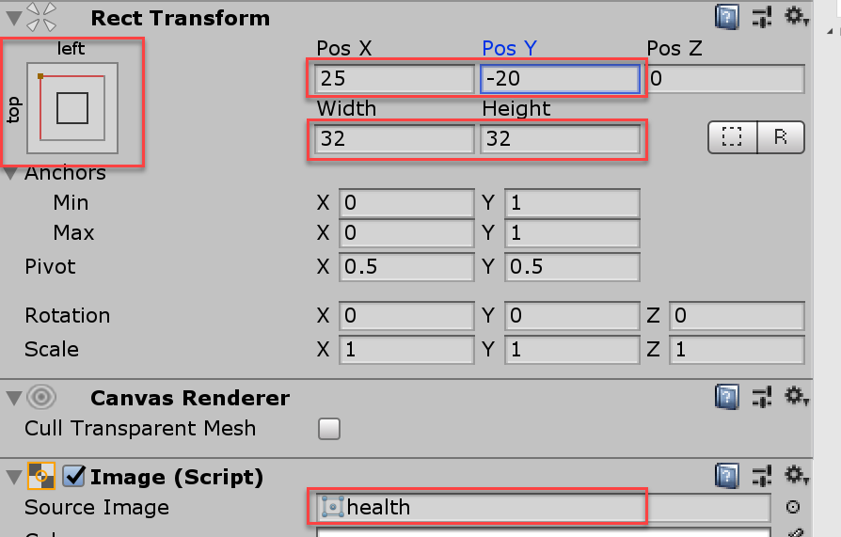
- Make any adjustments to the size and position as needed (remember position X, Y refers to the centre point).

Health Point Bar
The health point bar will be two images superimposed (laid) on top of each other to give the appearance of decreasing health as the player is hit. The way you do this in Unity is to use a Mask.
- Add another UI Image game object – make it a child of the Health Point Display
  - Rename it to Health Point Bar
  - No image for this game object to create the illusion of decreasing health
  - Under Rect Transform (see previous image), set
    - Anchor to Top Left
    - Pos X: 55 Pos Y: -32
    - Width: 160 Height: 24
    - Set the Pivot to 0, 0 as we are not going to draw from the centre point.
  - To create the masking effect, add a mask component using Add Component UI Mask. This will automatically add a Mask script to the game object.
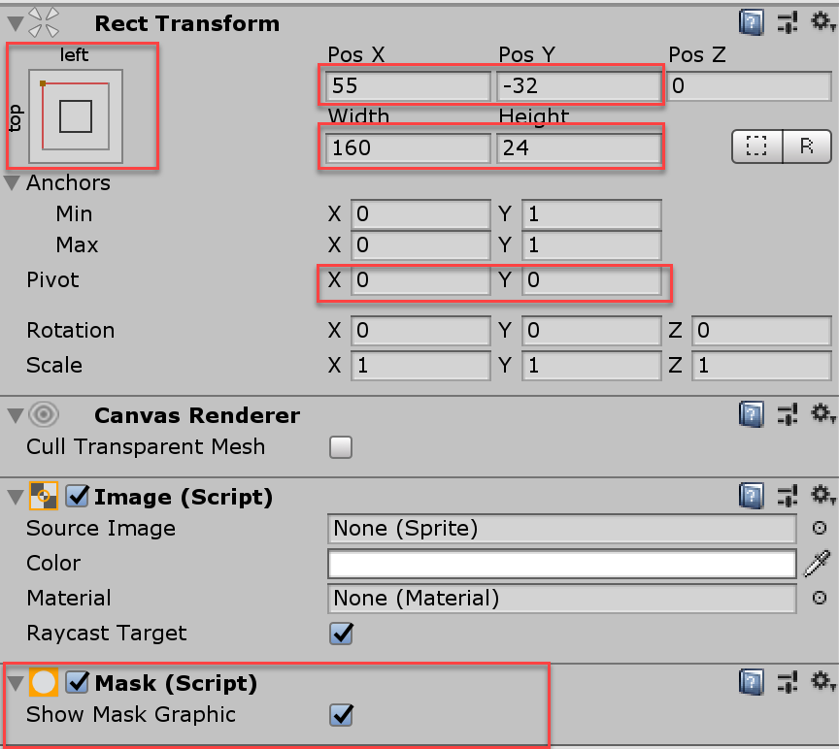
- Make any adjustments to the size and position as needed (remember this image is not drawn from the centre point)

Health Point Indicator
Note: This game object will be a child of the Health Point Bar game object
- Add another UI Image game object – make it a child of the Health Point Bar so it appears underneath the mask.
  - Rename it to Health Point Indicator
  - Under Image, set the image to the HealthPointBar you downloaded from Moodle.
  - Under Rect Transform (see previous image), set
    - Anchor to Top Left
    - Click the Set Native Size button. The width and height should be: Width: 160 Height: 24
    - Pos X: 80 Pos Y: -12 (it’s drawn from the centre point)

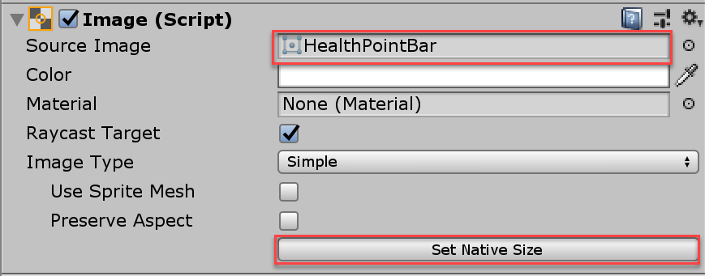
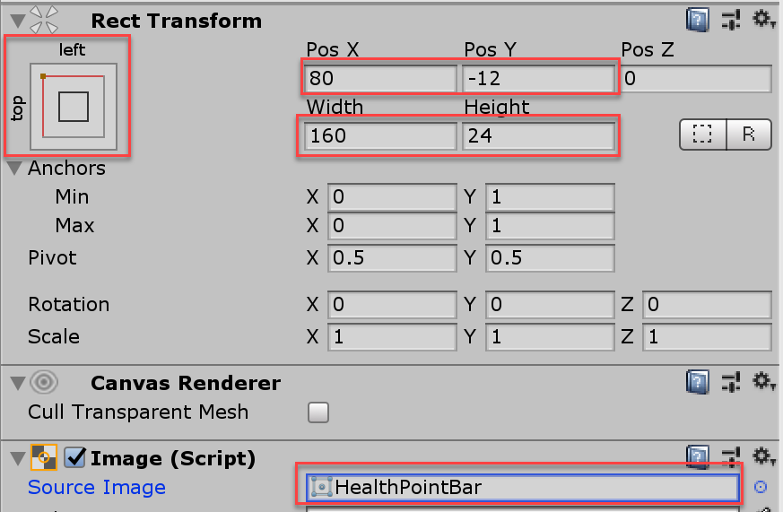

- Make any adjustments to the size and position as needed (remember position X, Y refers to the centre point).

Health Point Frame
This simply adds a black frame around the Health Point Bar
- Add another UI Image game object – make it a child of the Health Point Display.
  - Rename it to Health Point Frame
  - Under Image, set the image to the HealthPointFrame you downloaded from Moodle.
  - Under Rect Transform (see previous image), set
    - Anchor to Top Left
    - Click the Set Native Size button. The width and height should be: Width: 160 Height: 24
    - Pos X: 135 Pos Y: -20 (it’s drawn from the centre point)
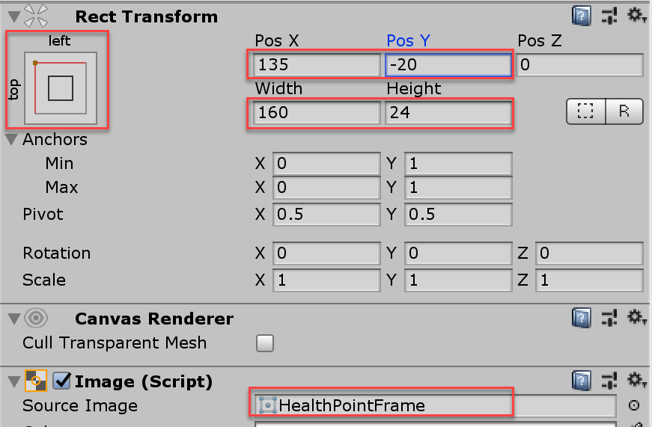

The Score
The score will be made up of an image and text
- Add another UI Image game object – make it a child of the HUD Canvas.
  - Rename it to Score
  - Under Image, set the image to your score image representing the number of fish Perky has eaten.
  - Under Rect Transform (see previous image), set
    - Anchor to Top Right
    - Click the Set Native Size button.
    - Pos X: -150 Pos Y: -25
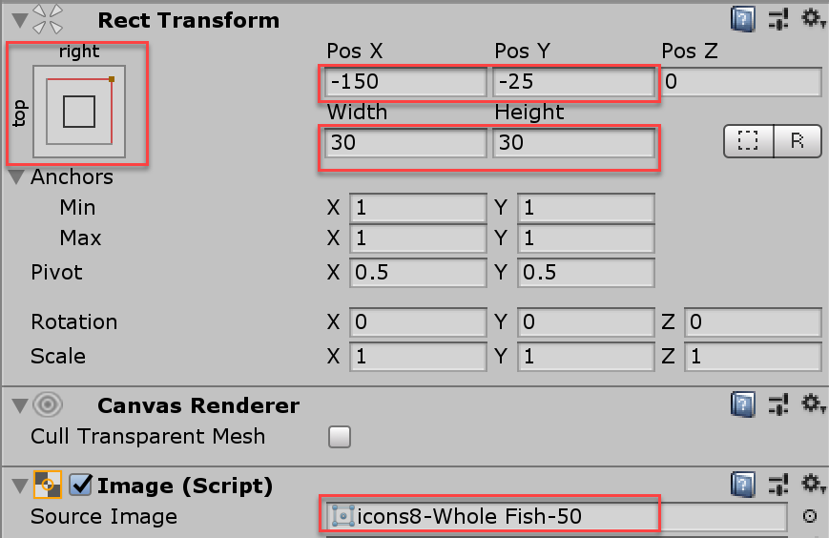
- Make any adjustments to the size and position as needed.

Score Text
- Now add a UI Text game object – make it a child of the Score game object.
  - Under Rect Transform (see previous image), set
    - Anchor to Top Left
    - Click the Set Native Size button.
    - Pos X: 90 Pos Y: -15
  - Make any adjustments to the size and position as needed.
  - Under the Text script component
    - Set the default text to 00000
    - Set the font to the Federation font you downloaded from Moodle
    - Set the font-size to 16 (you can adjust this if you wish)
    - Set the colour to a colour of your choice.
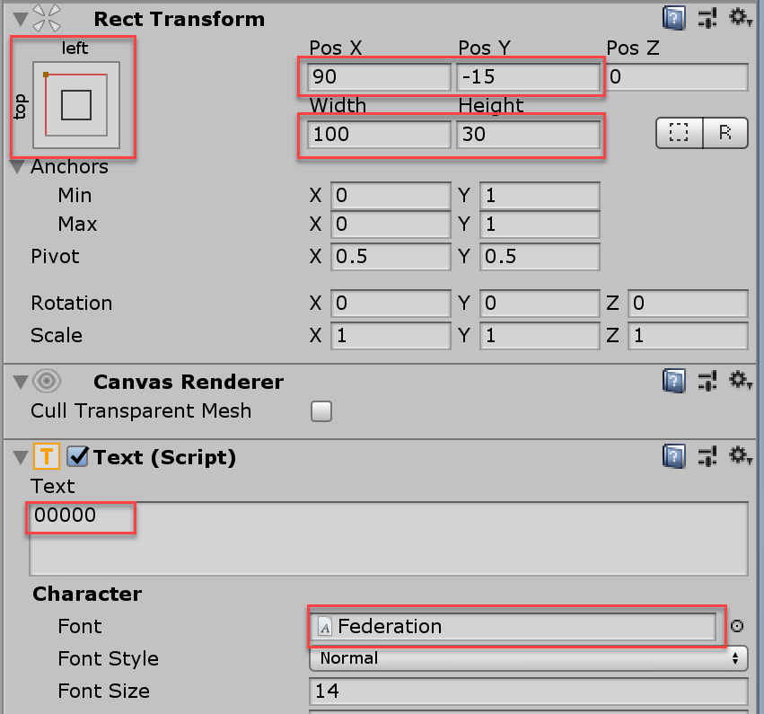

Timer
This is a challenge exercise for you to complete.

The Menu
You also need to create a menu that displays when game play ends or when the player presses a particular key.
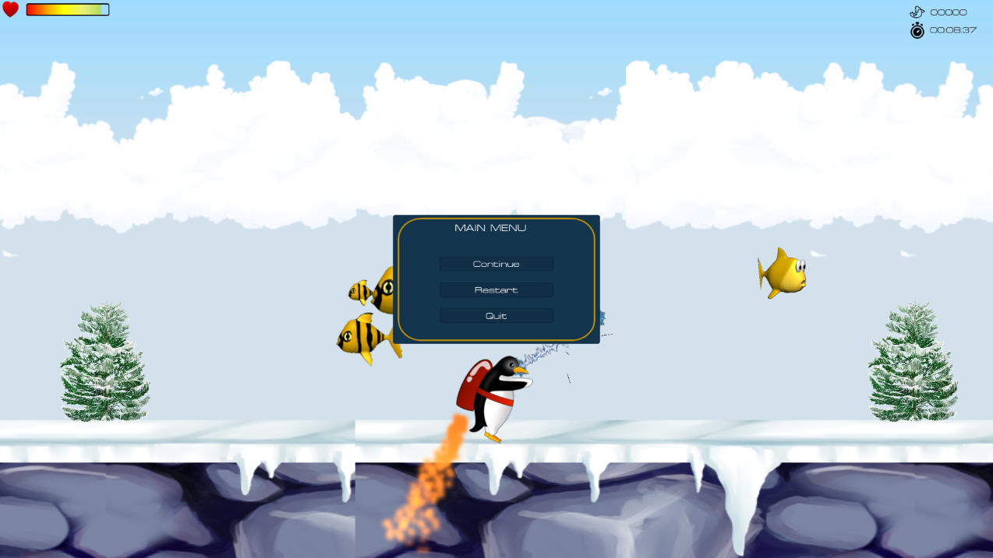
- Add a Panel object to the HUD Canvas
  - Rename it to Main Menu
  - Set the Anchor to middle centre.
  - Set the width to 400 and height to 250 (you can change this if you wish).
- Using the same principle, create the following child UI game objects for the main menu (see image below).
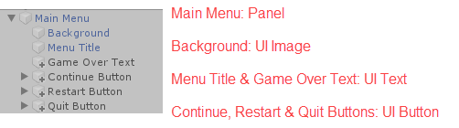
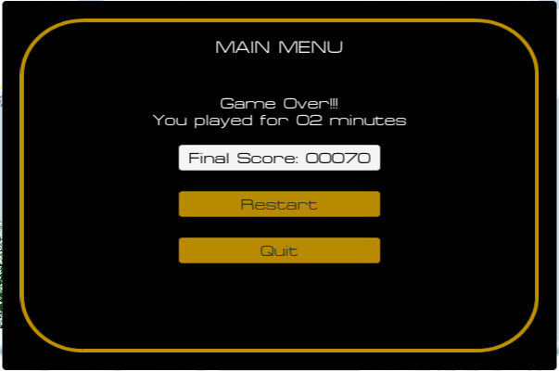
- Set the menu background colour to a colour of your choice (use better colours than mine).
- For the buttons, you can set the:
  - Normal Colour: normal display colour
  - Highlighted Colour: for either button or hover effect (I can’t quite remember).
- When you are happy with your main menu, go to the Inspector window and uncheck the Set Active box (see below) to make it invisible by default. You will make it visible using code when the user presses a key.
  - Make Main Menu invisible (will be displayed when user presses “M” key).
  - Also make the Game Over Text invisible (will only display when game is over).
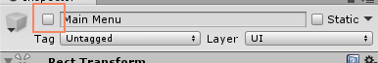
- The hierarchy of the HUD Canvas should be similar to the following yours may be slightly different depending on your design.
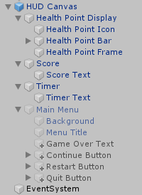

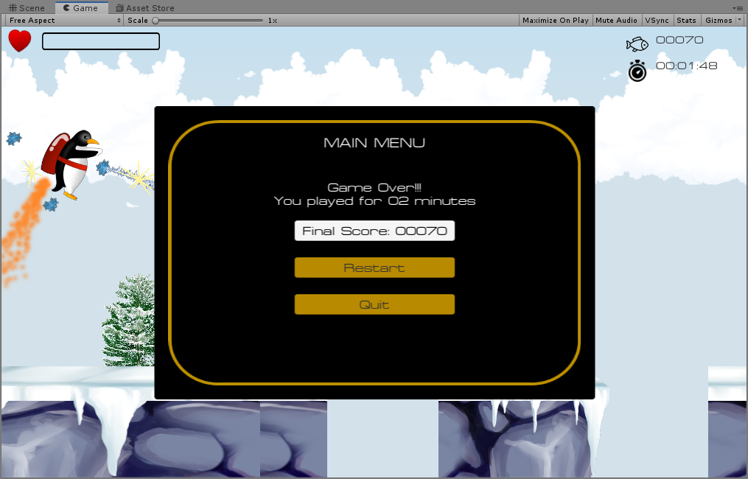
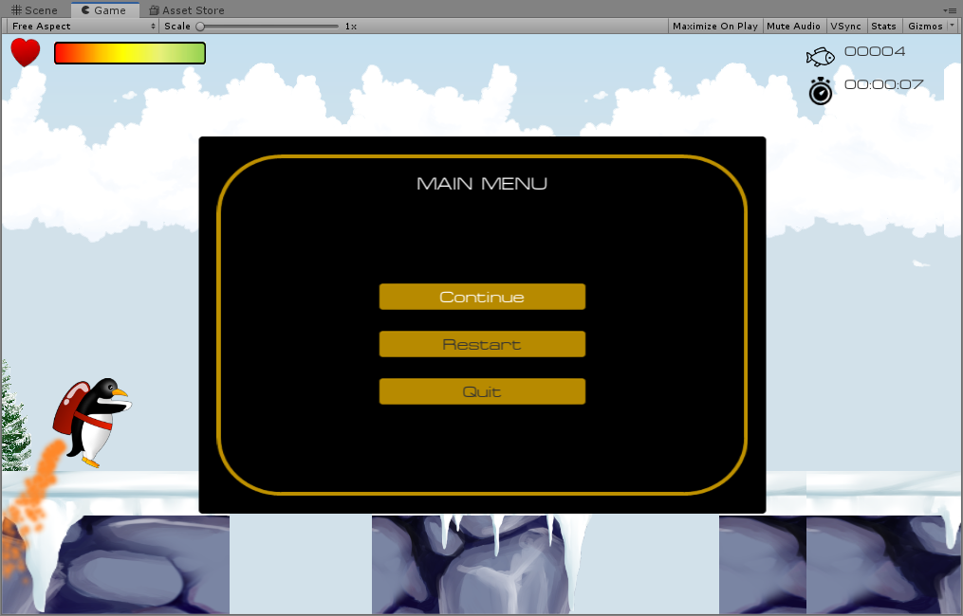

Adapted from: Mastering Android Game Development with Unity, Packt (2017), By Siddharth Shekar, Wajahat Karim.

