Was Death Celebrated or Feared in the Middle Ages

The middle ages spanned from approximately the year 500 to the year 1500, however, these dates vary within historical scholarship. The period known as the middle ages is generally understood to have happened after the fall of the Western Roman Empire and before the Renaissance. The medieval world occupied a wide range of geographical regions across Europe, and as such, was a very diverse, multi-cultural world. The medieval period was also a highly religious time, with the church controlling many aspects of people’s lives, including their beliefs around death. Many people looked towards Heaven as a reward for a life well lived, although, contemporary sources also show that fear of Purgatory and Hell were common concerns. A pure soul that had been baptised would be assured a place in Heaven. The soul of a person who had committed a mortal sin, such as murder, would go straight to Hell. Any other person who had not confessed or made amends for all their sins would have; ‘a fear of Purgatory and an awareness of the pains that awaited there’. The souls would pay for their unconfessed sins in Purgatory before being allowed entry into Heaven.
The church promoted a fear of Hell and Purgatory and profited from the contributions of parishioners who paid for prayers, pardons and blessings to speed a loved one’s soul out of Purgatory and into Heaven. Fear of death was a common concern for medieval people who often lived difficult lives under the authority of the church, whose religious philosophy promoted a view that that the fires of Hell and Purgatory were a certain fate for those who did not live a pure and Christian life.
This essay will discuss how death was feared in the middle ages through examining contemporary sources that illuminate the religious view point of the time. Sources include instances where death may have been celebrated. This will also be examined through the view of scholars such as; C.Daniel Given-Wilson, J.Mattern, J.S.W. Helt, N.Caciloa, P.Areis, P.Mitchell, T,Barr W. Langer.
Death was a common experience for most medieval people who would very likely encounter death during their life time. Life expectancy within the middle ages was awfully low, with the majority having a life expectancy of about twenty-five years. There were many factors that contributed towards this low life expectancy, including living conditions, diseases, war and famine. Death played a big part in medieval times and is something that was discussed and dealt with much more openly than it is nowadays. Many people in the middle ages feared a sudden death, however, a death which had been prepared for may have offered a relief from the trials of everyday life.
People in the middle ages considered that a death could be both good and bad. It was believed that a good death happened when you were forewarned and, therefore, prepared. It has been suggested that people were able to recognise when death was imminent and were able to prepare by getting their affairs in order, repenting their sins and having their family around them. This was considered a good death and was not feared by people of the middle ages, as they accepted it as part of life. In contrast to this, a bad death was a sudden death as a result of plague or violence. This type of death did not allow them the opportunity to prepare and repent their sins. A bad death was feared within the middle ages, as people believed that their souls would be sent to Purgatory, even though it was a process to enter Heaven, it was still to be a daunting experience for one’s soul. Given that there were both good and bad deaths, it is clear that death could well be considered an event to celebrate if it had been done well and the journey to heaven assured. A bad death, however, was clearly something to be feared as the consequences were terrible and, in many cases, sudden deaths were random, unpredictable events and, therefore, not something that could be prepared for.
In the middle ages it was believed that the diseases they suffered, such as dysentery, typhoid, leprosy and the black death, were sent as a punishment from God for their sins. The black death had a devastating effect on the people in Europe. In three years from 1348 to 1350, the black death killed at least one fourth of the population. With the black death bringing such a high mortality rate, and with the swiftness that the disease poisoned the body, around eighty percent who were infected by the plague usually died within two to three days. As a result of this, many turned towards the church, lavishing them with gifts and making vows for their future, in order to purify their sins. The church it seemed, offered them hope that their suffering in life would not continue in Heaven. The uncertainty and hardship of life was shown in contrast to the sure and certain hope of ‘faith in resurrection and eternal life’ presented in the funeral service.
Purgatory was not an eternal punishment but rather a temporary punishment on the path to Heaven, however, Purgatory in every other respect was identical to Hell and, therefore, a place of fear. Purgatory could be seen as a pilgrimage to Heaven, but due to the teaching of the church, fear was instilled into people’s view of the afterlife. From the teachings of the church, and the images which were depicted in stained glass windows, paintings and within manuscripts the church were conveying an image of Purgatory as being a place to be feared.
Images of Purgatory emphasised the terrible suffering that unconfessed sins could bring. The painting below is from The Coronation of the Virgin (1454) and depicts a scene of souls suffering the torment from the flames of Purgatory. Within this painting, it can be seen that people of all social standings are sent to Purgatory to purify their sins. It shows the devil taking the dammed to Hell, with angels comforting those whose sins have been repented.
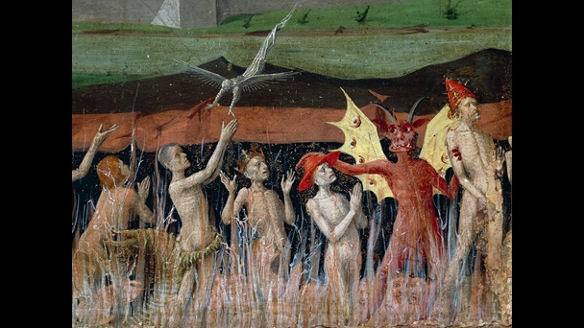
It is clear that the church used images such as these to cause fear among the people, in order to encourage them to attend church and offer donations, which would, according to the church, reduce the amount of time spent in Purgatory. Images from the middle ages depict the transition from Purgatory to Heaven or Hell as being weighed up by God, with their good deeds on one side of the scales and their bad deeds on the other. The church made people believe that, in order to accelerate this decision making process, thus reducing their suffering in Purgatory, it was necessary for loved ones of the deceased to lavish the church with more donations or prayers ‘where the sentence of the inmates could be mitigated by the prayers of those left on earth.’ Whereas, for the people who could not afford to pay for prayers or devote gifts to the church, the souls who they wished to pray for would be trapped in the suffering of Purgatory. The church held a Requiem mass for the souls forgotten in Purgatory, which was held on the second day in November every year. This again shows the Church using the teaching of Purgatory to instil fear among the people, but also shows its mercy by offering the people who cannot pay, one day to pray for their loved one’s souls. It was believed that if you brought prayers for your loved ones, their time in Purgatory would be less painful and they would not be forgotten, thus allowing the soul to reach its destination in the afterlife.
While death was not always feared in the middle ages, Hell was feared in many ways as it would condemn the soul to much pain, agony and suffering. Many people saw the body and soul as two entities, believing that their souls lived on in the afterlife. As such, they tried to ensure that they lived a good life, in fear of their souls suffering once they died. The illustration below is from the manuscript called The Book of Hours and was created in 1407:
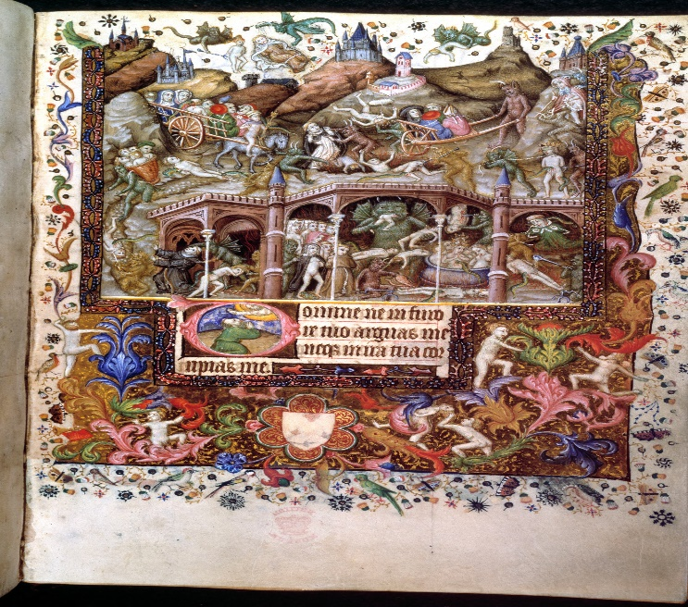
This image, along with other illustrations of Hell, strives to scare people into leading good lives by not sinning and accepting God. The image of Hell is portrayed as being full of demons and monsters torturing and devouring souls. As many people were illiterate, the church made sufficient use of artistic ways to portray how they wanted Hell to be perceived. In doing this, they ensured that people feared Hell and the consequences of leading a sinful life.
It was not just imagery of Hell that people understood, but the population that were educated and could read, could make their own interpretations of Hell from such writers as Dante. Dante Alighieri was a medieval author who was born in 1265 in Florence, Italy. He was best known for his poetic writing, but was also a well-respected scholar, philosopher and theologist, as well as having held several political offices within Florence. His description of Hell within his book, Divine Comedy, tells us in great detail many ways for hell to be feared. He describes Hell as having nine circles with each circle representing different sins, for example, circle two being described by Dante as ‘The hellish hurricane, never resting, sweeps along the spirits with its rapine; whirling and smiting, it torments them’. Further on in Dante’s work, he describes the souls being tormented in Hell. Dante is describing Hell through his journey with his ‘wise guide’ Vergil, he portrays a place of such hatred and evil that readers are fearful of such a place.
Death in the middle ages was considered a normality in everyday life. People did not necessarily fear death itself, whereas what happened to the soul in the afterlife seemed to cause more fear surrounding their death’s. Sudden, accidental and unpredicted deaths were seen as a bad death, which did not give the body time to repent for their sins thus, as described by the church, was putting their souls through a greater struggle in Purgatory. The church used the idea of Purgatory in its teachings as a temporary punishment for non-confessed sins, so the idea that after a duration in Purgatory the soul would have been purified and then seen fit to enter Heaven. Although this could be portrayed as a celebration this essay shows that fear was a main factor in the death of people within the middle ages. The idea of suffering in much pain and agony whilst in Purgatory was enough for one to fear death. Nevertheless, the fear of a mortal sinner on their understanding from the teachings of the church, with imagery from manuscripts or paint work in religious places and also even in written works such as Dante’s Inferno, would be sufficient enough for one to fear death.

Bibliography

Manuscript Sources
British Library, London, Add MS 29433
Primary Sources
A Scene in Hell, in The Book of Hours, Add MS 29433, [manuscript]. British Library, London. https://www.bl.uk/collection-items/illustration-of-a-scene-in-hell-from-a-book-of-hours (Accessed 8th October 2018).
Dante, A The Divine Comedy (trans) by Singleton, C. S. (New Jersey: Princeton University Press 1970). p. 49.
Enguerrand Quarton, The Coronation of the Virgin, 1454, [painting]. Musée De L'Hospice, Lille, France. https://www.bl.uk/collection-items/painting-of-purgatory-1454. [Accessed 8th October 2018].
Secondary Sources
Aries, P ‘Western Attitudes Toward DEATH: From the Middle Ages to the Present’ (trans) by Ranum, P. M, (London: John Hopkins University Press, 1974).
Barber, M. The Two Cities: Medieval Europe 1050-1320 2nd edition (Abingdon: Routledge, 1992).
Barr. T and Rutherford. R, The Death of a Christian: The Order of Christian Funerals, (Minnesota: Liturgical Press, 1980).
British Library, bl.uk, https://www.bl.uk/collection-items/painting-of-purgatory-1454 [accessed 8th October 2018].
Caciola, N. ‘spirits seeking bodies: death, possession and communal memory in the Middle Ages’, in Gordon, B and Marshall. (ed). The Place of the Dead: Death and Remembrance in Late Medieval and Early Modern Europe, ed. B. Gordon and P. Marshall (Cambridge: Cambridge University Press, 2000).
Daniel, C. ‘Death and Burial in Medieval England 1066-1550’ (London: Routledge, 1997).
Given-Wilson, C. An Illustrated History of Late Medieodies: death, val England (Manchester: Manchester University Press, 1996).
Langer, W. L. ‘The Black Death’, Scientific American, 210 1964, pp. 114-121.
Helt, J.S.W. ‘Women, Memory and will-making’, in Gordon, B and Marshall. (ed). The Place of the Dead: Death and Remembrance in Late Medieval and Early Modern Europe, ed. B. Gordon and P. Marshall (Cambridge: Cambridge University Press, 2000).
Mattern, J. Medieval Times: England in the Middle Ages (Huntington Beach: Teacher Created Materials, 2013).
Mitchell, L. Family Life in the Middle Ages (Westport: Greenwood Press, 2007).
Stanford Encyclopedia of Philosophy, 2001, https://plato.stanford.edu/entries/dante/#Lif [Accessed 9th October 2018].

J. Mattern,Medieval Times: England in the Middle Ages (Huntington Beach: Teacher Created Materials, 2013) p. 5.
L. Mitchell, Family Life in the Middle Ages (Westport: Greenwood Press, 2007) p. introduction vii.
J.S.W. Helt, ‘Women, Memory and will-making’, The Place of the Dead: Death and Remembrance in Late Medieval and Early Modern Europe, ed. By B. Gordon and P. Marshall (Cambridge: Cambridge University Press, 2000) p. 193.
Ibid. p. 193-194.
Ibid.
C. Given-Wilson, An Illustrated History of Late Medieval England (Manchester: Manchester University Press, 1996) p.5.
P. Aries, ‘Western Attitudes Toward DEATH: From the Middle Ages to the Present’ (trans) by P. M. Ranum (London: John Hopkins University Press, 1974) p. 2-14.
Ibid. p. 29-39
N. Caciola. ‘spirits seeking bodies: death, possession and communal memory in the Middle Ages, in The Place of the Dead: Death and Remembrance in Late Medieval and Early Modern Europe, ed. By B. Gordon and P. Marshall (Cambridge: Cambridge University Press, 2000) p. 66-69.
W. L. Langer, ‘The Black Death’, Scientific American, 210 1964, 114-121 (p. 115).
Ibid.
W. L. Langer, The Black Death p. 115.
R. Rutherford and T. Barr, The Death of a Christian: The Order of Christian Funerals, (Minnesota: Liturgical Press, 1980) p. 182.
British Library, bl.uk, https://www.bl.uk/collection-items/painting-of-purgatory-1454 [Accessed 8th October 2018].
Enguerrand Quarton, The Coronation of the Virgin, 1454, Musée De L'Hospice, Lille, France. https://www.bl.uk/collection-items/painting-of-purgatory-1454. [Accessed 8th October 2018].
Ibid.
Aries, Western Attitudes. P.32.
M. Barber, The Two Cities: Medieval Europe 1050-1320 2nd edition (Abingdon: Routledge, 1992) p. 279-280.
C. Daniel, ‘Death and Burial in Medieval England 1066-1550’ (London: Routledge, 1997) p. 3-12.
Ibid.
Ibid.
A Scene in Hell, [manuscript]. British Library, London. https://www.bl.uk/collection-items/illustration-of-a-scene-in-hell-from-a-book-of-hours (accessed 8th October 2018).
Ibid.
Stanford Encyclopedia of Philosophy, 2001, https://plato.stanford.edu/entries/dante/#Lif [Accessed 9th October 2018].
E. Peters, ‘The Shadowy, Violent Perimeter: Dante Enters Florentine Political Life’ Dante Studies with the Annual Report of the Dante Society, 113 (1995), 69-87 (p. 72-74).
A. Dante, The Divine Comedy (trans) by C. S. Singleton (New Jersey: Princeton University Press 1970). p. 49.
Dante, Inferno, p. 49.

