Developing Relationships and Workplace Achievements (October 2021)

Module Code: BMSW 5102
Module Lecturer: Gregory Cowan

Assignment 1

Assignment Title: Individual Presentation on - “Training and Development Needs for a HR officer”

Student Name: Fatima Haji
Student Number: 1920011

Contents
Introduction 3
Knowledge, Skills and Behaviours (KSB) Required by HR Professionals 4
Personal Skills Audit and Identifying Training and Development Needs 6
Benefits To Organisation and Individual of Effective Training and Development 8
Conclusion 9
References 10
Appendix: Personal Skills Audit 12

Introduction
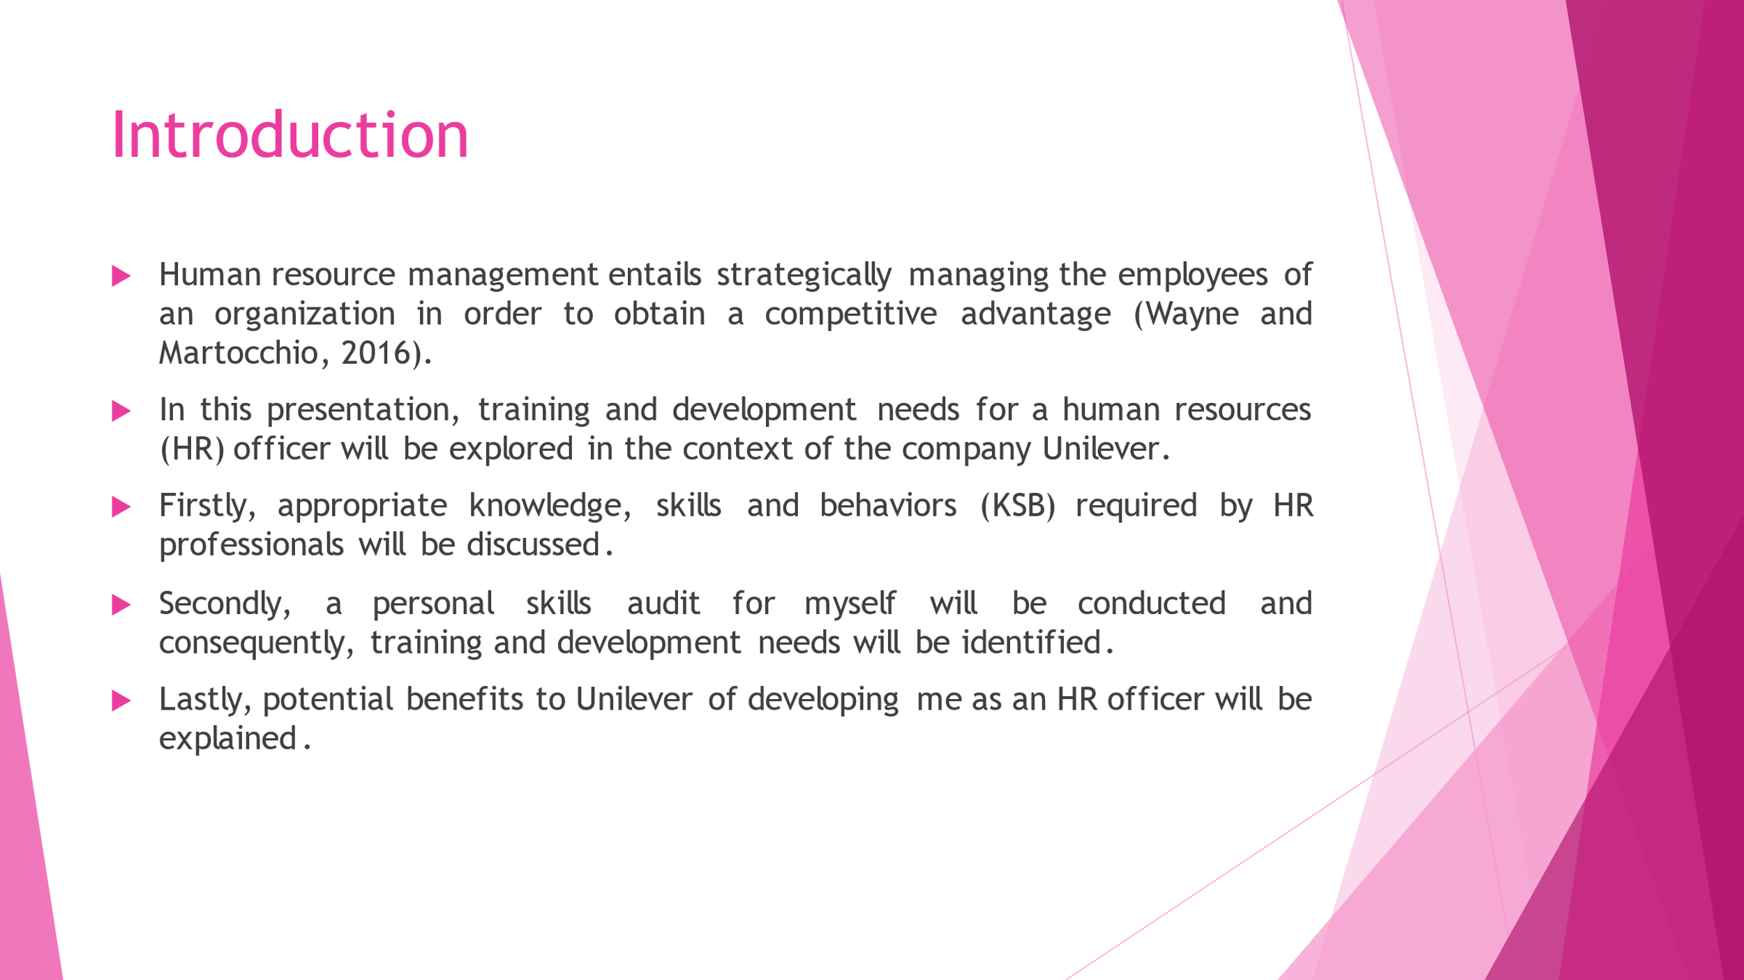
Human resource management entails strategically managing the employees of an organization in order to obtain a competitive advantage (Wayne and Martocchio, 2016). In this presentation, training and development needs for a human resources (HR) officer will be explored in the context of the company Unilever. Firstly, appropriate knowledge, skills and behaviours (KSB) required by HR professionals will be discussed. Secondly, a personal skills audit for myself will be conducted and consequently, training and development needs will be identified. Lastly, potential benefits to Unilever of developing me as an HR officer will be explained.

Knowledge, Skills and Behaviours (KSB) Required by HR Professionals
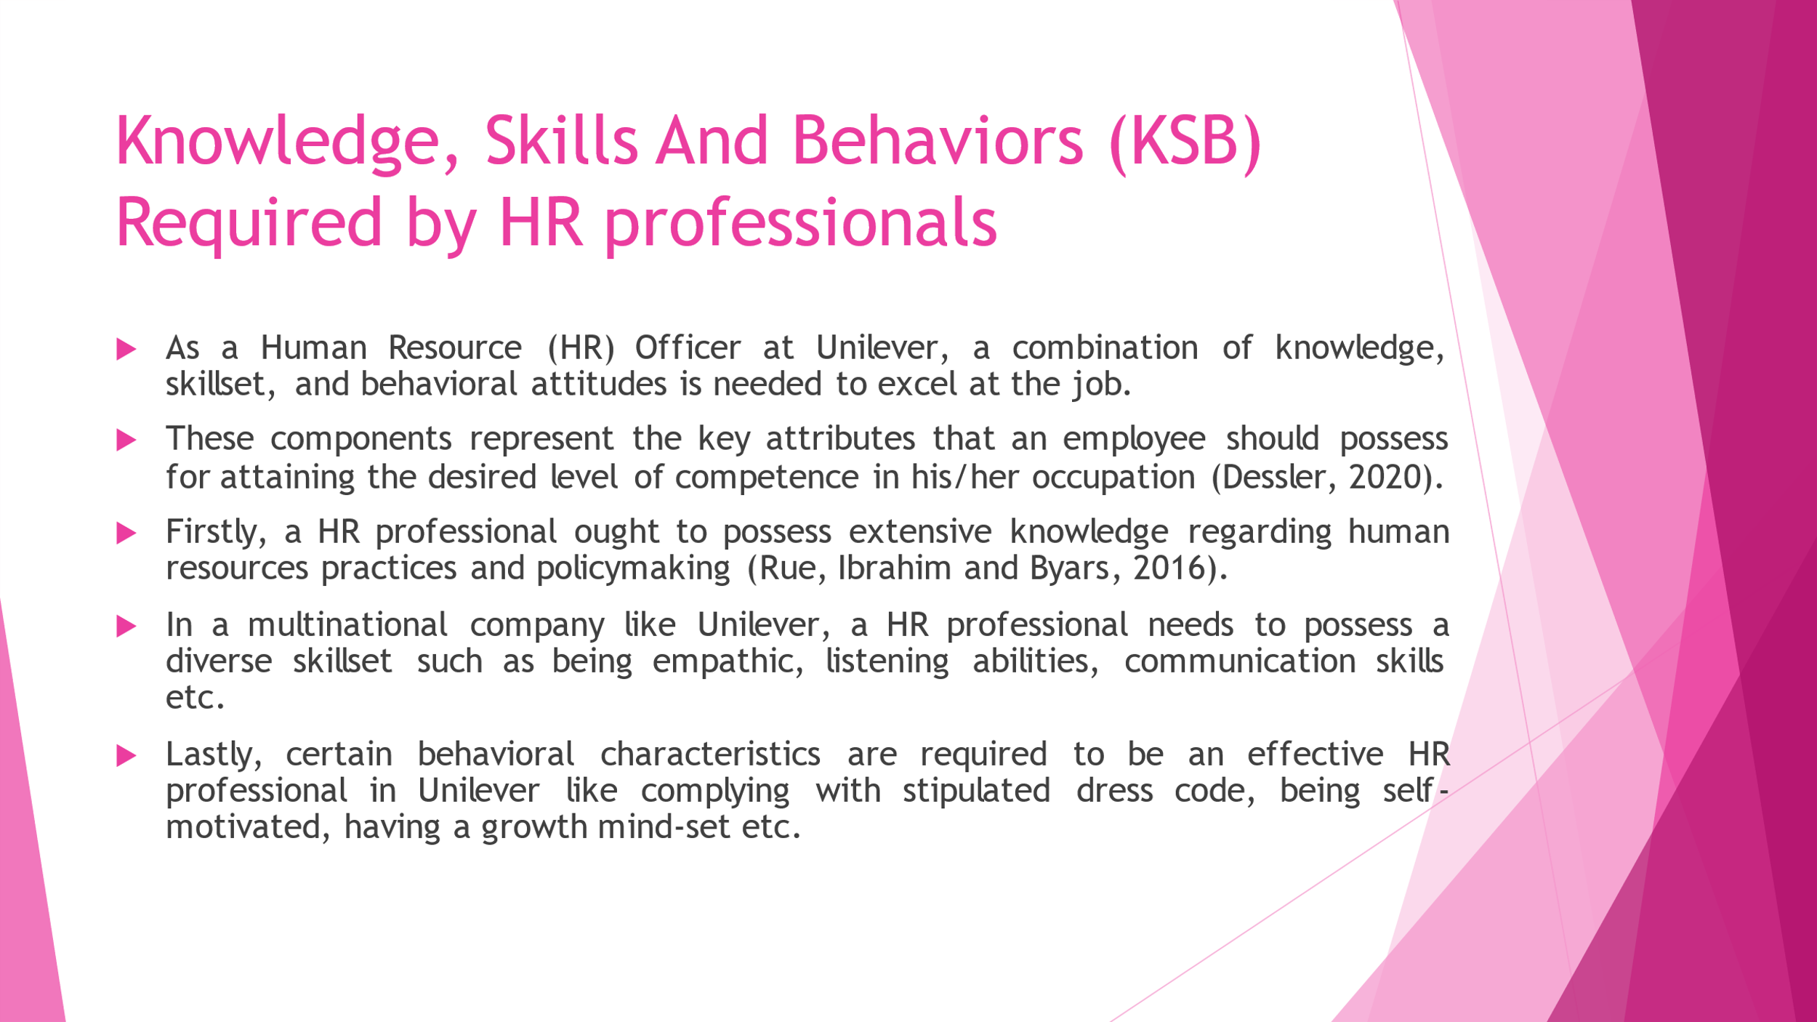
As a Human Resource (HR) Officer at Unilever, a combination of knowledge, skillset, and behavioural attitudes is needed to excel at the job. These components represent the key attributes that an employee should possess for attaining the desired level of competence in his/her occupation (Dessler, 2020). Firstly, a HR professional ought to possess extensive knowledge regarding human resources practices and policymaking (Rue, Ibrahim and Byars, 2016). Particularly, a HR professional needs to have a good grasp on theories regarding conflict management since workplace conflicts are very common occurrences. In many cases, the HR professional will have to undergo training and development based on models like the centralised training model, business-embedded model etc. So, having some degree of familiarity with such procedures can greatly facilitate a HR professional’s work. In a multinational company like Unilever, a HR professional needs to possess a diverse skillset such as being empathic, listening abilities, communication skills etc. Since the HR professional is expected to work in teams on a variety of projects, he/she will need to demonstrate empathy when interacting with colleagues (Lee and Ahn, 2020). The ability to listen carefully to what the top-level executives expect of the workforce is key to successful task performance. Moreover, constantly communicating with employees from different functions is also a requirement for HR professionals. Lastly, certain behavioural characteristics are required to be an effective HR professional in Unilever like complying with stipulated dress code, being self-motivated, having a growth mind-set etc. HR professionals need to abide by the official dress code in the workplace, as declared by the company (Valentine et al., 2020). The HR professional must have sufficient motivation within himself/herself to work for the betterment of the organisation. Lastly, the HR professional needs to adopt a growth mind-set towards career development within the organisation.

Personal Skills Audit and Identifying Training and Development Needs
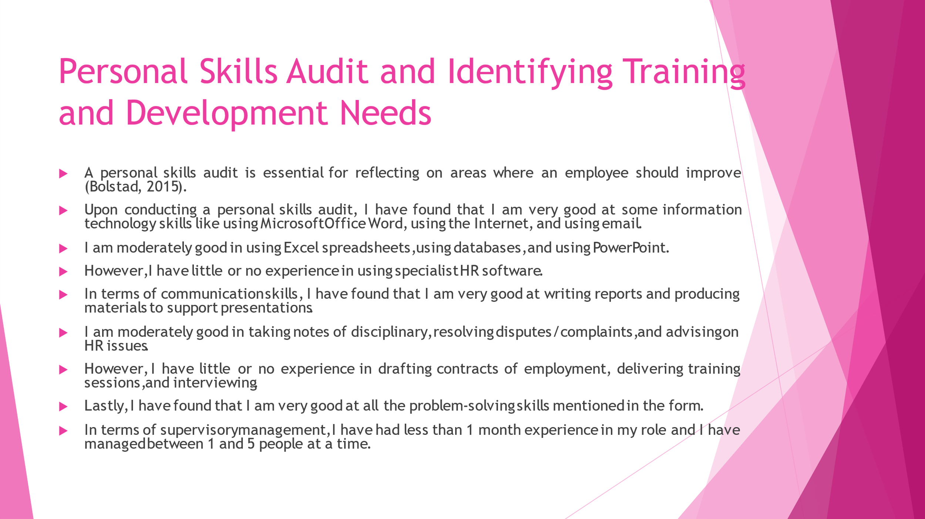
A personal skills audit is essential for reflecting on areas where an employee should improve (Bolstad, 2015). Upon conducting a personal skills audit, I have found that I am very good at some information technology skills like using Microsoft Office Word, using the Internet, and using email. I am moderately good in using Excel spreadsheets, using databases, and using PowerPoint. However, I have little or no experience in using specialist HR software. In terms of communication skills, I have found that I am very good at writing reports and producing materials to support presentations. I am moderately good in taking notes of disciplinary, resolving disputes/complaints, and advising on HR issues. However, I have little or no experience in drafting contracts of employment, delivering training sessions, and interviewing. Lastly, I have found that I am very good at all the problem-solving skills mentioned in the form. In terms of supervisory management, I have had less than 1 month experience in my role and I have managed between 1 and 5 people at a time.

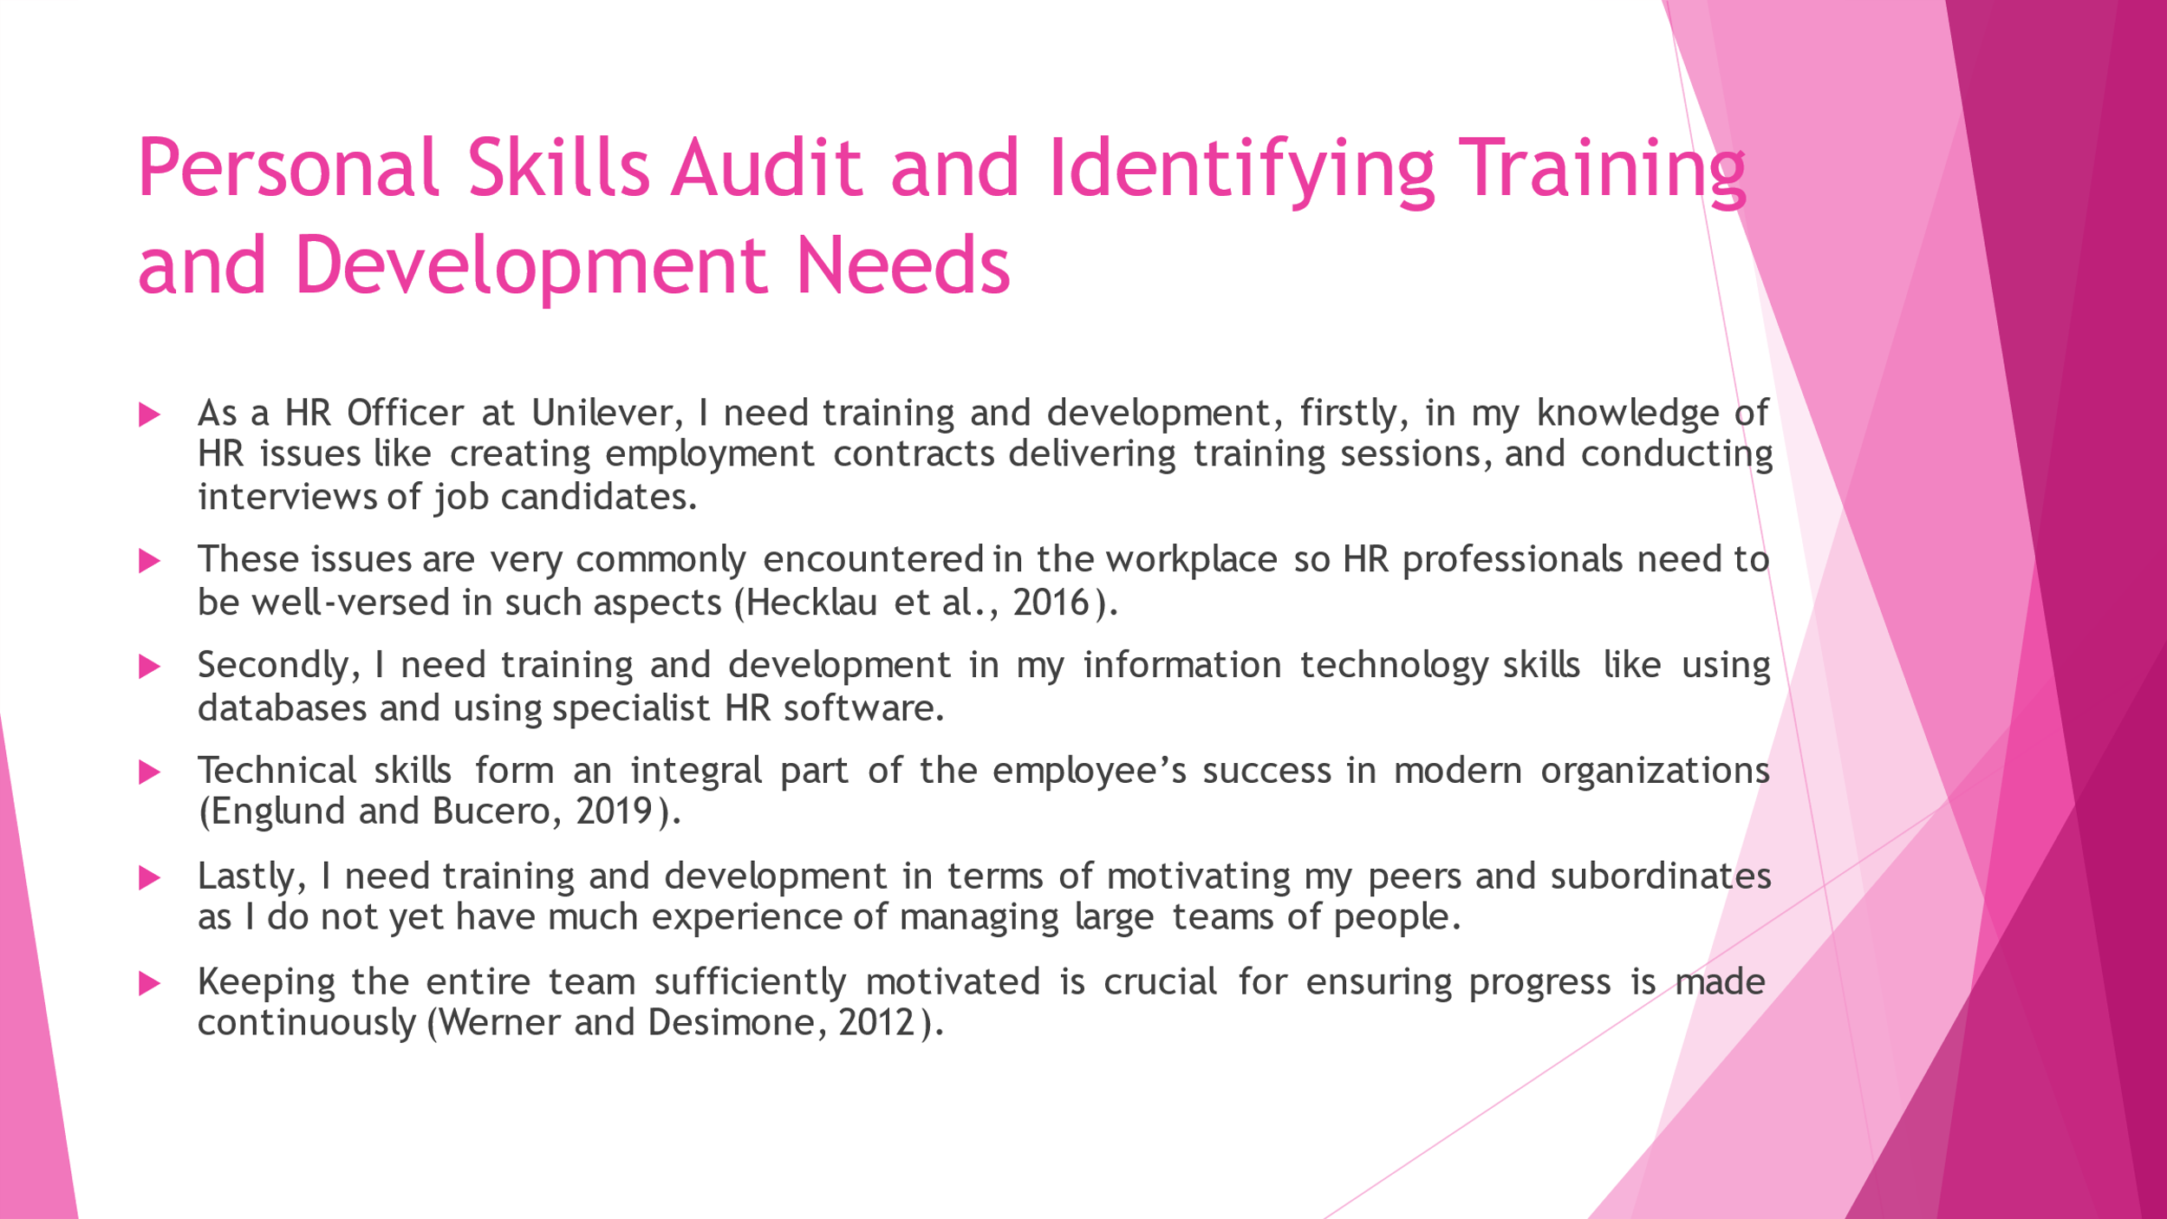
As a HR Officer at Unilever, I need training and development, firstly, in my knowledge of HR issues like creating employment contracts delivering training sessions, and conducting interviews of job candidates. These issues are very commonly encountered in the workplace so HR professionals need to be well-versed in such aspects (Hecklau et al., 2016). Secondly, I need training and development in my information technology skills like using databases and using specialist HR software. Technical skills form an integral part of the employee’s success in modern organizations (Englund and Bucero, 2019). Lastly, I need training and development in terms of motivating my peers and subordinates as I do not yet have much experience of managing large teams of people. Keeping the entire team sufficiently motivated is crucial for ensuring progress is made continuously (Werner and Desimone, 2012).

Benefits To Organisation and Individual of Effective Training and Development
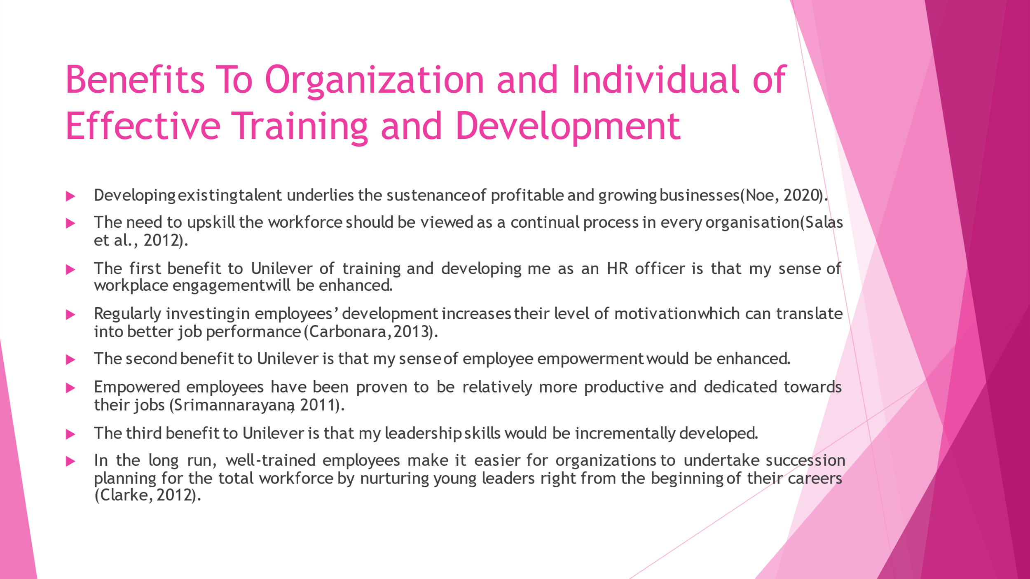
Developing existing talent underlies the sustenance of profitable and growing businesses (Noe, 2020). The need to upskill the workforce should be viewed as a continual process in every organisation (Salas et al., 2012). The first benefit to Unilever of training and developing me as an HR officer is that my sense of workplace engagement will be enhanced. Regularly investing in employees’ development increases their level of motivation which can translate into better job performance (Carbonara, 2013). The second benefit to Unilever is that my sense of employee empowerment would be enhanced. Empowered employees have been proven to be relatively more productive and dedicated towards their jobs (Srimannarayana, 2011). The third benefit to Unilever is that my leadership skills would be incrementally developed. In the long run, well-trained employees make it easier for organizations to undertake succession planning for the total workforce by nurturing young leaders right from the beginning of their careers (Clarke, 2012).

Conclusion
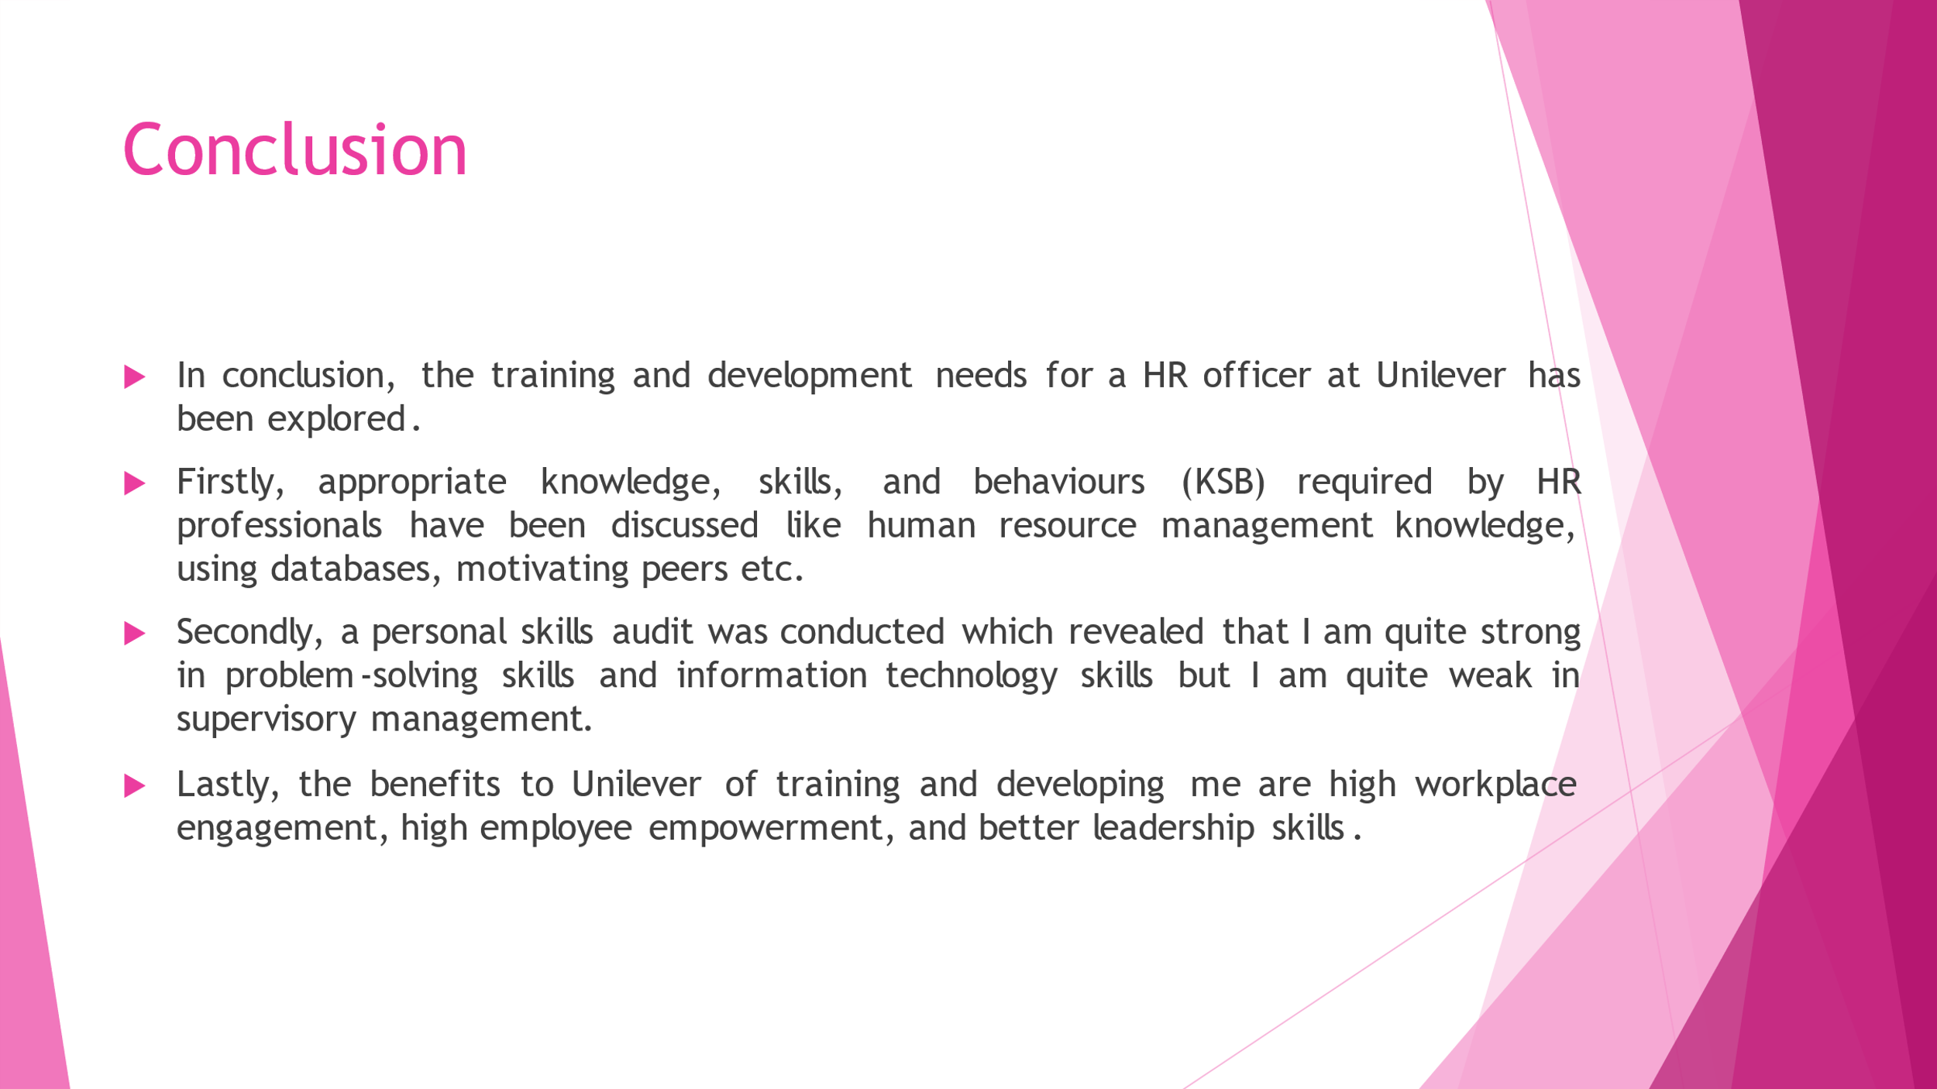
In conclusion, the training and development needs for a HR officer at Unilever has been explored. Firstly, appropriate knowledge, skills, and behaviours (KSB) required by HR professionals have been discussed like human resource management knowledge, using databases, motivating peers etc. Secondly, a personal skills audit was conducted which revealed that I am quite strong in problem-solving skills and information technology skills but I am quite weak in supervisory management. Lastly, the benefits to Unilever of training and developing me are high workplace engagement, high employee empowerment, and better leadership skills.

References
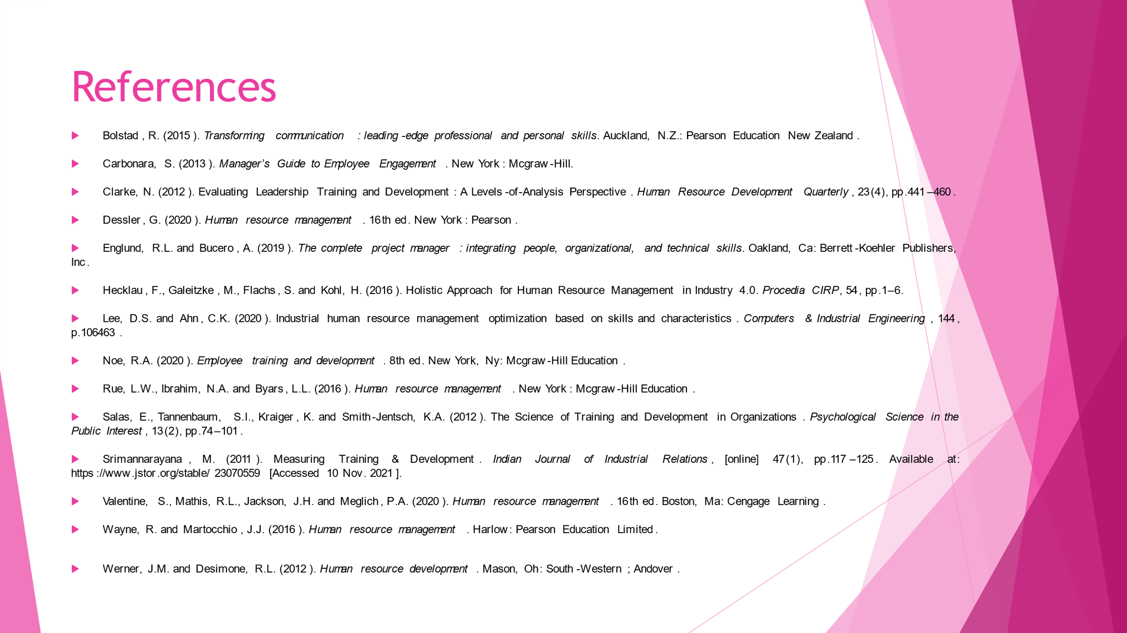
Bolstad, R. (2015). Transforming communication : leading-edge professional and personal skills. Auckland, N.Z.: Pearson Education New Zealand.
Carbonara, S. (2013). Manager’s Guide to Employee Engagement. New York: Mcgraw-Hill.
Clarke, N. (2012). Evaluating Leadership Training and Development: A Levels-of-Analysis Perspective. Human Resource Development Quarterly, 23(4), pp.441–460.
Dessler, G. (2020). Human resource management. 16th ed. New York: Pearson.
Englund, R.L. and Bucero, A. (2019). The complete project manager : integrating people, organizational, and technical skills. Oakland, Ca: Berrett-Koehler Publishers, Inc.
Hecklau, F., Galeitzke, M., Flachs, S. and Kohl, H. (2016). Holistic Approach for Human Resource Management in Industry 4.0. Procedia CIRP, 54, pp.1–6.
Lee, D.S. and Ahn, C.K. (2020). Industrial human resource management optimization based on skills and characteristics. Computers & Industrial Engineering, 144, p.106463.
Noe, R.A. (2020). Employee training and development. 8th ed. New York, Ny: Mcgraw-Hill Education.
Rue, L.W., Ibrahim, N.A. and Byars, L.L. (2016). Human resource management. New York: Mcgraw-Hill Education.
Salas, E., Tannenbaum, S.I., Kraiger, K. and Smith-Jentsch, K.A. (2012). The Science of Training and Development in Organizations. Psychological Science in the Public Interest, 13(2), pp.74–101.
Srimannarayana, M. (2011). Measuring Training & Development. Indian Journal of Industrial Relations, [online] 47(1), pp.117–125. Available at: https://www.jstor.org/stable/23070559 [Accessed 10 Nov. 2021].
Valentine, S., Mathis, R.L., Jackson, J.H. and Meglich, P.A. (2020). Human resource management. 16th ed. Boston, Ma: Cengage Learning.
Wayne, R. and Martocchio, J.J. (2016). Human resource management. Harlow: Pearson Education Limited.
Werner, J.M. and Desimone, R.L. (2012). Human resource development. Mason, Oh: South-Western ; Andover.

Appendix: Personal Skills Audit




